STRUCTURAL OPTIMIZATION FOR SEISMIC DESIGN

**Aman1, Sheela Malik2, Shivender3**

*1M.Tech Scholar,Ganga institute of Technology and Management, Kablana, jhajjar, Haryana)

amanammalhan111@gmail.com

*2 Assistant Professor, Ganga institute of Technology and Management, Kablana, Jhajjar, Haryana)

sheelamalik2209@gmail.com

*3Junior Engineer, CADA (Irrigation Deptt) Haryana, India

shivender3333@gmail.com

**ABSTRACT**

The use of heuristic search methods for earthquake-resistant design of structural frames is explored in this article. Specifically, the Optimization Search method is applied to optimize the weight of steel moment frame structures. A computer program was developed in FORTRAN that incorporates Optimization Search, structural analysis, and design in an iterative process to minimize weight for two-dimensional framed structures. The program was able to optimize the weight of various frames, including a nine-story, five-bay moment frame designed for the 1994 Uniform Building Code lateral force requirements, without requiring engineer input during the search process. The weight of the frame was reduced by 18.3% compared to the original design. The seismic performance of the optimized structure was evaluated using non-linear time history analysis, and it satisfied the desired Life Safety performance level outlined in FEMA-273. The Optimization Search design was compared to the original design in terms of maximum story plastic hinge rotations, story displacements, and inter-story drift ratios during non-linear time history seismic analyses.

## INTRODUCTION

Structural design has always been a very interesting and creative segment in a large variety of engineering projects. Structures, of course, should be designed such that they can resist applied forces (stress constraints), and do not exceed certain deformations (displacement constraints). Moreover, structures should be economical. Theoretically, the best design is the one that satisfies the stress and displacement constraints, and results in the least cost of construction. Although there are many factors that may affect the construction cost, the first and most obvious one is the amount of material used to build the structure. Therefore, minimizing the weight of the structure is usually the goal of structural optimization. The main approach in structural optimization is the use of applicable methods of mathematical programming. Some of these are Linear Programming (LP), Non-Linear Programming (NLP), Integer Linear Programming (ILP), and Discrete Non-Linear Programming (DNLP).

When all or part of the design variables are limited to sets of design values, the problem solution will use discrete (linear or non-linear) programming, which is of great importance in structural optimization. In fact, when the design variables are functions of the cross sections of the members, which is the case for most structural optimization problems, they are often chosen from a limited set of available sections. For instance, steel structural elements are chosen from standard steel profiles (e.g., WF, etc.), structural timber is provided in certain sizes (e.g., 4x8, etc.), concrete structural elements are usually designed and constructed with discrete dimensional increments to the whole inch, and masonry buildings are built with standard size blocks (e.g., 8”, or 10”).

Another important issue to point out is that the nature of structural optimization problems is usually non- linear and non-convex. Therefore algorithms for mathematical programming may converge to local optima instead of a global one.

Finally, there has always been the method of **Total Enumeration** for discrete optimization problems. In this method, all possible combinations of the discrete values for the design variables are substituted, and the one resulting in the minimum value for the objective function, while satisfying the constraints, is chosen. This method always finds the global minimum but is slow and impractical. However, some newly developed techniques, known as heuristic methods, provide means of finding near optimal solutions with a reasonable number of iterations. Included in this group are **Simulated Annealing**, **Genetic Algorithms**, and **Optimization Search**. Moreover, the reduction in computation cost in recent years, due to the availability of faster and cheaper computers, makes it feasible to perform more computations for a better result.

As far back as the 19th century, Maxwell [1] established some theorems related to rational design of structures, which were further generalized by Michell [2]. In the 1940’s and 1950’s, for the first time, some practical work in the area of structural optimization was done (Gerard [3] Livesley [4] Shanley [5]). Schmit [6] applied non-linear programming to structural design. By the early 1970’s, with the development of digital computers, which provided the capability of solving large scale problems, the field of structural optimization entered a new era and since then numerous research studies have been conducted in this area. Wu [7] used the Branch-and-Bound method for the purpose of structural optimization. Goldberg and Samtani [8] performed engineering optimization for a ten member plane truss via Genetic Algorithms. The Simulated Annealing algorithm was applied to discrete optimization of a three-dimensional six-story steel frame by Balling [9]. Jenkins [10] performed a plane frame optimization design based on the Genetic Algorithm. Farkas and Jarmai [11] described the Backtrack discrete mathematical programming method and gave examples of stiffened plates, welded box beams, etc. R. J. Balling [12], in the AISC “Guide to Structural Optimization”, presents two deterministic combinatorial search algorithms among other optimization methods, the exhaustive search algorithm and the Branch- and-Bound algorithm.

## SCOPE OF THIS STUDY

Advances in the speed of computing machines have provided faster tools for long and repetitive calculations. Perhaps, in the near future, an ideal structural analysis and design software program will be able to find the near optimal structure without any given pre-defined properties of its elements.

A structural optimization approach is proposed which is appropriate for the minimum weight design of skeleton structures, e.g., trusses and frames. Taking advantage of the Optimization Search algorithm, structural analysis and design are performed repetitively to reach an optimal design.

A computer program that is capable of finding the best economical framed structure satisfying the given constraints, in a structural optimization formulation based on Optimization Search, is developed and evaluated. The program performs search, analysis and design operations in an iterative manner to reduce the structural weight while satisfying the constraints.

Several frame structures have been optimized using the program (Kargahi [13]). For each problem, the program is fine-tuned by varying the two main search parameters, Optimization tenure and frequency penalty, in order to achieve the least weight. One of these frame structures is discussed in detail here.

## OPTIMIZATION SEARCH FOR COMBINATORIAL PROBLEMS

The distinguishing feature of Optimization Search relative to the other two heuristic methods, genetic algorithm and simulated annealing, is the way it escapes the local minima. The first two methods depend on random numbers to go from one local minimum to another. Optimization Search, unlike the other two, uses history (memory) for such moves, and therefore is a learning process. The modern form of Optimization Search derives from Glover and Laguna [14]. The basic idea of Optimization Search is to cross boundaries of feasibility or local optimality by imposing and releasing constraints to explore otherwise forbidden regions. Optimization Search exploits some principles of intelligent problem solving. It uses memory and takes advantage of history to create its search structure.

Optimization Search begins in the same way as ordinary local or neighborhood search, proceeding iteratively from one solution to another until a satisfactory solution is obtained. Going from one solution to another is called a move. Optimization search starts similar to the steepest descent method. Such a method only permits moves to neighbor solutions that improve the current objective function value. A description of the various steps of the steepest descent method is as follows.

1. Choose a feasible solution (one that satisfies all constraints) to start the process. This solution is the present best solution.
2. Scan the entire neighborhood of the current solution in search of the best feasible solution (one with the most desirable value of objective function).
3. If no such solution can be found, the current solution is the local optimum, and the method stops. Otherwise, replace the best solution with the new one, and go to step 2.

The evident shortcoming of the steepest descent method is that the final solution is a local optimum and might not be the global one.

In order to overcome this problem, Optimization Search uses recency-based and frequency- based memories. The effect of memory may be reviewed as modifying the neighborhood of the current solution (Glover and Laguna [15]). The modified neighborhood is the result of maintaining a selective history of the states encountered during the search. Recency-based memory is a type of short-term memory that keeps track of solution attributes that have changed during the recent past. To exploit this memory, selected attributes that occur in solutions recently visited are labeled Optimization-active, and solutions that contain Optimization-active elements are those that become Optimization. This prevents certain solutions from the recent past from belonging to the modified neighborhood. Those elements remain Optimization-active for a number of moves called the Optimization tenure.

Frequency-based memory is a type of long-term memory that provides information that complements the information provided by recency-based memory. Basically, frequency is measured by the counts of the number of occurrences of a particular event. The implementation of this type of memory is by assigning a frequency penalty to previously chosen moves. This penalty would affect the move value of that particular move in future iterations.

A description of the various steps of the Optimization Search method is as follows.

1. Choose a feasible solution to start the process. This solution is the present best solution.
2. Scan the entire neighborhood of the current solution in search of the best feasible solution.
3. Replace the best solution with the new one. Update the recency-based and frequency- based memories and go to step 2.

## MATHEMATICAL PROBLEM FORMULATION

The general weight-based structural optimization problem for skeleton structures with “n” members and “m” total degrees of freedom can be stated as:

Minimize Z=∑AiLi i = 1,2,…,n

Subject to: Dj  Djmax j = 1,2,…,m

-Simin  Si  Simax

Where Ai’s are the cross sectional areas of the members (design variables), Li’s are the lengths of the members, Dj’s are the nodal displacements, and Si’s are the stresses in the members. Unlike the conventional way of stating a mathematical programming problem, the constraints in the above problem do not contain the design variables, Ai’s.

It can be seen that the objective function Z, is a linear function of the design variables (Ai’s). Unfortunately this is not the case for the constraint functions. The constraints are non-linear functions of the design variables. In order to show this we should briefly discuss the displacement (stiffness) method, the most common method for structural analysis. This method is based on the basic equation of KD=R, where K is the mm global stiffness matrix of the structure (where the coefficients kij’s are defined as the force at node i due to a unit displacement at node j), D is the m1 vector of global joint displacements, and R is the m1 vector of global applied nodal forces.

The solution to this problem is obtained by matrix algebra by multiplying both sides of the equation by K-1 resulting in equations of the form D=K-1R. In order to examine the components of the matrix K-1, consider the components of matrix K, considering the simple case of a truss problem. Each component of the stiffness matrix of a truss consists of the summation of the elements in the form of EiAi/Li, which is a linear function of the design variables. However, in the process of inversion of matrix K, the Ai elements will appear in the denominator of matrix K-1, and will make the elements of the inverse matrix non-linear functions of the Ai’s. This in turn makes the elements of vector D, obtained by the product of K-1R, non- linear functions of the Ai’s. Similar reasoning can be used for flexural elements. For beam problems, the elements of the stiffness matrix K consist of EiIi/Li terms and therefore Ii terms will appear in the denominator of the K-1 matrix elements. For a general frame problem both ∑ciAi and ∑ciIi (with ci’s being constants) terms will appear in the numerator of the K matrix elements, and therefore in the denominator of the K-1 matrix elements.

As the problem indicates, the constraints consist of restrictions on the stresses and displacements. Since the subject of the study is the optimization of steel structural frames, the AISC-ASD Specifications for Structural Steel Buildings [16] is chosen for the purpose of determining the constraints on the stresses. For beams, the allowable flexural stress is calculated using the given formulas and compared to the demand in the beam members. For columns, the combined axial/flexural stress check as outlined in the specification is performed. The AISC specification does not provide limiting values for displacements or inter-story drifts. Those values are obtained from the building code used for the design of the case study buildings [17].

## OPTIMIZATION SEARCH AND STRUCTURAL OPTIMIZATION

It is competitively prohibitive to find the optimal solution of the above structural optimization problem. However, Optimization Search can be used to find a near-optimal solution. In such a problem, the design variables are the cross sections for the structural elements and are chosen from a set (or sets) of available sections sorted by their weight per unit length (or cross sectional area). The objective function to be minimized is the weight of the structure that is calculated by summing the product of weight per unit length by length for all structural elements. A move then consists of changing the cross section of an element to one size larger or one size smaller. Therefore, for a frame with n structural elements there will be 2xn moves at anytime during the search. The constraints are the stresses in the structural elements and the inter-story drifts for all story levels. The considered stresses are bending, combined axial and bending, and shear stresses.

The starting point of the search must be a structural configuration that satisfies the stress and displacement constraints. The search begins by evaluating the frame weight at the entire neighborhood of the starting point and the corresponding move values, choosing the best move (the one that results in the most weight reduction). The required replacements are then made to the structural properties, and structural analysis is performed. Based on the analysis results, stress and displacement constraints are checked. If all of the constraints are satisfied, the move is feasible and the search algorithm has found a new node. If any of the constraints are not satisfied, the structural configuration is set back to its original form, the second best move is selected, the corresponding changes are made to the structural model, and the analysis and constraint evaluation processes are repeated. This procedure is continued until a move that satisfies all the constraints is found. The search algorithm is now at a new node. At this stage, the Optimization tenure and frequency penalty for the performed move are applied to the selected move and the program proceeds by repeating the same algorithm at the new node.

It should be noted that a move is not finalized unless all constraints for the structural configuration that is the result of that move are satisfied. Therefore, there is no chance of staying in the infeasible region. For instance if a move results in a structural configuration with drift ratios exceeding the required limits, it will not be an acceptable move. Instead, the algorithm will go back to the previous configuration and take the next best move.

The Optimization tenure is applied by prohibiting the reverse of a move for a certain duration (e.g. if the section for element “i” is reduced to a smaller section, changing it back to the larger section becomes prohibited for a duration of Optimization tenure, and vice versa). The frequency penalty is applied in the form of a positive number added to the move value of a particular move (good moves have negative move values) and therefore reducing its chance for being selected as the best move in the future (e.g. if the section for element “i” is reduced to a smaller section, the move value of reducing the section of element “i” in the future will contain the frequency penalty).

## OPTIMIZATION SEARCH OPTIMIZATION COMPUTER PROGRAM

A structural optimization program is developed in the FORTRAN computer language using Optimization Search as a means of finding the near minimum weight for a framed structure under given static load conditions.

The main body of the program is the implementation of the Optimization Search method, as described earlier. This part of the program keeps track of the moves based on their recency and frequency, chooses the neighboring candidates at each stage, and prepares the required data for the next stages. This set of data contains cross-sectional properties for all elements of the structure.

The program also contains the necessary structural analysis subroutines. Direct stiffness method is used for this purpose. The output of this part is nodal displacements and internal member forces, which are the inputs necessary for the next part.

Finally, the constraint evaluation part of the program contains a stress check subroutine based on AISC- ASD Specification [16], and a story drift check subroutine based on building code requirements.

The search method also requires accessing section properties for a given set of available sections. The section properties are listed in section property data files. Since beams and columns are usually selected from different types of W-sections, two different section property files are generated, one for beams and the other for columns. Also, a third data file is prepared for the elements that are not part of the search. These are referred to as non-iterating elements and their size does not change during iterations.

A grouping method is implemented in the program by simply putting the elements that are desired to have the same section in one group and treating the group as one independent variable. In addition to resulting in more practical designs, the number of independent variables and therefore the time to run the program is reduced. The search method changes sections for the entire group of elements instead of a single structural element.

Strong Column/Weak Beam requirements based on the AISC Seismic Provisions for Structural Steel Buildings [18] are added to the program to further increase the practicality of the final designs.

## Case Study

A 9-story (10-story including the laterally supported first floor), 5-bay (one of the bays has moment connection on one side only, see Figure 1) SMRF frame (Figure 2) is considered for optimization using the developed program. This frame (SAC-9) is representative of existing steel structures in the Los Angeles area and was part of a SAC program of study following the Northridge earthquake (Mercado [19]). The starting point was intended to be the sections from the original design of the structure. However, the beam sections of the 6th and 7th floors are changed in order to make the structure compliant with the Strong Column Weak Beam (SC/WB) requirements. The original beam section of W36x135 is changed to W33x130 and W33x118 for the 6th and 7th floors respectively. Total weight at the starting point is 194,848 kg (430,128 lb). To study the effects of Optimization tenure and frequency penalty on the search performance, the search is initially performed with 6 different Optimization tenures and 7 different frequency penalties, for 100 iterations (42 runs). The chosen Optimization tenures are 3, 4, 5, 6, 7, and 8; and the chosen frequency penalties

are 9, 10, 11, 12, 13, 14, and 15 per element in each element group.

Figure 7 illustrates average final stress ratios for columns and beams at all story levels. The overall average column and beam stress ratios are 0.492 and 0.704 respectively. The inter-story drift ratios are also shown in Figure 7. The overall average drift ratio is 0.00239. Since there are low stress ratios in the columns while all drift ratios are very close to the limiting value of 0.0025, ***it can be concluded that the design of the 9-story frame was entirely displacement controlled***.

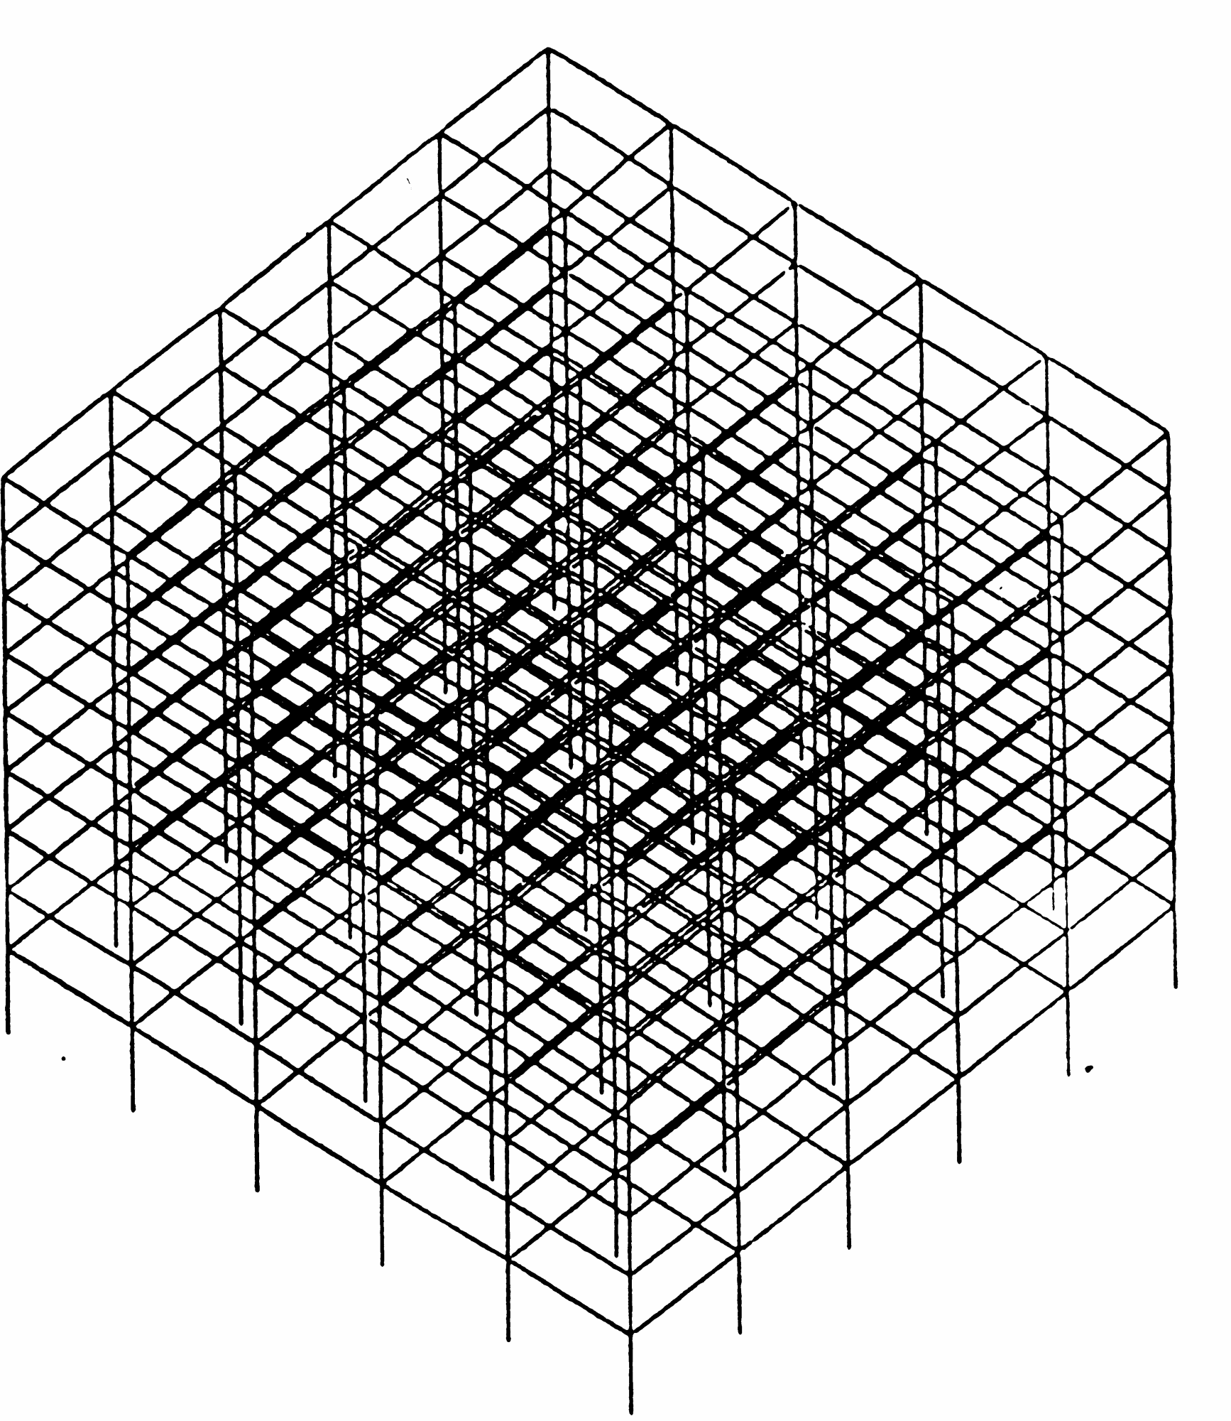

## Figure 1. 9-story SAC – Structural framing and typical floor plan

164000

163000

weight (kg)

162000

161000

160000

164000

163000

weight (kg)

162000

freq. pen. 9&10&11&12

freq. pen. 13&14

W24x68

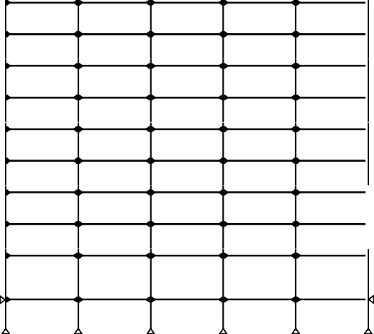

W27x84

W27x84

W27x84

W27x84

W27x84

W30x99

W30x99

W30x99

W30x99

W30x99

W36x135 W36x135 W36x135 W36x135 W36x135

W36x135 W36x135 W36x135 W36x135 W36x135

W36x135 W36x135 W36x135 W36x135 W36x135

W36x135 W36x135 W36x135 W36x135 W36x135

W36x160 W36x160 W36x160 W36x160 W36x160

W36x160 W36x160 W36x160 W36x160 W36x160

W36x160 W36x160 W36x160 W36x160 W36x160

column rotated

W24x68

W24x68

W24x68

W24x68

161000

160000

13'

13'

**W14x233**

**W14x257**

**W14x257**

**W14x257**

**W14x257**

**W14x233**

164000

13'

**W14x257**

**W14x283**

**W14x283**

**W14x283**

**W14x283**

**W14x257**

freq. pen. 15

163000

13'

weight (kg)

162000

13'

**W14x283**

**W14x370**

**W14x370**

**W14x370**

**W14x370**

**W14x283**

161000

13'

160000

13'

13'

**W14x370**

**W14x455**

**W14x455**

**W14x455**

**W14x455**

**W14x370**

3 4 5 6 7 8

Optimization tenure

18'

**W14x370**

**W14x500**

**W14x500**

**W14x500**

**W14x500**

**W14x370**

30' 30' 30' 30' 30'

12'

## Figure 2. 9-story SAC – Original frame

**Figure 3. 9-story SAC - Variation of achieved minimum weight with Optimization tenure for different frequency penalties, 100 iterations**

164000

Optimization tenure 3

164000

Optimization tenure 6

163000 163000

weight (kg)

weight (kg)

162000 162000

161000 161000

160000

164000

Optimization tenure 4

160000

164000

Optimization tenure 7

163000 163000

weight (kg)

weight (kg)

162000 162000

161000 161000

160000

164000

Optimization tenure 5

160000

164000

Optimization tenure 8

163000 163000

weight (kg)

weight (kg)

162000 162000

161000 161000

160000

9 10 11 12 13 14 15

frequency penalty

160000

9 10 11 12 13 14 15

frequency penalty

## Figure 4. 9-story SAC - Variation of achieved minimum weight with frequency penalty for different Optimization tenures, 100 iterations

200000 200000

190000 190000

180000 180000

weight (kg)

weight (kg)

170000 170000

160000 160000

150000

0 10 20 30 40 50 60 70 80 90 100

iterations

150000

0 20 40 60 80 100 120 140 160 180 200

iterations

W21x44

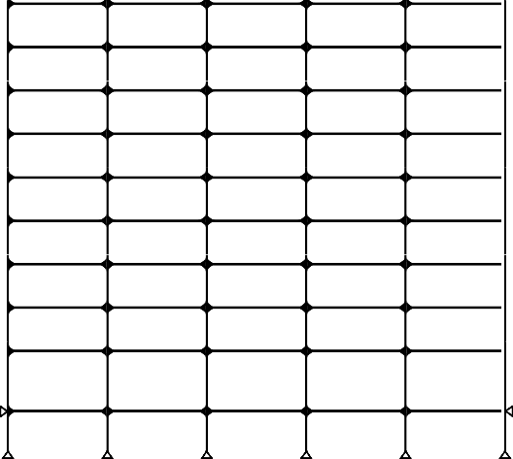

W24x62

W24x62

W24x62

W24x62

W24x62

W30x99

W30x99

W30x99

W30x99

W30x99

W30x108 W30x108 W30x108 W30x108 W30x108

W30x99

W30x99

W30x99

W30x99

W30x99

W33x118 W33x118 W33x118 W33x118 W33x118

W33x118 W33x118 W33x118 W33x118 W33x118

W30x99

W30x99

W30x99

W30x99

W30x99

W36x150 W36x150 W36x150 W36x150 W36x150

W33x130 W33x130 W33x130 W33x130 W33x130

column rotated

13'

**W14x145**

**W14x257**

**W14x233**

W21x44

13'

13'

13'

13'

**W14x159**

**W14x132**

**W14x311**

**W14x257**

**W14x193**

W21x44 W21x44

**W14x193**

**W14x193**

W21x44

**W14x311**

**W14x257**

**W14x311**

**W14x257**

**W14x311**

**W14x257**

**W14x193**

9

8



columns beams

7

6

5

**W14x283**

story level

4

3

2

1

0

-1

0.0 0.2 0.4 0.6 0.8 1.0

stress ratio

12'

|  |  |
| --- | --- |
|  |  |
|  |  |
|  |  |
|  |  |
|  |  |
|  |  |
|  |  |
|  |  |
|  |  |
|  |  |

0.002 0.00225 0.0025



18'

13'

13'

13'

**W14x455**

**W14x176**

**W14x370**

**W14x426**

**W14x370**

**W14x426**

**W14x370**

**W14x426**

**W14x370**

**W14x426**

**W14x370**

**W14x370**

drift ratio

30' 30' 30' 30' 30'

## Figure 7. 9-story SAC – Final beam and column sizes

**Figure 8. 9-story SAC – Final stress and drift ratios**

**MODELING ASSUMPTIONS FOR PERFORMANCE MEASUREMENT**

# In order to obtain a measure of performance for the final outcome of Optimization Search optimization, a series of non-linear time history analyses are performed. The RAM-XLinea computer program

[20] is used to study the formation of plastic hinges in the frame elements. Twenty seismic ground motion records developed for the Los Angeles area [21] and with the return probability of 10% in 50 years are used for the analyses. Minimum Life Safety performance is desired for such analyses.

# The RAM-Xlinea program is capable of performing non-linear time history analysis for two- dimensional frames. The plastic hinge beam-column element type (type 02) is chosen for modeling the beam and column structural elements. The inelastic behavior is represented by a two-component beam element with concentrated plastic hinges at the ends. The two components are the elastic-plastic component which admits concentrated hinges at the ends, and the infinitely elastic component that allows for strain hardening and gives the combined element a bi-linear character (Figure 9). Yielding takes place only in the plastic hinges. The hinge yield moments can be specified to be different at the two element ends, and for positive and negative bending. The effect of axial force on bending strength is taken into account by specifying P-M yield surfaces. Plastic hinges that yield at constant moment form in the inelastic component. The moment in the elastic component continues to increase, simulating strain hardening. Static loads applied along the element length, or initial forces due to other causes, can be taken into account by specifying equivalent fixed end forces.

Column and beam element stiffness properties are introduced by specifying modulus of elasticity, strain-hardening ratio, cross sectional area, and moment of inertia. The yield surface for the columns is introduced by specifying positive yield moment, negative yield moment, compression yield force, tension yield force, M/My+, P/Py+, M/My-, and P/Py-, as shown in Figure 10. For beams only the yield moments are introduced.

My

Complete Element

Elastic-Plastic Component

Elastic Component

+P

Py

0.15Py

-M Mp

Mp +M

0.15Py

Py

-P

Moment

Curvature

## Figure 9. Non-linear element parallel components

**Figure 10. Column P-M interaction diagram**

# FEMA 273 seismic rehabilitation guidelines [22] provides acceptance criteria for the desired performance level for different types of structural systems. The ratio of plastic rotation over yield rotation, p/y, is used to measure the performance of fully restrained steel moment frames. This ratio is limited to 7 for beams and columns with P/Pye < 0.20, if bf/2tf < 52/Fye, when Life Safety performance is desired.

The value of yield rotation of beams in FEMA 273 is given as

❑  *ZFye Lb*

*y* 6*EI*

*b*

and for columns is given as

❑  *ZFye Lc* (1  *P* )

*y*

where6*EIc*

*Pye*

bf is the flange width,

tf is the flange thickness,

Z is the plastic modulus of the section,

Fye is the yield strength of the steel material, Lb is the beam length,

E is the elasticity modulus of the steel material, Ib is the beam moment of inertia,

Lc is the column length,

Ic is the column moment of inertia, P is the column axial force,

and Pye is the column compression yield force.

## PERFORMANCE OF THE CASE STUDY STRUCTURE

10 10

Life Safet

Life Safety

la17

la16

9 9

8 8

la07

la09

7 7

6 6

la12 la19

5 5

story

la15

la14 la20

la01

story

4 4

la13

la11

la04 la03

la05

3 3

la10

la02 la08

la18

la06

2 2

1 1

0

0.000 0.010 0.020 0.030 0.040 0.050 0.060

rotation

0

0 2 4 6 8

plastic/yield rotation ratio

## Figure 11. 9-story SAC – Maximum plastic rotation of beams for different ground acceleration records, TS design

**Figure 12. 9-story SAC – Maximum** **p/****y**

## ratios for beams, TS design

The analysis indicates that the Optimization Search (TS) optimization final design for the 9-story SAC structure satisfies the performance-based regulations of FEMA273 at the Life Safety level with regard to the plastic hinge rotations of its elements. Plastic rotations in the columns are either zero or negligible. Maximum

/y ratio for the beams is 5.93 which is well below the value of 7 for Life Safety.

## COMPARISON OF THE OPTIMIZATION SEARCH DESIGNS AND THE ORIGINAL DESIGNS

In order to compare the TS final design with the original design, the original design frame was analyzed for the ground motion records that resulted in the largest plastic hinge rotations for the TS design. The values of maximum story plastic hinge rotations, story displacements and inter-story drift ratios are then compared against the corresponding values from the analyses of the TS design frames.

The original design 9-story frame is analyzed using the LA05 ground motion record that produced the most severe effects on the lower half, and the LA16 ground motion record that produced the most severe effects on the upper half of the TS Design frame. Figure 13 shows the values of maximum beam plastic rotations, maximum story displacements, and maximum story drift ratios at different story levels of the SAC-9 frame obtained from the original and TS designs under LA05 base acceleration. The values of plastic beam rotations are larger for the TS design at the lower floors. The maximum top floor displacement of the TS design reaches 0.945 m (37.2 in) while the comparable one from the original design is 0.711 m (28.0 in). The drift ratios are generally higher for the TS design under this ground acceleration. The maximum drift ratio is 0.0385 at the 4th floor level of the TS design and 0.0297 at the 3rd floor level of the original design. Figure 14 shows the values of maximum beam plastic rotations, maximum story displacements, and maximum story drift ratios at different story levels of the SAC-9 frame as obtained from the original and TS designs under LA16 acceleration. The beam plastic rotation demands are very comparable for the two designs under this ground motion. Maximum rotation demand for the original design occurs at the 7th and 8th levels while maximum values for the TS design occurs at the 9th and 10th levels. In both designs, there is no significant plastic rotation in the columns. The maximum top floor displacement of the original design reaches 0.594 m (23.4 in) while the one from TS design is 0.564 m (22.2 in) with the upper story levels of the original design frame generally having a larger displacement. The maximum drift ratio is 0.0306 at the 10th floor level of the TS design and 0.0231 at the 9th floor level of the original design. The larger drift ratios of the original design occur in the story levels 5, 6 and 7, whereas the larger drift ratios of the TS design occur in the story levels 8, 9, and 10.

10 10 10

Original

LS-Original TS

LS-TS

Original

TS

Original

TS

9 9 9

8 8 8

7 7 7

6 6 6

story

5 5 5

story

story

4 4 4

3 3 3

2 2 2

1 1 1

0

0 0.01 0.02 0.03 0.04 0.05 0.06

maximum story beam plastic rotation

0

0 0.25 0.5 0.75 1

story displacement (m)

0

0 0.01 0.02 0.03 0.04

interstory drift ratio

## Figure 13. 9-story SAC - comparison of TS and original designs for LA05 record, LS=Life Safety

10 10 10

Original

LS-Original TS

LS-TS

Original

TS

Original

TS

9 9 9

8 8 8

7 7 7

6 6 6

story

5 5 5

story

story

4 4 4

3 3 3

2 2 2

1 1 1

0

0 0.01 0.02 0.03 0.04 0.05 0.06

maximum story beam plastic rotation

0

0 0.25 0.5 0.75 1

story displacement (m)

0

0 0.01 0.02 0.03 0.04

interstory drift ratio

## Figure 14. 9-story SAC - comparison of TS and original designs for LA16 record, LS=Life Safety

**CONCLUSIONS**

As an alternative/automated approach to the analysis and design of framed steel structures, an optimization based structural analysis and design program is developed. The algorithm performs search, structural analysis, and structural design iteratively, using Optimization Search method.

The developed Optimization Search structural optimization program proves capable of achieving considerable weight reduction for two-dimensional frames. Medium size frames are analyzed and designed in a reasonable time, while engineer interface during the search is not required. To improve efficiency of the method, several searches are performed with different search parameters and the duration of search is increased if needed. The program is utilized to reduce the structural weights for the case study structure, a 9-story,5-bay frame, resulting in 18.3 weight reductions. Similar to the original design, the final Optimization Search designs of the 9-story frame was displacement controlled.

The frame being studied was analyzed and designed using a personal computer with an Intel Pentium II,

233 MHz processor that is relatively slow by current standards. The program was able to achieve significant weight reductions in a reasonable time. Sample run times for 100 and 200 iterations were 7 and 15 minutes respectively. The total possible number of permutations based on the available sections for beams and columns was 9.71x1028. Samples of the number of analyses performed by the program for 100 and 200 iterations were 1393 and 3160 respectively which represent a very small fraction of the total possible permutations.

The TS final design satisfied the desired Life Safety performance level as outlined in FEMA 273 in non- linear time history analyses. The plastic rotations of beam and column elements stayed well below the limiting values for such performance level.

The behavior of the TS frame was comparable with the original design in terms of its maximum plastic hinge rotations, story displacements, and inter-story drift ratios in non-linear time history analyses. The design of the buildings is primarily controlled by displacement constraints under service loads. This tends to give this building an overstrength relative to code specified lateral force. This is reflected in the low beam plastic rotations for the 9 story building even with the smaller beam and column section which were the result of the Optimization Search optimization.

## REFERENCES

1. Maxwell, C., “Scientific Paper II”, Cambridge University Press, 1890
2. Michell, A. G. M., “The Limits of Economy of Material in Frame-Structures”, Philosophical Magazine, Series 6, Vol. 8, No. 47, 1904
3. Gerard, G., “Minimum Weight Analysis of Compression Structures”, New York University Press, 1956
4. Livesley, R. K., “The Automatic Design of Structural Frames”, Quarterly Journal of Mechanics and Applied Mathematics, Vol. 9, 1956
5. Shanley, F., “Weight-Strength Analysis of Aircraft Structures”, Dover, NY, 1960
6. Schmit, L. A. Jr., “Structural Design by Systematic Synthesis”, Second Conference on Electronic Computation, Pittsburg, PA, 1960
7. Wu, P., “Structural Optimization with Nonlinear and Discrete Programming”, Ph.D. Thesis, University of Wisconsin-Madison, 1986
8. Goldberg, D. E., and Samtani, M. P., “Engineering Optimization via Genetic Algorithm”, Proceedings of the Ninth Conference on Electronic Computation, ASCE, pp. 471-482, 1986
9. Balling, R. J., “Optimal Steel Frame Design by Simulated Annealing”, ASCE Journal of Structural Engineering, Vol. 117, No. 6, 1991Jenkins, W. M., “Plane Frame Optimum Design Environment Based on Genetic Algorithm”, ASCE Journal of Structural Engineering, Vol. 118, 1992
10. Farkas, J., and Jarmai, K., “Discrete Structural optimization”, Springer-Verlag Wien, New York, 1997
11. Balling, R. J., “Guide to Structural Optimization”, ASCE Manuals and Reports on Engineering Practice No. 90, 1997
12. Kargahi, M., “Structural Optimization with Optimization Search”, Doctoral Dissertation, University of Southern California, Los Angeles, CA, 2002
13. Glover, F., and Laguna, M., “Modern Heuristic Techniques for Combinatorial Problems”, Halsted Press, New York, 1993