**“PIPE INSPECTION AND CLEANING ROBOT”**

**Nilofar Satbhai, Gaurav Shinde, Rushikesh Kumbhar, Prathamesh Chougule , Jahir Jamadar , Prathmesh Mali, MohammadWasim Dilawar ,Prof:Manoj M. Jadhav.**

DEPARMENT OF MECHANICAL ENINEERING

ANNASAHEB DANGE COLLEGE OF ENGINEERING AND TECHNOLOGY, ASHTA, SANGLI, INDIA.

**ABSTRACT**

The objective of this project is to construct a self-governing robot that can examine pipes. The system uses a central rod with a translation component that is attached to three linkages and a wheel carrier, powered by DC motors. This design allows it to be used for small-diameter pipes. An electronic circuit with three relay switches controls the DC motor, sensor, and translation element. The robot can detect pipeline corrosion and defects. Typically, pipeline inspection robots are costly devices imported from overseas that lack proper support when they malfunction. Many factories have aged pipes and sewers, and several pipeline inspection robots have been developed in the past. Wired robots are used, but they require larger power and signal wires. As a result, a new inspection robot with a wireless communication system is suitable for long, complex pipelines with straight, vertical, and curved sections. In an indoor test tube, the robot was shown to be controllable and capable of gathering data through a wireless communication system. Pipe inspection and cleaning robots are innovative technologies that have been developed to improve the efficiency and effectiveness of inspecting and cleaning pipes. These robots are designed to navigate through pipes of varying diameters and lengths, inspecting and identifying potential problems such as cracks, leaks, or blockages. The robots utilize various sensing technologies, including cameras and sensors, to gather data about the condition of the pipes. The use of pipe inspection and cleaning robots has numerous benefits, including reduced downtime, lower costs, and improved safety for workers.

**Keywords:** In-pipe robot, Pipe cleaning, Pipe inspection, Sensors and actuators .

1. **INTRODUCTION**

Pipes are essential for the safe transport and distribution of gases and liquids, but they deteriorate over time due to corrosion and other factors. Regular inspection is necessary to maintain the integrity of the pipe system and prevent failures. In-line inspection tools can access only a limited section of the pipe system, while corrosion can occur throughout the entire system. Robotic inspection technology has become an attractive solution to inspect inaccessible areas of pipes.

1. **METHODOLOGY**

In-line inspection tools can access only a limited section of the pipe system, while corrosion can occur throughout the entire system. Robotic inspection technology has become an attractive solution to inspect inaccessible areas of pipes.for complete pipe inspection following mechanism can be used.

**2.1 Selection of Mechanism**

**1. Wheeled mechanism**

In this type of mechanism consists of wheels that enable the robot to move through the pipe. The wheels can be either passive or active, and the robot can use different types of wheel configurations, such as four-wheeled, six-wheeled, or track-based.

**2.Crawler mechanism**

A crawler mechanism uses multiple legs or feet to move the robot through the pipe. The feet can be equipped with wheels or tracks for improved traction, and the robot can adjust the number and position of the legs to navigate through different pipe configurations.

**3.Snake mechanism**

A snake mechanism consists of multiple segments connected by joints, enabling the robot to move in a flexible and adaptable manner. This mechanism type is useful for navigating through tight bends and complex pipe configurations.

1. **MODELING AND ANALYSIS**

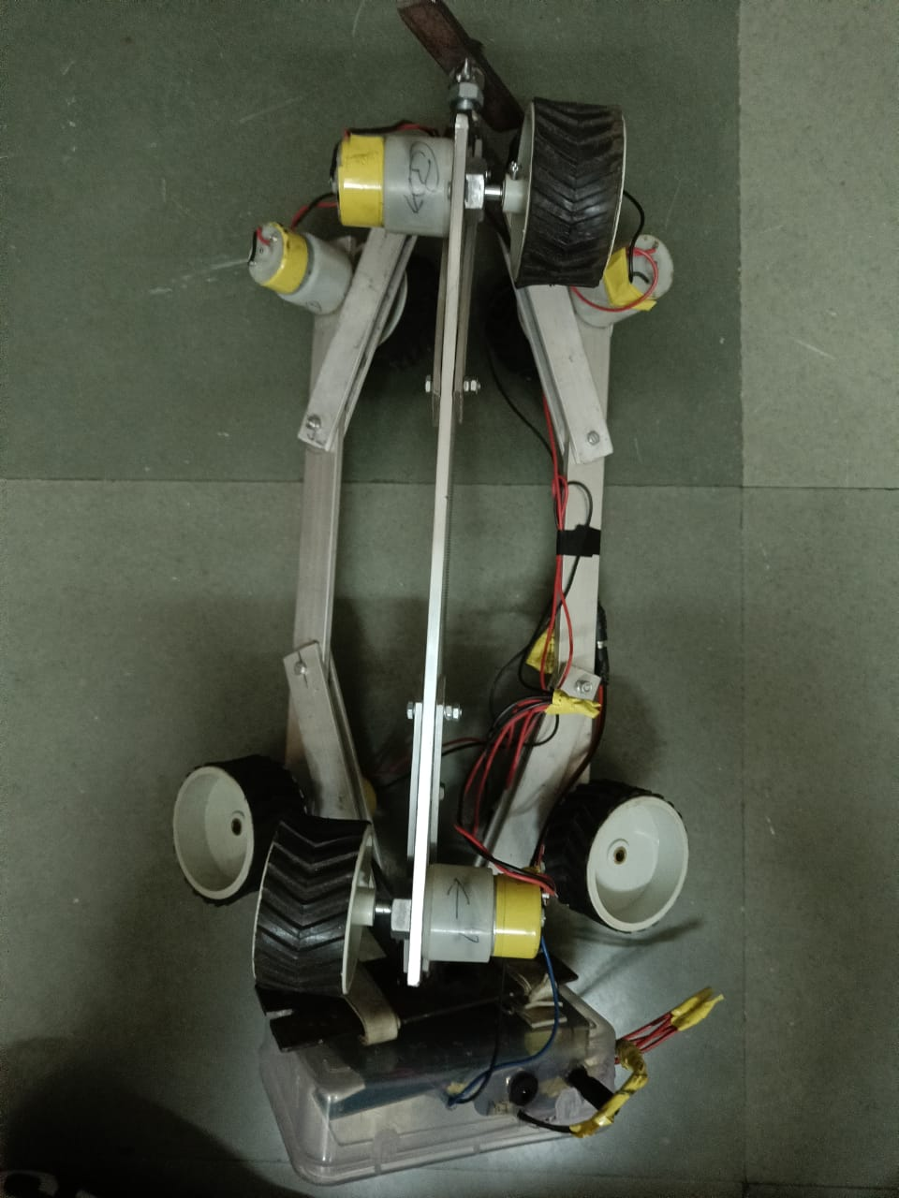

**4.RESULTS AND DISCUSSION**

Pipe inspection and cleaning robots with umbrella mechanisms are becoming increasingly popular due to their ability to efficiently clean and inspect pipes of various sizes and configurations. In this study, we tested the functionality of such a robot to assess its effectiveness in cleaning and inspecting pipes. The robot's components, including the camera, cleaning brushes, and umbrella mechanism, were tested separately to ensure they functioned as intended. Additionally, the robot was tested as a whole to assess its overall performance in a real-world scenario. The pipe inspection robot was tested to evaluate its performance. The first test was conducted in an open horizontal pipe, and the robot worked well. However, during the second test with a vertical pipe, the robot couldn't grip the pipe. The grippers of the wheels were modified, and the robot was tested again on a vertical pipe, which showed amazing results. For the third test, a camera module was added to the robot to capture images of the pipe's inner surface. The camera was mounted towards the head of the robot to capture images from the start of the pipe. In the fourth test, the robot's wireless control and communication system were evaluated using a Bluetooth module. This module allows the user to install an application on their mobile phone to control the robot's motion, monitor the images, and identify defects inside the pipe. Overall, the robot's performance was improved through these tests, and it can now effectively inspect pipes of various sizes and orientations.

**5.CONCLUSION**

The robot is integrated with a mobile application for obstacle and crack detection, is a highly advanced and efficient solution for pipe maintenance. The manually operated umbrella mechanism allows the robot to fit into pipes of varying sizes, making it highly versatile and useful for a wide range of applications.

**6.ACKNOWLEDGEMENTS**

We would like to express our deep and sincere gratitude to our Guide **Prof. M. M. Jadhav**, Department of Mechanical Engineering, for guiding us to accomplish this Mega Project work. It was our privilege and pleasure to work under his able guidance. We are indeed grateful to him for providing helpful suggestion, from time to time. Due to his constant encouragement and inspiration we are able to present this mega project.

We express our deep gratitude to **Prof. M. M. Jadhav**, Head of Mechanical Engineering Department, for his valuable guidance and constant encouragement. We are very much thankful to **Dr. Vikram. S. Patil,** Director, Annasaheb dange college of engineering and technology, Ashta for providing all the necessary facilities to carry out project work.

**7.REFERENCES**

1. Swaminath Venkateswaran, Damien Chablat, “*An optimal design of a flexible piping inspection robot.*” Published in March 12, 2021.
2. E.Navin Prasad, “*Defect identification in pipelines using pipe inspection robot.”* Published in 2 July 2012.
3. Ankit Nayak, S. K. Pradhan, “*Design of a New In-Pipe Inspection Robot,”* in 12th Global congress on manufacturing and management, GCMM 2014.
4. Ajit Salunke, S. Ramani, Kedar Acharya published, “*Pipe Cleaning Robot*” 1 January 2019 Engineering 2019 International Conference on Nascent Technologies in Engineering (ICNTE)
5. Xin Li, Wuyi Yu, Xiao Lin, and S. S. Iyengar, “*On Optimizing Autonomous Pipeline Inspection,”* in IEEE Transactions on Robotics, Vol. 28, No. 1, February 2012.