A Project report on

**DEVELOPMENT OF SOLAR POWERED  
SEED, FERTILIZER SOWING MACHINE**

Submitted in partial fulfilment of the requirements for the degree of

**Bachelor of Technology**

**in**

**Mechanical Engineering**

Submitted by

**Mr. Mayur Ashok Gavade (19111050)**

**Mr. Pratik Vasant Shingare (19111070)**

**Mr. Jeevan Kisan Bhanuse (19111100)**

**Mr. Avadhut Govind Joshi (20112069)**

**Mr. Avadhut Abaso Ghadge (20112076)**

**Mr. Amol Prakash Salunkhe (20112107)**

Under the guidance of

**Dr.P.D.Kulkarni.**



**DEPARTMENT OF MECHANICAL ENGINEERING**

**ANNASAHEB DANGE COLLEGE OF ENGINEERING AND TECHNOLOGY, ASHTA.**

**2022-23**

**CERTIFICATE**

This is to certify that the project report entitled **“Development of solar powered seed fertilizer sowing machine ”** submitted by

**Mr. Mayur Ashok Gavade (19111050)**

**Mr .Pratik Vasant Shingare (19111070)**

**Mr .Jeevan Kisan Bhanuse (19111100)**

**Mr. Avadhut Govind Joshi (20112069)**

**Mr. Avadhut Abaso Ghadge (20112076)**

**Mr. Amol Prakash Salunkhe (20112107)**

as the record of the project work carried out by them, is accepted as the Project Phase-1 Report in partial fulfilment of the requirements for the award of degree of Bachelor of Technology in Mechanical Engineering from Annasaheb Dange College of Engineering, Ashta, during the academic year 2022- 2023.

Place: Ashta

Date:

|  |  |  |
| --- | --- | --- |
| Dr.P.D. Kulkarni  PROJECT GUIDE |  | Prof. M. M. Jadhav  HEAD OF DEPARTMENT |

Director ADCET Ashta

Dr V. S. Patil EXTERNAL EXAMINER

**ACKNOWLEDGEMENT**

We would like to express our deep and sincere gratitude to our Guide **Dr P. D. Kulkarni,** Department of Mechanical Engineering, for guiding us to accomplish this Project work. It was our privilege and pleasure to work under his able guidance. We are indeed grateful to him for providing helpful suggestion, from time to time. Due to his constant encouragement and inspiration, we are able to present this mega project.

We express our deep gratitude to **Mr. M. M. Jadhav**, Head of Mechanical Engineering Department, for his valuable guidance and constant encouragement. We are very much thankful to **Dr. V. S. Patil,** Director, Annasaheb Dange college of Engineering and Technology, Ashta for providing all the necessary facilities to carry out project work.

**Mr. Mayur Ashok Gavade (19111050)**

**Mr. Pratik Vasant Shingare (19111070)**

**Mr. Jeevan Kisan Bhanuse (19111100)**

**Mr. Avadhut Govind Joshi (20112069)**

**Mr. Avadhut Abaso Ghadge (20112076)**

**Mr. Amol Prakash Salunkhe (20112107)**

**DECLARATION**

We hereby declarethat, the work reported in this project report entitled **“DEVELOPMENT OF SOLAR POWERED SEED, FERTILIZER SOWING MACHINE”** which is being submitted in partial fulfilment of the requirements for the award of the Degree of Bachelor of Technology in Mechanical Engineering from Annasaheb Dange College of Engineering, Ashta has not been submitted to any University or Institution for the award of any degree.

Place: Ashta

Date:

|  |  |  |
| --- | --- | --- |
| **Sr.No** | **Urn No** | **Sign** |
| **Mr. Mayur Ashok Gavade** | **(19111050)** |  |
| **Mr. Pratik Vasant Shingare** | **(19111070)** |  |
| **Mr. Jeevan Kisan Bhanuse** | **(19111100)** |  |
| **Mr. Avadhut Govind Joshi** | **(20112069)** |  |
| **Mr. Avadhut Abaso Ghadge** | **(20112076)** |  |
| **Mr. Amol Prakash Salunkhe** | **(20112107)** |  |

**ABSTRACT**

It is great to see that you are focusing on improving the agricultural process by designing and fabricating a manually operated single-row seed planter that can deliver seeds precisely and uniformly with uniform spacing, while also adding the capability to apply fertilizer. Such inventions can greatly benefit the rural farmers, who may have limited access to expensive and sophisticated equipment.

You mentioned that the single-row seed planter is designed to be interchangeable for different varieties and types of seeds. This is an important feature as it allows farmers to use the planter for different crops, thereby increasing their productivity and efficiency.

Additionally, by using an engine or prime mover to power the setup, the efficiency of the sowing process can be increased. This can lead to significant time and cost savings for the farmers, allowing them to focus on other aspects of their agricultural activities.

It is also important to consider the environmental impact of using fertilizers. While they can enhance the growth of plants, excessive use of fertilizers can lead to soil degradation and pollution of water bodies. It is therefore important to use fertilizers in moderation and adopt sustainable farming practices.

Overall, the design and fabrication of a manually operated single-row seed planter with added fertilizer mechanism is a great initiative towards improving the agricultural process, and I wish you all the best in your project work.

**INDEX**

|  |  |  |  |  |
| --- | --- | --- | --- | --- |
|  |  |  |  |  |
|  |  |  |  |  |
|  | **1** |  | **INTRODUCTION** |  |
|  | 1.1 |  | Problem Statement and Background |  |
|  | 1.2 |  | Advantages of the design and fabrication of manually operated single row seed plant |  |
|  |  |  |  |  |
|  | **2** |  | **LITERATURE REVIEW** |  |
|  | 2.1 |  | Development of conservation farming implements for two wheel tractors |  |
|  | 2.2 |  | Design is small scale grain harvester |  |
|  | 2.3  2.4 |  | Seed test from SARDI  Fertilizers and the use. |  |
|  |  |  |  |  |
|  | **3** |  | **THEORY** |  |
|  | 3.1 |  | Traditional method used for seed planting |  |
|  | 3.2 |  | Types of sowing Hand sowing |  |
|  | 3.3  3.4  3.5 |  | Mechanised agriculture  Factors affecting germination  Seed depth when planting |  |
|  | 3.6  3.7  3.8  3.9  3.10  3.11 |  | Seed bed  The preparation of a seedbed may include  Key times to test bed  Seed test and sampling  Feasibility studies  How to apply fertilizers |  |
|  |  |  |  |  |
|  |  |  |  |  |
|  |  |  |  |  |
|  |  |  |  |  |
|  |  | **4** | **Proposed work in project** |  |
|  |  | 4.1 | Specification of proposed mechanism |  |
|  |  | 4.2 | Specification |  |
|  |  | 4.3 | Analyse of different critical part of mechanism |  |
|  |  | 4.4 | Selection of material and drives |  |
|  |  |  |  |  |
|  |  |  |  |  |
|  |  | **5** | **Design of experiment setup** |  |
|  |  | 5.1 | Major points steps involve in test rig |  |

6 Design of Component

6.1 PMDC Motor

6.2 Rotating Wheels

6.3 Seed tank

6.4 Seed sowing disc and seed bucket

6.5 Seed chamber,plough and sand cover arrangement

6.6 Constructional detail of the device

6.7 Structural frame

7 Conclusion

8 Reference

LIST OF FIGURES

|  |  |  |
| --- | --- | --- |
| **Sr. No.** | **Title** | **Page no** |
|  |  |  |
| Figure 3.5 | Seed depth when planting | 8 |
| Figure 3.6 | Seed bed | 8 |
| Figure 6.1 | PMDC motor | 31 |
| Figure 6.1.1 | Construction of pmdc motor | 32 |
| Figure 6.4 | Seed sowing disc and seed bucket | 38 |
| Figure 6.6 | Constructional detail of device | 40 |
| Figure 6.7 | Structural frame | 43 |

ANNASAHEB DANGE COLLEGE OF ENGINEERING AND TECHNOLOGY, ASHTA



## DEPARTMENT OF MECHANICAL ENGINEERING PROJECT SYNOPSIS

**Name of program**: B. Tech. (Mechanical Engineering)

**Name of students**:

|  |  |
| --- | --- |
| **Name of the student** | **Roll No.** |
| Mr. Mayur Ashok Gavade | (630) |
| Mr. Pratik Vasant Shingare | (635) |
| Mr. Jeevan Kisan Bhanuse | (642) |
| Mr. Avadhut Govind Joshi | (658) |
| Mr. Avadhut Abaso Ghadge  Mr. Amol Prakash Salunkhe | (662)  (672) |

**Name of guide**: Dr. P. D. Kulkarni.

**Sponsors detail**: NA

**Title of project work**: Development of solar powered seed,

fertilizer sowing machine.

# Project Group Number: B12

**Relevance:**

Agriculture is indeed an important sector of the economy, as it provides food, raw materials and employment opportunities for a large part of the population. The use of machines and equipment in agriculture has increased efficiency and productivity, leading to better yields and higher income for farmers. Fertilizers play a crucial role in agriculture as they provide essential nutrients that help plants grow and produce higher yields. Fertilizers typically contain three main nutrients: nitrogen (N), phosphorus (P), and potassium (K), which are commonly referred to as NPK fertilizers. These nutrients are essential for plant growth and development, and a deficiency in any of these nutrients can lead to stunted growth, reduced yields, and lower quality crops.

**Problem definition:**

There are several potential solutions to address the challenges faced by Indian farmers in terms of spraying methods. One option is to explore the development of low-cost, locally manufactured sprayers that are easy to operate and require minimal labor. This could involve modifying existing manually operated sprayers to increase their efficiency and capacity, or developing new designs that are specifically tailored to the needs of Indian farmers. nother approach is to invest in research and development of new technologies, such as drone-based spraying systems or precision agriculture tools, which could help farmers to reduce labor requirements and increase efficiency. These advanced technologies could also potentially improve the accuracy and effectiveness of spraying, leading to better crop yields and reduced environmental impact.

**Introduction:**

While sprayers have revolutionized the agricultural sector by enabling farmers to obtain maximum output from their crops, there are also some potential drawbacks to their use. One major concern is the potential harm that pesticides and herbicides can cause to the environment and to human health. Pesticides and herbicides can be harmful not only to insects and pests, but also to other beneficial organisms such as bees, butterflies, and birds. Additionally, these chemicals can contaminate water sources and soil, potentially leading to long-term ecological damage. Another concern is the potential for pesticide resistance to develop in insects and pests, which can reduce the effectiveness of these chemicals over time. This can lead to the need for increased application rates or the use of more potent pesticides, which can further exacerbate the environmental and health risks associated with their use. Therefore, it is important to use sprayers and pesticides in a responsible and sustainable manner, minimizing their negative impacts while still achieving the desired results in crop production. This may involve utilizing integrated pest management strategies, rotating pesticides to reduce resistance, and properly disposing of any leftover chemicals or containers.

**Proposed Work:**

1. Design & development of solar powered seed and fertilizer sowing machine.

**1. Function:** For seed sowing and fertilizer.

**2. Specification:**

**i. Type:** solar operated and spraying is motorized

**ii. Power:** Through wheel and spraying is by motor.

**iii. Man power requirement:** one man

**iv. Overall dimensions (Tentative):** 1230 x 1250 x 835 mm

**v. Weight (Tentative):** 30 kg

**vi. Capacity:** 0.5 acer per hour.

**vii. Rows capacity**: 1rows minimum (2 rows for spraying)

**vii. Information:**

The machine consists:

1. Solar panel
2. Controlling circuit

**3. Analysis of different critical parts of mechanism.**

1. Selection of materials and drives for mechanism**.**

**This project will undergo through following six phases.**

**Phase I: Literature Survey**

Conducting a literature survey and gathering feedback from vendors and other industry experts is an important step in any research project, especially one that is focused on an industrial field. By doing so, you can gain a deeper understanding of the current state-of-the-art in the field and identify potential challenges or opportunities for innovation.

**Phase II: Concept Generation**

During this phase, you will need to use the feedback and suggestions gathered from end customers and vendors to refine the problem statement and ensure that the design meets the needs of all stakeholders. This may involve revisiting earlier design decisions and making adjustments based on new information or in sights.

**Phase III: Design calculations**

This is an important step in the process of creating a successful product, as it involves carefully selecting the appropriate materials, dimensions, and manufacturing methods to ensure that the product will function properly and meet the desired specifications. During this phase, it is important to refer to industry standards, catalogues, and reference books to ensure that your design meets accepted practices and is safe for use. You will also need to consider the functional requirements of each component, as well as any anticipated loading conditions, to select appropriate materials and ensure that each part will be able to withstand the stresses it will be subjected to.

**Phase III: Preparation of Drawings**

In addition to the component and assembly drawings, you will also need to prepare detailed documentation that outlines the specifications and requirements for each component and assembly. This documentation should include information such as materials specifications, tolerance requirements, and any special manufacturing or assembly instructions.

**Phase IV: Structural Analysis of the Critical Components**

To begin the analysis, you will need to identify the critical loading conditions that the component will be subjected to during operation. This will involve examining the forces, stresses, and strains that the component will experience, and identifying any potential points of failure or weakness.

**Phase V: Fabrication**

(01) Manufacturing of various components and subassemblies will be carried out by using suitable manufacturing processes.

(02) The components will be assembled per the drawing.

(03) Working trials of the project will be conducted to confirm and testing parameters (Time and speed) we will decide for to get best quality of product.

**Phase VI: Experimental Investigations (Actual Field Trial)**

During this phase, you will need to perform a series of tests on the mechanism to evaluate its performance under a variety of conditions. This may involve subjecting the mechanism to a range of different loads, speeds, and temperatures, and observing its behaviour and response.

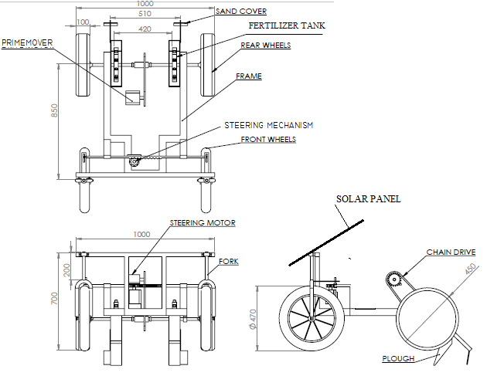

# Working Principle-

The fid shows the seed buckets in green colour, These seed buckets are fitted on the seed sowing disc with the help of screws. The buckets are designed in such a way that we can select the size of bucket as per seed type, size and shape. Also these buckets we fit on the seed sowing disc in such a way that the distance between two seed during the plantation we can adjust and set according to requirement. The motorized sprayer will operate with the help of motor and this we can run with the help of solar power.

|  |  |  |  |  |  |  |  |  |  |  |
| --- | --- | --- | --- | --- | --- | --- | --- | --- | --- | --- |
| **Sr.**  **No.** | **Activity/ Month** | **July** | **Aug** | **Sep** | **Oct** | **Nov** | **Dec** | **Jan** | **Feb** | **Mar** |
| 1 | Literature Review |  |  |  |  |  |  |  |  |  |
| 2 | Development of solar mechanism |  |  |  |  |  |  |  |  |  |
| 3 | Development of driving mechanism |  |  |  |  |  |  |  |  |  |
| 4 | Development of sowing mechanism |  |  |  |  |  |  |  |  |  |
| 5 | Experimentation |  |  |  |  |  |  |  |  |  |
| 6 | Report Writing |  |  |  |  |  |  |  |  |  |

**References :-**

1. Plant protection equipment

2. Effects of Multi-Mode Four-Wheel Steering on Sprayer Machine Performance

Author:- Mitchell A. Miller, Brian L. Steward, Mark L. Westphalen

3. Cleaning agricultural sprayers Author:- Paul E. Sumner and Michael J.

4. Sprayer Technology for Farm Mechanization Course Author:-Mohd. Hudzari

Haji Razali, *PhD*

1. Mr. R. S. Khurmi & J. K. Gupta Machine Design *Pub*.: Eurasia Publishing House Pvt. Limited.
2. Development of conservation farming implements for two-wheel tractors.

Submitted by :-

|  |  |  |  |
| --- | --- | --- | --- |
| Sr. No. | Name of  Student | Roll Number | Sign |
| 1 | Mayur Ashok Gavade | 630 |  |
| 2 | Pratik Vasant Shingare | 635 |  |
| 3 | Jeevan Kisan Bhanuse | 642 |  |
| 4 | Avadhut Govind Joshi | 658 |  |
| 5 | Avadhut Abaso Ghadage | 662 |  |
| 6 | Amol Prakash Salunkhe | 672 |  |

Date:

Place: ADCET, Ashta

Approved by:

Project guide name: **Dr. P. D. Kulkarni**

Project Review Comment member name: **Prof. R. R. Gaji**

Head, Department of Mechanical Engineering: **Prof M.M Jadhav**

**CHAPTER 1**

# INTRODUCTION

* 1. **Background**

1.1 **Problem Statement and Background :-**

That sounds like a fantastic invention for Maharashtra's agricultural sector! Addressing the present seed-sowing process' inefficiencies is crucial if we're going to help farmers become more productive while generating less waste.

Would you please elaborate on the mechanical gadget you have created? What are its characteristics, and how does it operate? Additionally, have you tested the product's efficacy in Maharashtra under various weather and ground conditions? It's crucial to make sure the tool works effectively and efficiently in every environment where it will be applied.

Have you also thought about how affordable the gadget is for farmers? The price of the device shouldn't be a deterrent for small-scale producers who might not be able to afford it. Not have the financial resources to invest in expensive equipment.

Overall, I think it's fantastic that innovations are being created to enhance agricultural practises in Maharashtra, and I wish you luck in your initiatives to aid farms in the state.

**1.2 Advantages:**

1. Simplicity of Control and Design

2. Standard MS parts and other tools make designing machines simple.

3. Unskilled labour can run machi

4. Demand very little upkeep.

5. Protective against severe harm.

6. Plan ahead and set aside time to sow seeds.

**CHAPTER 2**

# LITERATURE REVIEW

This subject encompasses the literature review for the doctorate project that was covered in the preceding chapter.

|  |
| --- |
| **2.1 Development of conservation farming implements for two-wheel tractors:** |

According to the literature, two wheel tractors are the primary form of traction used by small farmers in South Asia for tillage and other agricultural tasks. Despite being widely used, small farmers lack the resources to implement better farming techniques like conservation farming systems because there are no appropriate seed drills for two wheel tractors. Although there are no two wheel tractor conservation farming implements on the market, research and development of seed drills were continuing until they came to a halt in 2006.

**2.2 Designing of a Grain Harvester: A Tool used for Rural and urban Growers:**

That endeavour seems worthwhile and intriguing! The way small farms harvest and process their grains may be revolutionized, becoming more efficient and affordable for them, by a reaper-binder machine created for small-scale grain growers. It's wonderful to hear that you collaborated closely with a review group made up of industrial designers and farmers. Using this strategy, you should be able to make sure that your design is both practical and functional for the users for whom it is meant. Good wishes with your endeavor, and I hope it succeeds in assisting small-scale grain growers in satisfying the rising demand for locally sourced grains.

**2.3 Seed tests from SARDI**:

That seems like an excellent service. A variety of laboratory seed tests that adhere to worldwide standards and make use of different testing techniques, such as DNA-based tests, appear to be offered by SARDI Diagnostic services. Utilizing a variety of testing techniques can help guarantee that the results are cost-effective for clients and suitable for the specific crop and disease being tested. For farmers and other agricultural workers, accurate and trustworthy seed testing is essential because it can be used to spot potential diseases and guarantee the quality of the crop.

**2.4 Fertilizers and their use**

The book emphasises the leadership position of extension officers in their village or community, who are in charge of educating farmers on better farming practises. In order to improve crop production and boost farmer income, effective agricultural practises place a strong emphasis on the use of fertilisers.

The book also stresses the significance of understanding the fundamental concepts and procedures of farming in order to deal with any potential new issues or circumstances. Whenever there is a change in the technical, economic, or social environment, farmers are encouraged to modify their farming system or management techniques.

Small-scale farmers make up the majority of the rural poor in emerging nations, so introducing new agricultural systems and cutting-edge technologies is crucial for them. One of the most crucial instruments for advancing agriculture, promoting food security, and preserving soil productivity is fertiliser.

Overall, the book urges extension agents to assume the duty of enhancing living conditions in their area through the introduction and expansion of fertiliser use, as well as the upkeep of sustainable agricultural practises.

**CHAPTER 3**

**3.1 Traditional method used for seed plantation:-**

There are various kinds of sowing for hand sowing, including:

**• Flat sowing**

**• Ridge sowing**

**• Wide bed sowing**

These varieties may be combined with various sowing patterns, such as:

**• Standard sets**

rows with indentations at even rows (so that the seeds are placed in a crossed pattern). This approach is much superior because the seedlings may receive more light as they emerge.

**3.2 Types of sowing Hand sowing**

Traditional seed-sowing techniques like hand sowing are still employed in some circumstances, especially for tiny areas. It entails scattering handfuls of seed over prepared ground and incorporating it into the earth with a drag, swan-neck hoe, or harrow. In order to enable plants to grow stronger indoors during cold weather, hand sowing can be combined with pre-sowing in seed trays.

Typically, seeds are sown in farmland using seed drills. Less seed is required because seed drills are more precise and plant seeds at a precise depth below the earth. Tractors are most frequently used to drive grain drills, but they can also be pulled by horses or pickup trucks.

A seed rate of about 100 kg per hectare is normal, though it can vary based on the crop species, soil characteristics, and farmer preferences. A crop can lodge if the seed rate is too high, while a rate that is too low can lead to inefficient use of the ground, plant competition, and lower yields.

**3.3 Mechanized Agriculture**:-

Agriculture has undoubtedly benefited greatly from mechanization, which has improved productivity, efficiency, and yields. It has enabled farmers to grow more food using fewer resources, lowering food costs and assisting in feeding a growing worldwide population.

Mechanization has some detrimental effects on the ecosystem and on agriculture, though. The displacement of agricultural labour is one of the biggest effects. Many individuals who once worked in agriculture have had to find other job opportunities as machines have taken the place of human and animal labour. This has aided in the trend of urbanization, whereby residents of rural areas migrate to urban areas in quest of employment.

In addition, mechanization is contributing to enhance environmental pollution. For example, the use of pesticides and fertilizers can contaminate soil and water, harming wildlife and human health. The emissions from farm machinery can also contribute to air pollution, which can have negative impacts on human health and the environment.

Overall, mechanisation has greatly benefited agriculture, but it is essential to take into account any possible drawbacks and work to mitigate them. This can be done by creating and putting into practise sustainable farming techniques like precision farming and conservation agriculture, which aim to lessen the negative effects of agriculture on the environment while keeping high levels of productivity.

# 3.4 Factors Affecting Germination

**Moisture:** What a fantastic way to describe how seeds germinate! Just to give a little more information, water enters the seed during the imbibition phase through tiny pores called micropyles, which are typically found at one end of the seed. The zygote then swells and emerges from the seed coat after the water has passed through the seed coat and into its cells. The embryo needs its stored food stores for energy as it grows and develops after breaking through the seed coat. As you pointed out, photosynthesis doesn't commence until the true leaves appear and the plant is large enough to start making its own food.

**Air:** You're right, that is true. When seeds are dormant, their metabolic activity is limited and their oxygen needs are minimal. The metabolic activity of the seed, however, drastically increases during germination, necessitating a greater demand for oxygen for growth and energy production. Through microscopic pores in the seed coat known as "micropyles," seeds can take in oxygen from the air. Water is also necessary for seed growth, and water frequently contains dissolved oxygen. Therefore, the water that seeds are placed in can also provide them with oxygen.

**Temperature:**  That is true! In order for seedlings to germinate, temperature is essential. The ideal temperature range for germination varies depending on the product. If the soil temperature is too high, it may prevent germination or cause the seeds to dry out. If the soil temperature is too low, the seeds may not grow or may take longer to germinate. For seed starting indoors or in a greenhouse, where environmental variables can be more easily regulated, proper temperature control can be particularly crucial. You can improve your chances of successful germination and, eventually, a successful crop yield, by keeping the ideal temperature range.

**Light:**  That is accurate, yes. varied plant species can have very varied responses to light when it comes to germination. Some seeds, like lettuce, should be sown shallowly on the soil surface because they need sunshine to germinate. Other seeds, like tomato seeds, should be buried deeper in the ground because they favour darkness. Wild flower and plant seeds, like those of poppies or violets, typically prefer darkness to germinate, so they should be covered with soil. This is due to the fact that they have adapted to grow in the typically dim, natural conditions of the forest floor. However, the majority of contemporary vegetable crops, like beans and peas, either favour light or are not substantially impacted by it.

**3.5 Seed Depth When Planting**

That is a wise general principle to keep in mind when sowing seedlings. In order for seeds to receive the proper amount of moisture and oxygen to germinate and develop, they must be planted at the proper depth.

As you stated, some seeds, like those for lettuce, celery, and some kinds of flowers like petunias and snapdragons, need light to germinate. It's crucial to merely gently press these seeds into the ground without covering them with additional soil.

On the other hand, some seeds require a deeper germination to develop sturdy roots and gain access to the nutrients they require to expand. Examples include beans, corn, and squash. Depending on the size of the seed, these should be buried between one and two inches deep.

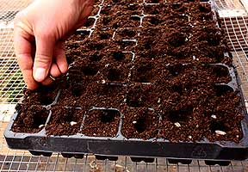

**Fig :- Seed Depth when planting**

**3.6 Seed Bed :-**

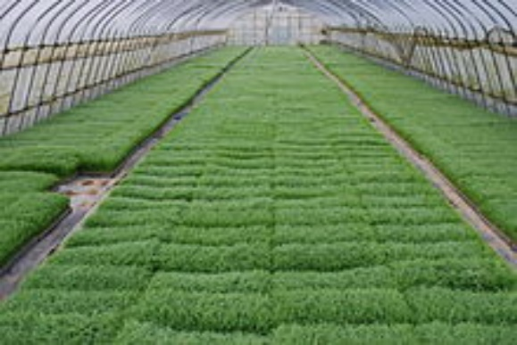

**Fig :- Seed Bed**

I appreciate you providing knowledge on seedbeds and their setup. It is significant to remember that successful seed germination and subsequent plant development depend on properly preparing the seedbed. The texture, moisture content, and nutrient content of the earth all affect the growth and development of seedlings.

For seed germination, variables like temperature and humidity must also be taken into account in addition to the preparation of the soil. For some seeds to sprout, particular circumstances must exist, such as cold stratification or scarification.

It is also important to note that growing seedlings in raised beds or containers can give you greater control over the soil's conditions and shield your young plants from pests and disease.

Overall, seedbed preparation is a crucial stage in farming and gardening and necessitates close attention to detail in order to create the ideal environment for successful plant growth.

**3.7 The preparation of a seedbed may include:**

**1. The tidying up of the mess.**

Since plant contains disease spores and eggs of insects, It can removed from the area at which it affected. The seed growth will also be bodily hampered by rocks and stones.

**2. Levelling.**

For even drainage, the land will have been levelled.

**3. Earth Fracturing.**

Digging will loosen up compacted dirt. This enables the passage of oxygen and water and aids the seedling's insertion into the ground. A structure of fine soil is necessary for small seedlings. By using an instrument like a rake, the surface of soil can be broken down into a fine structure.

**4. Improving the soil.**

By adding of organic materials, like compost or peat, may help the soil structure.

**5. Fertilizing .**

Fertilizer can be used to modify the soil's nitrate and phosphate amounts. You can also add micronutrients if the earth lacks any of them. The seedlings may be transplanted to a boundary as young plants or they may be allowed to mature into adult plants in the seedbed, possibly after being thinned to eliminate the weaker ones.

**3.8.1 Key Times to Test Seed**

Once entrenched, the pathogen may be carried by additional hosts, volunteers, or leftovers, promoting the spread of the illness.

**3.8.2. Highly susceptible hosts**

That is accurate, yes. A key instrument for farmers to reduce the risk disease from pathogens in susceptible crop varieties is seed testing. Certain diseases can seriously harm crops even when initial inoculum levels are low if the surrounding environment is conducive to their growth. Examples of pathogens that can be found in seed, soil, or agricultural residue include bacterial blight in peas, anthracnose in lupins, and Ascochyta blight in chickpeas. Growers can prevent disease outbreaks and possible crop losses by identifying infected seed and discarding it before planting by testing seed for the presence of these pathogens.

**3.8.3. High disease environments**

Finding seeds with little inoculum can undoubtedly help to lower the likelihood of a disease epidemic. Because there are fewer disease-causing organisms on the seed when the inoculum levels are low, there is a lower chance of an epidemic. This is particularly true if the environment around the plants encourages the growth of the illness. In general, finding seed with low inoculum levels and performing seed tests can be efficient methods for lowering the risk of disease epidemics in crops, particularly in areas where specific diseases are known to be common.

**3.8.4. Saved seed following disease outbreaks**

It is advised to try early so you have time to find substitute seed if required. If your seed is tested, it can be determined whether it is diseased or suffers from other quality problems that could impact how well it performs. You might need to search for other seed sources that are disease-free and of high quality if your seed passes the test.

**3.8.5. Interstate and international quarantine**

When shipping seeds to domestic or foreign marketplaces, it's critical to acquire the required disease approval. The certification guarantees that the seeds are clear of any dangerous diseases or pests that might possibly damage crops in the recipient nation.

### 3.9 Seed tests and sampling

### The proper collection of the seed sample is crucial because it affects how accurately the test findings apply to the entire seed batch. The seed samples must be representative of the entire seed batch and can be obtained from bulk or bags.

**Step 1:** Make sure to thoroughly mix the seed batch before taking subsamples to ensure that the sample is representative of the whole batch. Use a consistent method for taking sub-samples, such as a scoop or a pipette, to ensure that each sub-sample is the same size. Keep track of the weight of each sub-sample to ensure that the total weight is four times the necessary sample amount.

**Step 2:** Thoroughly combine the sub samples and distribute them out over a spotless area.

**Step 3:** Pile the seed, then divide it into two sections of similar size. Once there are eight identical pieces, divide each one in half again. The placement of these should be in two parallel groups of four examples.

**Step 4:** Keep the first and third samples together in one row, while the second and fourth samples are kept together in the other row.Throw away the other four examples.

**Step 5:** Combine the final four samples in

**Step 6:** Repetition of steps 3 and 4 is necessary to acquire the minimum sample weight.

**3.10 Feasibility Studies**

You may have created a tool to aid paddy farmers in hand planting and increase their productivity. Your device can help farms avoid losses from hand sowing and help with labour constraints by ensuring the proper distance between seedlings. Additionally, your device can save producers time, work, and effort by removing the need for transplanting. Another useful feature is the inclusion of a levelling plate, which can guarantee that the area is level before sowing. This can ensure that the crop develops uniformly and help to improve the crop's general quality.

**3.11 How to apply fertilizers**

In order to ensure optimum agricultural production and minimum environmental pollution, fertiliser application must be done correctly. Considerations for crop variety, sowing date, crop rotation, soil type, and temperature should all be made when determining when and how much fertiliser to apply.

If not absorbed by the plant roots, mobile minerals like nitrogen are especially prone to leaching out of the soil profile. In order to give the produce the best chance of success, it is crucial to spread these nutrients as soon as feasible.

If there is no quick rains or drainage to wash the fertilisers into the soil, they should be integrated into the soil as soon as possible. Fertilizers like urea and diammonium phosphate are susceptible to loss through ammonia emission to the air. On saline soils, incorporation is especially crucial. If there is no quick rains or drainage to wash the fertilisers into the soil, they should be integrated into the soil as soon as possible. Fertilizers like urea and diammonium phosphate are susceptible to loss through ammonia emission to the air. On saline soils, incorporation is especially crucial.

**3.11.1 Broadcasting**

Fertilizer is frequently applied to fields and pasture by broadcasting. This technique entails applying fertiliser to the soil's surface by hand or with specialised tools like spreaders for fertiliser. For crops that are thick or not grown in rows, like grasses, and for fertilisers that need to be incorporated into the soil after application, like phosphate fertilizers, broadcasting is particularly helpful. The ability to spread fertiliser across the full area fairly evenly is one benefit of broadcasting. To prevent over- or under-fertilizing specific regions, which can result in uneven agricultural development and lower harvests, it's crucial to make sure the spreading is as uniform as possible. Tilling or tillage can be used to incorporate the fertiliser into the soil.

**3.11.2 Row or band placement**

Agriculture uses the method of localised fertiliser placement to maximise fertiliser use and boost crop production. Farmers can lessen fertiliser use and fertiliser discharge, which can cause environmental harm, by applying fertiliser only to specific fields where it is required. The method entails sprinkling fertiliser underneath the soil's surface in bands or segments, or to the side and beneath the seed. You can carry out this manually or with the aid of specialised sowing and fertiliser piercing tools, such as seed-cum-fertilizer drills. Row crops with comparatively wide spacing between rows, such as maize, cotton, and sugar cane, are best suited for localised fertiliser application. Additionally, it can be applied to sediments that frequently bind phosphate and potassium. When using localised fertiliser application, it is essential to take great care. Fertilizer that is applied too closely to a seed or plant that is germination can cause salt damage to the embryo and root burning, which can result in poisoning. To prevent any damage to the plant, it is crucial to measure out the proper quantity of fertiliser and make sure it is covered with dirt.

**3.11.3 Top-dressing**

In agriculture, top-dressing is a standard practise when extra nutrients are required to promote agricultural growth and development. Because nitrogen can easily be lost through leaching if applied as a singular treatment at sowing, it is frequently applied as a top-dressing. Split nitrogen treatments can decrease the danger of nutrient losses and increase fertiliser use effectiveness. Additionally, potassium is occasionally top-dressed, particularly on light soils where it might not penetrate as deeply into the soil profile. Since it doesn't travel around the earth much, phosphate is usually spread as a base dressing. Farmers can increase harvests and minimise fertiliser wastage by spreading minerals in a way that fits the crop's nutritional needs.

**3.11.4 Side-dressing**

Fertilizer is often spread on the ground next to plant sections in a practise known as "side-dressing." As a result, the nutrients are immediately accessible to the bases of the plants, fostering their growth and development. During the growing season, when the plants require an extra increase of nutrients to support their growth and development, side-dressing is usually done. It is especially helpful for permanent crops like trees and widely spread crops like corn, cotton, and sugar cane, which need regular fertiliser inputs to stay healthy and productive.

**3.11.5 Foliar application**

When micronutrients are required in tiny amounts or may become inaccessible if applied to the soil, foliar application is an efficient method to give them to plants. The nutrients can be applied directly to the foliage, where they will be rapidly absorbed by the plant and put to use in its growth and development. When making the spray, it's crucial to use the nutrient solution's suggested concentration in order to reduce the risk of foliage scorch. Applying a solution that is overly concentrated risks damaging the foliage and lowering the treatment's efficacy. Additionally, it is advised to apply the nutrient solution to the plants on overcast days, as well as in the early morning or late afternoon when it is cooler and the foliage are more vibrant.

**CHAPTER 4**

**4.1** The creation of a mechanised seed-sowing cumulative fertiliser

Details of the Proposed Mechanism

These devices can run autonomously because of their tiny size.

**4.2** Specification

i. Type: Wireless motorised

ii. One individual performed the labour iii. The approximate overall measurements are 3 feet by 3 feet by 4 feet in height. Up to 1 acre can be worked on each day vi. A device for changeable seed sowing and seed fertiliser are included in the machine.

**4.3**. Analysis of various crucial mechanisms' components

**4.4**. Material and motor selection The six stages of this undertaking are as follows.

**Initial Phase**: Literature Review

Overall, a thorough knowledge of the industrial field can be obtained through a mix of a literature review and industrial trips, which can also help direct the course of your project. It can also assist in locating possible remedies and areas for invention that could enhance the sector and benefit suppliers and clients.

**Second phase**: concept creation

Based on the issue statement and input from the end user and suppliers, you are designing and outlining the key elements of your project. The development of a schematic drawing during this stage is crucial for directing the production of the real components. A crucial stage in the project development process, the schematic layout design phase lays the groundwork for the production of the real components.

**Phase III**: Calculations for the design

Engineers typically collect data from a variety of sources during this phase, including industry standards, product inventories, and reference books, to complete the component designs and choose the best materials based on their intended use and anticipated loading conditions.

**Phase III:** Preparation of Drawings

Engineers typically collect data from a variety of sources during this phase, including industry standards, product inventories, and reference books, to complete the component designs and choose the best materials based on their intended use and anticipated loading conditions.

**Phase IV:** Analysis of the Critical Components' Structure

Process of analysing and selecting the optimal specifications for a component that is being loaded critically during a certain period. This is a common approach to ensuring that the component can withstand the stresses it will be subjected to, and that it will perform optimally under those conditions. When selecting the measurements of the component, you will need to consider factors such as its size, shape, and weight, as well as any other constraints that may be present, such as space limitations or the need for the component to fit with other parts of the system.

**Phase V:** (1)Fabrication Various components and subassemblies will be manufactured using efficient manufacturing techniques.

(02) The parts will be put together in accordance with the design.

**(**03) The project will go through working tests to validate and test factors (Time and pace) that we will settle for to get the best product quality.

**CHAPTER 5**

**Design of experiment set up**

**5.1 Key elements and procedures in test equipment construction.**

**•** The motor shaft's design.

• Main hinge design.

• The setup for supplying seeds.

• Wheel design

• The handle's style.

• A list of additional components or pieces used in the seedplanter.

* + 1. **Design of drive shaft.**

Diameter of rear wheel = 600mm

Circumference of ground wheel = ПD = 3.14 x 600 = 1884 mm

Number of run made by circumference wheel for 100m = 100x1000 / 1884 = 53.07

Say = 53 revolution.

Considering 2000 sq feet land

Length x width of 2000 sq feet land

2000 sq feet = 185 sq meter

Considering the distance between two row = 1.5 feet = 0.45 m

Number of rows in above area = 10 / 0.45 = 22.22 = say 24 rows

By using developed mechanism, we can cover two rows at a time

So 24 / 2 = 12 times machine has to travel along the side of 18.5 m

So total distance required to cover = 18.5 x 12 = 222 meter

Number of run made by circumference wheel for 222 = 222x1000 / 18884 = 117.8

Say = 118 revolution.

Per revolution the 12 grains are required

So for 2000 sq feet (185 sq meter) area grains are required = 12 x 118 = 1416 grains.

**5.1.2 Motor selection**

The effort required to pull the machine manually is assumed = 100N

So Maximum Torque T = Effort x Radius of wheel

Torque on drive shaft T = 100 *100

= 10000 N-mm

Ϭ = 145 N/ mm2 considering factor of safety = 4

**Carbon steel C40**



σ = 145 N/mm2

As per ASME code

0.3 X Yield strength N/mm2

0.18 X ultimate strength N/mm2} whichever is smaller

0.3 x 330 = 99 N/mm2 ………………………………………….(a)

0.18 x 580 = 104 N/mm2 …………………………………….........(b)

From equation (a) & (b)

Allowable stress value will be 99 N/mm2

If key ways will provide to shaft then

τ = 99 x 0.75 = 74.25 N/mm2

Max torsion moment equation is given by

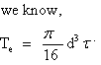

Where T = 10000N-mm

By using above equation drive shaft dia d = 8.82mm ……………….

**Design against bending:**

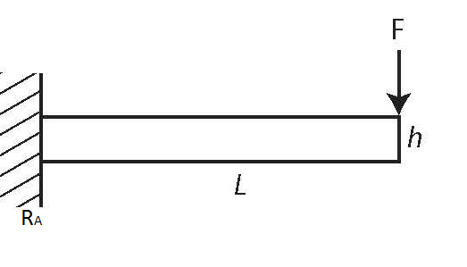 **Fig. Drive shaft loading condition.**

F = 1000 N

The wheel dia D = 40mm



RA = 1000

As per load condition and farm condition the total load on wheel is considered

Calculation of bending moment at loading point P,

BM at M = 1000 x 50 = 50000N-mm

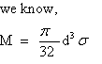

Ϭ = 145 N/ mm2 considering factor of safety = 4

By using above equation drive shaft dia d = 15.49mm ………………..

From equation A and B we have selected the diameter of shaft = 20mm considering extra jerk and for safe design.

According to maximum shear stress theory

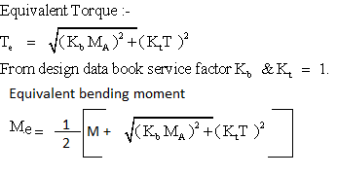

Te = 53851.6 N-mm

Me = 51925.8 N-mm

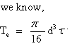

ځ = 34.40 < 74 N/mm2 and

Ϭ = 66.07 < 145 N/mm2

By using above equation we have checked the allowable shear stress and allowable bending stress and it is seen that the both values are within limit hence design is safe.

**5.1.3 Bearing selection**

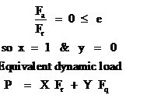

P = RB = 500 N

Life in hrs = 10000 hrs

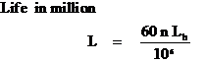

L = 36 millions of rev.

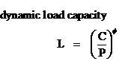

a = 3 for ball bearing.

From SKF bearing catalogue we have selected the bearing static capacity for shaft dia 20mm = Co = 2.32 KN

From above equation = C = 285 N

So calculated dynamic capacity C < bearing catalogue dynamic capacity C = 4.32KN

Hence from catalogue bearing selected = 61804

**CHAPTER 6**

**Set up Design**

**6.1 PMDC Motor :-**

In our project we have used the PMDC Motor for to give drive to chain drive.

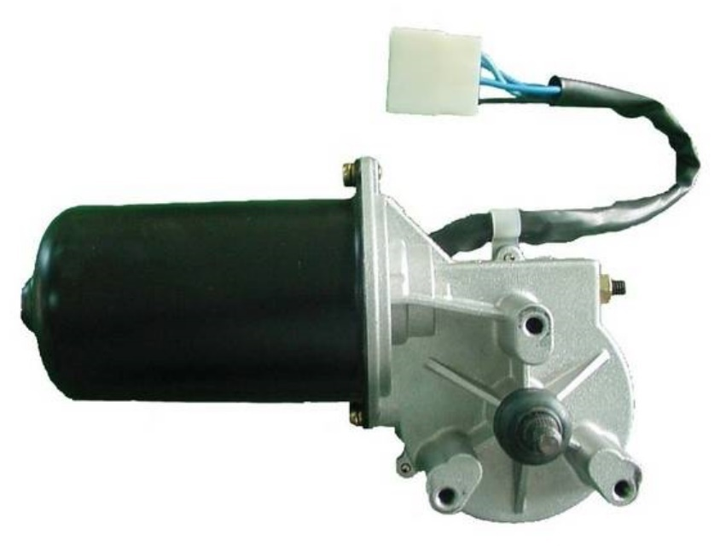

## A direct current motor operates on the mechanical force that a current-carrying wire experiences inside of a magnetic field, which is the fundamental working principle of a DC motor. I am also aware that permanent magnet DC motors, also known as PMDC motors, are ideal for uses where speed control of the motor is not necessary because they work by using a set magnetic field created by a permanent magnet.

## Battery-operated devices, car starting motors, windscreen wipers, washers, fans for warmers and air conditioners, and window actuators are all popular applications for PMDC motors. Due to their small dimensions and great efficiency, they are additionally utilised in numerous fractional and sub-fractional kW uses. In fact, permanent magnet DC motors have a straightforward design.

## Battery-operated devices, car starting motors, windscreen wipers, washers, fans for warmers and air conditioners, and window actuators are all popular applications for PMDC motors. Due to their small dimensions and great efficiency, they are additionally utilised in numerous fractional and sub-fractional kW uses. As you stated PMDC motors are indeed widely used in a variety of applications and have a straightforward construction. This is particularly true for low power and small size uses. However, it should be noted that permanent magnet DC motors are not always the best option in some high-performance applications, such as electric cars and industrial automation, because their magnetic field cannot be readily regulated and changed to suit various working conditions. Other motor kinds, like brushless DC motors and AC induction motors, can be used in these situations.

## 6.1.1 Construction of PMDC Motor

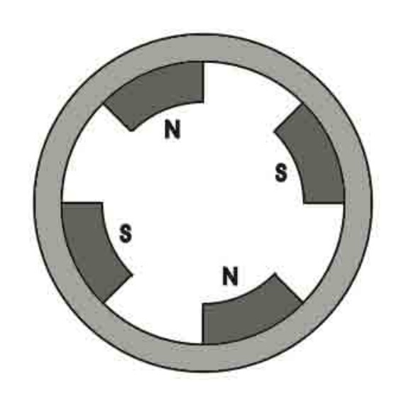

Enduring magnet Robotics, vehicles, and home products are just a few of the many uses for DC motors. A PMDC motor's ease of building, which results in reduced costs, greater dependability, and better effectiveness when compared to other kinds of DC motors, is one of its primary benefits.

Neodymium or samarium cobalt are typically the materials used to make the permanent magnets in PMDC motors. Due to the high magnetic energy density of these magnets, smaller, lighter engines with increased thrust and power production are possible. However, if exposed to high temps or powerful magnetic fields, these magnets are also brittle and readily demagnetize.

## A PMDC motor's armature winding is typically created as either a lap or wave winding, based on the particular needs of the motor. The armature winding's alternating current is transformed into direct current, which travels through the motor's windings, by the use of the commutator and brushes. The commutator is a cylindrical collection of metal pieces attached to the armature coil and isolated from one another. The brushes, which are formed of carbon or graphite, move over the commutator pieces to keep the armature winding and the external circuit electrically connected. For many uses that demand high torque and power production, permanent magnet DC motors are a straightforward, effective, and dependable option.

## 6.1.2 Working Principle of PMDC Motor

The spinning component of a PMDC (permanent magnet DC) motor is called the armature, and it is usually constructed of several wires organised in a cylindrical arrangement. An electric current flows through the wires as the armature spins, cutting through the magnetic field created by the permanent magnet. The orientation of the conductors and the magnetic field's path decide the direction of the current.

Fleming's left-hand rule states that a force is created on each wire as a result of the magnetic field's interaction with the current flowing through the conductors, which causes the armature to spin. The magnetic field's intensity, the conductor's current movement, and the magnitude of the force are all related.

The force exerted on each wire and the armature's radius determine how much power the motor can generate. The orientation of the magnetic field and the passage of current through the conductors both affect the torque's direction. This force is applied to a weight that is attached to the motor shaft, such as a fan or a pump.

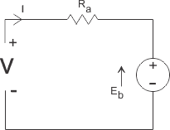

**Fig. Permanent Magnet DC Motor or PMDC Motor Equivalent Circuit**

The comparable circuit of a permanent magnet dc motor does not require drawing field coils because the field in a PMDC motor is generated by a permanent magnet. The armature's supply voltage will decrease due to armature resistance, and the motor's reverse emf will balance out the remaining supply voltage. Consequently, the motor's voltage expression is provided by,



Where I, is armature current and R is armature resistsnce of the motor. Eb is the back emf and V is the supply voltage.

#### 6.1.3 Advantages of PMDC Motor

**Compared to other dc motor kinds, PMDC motors have some benefits.**

1. Field stimulation setup not required.

2. Since no input power is used for stimulation, dc motor efficacy is increased.

3. There is no field coil, so there is less room for the field coil, which lowers the motor's total size.

4. More affordable and practical for uses with fractional kW ratings.

#### 6.1.4 Disadvantages of PMDC Motor

#### 1. In a DC motor, the armature reaction refers to the interaction between the magnetic field produced by the rotor (the armature) and the stator's magnetic field. This interaction can cause a demagnetizing effect on the stator's magnetic field, which can result in a weaker magnetic field and reduced motor performance.

#### 2. Excessive armature current can also cause demagnetization of the poles in a DC motor, particularly during starting, reversing, and overloading conditions. When the armature current is high, the magnetic field produced by the armature can partially or completely cancel out the magnetic field produced by the stator, leading to demagnetization of the poles.

#### 3. In a permanent magnet DC (PMDC) motor, the strength of the magnetic field in the air gap is determined by the strength of the permanent magnets, which cannot be directly controlled or adjusted. This can make it challenging to regulate the motor's speed and torque precisely, particularly in applications where speed and torque control are critical.

#### 6.1.5 Applications of PMDC Motor

PMDC motors are frequently used in numerous uses that call for compact size and straightforward control. They are effective, dependable, and economical.

Worm drives are a practical form of gear configuration that provide high gear reduction ratios in a small footprint. The worm wheel and screw, as you stated, have their axis at 90 degrees to one another, which makes them perfect for transferring power between shafts that aren't parallel. The worm's construction also enables high gear

Worm gears have fewer teeth per unit of gear reduction than spur gears, allowing for smaller, more compact transmission designs. Worm drives do have some drawbacks, though, including decreased effectiveness and increased friction because of the sliding interaction between the worm and worm wheel. As a result, they are frequently employed in low-speed situations where the high gear reduction ratio is of the utmost importance.

**6.2 Rotating Wheels:**

While the rib sections are intended to give the user traction as they drag the assembly in the desired direction, it appears that the rotating wheels are intended to prevent the equipment from becoming trapped in the wet ground. It's also essential to remember that the longevity and efficacy of such tools depend on proper use. To prevent mishaps or equipment harm, it's crucial to adhere to the manufacturer's directions and any safety recommendations. It can be helpful to have equipment that is particularly made for planting in wet soil because it can help guarantee that the seeds are planted at the proper level and have enough touch with the soil. This may raise the likelihood of effective sprouting and development.

**6.3 Seed Tank:**

Before the seeds are discharged through the perforations in the rotating cylinder at the bottom of the hopper, they are first kept in the seed drum, also referred to as the seed hopper. This disc, which regulates the pace at which the seeds are distributed, is also known as the seed sowing disc or metering device.

The exact seed positioning and spacing made possible by seed drills is essential for attaining uniform crop development and increasing output. When compared to physically sowing seeds, using a seed drill can help producers save time and effort, reduce seed waste, and increase agricultural output.

**6.4 Disc of seed sowing and seed bucket:**

One seed from this seed drum descends from the revolving wheel during each full turn, allowing for a seamless and efficient seed planting process.



Various kinds of seeds and sowing circumstances can be accommodated by seed drills thanks to their adjustable design. Usually made of plastic or metal, the seed containers can be simply replaced or changed to alter the distance between seeds. Farmers are able to maximise their planting for the highest output and productivity thanks to this.

Modern agriculture relies heavily on seed drills, which enable producers to rapidly and precisely plant crops over vast regions. Farmers can increase harvests, lower labour costs, and reduce wastage by using seed drills.



**6.5 Seed chamber, Plough and sand cover arrangement:**

The revolving seed sowing device, seed storage tank, seed containers, ploughs, and sand cover are providing an effective and organized way to plant seeds in various farming situations. The precision of the revolving seed sowing device in placing seeds in the seed chamber can help ensure uniform and accurate seed spacing, which is crucial for maximizing crop yield and reducing waste. The seed storage tank and seed containers can also help simplify the process of gathering and distributing seeds, which can save time and effort. The ploughs are essential for preparing the soil and adjusting row spacing to accommodate different crops. Proper soil preparation can help ensure that the seeds have the right environment for germination and growth, and adjusting row spacing can help optimize plant growth and yields. Lastly, the sand cover is vital in ensuring that the seeds are adequately coated in soil, which is necessary for healthy germination and development. this method of planting seeds offers a dependable and efficient approach that can help farmers achieve optimal yields while minimizing waste and effort. It's important to continue exploring and utilizing innovative technologies and techniques like this to help address the challenges of sustainable agriculture and food security.

**6.6 Constructional details of the device**

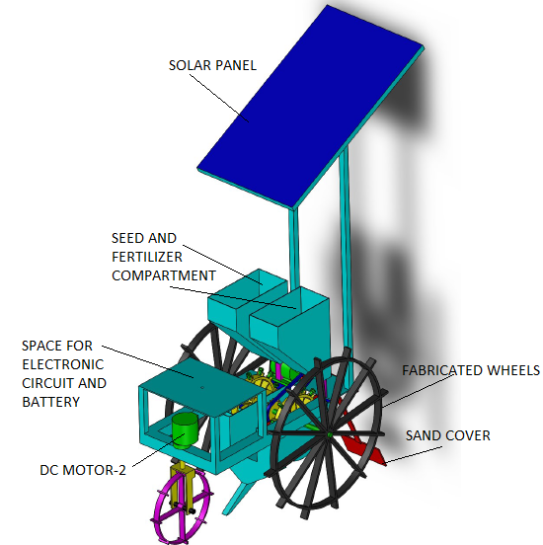

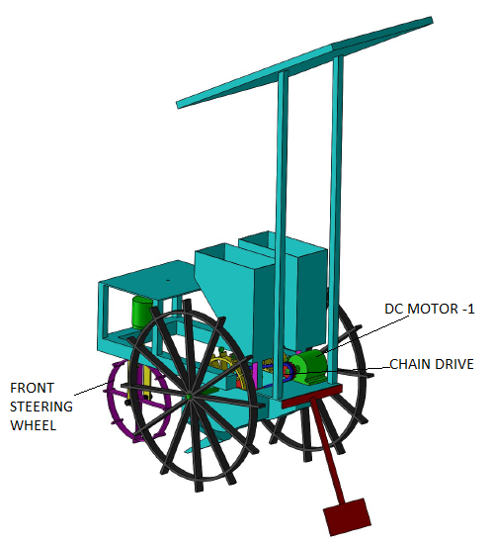

In order to excavate the necessary number of rows for seed planting, the project's comprehensive sketch is intended to take into account both field conditions and client requirements.

The suggested method makes use of the following key components.

1. The framework

2. Wheels driven by batteries.

3. Tank for storing seeds.

4. A seed-planting device

5. Seed trough.

Seed compartment 6.

7. Plough.

8. Setup for the sand layer.

The plough is made of 6 mm metal so that it can withstand the jolt that occurs when ploughing. MS is the substance used to make the blade.

* 1. **Structural Frame:-**

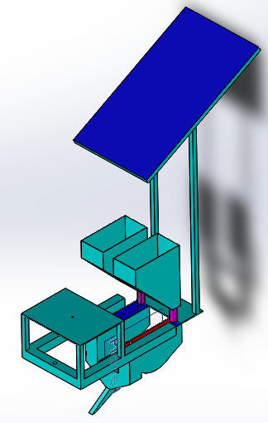

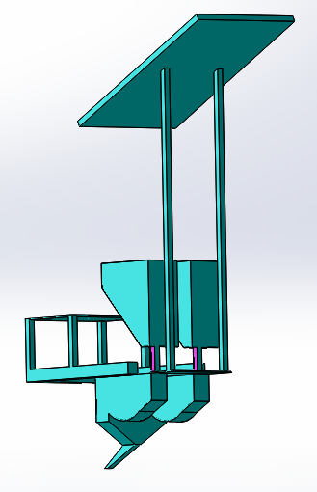

A primary frame is equipped with sliding contact bearings, a shaft assembly, a rotating disc, and a stationary storage tank configuration, and the machine's sheet body is made using a forming process. The rotating disc is made so that the seeds exit the cylinder in a precise order and at the right intervals to reduce waste. This device can be utilised in farming situations to precisely and effectively sow seeds.



The components and their arrangements are all displayed in the above figure. The electronic engine from a Seed bike, which runs on a 12V/12Amp battery, is used in this mechanism. Therefore, the amount of effort needed to run this equipment will be greatly reduced. When the engine is initiated, the chain drive causes the back shaft to spin, which causes the attached seed disc to rotate in the seed half cylinder. The movement of the seed disc in the seed half drum causes the seed to be raised by seed buckets and transported to the field by the arrangement of the plough.

**CHAPTER 7**

**Conclusion**

About 70% of Indians reside in rural regions, where the agricultural industry is their primary source of revenue. Therefore, it is crucial to give the agriculture industry particular attention and to implement modern, more advanced techniques. This will improve the country's development rate. When our solar-powered machine is compared to various conventional seed-sowing techniques, the following conclusions can be drawn:

1) Sowing rate can be regulated

2) The ability to attain seed spacing

3) Requires less physical labour

4) Produces no emissions

5) Is cost-effective

6) Different types of seedlings can be sown

**CHAPTER 8**

**References**

Agricultural Engineering International: the CIGR Journal of Scientific Research and Development, H. Heege and B. Feldhaus, "Site Specific Control of Seed-Numbers per Unit Area for Grain Drills." PM 01 012, Volume IV, December 2002 Manuscript.

2) Professor Pranil Sawalakhe Department of Mechanical Engineering, Priyadarshini College of Engineering, Nagpur, India. Amit Wandhare, Ashish Sontakke, Bhushan Patil, Rakesh Bawanwade, and Saurabh Kurjekar.

Principals of Agricultural Engineering, Volume 1, Sahay (1990), Textbook, Jain Brothers, New Delhi, India.

4) The Rahuri Agriculture R and D section has a horizontal seed metering equipment.

5) "Solar Sprayer - An Agriculture Implement," International Journal of Sustainable Agriculture, 2 (1): 16–19, 2010, ISSN 2079–2107; R. Joshua, V. Vasu, and P. Vincent