**“COMPARATIVE STUDY OF PETROL**

**AND ETHANOL BLENDING”**

**Vrushabh Babaso Patil, Prajyot Gunpal Herwade, Abhijeet Prakash Patil, Abhishek Ashok Tandale,Mohammadarbaz K Junedi,Prof:Rajkumar Tukaram Patil .**

DEPARMENT OF MECHANICAL ENINEERING

ANNASAHEB DANGE COLLEGE OF ENGINEERING AND TECHNOLOGY, ASHTA, SANGLI, INDIA.

**ABSTRACT**

The major energy demand is fulfilled from the conventional energy resources like coal. Petroleum and natural gas (NG). Petroleum-based fuels are limited reserves concentrated in certain regions of the world. These sources are in the verge of getting extinct. The scarcity of known petroleum reserves will make renewable energy resources more attractive. The world energy demand continues to increase. The most feasible way to meet this growing demand is by utilizing alternative fuels. One such fuel that exhibits great potential is biofuel, in particular, ethanol.

1. **INTRODUCTION**

World energy consumption is increasing steadily due to enhancement of the quality of the life, increasing population, industrialization, rapid economic growth of the developing countries, increasing transportation of the people and the goods. There are many types of the fuels available worldwide, the demand for which strongly depends on application and the use, location of the regional resources, cost, cleanliness and some environmental factors, safety of the generation and utilization, socioeconomic factors, global and the regional politics. Due to rapid depletion of the reservoirs of the fossil fuels, world turns towards to the alternative options. There are different types of petroleum based alternative fuels like bio diesel and bio ethanol’s, natural gas, hydrogen etc. Ethanol can be produced from cellulosic biomass. Such as trees and grasses. Secondly, ethanol (CH, CH, OH) is made up of a group of chemical compounds whose molecules contain a hydroxyl group. OH, bonded to a carbon atom, so, the oxygen content of this fuel favors the further combustion of gasoline.

1. **METHODOLOGY**

**Experimental Procedure**.

The experimental procedure followed for this experimentation is as follows:

**i**. In first part, after attachments of the accessories, tests were carried out on the engine using gasoline (pure petrol) as a fuel in order to provide base line data.

**ii**. Initially engine loaded at full load condition and then load is removed as per requirement of the speed range, as the load decreases the speed increases, the testes were carried out at the wide-open throttle and first gear with varying speed from 4000 to 6300 rpm. After this, same tests were carried out for the various ethanol gasoline blends from E0 to E20.

**iii.** According to different gasoline blend gas analyzer shows CO%, CO2%,HC (ppm)

1. **MODELING AND ANALYSIS**

**Experimental set up**

Experimental set up consist of a single cylinder four stroke SI engine, five gas analyzer. eddy current dynamometer, control unit etc. Photographs 4.1 to 4.4 present are pictures of the experimental set up. The specifications of the test engine,

dynamometer, and gas analyzer are as follows.

Table No3.1: Engine Specifications

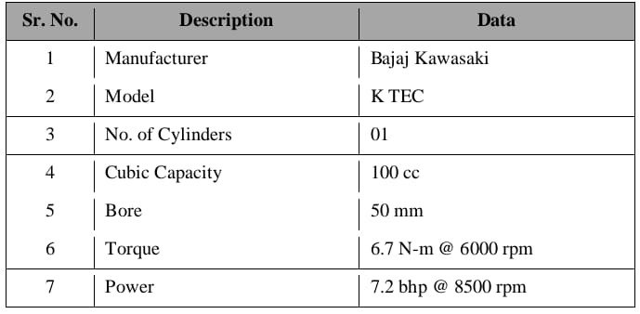



Image1 :Test Engine

Table No3. 2: Dynamometer Specification

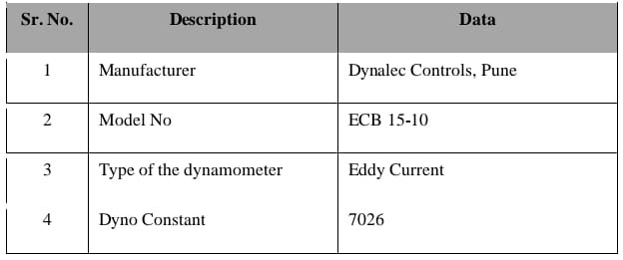

Table no3. 3 :Five Gas Analyzer Specification

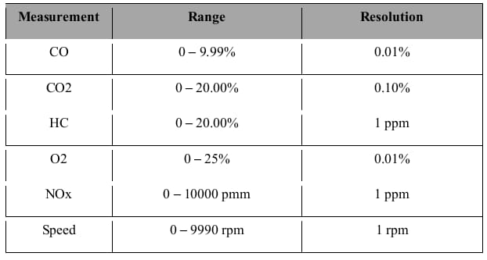

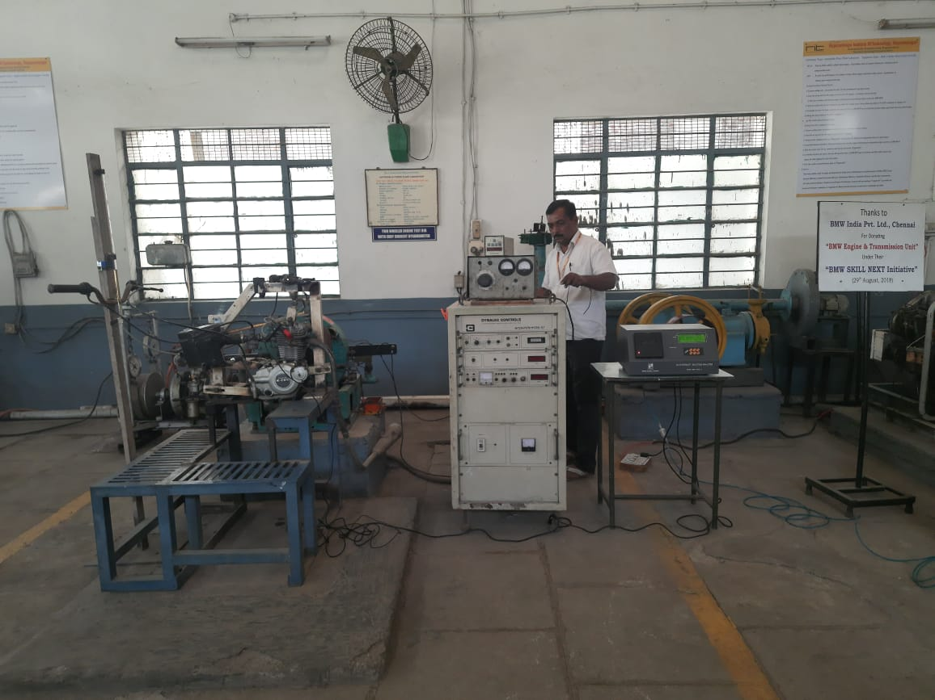

Image no2:Experimental Setup

1. **RESULTS AND DISCUSSION**

The experimentation were carried out to find out the effect of various ethanol gasoline blends, emission characteristics of the single cylinder petrol engine at atmospheric condition, From the observations, various parameters were calculated like engine torque, power developed, fuel consumed by the engine particular blends at various operating conditions.

**4.1 Statistical Representation of the Results**

**Performance and emission characteristics for various ethanol gasoline blends at different speeds.**

|  |  |
| --- | --- |
| Table 4.1: Results for pure Gasoline |  |
|  |  |
| Table 4.2: Results of E5 (95% Gasoline and 5% Ethanol by Volume |  |
|  |  |
| Table 4.3: Results of E10 (90% Gasoline and 10% Ethanol by Volume |  |
|  |  |
| Table 4.4: Results of E15 (85% Gasoline and 15% Ethanol by Volume) |  |
|  |  |
| Table 4.5: Results of E20 (80% Gasoline and 20% Ethanol by Volume) |  |
|  |  |

* 1. **Graphical Representation of the Result.**

|  |  |
| --- | --- |
| **4.2.1 CO2% Vs Ethanol %** | **4.2.1 CO2% Vs Ethanol %** |
|  |  |
| **4.2.3 HC% Vs Ethanol %** | **4.2.4 Brake Power Vs Ethanol %** |
|  |  |
| **4.2.5 Torque Vs Ethanol %** | **4.2.6 BMEP Vs Ethanol %** |
|  |  |

1. **CONCLUSION**

The performance and emission characteristics of the S1 engine have been tested by using at ethanol gasoline blends, for E0 constant speed and different loading condition Table 5.1: Results for pure Gasoline. There are some limitations for these experimentations like, we are unable to create all the environmental conditions as per the testing standards, unavailability of the different electronic accessories, advanced measuring system etc.

Ethanol can provide advantage for engine performance, fuel economy and exhaust emissions. Gasoline ethanol blends including ethanol at low proportions can be used without any engine modification but pure ethanol requires major modifications to the engine design and fuel system. Consequently, we of gasoline ethanol blends in SI engines is more practical than using ethanol alone.

If government concentrate on the advanced technology and development of the cost-effective methods for the continuous supply of the ethanol, provides the additional facilities to the companies for activities related to the use of ethanol gasoline blends, develops some sensitive zones to popularize the use of bio-fuels then ethanol will be best fuel.

1. **REFERENCES**
2. A.A. Abuhabaya and J.D.Fieldhouse, Variation of engine performance and emission using ethanol blends, Paper No. 1789-36 MATADOR Conference-2010, pp.1-5.
3. Rodrigo C. Costa, Jose R. Sodre, 'Hydrous ethanol vs. gasoline-ethanol blend: Engineperformance and emissions', Elsevier Ltd, Fuel 89, 2010, pp. 287-293.
4. A.A. Abuhabaya and J.D.Fieldhouse, Variation of engine performance and emission using ethanol blends, Paper No. 1789-36 MATADOR Conference-2010, pp.1-5.
5. Li-wei jia, Mei-qingshen, Jun wang a, Man-qunlin, 'Influence of ethanol-gasoline blended fuel on emission characteristics from a four-stroke motorcycle engine',Journalof Hazardous Materials, 123, 2005, pp. 29-34.
6. Huseyin Serdar Yucesu, TolgaTopgul, Can Chinar, Melih Okur, 'Effect of ethanol- gasoline blends on engine performance and exhaust emissions in different compression ratios, Applied Thermal Engineering 26, 2006, pp. 2272-2278.
7. Talal Yusuf, GNajafi and David Buttsworth, Theoretical and experimental investigation of SI engine performance and exhaust emissions using ethanol-gasoline blended fuels,International Conference on Energy and Environment, 2009, pp.1-10.
8. Dragoslava d. Stojiljkovi, dusan b. Nestorovi, Vladimirv. Jovanovi, and nebojsa g Mani, Mixtures of bioethanol and gasoline as a fuel For SI engines, Thermal Science: Vol.13, no.3, 2009, pp.219-228, pp 1-8.