DATA MINING IN MARKET ANALYSIS

**P.RADHA ASSISTANT PROFESSOR**

**DEPARTMENT OF COMPUTER SCIENCE**

[**radhap@skasc.ac.in**](mailto:radhap@skasc.ac.in)

**SRINIKASH. S AND SANJAY. B STUDENT**

**DEPARTMENT OF COMPUTER SCIENCE**

[**srinikashs21mcs060@skasc.ac.in**](mailto:srinikashs21mcs060@skasc.ac.in)[**,sanjayb21mcs048@skasc.ac.in**](mailto:sanjayb21mcs048@skasc.ac.in)

# ABSTRACT:

A sizably voluminous chunk of data is engendered each minutein enterprise business. Extracting information from piles of data avails in extracting patterns that can soothsay and guide future demeanor of the enterprise. Data mining techniques filter through immensely colossal magnitudes of raw data and extract serviceable information that gives enterprise businesses a competitive edge in the market. Sundry cases on customer purchasing habits have been presented and additionally utilized in authentic quandaries. Data mining techniques are highly efficacious in analysing consumer comportments. It avails enterprises to make apprised business decisions, enhances business perspicacity, thereby amending the company’s revenue, detecting anomalies, fraud detection and abbreviating cost overheads. In this paper the author reviews sundry such techniques. Further, the application of these techniques in sundry scenarios is analyzed.

# INTRODUCTION:

Companies use data mining as a method to transform unusable data into useful information. Using software to examine patterns in incredibly large batches Businesses may use data to understand their customers better, create more effective marketing campaigns, boost sales, and cut costs. Effective data collection, warehousing, and processing are required for data mining. Analyzing a customer's psychological thinking, putting it into statistical form, and visually determining whether there is any technical format that allows us to examine his purchasing behaviour. After evaluating the data, the retailers can use it for a variety of things, like providing consumers with coupons based on their purchasing patterns and choosing when to sell items on sale or at full price. When only a small portion of information that is not representative of the entire sample group is utilized to support a certain premise, data mining can be problematic.

# REVIEW OF LITERATURE:

Fayyad et al. (1996)[3] In their paper From Data Mining to Knowledge Discovery in Databases, KDD "discovers data patterns that are valid, novel, potentially useful, and ultimately understandable. described as an “important process”. All valid facts available in electronic form were used to generate the defining data. A pattern is a model expressed in language as a subset of data. A pattern must be valid to be true and modelable for all new data. This process involves multiple steps from data preparation to knowledge enrichment, all repeated until the desired result is achieved. Non-trivial indicates that some inference calculation is required to distinguish it from the traditional value calculation. Fayyad and Stolorz (1997)[4], in their paper, describe KDD as “a general method for discovering valuable knowledge from data, and mining is a process that uses several algorithms for the knowledge extraction process. It's one of the other steps in the Data mining can be used to identify buyer patterns and eliminate potential buyers from your customer list.

Data mining as a direct marketing tool has been shown to bring more benefits than traditional mass-marketing avenues as it only targets potential buyers. Michael Goebel et al. (1999)[6] gave an overview of common knowledge discovery tasks and different methods for solving them in the article "Overview of Data Mining and Knowledge Discovery Tools". A feature classification scheme has been proposed that has been used to study knowledge and data mining software. They specified some key features that must be considered important for knowledge discovery software to be used effectively and to address more understudied problems. Many organizations in the world today use very large databases with no growth limit.

Millions of new data records are added to these databases every day. These types of databases offer new challenges and unique opportunities for mining these data streams. Pedro Domingos et.al (2000) [7] described and evaluated his VDTFs on these huge databases. They used the Hoeffding tree. This allows training in a fraction of the constant time per example and has a high asymptotic similarity to stack time. Distinguishing Data Mining from Information Hand et.al (2001)[8] describes data mining as “analyzing huge data sets to discover unexpected relationships, examining data in a more logical way, and finding desired results. to provide According to Rygielski et.al (2002)[9], data mining technology added a new dimension to his CRM.

# Data Mining Tasks: Classification:

Finding a model that adequately describes the various data classes or concepts is the process of classification. The goal is to be able to forecast the class of objects whose class label is unknown using this model. This model was developed by the examination of training data sets.One example is when political parties group voters into identifiable buckets.Adding new clients to a group of established ones.

# Regression:

In statistical modeling, regression analysis isstatistical methods for estimating Relationships between variables. Including Many techniques for modeling and analysis Multiple variables with focus dependent variable and One or more independent variables.Example: Predict the next unemployment rateYear. Estimate insurance premiums.

# Association analysis:

Association is a data mining function. Discover co-occurrence probabilities of items in a collection. Relationship Between simultaneous elements is represented as federal rule.Example: find cross-selling opportunities for Retailers based on transaction purchase history.

# Exploring and Expanding Business:

Data mining is defined as a business process.To explore and discover large amounts of data Meaningful patterns and rules [4]. Enterprise can be improved using data mining get their business and profits Competitors. most important business Areas where data mining excels Shown in the figure below. Digital marketing is a customer-oriented marketing method. Not only is digital information easier to integrate, categorize, and distribute, it also enables faster interactions between providers and consumers. In the past, it usually took a very long time for marketing to be analyzed and made an impact. Today, digital marketing enables greater synergies in marketing promotions.With the rapid changes in the business environment, technological progress and digital transmission, enterprise marketing must change rapidly.

Similarly, the market strategy should also change from a Red Sea strategy to a Blue Ocean strategy. With the changing environment, not only the market space is further expanded, but also the market environment is becoming more difficult. From traditional store sales, telemarketing, face-to-face marketing, to internet marketing evolutions such as: B. Sales and purchases through websites, keyword marketing, blog marketing, etc. The ubiquitous Internet brings the world together.

This seems to make the development of digital marketing communications all the more important. Businesses are no longer confined to traditional methods such as time and space, increasing the potential for customer contact and interaction.

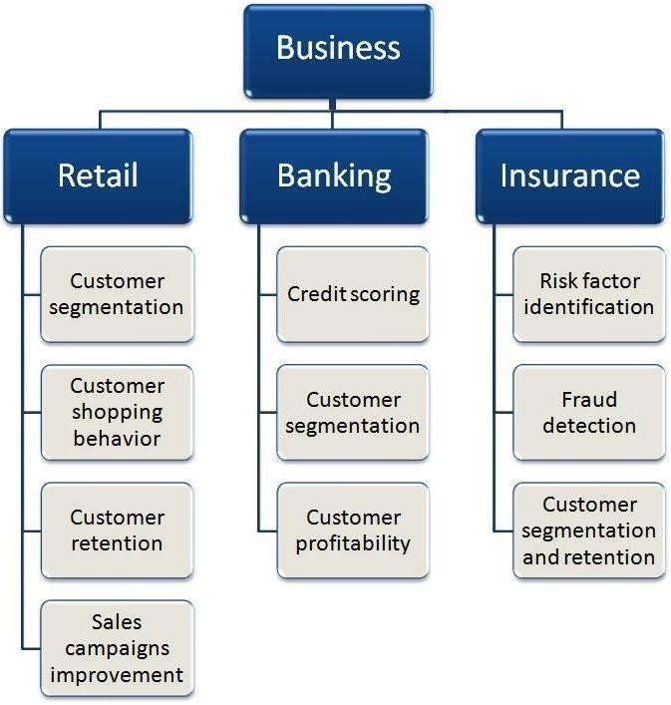

# Apriori Algorithm:

In 1994 the a priori algorithm was proposed By Agrawal and Srikant [3]. it's a classic Algorithm for learning association rules. Apriori is designed to work on databases Include transactions (e.g.A collection of items purchased by a customer, or commercial website traffic details).

Similar to association rule mining, Given a set of itemsets (for example, Retail deal, each listing individually purchased items), the algorithm is find subsets that have at least something in common Minimum number of itemsets.Apriori Use a bottom- up approach.

# Predicting the customer behaviour:

Predicting customer behavior is the most important activity in enterprise business. All the above methods provide companies with a large amount of useful information. The following section presents some scenarios where the above method is implemented.

*Case study 1 : Application of Association Rule mining in Recommender systems*

Recently, recommender systems are very popular in various fields. Movies, music, books, research articles, search queries, social tags, to name a few. These systems combine ideas from intelligent systems, machine learning, and information retrieval to help businesses predict customer behavior.

He has two approaches to recommender systems. One is collaborative filtering and content-based filtering. Collaborative filtering techniques collect and analyze large amounts of information about a user's behavior, activities, or preferences to predict what a user might like based on their similarity to other users. One approach is to use a priori algorithm. This case study uses the Apriori algorithm to extract association rules from user profiles. A PVT system is used as an example. The PVT system is a recommendation program that suggests TV channels to users based on their viewing habits. The system manages both highly rated and poorly rated TV channels. The Apriori algorithm treats a user profile as a transaction, treats the ratings of the programs it contains as an itemset, and can be used to derive levels of trust between a set of rules and associated programs.

Confidence scores are obtained as

similarity scores and used to populate the program's similarity matrix. Here are the steps: Relationships between programs are identified beyond simple overlaps. For example, someone who watches reality

shows like Rodies or Big Boss may not be interested in shows like KBC or Indian Idol. However, if a relationship could be established between Rodies and Indian Idol, it could be the basis for pattern matching. This relationship can be identified by finding support and confidence values. In this case study, confidence values are captured as similar values and recommended to users. You can use direct programmatic similarity to derive rules and concatenate these rules to get new results.

*Case Study 2: Classification model for Target selection in direct marketing*

A predictive response model was developed using data mining techniques to predict the likelihood that Ebedi Microfinance Bank (Nigeria) customers will respond to promotions and offers using historical purchase data. [2] To this end, a predictive response model was built using data mining techniques using the customer's past purchase data. Data were stored in a data warehouse that served as a management decision support system.

Response models were created from customer purchase history and demographic datasets. The purchasing behavior variables used in model development are as follows. Recency: This is the number of months since the last purchase and the first purchase. Predicting responses to subsequent offers is usually the strongest of the three traits. It seems very logical. If you recently purchased something from a company, you are more likely to make another purchase than someone who has not purchased recently.Frequency: This is the number of purchases.

You can include total purchases or all purchases within a specific time period. This property is second only to timeliness in predictive power of responses. Again, it's pretty intuitive as to why it's relevant to future purchases. Amount: This is the total amount. Like frequency, it can be for a

specific time period or include all purchases. Of the three, this property is the least powerful for predicting responses. But when used in combination, they can add another dimension of understanding. Demographic information includes customer's personal characteristics and information such as age, gender, address and occupation. A Bayesian algorithm, or more precisely a Naive Bayes algorithm, was used to build the classification system. Both filter and wrapper feature selection techniques were used in determining the inputs to the model. The results obtained show that Ebedi Microfinance Bank can plan effective marketing of its products and services by obtaining key reports on customer status.

# Conclusions:

In today's business world, getting the customer's attention plays an important role.Every company makes a lot of products, so it's a big problem for a company to stand out in a competitive market. The benefits of running a business with innovative products, services, brands, quality, etc.; how to combine marketing techniques with the product; how to educate everyone about the product; is one of the key success factors in Company.

Overall, digital marketing suggests appropriate ways to communicate with consumers based on product marketing information, historical records, and analysis of consumer buying behavior. Product information below includes product type, price, location, and promotions. Historical records include past marketing strategies, practices, and market responses to assess, consult, and research potential or unknown marketing influencers. When it comes to consumer behavior, we can get feedback and suggest interesting products. Different characteristics of consumer behavior, marketing strategies should be

accompanied by differences in consumer age, gender, occupation, income and lifestyle. In other words, product information, history records, and consumer purchasing behavior from a product-related perspective influence companies to formulate marketing strategies for various product

**REFERENCES:**

1. Barry Smyth, Kevin McCarthy, James Reilly, Derry O’Sullivan and Lorraine McGinty, “Case-Studies in Association Rule Mining for Recommender Systems”. Science Foundation Ireland (SFI) under Grant No.

03/IN.3/I361

1. Eniafe Festus Ayetiran; “A Data MiningBased Response Model for Target Selection in Direct Marketing”, I.J. Information Technology and Computer Science, 2012, 1,

9-18

1. Shu-Ching Wang,Shun-Sheng Wang

Chih-Ming Chang,”Systematic Approach for Digital Marketing Strategy through Data Mining Technology”.Department of Informa tion Management, Chaoyang University of Technology Taichung 409, Taiwan,2014,4-1.

1. Ruxandra PETRE,” Data Mining Solutions for the Business Environment”. University of Economic Studies, Bucharest, Romania.

Database Systems Journal vol.IV, no.4/2013