Structural and optical properties of cadmium sulfide (CdS) thin films by spray pyrolysis.
V.D. Ingale^{a*}, S G. Miss.CHATE D M ^{b*,} Mr.Humbe S S ^{c*,} Mrs. Galande S H ^{d*}
ª Baburao Munde Patil Jr. Collage Devgaon , Physics Department Kaij 431123 India
^{b} Swami Vivekanand Polytechnic, Jola Tq. Kaij Beed, 431123 India
^{c} Swami Vivekanand Polytechnic, Jola Tq. Kaij Beed, 431123 India
^{d} Swami Vivekanand Polytechnic, Jola Tq. Kaij Beed, 431123 India

Corresponding author - mobile no. +91 7757946672
e-mail- vishal.photonics@gmail.com

Abstract- Cadmium sulfide thin films have been synthesized by spray pyrolysis method on glass substrates. The synthesized thin films are characterized by different characterization techniques such as XRD, SEM, EDAX and UV-Vis-IR spectroscopy. The XRD analysis shows that films are polycrystalline in nature with hexagonal structure and no preferential orientation. The XRD analysis confirms grain sizes close to nano regime. Surface morphology of samples is studied by SEM which also shows grain sizes around 150 nm. Compositional analysis from EDAX data shows that the films synthesized have slight deviation from stoichiometry and are cadmium rich. Optical studies revealed the direct band gap nature of CdS. It has 2.4 eV band gap value. CdS is one of the important semiconducting materials used in hetero-junction thin film solar cells such as CdS/CdTe, CdS/CuInSe₂, CdS/CuInGaS₂.

Keywords- CdS thin films, XRD, SEM, EDAX and UV Vis-IR spectroscopy.

1. Introduction- Extensively studied and technologically incorporated Cadmuim Sulfide (CdS), is an important semiconductor material used in polycrystalline thin film solar cells. The n-type semiconducting nature and wide band gap has made it the common window layer in many hetero-junction solar cells such as CdS/CdTe, CdS/CuInSe₂, CdS/CuInAlSe₂ (CIAS), CdS/CuInGaSe₂ (CIGSe), CdS/CuInGaS₂ (CIGS), CdS/Cu₂ZnSnS₄. [1] Among these CIGS and CdTe based modules are in production lines by companies like First Solar, Global Solar, Shell Solar etc. [1] . This material has direct band gap with value of 2.4 eV and excellent stability in electrolytes. CdS has attracted as an electrode to be used in Photo-Electrochemical solar cells (PEC)-the next generation solar cells mimicked from dye sensitized solar cells (DSSC).
CdS thin films are prepared by many deposition techniques such as Chemical Bath Deposition (CBD), Electro-deposition, Sputtering and Spray pyrolysis etc. [2-5]. Among these different methods, spray pyrolysis is a simple and inexpensive technique with easy doping. Although CBD is used in thin film PV industry, reports on CBD showed secondary phases such as Cd(OH)₂ and CdO which results into deterioration.[1, 6-8]. CdS films deposited by spray pyrolysis method do not show such phases but they do exhibit non stoichiometry with either cubic or hexagonal or mixed structures.[9] This work reports the synthesis of CdS thin films by spray pyrolysis method and the results obtained from structural, morphological, compositional and optical characterizations have been discussed.
2. Experimental details- Spray pyrolysis is a simple chemical route to synthesis thin films of thicknesses down to nanoscale. In this method precursor solution is sprayed on preheated substrates to get the desired material to be deposited. Aqueous solutions of Cadmium chloride monohydrate (CdCl_{2.}H₂O) and Thiourea (CH₄N₂S), in equimolar concentrations (0.06 M) are sprayed on glass substrates at 350⁰C. The films are allowed to cool naturally. With spray rate 3 ml/min, 30 ml solution is sprayed by using nitrogen gas at 0.2 kg/cm² pressure. The carrier gas used is nitrogen with 99% purity to reduce completely the probability of oxide phase formation in film. It is ensured that all the spray parameters shall remain constant throughout the spray time. Prior to the deposition, the glass substrates are boiled with chromic acid and cleaned. They are kept in distilled water, rinsed and allowed to dry in air then weighed before use for gravimetric calculation of thickness of the films after deposition.
The thin films are characterized by different characterization techniques such as XRD, SEM, EDAX and UV-Vis-IR spectroscopy. The XRD data obtained using Philips diffractometer with Cu-K_{α} radiation of 1.54 A⁰. For surface morphology and compositional analysis, the characterizations SEM and EDAX are carried out using JEOL-JSM 5600. The absorption spectrum of the thin film in the wavelength range 350 to 950 nm was recorded using SHIMADZU UV-1700 spectrophotometer.

3. Results and discussion-
3.1 X ray diffraction studies- The X-ray diffraction pattern of the film in figure (1) shows that films deposited are polycrystalline in nature. The calculated d-values of the fundamental peaks are compared with standard JCPDS file no.77-2306 which confirms the hexagonal structure Table (2). It is observed that there is no preferred orientation in which the crystallites have deposited. The diffractogram ensures no formation of CdO and absence of elemental cadmium or sulfur.
Fig. 1 XRD pattern of CdS film
The lattice parameters were calculated as a=b= 4.137 and c= 6.712 agree with standard values. The crystallite size calculated for some prominent peaks using Scherrer’s formula Table (1) given by the equation: D= kλ/βcosθ where D is crystallite size, λ is the wavelength of X-ray; β is Full Width at Half Maximum (FWHM). From the crystallite sizes calculated it is confirmed that films deposited are nanocrystalline.
Table 1. Crystallite size calculated for some prominent peaks
Peak Angle (2θ) FWHM Crystallite size
No. (A⁰) (rad) (nm)
02 26.52 0.008352 183.40
03 28.20 0.009048 171.88
05 43.76 0.013224 143.50

Table 02. XRD data of CdS thin films deposited at 350⁰ C
Peak Angle (2θ) d-values (A⁰) plane I/I₀
No. (deg.) observed standard (hkl)
01 24.82 3.5843 3.5818 100 56
02 26.52 3.3582 3.3565 002 99
03 28.20 3.1619 3.1601 101 100
04 36.66 2.4493 2.4492 102 19
05 43.76 2.0670 2.0680 110 35
06 47.90 1.8975 1.8977 103 30
07 51.92 1.7597 1.7909 200 24

3.2 Scanning electron microscopy studies- The nanocrystalline nature of the film is further revealed from morphological pictures obtained. The fig.2 and fig.3 shows micrographs of the CdS films deposited at 350⁰C with equimolar (0.06M) precursor concentrations. SEM image from the fig.02 shows that film comprises of clusters of different sizes formed by crystallites. At 50,000 x magnifications (fig.03) grain sizes calculated are around 150 nm. These grain sizes as depicted in the picture are quite close to crystallite sizes calculated from XRD data. Thus it showed a good agreement between XRD and SEM regarding grain size.
For compositional analysis EDAX technique was used. Fig.04 shows EDAX pattern of the film. The average atomic percentage of Cd:S was found to be 51.82 :48.18. It indicates that films deposited are not stoichiometric showing slight deviation and are cadmium rich. The non stoichimetry as found in CdS fims deposited by spray pyrolysis is reported by other researchers also. [9] It may be due to the volatility of sulfur precursor solution used at spray temperatures but it is need to be surveyed and studied.
3.3 Optical studies- The optical absorption spectrum of the CdS thin film was taken for wavelengths ranging between 350 nm to 950 nm. The nature of transition (direct or indirect) was determined by plotting (αhν)^{1/2} vs hν. The optical absorption coefficient α is evaluated by using relation from (αhν) = A(hν-Eg)^{n} where A is the constant, hν is photon energy, Eg is band gap and n = ½ or 2 for direct and indirect transitions respectively. The plot is given in fig. 05

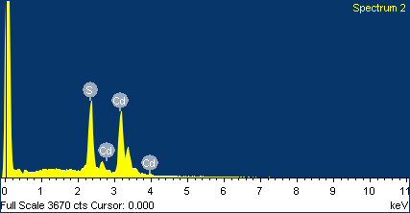
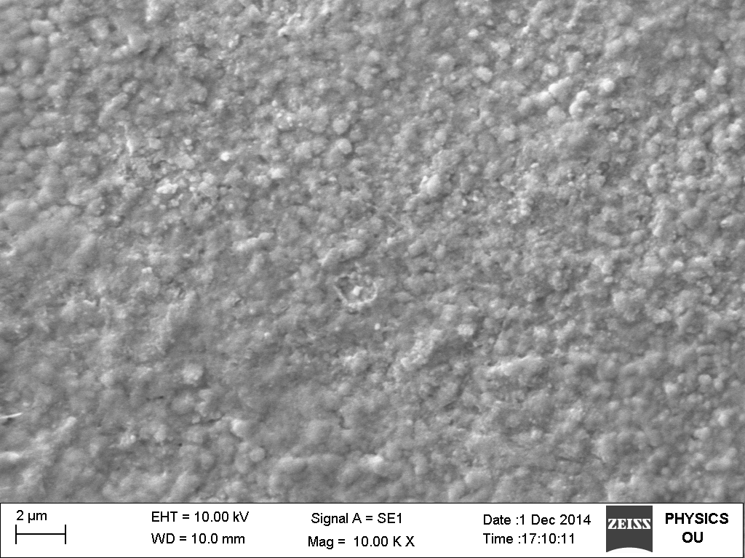
Fig. 02SEM of CdS film . Fig.04 EDAX spectrum of CdS thin film

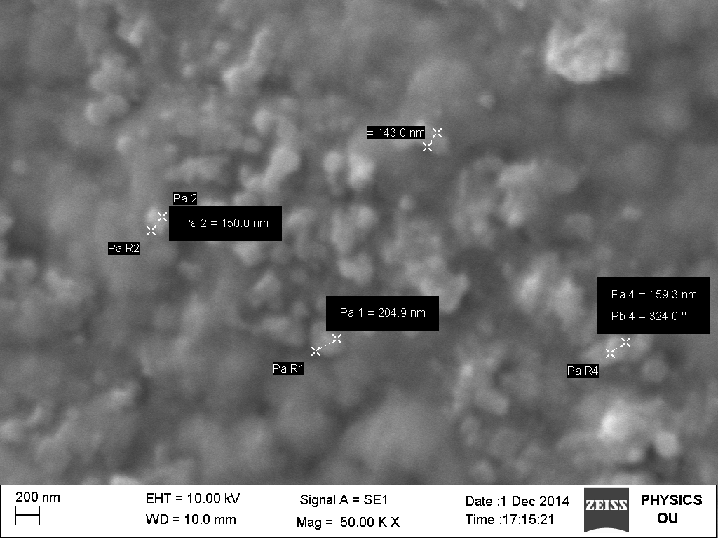
Fig. 03 SEM of CdS film deposited at 50K magnification.
The straight line portion of graph (fig.05) is extrapolated on x axis to obtain the band gap value of CdS thin film as 2.4 eV which is a reported one.[10,11] Fig. 06 shows transmission spectrum of the CdS thin film. It shows 99% transparency to wavelengths longer than 518 nm up to 1000 nm and 98% for shorter ones down to 350 nm. The CdS thin films are highly transparent to the above wavelength range which matches with the sun spectrum; as its flagship application is n-type window layer in hetero-junction polycrystalline thin film solar cells.
Fig.05 (αhν)^{1/2} vs hν Fig. 06 Transmittance spectrum of CdS
4.0 Conclusion- Thin films CdS have been deposited successfully by a spray pyrolysis method. Polycrystalline nature having hexagonal structure is confirmed from XRD analysis. No mixed phases were found in the films but it is also revealed that films do not show any preferred orientation. Films deposited show non uniform grain sizes as depicted in the micrographs obtained from SEM. A good agreement between morphological study and XRD data analysis showed the grain sizes in the nano regime thus confirming the nanocrystalline nature of the thin films. Optical studies showed the direct band gap nature with band gap value 2.4 eV. Transmission spectrum depicts the highly transparent nature of thin films for wavelengths close to terrestrial spectrum of sun.
Acknowledgements- One of the authors V.D. Ingale to Dr. E.U.Masumdar of Shahu College, Latur. The author is also thankful to Dr. Barote M.A. of Azad College, Ausa. and Mr. T.V. Chavan research Scholar from Solapur University.

References-
[1] R.Noufi and K.Zweibel, NREL/CP-520-39894, May 2006
[2] O.V. Salata, P.J. Dobson, P.J. Hull, J.L. Hutchinson, Thin Solid Films 251 (1994)
[3] J.B. Mooney and S.B. Radding, Annu. Rev. Mater. Sci.,12,1(1982).
[4] O. Zelaya-Angel, R. Lozada-Morales, Phys. Rev. B 62 (2000) 13064
[5] P.S. Patil, Mater. Chem. Phys., 59(3), 185 (1999).
[6] A. Kylner and M. Wirde Japn. J. Appl. Phys. 36 (1997) 2167
[7] T. Nakada, H. Fukuda, A. kunioka and S. Niki 13th Europian Photovoltaic Solar Energy
Conference, Nice (1995) 597
[8] A. Kylner, J. Lindgren and L. Stolt, J. Electrochemical Society 143 (1996) 2662
[9] J.E. Hill and R.R. Chamberlin US Patent 34808 (1964)
[10] X.L. Tong, D.S. Jiang, W.B. Hu, Z.M. Liu, M.Z. Luo, Appl. Phys. A 84 (2006) 143
[11] P.P. Hankare, P.A. Chate, D.J. Sathe, Solid State Sci. 11 (2009) 1226.

