**REVIEW PAPER ON**

**ARCHITECTURAL BIM AND STRUCTURAL DESIGN OF A PROPOSED GROUND+3 RESIDENTIAL BUILDING WITH MEP SERVICES USING REVIT SOFTWARE.**

**Gowri M D(1) Gaganashree C M(2) Shashidhar(3) Santhosh Kumar (4) Prof. Sridhara S(5)**

**5– Assistant Professor, Dept of Civil Engineering, 1,2,3,4, – UG Students Dept of Civil Engineering Dayananda Sagar Academy of Technology and Management, Bangalore.**

**Abstract** - Autodesk Revit software can be used to design the project. Autodesk Revit, which produces a holistic vision of the construction. Building information technology makes it simple to model buildings and connects us to Revit architecture, Revit MEP, and Revit structural. The benefits of BIM were proved when it came to enhancing a mechanical, electrical, and plumbing (MEP) layout throughout the design phase . To digitalize and integrate MEP-related information into the as-built model, the current study proposes a set of solutions based on Building Information Modelling /Model (BIM) Technology, including the automatic establishment of the logic chain for MEP systems, an equipment grouping and labelling scheme, and an algorithm to transform BIM information to GIS map model. Using BIM software, the model is examined to remove the most common execution faults. In order to assist sustainable design and clash detection, Autodesk Revit Architecture is helpful. BIM is used for 3D modelling, which includes the 4th dimension of time and the 5th dimension of model cost.

**Key words:** REVIT, BIM and MEP.

**INTRODUCTION**

Autodesk Revit is building information modelling software developed by Autodesk that is used by architects, landscape architects, structural engineers, MEP engineers, designers, and contractors. It enables users to create a building and its components in 3D, annotate the model with 2D drawing elements and acquire building information from the database of the building model. Building information modelling (BIM) is a new approach to building project design and documentation. BIM models and organizes information that enables the automatic development of drawings and reports, design analysis, schedule simulation, facilities management, and more, eventually allowing the building team to make more informed decisions. In BIM, numerous professions and players collaborate and effectively share information to produce a well-organized design and construction process. Apart from architectural modelling, Revit also consists of tools for MEP design and structural design. Modelling tools may work with either pre-created solid objects or imported geometric models. While designing, users may work with "families" (walls, ceilings, furniture, etc.) or import geometries. The "families" function is what makes Revit one of the top civil engineering software applications. The Revit work environment enables users to alter whole structures or assemblies (in the project environment) as well as individual 3D forms (in the family editor environment).

**LITERATURE REVIEW**

**Abanda et al (2015**) studied a critical analysis of Building Information Modelling systems used in construction projects. The purpose of this study is to undertake a comprehensive and critical evaluation of a wide range of BIM software systems currently utilised in the management of construction project information. It should be mentioned that, while it is difficult to assess all BIM systems, the study takes a holistic approach that includes the majority of the major BIM system categories. A systematic study of the literature, a structured questionnaire survey, action learning, focus group discussions, and email surveys are among the methods used. Emerging BIM systems provide tremendous opportunity to tackle industry-wide obstacles.

**Jun Wang et al (2016)** presented Building information modeling-based integration of MEP layout designs and constructability. The goal of this study is to develop a practical BIM framework for integrating MEP Layout from the basic design stage through the construction phase. The problem of collision detection is reviewed since BIM technologies for collision detection are ineffective in 78% of cases. To overcome the design and constructability concerns, four types of coordination stages were used: MEP system coordination, MEP spatial layout coordination, MEP constructability coordination, and MEP verification based on the construction variation. Workers manually measured construction variations between as-planned and as-built buildings in this project using tapes.

**Soundarya et al (2017)** studied building information modelling of a two storey building using Autodesk Revit and Autodesk Navisworks manage. The use of BIM adds new dimensions to a project and makes it easier to see every potential feature of a structure as it is being designed. In order to reduce execution mistake to a minimum, BIM software analyses the final model. To reduce costs and speed up projects, the majority of big construction firms are experimenting with BIM. The full building life cycle is illustrated with the use of BIM data. The BIM has five dimensions (cost). BIM comes with a variety of software for handling various dimensional parameters. Building modelling is a feature of 3D BIM software like Autodesk Revit. Software for 4D BIM, such as Autodesk Revit and Naviswork, may provide a project's duration. The cost of a project is addressed by 5D BIM software (Autodesk Revit and Autodesk Naviswork manage). The two-story structure was designed, and Autodesk Revit was used to execute the 3D modelling of the two-story building's schedules, phasing stage, design alternatives, and energy analysis. Autodesk Navis work manage is used to find conflicts between the building's simulation and time.

**Liyuan Wang et al (2018)** presented application of BIM Technology in Interference Check in Construction Work. It is challenging for designers using traditional two-dimensional graphic design to identify space interference between pipes, structures, and buildings and make suitable alterations. Designers raised an unique approach for the cross-cutting issue by using simulation software Revit and Navisworks for Building Information Modeling projects. The BIM-based multi-specialty collaborative design pattern will become a future trend with the implementation of BIM technology. BIM provides designers to invest more time and focus to professional design even while improving the quality of collaborative designs and building projects.

**Zhen-Zhong Hu et al (2018)** proposed to apply the BIM technology to build up a comprehensive as- built building model containing MEP related information for delivery. An algorithm of generating the GIS map based on the BIM information. Improving the efficiency of the MEP system is crucial for the success of a building project and is a primary goal of Operational and maintenance management. Furthermore, the current study investigates at cross-platform O&M intelligent management software, which is useful in raising O&M management efficiency and improving emergency response performance.

**Rakesh Reddy et al (2019)** explained Design and modelling of G+ 5 commercial building by Autodesk Rivet architecture, Which renders complete perspective of the construction. The building model is integrated with Revit architecture, Revit MEP, and Revit structures utilizing BIM technology. Every project completed in Revit will have 2d, 3d, section views, elevations with details and schedules, and quantities. The three-dimensional realistic image gives a detailed picture of the family and the components installed within the building model. This project provides comprehensive building modelling and precise families ranging from furniture to lighting fixtures, as well as the ability to import existing models from other softwares such as Auto CAD, etc.

**A S Hadi et al (2020)** carried out the Integrity of Revit with structural analysis software and this study analyses how engineers can benefit from using Building Information Modeling (BIM). The compatibility of Revit with structural analysis tools such as Robot Structural Analysis and E-tabs is being investigated. It offers the reinforcement area necessary for all frames in the structure. The amount of reinforcement estimated using Revit for columns, walls, and floors according to what was designed at RSA and E-tabs was compared to the building's actual reinforcements. BIM allows structural engineers to evaluate numerous structural possibilities and optimise the optimum scenario to achieve the most cost-effective design with the least errors. In addition, BIM models preserve all analysis, design, and documentation information in one place.

**Sachin A et al (2020)** outlined a Case Study on Building Information Modelling for Residential Buildings. This project is studying BIM application on an existing building, which has G+1 floor and a total built up area. BIM enables more intelligent resource use and process optimization, resulting in increased productivity and probability. The purpose is to utilise BIM to visualise, 3D coordinates, plan, schedule, estimate, and record a residential building. The following are the uses of Building information modelling that serve mostly by the function that they fulfil on the project, as well as additional attributes for each BIM such as Virtual construction, Design and engineering, Construction management, Operations and maintenance.

**Yasir shaikh et al (2020)** carried out energy analyse of multi stored G+15 Residential Building. The project's basis for doing an energy analysis of a G+15 Residential Building utilizes Autodesk BIM capabilities. The goal of the study is to determine how BIM energy analysis may be used to assist anticipate how much energy a building will need. Building functionality, user comfort, and operation all demand a certain amount of energy. The energy required is a result of energy losses from the building envelop, including transmission and ventilation losses. The Revit programme may be used to make any significant changes, steps to reduce energy costs, or to prevent energy waste. The Autodesk Revit Software, often associated with Green Building Studio, a cloud-based energy analysis application, is employed for this purpose. Applying energy-efficient lighting and heating conditions in the green building studio will maximise energy savings and minimise energy loss in the structure. Overall, the many criteria examined for the project demonstrate that the conventional building's energy efficiency has increased, turning it into a green structure.

**Ramesh Babu et al (2020)** presented design and analysis G+5 Residential Building. Using Autodesk Revit software, the structure can be built. Multi-story residential structures are the ideal choice for areas with a high population density. A multi-story residential structure with floors above the ground level is intended to expand the floor area of the building in the smallest possible built-up space. Designing and planning to construct an ideal building are topics covered in structural analysis. Robot Structure Analysis Professional, which enables you to evaluate the impacts of structural loads and confirm code compliance using cutting-edge BIM tools, may be used to provide comparable functionality through the use of Robot Structure Analysis. Software that connects with BIM processes is only accessible in the collection for architecture, engineering, and construction. They demonstrate the modelling and structural design of a school building. They employed REVIT SOFTWARE and ROBOT STRUCTURAL ANALYSIS to complete the process. Building was built in accordance with the PRINCIPLES OF PLANNING and BUILDING BYE LAWS.

**AIM**

Architectural BIM and Structural Design of a Proposed G+3 Residential Building with MEP Services using REVIT Software.

**OBJECTIVES**

* Architectural and structural design of residential buildings according to the Indian Building standard codes (IBC) using autodesk revit software and validating the design loads using E-tabs.
* A holistic approach using BIM technology and providing MEP services.

**METHODOLOGY**

The first step is to collect the plan of the residential building which is imported from AutoCAD to auto disc Revit software.

REVIT ARCHITECTURE

* 2D diagram of the plan is converted to a 3D diagram by adopting BIM technology and then creating the basic wall, window, floors etc using Revit architecture.

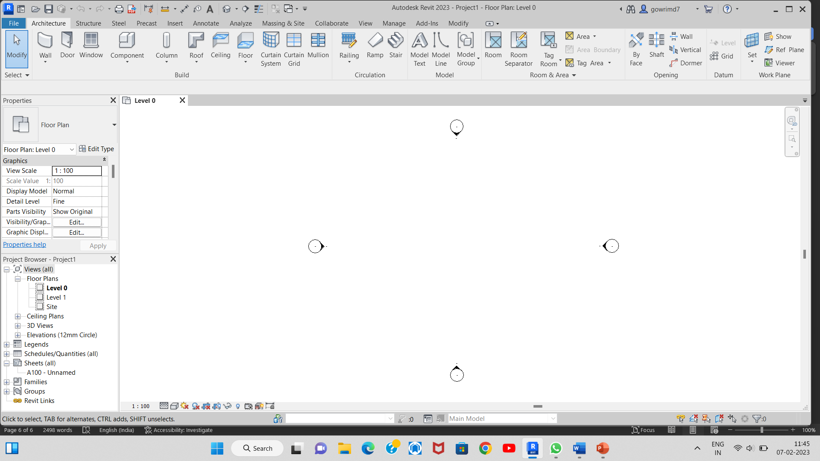

REVIT STRUCTURE

* Model is designed by adding structural elements like columns, beams and footings which are designed according to Indian standard codes using revit structure.
* The materials used are of green benefits that is, using materials like green roofing, glazing with low emissivity coating, autoclaved aerated concrete blocks, cork flooring are assigned to the model.

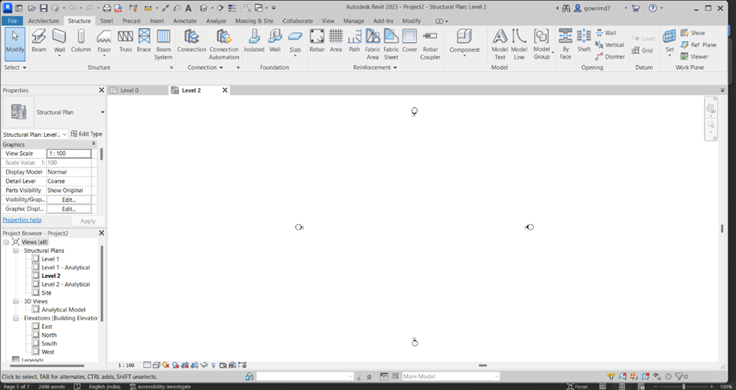

REVIT MEP

* Services are provided to the model by revit MEP software tools.The clashes during MEP designing is analysed and cleared.
* The design structure is analysed using analysis softwares E-tabs and SAFE.E-tabs is used to analyse the loads of structural elements that are column and beams and SAFE is the footing loads.
* O and M software is used to maintain the facilities like building, ground, equipment systems etc to lower the cost of daily expenses in the maintaining. It can be done using O&M software where the activities performed day by day are maintained in the software properly.
* Holistic visualisation of the building can be made using project review softwares. NAVISWORK is used to visualise the building by combining the data and the model in the software.

1.MECHANICAL

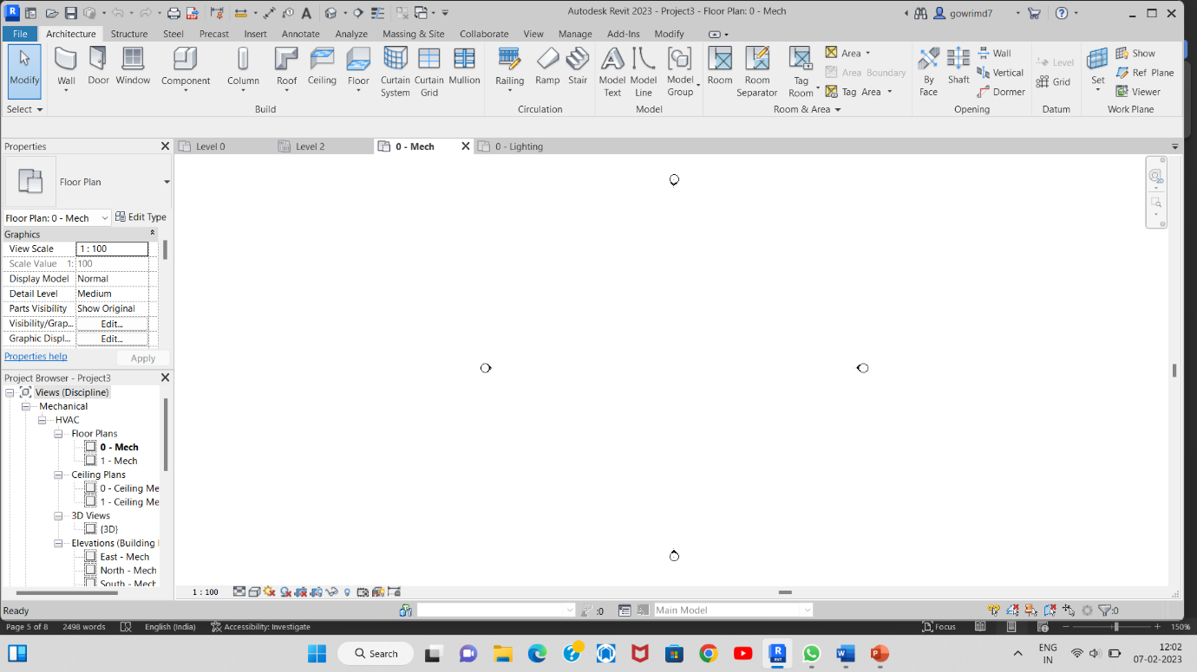

2.ELECTRICAL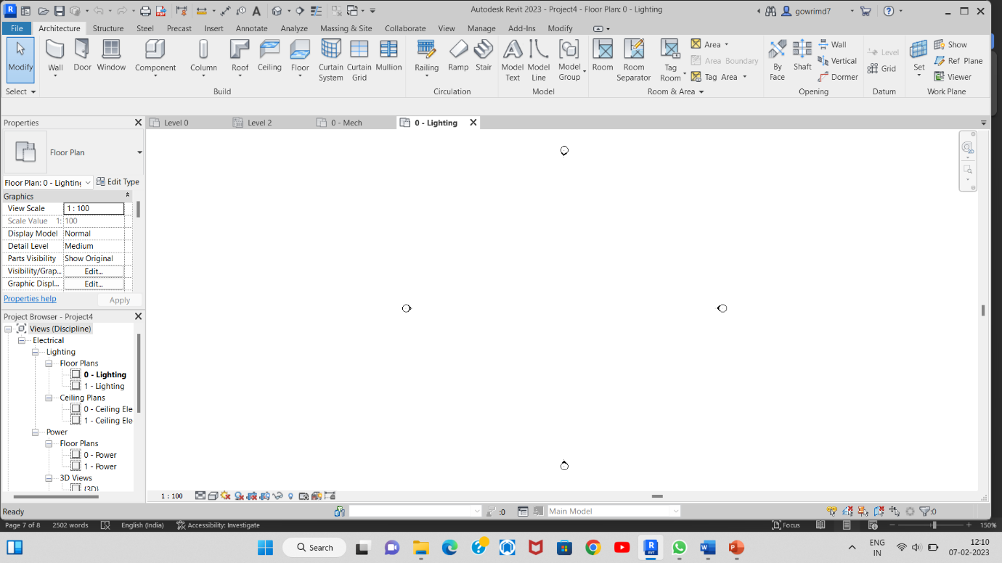

3.PLUMBING

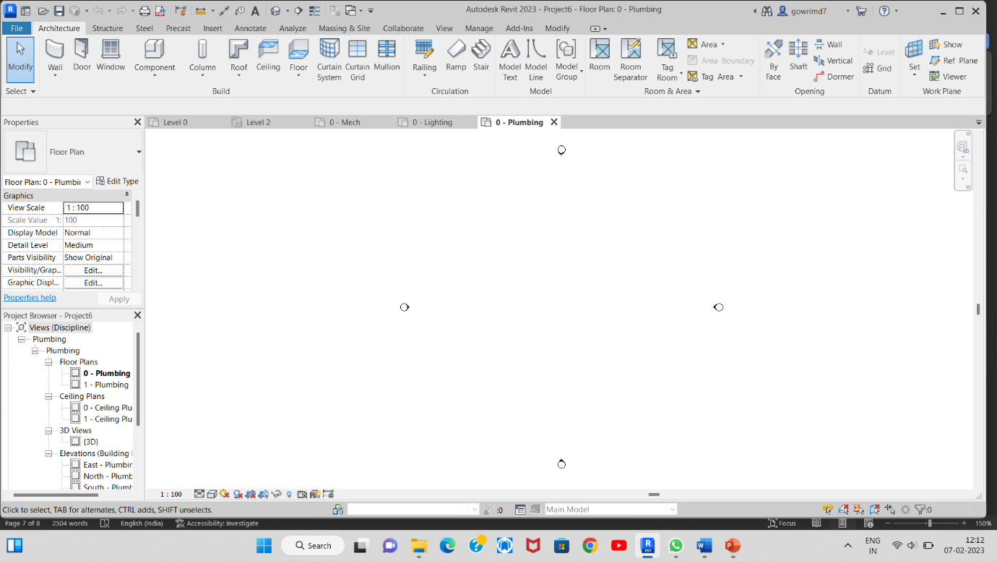

**CONCLUSION**

The Preceding research emphasises the use of BIM in Revit software. The BIM is an unique and promising strategy being used by owners, architects, engineers, and builders in India over time. BIM is used in the study for visualisation, 3D coordinates, planning, scheduling, estimate, and record-keeping. A good image of the family and the components included in the construction model is provided by a three-dimensional realistic view. Autodesk Revit software will be used for architectural design, including mechanical, electrical, and plumbing services (MEP).

**REFERENCES**

1.Liyuan Wang, et.al, Application of BIM Technology in Interference Check in Construction Work(2018).

2.A S Hadi , Application of BIM Structural Engineering, 2020Vol. 26 (2021).

3.Soundarya R & Uma R. N, Building Information modelling of two story building using Autodesk Revit and Autodesk Navis work manage, Vol. 6, Issue 4, Jun– Jul 2017.

4.Dr. V. Ramesh Babu et.al, Design and Analysis (G+5) of Residential Building, Volume 7, Issue 3 , March 2020.

5.Yasir Shaikh, Vaibhav Sawant, Anant Satam, Harshad Waingankar, Dinesh M. Joshi, Revit Structure, Vol. 3: Issue 2, 2020.

6.Zhen-Zhong Hu, Pei-Long Tian, Sun-Wei Li, Jian-Ping Zhang, Research paper BIM-based integrated delivery technologies for intelligent MEP management in the operation and maintenance phase, Accepted 8 August 2017.

7.Jun Wang, Xiangyu Wang, Wenchi Shou, Heap-Yih Chong, Jun Guo, Building information modeling-based integration of MEP layout designs and constructability, Accepted 16 October 2015.

8.E. Rakesh Reddy, S. Kailash kumar , Design and Modelling of G+5 Commercial Building by Autodesk Revit Architecture, Volume-9 Issue-2, December, 2019.

9.F. h abanda, et.al, A critical analysis of building information modelling systems used in construction projects, Volume 90, December 2015.

10.Bedilu Habte, Eyosias Guyo, APPLICATION OF BIM FOR STRUCTURAL ENGINEERING: A CASE STUDY USING REVIT AND CUSTOMARY STRUCTURAL ANALYSIS AND DESIGN SOFTWARE, Journal of Information Technology in Construction - ISSN Vol. 26 (2021), Habte & Guyo, pg. 1009,SUBMITTED: February 2021 November 2021