**SMART CROP PROTECTION AND ALERTING SYSTEM**

**Ranjith Kumar M1, Dr.Azha.Periasamy2**

1Department of Electronics and instrumentation & Bharathiyar University,Coimbatore

2Associate Professor Department of Electronics and instrumentation & Bharathiyar University,Coimbatore

**ABSTRACT**

Crops in the farms are destroyed by neighbourhood animals including elephants, cows, goats, birds, etc. For the farmers, it is an enormous losses. Farmers cannot block entire fields or remain on the field all day to secure it. so here is proposed the smart  crop protection and alerting system. This is a microcontroller based system. This system uses a motion sensor to detect the motion of the animals or sound sensor detects the frequency range of the animals approaching  close proximity to the field. The sensor instructs the microcontroller to operate in this situation. The  microcontroller sends the SMS to the farmer to alert him. So he can visit the farm if the animals don't turn around.

**Keywords:** PIC 16f877a, GSM Module SIM 800C, Motion sensor, Sound sensor, 16*2 LCD display.

**1. INTRODUCTION**

Agriculture is a major contributor to the economies of many nations in the worldwide. Despite economic growth, agriculture remains the foundation of the economy. Agribusiness is  the backbone of the economy. The gross domestic product benefits from it. Food needs are met by agriculture, which also provides a variety of industrial raw resources. However there will be a significant loss of crops due to animal interference in agricultural lands. The crop will be completely ruined. Farmers will lose a significant amount of money. Protecting agricultural fields or farms from animals  is crucial to prevent these financial losses. In this suggested work, method has been developed to stop animals from entering the farm in order to solve this issue.

**2. PROPOSED WORK**



**Fig 1: Block diagram**

In the proposed work PIR, Sound sensor and GSM is used. When animals come close to the PIR sensor and it detects the animals motion.When the sound sensor detects the sound of the animals that data will also be sent to the microcontroller, the microcontroller takes a further action.when the microcontroller gets the data it will be started to send the sms to the owner. LCD Display displays while the sms is sending or not.GSM module is used to send sms to the farmer when sound or motion is detected.Once the sms is received the farmers knows some animals are enter into the farm.

**2.1 ADVANTAGES**

* We do not need to stay on the field.
* This system can be used for all the field.
* And it will notify the farmer via SMS.

 **3. PROGRAM FLOW**

**Fig 2: Flow chart**

**4. PIR SENSOR**

When a moving object passes in front of the PIR sensor, it emits infrared radiation, which is detected by the pyroelectric sensor. The sensor then generates a voltage signal, which is sent to a processing circuit. The processing circuit analyzes the signal and determines whether it is a valid motion detection event. If it is, it triggers an output signal, which can be used to activate a device.

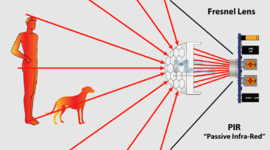

**Fig 3: PIR sensor**

**5. SOUND SENSOR**

It works similar to our ears. Our Ears have a diaphragm which converts the detected the vibration and converts it in the signal. Similar to this, sound sensors use a microphone to transform vibration into an audio signal (voltage and current proportional). This microphone has an inbuilt diaphragm, made up of magnets which are coiled by metal wire. Whenever sound waves hits the diaphragm, magnets vibrate and at the same time coil induces the current.

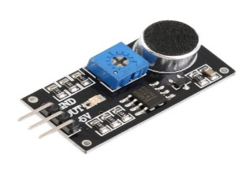

**Fig 4: sound sensor**

**5.1 PIN CONFIGURATION**

* Pin1 (VCC): 3.3V DC to 5V DC.
* Pin2 (GND): Is a ground pin.
* Pin3 (DO): This an output pin.

**6. GSM SIM 800**

A GSM modem is a device that enables communication between computers and other processors across a network. It can also be a mobile phone. A SIM card is necessary to run a GSM modem, which utilises a network range to which the network operator has subscribed. It has three different connections options for computers, Bluetooth, USB, and serial.With the proper cable and software driver, a regular GSM mobile phone may function as a GSM modem when connected to a computer's serial port or USB port. Often, a GSM modem is preferred over a GSM mobile phone. Transaction terminals, supply chain management, security applications, and weather forecasting are just a few areas where the GSM modem may be used.

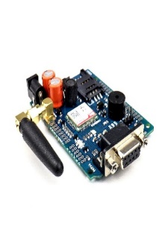

**Fig 5: Gsm Module**

**7. PIC 16F877A**

An 8-bit CMOS Flash-based microcontroller is the PIC16F877A-I/P. The PIC16F877A has a synchronous serial port that can be configured as either a 3-wire Serial Peripheral Interface (SPITM) or a 2-wire Inter-Integrated Circuit (I2CTM) bus, 256 bytes of EEPROM data memory, self-programming, an ICD, two comparators, eight channels of 10-bit Analogue-to-Digital (A/D) converter, two capture/compare/PWM functions, and a Universal Asynchronous Receiver Trans (USART). During normal operation, the data EEPROM and flash programme memory are readable and written (over the full VDD range). The register file space does not directly map this memory there.

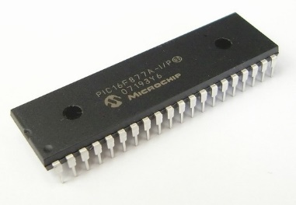

**Fig 6: 16f877a**

**8. RESULT & DISCUSSION**

Here the results will be shown as software-based using proteus simulation software.And the MPLAB IDE is used to program the microcontroller and its interfaced components.

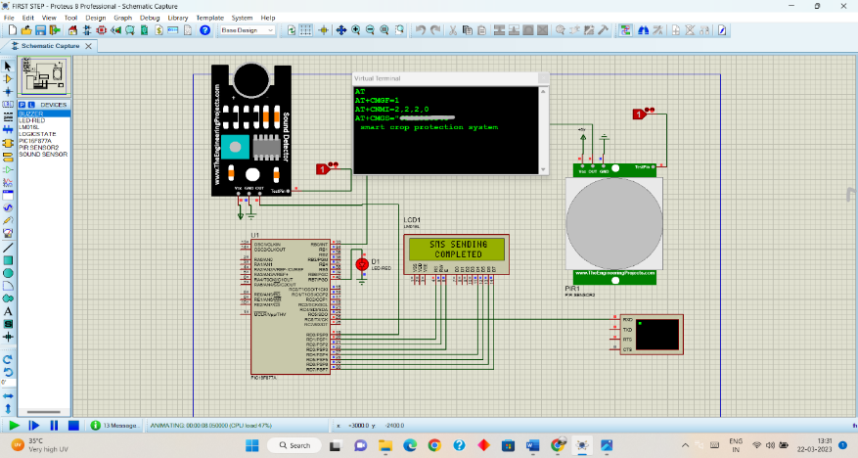

**Fig 7: Simulation**

When an animals are try to enter into the farm the PIR sensor and sound sensor logically high value of 1. Then it passes the signals to the PIC microcontroller and it will communicate the GSM to alert the farmer.

**9. CONCLUSION**

Overall, the smart crop protection and alerting system can help farmers be more proactive in protecting their crops and ensuring a successful harvest, leading to increased profitability and sustainability in agriculture.

**10. REFERENCES**

.1.R. Vigneshwar and R. Maheswari, “Development of embedded based system to monitor elephant intrusion in forest border areas using internet of things,” International Journal of Engineering Research, vol. 5, no. 7, pp. 594–598, 2016.

2. Padmashree S. Dhake, Sumedha S. Borde, “Embedded Surveillance System Using PIR Sensor”, International Journal of Advanced Technology in Engineering and Science, www.ijates.com Volume No.02, Issue No. 03, March 2014.

3. A. V. Deshpande, “Design and implementation of an intelligent security system for farm protection from wild animals,” International Journal of Science and Research, ISSN (Online), pp. 2319–7064, 2016.

4. V. Bavane, A. Raut, S. Sonune, A. Bawane, and P. Jawandhiya, “Protection of crops from wild animals using intelligent surveillance system.”

5.K. Rao, R. Maikhuri, S. Nautiyal, and K. G. Saxena, “Crop damage and livestock depredation by wildlife: a case study from Nanda Devi biosphere reserve, India,” Journal of Environmental Management, vol. 66, no. 3, pp. 317–327, 2002.