# PREDICT THE CUSTOMERS RESPONDING TO THE PERSONALLOAN CAMPAIGN

**Mohanraj.R**

**II-M.Sc.ComputerScience**

**SriKrishnaArtsandScienceCollegeCoimbatore**

**Elango.M**

**II-M.Sc.ComputerScience**

**Sri Krishna Arts and Science CollegeCoimbatore**

## ABSTRACT

Banks advertise their personal loanofferings to potential customers becausepersonal loans are a significant source ofrevenue.Themajorityofthesecampaignstarget a random database of customers,leading to annoying telemarketing callsrather than effective lead conversionstrategies.

how to make the campaigns more likely toconvert customers by focusing on the rightgroupofpeople.Tocreateamodelthatcan predict whether a customer willrespondtoapersonalloancampaignornot, use previously available data on thedemographics,bankdetails,andtransactionpatternsofcustomerswhohaveresponded to the campaign and those whohavenot.

(Keywords: retail bank customers,marketingstrategy,personalloans.)

## INTRODUCTION

The bank's clientele is expanding. In orderto attract more loan business and makemore money from interest on loans, thebank wants to expand its base ofborrowers—alsoknownas assetcustomers. As a result, the bank wants toswitchfromcustomerswith liabilitiesto

customers with personal loans. whilekeeping them in their role as depositors).The bank ran a campaign for liabilitycustomers last year that had a healthyconversion rate of over 9 percent success.The department expects you to develop amodel that will assist them in locatingpotential customers who are more likely toacquirethe loan.

## BANKING

Thevariousareasorcomponentsofknowledgethataregatheredtocomprehendhow the specific field or banking segmentsoperateinrelationtoproductsandservices,sales and distribution, customers, process,technology, and people are referred to asbankingdomain concepts.

# FunctionsOfBankingDomain

Becauseofthewidespreadnatureofbankingdomainconcepts,theycanbasically be divided into the following twoindustriesorfunctionsthatbanksperform:

Corebanking,retailbanking,corporatebanking,service-basedbanking,loans,privatebanking,front-enddelivery,andconsumerfinancearejustsomeoftheprimaryfunctionsofthetraditionalbankingsector,Tradefinance.

Table1.Featuresofthedataset

|  |  |  |
| --- | --- | --- |
| Featurenames | Description | Featuretypes |
| CUST_ID | Customeridentificationnumber | numeric |
| TARGET | Targetcustomer | numeric |
| AGE | Ageofthe customer | numeric |
| GENDER | genderofthecustomerwhichismale,femaleandothercategory | categorical |
| BALANCE | bankbalance | numeric |
| OCCUPATION | Occupation | categorical |
| SCR | genericmarketingscore | numeric |
| HOLDING_PERIOD | lengthofrelationinabank | numeric |
| ACC_TYPE | Accounttype-savingsaccount,currentaccounttype | categorical |
| ACC_OP_DATE | Accountopeningdate | categorical |
| LEN_OF_RLTN_IN_MNTH | Lengthoftherelationshipinamonths | numeric |
| NO_OF_L_CR_TXNS | No.ofcreditcardtransaction | Numeric |
| NO_OF_BR_CSH_WDL_DR_TXNS | Numberofbankcashwithdrawaltransaction | Numeric |
| NO_OF_ATM_DR_TXNS | No.ofATMdebittransaction | Numeric |
| NO_OF_NET_DR_TXNS | No.ofnetdebittransaction | Numeric |
| NO_OF_MOB_DR_TXNS | No.ofmobilebankingdebittransaction | Numeric |
| NO_OF_CHQ_DR_TXNS | No.ofchequedebittransaction | Numeric |
| FLG_HAS_CC | Customerwhohavecreditcards | Numeric |
| AMT_ATM_DR | Amountwithdrawnfrombank | Numeric |
| AMT_BR_CSH_WDL_DR | amountcashwithdrawnfrombranch | Numeric |
| AMT_CHQ_DR | amountdebitedbychequetransaction | Numeric |
| AMT_NET_DR | amountdebitedbynettransaction | Numeric |
| AMT_MBL_DR | Amountdebitedbymobilebankingtransaction | Numeric |
| FLG_HAS_ANY_CHGS | customerwhohavependingcharges | Numeric |
| FLG_HAS_NOMINEE | customer'snominee | Numeric |
| FLG_HAS_OLD_LOAN | customerhaveanyoldloanorpendingloan | Numeric |

Correlationofattributes

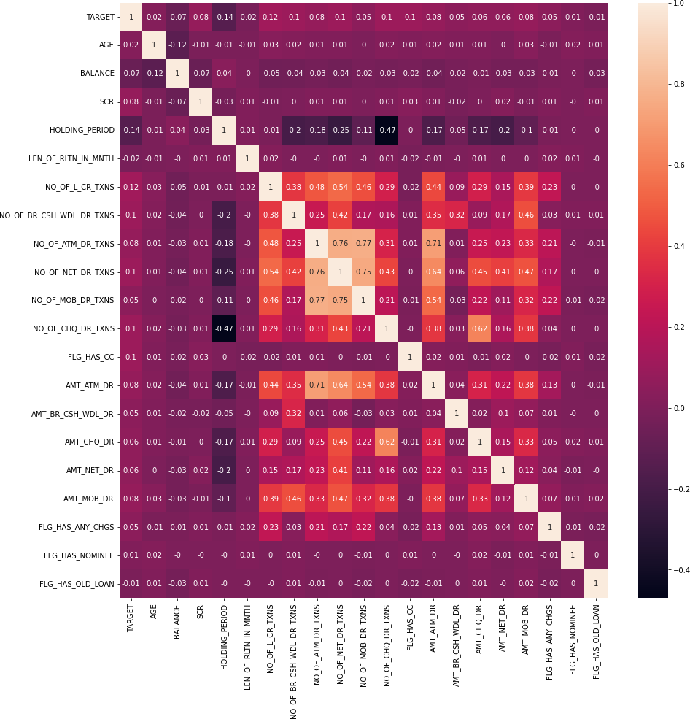

## MaterialandMethods

**Dataset**

Table 1 shows some of the features that were checked in the bank loan dataset for this study.Likewise,table1showsmean,standarddeviation,minesteem,maxworthandcomponenttype.There are no duplicates, missing values, or string-type values. Due to the fact that duplicationandmissingvaluescanhaveanegativeimpactonpredictionresultsandsomemachinelearningalgorithms cannot work with string values, this information is critical. A label encoder couldbeused to solve theissueif thereis a string value.

Columns that aren't needed for this study must be chosen after these details. To get a sense ofhow the columns affect the target column, Personal Loan, look at the correlation matrix inFigure1.Thecorrelationmatrixdemonstratesthateachcolumnhasapositiveornegativeeffectonthetargetvalue.BecauseCUST_IDisauniquevaluefor eachdatasetmember,thecolumnwas removed. The dataset can be used for ML algorithms after these details and deletions aremade.

## Methods

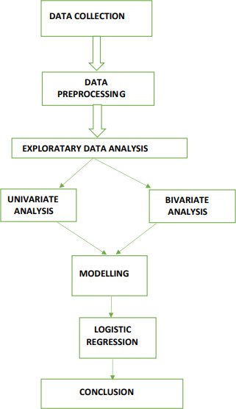

**Classification**

Themosttypicalapplicationoflogisticregression is binary logistic regression, inwhich the outcome is binary (yes or no).Logisticregressionisusedtosolveclassification problems. In reality, you canseecalculatedrelapseappliedacrossdifferentregions and fields.

Inthemedicalfield,logisticregressioncanbe utilized to determine whether a tumorwilllikely be benignor malignant.

Inthefinancialsector,logisticregressioncan be utilized to identify fraudulenttransactions.

Atargetedaudience'sresponsecanbepredicted using logistic regression inmarketing.

Depending on the number of predictedoutcomes, there are two additional types oflogisticregression.

The three different kinds of logisticregression: Whenwehavetwopossible outcomes, such as our initialexample of whether or not a person islikely to be infected with COVID-19, weusebinary logisticregression.

1. Multinomial logistic regression is usedwhenwehavemultipleoutcomes,suchas

when we expand on our initial example todetermine whether a person might have thecold,theflu,an allergy, or COVID-19.

1. Ordinal logistic regression is used whenthe outcome is arranged, like when weexpand on our initial example to helpclassify a COVID-19 infection as mild,moderate,orsevere.

## ExperimentalStudyandFindings

In this study, confusion matrix, accuracyscore, precision score, recall score and f1scoremetricswillbeusedtoevaluateclassificationalgorithm.

## EvaluationMetrics

Evaluation metrics can be used to providean explanation for a model's performance.Oneimportantfeatureisthatevaluationmetricscantellthedifferencebetweenmodelresults.

## ConfusionMatrix

It is a N X N matrix, where N representsthe predicted number of classes [20]. Theconfusion matrix from Table 2 will be usedinthis article.

Table2.Confusionmatrixcellrepresentation

|  |  |  |
| --- | --- | --- |
|  | Predicted:0 | Predicted:1 |
| Actual:0 | TN | FP |
| Actual:1 | FN | TP |

## AccuracyScore

Theterm"accuracy"referstotheproportionofcorrectpredictionsinthetotalnumber of predictions[20]. The followingequationwas usedto determineprecision.

(TP+TN)/(TP+TN+FP+FN)isthe

accuracy.

## PrecisionScore

Precision is the percentage of affirmativecasesthatarecorrectlyidentified.Thepredictivemodel'sperfectionisdemonstrated by its precision score.Thefollowing equation was used to determineprecision.

Precisionequals(TP/TP+FP).

## RecallScore

Recall is the percentage of actual positivecasesthatareaccuratelydetected.Thefollowing equation was used to determinerecall.

Remember:(TP)/(FP+FN)

## F1Score

The F1-Score is the harmonic mean of theprecisionandrecallvaluesforaclassificationproblem.Thefollowingequationwas usedto determineF1.

F1 = 2 (Precision minus Recall PrecisionplusRecall)

## CONCLUSION

Here, the Binomial Logistic Regressiontechnique is used to not only predict theclass of customers responding to thepersonalloan campaignbut alsotocompile a list of statistically significantindependent variables that influence thecustomers'responses.Basedonthemodel,it can also predict the likelihood that acustomerwill respond or not.Bydeveloping a model that can predictwhetheracustomerwill respondto a

personal loan campaign or not by usingpreviouslyavailable dataon thedemographics,bankdetails,andtransaction patterns of customers who haveresponded to the campaign and those whohavenot as training data.

## References

Loanapprovalpredictionbasedonmachinelearning,byK.Arun,G.Ishan,andK.Sanmeet.Comput.IOSRJ.Eng,2016.18(3):p. 18-21.

1. M.Bhandari,HowtoUseMachineLearningModelstoPredictLoanEligibility[citedonJanuary2,2022];Accessiblefrom:https://towardsdatascience.com/predictloan

-eligibility-using-machine-learning-models7a14ef904057.

1. Predictloanapprovalinbankingsystem:amachinelearningapproachforcooperativebanks'loanapproval,byAphale,A.S.,andS.R.Shinde.2020editionof the International Journal of EngineeringResearchandTechnology.9(8):991-995
2. Walke,K.Bankindividualadvancedisplaying.[citedonOctober3,2021];Accessible from:

<https://www.kaggle.com/krantiswalke/bank-personal-loanmodelling>.

1. Accurate loan approval prediction usingamachinelearningapproach,byJ.Tejaswini,T.M.Kavya,EngineeringSciencesJournal. 11(4):p.523-532.