Distributed Operating System and Infrastructure for Scientific Data Management

Authors Name Krishnakant Soni
Department Name: Computer Science Department
City: Khandwa(M.P.) Country: India

ABSTRACT
The aim of the article is to give a comprehensive overview of the operating systems used. This article also describes many of the main stylistic issues involved in building such a system. A distributed operating system can be a software system that includes a set of independent, networked, communicating, and physically distinct procedural nodes. Each of the individual nodes has a select set of global potion pack software systems. Each set can be a combination of 2 different service providers. The first is the edge kernel or microkernel, which directly controls the hardware of that node. The second may be a set of higher level system management elements that coordinate a node's individual and collective activities. These parts encapsulate the functions of the microkernel and support user applications. The microkernel and the collection of administrative parts work together.
INTRODUCTION
A distributed software system is a related software system running on various technologies that runs on to create a useful set of services there, typically 1087 to run a set of machines as an additional machine type. A distributed operating system provides the base services and functions required by the associated operating system, adding specific attributes and configurations so that it can support additional requirements such as increased scalability and availability. Users, a distributed operating system works similar to a monolithic operating system for a single node. This means that although it is made up of many nodes, it appears as a single node to users and applications. Separating negligible system-level convenience from additional standard user-level services ensures a "separation of mechanism and policy".

EXAMPLES OF DISTRIBUTED OPERATIVE
SYSTEMS
l. IRIX operating system; is that the implementation of UNIX System V, the release of three multiprocessor workstations with ordinal number 14.
2. Type of Aix software system for IBM RS/6000 computers.
3.Solaris software system for SUN digital workstations.

GOALS
1. There are many types of distributed computer systems and many challenges that must be overcome in order to be successful with One. The primary goal of the distributed computing system is to connect users and resources in a transparent, open, and accessible manner.
2. A style goal in building a distributed system is to create a single system image; Having a set of independent computers looks like a system to the user.
Hardware Concepts
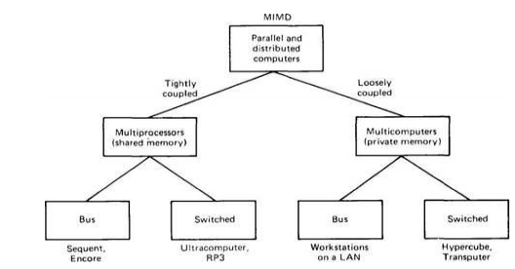
Although all distributed systems contain multiple processors, there are many alternative ways to combine them, and as Flynn (1972) knew 2 basic characteristics of to classify portable multiprocessor systems: the number of instruction streams and therefore the amplitude of the knowledge flow.

- SISD Uniprocessors
- SIMD Matrix Processors - processors work with a defect
- MISD - no excellent computer fits this model
- MIMD Distributed Systems MIMD is divided into 2 classifications
Tight coupling - Short communication latency between computers, high speed (e.g. parallel computers running on -connected computers) (MULTI-PROCESSOR) Loose coupling - Huge communication latency, low speed (distributed Systems running on independent computations)) (MULT COMPUTER) Can also be classified as a bus - any machines connected via a medium (eg. with probably completely different circuit diagrams (eg Internet) MULTIPROCESSORS : the processors share memories.
- Bus-based multiprocessors:
In a bus-based system, all processors are connected to 1 system buses. System memory and peripherals are connected to this bus. When hardware A writes a word into location , hardware B scans the same word.

- Switched Multiprocessors:

It is Used for more than 64 CPUs and
Divide memory into smaller modules and
Connect all processors to each memory module. There are Two common methods between communicating hosts that allow other hosts to communicate without reducing their network speed. The great advantage of the switch is that it offers us a scalable network.

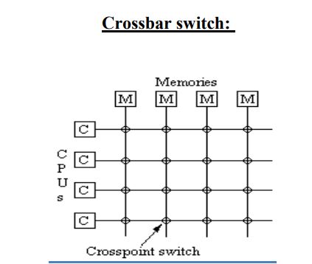
MULTICOMPUTERS: CPUs have separate
memories.

(A) Bus-based multicomputers:
Bus-based multicomputers are much easier to design in this we shouldn't have to deal with shared memory problems: each processor only has its own native memory with a native network.

(B) SwitchedMulticomputers:
In a switched connection, all hosts connect to the network switch. The switch always forwards traffic backwards after a write, storage is consistent.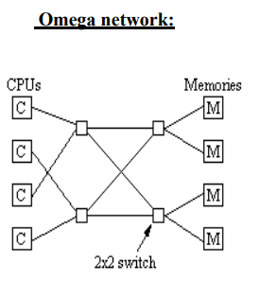
SOFTWARE CONCEPTS:
There is no single definition or goal for distributed software, but when designing distributed software we often touch on the same goals and concerns. These general goals are transparency and scalability. These include problems as diverse as: A network of redundant web servers.
ADVANTAGES OVER CENTRALIZED SYSTEMS
- 1. Speed :
Speed Distributed systems can achieve very high speeds compared to centralized systems.
2. Intrinsic Distribution:
Another reason to build a distributed system is that some applications are inherently distributed. Banking services, flight reservation, etc. are examples of inherently distributed applications.
3. Reliability:
One is more reliability. By spreading the workload across multiple machines, a single chip failure will disable at most one machine, leaving the others untouched. For critical applications such as nuclear reactor or aircraft control, using a distributed system to achieve high reliability can be a dominant consideration.
4. Incremental Growth:
You can easily add more processors to your system, allowing it to grow incrementally as your needs grow.
DESIGN ISSUES
1. Transparency: At a high level, transparency means hiding the distribution from users. At low levels, transparency means hiding the distribution from programs. There are several forms of transparency:
(A) Location transparency: Users don't care where resources are located. Migration transparency: Resources can move freely.
(B) Replication transparency: users cannot know if there are multiple copies of the same resource.
(C) Transparency of Competition: Users share resources transparently and without interference.
(D) Parallel Transparency: Operations can be performed in parallel without users' knowledge.
2. Flexibility: Building distributed systems should be easy. A popular approach is to use a microkernel. A microkernel is a departure from monolithic operating systems that attempt to handle all system requests. Instead, it only supports very basic operations: IPC, some memory management, some process management, and low-level I/O. Everything else is taken care of by the servers at the user level.
3. Reliability: Reliability includes several factors: data must not be lost, the system must be secure, and the system must be fault-tolerant.
4. Performance: Communication links can be slow and affect network performance. When we use parallelism, it can be fine-grained (within a procedure, array operation, etc.) or coarse-grained (procedure level, service level).
5. Scalability: We want a distributed system to scale indefinitely. This will not normally be possible, but the degree of scalability is always taken into account.
APPLICATIONS
Network applications:
- Online and peer-to-peer multiplayer games and virtual reality communities.
- Distributed databases and distributed database management systems Distributed information processing systems such as bank and airline reservation systems Real-time .

Process control:

- Aircraft control systems Industrial control systems Parallel computing:
- Scientific computing, including cluster and network computing, and various volunteer computing projects.

CONCLUSION
Distributed systems contain independent processors that the interacts with to form a complete system that looks like a single laptop. You need a variety of valid outputs with a reasonable price/performance ratio to run distributed applications perfect and gradual growth of with increasing work. They even have bugs like extra composite computer code, potential communication bottlenecks on and poor security on . Despite this, there is a lot of interest in building and bringing it to the Intero world.Sharing between operating systems turns all hardware and computer code into an integrated system, much like a regular time-sharing system. Distributed systems must be designed with suspicion. The key issue is simplicity: hiding the entire distribution from fixed users and applications. Another problem is flexibility. The project should be created with the theme of creating simple potential changes.

REFERENCES

[1] Dos concepts and design By Pradeep K. Sinha
[2]Dos concepts and design ByAndrew S.Tanenbaum
[3] Distributed Systems: Principles and Paradigms Hardcover, By Andrew S. Tanenbaum (Author), Maarten van Steen (Author)
[4] www.cs.usfca.edu
[5] Dennis, J.B. and Van Horn, E.C. "Programming Semantics for Multiprogrammed Computations," Comm.ACM, vol. 9, pp. 143-154, March 1966
[6] www.b-u.ac.in/sde_book/distrib_computing.pdf
[7] Birrell, A.D., and Needham, R.M. "A Universal File Server," IEEE Trans. Software Eng., vol. SE-6, pp.450-453, Sept. 1980
[8] .Birrell, A.D. and Nelson, B.J. "Implementing Remote Procedure Calls," ACM Trans. Comp. Syst., vol. 2,pp. 39-59, Feb. 1984.
[9] Dalal, Y.K. "Broadcast Protocols in Packet Switched Computer Networks," Ph. D. Thesis, Stanford Univ.,1977.

