BIOSYNTHESIS OF SCAFFOLD FOR THE TREATMENT OF 3rd DEGREES BURN WOUNDS – A REVIEW

PRIYADHARSHINI SARAVANAKUMAR. S,RAKSHANA RAJENDHIRAN. R,SANGEETHA JAGANATHAN.J,SRIDHIVYA.M

Department of Biotechnology,

V.S.B ENGINEERING COLLEGE, KARUR

**ABSTRACT**

Scaffold structures are ingenious transporters for transporting cells and drugs, separating endothelial and epithelial cells, and enhancing torsional repair by creating developmental factors for angiogenesis at skin injuries. Wound healing primarily means healing the skin. It begins shortly after injury to the epidermal layer and can last for years. A third-degree burn destroys the first three layers of skin and fatty tissue. A third-degree burn may not hurt immediately, but you will notice that the skin gets black, dry and leathery. This type of burn is serious and requires treatment. Your healing time will vary depending on the size and location of the burn. Many plants are used in folklore to treat cuts, wounds, and burns. Plant-based regular polymers, derived from green and sustainable sources, can be used as such novel bio scaffolds with beneficial properties for tissue engineering that require negligible material handling in modern applications, and meet the requirements.

**KEYWORDS: Scaffold, angiogenesis, epidermal layer, plant-based polymer, fatty tissue.**

**INTRODUCTION**

*Moringa oleifera* is the blossoming plant family *Moringaceae* has a place with the biggest gathering of Angiosperms. *M. oleifera* is a multi-reason plant, which is utilized as food and a rich wellspring of fundamental nourishing parts like amino acids, and carotenoids [1]. Moringa oleifera (Moringaceae) is a fast-growing conifer native to the southern Himalayan regions of northern India. It is one of 13 species in the same genus and is most common in tropical and subtropical regions up to 2000 m [2][3]. *Moringa oleifera* is rich in anthraquinones, especially emodin, and chrysophanol. Anthraquinones have potent anti-inflammatory effects, which have the potential to activate various growth factors and chemokines and initiate angiogenesis processes that play a major role in wound healing [4][5]. The Moringa leaves were cleaned with distilled water and the leaves are allowed to drain and crushed. The leaf extract can be used for the synthesis of scaffolds in the treatment of burn wounds.

**MORPHOLOGY**

*M. oleifera* is a quickly developing, deciduous tree. It can arrive at a level of 10-12 m (32-40 ft) and the storage compartment can arrive at a width of 45 cm (1.5 ft). The bark has a whitish-dark tone and is encircled by thick plug. Youthful shoots have purplish or greenish-white, bristly bark. The tree has an open crown of hanging, delicate branches and the leaves develop padded leafage of tripinnate leaves. The blossoms are fragrant and sexually open, encompassed by five inconsistent, daintily veined, yellowish-white petals. The blossoms are around 1.0-1.5 cm (1/2") long and 2.0 cm (3/4") wide. They develop on thin, bushy stalks in spreading or hanging later blossom bunches which have a length of 10-25 cm. The blossoms are fragrant and sexually open, inconsistent, daintily veined, yellowish-white petals. The blossoms are around 1.0-1.5 cm (1/2") long and 2.0 cm (3/4") wide. They develop on thin, bushy stalks in spreading or hanging later blossom bunches which have a length of 10-25 cm. The blossoms are fragrant and sexually open, encompassed by five inconsistent, daintily veined, yellowish-white petals. The blossoms are around 1.0-15 cm (1/2") long and 2.0 cm (3/4") wide [6].

**SYNTHESIS OF SCAFFOLD**

# 

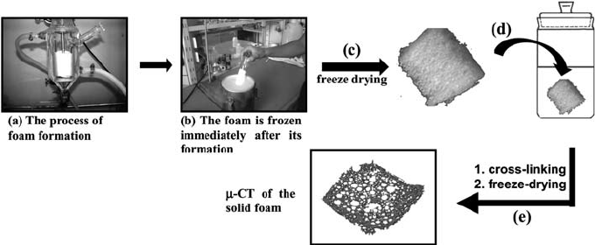

# The process of scaffold synthesis: (a) foam formation, (b) foam freezing in liquid nitrogen, (c) foam-freeze drying, (d) process of cross-linking of the lyophilized gel in a solution containing the cross-linking agent, and (e) foam purification and freeze-drying [7].

**MATERIALS AND METHODS**

1. Collection and authentication of plant material.

2. Cold extraction of plant material using methanol.

3. Biosynthesis of scaffold using plant extract.

4. Swelling effect of bio scaffold.

5. Anti- bacterial activity of bio scaffold by agar well diffusion method.

6. Anti-fungal activity of bio scaffold by agar well diffusion method.

7. Anti- inflammatory effect of bio scaffold by albumin denaturation assay

method.

8. SEM characterization of bio scaffold.

9. Moisture content of bio scaffold.

10. Hemocompatibility effect of bio scaffold by hemolysis analysis.

11. Cytocompatibility of bio scaffold by MTT assay.

12. Statistical analysis of results by Graph pad prism software.

**Collection and authentication of plant material**.

Lately collected Moringa oleifera leaves were washed completely with double distilled water to remove dust patches, counted, and transferred into the round bottom beaker, and it was mixed with water and refluxed for 40 twinkles at 70 degrees at the heating mantle. Also, the excerpt was filtered by Whatman sludge paper with several times and kept in sterile bottles under cooled conditions for the unborn use [8]. *Moringa oleifera* leaves and extract are shown in Figures 1(a) and 1(b).

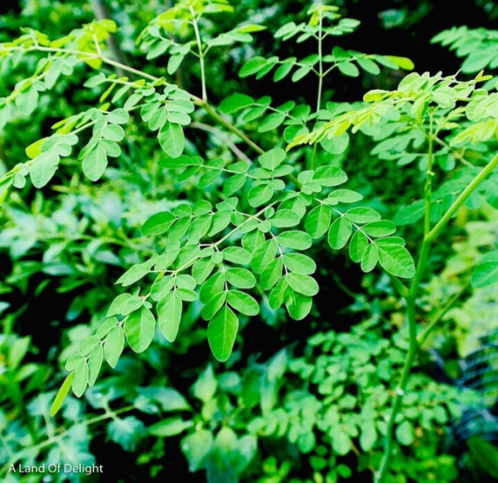 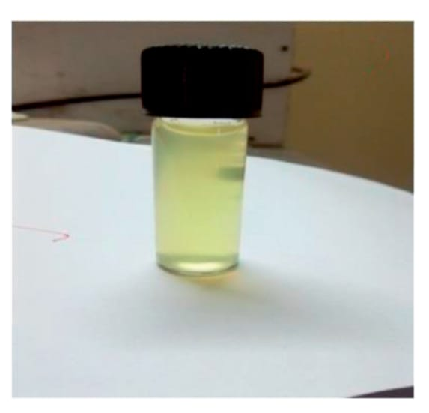

(a) (b)

**Cold extraction of plant material using methanol**

Plant succus prepared from ~200 g fresh plant leaves were evaporated to dryness and dissolved in 100 mL of 100% methanol (MeOH) overnight. Extracts (50 mL) were then transferred to clean vessels, evaporated to dryness, and redissolved in dimethyl sulfoxide (DMSO) to yield a final concentration of approximately 10 mg/mL [9].

**Biosynthesis of scaffold using plant extract**

Using leaves extract, scaffolds are biosynthesized by decellularization method.

**Swelling effect of bio scaffold**

During cell culture, swelling facilitates the cells infiltration into the scaffolds in a three-dimensional fashion. Swelling also increases the pore size and total porosity, and thus maximizing the internal surface area of the scaffolds [10].

**Agar well diffusion method**

The Agar well diffusion method is widely used to evaluate the antimicrobial activity of plants or microbial extracts. Similarly, to the procedure used in disk-diffusion method, the agar plate surface is inoculated by spreading a volume of the microbial inoculum over the entire agar surface. Then, a hole with a diameter of 6 to 8 mm is punched aseptically with a sterile cork borer or a tip, and a volume (20–100 µL) of the antimicrobial agent or extract solution at desired concentration is introduced into the well. Then, agar plates are incubated under suitable conditions depending upon the test microorganism. The antimicrobial agent diffuses in the agar medium and inhibits the growth of the microbial strain tested [11].

**Albumin denaturation assay method**

We modified the inhibition protein denaturation method slightly. One millilitre (0.1%) of bovine albumin fraction, one millilitre of Tris-HCl buffer solution with a pH of 7.8, and one millilitre of test solutions made up the reaction mixture (5 ml). The mixtures were heated for denaturation at 72 °C for 2-4 minutes after 20 minutes of incubation at 37 °C. The turbidity of the samples was measured spectrophotometrically at 660 nm after they had cooled to room temperature. As a positive control and a blank solution, respectively, aspirin and buffer were used. 1 mL of distilled water, 1 mL of bovine albumin fraction (0.1%), and 1 mL of buffer solution made up the control solution [18].

**SEM characterization**

Scaffold consistency and fiber size were assessed by scanning electron microscopy and subsequent image analysis. Fiber diameter was determined using diameter J 34, n = 4. 250x magnification. The presence of a dense cell layer is further confirmed by the SEM image, where a cellular carpet is visible in each condition after 16 days [12].

**Moisture content of bio scaffold**

The prepared scaffolds with different compositions were stored for one week in a desiccator kept at 20 °C at 58% relative humidity. After that, they were weighed in Petri dishes and dried in a vacuumovenat 40 °C for 24 hours. Moisture content is defined as the percentage weight loss of the original sample during drying. The following formula is used to calculate the moisture content; MC=(Wo-Wod)/Wo *100%

where MC is the moisture content, Wo is the initial weight of the sample and Wod is the shelf weight after drying [13].

**Hemocompatibility effect of bio scaffold by hemolysis analysis**

By measuring the proportions of hemoglobin released into the solution phase from erythrocytes in whole blood subjected to the test materials, hemolysis was examined. Sections of P4HB film measuring 5 mm by 10 mm were cut. Parts underwent three NS washings. The hemoglobin source was eight milliliters of anticoagulated blood diluted with ten milliliters of NS. The test group included 5 siliconized test tubes with 10 mL of NS and P4HB within each. Five tubes in the negative control group only contained 10 mL of NS. The positive control group consisted of five tubes that each contained 10 mL of distilled water to cause the maximum amount of erythrocyte lysis. After 30 minutes of water bath preheating at 37°C, 0.2 mL of diluted anticoagulated fresh whole blood was added to each test tube, and the tubes were then sealed [14].

**Cytocompatibility of bio scaffold by MTT assay**

The cytocompatibility of these scaffolds by MTT assay. Experimental scaffolds were initially sterilized and then activated by soaking in 75% ethanol for 30 min. They were washed three times with PBS. Cells were seeded at a density of 5 x 103 cells per well in a 96-well plate for adequate cell attachment. After 2hrs, the medium was removed and replaced with a vehicle dilution solution (experimental groups) with medium alone (negative control) or DMSO (positive control, 5% in medium). After hours, a medium containing FBS was added to provide nutrients. Under similar conditions, 10 μl of MTT solution was added to each well at predetermined incubation intervals (1, 2, and 3 days), followed by incubation for an additional hour. The contents of the well were discarded and 100 µL DMSO was added to completely dissolve the *formazan* crystals before an additional 10 min incubation period. Finally, the absorbance was measured using a microplate reader at 570nm [15].

**Statistical analysis of result**

Data are presented as mean ± standard deviation (SD). One-way analysis of variance (ANOVA) was used to analyze significant differences. A Welch test was performed to ensure that the data were not subject to platy kurtosis. A P value and lit; 0.05 was considered statistically significant. Calculations were performed using SPSSV analysis of results[16]**.**

**SIGNIFICANCE**

Scaffolds, 3D structures, not only support tissue formation but can also protect the wound, becoming an effective "fence" against external contamination. It is of great interest that scaffolds must provide physical support and interaction with cells to initiate the physiological processes (cell adhesion, proliferation, and differentiation) that lead to the assembly of cells into functional units. Scaffolds must be both porous and biocompatible, as cells must attach and pass through their networks. These characteristics must be considered when designing scaffolds for wound care applications while maintaining high productivity and low cost of production [17].

**CONCLUSION**

Next generation wound care scaffolds use therapeutic materials that combine interactive and bioactive tools and therapeutic and diagnostic functions into a single scaffold. New technologies are believed to integrate target biomarkers into scaffolds to monitor wound healing.

**REFERENCE**

1. Insight into the phytochemical composition, biological activities and docking studies of Moringa oleifera Lam. to authenticate its use in biopharmaceutical industries Author links open overlay panel Jallat Khan, Muhammad Imran Tousif , Muhammad Saleem, Mamona Nazir, Saba Touseef , Kaynat Saleem, Sumreen Asim, Ahmad Khan, Muhammad Adnan Asghar, Gokhan Zengin, Nusrat Shafiq, Muther Mansoor Qaisrani 8 September 2021.

2. Moringa oleifera Seeds and Oil: Characteristics and Uses for Human Health Alessandro Leone, Alberto Spada, and Simona Bertoli 2016 Dec.

3. Leone A., Spada A., Battezzati A., Schiraldi A., Aristil J., Bertoli S. Cultivation, genetic, ethnopharmacology, phytochemistry and pharmacology of Moringa oleifera leaves: An overview. Int. J. Mol. Sci. 2015; 16:12791–12835.

4.Robson MC, Steed DL, Franz MG. Wound healing: Biologic features and approaches to maximize healing trajectories. Current Problems in Surgery, 2001; 38(2):72-140.

5.Church D, Elsayed S, Reid O, Winston B,Lindsay R. Burn wound infections. Clinical Microbiology Reviews. 2006; 19(2):403-34.

6.Samikkannu raja Moringa oleifera Lamk. improvement for semiarid and arid ecosystem: Analysis of environmental stability for yield August 2013.

7. Polysaccharide based scaffolds obtained by freezing the external phase of gas-in-liquid foams† Andrea Barbetta, * Antonio Carrino, Marco Costantini and Mariella Dentini*13th August 2010

8. Moringa oleifera Leaf Extract-Mediated Green Synthesis of Nanostructured Alkaline Earth Oxide (MgO) and Its Physicochemical Properties Archana Venkatachalam,1 Joseph Prince Jesuraj,1 and kalainathan Sivaperuman 23 June 2021

9.Traditional Preparations and Methanol Extracts of Medicinal Plants from Papua New Guinea Exhibit Similar Cytochrome P450 Inhibition Erica C. Larson, Christopher D. Pond, [...], and Louis R. Barrows 2016 Aug 24.

10.Peter M, Ganesh N, Selvamurugan N, Nair SV, FuruikeT, Tamura H, Jayakumar R. Preparation and characterization of chitosan–gelatin/nanohydroxyapatite composite scaffolds for tissue engineering applications. Carbohyd. Polym. 2010; 80:687–694.

11.Magaldi S., Mata-Essayag S., Hartung de Capriles C. Well diffusion for antifungal susceptibility testing. Int. J. Infect. Dis. 2004; 8:39–45.33. Valgas C., De Souza S.M., Smânia E.F.A. Screening methods to determine antibacterial activity of natural products. Braz. J. Microbiol. 2007; 38:369–380.

12. RhiannonGrant1, John Hallett2, Stuart Forbes2, David Hay2 & AnthonyCallanan1 18 April 2019 Blended electrospinning with human liver extracellular matrix for engineering new hepatic microenvironments

13.Karen B Chien, Ramille N Shah, Novel soy protein scaffolds for tissue regeneration: Material characterization and interaction with human mesenchymal stem cells February 2012

14. Gao Y, Chen L, Zhang Z, Gu W, Li Y. Linear Cationic Click Polymer for Gene Delivery: Synthesis, Biocompatibility, and In Vitro Transfection. Biomacromolecules. 2010; 11:3102–3111

15. Effect of Icariin on Engineered 3D-Printed Porous Scaffolds for Cartilage Repair by Ranjith Kumar Kankala, Feng-Jun Lu 1, Chen-Guang Liu 10 Shan-Shan Zhang ¹, Ai-Zheng Chen, *Shi-Bin Wang 2018

16. Oksanen, J., F.G.F. Blanchet, M. R. Kindt, et al., vegan: Community Ecology Package, version 2.5-6. (2019).

17. Rubio-Elizalde, I.; Bernáldez-Sarabia, J.; Moreno-Ulloa, A.; Vilanova, C.; Juárez, P.; Licea-Navarro, A.; Castro-Ceseña, A.B. Scaffolds based on alginate-PEG methyl ether methacrylate-Moringa oleifera-Aloe vera for wound healing applications. Carbohydr. Polym. 2019, 206, 455–467. [CrossRef] [PubMed].

18. Sharmila Dharmadeva, Lahiru Sandaruwan Galgamuwa, and Nishantha Kumarasinghe In vitro anti-inflammatory activity of Ficus racemosa L. bark using albumin denaturation method 2018 Oct-Dec.