# IMPACT OF JOB STRESS ON THE PERFORMANCE OF THE EMPLOYEES WORKING IN OIL MILLS IN ERODE DISTRICT

# Dr. S. Subhashini, MBA, M.Phil, Ph.D

Associate Professor, Annapoorana Engineering College, Salem

***Abstract-*** *The job stress that individuals face in their specific tasks is one of the many elements that affect how well they perform in a company. Work stress frequently results from unforeseen obligations and tasks that don't fit with a person's expectations, knowledge, or talents, making it difficult for them to handle. When employees feel unsupported by managers or coworkers, or that they have little control over work procedures, job stress can escalate. The study is focused on the Job stress of the employees working in Oil Mills in Erode District and analyzes its impact on the Job performance. Data were collected from a sample of 100 employees working in selected Oil Mills in Erode. The results reveal the areas that form major causes of Job stress and its relation to Employee’s work performance.*

***Keywords****-* Job stress, job performance, organizational commitment, work overload

# INTRODUCTION

The major aspect in accomplishing organizational objectives and goals is human resources, which are essential for the success of any corporation. Organizations nowadays are looking for ways to improve employee performance through a variety of techniques because they recognize that it is one of the major drivers of any company's success. The goal of organization is to bring people together to carry out activities and achieve goals by making effective and efficient use of the available resources.

Employee performance is one of the primary success elements for firms, which they use to outperform the competition, accomplish their objectives, and generate profits. Employee job performance is influenced by a variety of variables, such as motivation, perceived stress level, corporate culture, and organizational commitment, work environment, etc. In any firm, employee performance is significantly impacted by job stress. Job Stress is proving to be of leading factor having either a positive or negative effects on the performance of employees. Robbins (2004), Stress is a dynamic condition in which an individual is confronted with opportunity, constraint or demand related to what he desires and for which the outcome is perceived to be both uncertain and important. From this definition one can say that stress is not necessarily bad, it also has a positive value when it offers

Potential gain. Major stress causing parameters include long working hours, work overload, poor communication, lack of participation in decision making, job insecurity, lack of feedback, poor social support, etc.,.

# REVIEW OF LITERATURE

**Khaled Adnan Bataineh (2019),** the research inspected the work / life balance, happiness and performance of employees. Accordingly, the above model based on the data set of the (Med Pharma) Pharmaceutical Industries (Jordan) tested in a questionnaire-based survey. The results indicate that the combination of work-life and happiness has a significant and essential effect on employee performance. However, the output of employees does not have an impact.

**Reddy et al. (2018)** in their study concludes that stream wise difference in stress does exist in students. It is important to deal with stress at personal, social and institutional level. Remedies such as feedback, yoga, life skills training, mindfulness, meditation and psychotherapy have been found useful to deal with stress. To identify the main reason of stress is the key to deal with it. Professionals can develop tailor made strategies to deal with stress. The integrated well being of the students is important not only for the individual but for the institute as well.

**Pradhan and Hati, (2017),** Research has been conducted to examine the influence of employee welfare (i.e. meaning, skills, self-identification and effects) on psychological empowerment. Attempts have made to investigate the interim role of satisfaction in the relationship between well-being and empowerment of employees. The study considered 96 sample and randomly selected Indian service sector managers collected data. The final result of the study showed that the well-being of staff was positive about the capacity of employees. Happiness has been a crucial mediator between the well-being and empowerment of workers.

**Dimitrov (2017)** in his study claimed that stress can be addressed by ensuring that the students give utmost importance to their welfare. Food, exercise, work, recreation are some of the areas to focus on. He also concluded that the education system is more to do with the academic qualifications and does not contribute enough to the holistic development of students. Students are usually conditioned in a way that makes them fearful to take up upcoming challenges as the focus is only the academics and not the development of a go getter mentally. There are not many choices for the medium of education. English being the only option available can pose as a hindrance for the students from rural background. There are not many courses available that are employment centric. Fresh graduates need more communication skills development for better placements.

**Azman Ismail (2014)** in his study confirm that the ability of employees to appropriately manage, regulate and control physiological and psychological stresses in executing job may lead to an enhanced job performance in the organization.

**Garg (2010)** postulated that job or occupational job stress is an outcome of mismatch between the individual capabilities and organizational demands.

# STATEMENT OF THE PROBLEM

Most businesses that attempt to increase productivity end up with disgruntled workers who are overworked in order to meet deadlines. This can have negative psychological and physical impacts on the workers, which could result in something contrary to what these organizations want to achieve.

The success of every organization vests mainly in the job performance of the employees. Due to stress, employees get dissatisfied in their jobs and this dissatisfaction is gradually reflected to less productivity. In today’s competitive world, organizations that satisfy the employees could alone survive. Among the various Human Resource Management techniques, Stress Management plays an important role.

# OBJECTIVE OF THE STUDY

1. To assess the various factors causing stress.
2. To analyze the association between the Demographic variable of the employees and the stress realized.
3. To suggest measures to increase job performance among the employees of the organization.

# METHODOLOGY

The research design chosen is Descriptive in nature. The Universe of the study comprises of employees working in Oil Mills in Erode District. A sample of 100 employees from various departments was selected as respondents on the basis of purposive sampling. In this study, the primary data was collected through questionnaire which consists of both open ended and close ended questions. The secondary data was collected from Journals and websites.

# METHODOLOGY

**6.1 Perception of the respondents towards the various factors causing stress**

Women employees are subject to much stress which leads to work life imbalances. And so it is essential to find the serious factor that leads to such stress in job. The respondents were asked to rate on various stress causing parameters on a Likert Scale to determine their perception toward the factor that leads to much stress.

**Table 1: Perception of the respondents towards the various factors causing stress**

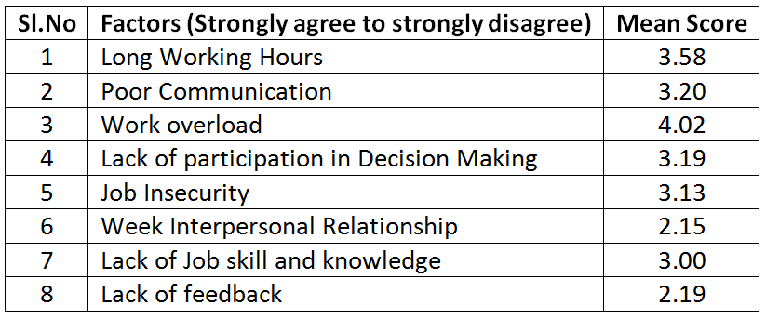

From the above table, it is inferred that the respondents strongly agree with work overload as the major stress causing factor and do not have much opinion on week interpersonal relationship as a stress causing factor.

**6.2 Significant relationship between Demographic variable and Job stress experienced**

Here we attempt to find out the relationship between the Total Work experience of the women employees and stress realized in job.

**Null Hypothesis**

There is no significant relationship between the Total Work experience of the women employees and the stress realized in job.

**Alternate Hypothesis**

There is significant relationship between the Total Work experience of the women employees and the stress realized in job.

**Table 2: Association between Work Experience of the respondents and the stress realized by them in their jobs**

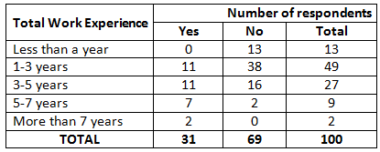

**Table 2(a): Calculated Chi-square and Table value**

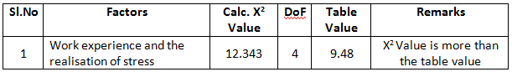

Table 2 & 2(a) shows that calculated value is more than the table value at 5% level of significance. So the null hypothesis is rejected. Hence there is a significant relationship between the total work experience of the women employees and the stress realized by them in job.

**6.3 Measures to be adopted by the organization to increase job performance among the employees.**

In an attempt to find out the factors to increase job performance among the employees and decrease job stress,

various factors were identified and the respondents were asked to give their opinion ranging from strongly

agree to strongly disagree.

**Table 3: Preferences regarding the measures to increase Job Performance**

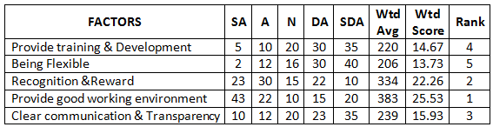

Table 3 shows that a good working environment is much preferred and will prove to be a good measure in reducing stress and thereby increase job productivity. The employees also prefer an appropriate Reward system and transparent communication methodology to be adopted in the organization.

# FINDINGS OF THE STUDY

It is observed that the women employees of the Oil Mills strongly agree that Work overload is the major cause of stress. Irrespective of the total working experience of the employees, there is stress prevailing at all levels of employees. A good working environment is much preferred and will prove to be a positive measure in reducing Job stress and thereby increase job productivity.

# CONCLUSION

In today’s competitive world, employees are considered as the most important assets of any organization. But stress among the employees might decrease the productivity and would eventually lead to decreased Job Performance in the organization. The study recommends a good stress management technique to be used by the organization to keep their employees away from stress and thereby lead to increased performance of the job. A good Grievance handling mechanism can also be followed to decrease stress and increase their job performance.

# REFERENCE

1. Azman Ismail & Noorshafine Saudin - “JobStress and Its Impact on Job Performance” - 3rd International Conference on Information, Business and Education Technology (ICIBET 2014)
2. Bowin, R.B. & Harvey D. (2001). Human Resource Management an Experiential Approach. 2nd Ed. New Jersey: Prentice Hall.
3. Dean, C. (2002). Stress and Work Performance. HR Future. 2 (5).
4. Dimitrov.G (2017). A study on the impact of Academic Stress among college students in India, Ideal Research. 2
5. Garg, P. (Sep 2010). Case Study, 3, 52-58.
6. Pradhan, R. K., Hati, L. (2017). Impact of employee wellbeing on psychological empowerment: Mediating role of happiness. International Journal of Manufacturing Technology and Management, 31(6), 581–595.
7. Khaled adnan Bataineh, 2019. "Impact of Work-Life Balance, Happiness at Work, on Employee Performance," International Business Research, Canadian Center of Science and Education, vol. 12(2), pages 99-112, February
8. Reddy,K.J., Menon. K., Anjanathattil (2018). Academic Stress and its Sources among University Students, Biomed Pharmacol Journal,11(1), 531-537Enyonam Peace Amoako , Opoku Adu Gyamfi, Addai Kyeremeh Emmanuel and Batola David,- “The Effect of JobStress on Job Performance at Aspet A. Company Limited”- Global Journal of Arts, Humanities and Social Sciences - Vol.5- No.8- pp.1-17 - Sep 2017
9. Robbins, S.P. (2004). Organization Behavior. 11th Ed. New Jersey: Pearson Prentice Hall.
10. Sumathi V et. al.,- “An empirical study on work stress among the employees in textile industries with special reference to Erode district” - International Journal of Management Research & Review -Volume 6 - Issue 11 - Nov. 2016

11."WHO - Stress at the workplace". www.who.int. Retrieved 2015-10-27.