**Modeling and Finite Element Analysis of Rigid Flange Coupling with Two Different Materials and Different Designs of Flanges of Coupling**

1Vivek, 2Dr. Rajeev Arya

1M. Tech. Scholar Mechanical Eng. Dept. NIIST, Bhopal

2Ph.D. in Mechanical Eng. , Director NIIST, Bhopal

**Abstract**

A Coupling is a gadget which is answerable for the employable force transmission between two shafts turning at specific RPM. Coupling is utilized to interface two unique shafts at their end and can slip or come up short contingent on as far as possible. It is the essential piece of any force transmission and may keep going for long time whenever planned and looked after appropriately. In this project The Finite Element Analysis has been done of the Rigid Flange Coupling to check the stress behavior of the Different parts of the rigid flange coupling With respect to different materials and different designs of the flanges. In this regard, a model of the flange coupling has been prepared in CATIA V5 R21 software. For performing FEM analysis the Ansys software is used. In Ansys 2022 R1 software we had provided the engineering data into the software and then model have been imported. And then some boundary conditions have applied to get the particular solutions. So to check the stress behavior of coupling firstly EN8 and C40 material have been assigned to that particular flange coupling and points of failure had been noted accordingly. Secondly, EN24 and C45 material in fact, a better one which would withstand more amount of stress have been assigned and failure results had been noted again. Also different designs of flanges used for analysis. Finally, from the results obtained comparison have been done between the results and suggestions are prescribed.

**Keywords:** Modeling, Analysis, Ansys, Suggestions, Failure, FEA;

1. **Introduction:** In engineering applications there arise several cases where two shafts have to be connected so that power from driving shaft is transmitted to driven shaft without any change of speed. Such shafts are generally coaxial and can be misaligned and these can be connected through machine components known as couplings.

**Types of Couplings:** There are mainly two divisions of couplings are there:

1. Rigid Couplings
2. Flexible couplings

**1.1 Rigid Couplings:** Rigid Couplings connects perfectly aligned shafts. These are simple in design and less costly. Rigid Couplings have following types:

1. Sleeve or Muff Coupling
2. Clamp or Split-muff or Compression Coupling
3. Flange Coupling

**1.2 Flexible Couplings:** Flexible couplings are couplings which connects two shafts having lateral alignment or angular misalignment. Flexible elements are provided in flexible coupling which absorb shocks and vibrations. Flexible Couplings are of following types:

1. Bushed pin type Coupling
2. Universal Coupling
3. Oldham Coupling

**1.3 Flange Coupling:** Flange coupling, shown in Figure 1 is used to connect two strictly coaxial shafts. The two flanges are usually made in cast iron. These flanges are separately keyed to driving and driven shafts. The two flanges are same except that one has a circular projection and other has a corresponding recess to make a register. The flanges are joint by the nuts and bolts at the periphery of the flanges. The faces of flanges are machine finished true right angled to the axis of shafts.

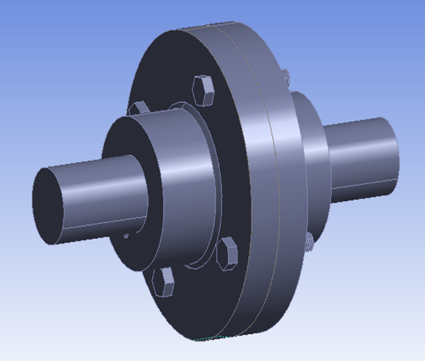

Figure 1 Rigid Flange Coupling

1. **Literature survey**
2. **Bala Voruganti et al. (2021):** In this project spine coupling was developed and analyzed with 3 different materials in this mild steel was an existing material and remaining two are en-9 and sae1020. In order to develop the model they used solid works as CAD tool to design the model and other CAE Tool were used for analysis. They concluded that the sae1020 shown better strength than the other two materials namely mild steel and en-9.
3. **Jain Harshit et al. (2021):** In this project they designed and showed working of the universal joint, Also determined the stresses, strains and element displacement in the existed design of the universal joint. suggested a minimum factor of safety for the joint. They performed the static FEA of the universal joint by the use of the Fusion 360 software.
4. **Dr. Reddy Mallikarjuna et al. (2019):** In this project, they designed and modeled the rigid flange coupling to reduce the shear-stress on the nuts and bolts section of a rigid-flange coupling by carrying out the stress-analysis using FEM. The 3-D model was designed in NX8.0 and the stress analysis was analysed in ANSYS15 workbench.
5. **Gattani G. et al. (2015):** In this paper they presented the concept of reducing maximum shear stresses by adding a new material between shaft and hub. The modeling of rigid flange coupling had been done in CREO 2.0 and analysis of rigid flange coupling was carried out with the help of ANSYS 15 Software for calculated torque.
6. **Khamanker S.D. et al. (2014):** In this project they analyzed rigid flange coupling which is similar to the universal joint. For this they done Finite Element Method analysis of rigid flange coupling with the help of ANSYS Software for different torque and load condition and then verified it by manual calculation.
7. **Chavan Shivaji G. et al.(2014):** In this project they presented a theoretical model and a simulation analysis of flange and bolted joints deformation, stresses. The flange and Nut-Bolts force and contact stiffness factor are considered as parameters which were influencing the joint deformation. The flanged joint was modelled and simulation using ANSYS 14 Software.

**3. Design and calculation**

**3.1 Material information**

Table 3.1 New Design calculation and Material information

|  |  |  |
| --- | --- | --- |
| Properties | Material | |
| EN24 | C45 |
| Density | 7800 (kg/m3) | 7850 (kg/m3) |
| Young Modulus | 2.1E+11 (Pa) | 2.0E+11 (Pa) |
| Poisson Ratio | 0.280 | 0.30 |
| Tensile Yield Strength | 785 (MPa) | 350 (MPa) |
| Ultimate Tensile Strength | 1. (MPa) | 650(MPa) |

*Selection of material-EN24 material for flange and shaft, and material C45 for bolts and key.

**3.2 Design parameters:–**

1. Power (P) = 3.1125 kW
2. Speed of input shaft (N) = 36 rpm
3. Diameter of shaft (d) =50mm
4. Allowable Shear Stress for key and bolt 𝜏𝑎𝑠 = 𝜏𝑦𝑠 / FOS = 0.5σyt / FOS

= 0.5 × 350 / 3

= 58.33 MPa

1. Allowable Shear Stress for flange and shaft 𝜏𝑎𝑐 = 𝑢𝑐 / FOS = 0.5σut / FOS

0.5 × 785 / 3

= 130.83 MPa

1. Torque, 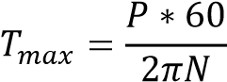

=825.616 N-mm

* 1. **Design Calculation**

*1) Design of shaft*

Shear stress of shaft 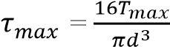

=33.6386 N/mm2 (shear stress induced in shaft)

Since, the shear stress induced in the shaft is less than 130.83 MPa therefore the design is safe against shear failure.

1. *Design of key*

Width of the key (w) =12.5mm

Height of the key (h) =8.5mm

Length of the key (L) =77mm

Shear stress of key, 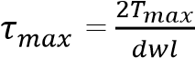

=35.226 N/mm2 (shear stress induced in key)

Since, the shear stress induced in the key is less than 58.33 MPa therefore the design is safe against shear failure.

1. *Design of hub*

Length of hub (l) =75mm

Outer diameter of hub (D) =100mm

Shear stress induced in hub, 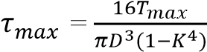

=4.4851 N/mm2 (shear stress induced in hub)

Since, the shear stress induced in the hub is less than 130.83 MPa therefore the design is safe against shear failure. Where…….. (K=d/D)

1. *Design of flange*

Thickness of flange (t) =0.5d=25mm

Diameter of bolt circle (𝐷1) =3d=150mm

Outer diameter of flange (𝐷2) =4d=200m

Shear stress induced in flange, 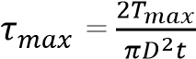

=8.4095 N/mm2 (shear stress induced in flange)

Since, the shear stress induced in the flange is less than 130.83 MPa therefore the design is safe against shear failure.

1. *Design of bolt*

Number of bolts (N) =4

Take, Bolt diameter (𝑑𝑏) =12mm

Shear stress induced in bolt, 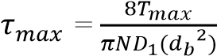

=2.7037N/mm2 (shear stress induced in bolt)

Since, the shear stress induced in the bolt is less than 58.33 MPa therefore the design is safe against shear failure.

**4. Modeling and Analysis**

**4.1Modeling**

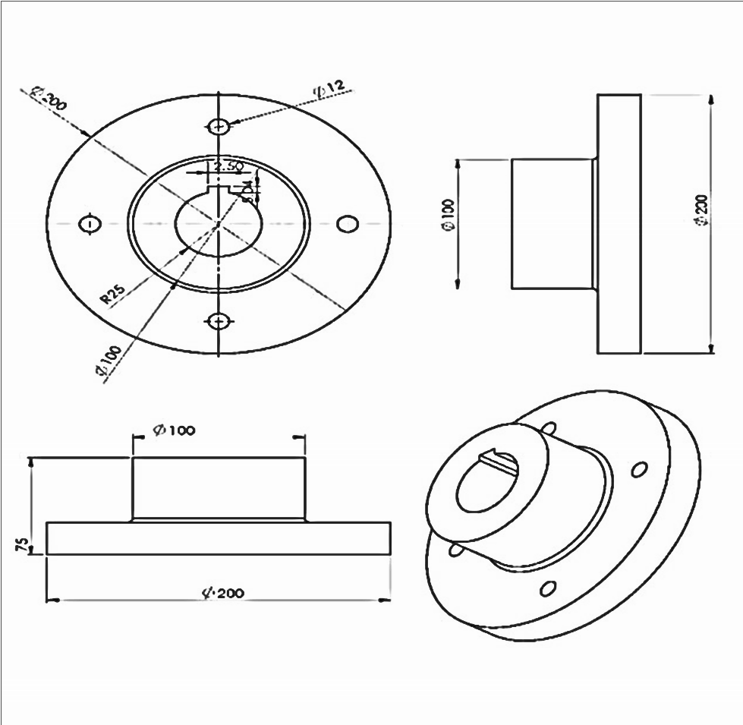The geometry of a Rigid Flange Coupling considered to analyze is shown in Fig 5.6 with its overall dimensions. And the modelling of different parts of the couplings has been done in the CATIA V5 software and then assembled.

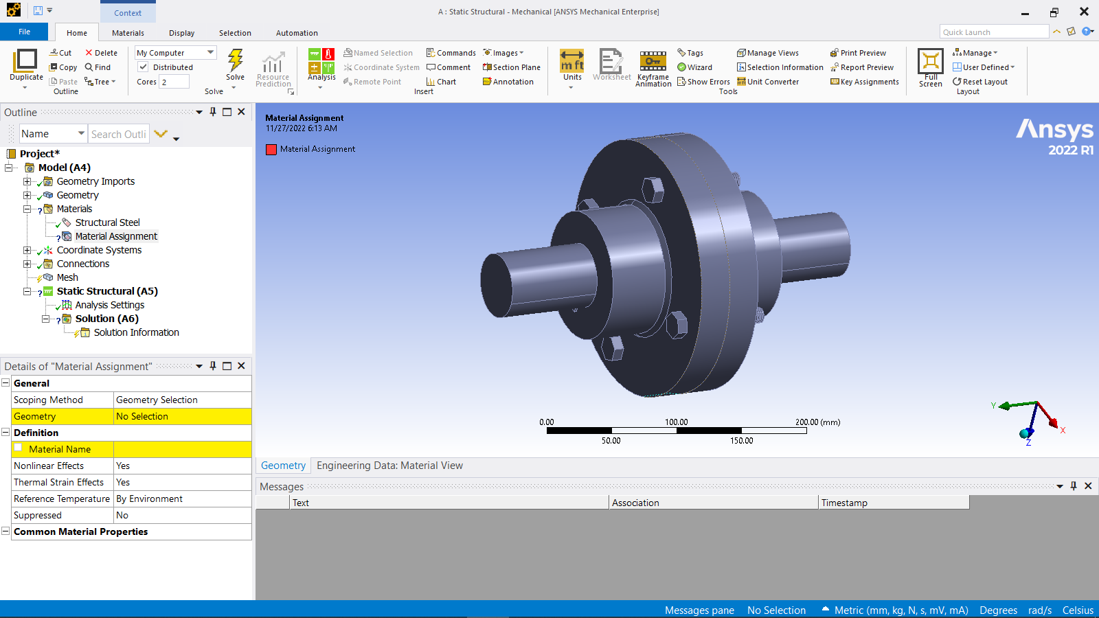

Figure 4.2

Model of Rigid Flange Coupling

Figure 4.1

Dimensions of Rigid Flange Coupling

**Different designs of flanges :**

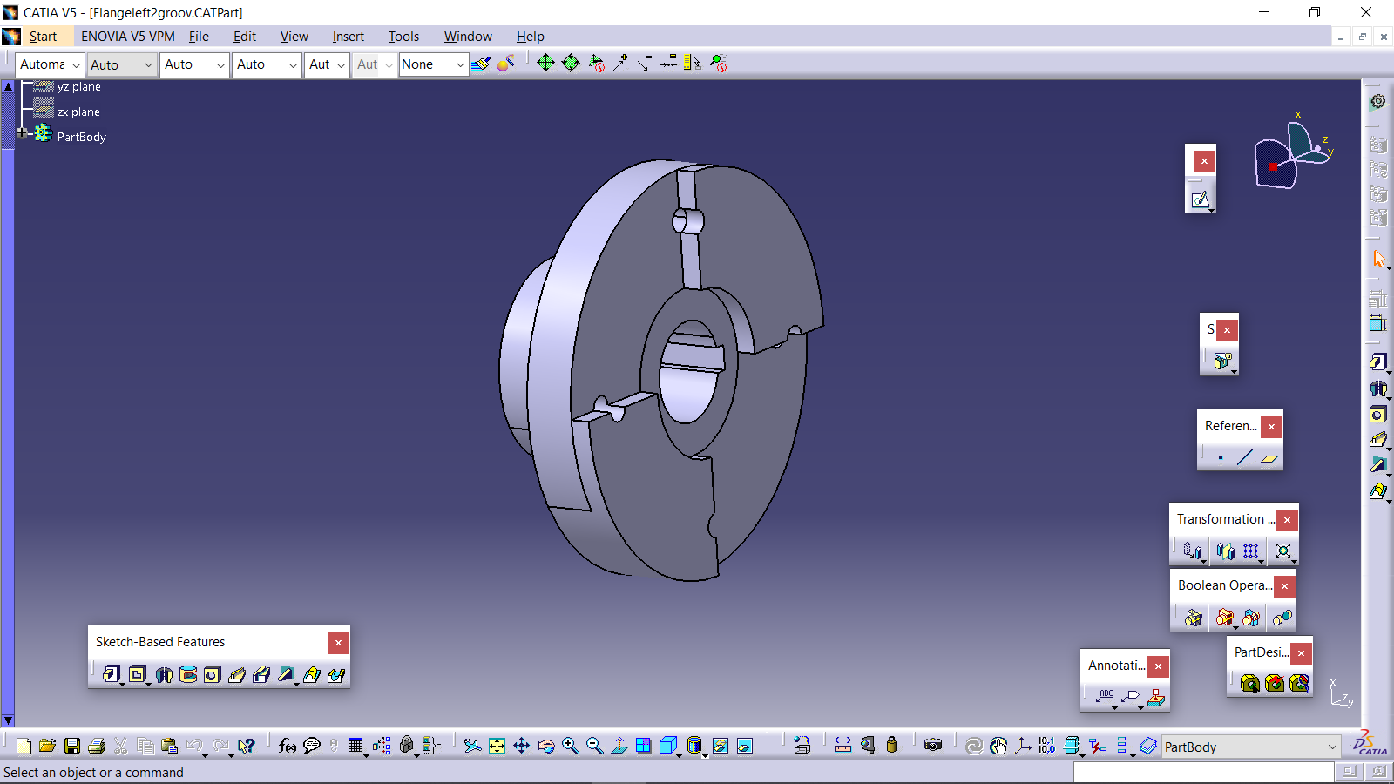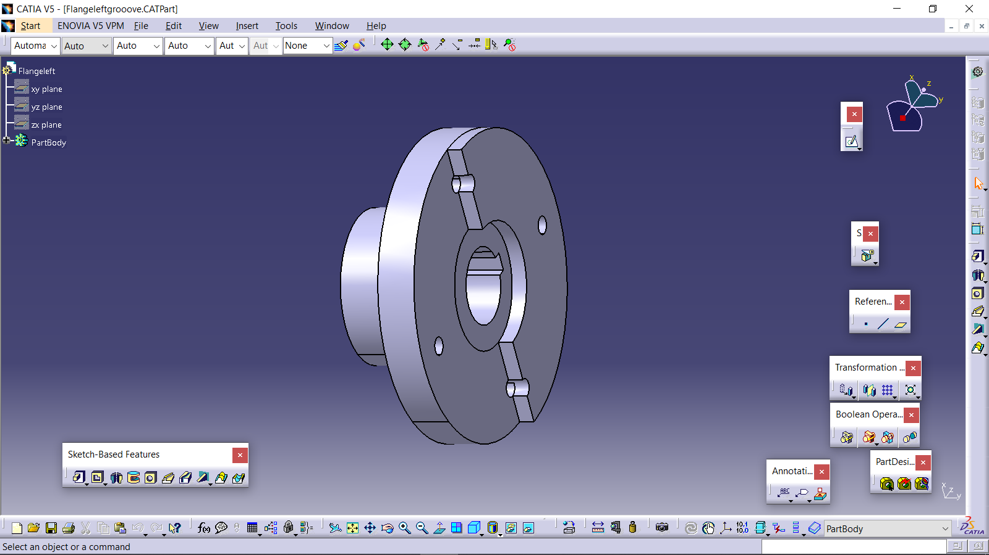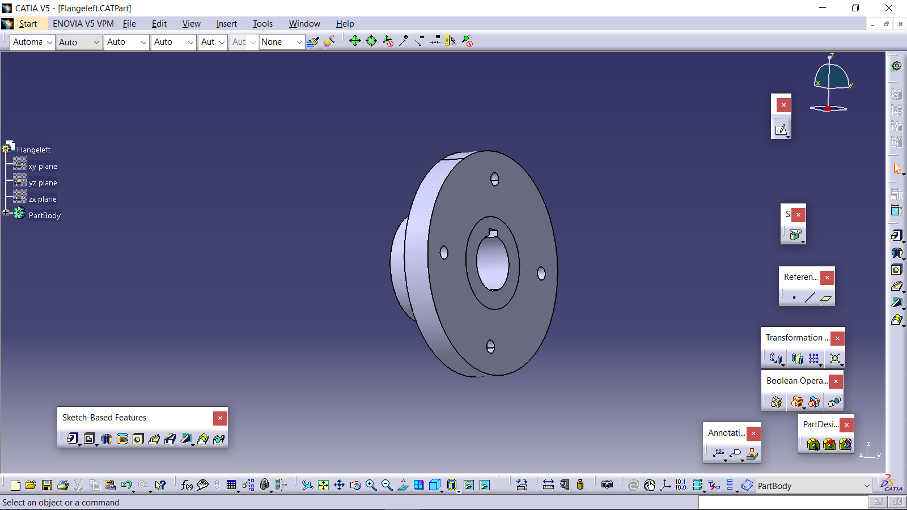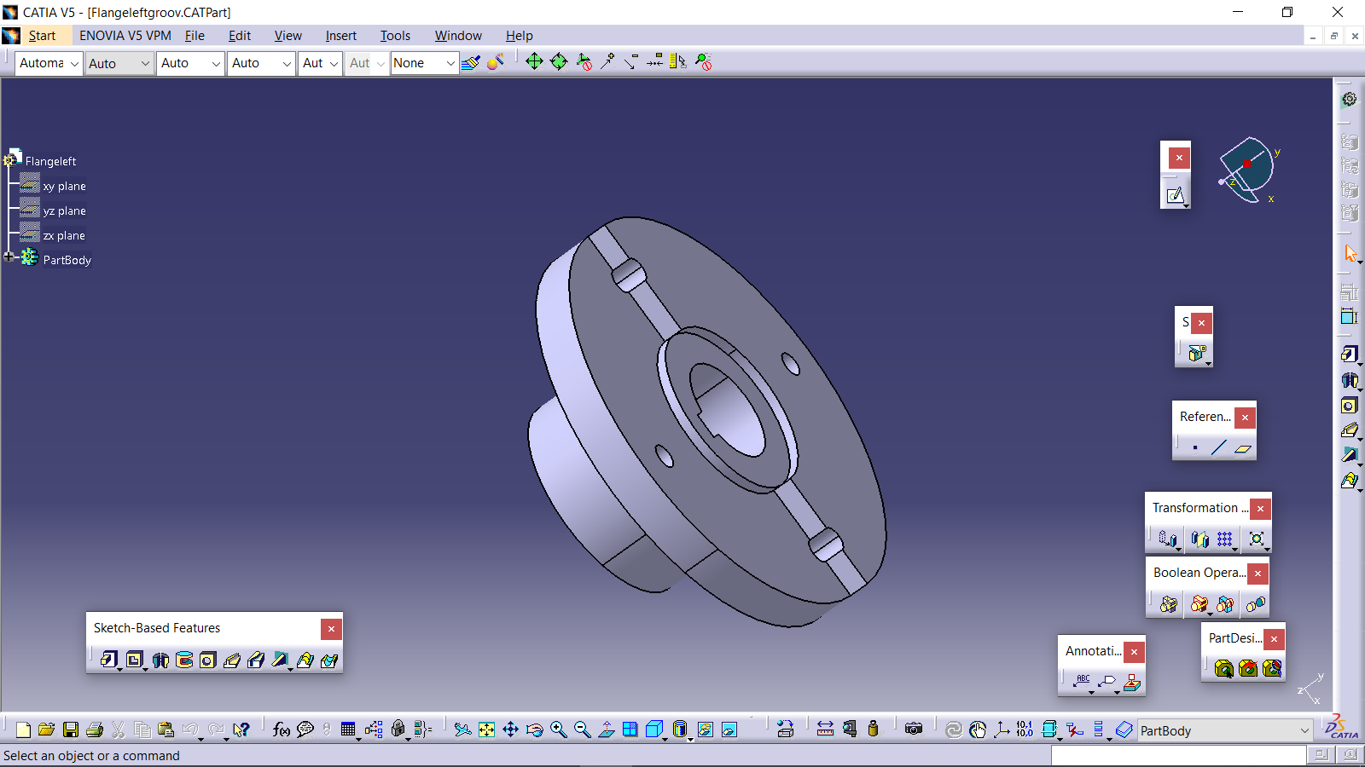

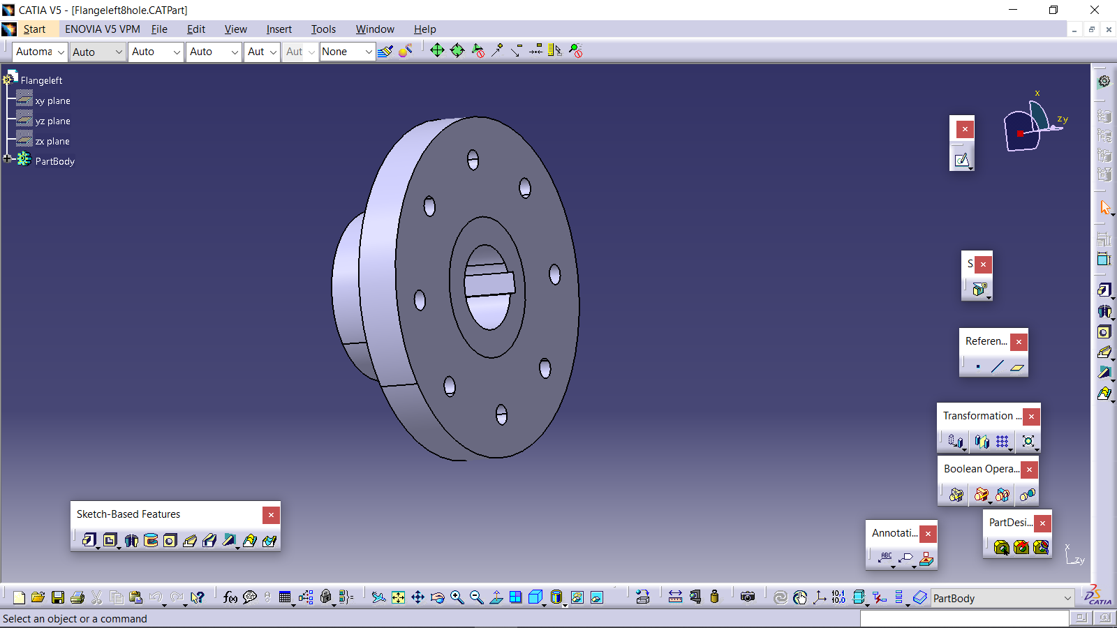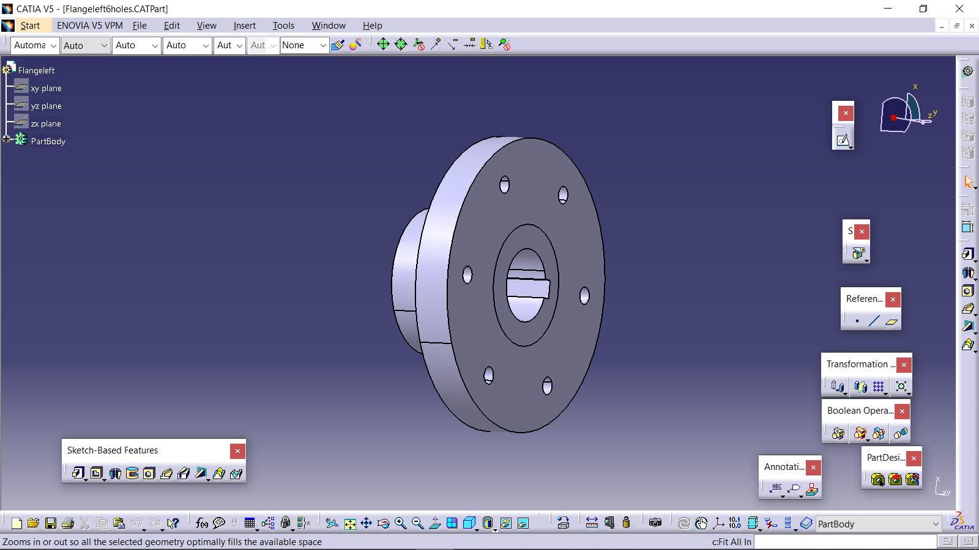

Figure 4.3

Different designs of flanges

**4.2Analysis of Rigid Flange Coupling**

For analyzing the Rigid Flange coupling in the Ansys 2022 R1 software, the following process has been used:

1.Providing the Engineering Data to the software 2.Making geometry or importing the needed one

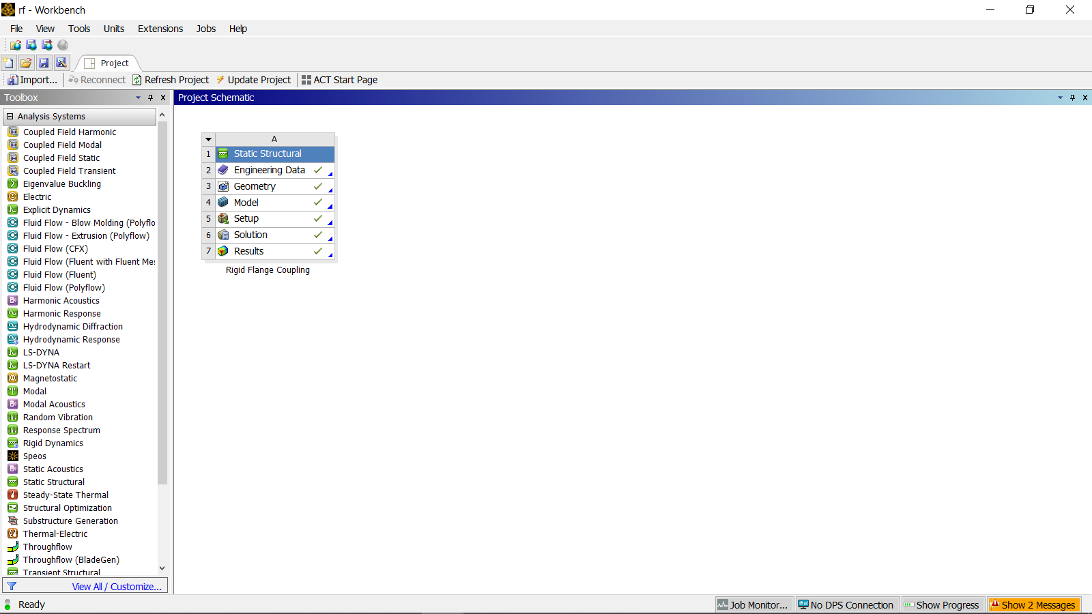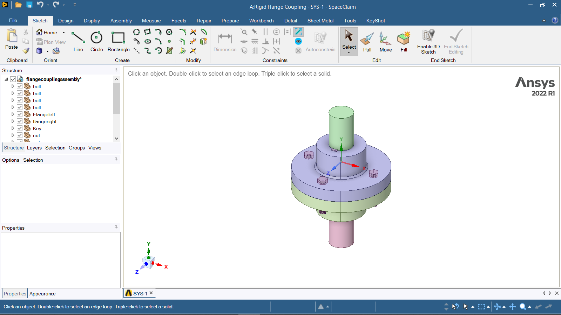

Fig. 4.5 importing geometry

Fig. 4.4 providing engineering data

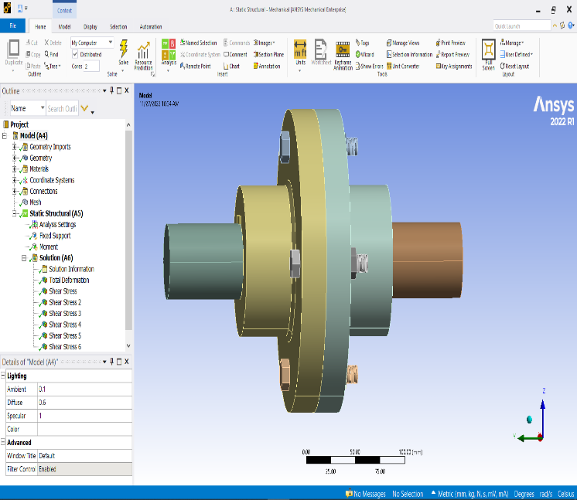

3.Assigning the appropriate

material to the components

4.Generating mesh

5.Giving the boundary conditions

6.Generating solution according to FEA.

Fig. 5.4 Analysis of Rigid Flange Coupling

Fig. 4.6 FEA

**5. Results :** There are several methods for analyzing. In this Project Ansys Software is used for Analyzing. After applying the boundary constraints and solving the following results are obtained.

**5.1) Total Deformation: 5.2) Shear Stress in whole Assembly**

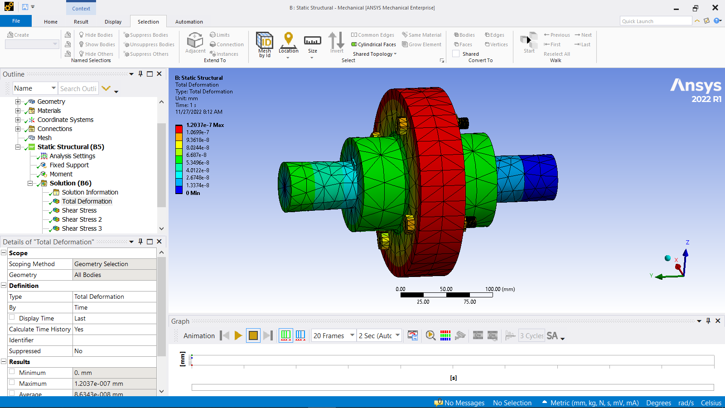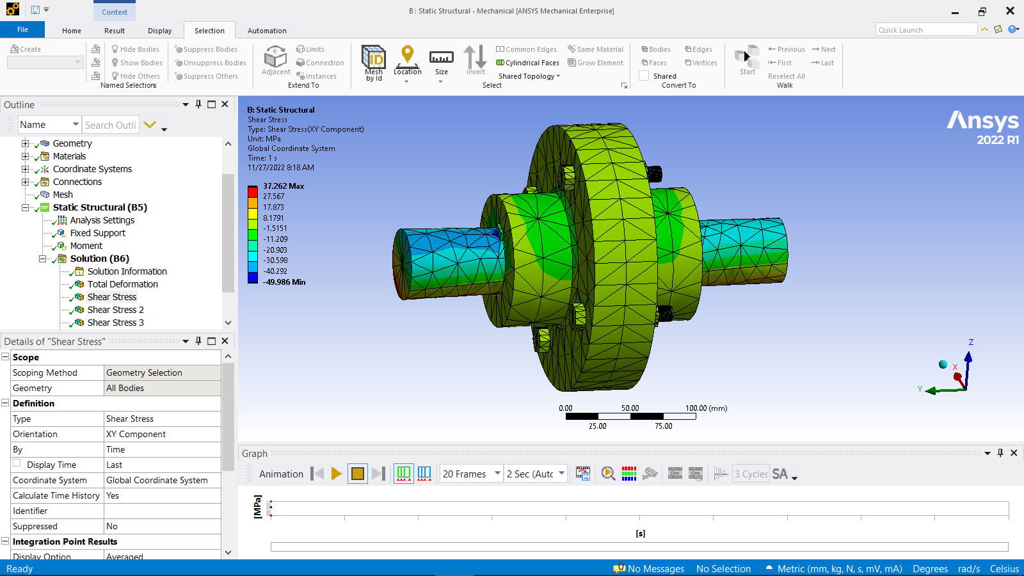

Fig. 5.1 Total Deformation Fig. 5.2 Shear Stress in Rigid Flange Coupling

Maximum deformation obtained is about 1.2037e-7 mm. Maximum shear stress obtained is 37.262 N/mm2.

**5.3) Shear Stress in Flange 5.4) Shear Stress in Key**

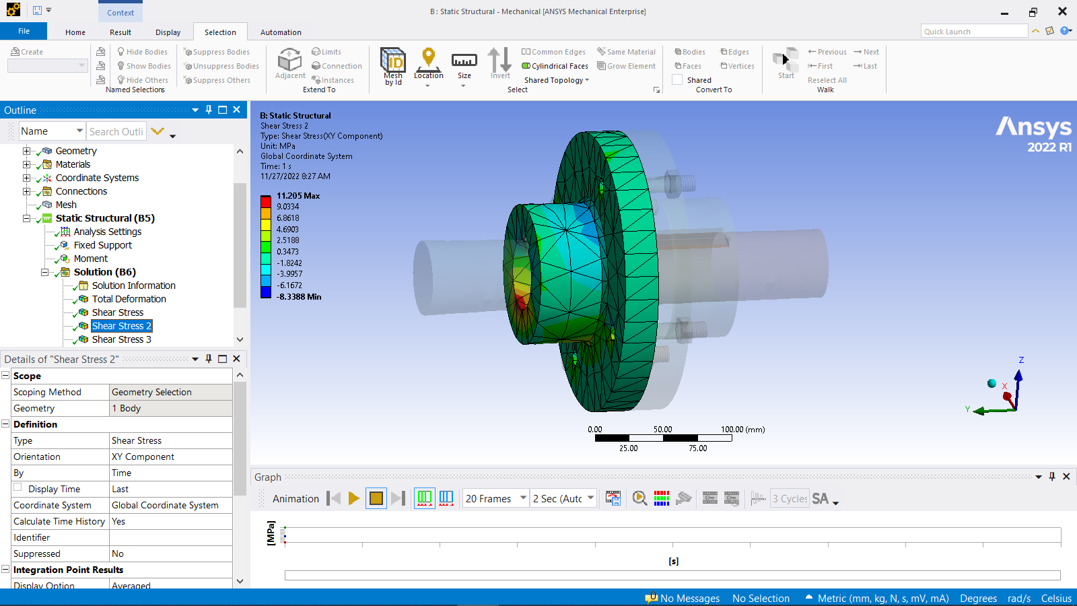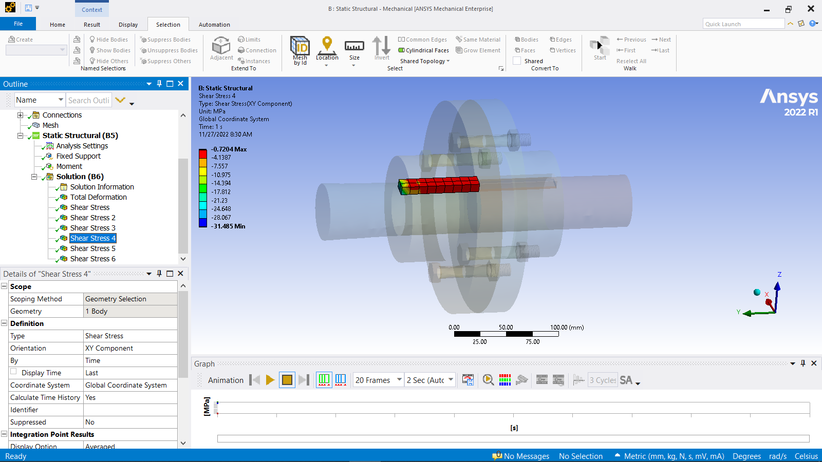

Fig. 5.3 Shear Stress in Flange Fig. 5.4 Shear Stress in Key

Maximum shear stress obtained is 11.205 N/mm2. Maximum shear stress obtained is -0.7204 N/mm2.

**5.5) Shear Stress in Bolt 5.6) Shear Stress in Nut**

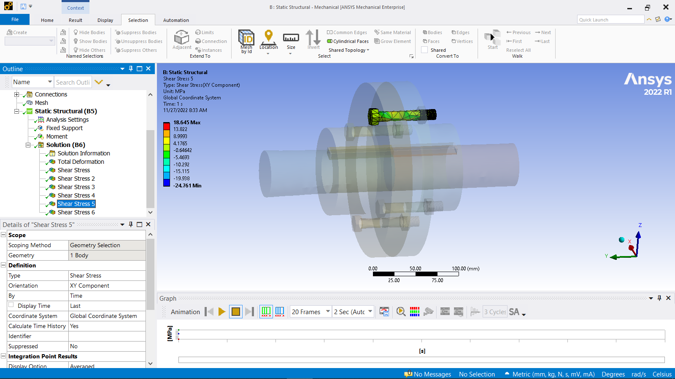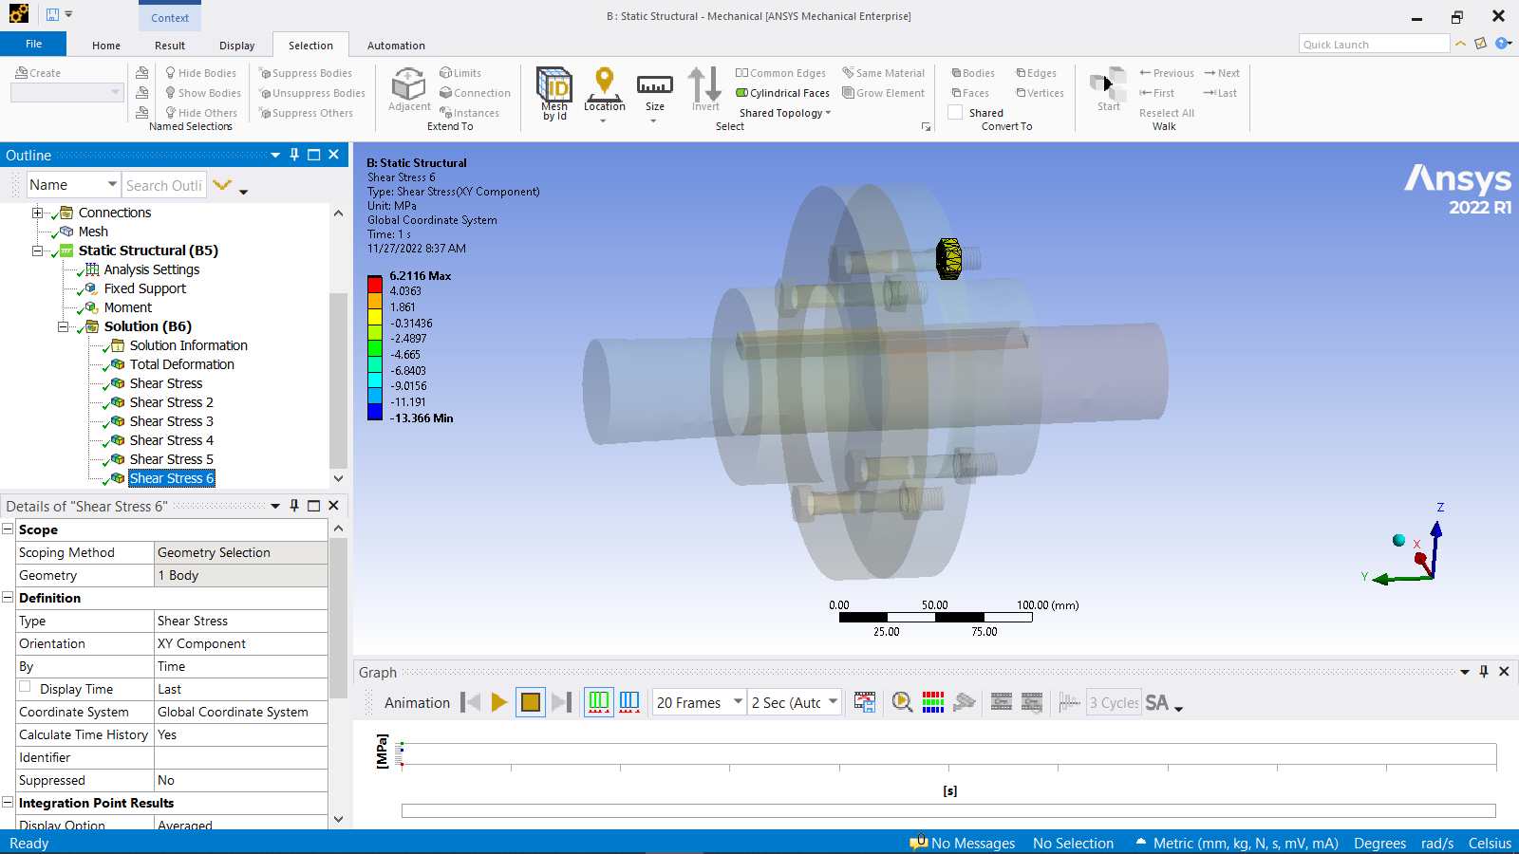

Fig. 5.5 Shear Stress in Bolt Fig. 5.6 Shear Stress in Nut

Maximum shear stress obtained is 18.645 N/mm2. Maximum shear stress obtained is 6.2116 N/mm2.

**6. Conclusion:** After modelling and analyzing the assembly we came to know the stress behavior in the whole assembly and also we found out the maximum stress obtained in each part of the assembly. Also a comparison of the stresses in different parts has been done to understand the change in stress behavior due to the change in material.

**Table 6.1 Table of Comparison of results**

|  |  |  |
| --- | --- | --- |
| Property | **EN8 & C40** | **EN24 & C45** |
| Total Deformation of whole assembly | 0.15454 mm | 1.2037e-7 |
| Max shear stress of whole assembly | 39.017 MPa | 37.262 MPa |
| Max shear stress in Flange | 31.573 MPa | 11.205 MPa |
| Max shear stress in Key | 5.1677 MPa | -0.7204 MPa |
| Max shear stress in Bolt | 21.732 MPa | 18.645 MPa |
| Max shear stress in Nut | 11.862 MPa | 6.2116 MPa |

**Table 6.2 Comparison of maximum shear stress in different types of flanges**

|  |  |  |  |  |  |
| --- | --- | --- | --- | --- | --- |
| Property | **Flange having 4 holes** | **Flange having 6 holes** | **Flange having 8 holes** | **Circular flange** | **Flange having semicircular face** |
| Total Deformation of whole assembly(mm) | 1.2037e-7 | 1.1495e-7 | 1.071e-7 | 1.2037e-7 | 1.2265e-7 |
| Max shear stress of whole assembly(MPa) | 37.262 | 136.86 | 80.199 | 37.262 | 300.77 |
| Max shear stress in Flange(MPa) | 11.205 | 22.27 | 17.32 | 11.205 | 42.50 |

Chart 1 comparison of results

From the above comparison we can see that the results obtained by manufacturing the rigid flange coupling from EN24 and C45 material are far better than the rigid flange coupling manufactured with EN8 and C40 material. Hence we can understand the materials chosen for this project work are better than previous one and shows better life and reliability. Also the slotted face flanges shown generation of higher stress than the simple one.

**6. References:**

1. VORUGANTI BALA LAXMI, SHAKTI PRASANNA JENA  
   EEO.FLANGE COUPLING ANALYSIS WITH MILD STEEL, EN-9, SAE1020, MATERIALS  
   2021;20(4):1539-1544  
   »  doi: [10.17051/ilkonline.2021.04.177](http://dx.doi.org/10.17051/ilkonline.2021.04.177)
2. Kanishk Yadav, & Harshit Jain. (2021). Modeling and Finite Element Analysis of Universal Joint. Advancement in Mechanical Engineering and Technology, 4(1), 1–4. <http://doi.org/10.5281/zenodo.4624800>
3. A STUDY AND ANALYSIS OF DESIGN AND ANALYSIS OF RIGID FLANGE COUPLING 1 SHANIVARAPU GANGA RANI, 2 P.HUSSAIN, 3A.GOUSE PEERA, 4Dr.P.MALLIKARJUNA REDDY Vol 10, Issue 11, Nov/2019
4. Rujuta M. Nakhale and G. K. Gattani “Design and Analysis of Coupling using ANSYS”. (IJPRET),2015; Volume 3 (9): 202- 206, ISSN: 2319-507X(IJPRET)
5. 1 Swati N. Datey , 2 S.D. Khamankar, 3Harshal C. KuttarmareShivaji Finite Element Analysis of Universal Joint IOSR Journal of Mechanical and Civil Engineering (IOSR-JMCE) e-ISSN: 2278-1684,p-ISSN: 2320-334X, Volume 11, Issue 3 Ver. V (May- Jun. 2014), PP 64-69 | Page
6. G. Chavan “Stress analysis of flangedjoint using finite element method”. (IJSR), Volume 3Issue 8, August 2014, ISSN (Online): 2319-7064
7. Machine design by R.S.Khurmi, ISBN:978-81-219-2537-2
8. <https://www.slideshare.net/jsunny155/design-of-an-unprotected-flange-coupling>