A review on grid power quality improvement in wind energy system using STATCOM

**Ms Anshu Yadav**

Department of Electrical Engineering, Babu Banarasi Das University, Lucknow, Uttar Pradesh, India

**ABSTRACT**

The sources such as wind power and solar power are expected to be promising energy sources when it is connected to the power grid. The wind generators have a significant impact on the power quality, voltage profile and the power flow for customers and electricity suppliers. The power exhausted from above energy sources varies due to environmental conditions. Due to the fluctuation in nature of the wind, the wind power injection into an electric grid affects the power quality. The influence of the wind sources in the grid system concerns the power quality such as the reactive power, active power, voltage variation, harmonics and electrical behaviour in switching operation[1]. Demonstration of a grid side connected wind turbine is considered here with the problem arise due to the above system. At the point of common coupling a Static Synchronous Compensator with Battery Energy Storage System-STATCOM/BESS, can regulate four-quadrant active and reactive power, which is an ideal scheme to solve problems of wind power generation. As the power from wind generation varies with time so the battery energy storage used to maintain constant real power comprehensively from varying wind power. The power generated through wind generator can be stored in the batteries at low power demand hours[2-4].

**Keywords**: Power Quality, STATCOM, Wind Energy, BESS

**Introduction**

Recently a rapid development of wind power generation has been experiencing in a global scale. As with increasing the size of wind turbines and wind farms, a large amount of wind power is injected into the power system. Due to random nature of wind energy a huge penetration of power may cause important problems and also affect the characteristics of the wind generators[1]. The integration of wind energy into existing power system presents a technical challenges and that requires consideration of voltage regulation, stability, power quality problems.

The power quality issues can be viewed with respect to the wind generation, transmission and distribution network, such as voltage sag, swells, flickers, harmonics etc. The voltage variation, flicker, harmonics causes the malfunction of equipments namely microprocessor based control system, programmable logic controller; adjustable speed drives, flickering of light and screen[2-4]. It may leads to tripping of contractors, tripping of protection devices, stoppage of sensitive equipments like personal computer, programmable logic control system and may stop the process and even can damage of sensitive equipments. The power quality is an essential measure and is greatly affected by the operation of a distribution and transmission network. So as the power quality problem is of great importance to the wind turbine generation

To reduce the disturbances produced by variation in wind flow, we use the induction generator connected directly to the grid system. The induction generator is simple and robust having reactive power for excitation. A STATCOM based control technology has been used for improving the power quality which can technically manages the power level associates with the commercial wind turbines. In the event of increasing grid disturbance, a battery energy storage system for wind energy generating system is generally required to compensate the fluctuation generated by wind turbine.

**Power quality problems**

Perfect power quality means that the voltage is continuous and sinusoidal having a constant amplitude and frequency. Power quality can be expressed in terms of physical characteristics and properties of electricity. It is most often described in terms of voltage , frequency and interruptions. The quality of the voltage must fulfill requirements stipulated in national and international standards. In these standards, voltage disturbances are subdivided into voltage variations, flicker, transients and harmonic distortion.

**Voltage Variation and Voltage Deep**

The voltage variation can occur in specific situation, as a result of load changes, and power produce from turbine. These can expected in particular in the case of generator connected to the grid at fixed speed. The large turbine can achieve significantly better output smoothing using variable speed operation, particularly in the short time range[1]. The speed regulation range is also contributory factor to the degree of smoothing with the large speed variation capable of suppressing output variations. The start up of wind turbine causes a sudden reduction of voltage. Voltage sag is a phenomenon in which grid voltage amplitude goes below and then returns to the normal level after a very short time period. Generally, the characteristic quantity of voltage sag is described by the amplitude and the duration of the sags.

**Switching Operation And Harmonics**

Switching operations of wind turbine generating system can cause voltage fluctuations and thus voltage sag, voltage swell that may cause significant voltage variation. The acceptances of switching operation depend not only on grid voltage but also on how often this may occur. The harmonics distortion caused by non-linear load such as electric arc furnaces, variable speed drives, large concentrations of arc discharge lamps, saturation of magnetization of transformer and a distorted line current.

**Flickers and Reactive Power**

Flicker is the one of the important power quality aspects in wind turbine generating system. Flicker has widely been considered as a serious drawback and may limit for the maximum amount of wind power generation that can be connected to the grid. Flicker is induced by voltage fluctuations, which are caused by load flow changes in the grid

**Objectives of the study**

* To improve the power quality factor of the grid connected wind energy system by implementing the STATCOM control scheme and reduce the THD

**STATCOM**

A STATCOM, connected in shunt, with the system is capable of improving transient stability by compensating the reactive power at the point of common connection. The ultimate objective of applying reactive shunt compensation in a transmission system is to increase the transmittable power during transients. This is achieved by increasing (decreasing) the power transfer capability when the machine angle increases (decreases). In Figure 1, which shows the single line diagram of a STATCOM, if the DC capacitor voltage, V, is increased from its nominal value, the STATCOM is “overexcited” (capacitive mode) and generates reactive power. If the dc voltage of the DC capacitor bank is decreased below the nominal value, the STATCOM is “under excited” (inductive mode) and absorbs reactive power from the system. This is completely analogous to increasing or decreasing the field voltage of a synchronous compensator.

The proposed STATCOM control scheme for grid connected wind energy generation for power quality improvement has current injection in such a way that it reduces the current harmonics as well as makes the source voltage at its desired value by adjusting the phase angle. The injected current will cancel out the reactive part and harmonic part of the load and induction generator current, thus it improves the power factor and the power quality. The grid connected system consists of wind energy generation system and battery energy storage system with STATCOM. Renewable energy sources often produce power and voltage varying with natural conditions (wind speed, sun light, etc).However, electric utility grid systems cannot readily accept connection of new generation plant without strict conditions placed on voltage regulation due to real power fluctuation and reactive power generation or absorption, and on voltage waveform distortion resulting from harmonic currents injected by nonlinear elements of the plant. Fluctuating wind speed also causes the system frequency to deviate from the 50 Hz standard, as many protection relays have the frequency margin of 1%, which causes thermal function of the power system protection

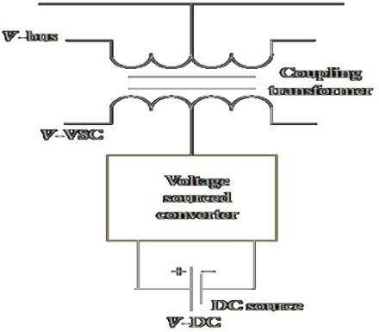

# **Figure -1 Single line diagram of STATCOM**

equipment .As a result, it has become the major concern for the Transmission System Operators (TSO) or the utility companies to resolve the wind power smoothing issue. Energy Storage System (ESS) is needed to smooth the intermittent output power fluctuations of the wind farm. A lot of choices for the ESS are present nowadays in the market e.g. Pumped Hydro Energy Storage (PHES), Compressed Air Energy Storage (CAES), Flywheel, Super capacitors Energy Storage (SES), Superconducting Magnetic Energy Storage (SMES), Hydrogen Energy Storage System (HESS), Batteries Energy Storage System (BESS), etc, which are used to overcome the fluctuated wind farm output power

# **STATCOM With BESS Configuration**

Voltage or current source inverter based flexible AC transmission systems (FACTS) devices such as static var compensator(SVC), static synchronous compensator (STATCOM), dynamic voltage restorer (DVR), solid state transfer switch (SSTS) and unified power flow controller (UPFC) have been used for flexible power flow control, secure loading and damping of power system oscillation. But FACTS/ESS, i.e., FACTS with energy storage system (ESS) have recently emerged as more promising devices for power system applications.

This work focuses on STATCOM incorporated with battery energy storage system (BESS), i.e. ,STATCOM/BESS topology for wind power application. Figure-2 presents typical architecture of connected STATCOM with BESS to electric utility system. The static synchronous compensator, or STATCOM, is a shunt- connected power electronic converter-based FACTS device. Unlike static var compensator(SVC), the STATCOM does not employ capacitor or reactor banks to produce reactive power. The major disadvantage of a traditional STATCOM (with no energy storage) is that it has only two possible steady-state operating modes, namely, inductive (lagging) and capacitive (leading).

Even though both the traditional STATCOM output voltage magnitude and phase angle can be controlled, they cannot be independently adjusted in steady state due to the lack of significant active power capability of STATCOM. Typically, the STATCOM converter voltage is maintained in phase with the PCC voltage, thus ensuring that only reactive power flows from the STATCOM to the system.

However, the real power capability of the STATCOM is very limited due to the absence of any energy storage at DC bus .Compared with the traditional STATCOM, the STATCOM + BESS offer more flexibility. In case of STATCOM + BESS, the number of steady-state operating modes is extended to various situations such as inductive mode with DC charge and DC discharge, capacitive mode with DC charge and discharge.

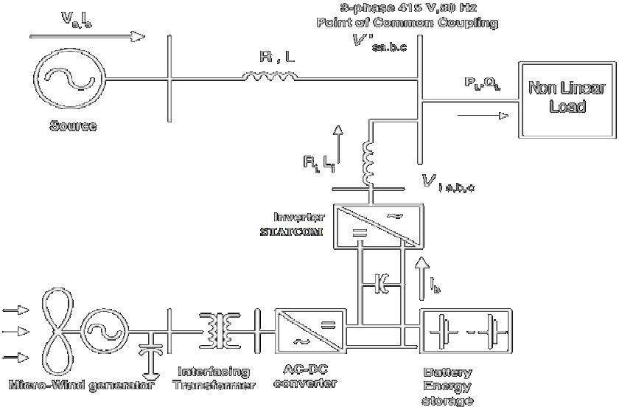

# **Figure 2 Connection of STATCOM with BESS**

# **Control Strategy**

The control scheme with battery storage and micro wind generation system utilizes the dc link to extract the energy from the wind. The wind generator is connected through a step up interfacing transformer and to the rectifier bridge so as to obtain the dc voltage. Also a lead acid cell battery is used for maintaining the dc bus voltage constant. Thus the inverter is implemented successfully in the distributed system. The control scheme approach is based on injecting the current into the grid using hysteresis band current controller. Using such techniques controller keep s the control system variables between the boundaries of hysteresis area and thus gives correct switching signals for the inverter operation. Fig. 4 shows the control scheme for generating the switching signals to the inverter The control algorithm needs the measurement of several variables such as three-phase source current isabc for each phases, dc bus , voltage Vdc, and inverter current idc with the help of measurement sensors. The current control unit receives an input of reference current i*sabc and actual current is measured from each phases respectively, which are subtracted so as to activate the operation of the inverter in current control mode

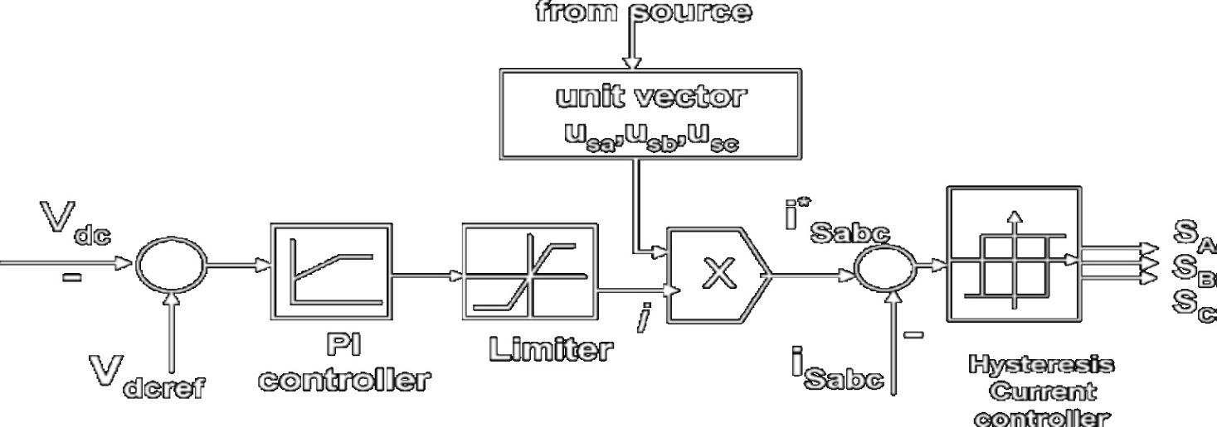

# **Figure – 3 Control Scheme**

the grid using hysteresis band current controller. Using such techniques controller keep s the control system variables between the boundaries of hysteresis area and thus gives correct switching signals for the inverter operation. Fig. 3 shows the control scheme for generating the switching signals to the inverter

**Acknowledgment**

The completion of any project brings with it a sense of satisfaction, but it is never complete without thanking those

people who made it possible and whose constant support has crowned our efforts with success. One cannot even imagine the power of the force that guides us all and neither can I succeed without acknowledging it. My deepest gratitude to Almighty God for holding my hands and guiding me throughout our lives.

I wish to express my deep sense of gratitude to my Guide, Prof. V.K Maurya, HoD in Electrical Engineering Department of BBD University , Lucknow, for his able guidance and useful suggestions, which helped me in completing the seminar work, in time.

**References**

[1] Mundackal, J.; Varghese, A.C.; Sreekala, P.; Reshmi, V., "Grid p ower quality improvement and battery energy storage inwind energy systems,"Emerging Research Areas and 2013 International Conference on Microelectro nics,Communications and Renewable Energy (AICERA/ICMiCR), 2013 Annual International Conference on, vol., no., pp.1,6,4-6 June 2013

[2] Nirmala, N.; Kumar, V.S., "A STATCOM-control scheme for wind energy system to improve p ower quality," InformationCommunication an d Embedded Systems (ICICES), 2013 Internationa l Conference on, vol., no., pp.1108,1113 , 21 -22 Feb.2013

[3] Shanthini, K.; Verappan, N., “Power quality enhancement of wind generators connected to grid,” Emerging Trends in Electrical Engineering and Energy management (ICETEEEM), 2012 International Conference on ,vol., no., pp.398,403,13-15 Dec. 2012

[4] Sattar, A.; Al Durra, A.; Caruana, C.; Muyeen, S.M.; Tamura, J., "Real time implementatio n of the BESS to smoothen the output power fluctuation of the variable speed wind turbine generator, "Electrical Machines and Systems (ICEMS), 201215th International Conference on, vol., no., pp.1,6, 21-24 Oct. 2012

[5] Mohod, S.W.; Aware, M.V., "A STATCOM -Control Scheme for Grid Connected Wind Energy System for Power Quality Improvement, "Systems Journal, IEEE, vol.4, no.3, pp.346,352, Sept. 2010

[6] Muyeen, S.M.; Takahashi, R.; Murata, T.; Tamura, J.; Ali, M.H., "Stabilization of wind farms connected with multimachine power system by using STATCOM/BESS, "Electrical Machines and Systems, 2007. ICEMS. International Conference on, vol., no., pp.232,237, 8- 11 Oct. 2007

[7] Francisco Diaz Gonzalez1, Marcela Martnez-Rojas (2011) “Strategies for Reactive Power Control in Wind Farms with STATCOM” IREC Catalonia Institute for Energy Research. Yuvaraj, Dr.S.N.Deepa N.D. (2011) “Improving grid power quality with FACTS device on integration of wind energy

[8] system” student pulse | april 2011 | vol.3, issue 4 ,www.stud entpulse.com

[9] Ganesh.Harimanikyam,S.V.R.Lakshmi Kumari (2012)

=Power quality improvement of grid connected wind energy systemby STATCOM for balanced and unbalanced linear and no nlinear loads International Journal of Engineering Research andDevelopment e- ISSN: 2278-067X, ISSN: 2278- 800X,www.ijerd.com Volume 3, Issue 1 (August 2012)

[10 ]A. Arulampalam, M. Barnes, N. Jenkins and J.B. Ekanayake, “Po wer quality and stability improvement of a wind farmusing STATCOM supported with hybrid battery energy storage” IEE Proc.-Gener. Transm. Distrib., Vol. 153, No. 6,November 2006.

[11 ]A. Chakraborty, S. K.Musunuri, A. Srivastava, A. Kondabathini, “Integrating STATCOMand Battery Energy StorageSystem for Power SystemTransient Stab ility: A Review and Application,” Hindawi Publishing Co rporation, Advances inPower Electronics, Volume 2012, Article ID 676010

[12 ]V.Suresh Kumar,Ahmed F.Zobaa, R.Dinesh Kannan and K.Kalaiselvi (2010) “Power quality and stability imp rovement inwind park system using STATCOM” JJMIE Volume 4, Number 1, Jan. 2010 ,ISSN 1995-6665Jordan Journal ofMechanical and Industrial Engineering

[13 ]M.Chiranjeevi, O.Venkatanatha Reddy (2012) “A Bess- STATCOM based control scheme for grid connected wind Energysystem for power quality improvement” International Journal of Engineering Research and Applications (IJERA)

ISSN:2248-962 2Vol. 2, Issue 2,Mar-Apr 2012