**SIMULATION AND ANALYSIS OF MEMS BASED PIEZOELECTRIC ENERGY HARVESTING SYSTEM**

**Dilbagh Singh1, Simranjit Kaur2, Saleem Khan3**

1M.Tech Student, Dept. of Electronics & Communication Engg., Sri SAI CET, Pathankot, India1

Asst. Prof., Dept. of Electronics & Communication Engg., Sri SAI CET, Pathankot, India

3Department of Electronics, GGM Sc. College, J&K, India

**ABSTRACT**

An Energy Conversion Efficiency depends on the piezoelectric material's properties, including its thickness. Thicker materials are more efficient in converting mechanical strain into electrical energy as they can store more mechanical energy. The resonant frequency of a piezoelectric material, which is the frequency at which it vibrates the most, is directly proportional to its thickness. Therefore, thicker materials have a lower resonant frequency and are more appropriate for low-frequency vibration energy harvesting applications. However, increasing the thickness of piezoelectric material comes with trade-offs, such as higher cost and weight, limiting their practical use in some applications. Thicker materials may also have a lower resonant frequency, making them less suitable for high-frequency vibration energy harvesting.

**Keywords:** MEMS, energy harvesting, piezoelectric, power density.

1. **INTRODUCTION**

Microelectromechanical System development has accelerated during the past few years (MEMS). Devices that are portable, small, and self-powered are in high demand. By absorbing the energy around a system and turning it into a form of useful electrical energy, this may be accomplished. The term "energy harvesting" refers to this. Energy collecting techniques have been created in various ways. This has made a significant contribution to the creation of MEMS devices that use little power [26], [27]. Wireless sensors and other MEMS devices are instruments that measure physical quantities. The variance in these microstructures' physical characteristics is used to accomplish. These micro-systems' development has also benefited from improvements in the fabrication techniques for them. Many other uses may be possible for such gadgets. Monitoring the structural integrity of buildings, strain measurements in implants, data measurements in hostile environments like space or on the tips of aircraft wings, locating people in commercial buildings so that the environment can be controlled in a more energy-efficient way, sensing harmful chemical agents in high traffic areas, monitoring the formation of fatigue cracks on aircraft, monitoring pressure in automobile tyres are just a few potential applications. One of the most popular structures among the several types of energy harvesters now in use for capturing ambient vibrational energy from the environment is the piezoelectric energy harvester. Direct piezoelectric effect and reverse piezoelectric effect are two examples of non-conventional energy storage systems that use piezoelectric materials to transform mechanical energy into electrical energy. The amount of energy harvested by piezoelectric energy harvesters is sufficient to operate low power MEMS and tiny electronic devices, such as wireless sensors, portable electronics, and apparel electronics [28]. In a number of industries, including structural health monitoring and medical equipment, wireless sensors have gained popularity. Self-powered wireless sensors are more beneficial than those that utilise normal batteries since they are not subject to the typical lifespan constraint. Although it is possible to repair or recharge the batteries, the difficult access to their locations makes this sort of solution costly and occasionally impractical. In order to satisfy the demands, piezoelectric energy harvesters provide a suitable option. The most frequent type of construction used in mechanical energy harvesters is the cantilever beam. This is because the cantilever structure's greatest deflection at the free end allowed for the extraction of the most amount of electrical output possible. To scavenge the most power, piezoelectric cantilever energy harvesters operate based on resonance. The process of obtaining the energy present around a system and transforming it into useable electrical energy is known as energy harvesting, power harvesting, or energy scavenging. The need to power mobile devices and sensor networks without batteries is one of the driving forces behind the hunt for innovative energy harvesting technologies. Electrochemical batteries have been the primary source of electrical energy for a lot of gadgets. However, because to their low energy storage capacity and restricted lifespan, batteries lag behind today's rapid growth of wireless and mobile applications, creating problems with replacement and disposal. In addition to these intrinsic restrictions, battery technology has advanced rather slowly over the past ten years while computer system performance has increased rapidly. It's difficult to replace the battery in portable gadgets [31]. When it comes to wireless sensors, these gadgets may be positioned in extremely far-off places, like structural sensors on a bridge or GPS tracking devices on wild animals. Simple battery change might turn into an extremely expensive or even difficult process. It is not practical to change batteries for embedded sensors used, in example, to monitor the structural health of car or aircraft bodies. Energy harvesting is a concept that aims to create self-powered technology without the need for disposable power sources. Ambient energy in the surrounding medium can be derived from external sources such as light, temperature gradients, wind, water flow, mechanical vibration, and human/animal activity and utilized to replenish or charge [32]. This collected energy may subsequently be utilized to extend the life of the power source or, in the best-case scenario, offer limitless energy for wearable electronics, such as wireless sensor networks and portable electronics like cell phones and mobile laptops. Recent developments in wireless technology and low-power electronics, such as MEMS systems, enable the fast reduction of sensor and electronics size, cost, and power consumption. As a result, research into energy harvesting for useful real-world applications has exploded [3-4]. Piezoelectric materials have the unique property of generating an electrical charge or voltage when subjected to mechanical stress or strain, and vice versa. When a piezoelectric material is mechanically strained, it becomes electrically polarized, with the level of polarization proportional to the applied strain. Conversely, when an electric field is applied to the material, it deforms. This property enables the use of piezoelectric materials to convert mechanical energy into electrical energy [4]. Compared to other methods of extracting electrical energy from vibration sources, such as electromagnetic induction and electrostatic conversion, piezoelectric devices are particularly attractive as they can directly convert vibrational energy into electrical energy. Piezoelectric vibration energy harvesters (PVEHs) are simple to construct, requiring minimal complex geometries or additional parts [5]. Piezoelectric generators are also well-suited for use in both micro- and macro-scale devices due to the availability of both thin and thick piezoelectric films [9]. Furthermore, piezoelectric-based harvesters can generate relatively high output voltage at low electrical current, providing the necessary voltage level (0.3-4 Volts) to directly power a sensor or charge a backup battery. In contrast, electromagnetic generators may require transformers to handle applications requiring voltages higher than 2V [10]. A unimorph configuration is made up of a single piezoelectric layer sandwiched between two electrodes and structural layers. On the other hand, bimorph designs consist of two piezoelectric layers that are electrically coupled either in series or in parallel. The two useful modes of transduction are the 3-1 and 3-3 modes of operation, which are determined by the direction of the electrical field and the applied strain [52]. In the 3-1 mode, the mechanical strain is applied in the "1" direction, while the voltage (and therefore, the electric field) acts perpendicular to the "3" direction. In the 3-3 mode, both the voltage and strain move in the "3" direction. The choice of electrode arrangement is dependent on the mode of operation [31], [57], [58]. For cantilevered PVEH systems, standard capacitor-type electrodes are used for 3-1 modes of operation, while interdigitated electrodes (IDTEs) are frequently employed to achieve 3-3 modes of operation, as shown in Figures 3.1 and 3.2, respectively.

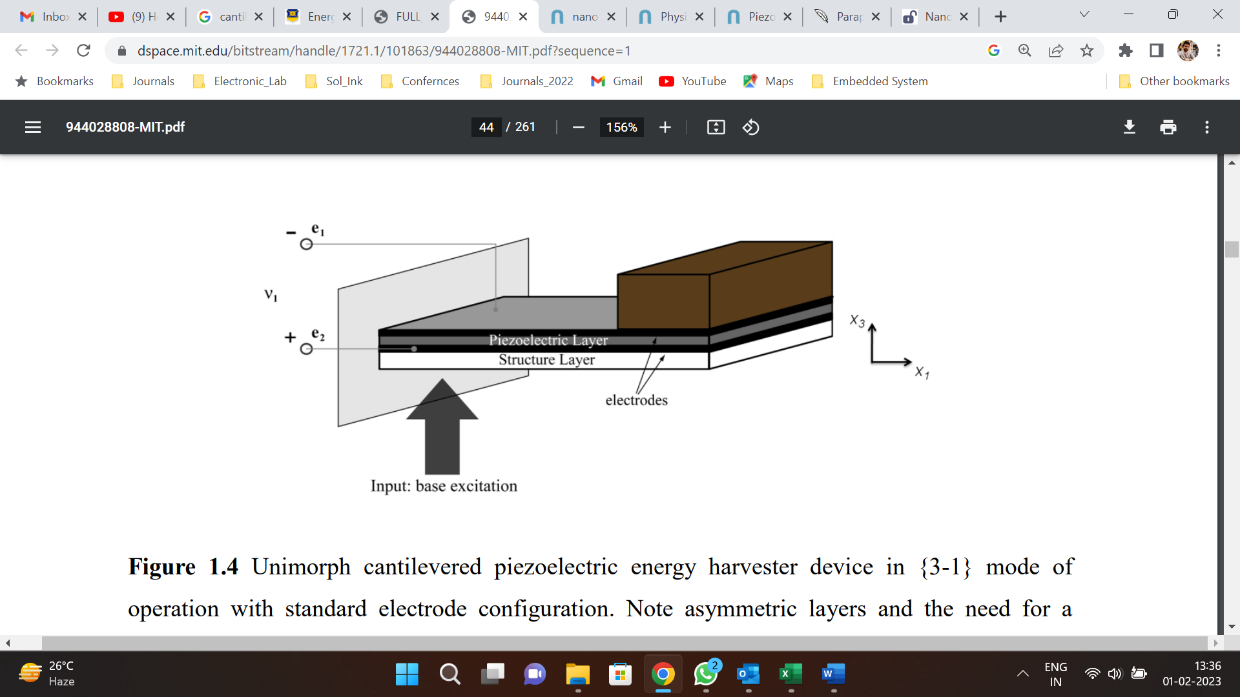

**Figure 1:** Unimorph cantilevered piezoelectric energy harvester device.

1. **METHODOLOGY**

The initial step in the simulation process is to design the beam's geometry. The harvesting device comprises a cantilevered beam with a mass attached to its end, as depicted in the illustration. Currently, this device can replicate Unimorph and Bimorph piezoelectric harvesters. The Bimorph beam consists of two interconnected piezoelectric layers arranged in a sandwich-like structure with the metallic substrate, while the Unimorph beam features only one piezoelectric layer and a single layer of metallic substrate. This version does not support beams with multiple substrates or piezoelectric films (such as Multimorph). All dimensions such as length, thickness, and width need to be specified in the "Geometry" tab. The substrate's thickness should be entered as "0" if there is no substrate to be simulated. However, if the "point-mass" approximation is to be used, its length can also be given as "0". The space occupied by the proof mass is crucial in compact devices. The distance between the beam and the floor is not significant in millimeter-sized devices, but it can have a significant impact on the squeezing force in MEMS scale cantilevers. The initial step in the simulation process is to specify the dimensions of the beam, which can be done on the "Geometry" tab. The cantilevered beam, which includes a mass at the end, is the basic design for the harvesting tool, and the user can choose between Unimorph and Bimorph piezoelectric harvesters. Multimorph beams with multiple substrates or piezoelectric films are not currently supported. The dimensions, such as length, thickness, and width, must all be specified. If there is no substrate, the thickness of the substrate can be set to zero. However, if the "point-mass" approximation is used, its length can also be set to zero. The distance between the beam and the floor can have a significant impact on the squeezing force in MEMS scale cantilevers, although it is not important for millimeter-sized devices. After setting the dimensions, the "Mechanical Properties" page allows the user to select the materials for the beam and the proof mass value. There are two options available: "Material from Database" and "Custom material." In the first mode, the user can choose from a list of materials, and a table with the corresponding values for each property is provided in the documentation. For the second option, all relevant characteristics can be manually entered, making it ideal for comparing against experimental data. Elasticity and density moduli, as well as the transverse piezoelectric coefficient and dielectric constant for the piezoelectric films, are required parameters for both materials. In the next phase of the simulation, the user can test the device under various excitation scenarios. The programme offers predefined values for observed oscillations from various sources and can generate sinusoidal, random, and impulsive vibrations. Additionally, a recorded file can be uploaded, and all enabled choices will be combined into a single input signal for analysis. The simulation process flow for piezoelectric vibrational energy harvesting on the nanoHub MEMS lab can be broadly divided into the above steps.

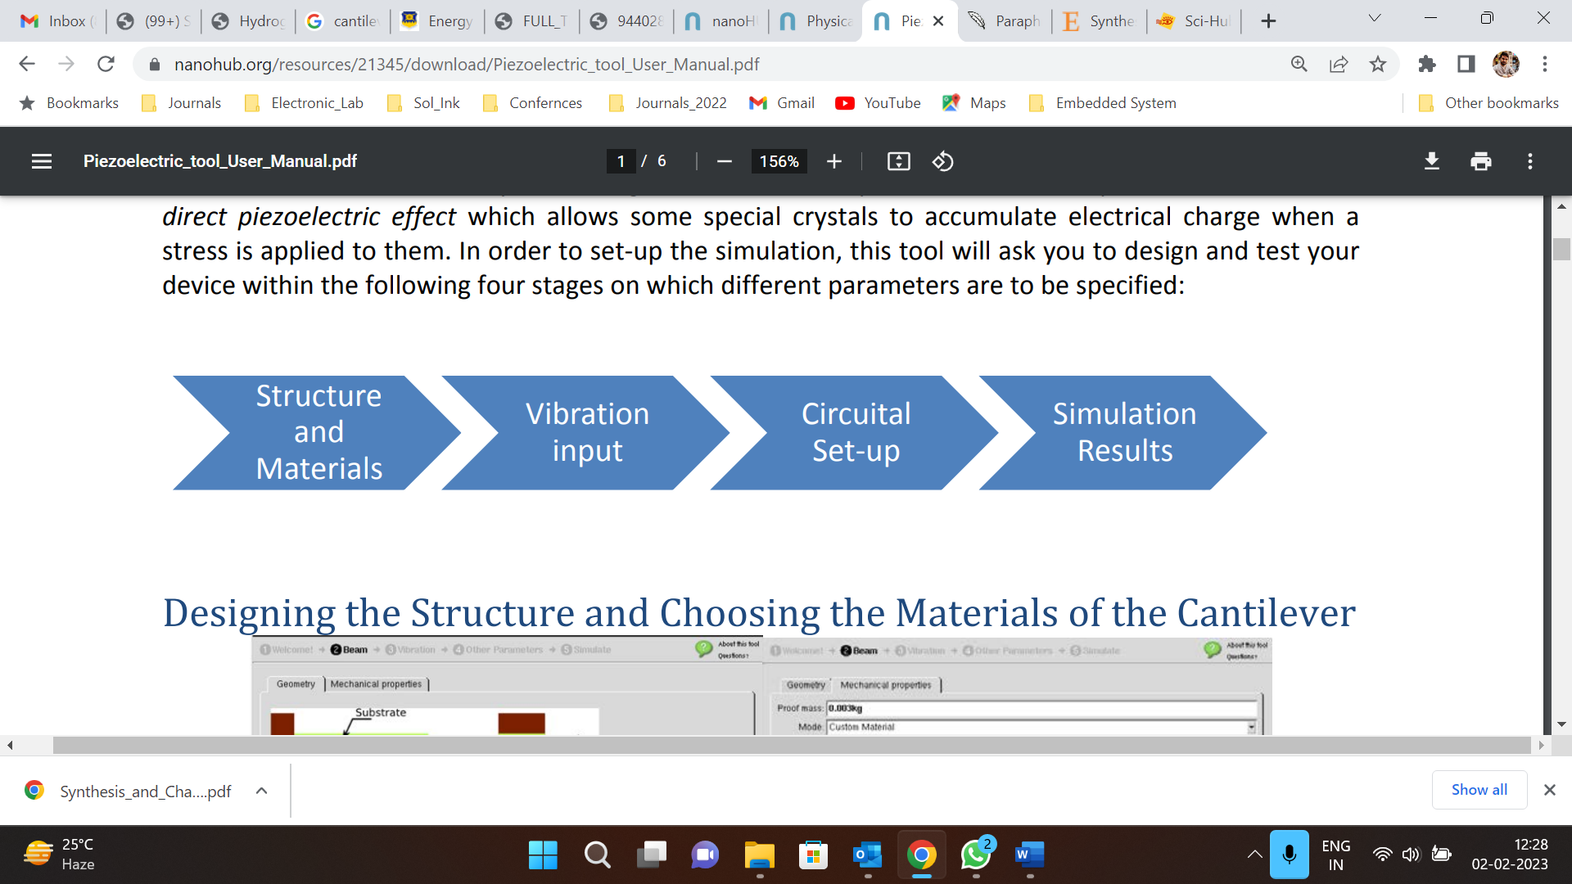

**Figure 2:** Design and test process flow.

1. **RESULTS AND DISCUSSION**

The device is composed of a piezoelectric film with electrodes, a substrate, and a proof mass, each with its specific function. The system's dynamics can be understood from two perspectives: mechanical and electrical. From the mechanical perspective, it can be modeled as a classic mass-spring-damper system with an added term accounting for the electrical force generated by the piezoelectric material. The simulation is performed with the following parameters: a calculated simulation period of 0.21873 seconds, a sampling frequency of 6.8577 kHz, a natural frequency of 342.89 Hz, an open-circuit resonance of 349.59 Hz, an average harvested power of 1.7736e-06 microWatts, a peak power of 2.4078e-05 microWatts, an estimated device volume of 0.06397 cm3, a power density of 2.7726e-08 mW/cm3, an input RMS acceleration of 0.025032 g RMS, and a power-to-acceleration ratio of 0.0028304 microWatts per g RMS squared.

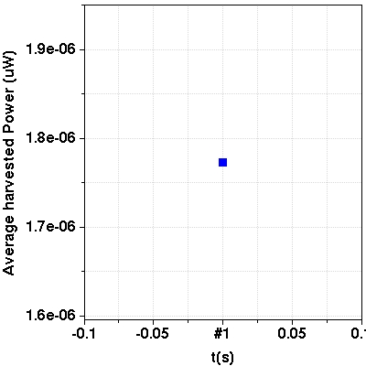 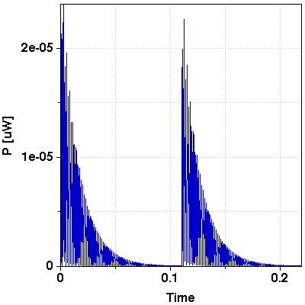

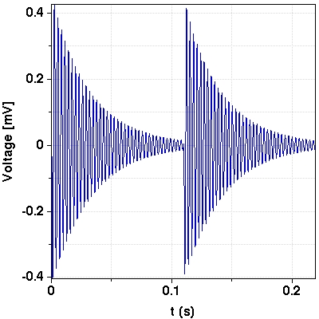 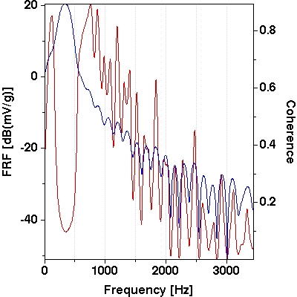

**Figure 3:** Output parameters (a) average energy harvested, (b) power, (c) voltage, (d) frequency response function/coherence.

Table II presents the output parameters, which include the natural frequency, resonance, harvested power, peak power, device volume, power density, and power-to-acceleration ratio. The generated voltage and power in response to the input excitation for a limited time interval. It can be inferred from the graphs that the substrate thickness is a crucial factor in power harvesting.

**Table 1.** Output parameters computed from simulation.

|  |  |  |  |  |  |  |  |  |  |
| --- | --- | --- | --- | --- | --- | --- | --- | --- | --- |
| **Parameters** | **Substrate Thickness** | | | | | | | | |
| 100 | 150 | 200 | 250 | 300 | 350 | 400 | 450 | 500 |
| Natural frequency [Hz] | 258.35 | 333.23 | 409.38 | 486.09 | 563.09 | 640.25 | 717.51 | 794.84 | 872.21 |
| Open-circuit resonance [Hz] | 270.41 | 349.35 | 429.21 | 509.48 | 589.94 | 670.5 | 751.13 | 831.8 | 912.5 |
| Average harvested power [uW] | 0.00088987 | 0.002837 | 0.046472 | 0.11971 | 0.14502 | 9.619 | 2.6266 | 1.3049 | 0.80475 |
| Peak power [uW] | 0.01226 | 0.038341 | 0.50144 | 1.0826 | 1.5796 | 0.12117 | 0.019179 | 0.0077351 | 0.0042368 |
| Estimated device volume [cm3] | 0.055401 | 0.072278 | 0.0941 | 0.11235 | 0.12886 | 0.13526 | 0.14903 | 0.1643 | 0.17982 |
| Power density [mW/cm3 | 1.6062e-05 | 3.925e-05 | 0.00049386 | 0.0010655 | 0.0011254 | 7.1113e-05 | 1.7624e-05 | 7.9427e-06 | 4.4752e-06 |
| Input RMS acceleration | 0.71439 | 0.72402 | 0.72965 | 0.73228 | 0.73426 | 0.73537 | 0.73622 | 0.73663 | 0.73718 |
| Power-to-acceleration ratio [Uw/RMS]2 | 0.0017436 | 0.0054118 | 0.08729 | 0.22324 | 0.26899 | 0.017787 | 0.0048459 | 0.0024049 | 0.0014809 |

1. **CONCLUSION**

Energy Conversion Efficiency depends on the piezoelectric material's properties, including its thickness. Thicker materials are more efficient in converting mechanical strain into electrical energy as they can store more mechanical energy. The resonant frequency of a piezoelectric material, which is the frequency at which it vibrates the most, is directly proportional to its thickness. Therefore, thicker materials have a lower resonant frequency and are more appropriate for low-frequency vibration energy harvesting applications. However, increasing the thickness of piezoelectric material comes with trade-offs, such as higher cost and weight, limiting their practical use in some applications. Thicker materials may also have a lower resonant frequency, making them less suitable for high-frequency vibration energy harvesting.

1. **REFERENCES**
2. J. H. Agarwal, “Electronic Aids for Enhancement of Agricultural Production,” IETE Technical Review, vol. 10, no. 1, pp. 57–64, Jan. 1993, doi: 10.1080/02564602.1993.11437288.
3. H. Toshiyoshi, S. Ju, H. Honma, C. H. Ji, and H. Fujita, “MEMS vibrational energy harvesters,” Sci Technol Adv Mater, vol. 20, no. 1, pp. 124–143, Jan. 2019, doi: 10.1080/14686996.2019.1569828.
4. S. Boisseau, G. Despesse, T. Ricart, E. Defay, and A. Sylvestre, “Cantilever-based electret energy harvesters,” Smart Mater Struct, vol. 20, no. 10, p. 105013, Aug. 2011, doi: 10.1088/0964-1726/20/10/105013.
5. Y. Zhuang et al., “Flexible composites with Ce-doped BaTiO3/P(VDF-TrFE) nanofibers for piezoelectric device,” Compos Sci Technol, vol. 200, p. 108386, Nov. 2020, doi: 10.1016/J.COMPSCITECH.2020.108386.
6. Y. Cho et al., “BaTiO3@PVDF-TrFE nanocomposites with efficient orientation prepared via phase separation nano-coating method for piezoelectric performance improvement and application to 3D-PENG,” Chemical Engineering Journal, vol. 427, p. 131030, Jan. 2022, doi: 10.1016/J.CEJ.2021.131030.
7. R. Zhang et al., “All-inorganic triboelectric nanogenerators based on Mo6S3I6 and indium tin oxide,” Nano Energy, vol. 89, p. 106363, Nov. 2021, doi: 10.1016/J.NANOEN.2021.106363.
8. L. Zhou et al., “Ultra-Stable and Durable Piezoelectric Nanogenerator with All-Weather Service Capability Based on N Doped 4H-SiC Nanohole Arrays,” Nanomicro Lett, vol. 14, no. 1, pp. 1–10, Dec. 2022, doi: 10.1007/S40820-021-00779-0/TABLES/1.
9. M. G. Greeshma and S. Prabha Rajeev, “Optimising proof mass for cantilever based piezoelectric energy harvester,” Mater Today Proc, vol. 59, pp. 623–627, Jan. 2022, doi: 10.1016/J.MATPR.2021.12.179.
10. N. Sugita, M. Kine, D. Han, and T. Shinshi, “Experiment and modelling of cantilever-based electromagnetic energy harvester driven by direct impact of spherical ball,” Microsystem Technologies, vol. 28, no. 8, pp. 1911–1923, Aug. 2022, doi: 10.1007/S00542-022-05333-5/FIGURES/11.
11. J. Song, G. Sun, X. Zeng, X. Li, Q. Bai, and X. Zheng, “Piezoelectric energy harvester with double cantilever beam undergoing coupled bending-torsion vibrations by width-splitting method,” Scientific Reports 2022 12:1, vol. 12, no. 1, pp. 1–14, Jan. 2022, doi: 10.1038/s41598-021-04476-1.
12. C. Zhao, G. Hu, and Y. Yang, “A cantilever-type vibro-impact triboelectric energy harvester for wind energy harvesting,” Mech Syst Signal Process, vol. 177, p. 109185, Sep. 2022, doi: 10.1016/J.YMSSP.2022.109185.
13. Q. Tan, K. Fan, J. Guo, T. Wen, L. Gao, and S. Zhou, “A cantilever-driven rotor for efficient vibration energy harvesting,” Energy, vol. 235, p. 121326, Nov. 2021, doi: 10.1016/J.ENERGY.2021.121326.
14. L. Jidi et al., “Effect of single-side stroke limiter on cantilever-based piezoelectric energy harvesting from low frequency vibrations,” Smart Mater Struct, vol. 30, no. 5, p. 055008, Apr. 2021, doi: 10.1088/1361-665X/ABEE36.
15. T. Satyanarayana, Y. Nikhitha, Ch. Neeraj Kumar, K. Jeevan Naga Sai, and V. Lohitha, “Optimization of bimorph cantilever based piezoelectric energy harvester for high efficiency,” Mater Today Proc, Jul. 2021, doi: 10.1016/J.MATPR.2021.07.054.
16. O. ben Dali et al., “Ferroelectret energy harvesting with 3D-printed air-spaced cantilever design,” Nano Select, vol. 3, no. 3, pp. 713–722, Mar. 2022, doi: 10.1002/NANO.202100210.