**Modeling and Simulation of Dynamic Voltage Restorer in Power system**

**Tananjay Prakash 1, Prof. Duirgesh Vishwakarma2**

1M.tech Scholar, Electrical Department, Radharaman Engineering College Bhopal, MP, India

2Assistant Professor, Electrical Department, Radharaman Engineering College Bhopal, MP, India

**ABSTRACT**

In the modern power system, power quality is a crucial topic that can have an impact on utilities and consumers. Many issues in the contemporary electric power system were brought on by the integration of renewable energy sources, smart grid technologies, and increasing usage of power electronics equipment. The delicate equipment can be harmed by voltage harmonics, voltage sag, and voltage swell. These devices are vulnerable to input voltage changes brought on by system interference. Power quality is therefore crucial for the efficient and secure operation of the power system in the present period, with an increase in delicate and expensive electronic equipment. often used to address issues with distribution grid non-standard voltage, current, or frequency. In order to maintain the voltage profile and ensure consistent load voltage, it injects voltages into the distribution line. To demonstrate the effectiveness of the DVR-based proposed technique to smooth the distorted voltage brought on by harmonics, simulations were run in MATLAB/Simulink. To incorporate 3rd and 5th harmonics, a power system model with a customizable power source was developed. The reaction of the systems to load voltage in situations with and without DVR is assessed. It has been observed that the suggested DVR-based technique successfully controlled the voltage distortion, resulting in a smooth corrected load voltage. With the insertion of the third and fifth harmonics in the supply voltage,

**Keywords:** Dynamic Voltage Restorer, FACTS, Total Harmonic Distortion, Sag, Swell, Harmonics

1. **INTRODUCTION**

Electric power is invisible, a universal resource that is readily available in most parts of the world and is now recognized as a daily consumer need [1]. Renewable Energy Systems (RES) are used to support primary energy demand in solar, solar thermal, wind, etc. The intermittent nature of RES, harmonics, and reactive power problems halt power system performance by causing power system stability problems [2], [3]. Flexible AC Transmission System (FACTS) devices are widely adapted for reactive power compensation, voltage stability and power quality in distribution networks around the world [4], [5].

However, FACT devices also change various parameters in the transmission and distribution system [6]. This work presents a power quality study that aims to identify the causes of poor power quality and provide solutions to these power quality problems. Some equipment, such as computers, laptops, relays, solid state drives, adjustable speed drives, and optical devices, are known as sensitive equipment. These devices are sensitive to variations in input voltage caused by interference with other parts of the system.

The power system is divided into the following parts such as generation, transmission, distribution, and by using other transmission line power systems supplied to different loads on the distribution side. Power quality plays a critical role in the power system when variable power is supplied to the load. Subsequently, domestic and industrial customers with sensitive loads are affected by poor power quality.

Even on the distribution side, there are different load types, but poor power quality affects sensitive loads more than others. There are many applications where sensitive cargo is in increasing demand, such as hospital operating rooms, semiconductor systems in processing plants, database systems, instruments for monitoring air pollution in crowded areas, precise equipment is required and accurate for data processing and service providers. . If the power system causes the sags and distorted voltages, these devices can fail, and failure of that device leads to a significant loss of money. Therefore, the distribution side depends on the quality of the network. The electrical characteristics are determined by the power system that does not interfere with the performance of the system and performs its function in a controlled manner. This article discusses voltage rise and distorted voltage with high harmonics.

When the load voltage is disturbed, it causes voltage dips, transients, voltage surges and distorted high voltage with harmonics and total harmonic distortion (THD) due to the occurrence of faults. The vulnerability of voltage drop and harmonic problems is mainly for delicate instruments. Few problems arise due to voltage drops which can also lead to torque disturbance in motors, device wear, device misfire etc. Harmonic is an essential problem to solve power quality effectively.

When faults occur in the power system causing a large current to be drawn from the power system, a transient RMS voltage reduction appears, commonly known as a sag or sags [7]. For example, when someone turns on an air conditioner or a heavy motor, load starting and remote troubleshooting by a utility company are the root cause of dropped production. When the motor starts, it produces six times more current than the actual current. During motor starting, a significant amount of reactive power is absorbed which will lead to the introduction of a voltage drop. The stress profile of the stress subsidence is shown in Figure 1.

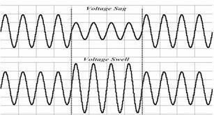The voltage rise is defined as the increase in the voltage value from the fundamental value, for example, during the half cycle at 1 minute, the change in voltage from 10 to 80%. Also, when the voltage drops, the surge causes a continuously increasing voltage profile. There are several types of stress swelling, including i. Immediate swell, ii. Temporary storm surge, and iii. Temporary swelling. When the connection of large loads is interrupted, an increase in voltage also occurs. An increase in the faulty phase voltage and loose connection of the natural wire causes a single line to ground (SLG) fault. Overheating and destruction of electrical instruments and breakdown of insulation are consequences of power surges. Figure 1 shows the stress increase in the stress profile.

Fig1: Voltage waveform with sag and swell [7].

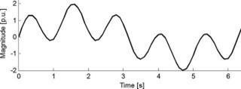Harmonic distortion is the problem of voltage produced by variation in the fundamental by three, for example 50 Hz fundamental when multiplied by three as 3 × 50 = 150 Hz. That is the 3rd harmonic of the fundamental frequency, as shown in Figure 2, the waveform with harmonic content. The switching function in power electronics causes the generation of harmonics. Failure of circuit breakers, overheating of neutrals, transformers and other power distribution instruments, destruction of circuits without proper handling based on a clear sine wave energized at the zero crossing point are the indicators of a harmonic problem [3], [8].

Fig2: Waveform with harmonic content [7].

The main contributions of this research work are summarized below:

* Reduce THD to below 5% by mitigation the problem of distorted voltage due to subsidence, swell or harmonics.
* Access and analyze the performance of the proposed model with the use of MATLAB / SIMULINK in combination with the use of DVR and also without.
* Examine the power system by inserting harmonics 3 and 5 into the input voltage profile.
* to evaluate DVR performance based on: power system with the same insertion of harmonics 3 and 5 comparing their results to a system without DVR.

The rest of the document is organized as; Part II provides a comprehensive overview of the literature on the use of DVR. The mechanism, working principle and operation of the DVR are shown in section III; the results of the simulation are presented and discussed in section IV and finally a conclusion is drawn focusing on the main findings of this work.

1. **LITERATURE SURVEY**

Transmission and distribution system problems were addressed in some countries using the FACTS and D- FACTS devices. According to the IEEE recommendations, FACTS can be expressed as [9], "AC transmission systems incorporating static and power electronics-based controllers for increased power transfer and more immeasurable manageability." Today, the demand for electricity has increased significantly while the development of generation and transmission systems is not enough due to limited resources, economic problems and some environmental restrictions. The current transmission system cannot be easily expanded due to limited resources. That is why expanding transport capacity is a feasible solution. Transmission lines are not fully utilized due to a number of limiting factors that affect the carrying capacity of the transmission line. These factors are considered the thermal, dielectric and stability limit. FACTS controllers can control the power and increase the usable capacity of current lines. FACTS controllers allow current to flow through the line under normal conditions and when exposed to faults and allow a line to carry current close to thermal values [10], [11].

The DVR is used in the distribution feeder to protect the load from faults due to voltage sags and spikes. The DVR is mounted in series with the load and a Battery Energy Storage System (BESS) is connected to a transformer and an inverter is also connected to the DVR, offsetting active and reactive power needs for brownout reduction and overvoltages [12]. For voltage stability, the DVR injects voltage to the distribution system, the DVR to the system through the transformer. The DVR is the FACTS device, which compensates for disturbances such as voltage sags, swells, and load voltage harmonics. DVR injects the voltages in series with the transmission lines and injects a small number of voltages under normal conditions. But when a fault occurs, the DVR calculates the necessary voltages to protect the load through sinusoidal pulse width modulation (SPWM). Then those voltages are injected into the system to maintain the situation. In steady state, the DVR absorbs or supplies the active orreactive power, but when a fault occurs, the DR supplies or absorbs the active or reactive power of the DC link [13].

Martiningsih et al., recommended the installation of DVR, its power station PT DSS, the DVR acts as a compensator and is connected in series with the distribution line. The proposed PI-based DVR is capable of recovering from power quality limitation. [14]. Eltamaly and others have proposed a DVR-based strategy to reduce voltage drop across DVRs to improve power system quality. Until the degradation in the performance of electrical equipment. The results determine that the DVR adequately compensates for dips/swells and implements the correct voltage adjustment [15]. Ali and others have proposed a new DVR with a power electronic transformer (PET) to reduce symmetric and asymmetric sag and expansion. The results show that the new design effectively reduces symmetric and asymmetric voltage sag and voltage expansion in the distribution line [16].

# PROPOSED DYNAMIC VOLTAGE RESTORER

The frequency of the supplied voltage can determine the quality of the power supply, which is an important indicator of the quality of the power supply. The voltage

drop is interpreted as a drop in the RMS (Root Mean Square) value of voltage that can occur from 10 ms to 60 seconds with a voltage drop depth of 0.9 per unit (p.u) 0.1

p.u of a nominal p.u to IEEE standards [22]–[24]. Regular brownouts are typically monitored for load at the distribution level for various reasons. Voltage dips are very unbearable for some delicate loads in high-tech sectors. Load stress requirements can be maintained through complicated tasks with a specific frequency and exact value of stress sag during deformation and oscillation.

Typically, manufacturing destruction and downtime is the result of a brownout that is costly and creates serious problems for consumers. A specific amount of power and voltage is supplied to the distribution system through the use of electrical appliances which are also called power consuming appliances. The complex problem could be mitigated. Compared to conventional voltage drop troubleshooting methods, DVR is believed to be an efficient method to control voltage drop and distortion. In this work, the performance of the power system is evaluated by eliminating voltage drop through a DVR at the distribution level.

## PRINCIPLES OF DVR OPERATION

A DVR consists of a GTO or IGBT-based voltage source converter (VSI), an energy storage instrument, a capacitor bank, and an injection transformer. DVR is also known as solid state power electronics. Figure 3 shows a DVR connected to a distribution bus.

Practical guideline of DVR how it works by transformer injection methods; a hard-conversion converter creates a control voltage, which is matched to the bus voltage. In [25], [26] different transducer control topologies for drop-controlled transducers are presented. The DC voltage source behaves as an energy storage device provided by the DC capacitor, as shown in figure 4. To reduce the problem of voltage, drop, the DVR does not do it efficiently when there is no problem with voltage drop under optimal conditions. DVR will produce the required high frequency-controlled voltage with the existence of a distribution system, a required phase angle that ensures that the load is perfect and conserved. To maintain consistency in the voltage supply to the load in this situation, the capacitor will discharge. It should be noted that the DVR can absorb and produce reactive power, but an external power source is used for reactive power injection. Voltage drop detection time and power electronics shorten the response time of the DVR. Compared to conventional voltage correlation methods, for example, the response time of the DVR's bypass

transformers is less than 25 milliseconds.

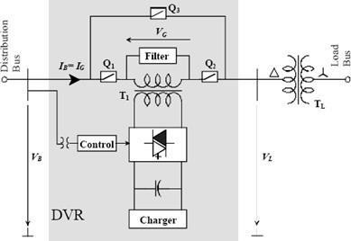

Fig 3: Principle design of DVR connected at distribution end [15].

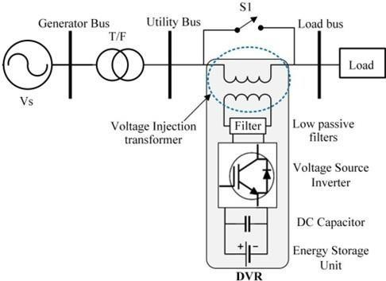

Fig4: Basic Configuration of DVR. Different filter placements in DVR [15].

1. **ENERGY STORAGE UNIT**

Various devices are used to store energy, such as flywheels, lead-acid batteries, superconducting magnetic energy storage (SMES), and supercapacitors [28]. As the voltage that is produced falls, the storage unit supplies the real power required, since it is its main function. The compensation power of the DVR is determined by the active power produced by the energy storage device. Instead of using other storage devices, devices with a longer charge and discharge response time are used, which are lead-acid batteries. The discharge rate determines the internal space available for energy storage, and this discharge rate is based on a chemical reaction [29], [30].

1. **VOLTAGE SOURCE INVERTER**

The use of pulse width modulated VSI (PWMVSI) is widespread. A DC voltage has been created across an energy storage device, as explained in the previous section. A VSI is the source of the DC-AC voltage voltage conversion. When the dip occurs, a boost voltage injection transformer in the DVR's power circuit is used to increase the magnitude of the voltage. Therefore, a minimum voltage value at VSI is sufficient.

1. **PASSIVE FILTERS**

The use of low passive filters in this method converts the PWM inverted pulse waveform to a sinusoidal waveform. In VSI, to achieve this conversion, it is mandatory to remove the high-quality harmonic components during the DC-AC transformation, and also compensated output voltage. A passive filter is an essential source in the voltage converter. That is why it is used both on the low voltage side, such as the inverter side of the injection transformer, and on the high voltage side, such as the load side, as shown in Figure 5.

If we put the filters on the inverter side, it can exceed the maximum value of harmonics that pass through the voltage transformer. So the voltage on the injection transformer is also reduced. When the filter is placed on the inverter side and causes reversed phase shift and voltage drop, that is the downside of the filter. This problem can be solved by placing the filter on the load side. The secondary side of the transformer allows for the high rated harmonic currents because the transformer is needed with high values.

1. **BYPASS SWITCH**

DVR is a daisy-chain device. The current flowing through the inverter when the fault exists on the downstream phase causes a fault current. The bypass switch is used to protect the drive. Typically, a toggle switch is used to bypass the inverter circuit. As long as the current is within the range of inverter parts, the lever detects the scale of the current and finally turns it off. On the other hand, it allows bypassing the inverter components when the current is high [15].

1. **VOLTAGE INJECTION TRANSFORMERS**

There are two sides of the voltage injection transformer as one is the primary side connected in series with a distribution line. The other is the secondary side that is connected with the power circuit of the DVR. For 3-phase DVR, one 3-phase transformer or three single-phase transformers can be used, but for single-phase DVR, only one single-phase transformer is allowed. The “Delta-Delta” type connection is used at the moment of contact between the three-phase DVR and three single-phase transformers [31].

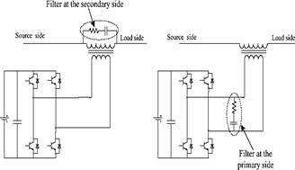

Fig5: Different filter placements in DVR [15]. Single line diagram of test system without DVR

Usually, the amount of voltage supplied by the VSI output filtered to a necessary range also simulates the DVR circuit of the transformation network caused by the configuration transformer. According to the required voltage on the secondary side of the voltage, the previously examined and significant values are turns ratios. Inverter circuit components suffer from high turns ratio cost with high frequency currents: primary side current with high winding high frequency ratios can affect inverter circuit components. The value of the transformer is an important reason to determine the working efficiency of the DVR. The importance of the turns ratio of the injection transformer refers to the upstream distribution transformer. Should a Δ-Y association occur with the unbiased ground, no zero group current will flow to the auxiliary current during an unbalance deficiency or a ground deficiency on the high voltage side. In this way, only the positive and negative segments are rewarded by the DVR [32].

**B. BUSINESS MODES**

1. **A VOLTAGE SAG/SWELL IN THE LINE**

The power supply elements are used to provide the storage power and use the reactive power to inject power into the DVR when there is a difference between the dropout voltage and the dropout voltage. The maximum capacity of the DVR is limited due to DC power storage estimates and the voltage insertion transformer ratio. In the case of 3 single-phase DVRs, the degree of injected voltage can be estimated individually. The injected voltages are composed as a frequency and phase angle comparable to the system voltages [33].

1. **IN NORMAL OPERATION**

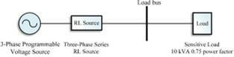The DVR would not inject voltage to the load if there is no drop during normal process. The device works in self- charging media or standby when the energy storage device is finally charged. There are several self-sufficient sources by which the energy storage device could be charged.

1. **A SHORT CIRCUIT OR A FAILURE**

A bypass switch is simulated during the downstream movement of the distribution line, and in order to avoid the electrical parts of the inverter, it will be bypassed from the inverter circuit [15].

**C. COMPENSATION TECHNIQUES**

1. **PRE-SAG COMPENSATION**

It is a process used for non-linear loads, for example, thyristor controlled drives. Phase angle and voltage magnitude compensation is performed on non-linear loads. The pre-sag compensation method is shown in Figure 6(a). This method requires a voltage injection transformer and a high value energy storage device.

1. **PHASE COMPENSATION**

The in-phase compensation method is used for active loads. There is only a compensation requirement for voltage magnitude, but not for phase angle compensation. The voltage in compensated form is in phase with the collapsed voltage in this method. For compensation and support of DVR in terms of energy storage devices, the process is presented in Figure 6(b), it is used when both real and reactive power is required.

1. **GRAPHICAL RESULTS AND DISCUSSION**

The simulations run on Intel(R) Core(TM) i5-7200U at 2.5 GHz and Windows 10 operating system. The MATLAB/Simulink software environment has been adapted to perform the analysis of the proposed configuration.

The 10 kVA load with a power factor of 0.75 is considered a sensible load. Sensitive load is supplied by 415 V load and 50 Hz frequency to a three-phase power system. The single-line diagram of the test system without DVR is shown in Figure 7. It shows that the test system has a Three-phase, it is connected to a programmable voltage source, an RL source and an active and reactive sensitive load. Table II below lists the test system parameters and values. In this chapter, a convention of black, red and blue is adapted for all three phases and with the same line design.

The simulation was performed with a three-phase test system without a DVR connected to sensitive loads in MATLAB/Simulink and then a proposed DVR model with the power system in Simulink is shown in Figure 7. The simulations were performed with a triphasic test system of and without DVR connected to sensitive loads in MATLAB/Simulink. The single-line diagram of the test system and DVR is shown in Figure 8(a), and its Simulink screen is also illustrated in Figure 8(b).

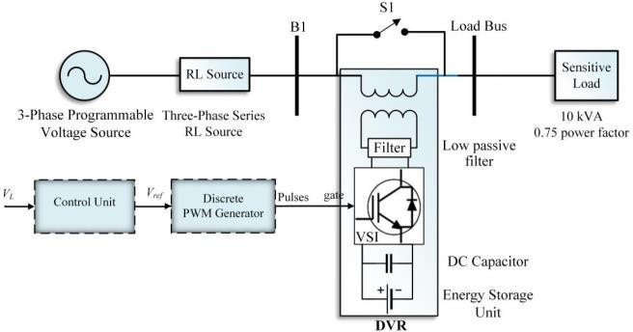

Fig6: Single line diagram of test system without DVR

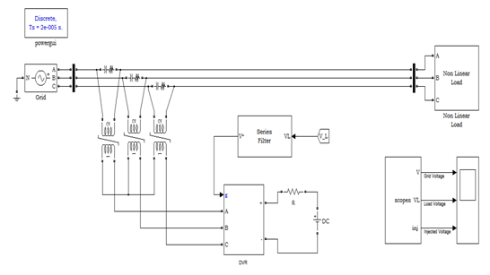

Fig: 7 (a) Single line diagram of test system with DVR (b) Simulink model of the test system with DVR.

Simulation results are given here for non-linear loads. Fig. 8 and fig.9 shows the load voltage and current before connecting the series active filter and Fig. 10 and fig. 11 shows the charging load voltage and load current after connection to DVR.

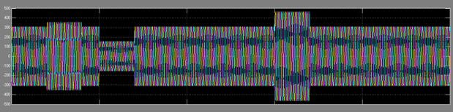

Fig.8 Graphical representation of load voltage without DVR

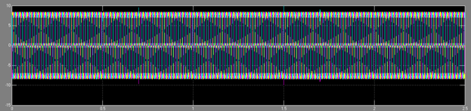

Fig. 9 Graphical representation of load voltage without DVR

For successful performance of HseAPF is the reference voltage. In this article, the reference voltage is presented using the instantaneous reactive power factor. HSeAPF helps reduce total harmonic distortion and keep it at an acceptable level. HSeAPF helps improve power quality. Simulation results with MATLAB/Simulink confirm this. Neuro Fuzzy Controller can be used effectively and efficiently to control hybrid series active power filters. 2.40% and 2.69%, and for scenario 2, there were 3.74%, 4.04% and 3.60% of THD in the voltage profile. This improvement and reduction of the THD in the load voltage explains the effectiveness of the DVR-based control strategy used in this work.

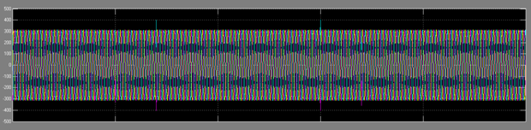

Fig. 10. Graphical representation of Load Voltage with Dynamic Voltage Resorer.

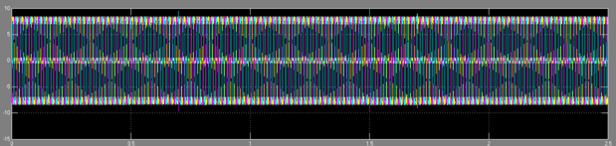

Fig. 11 Graphical representation of Load Current with Dynamic Voltage Resorer.

**V. CONCLUSION**

The DVR is presented as the most prominent device to improve power quality and proved to be a useful and high- performance device. Through the MATLAB/Simulink platform, a simulation of a DVR with a power circuit is carried out through the structure and modeling of the control circuit and the power system with sensitive load. DVR was implemented with the test system and tested with and without DVR. A programmable voltage source is used to supply a distorted voltage first with 3rd harmonic content and then with 5th harmonic insertion into the supply voltage. The proposed DVR-based control strategy was effective in compensating for distorted load voltage and maintained a more stable and smooth voltage profile with much lower harmonic content. In order to keep the normal and stable charging voltage in the optimal range, correction of any voltage supply problems is possible when the DVR injects the proper voltage component this research.

**REFERENCES**

1. N. Khan, S. Dilshad, R. Khalid, A. R. Kalair, and

N. Abas, “Review of energy storage and transportation of energy,” Energy Storage, vol. 1, no. 3, Jun. 2019, doi: 10.1002/est2.49.

1. M. A. Basit, S. Dilshad, R. Badar, and S. M. Sami ur Rehman, “Limitations, challenges, and solution approaches in grid‐connected renewable energy

systems,” Int. J. Energy Res., no. June 2019, p. er.5033, Jan. 2020, doi: 10.1002/er.5033.

1. A. Kalair, N. Abas, A. R. Kalair, Z. Saleem, and

N. Khan, “Review of harmonic analysis, modeling and mitigation techniques,” Renew. Sustain. Energy Rev., vol. 78, pp. 1152–1187, Oct. 2017, doi: 10.1016/j.rser.2017.04.121.

1. F. H. Gandoman et al., “Review of FACTS technologies and applications for power quality in smart grids with renewable energy systems,” Renew. Sustain. Energy Rev., vol. 82, pp. 502– 514, Feb. 2018, doi: 10.1016/j.rser.2017.09.062.
2. A. M. Sharaf and A. A. Abdelsalamy, “A novel facts based dynamic voltage compensation scheme for smart electric grid stabilization and efficient utilization,” in 24th Canadian Conference on Electrical and Computer Engineering(CCECE), May 2011, pp. 000042–000047, doi: 10.1109/CCECE.2011.6030405.
3. A. R. Kalair, N. Abas, A. Kalair, Q. U. Hasan, and

N. Khan, “Impact of FACTS Devices on Transmission and Distribution System.,” J. Act. Passiv. Electron. Devices, vol. 14, no. 4, 2019.

1. M. Büyük, M. Inci, and M. Tümay, “Performance comparison of voltage sag/swell detection methods implemented in custom power devices,” Rev. Roum. Sci. Techn.–Électrotechn. Énerg, vol. 62, no. 2, pp. 129–133, 2017.
2. Y. W. Li and J. He, “Distribution system harmonic compensation methods: An overview of DG- interfacing inverters,” IEEE Ind. Electron. Mag., vol. 8, no. 4, pp. 18–31, Dec. 2014, doi: 10.1109/MIE.2013.2295421.
3. N. G. Hingorani and L. Gyugyi, Understanding FACTS: Concepts and Technology of Flexible AC Transmission Systems. New York, USA: Wiley- IEEE press, 2000.
4. Y.-H. Song and A. Johns, Flexible ac transmission systems (FACTS), no. 30. IET, 1999.
5. K. Habur and D. O’Leary, “FACTS-flexible alternating current transmission systems: for cost effective and reliable transmission of electrical energy,” Siemens-World Bank Doc. Draft Report,

Erlangen, p. 46, 2004

[20] A. I. Omar, S. H. E. Abdel Aleem, E. E. A. El- Zahab, M. Algablawy, and Z. M. Ali, “An improved approach for robust control of dynamic voltage restorer and power quality enhancement

1. W. Frangieh and M. B. Najjar, “Active control for power quality improvement in hybrid power systems,” in Third International Conference on Technological Advances in Electrical, Electronics and Computer Engineering (TAEECE), Apr. 2015, pp. 218–223, doi: 10.1109/TAEECE.2015.7113630.
2. S. Agalar and Y. A. Kaplan, “Power quality improvement using STS and DVR in wind energy system,” Renew. Energy, vol. 118, pp. 1031–1040, Apr. 2018, doi: 10.1016/j.renene.2017.01.013.
3. W. Martiningsih, U. Yudho Prakoso, and Herudin, “Power quality improvement using dynamic voltage restorer in distribution system PT. DSS Power Plant,” MATEC Web Conf., vol. 218, p. 01003, Oct. 2018, doi: 10.1051/matecconf/201821801003.
4. A. M. Eltamaly, Y. Sayed, A.-H. M. El-Sayed, and

A. N. A. Elghaffar, “Mitigation voltage sag using DVR with power distribution networks for enhancing the power system quality,” IJEEAS Journal. ISSN, pp. 2600–7495, 2018.