**“DESIGN AND DEVELOPMENT OF AUTOMATIC SOLAR POWERED CROP CUTTER FOR HARVESTING”**

**Akshay Patil, Rutuja Patil, Sakshi Patil, Priyanka Waghela**, **Anuraj Patil,**

**Prof.Ganesh Rakate.**

DEPARMENT OF MECHANICAL ENINEERING

ANNASAHEB DANGE COLLEGE OF ENGINEERING AND TECHNOLOGY, ASHTA, SANGLI, INDIA

**ABSTRACT**

Now a day’s problem of power cut related to pollution etc. we face such a problem, to avoid or deal with this problem, we have a plane to make a device that does not face such a problem, so we think of a device that can run its function. Without causing problems, the crop cutting project here we have chosen to use renewable energy sources due to the energy efficiency of the solar energy harness. The purpose of the design is to find a mower that is portable, durable and easy to operate. It also aims to develop a self-propelled electric lawn mower. The battery powered computer electric motor is at the center of the gadget. There is a speed multiplier wheel that drives the cutting blades, as well as a 12V alternator charger and a lifting mechanism to change the cutting height. The design is unique because it does not require an engine due to the use of folding blades and a built-in alternator to charge the battery. With a labor force of 0.24kN, the cutting efficiency was 89.55 percent in the performance test. As a result, the tool is considered highly productive and adaptable to all kinds of cutting conditions.

**Keywords:** Agriculture, Crop Cutting, Farming, Renewable Energy, Solar Energy Etс.

**1.INTRODUCTION**

In recent years, interest in the development of autonomous vehicles in agriculture has increased. This development led many researchers to start developing more rational and adaptive vehicles. In the field of autonomous agricultural vehicles, a number of small autonomous machines are being conceptualized to determine whether they will outperform conventional large tractors in terms of efficiency (Blackmore et al., 2004). These vehicles must be capable of operating 24 hours a day, 365 days a year in most weather conditions, and must be intelligent enough to operate in a semi-natural environment for long periods of time unattended while performing useful functions. Task In addition, such a system can have a lower environmental impact if it can reduce the use of chemicals and the use of large amounts of energy, such as diesel and fertilizers, through control that is more responsive to stochastic requirements.Solar energy is currently the most effective alternative energy source in this case. Solar crop cutters are based on the grazing principle. The Sun provides a consistent amount of energy to the Earth's atmospheric system, which is used for a variety of purposes. The total amount of solar energy is 30,000 times the world's annual energy. Solar energy harvesters are based on the same principles as the early inventions of other harvesters. It generates the energy required to power the chair using flat plate solar collectors. A harvester that uses the sun as its energy source is expected to solve some problems that are not associated with conventional IC engines and motor-driven electric harvesters. Solar tillers will be easier to use, less time consuming and user friendly.

**METHODOLOGY**

Planning

Software Development

**2.1 Planning**

**2.1.1 Design**

The design contains a attractive and high durable machine compare to the other machines available in the market. The design is compact and light weight which makes it easy and simple to use.

* **2.2 Implement**
* **2.2.1 Development**

The crop is made up of a number of components like DC motor, Rechargeable Battery, Solar Panel, and Solar Charge Controller . These components are mounted on a welded chassis which are placed on two vehicles which is measuring one inch in length,. and they are all linked by an electrical system. The solar Energy is converted into Electrical Energy and that energy is store in the Battery .and then its converted into Mechanical Energy .

1. **MODELING AND ANALYSIS**

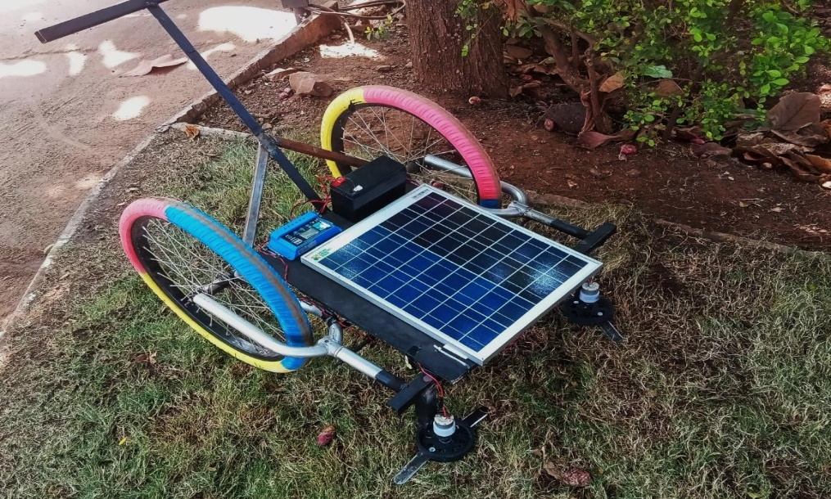

**Figure 1:** Project setup

1. **RESULTS AND DISCUSSION**

The concept is defined in this initial phase followed by a very simple design that continues throughout the project.The experience gained in the project, including planning and skills in use of different tools, can help us develop the career path in the future.The development of solar energy is a critical component of this study, because a strong interaction between several components is required. The main goal of this project work is to cut plants in the best way possible. This is a cheaper and more environmentally friendly process. The machine running time is about two hours continuous which can it work in one time charge of battery.

**3.REFERENCES**

1. Sachin. M. Moghe, 2015, "A Review on Human Powered Mini Paddy Harvester", International Journal for Engineering Applications and Technology, ISSN: 2321-8134, Vol. 15(4), pp. 1-6.
2. Kongre U. V, 2017, "Fabrication of Multi-Crop Cutter", International Journal of Research in Science and Engineering, ISSN: 2394-8299, Vol.2 (3), pp.1-9.
3. Kongre U. V. Lokesh Shahare, Aakash Mutkale, and Akshay Komawar, 2017 "Design of Multi-Crop Cutter”, International Journal of Research in Engineering, ISSN: 2394-8280. Vol. 2(3), pp.1-7.
4. Pedersen S.M, 2004, "Agricultural Robots-Applications and Economic Perspectives", University of Copenhagen Vol. 21, pp.1-8.
5. Zakiuddin K.S., Singh M. P., Modak J. P, 2019, "Design and development of the human energized chaff cutter". New York science journal, Vol.73 (5), pp.1-5.
6. Maruthi G. Prasad Yadav, GMD Javeed Basha, 2016 “Fabrication and performance test of an Ultraportable Crop cutter”, IJRSET, Vol. 2(5), pp. 1- 7.