**WORKING OF HOUSE COOLER USING SOLAR POWER**

**-**

**LAXMAN TUKARAM TAMBE, DIPALI NANASAHEB MORE, KHALAPURIKAR G.M.**

1.HOD, MECH DEPT, MS. POLYTECHNIC, BEED, MAHARASHTRA,INDIA

2 LECTURER, EE DEPT, YCIP ,BEED, MAHARASHTRA, INDIA

3 LECTURER, MECH DEPT, ADITYA POLYTECHNIC,BEED, MAHARASHTRA, INDIA

1. **ABSTRACT**

Using solar power we can run home appliances like cooler. Energy comes in different forms. Light is a form of energy. So is heat. So is electricity. Often, one form of energy can be turned into another. This fact is very important because it explains how we get electricity, which we use in so many ways. Electricity is used to light streets and buildings, to run computers and TVs, and to run many other machines and appliances at home, at school, and at work. One way to get electricity is toThis method for making electricity is popular. But it has some problems. Our planet has only a limited supply of oil and coal.In this method details about Endless Energy, Solar Cells Galore, Energy from Sunshine , Understanding Electricity. This is mechanical and electronic device

Keywords: D.C. Motor, Solar Panel; Frame, Charge Controller, Switches, battery.

1. **INTRODUCTION**

COOLER

BATTERY

SOLAR PANEL

CHARGE

CONTROLLER

FIG. Block Diagram

In all country facing problem of fuel and electricity in some villages due to this issue load shedding is applied for government to save electricity .In some villages there is no electricity available especially mountain and hilly area. In this area this will be best solution for summer session.

**LIST OF PART**

1. **SOLAR PANEL**
2. **CHARGE CONTROLLER**
3. **BATTERY**
4. **COOLER**
5. **SOLAR PANEL**

Solar panel 24 volt is used for track power for run cooler.330 watt power can be generated by using th8is solar panelcost -effective polycrystalline technology.built with high efficiency a grade 5bb solar cells.ar-coated glass for better sunlight absorption.silver anodized aluminium frame with mounting holes for fast & easy installation.excellent power output in low light & cloudy skyconditions.double el tested for hot spots & microcrack free solar modules. water & dust proof ip68 rated junction box with 4mm cableand 2 mc4 connectors.bestcompatible with24v inverter & 24v battery setup.bis certified, almm listed & complies with all iec standards.value for money. lower installation cost & higher roi.

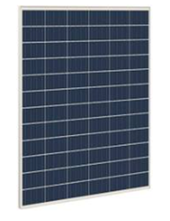

FIG:-SOLAR PANEL

1. **CHARGE CONTROLLER**

This is a Digital PWM Solar Charge Controller for the lead-acid batteries connected to a solar power system. When connected to the battery, this charge controller automatically detects the battery voltage from 12V-24V. This charge controller has some advanced features like built-in short circuit protection, open-circuit protection, reverse voltage protection, overload protection, etc which makes it ideal for grid power systems.

#### **Features:**

1. Built-In Industrial Micro Controller
2. Big LCD Display
3. Full 4 Stage PWM Charge Management
4. Dual MOSFET Reverse Current Protection
5. Low Heat Production
6. Built-In Industrial Micro Controller
7. Big LCD Display
8. Full 4 Stage PWM Charge Management
9. Low Heat Production
10. Automatic identification of system voltage level
11. Adjustable parameters of battery charge-discharge control
12. Settable operating modes of load
13. With dual USB 5V output
14. Battery type setting
15. Dual Mosfet reverse current protection

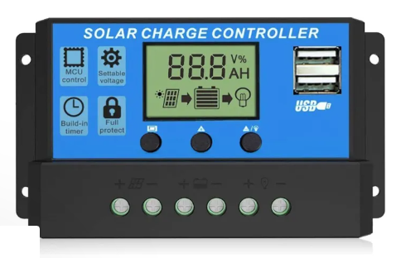

**Figure 3:** Charge Controller.

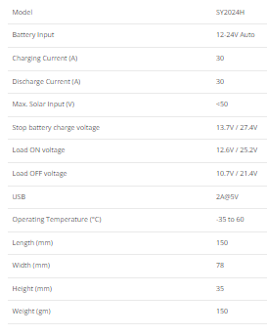

Table 1 : features of charge controller

# 3 D.C. MOTOR

High Torque D.C. motor with 4000 rpm and 12 V Motor Having Shaft Dia. 3.17 Mm and total length of motor diameter 36 mm and body dia. 50 mm.

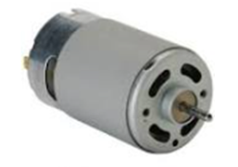

Figure 4:- DC Motor

1. **. BATTERY**

A 24 Volt system is made up of two 12 Volt batteries connected in series and is known as a pack. The voltages of each battery are added together whilst the Ah capacity of the pack remains the same as that of a single battery.

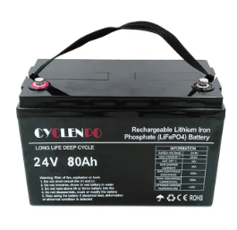

**FIGURE 5:- BATTERY**

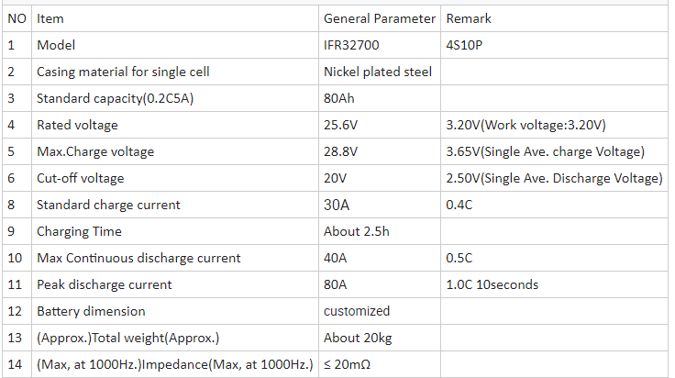

TABLE 2:-BATTERY FEATURES

1. **DISCHARGE TIME**

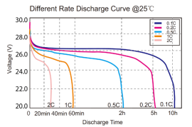

1. **WORKING**

Working of solar cooler is very easy. We have keep our solar pane in sun light. Output of solar panel is input od charge controller and output of charge controller is input of battery .Battery supply power to DC MOTOR.DC motor in fitted to frame of cooler .operating of this cooler is user friendly and easy. As we are using this cooler in home there is no risk of electric shock.

1. **CONCLUSION**

This Type of devices in need of world to save electricity and energy sources. By using such type of equipment we can generate power in that area where no electricity is available.

1. **REFERENCES**
2. <https://www.pdfdrive.com/solar-power-books.html>
3. owerBrick_PRO+_24V_150Ah_Lithium-Ion_battery.pdf <https://dl.icdst.org/pdfs/files/b334382400c223631bea924f87b0a1ba.pdf>
4. <https://d1.amobbs.com/bbs_upload782111/files_36/ourdev_618134W9PIAM.pdf>
5. Ganesh Kumar and P.Vasanth Sena, “Novel Artificial Neural Networks and Logistic Approach for Detecting Credit Card Deceit,” International Journal of Computer Science and Network Security, Vol. 15, issue 9, Sep. 2015, pp. 222-234
6. Gyusoo Kim and Seulgi Lee, “2014 Payment Research”, Bank of Korea, Vol. 2015, No. 1, Jan. 2015.