Accident Prevention for EV by using Ultrasonic Sensors

Piyusha Suryawanshi*1, Rahul Mali*2, Pranali Suryawanshi *3, Londhe Shreysah*4

*UG Scholor ,Department Of Elecrical Engineering*

*Annasaheb Dange College Of Engineering and Technology,Ashta,Maharashtra* [*piyusha24122001@gmail.com*](mailto:piyusha24122001@gmail.com)[*pranalisuryawanshi209@gmail.com*](mailto:pranalisuryawanshi209@gmail.com%20) [*accrakeshmali@gmail.com*](mailto:accrakeshmali@gmail.com%20) [*shreyashlondhe28@gmail.com*](mailto:shreyashlondhe28@gmail.com)

Date of Submission: 24-03-2023 Date of Acceptance:

## ABSTRACT:

Every day, numerous people are killed in traffic accidents. Typically death arises owing of the passenger was hurt in a car accident, but most of the time the information about the accident did not reach the emergency room until it was too late, and the injured person died as a result. As a result, every automobile must have an automated system that not only detects a road collision effectively but also immediately notifies the emergency department. A variety of automatic road accident detection technologies have been proposed by researchers. Airbags, cellphones, infrared sensors (IRsensors), and mobile applications are commonly used in these strategies. None of these strategies are perfect for detecting traffic accidents automatically. The filters used in cellphones can make identifying low-speed fender benders challenging. The suggested system does not specify the threshold distances on which it would react when using an infrared sensor. The airbag technique is not intended for motorcycles or cycles. If a mobile application is utilised for accident detection, different smart-phone models have varied processor speeds, hence the programme may not operate well in all models. As a result, a unique technique based on ultrasonic sensors is offered in this study. Accident detection employing an ultrasonic sensor allows for the identification of an accident not only in diverse street settings, but it may also work effectively under adverse conditions.

## INTRODUCTION

Self-driving cars are being billed as the ultimate solution for future automotive technology because they will revolutionize the transportation industry like no other change since the invention of the automobile. Over the last century, automotive innovation has resulted in safer, cleaner, and more affordable vehicles, but progress has been slow. Industry is currently experiencing a paradigm shift towards autonomous driving technology. This technology has the potential to bring enormous benefits to society in terms of road safety, no accidents, no congestion, no pollution, and most importantly, the safety and benefits of disabled people in society.

Self-driving cars use a variety of sensors and actuators that make driving decisions based on various parameters to move a manually driven car into a self-driving car. Self-driving cars sense their environment and function without human intervention. A human does not need to control the vehicle or be physically inside the vehicle. Fully automated cars are confident and able to make their own decisions.

Collision avoidance systems are a technology that is currently emerging in the automotive field. Pre-crash systems, forward collision warning systems, and collision avoidance systems and automatic collision avoidance systems are other names for these systems. Because Traffic accidents are the greatest source of death and injury globally, automatic collision avoidance systems are automotive safety systems designed to reduce accidents. If the driver is not paying attention to the road and other parameters, it can cause damage not only to the vehicle (car), but also to life. One Play Danger for the future. An automated anti-collision system is installed inside the vehicle to warn the driver of potential road hazards. Once detected, the system either warns the driver of an impending collision or takes autonomous action (by braking or steering) without driver direction. In this system, a microcomputer detects an obstacle with a speed sensor and issues a command to an actuator to stop the vehicle. Advances in technology make it possible to minimize human error and avoid casualties.

## Literature Review

* **"Sensor-Based Accident Prevention System" Aravinda, Chaithra Lakshmi C, Deeksha, and Ashutha K are the authors.**

This article introduces an accident prevention system using sensors. That is, put an ultrasonic sensor on one side of the road before the curve and an LED light after the curve. Ultrasonic sensors, often known as obstacle sensors, convey signals as pulses from a trigger. If a vehicle is there, the signal strikes the vehicle and is picked up by the sensor. At this point, the bright side of the curve lights up. If there is no car, the light will not come on because the sensor will not receive the signal. When a signal is detected, the vehicle lights come on to inform the driver that a vehicle is approaching from the front. The driver senses the signal and brakes or stops the vehicle if necessary. This paper's goal is to minimise the amount of accidents on curving roadways. It does this by warning the driver via LED lights that come on when the vehicle is coming from the wrong side of the curve. Vehicles are detected using an ultrasonic sensor connected to an Arduino UNO microcontroller. This could save thousands of lives on the winding streets [1].

* **“Diminishing Road Accidents On Sharp Curves Using Arduino”. Ranga Sreedhar**

**Galla.**

The goal of this text is to reduce accidents on slippery roads and slopes. The driver cannot see the other side of the road from the car on curving roads. Many accidents occur at night as a result of the strong illumination from incoming vehicles' headlights. Furthermore, the problem of nighttime light intensity will arise on twisting highways and mountain routes, claiming human life. The answer is to notify drivers of cars approaching from the other direction. This is performed by installing an ultrasonic sensor and an LED light on one side of the road before the bend on the other side of the road after the bend. This enables the sensor to identify when a vehicle approaches Turn on the LED lights on the other side of the curve.

* **"Smart Mountain Road Safety and Vehicle Accident Prevention System" Sandeep Rudra, Kartik Venkata Mutya.**

Road traffic accidents are Several governments recognise it as a severe public health risk, and the number of deaths in developing countries is growing substantially. One of the most important elements in all traffic accidents is careless and reckless driving as a result of prolonged waiting and blind turns. Every year, an estimated 1.1 million people are killed in traffic accidents, with another 19 million to 49 million wounded. To prevent these traffic accidents, a dependable and cost-effective technique is required. It is hoped that the procedures given in this article would assist ease this anxiety, particularly in the case of major highway vehicle accidents. This method is simple to adopt in low-income nations, and it has the potential to save thousands of lives.

## METHODOLOGY



**Fig. Block Diagram Of Proposed system**

Because electric vehicles are more efficient, It is less expensive to charge an electric car than to fill up with gasoline or diesel for your travel requirements. Uses might include self-driving autos. To detect the EV's surroundings, we placed an object-sensing ultrasonic sensor that detects instant and nearby objects and relays information to the sensor. When the ultrasonic sensor detects an object, it outputs the distance between the objects to the display. The distance between them decreases as they get very close to the vehicle. It employs an 8-axis ultrasonic sensor that detects objects in 360 degrees and subtly changes direction depending on the orientation of the object. This autopilot mode done so that the direction of the speed of the car object changes. It also uses the orientation of the front panel camera. Figure 3.1 depicts the proposed system's block diagram.

A 16MHz crystal oscillator, a USB connector, a power jack, an ICSP header, and a reset button are all included, as are 54 digital I/O pins (15 of which may be used as PWM outputs), 16 analogue inputs, 4 UARTs (hardware serial ports), a USB connector, a power jack, an ICSP header, and a reset button. There is everything needed to support the microcontroller. Just connect it to your computer through USB or power it with an AC-DC converter or battery to get started. The Mega 2560 board is compatible with most shields intended for the Uno and earlier Duemilanove or Diecimila boards. The Arduino Mega 2560 uses the ATmega2560 microcontroller.

Ultrasonic sensors have been available for decades, and their characteristics, affordability, and adaptability continue to dominate the sensor industry. An ultrasonic sensor is a piece of electronic equipment that produces ultrasonic waves, determines the distance to an item, and transforms these waves into electrical impulses.

The speed of transmitted ultrasonic waves exceeds the speed of audible sound. The ultrasonic sensor's operation is similar to that of sonar or radar in that it assesses target/object properties through appropriate processing of received sound/radio echoes. These sensors generate high-frequency sound waves and analyse the echoes.

DC motors with shaft gears for maximum performance. Since the shaft extends through the centre of the gear assembly, they are known as centre shaft DC geared motors.

# System:

The first ultrasonic sensor trig pin is connected to the microcontroller's pin 26 and the echo pin is connected to the microcontroller's pin 27, with vcc connected to +5volt and gnd connected to ground.

The second ultrasonic sensor's trig pin is linked to the microcontroller's 2 pin, and the echo pin is attached to the microcontroller's 3 pin, with vcc connected to +5volt and gnd connected to ground.

The The trig pin of the third ultrasonic sensor is connected to the microcontroller's 4 pin, and the echo pin is connected to the microcontroller's 5 pin, with vcc connected to +5volt and gnd connected to ground.

The fourth ultrasonic sensor's trig pin is linked to the microcontroller's 6 pin, and the echo pin is attached to the microcontroller's 7 pin, with vcc connected to +5volt and gnd connected to ground.

The fifth ultrasonic sensor's trig pin is linked to the microcontroller's 8 pin, and the echo pin is attached to the microcontroller's 9 pin, with vcc connected to +5volt and gnd connected to ground.

The six ultrasonic sensor trig pins are linked to the microcontroller's 10 pin, and the echo pin is attached to the microcontroller's 11 pin, with vcc connected to +5volt and gnd connected to ground.

The seven ultrasonic sensor trig pins are linked to the microcontroller's 12 pin and the echo pin is attached to the microcontroller's 13 pin, and vcc is connected to +5volt and gnd is connected to ground.

The eighth ultrasonic sensor trig pin is linked to the microcontroller A0 pin, and the echo pin is attached to the microcontroller A2 pin, and vcc is connected to +5volt and gnd is connected to ground.

We also used 16X2 display ,pin A2,A3,A4,A5 of Arduino are connected to data pin of LCD D7,D6,D5,D4, and RS is connected A6 and enable is connected A7

Buzzer pin is connected with A14 of microcontroller and gnd pin of buzzer is connected with gnd .

We also used 2 L293D motor that drives 4 motor ,pin no A8,A9,A10,A11  is connected with L293d motor driver board pin Dc1,Dc2,Dc3,Dc4 and En1,En2,En3,En4 is connected with microcontroller pin A12,A13,A15,28 .This Pin is allow to pass a particular voltage to the motors.

.

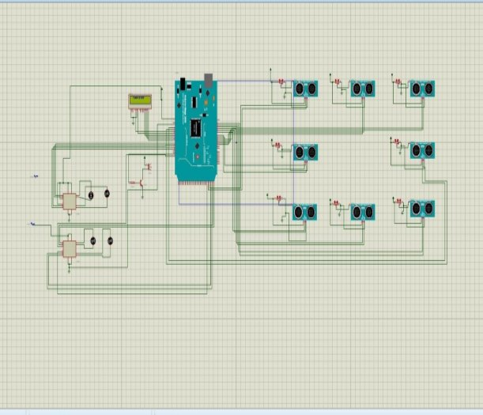

**Fig : SIMULINK Model**

**Test and Result :**

When we give the supply to EV it started and LCD get on and showes autopilot EV on display of LCD.

When other vehicles are very near to the Autopilot EV or distance between other vehicles or Autopilot EV is less then Autopilot EV runs at slow mode.

LCD display shows us EV run at slow mode.

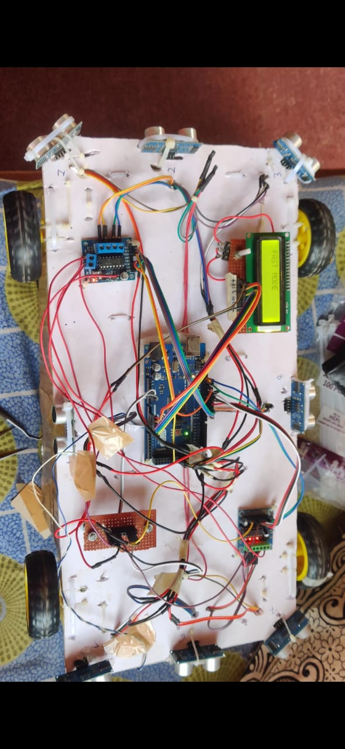

## Fig .Prototype EV

When EV is surrounded by the vehicles on left side then it automatically turn right and make the directions.



**Fig. Prototype in running condition**

When the any other objects or vehicles comes suddenly infront of EV then the Autopilot EV are automatically stops.

## Conclusion:

Individuals are constantly in a rush to get to their destination as quickly as possible in order to save time or get to their destination on time. Doing so may result in injury or death. In this project, a prototype of a vehicle collision avoidance system has been successfully implemented in an electric vehicle. The main motivation behind the project is to reduce accidents. In this project, the vehicle will automatically stop when an object approaches. It also considers vehicle speed while considering distance. Using the Arduino board and IDE was very helpful during the development of the project. You will also learn how to design circuits with Proteus design software. The full design is complete at this point, but the actual hardware implementation will begin in the next phase of the project.

# Reference :

1) Mohanad Abdulhamid, Otieno Amondi, “Ultrasonic Sensor Collision Avoidance System”, Land Forces Academy Review Vol. XXV, No. 3(99), 2020

2) Mahesh A. Rakhonde; S.A. McCullough; R D. Komati, “Vehicle Crash Detection and

Avoidance with Pollution Monitoring Systems Using IoT,” IEEE Global Conference on Wireless Computing and Networking (GCWCN) 2018

3) D.Kumar, S.Gupta, S.Kumar, S. Srivastava Accident Detection and Reporting System

Using GPS and GSM Module,” Dept. of Electronics and Instrumentation Engineering, 35 Galgotias College of Engineering and Technology, Greater Noida, India, Volume 2, Issue 5,

May 2015. 4) World Health Organization, “Road Traffic Injuries”, Letter Zugriff am

20.07.2018.

5) World Health Rankings, 'Health Profile: Pakistan', Letter Zugriff am 20.07.2018.

6) J. White, C. Thompson, H. Turner, B. Dougherty, D. C. Schmidt, “RecWatch: Automatic Traffic Incident Detection and Notification with Smartphones,” Mobile Networks.

7) S.K. Poornesh, T.V. Harsha, “Automated Vehicle Accident Detection and Messaging

Systems Using GPS and GSM Modems,” International Journal of Scientific & Engineering Research, vol. 4, S. 1937–1940, 2013. V. Praveena, A. R. Sankar, S. Jeyabalaji, and V.

Srivatsan, “Efficient accident detection and rescue system using ABEONA algorithm,” International Journal of Emerging Trends and Technology in Computer Science.

8) B. Fernandes, V. Gómez, J. Ferreira, A. Oliveira, “Mobile Applications for Automated

Accident Detection and Multimodal Warning,” 81st Vehicle Technology Conference (VTC Spring). IEEE, 2015, S. 1–5.

9) U. Khalil, T. Javid and A. Nasir, “Automatic Traffic Incident Detection Technologies: An

Overview,” International Symposium on Wireless Systems and Networks (ISWSN). IEEE, 2017, pp. 1-6.

10) Asmita H., Jathin Sreenivas, Nandini S. Kannan and Sarita, Incidents and Detections,

Volume V, Issue V, May 2016. Incident Identification System by SMS Notification,”