**Avantika Sonalikar**\*1**, Aditya Bhoyar**\*2**, Ritik Pardhi**\*3**, Vivek Patil**\*4**, Vaibhav Mohile**\*5**, Satnam Tandekar**\*6

*1Assitant Prof. Avantika Sonalikar, Department of Electrical Engineering (E&P), Priyadarshini College of Engineering, Nagpur, Maharashtra

*2,3,4,5,6Student, Department of Electrical Engineering (E&P), Priyadarshini College of Engineering, Nagpur, Maharashtra

**ABSTRACT**

The project aims at fabricating a grass cutting machine system which makes the grass cutter based motor running through solar energy. Due to the continuous increase in the cost of fuel and the effect of emission of gases from the burnt fuel into the atmosphere, this necessitated the use of the abundant solar energy from the sun as a source of power to drive a grass cutter. A solar powered grass cutter was designed and developed, based on the general principle of moving. A Solar grass cutter is a machine that uses blades to cut a lawn at an even length. Even more sophisticated devices are there in every field. Power consumption becomes essential for future. Solar grass cutter is a very useful device which is very simple in construction. It is used to maintain and upkeep lawns in gardens, schools, college’s etc. We have made some changes in the existing machine to make its application easier at reduced cost. Our main aim in pollution control is attained through this. Unskilled operation can operate easily and maintain the lawn very fine and uniform surface look. In our project, solar grass cutter is used to cut the different grasses for the different application.

**INTRODUCTION**

Conventional Grass cutter machines are operated by fuel and electrical energy which are costly and requires high maintenance . Most of the grass cutter available in today’s market is of IC engine type and runs on fuel. Use of IC engine cutter release huge amount of carbon in the environment. Pollution is a major issue for whole world. It is manmade and can be seen in own homes. The name solar powered grass cutter provides the information that the usage of solar energy to power an electric motor which in turn actuates the rotor blade and that cut the lawn. Grass cutter machines have become very essential to our daily living in maintaining the yards. Furthermore, environmental awareness on usage of grass cutting machines has caught a great interest among consumers. energy consumption is becoming an increasingly important topic. In today's climate of growing energy needs and increasing environmental concerns, alternatives to the use of non-renewable and polluting fossil fuels must be investigated. One such alternative is solar energy. A solar-powered grass cutter uses blades to cut grass at an even length. Its construction is very simple. It consists of a DC motor, a switch for controlling the motor and a battery for charging it through a solar panel. The older method of cutting grass is manually with the use of hand devices such as scissors. This requires more human effort and more time to do the work. The results are uneven. Engine-powered machines increase air pollution and noise and require maintenance. Moving standard motorpowered grass cutters require hard work and are difficult for. Cutting grass cannot be easily accomplished by the elderly and children. The advantage of powering a grass cutter by solar energy rather than by fuel is mainly ecological. With reference to current literature availability, there are different types of grass cutter that are exist in the markets, which may not fulfil the performance and operational cost criteria. The main concentration of this paper is to design and fabricate a solar powered grass cutter which is cost effective, easy to maintain, operated in rural areas, and easy to use. With the help of this portable Solar powered grass cutter, consumers can easily maintain and beautify their yards without any hassle.

**METHODOOLOGY**

Solar powered grass cutter comprises of direct current (D.C RS775) motor, a rechargeable battery, solar panel, a stainless steel blade and control switch. The solar powered grass cutter is operated by the switch on the board which closes the circuit and allows the flow of current to the motor which in turn drive the blade used for mowing. The battery recharges through the solar charging controller. Performance evaluation of the developed machine was carried out with different types of grasses.. Motor powered push lawn mowers and riding lawn mowers create noise pollution due to the loud engine, and local air pollution due to the combustion in the engine. Also, a motor powered engine requires periodic maintenance such as changing the engine oil. Even though electric lawn mowers are environmentally friendly, they too can be an inconvenience. Along with motor powered lawn mowers, electric lawn mowers are also hazardous and cannot be easily used by all. Also, if the electric lawn mower is corded, mowing could prove to be problematic and dangerous

BLOCK DIAGRAM

BLADES

DC MOTOR

SWITCH

BATTERY

SOLAR CHARGE CONTROLLER

SOLAR PANEL

**MODELLING AND ANALYSIS**

HARDWARE REQUIREMENTS

The hardware components required for the project are listed as follows

SOLAR PANEL

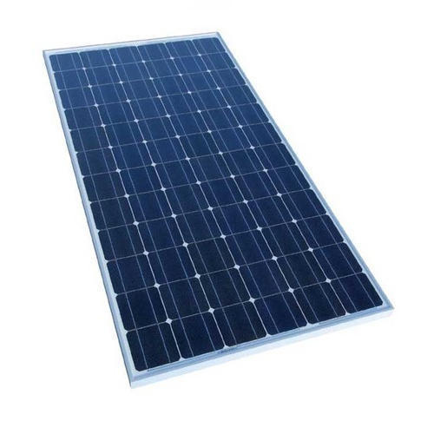

A solar panel is a set of solar photovoltaic modules electrically connected and mounted on a supporting structure. A photovoltaic module is a packaged, connected assembly of solar cells. The solar panel can be used as a component of a larger photovoltaic system to generate and supply electricity in commercial and residential applications. A solar panel is a device that collects photons of sunlight, which are very small packets of electromagnetic radiation energy, and converts them into electrical current that can be used to power electrical loads.

CHARGE CONTROLLERS

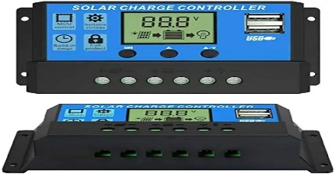

Most stand-alone solar power systems will need a charge controller. The purpose of this is to ensure that the battery is never overcharged, by diverting power away from it once it is fully charged. Only if a very small solar panel such as a battery saver is used to charge a large battery is it possible to do without a controller. Most charge controllers also incorporate a lowvoltage disconnect function, which prevents the battery from being damaged by being completely discharged. It does this by switching off any DC appliances when the battery voltage falls dangerously low.

BATTERY

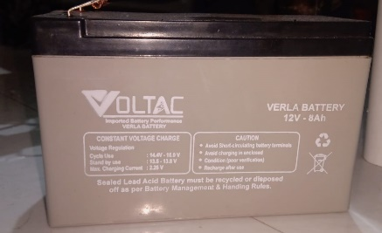

An electric battery is a collection of one or more electrochemical cells in which stored chemical energy is converted into electrical energy. The principles of operation haven’t changed much since the time of Volta. Each cell consists of two half cells connected in series through an electrolytic solution. One half cell houses the Anode to which the positive ions migrate from the Electrolyte and the other houses the Cathode to which the negative ones drift. The two cells are may be connected via a semi permeable membranous structure allowing ions to flow but not the mixing of electrolytes as in the case of most primary cells or in the same solution as in secondary cells.

RS 775 DC MOTOR

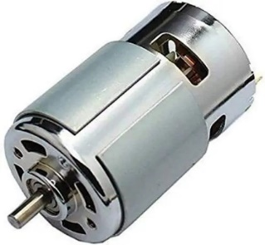

A DC motor is any of a class of rotary electrical motors that converts direct current electrical energy into mechanical energy. The most common types rely on the forces produced by magnetic fields. Nearly all types of DC motors have some internal mechanism, either electromechanical or electronic, to periodically change the direction of current in part of the motor.

BLADES

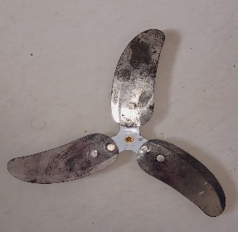

The blades are mounted according to the need. After the blade mount was finished being fabricated. inserted it on the shaft. Then to make sure the mount was supported vertically drilled a small hole completely through the mount and shaft. This allowed me to insert a bolt as an added safety measure. It is easy to cut the grass and the moving the blades will be freely. The blades moves with the help of dc motor which is connected with the blades, due to dc motor blades moves very fast which uses to move the shaft. Motor capacity is 12 watts and there is a blade arrangement in front of the frame

FRAME

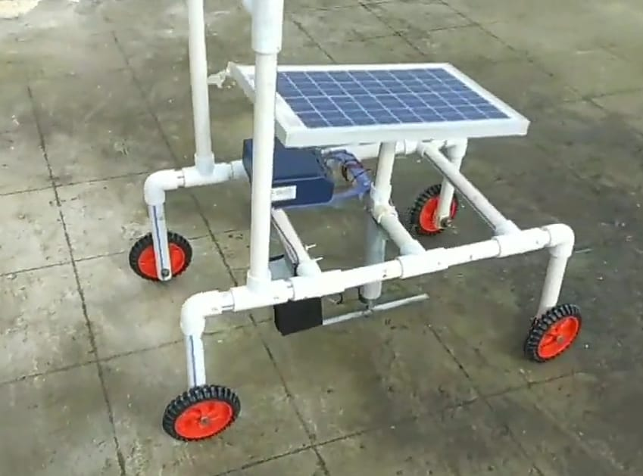

External Frame Work: The external frame work is having 1 inch PVC hallow pipes, elbows and tees. The wheels are attached to the body as shown in fig. the blade is coupled to the shaft of the motor. The motor is attached to the body through the 1 inch by 1.5 inch PVC reduceroverall height of the model is 4.5 ft.

WHEEL

Wheels are attached to the body of the model through nuts and bolts. With the help of wheels it becomes more easier to move the model from one place to the other.

**RESULT & DISCUSSION**

Rating of motor:-

Motor full load current:-2.4 Amp

Voltage:-12v

Power = Voltage × Current

Power= 12×2.4=28.8 W

* Selection of battery size,

Battery size in Ah = total load(W)×Backup time in hrs(H)

Battery Voltage(V)

=28.8×1/12

=2.4Ah

But 2.4Ah battery is not available in market hence we select the nearest available rating of battery i.e. 8 Ah

* Battery charging current,

=Battery rating× 1/10th of battery rating

= 8/10=0.8A

* Total current :- 2.4+0 .8

. =3.2 Amp

* Solar panel watts selection=Voltage × current

. =12×3.2

=38.4 W

Required rating of solar panel is not available hence we select nearest available rating i.e.40Watts

**CONCLUSION**

Our project entitled solar based grass cutter is successfully completed. It will be easier for the people who are going to use project for further modification. This grass cutter occupy less space and light in weight and as it uses nonconventional source of energy hence running cost is zero. It has facility of charging battery while grass cutter is in the working condition. The cost of solar based grass cutter is less than the market grass cutter. Grass cutter is used to keep the lawn clean and uniform in schools, gardens and playgrounds

**References**

[1] Fabrication of solar grass cutter(march-april 2016) Mr.Pankaj Malviya, Mr.Nukul Patil, Mr. Vaibhav Mandloi

[2] Solar Based Grass Cutting (January-June 2017) Ms. Bhagyashri R. Patil, Mr.Sagar S. Patil

[3] Praful P. Ulhe, Manish D. Inwate, Fried D. Wankhede and Krushankumar S. Dhakle, Modification of Solar Grass Cutting Machine,International Journal for Innovative Research in Science and Technology,Vol.2,2016,2349-6010.

[4] M. Y. D. Ambekar and A. U. Ghate, “SOLAR BASED GRASS CUTTER,” Int. J. Electr. Electron. Eng., vol. 9, no. 1, pp. 694–698, 2017.

[5]WWW.solar powered grass cutter.com [on line]

[6] E. Naresh, Boss Babu and G. Rahul, Grass Cutting Machine By Solar Power, International Journal and Magazine of Engineering, Technology, Management and Research, Vol.3, 2016,2348-4845