**SIMULATION & DEVELOPMENT OF HIGHER EER FOR OIL FLOODED ROTARY SCREW COMPRESSOR**

**Karani Singh1,Ramnarayan Sahu2, Yogesh Mishra3**

1Research Scholar Master of Technology (MD&R) Department of Mechanical Engineering, NIIST, Bhopal

2 Assistant Professor Department of Mechanical Engineering, NIIST, Bhopal

3Professor and Head Department of Mechanical Engineering, NIIST, Bhopal

**Abstract**

The oil-flooded rotary screw compressors (OFRSC) are commonly consumed for industrial, commercial gas processing and refrigeration. An enhanced design for advanced performance demands minimum possible energy losses. The need of competent OFRSC can be achieved through the superior air-oil separation efficiency and reduced pressure dip slump. The work presented here is performed using the Computational Fluid Dynamics (CFD) simulation for predicting and evaluating the operation of Liquid-Gas separation and the pressure slump characteristic in a tangential inlet cyclone. The Air-Oil separator (AOS), which is part of oil flooded rotary screw compressor, is modelled and CFD simulation is performed with the help of ANSYS Fluent. For the simulation of AOS finite volume discretization method is used. In case of highly swirling flow, the Reynolds Stress Model is used for better predictions. The results produced by this simulation are compared with existing AOS whose experiment data is collected. After validating the existing system, system is modified. The modification is done on geometrical parameter. CFD of the modified system is performed to predict flow behaviour, primary separation efficiency and pressure drop. The predicted values from CFD modelling are compared with experimental data. For different geometrical parameter, equation of primary separation efficiency in terms of pressure drop and angular position is formulated which is key outcome of this work.

***Keywords:*** *CFD, OFRSH, AOS, Simulation, Liquid-Gas, Compression*

**Introduction**

The machines that take in air or any other fluid at lower pressure and compress it to higher pressure are called compressors. The compressor is power consuming machine in which mechanical work is converted into the pressure energy of fluid. They are also considered as reverse heat engine. Generally, the compressors are driven by electric motors, I.C. (Internal combustion) Engines or gas turbines. A compressor used for increasing the pressure of air is called air compressor. The gases or vapors can be compressed from one state to another state at constant temperature (isothermally) or by an adiabatically or by a polytropic process (pressure, temperature and volume varies during compression process and there is an exchange of heat energy between the system and the surroundings). The constant temperature (isothermal compression) and adiabatic compression are very difficult to achieve in practice. Therefore, the compression of gases or vapors is always polytropic. Among the various types of compressors, the rotary screw compressors are the focus point of the present research. Rotary, helical screw, oil injected, positive displacement compressors are constant-volume, variable-pressure machines. They are available in a range from 25 to 3000 cfm at pressures up to 600 psig (41 bars) in single, two and three- stage designs [1]. Rotary screw compressor consists of two rotors, one male rotor which contains number of helical lobes and one female rotor which contains number of corresponding grooves. Air is compressed between cavities which are formed by meshing of rotors. The cylinder consists of two rotors called as air end in which air is compressed in presence of oil [1]. In air end oil flow is there whose function is to liberate the heat which is generated because of compression and provide lubrication between two rotors. This oil is mixed with the compressed air so from compressed mixture oil must be removed which can be done by Separator. As shown in figure 1.

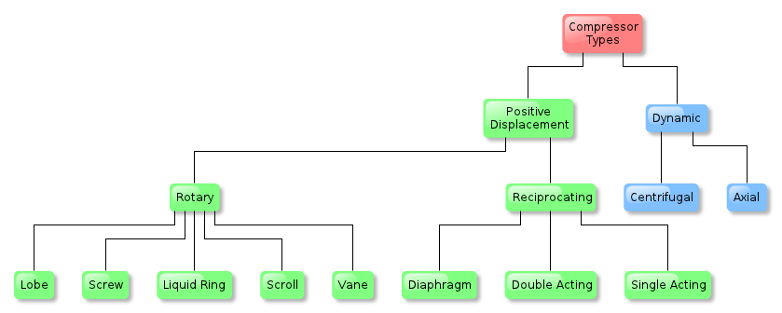

**Fig. 1. Various types of compressors**

There are many components involved in screw compressor and each of them have its own significant which affect the performance of the compressor (refer Fig. 1.2). Mainly Screw compressor consist of air filter, air end (rotor assembly), separator tank, air cooler, oil cooler, oil filter and moisture separator. Air filter is provided to capture impurities like dust particles present in atmospheric air. Filtered air comes from air filter is entered into airend assembly which consist of two rotors in which air is compressed. Simultaneously oil is entered in airend to provide lubrication between rotors and to liberate the heat which is generated due to compression. In airend both oil and air mixed. At exit of airend non return valve is provided through which air-oil mixture is entered into separator tank. Flow at inlet of the separator tank is highly dispersed. Function of Separator tank is to separate oil from mixture. Separation process is done in two stages. First stage is called mechanical separation also called as primary separation and second one is called as secondary separation which is done by passing remaining mixture through porous material. At the end of secondary separation, remaining air has a notable quality. This air is passed through MPCV (Minimum Pressure Check Valve) and entered air cooler where it is cooled by air cool heat exchanger. At the exit of the air cooler air having moisture content which needs to remove from air in dry air application so this air passed through moisture separator after that air is delivered to the desired application. Oil which is separated primarily is passed through temperature control valve (TCV). Function of the TCV is to guide the oil flow according to its temperature. If the temperature is lower than specified limit oil is diverted towards oil filter otherwise it goes into oil cooler which is air cool heat exchanger and after passing through oil cooler oil is entered into oil filter where impurities present in oil is cured and it moves further to airend. As shown in figure 2.



**Oil Flooded Screw**

**Compressor**

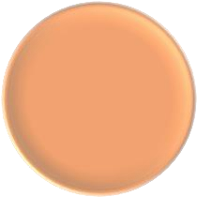

**Motor**



**Airend**



**Air Intake**

**System**

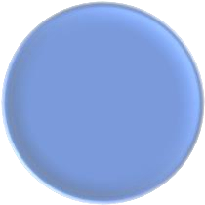

**Air/oil**

**Sep.**

**System**



**Air/Oil**

**Cooling**

**System**

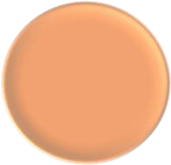

**Sound**

**Canopy**



**Fitting &**

**HWs**



**Starter &**

**Control**

**Fig.2. Schematic depiction of the components of an oil-flooded rotary screw compressor**

**Literature Review**

**Eastwick et al.** simulated air-oil separation in the aeroengine breather system to predict the performance of the breather by varying shaft speed and configuration of the breather (refer Fig. 2.1). Inside the separator, the separation primarily occurs because of the centrifugal action and after that the porous material gets separated from the oil droplets with the principle of coalescence. The porosity and flow resistance were calculated using the Darcy's law. The Lagrangian particle tracking was used to study the droplet motion of oil. The effect of shaft speed on droplet diameter and pressure drop were also studied.

**Gimbun et al.** According to him predicted the effect of inlet velocity and temperature on pressure drop in the gas cyclone (refer Fig. 2.3 and Fig. 2.4). Deviation of predicted value was 3% from the measured experimental value. They were used Reynolds Stress Model (RSM) model for simulation and similar study had been done by Chuah et al. [6] in cyclone cone effect study.

**Chuah et al.** studied the effect of tip diameter on the pressure drop of cyclone separator (refer Fig. 2.5). The cyclone separator is used as a particulate control element. The effect of cone dimension and how the axial velocity and tangential velocity vary with the cone were studied. For solving the turbulent flow in FLUENT, multiple turbulence models are available from which standard k-epsilon model, renormalized k-epsilon model and RNG k-epsilon model cannot predict the highly swirling flow. The RSM can predict the swirling flow by solving all stress components acting on the fluid particles.

**Elsayed et al.** observed the effect of inlet dimensions of cyclone on its performance and investigated the pattern of flow field. It was found out that the maximum tangential velocity decreases a higher cyclone inlet dimension (refer Fig. 2.6). To separate the phases, the strong swirling flow was used, which induced the centrifugal force acting on the solid particles. One way coupling (Euler- Lagrangian approach) was used to simulate the problem, whereas the RSM method was used to predict the swirling flow. The hexahedral grid was generated using GAMBIT software tool. At the end of the study, it was concluded that the wider inlet cyclones are not preferred.

**Wang et al.** studied the methods of numerical simulation to study the flow behavior of oil-gas separator. For highly swirling flow, the RSM model with QUICK difference scheme and PRESTO for pressure interpolation with SIMPLE algorithm for discretization was used. The velocity and pressure fields were analyzed for three-dimensional turbulence flows having strong swirling behavior. The separation mechanism was studied by means of CFD analysis of the oil-gas separator. The streamline behaviors were analyzed for high swirling flow.

**Motin et al.** predicted the flow behavior of cross-flow filtration hydro cyclone (CFFH) for a particular design and found the separation efficiency of the same with CFD (refer Fig. 2.7). Simulation of CFFH was performed in ANSYS Fluent to study the oil-water separation having low permeability membrane. The Eulerrian-Lagrangian approach was used to model the problem for continuous phase and discrete phase motion respectively.

**Kuang et al.** simulated the fluid flow in a dense medium cyclone. The study investigated the initial shape of the air core and its position with the help of multiphase Volume of Fluid (VOF) model. In the next step, the coal particles were tracked in the fluid flow for analysing the density distribution, partition curve, split ration and other constituent parameters.

**Abilgaziyev et al.** modified the design of oil-catch can by changing the inlet pipe length and position of outlet. The oil-catch can device is used to separate the oil from the mixture coming from the crankcase and to remove the oil particles from the mixture. The analysis was performed for radial and tangential outlets. The mesh sensitivity was also observed in the investigation. Different mesh configurations having number of cells 27381, 43725, 71405, 112525 and 176989 were used.

**Rane et al.** presented their work on the customization of the mesh generation for CFD analysis in the rotor pairs of the twin screw type rotary compressor. The grids were developed for different types of meshing namely diffusion smoothing (SH) and key-frame re-meshing (KR) along with a used defined cycle (UH); all three by considering 3 different scenarios. Hence, total nine cycled were studied with different number of cells and nodes for the identification of errors in pressure, mass and temperature. However, the attempts to solve the flow inside the rotors were not successful by KR meshing method due to the numerical mesh complexity.

## **Research Gaps**

Based on the literature survey conducted as elaborated earlier, there are few research gaps has been identified as listed below.

An explanatory methodology for achieving near to class zero quality air in contact cooled rotary screw compressor is not found in the literature.

The methods of enhancing the efficiency of contact cooled rotary screw compressor by reduce the pressure drop in the compressor sub system have not been studied.

## **Objectives**

The aim of the present work is focused on the evolution of the design of air-oil separator for the performance enhancement of the oil-flooded rotary compressor. Based on the identified research gaps, the objectives of the present work are defined as listed below:

* To improve the air oil separation efficiency.
* To reduce the pressure, drop across the separation sub-system.
* To provide energy efficient power saving solution to industries.

## **Methodology**

The present study of enhancing the performance of the air-oil separator (AOS) in terms of separation efficiency and reduced pressure drop has been conducted by designing different sets of system combination. These diverse system configurations consist of altering air-oil mixture inlet tilt angle and the porosity of the porous medium used inside AOS system. The entrance tilt angle is investigated at the values of -10°, 5°, 0°, 5°, and 10°, while the porosity values were varying as 0.8, 0.85, 0.9, and 0.95. The pressure drop and separation efficiency are computed for the different combinations of these parameters and the most energy efficient solution has been identified. The computation has been conducted through the Computational Fluid Dynamics (CFD) analysis and then validated by means of experimental observations.

Air Oil separator used in Rotary screw compressor to separate the oil from the compressed air-oil mixture. Construction of Air-oil separator and separator element is shown in Fig. 4.1. It is also called as separator tank. Separation process occurs basically in two steps. Primarily, oil is separated because of density difference and swirling motion of the mixture. Secondary separation is done by porous media. The Location and perform criteria of separator we discuss in the present study. With mixture volume fraction it depends which method we use for partial tracking separation if the it is less than 10% than we use DPM and or if more than 10% we us VOF in our case it is 1 to 2%so we used DPM for this. Again, the flow of oil which is very less compared to air so in CFD first continuous phase simulation is performed and then in post processing see the behavior of oil particle that travel along the flow and how much of them are trapped in wall. Compressed air-oil mixture is entered from the inlet is provided to make tangential inlet for the tank. Tangential inlet creates swirling motion of mixture. Primarily oil is separated because of this swirling motion of the mixture which is called mechanical separation or primary separation. After primary Separator element consists of porous material whose porosity is 0.8 with in exit system in this porous material is made of fiber glass which works on principle of coalescence. According to principle of coalescence small droplets of oil particles are collected and form large droplets. Large droplet having higher density is settled down at bottom curvature plate of the element. As shown in figure 3.

**Fig.3 Construction of an air-oil separator**

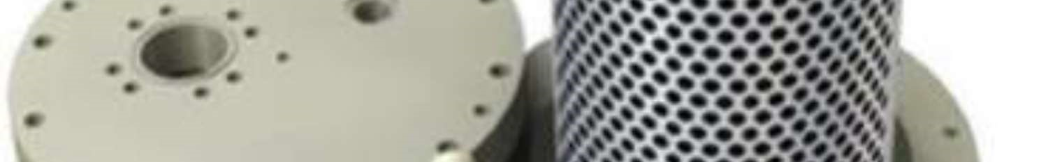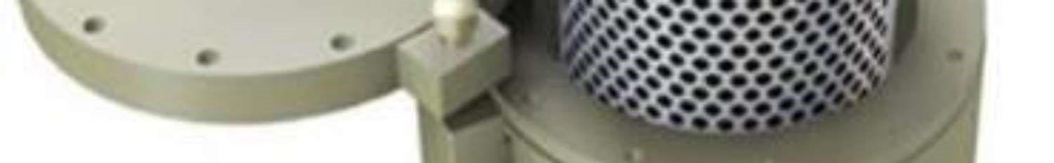

**Results**

In any field, some software is required to analyze design modification, because every time manufacturing of modified design and its testing is required to invest a huge amount of money. The simulation software is used to see how the system is behaving under different conditions. CFD is fluid dynamics tool which helps to predict flow behavior for different condition and from that result one can judge which design is feasible and giving more efficient performance, for the multiphase flow with two fluid are immiscible, the Volume of fluid (VOF) or Discrete Phase model (DPM) is used. The VOF model can solve two or more immiscible fluid by solving a single set of momentum equations and tracking the volume fraction of each of the fluids throughout the domain. The flows in which the dispersed-phase volume fractions are less than or equal to 10% can be modelled using the discrete phase model. For the present study, the secondary phase volume fraction: >10% VOF and <=10% DPM is used. The Air-oil volume fraction is calculated by taking performance data of 7 bar screw compressor. From the calculation, it is seen that the 7 bar machine have 1.88% volume fraction of oil. From above, it can be seen that all oil-flooded velocity machine have volume fraction of oil less than 10%, therefore the DPM method is applicable for CFD analysis.

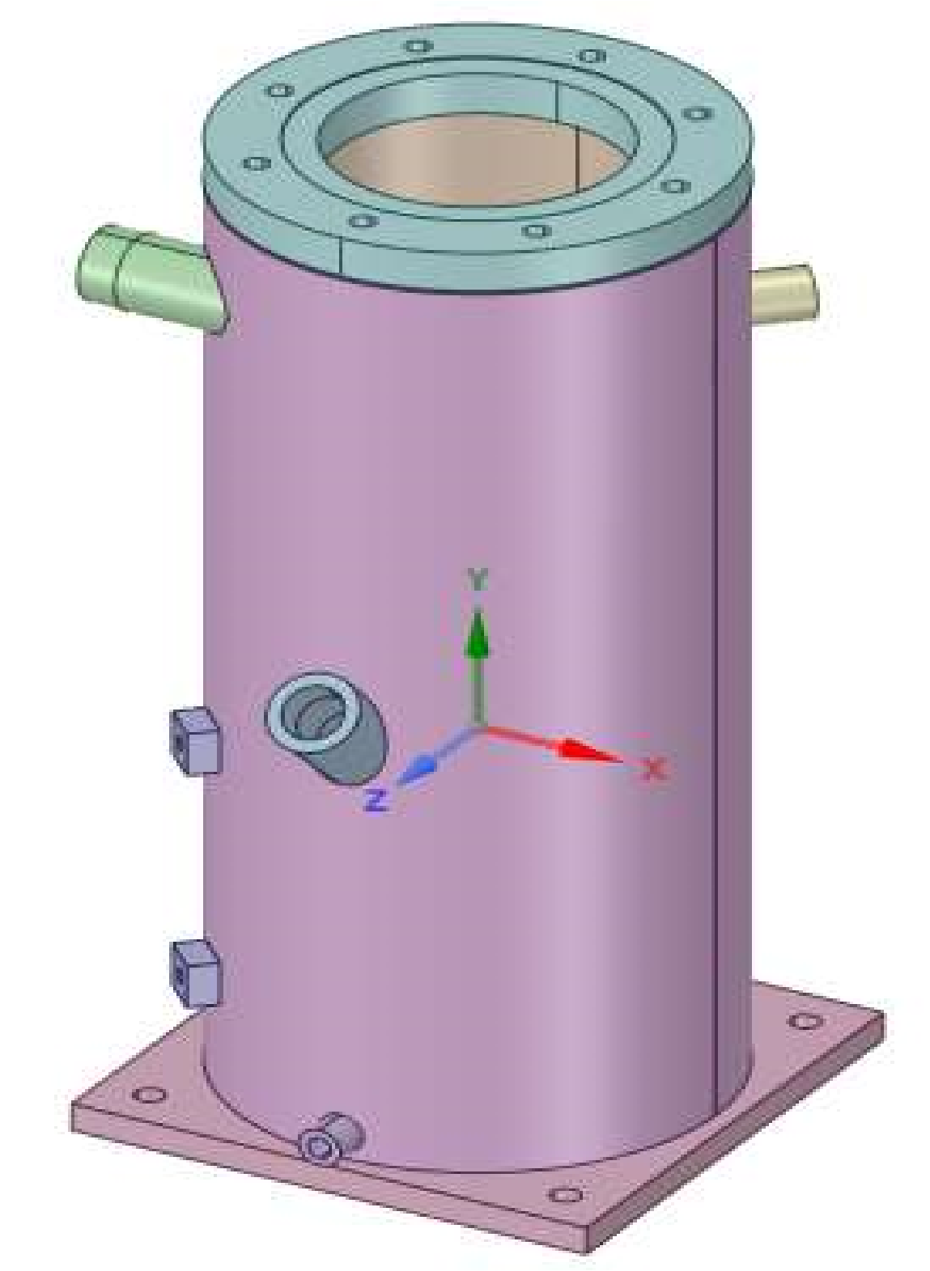

**Fig.4 3D model and a graphical representation of a standard air-oil separator**

## **ANOVA analysis**

Analysis of variance (ANOVA) is a set of statistical models and their related estimate processes (such as "variation" among and across groups) used to assess mean differences. Ronald Fisher, a statistician, invented ANOVA. ANOVA is based on the law of total variance, in which the observed variance in a specific variable is partitioned into components attributed to different sources of variation. ANOVA, in its most basic form, gives a statistical test to determine if two or more population means are equal, and therefore extends the t-test beyond two means. In other words, the ANOVA is used to compare the differences between two or more means.In addition to the optimization in terms of the MRPI, the further analysis of the parameter variance, termed as ANOVA analysis has been conducted for the identification of the optimal values of angle and porosity. The statistical parameters of the variable in separator efficiency and pressure drop are identified by the ANOVA analysis for variable angle and porosity (refer Table 5.19 and Table 5.20). Further, the main effect plots of separator efficiency, pressure drop and MRPI (refer Fig. 5.15, Fig. 5.16 and Fig. 5.17 respectively) supports the earlier claim and pronounces the 5° angle and 0.9 porosity as the optimal configuration for the performance of AOS. Moreover, the interaction plot for the pressure drops and separator efficiency is depicted.

|  |  |  |  |  |  |
| --- | --- | --- | --- | --- | --- |
| Source | DF | Adj SS | Adj MS | F-Value | P-Value |
| Angle | 4 | 0.2515 | 0.06288 | 1.49 | 0.266 |
| Porosity | 3 | 0.2292 | 0.07639 | 1.81 | 0.199 |
| Error | 12 | 0.5068 | 0.04224 |  |  |
| Total | 19 | 0.9875 |  |  |  |

Table 1 ANOVA analysis of variance in separator efficiency ()

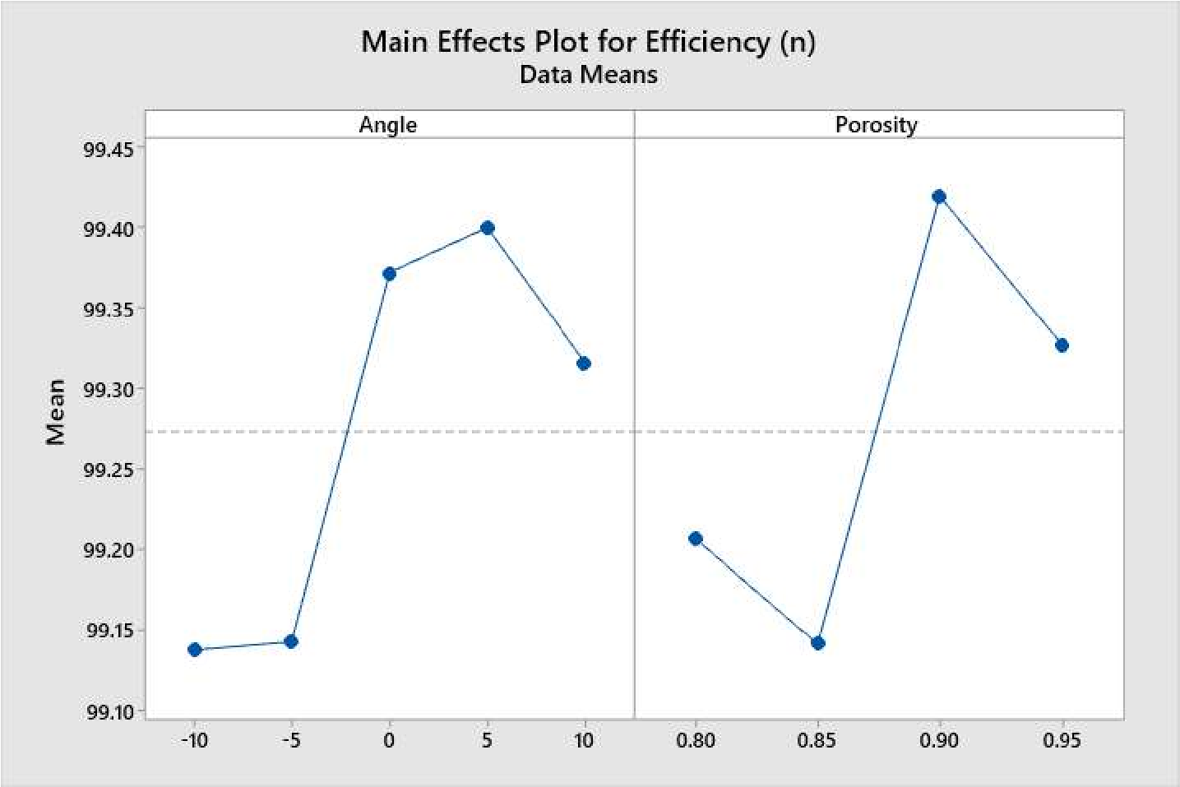

Fig.5 Main effects plot for efficiency

**Conclusions**

The current study focuses on the examination of the air-oil separation device for improving the performance of an oil-flooded air compressor. The investigation was carried out using CFD analysis, and the results were compared to the experimental data collected for the traditional system. The CFD findings agreed well with the experimental data. Based on the findings, the k - lly predicts the

-

swirling flow in AOS, and hence RNG may be considered the optimum technique for swirling flow applications. We may infer from this work that the RNG k- model accurately predicts the whirling stream in the air-oil separator.

Additionally, the system is suited for DPM implementation since the oil volume part, or VOF, is less than 10% AOS and provides relatively accurate performance forecasts. DPM was used to follow each individual particle through the continuous fluid in order to calculate the particle paths inside the flow. It is fair to infer that because the volume percentage of loaded particles in a measured cyclone is so low (3 5%), the flow field is not affected by the availability of the particles.

**Future Scope**

The current work has concentrated entirely on reducing the contamination of oil particles during the filtering process using CDF modeling and experimental investigation. Through study of the porosity of the air-oil separator filter element, the inquiry has successfully decreased the oil incursion from the standard 5 PPM value to 1.34 PPM, which is a significant step towards converting an oil-flooded system to an oil-free system. There is a good chance that the earlier detected 1.34 PPM contamination will be reduced to completely zero contamination as a future scope to the current activity. For industrial applications, this is quite desired. Additionally, the absence of oil penetration opens up several additional economic applications.

**References**

1. J.P. Rollins, Compressed Air and Gas Institute, Compressed Air and Gas Handbook, Compressed Air and Gas Institute, New York, 1961.
2. Compressor, (n.d.). https://en.wikipedia.org/wiki/Compressor (accessed May 5, 2021).
3. R Series 45-75 kW Oil-Flooded Rotary Screw Compressors, (n.d.). <https://www.ingersollrand.com/en-us/air-compressor/oil-floode> aircompressors/r-series-47-75-kw (accessed May 5, 2021).
4. I. Care, C. Eastwick, K. Simmons, CFD Computation of Air-oil Separation in an Engine Breather 179, in: 1999.
5. J. Gimbun, T.G. Chuah, A. Fakhru’l-Razi, T.S.Y. Choong, The influence of temperature and inlet velocity on cyclone pressure drop: A CFD study, Chem. Engg Process. Process Intensif. 44 (2005) 7–12. <https://doi.org/10.1016/j.cep.2004.03.005>.
6. T.G. Chuah, J. Gimbun, T.S.Y. Choong, A CFD study of the effect of cone dimensions on sampling aerocyclones performance and hydrodynamics, Powder Technol. 162 (2006) 126–132. https://doi.org/10.1016/j.powtec.2005.12.010.
7. K. Elsayed, C. Lacor, The effect of cyclone inlet dimensions on the flow pattern and performance, Appl. Math. Model. 35 (2011) 1952–1968. https://doi.org/10.1016/j.apm.2010.11.007.
8. Z. Wang, C. Yuan, J. Han, Y. Yu, The analysis of internal flow field in oil-gas separator, Procedia Eng. 15 (2011) 4337–4341.https://doi.org/10.1016/j.proeng.2011.08.814.
9. A. Motin, M.D. Gaustad, V. V. Tarabara, A. Bénard, Simulations and performance of the crossflow filtration hydrocyclone (CFFH) for oil-water separation, Am. Soc. Mech. Eng. Fluids Eng. Div. FEDSM. 1 C (2013). https://doi.org/10.1115/FEDSM2013-16195.
10. A. Motin, V. V Tarabara, Fedsm2014-21289 Cfd Study of Hydrodynamics and Separation Performance of a, in: Proc. 4th Jt. US-European Fluids Eng. Summer Meet. FEDSM2014-21289, ASME, Chicago, 2014: pp. 1–10. https://doi.org/10.13140/2.1.3389.0563.
11. X. Gao, J. Chen, J. Feng, X. Peng, Numerical and experimental investigations of the effects of the breakup of oil droplets on the performance of oil-gas cyclone separators in oil-injected compressor systems, Int. J. Refrig. 36 (2013) 1894– 1904. <https://doi.org/10.1016/j.ijrefrig.2013.06.004>.
12. S. Kuang, Z. Qi, A.B. Yu, A. Vince, G.D. Barnett, P.J. Barnett, CFD modeling and analysis of the multiphase flow and performance of dense medium cyclones, Miner. Eng. 62 (2014) 43–54. <https://doi.org/10.1016/j.mineng.2013.10.012>.
13. A. Abilgaziyev, N. Nogerbek, L. Rojas-Solórzano, Mohammadjavad, A. Shahrabi, A. Abilgaziyev, N. Nogerbek, L. Rojas-Sol´orzano, Design Optimization of an Oil-Air Catch Can Separation System, J. Transp. Technol. 05 (2015) 247–262. https://doi.org/10.4236/jtts.2015.54023.
14. M.B. Dusane, M.R. Nandgaonkar, Droplet Diameter Using Multiphase Simulation For Diesel Engine, Int. J. Res. Eng. Adv. Technol. 2 (2014) 1–5.
15. H.S. Kim, G.H. Kang, P.H. Yoon, Y.C. Sa, B.Y. Chung, M.S. Kim, Caractéristiques de l’écoulement d’un mélange de frigorigène et d’huile dans un séparateur d’huile, Int. J.Refrig. 70 (2016) 206–218. https://doi.org/10.1016/j.ijrefrig.2015.08.003.