**“HEAT TRANSFER ENHANCEMENT OF FLAT PLATE HEAT EXCHANGER TUBE BY VARYING GEOMETRICAL CONFIGURATION USING CFD*”***

DHANANJAY KUMAR YADAV1,

Research scholar, Department of Mechanical Engineering, Scope College of Engineering, Bhopal.

SANDEEP KUMAR SHAH 2,

Associate Professor, Department of Mechanical Engineering, Scope College of Engineering, Bhopal.

Dr. MUKESH KUMAR LALJI3

Principal - Part Time Diploma Course

I/c H.O.D. Architecture Department

S. V. Polytechnic College, Shyamla Hills, Bhopal (M.P.)

Department of Technical Education, Employment and Skill Development, M. P. Govt., Bhopal, Madhya Pradesh, India.

**Abstract :** A plate fin heat exchanger is a type of heat exchanger design that uses plates and finned chambers to transfer heat between liquids. It is often classified as a compact heat exchanger to emphasize the relatively high ratio between the heat transfer surface and the volume. The main objective of the present work is to configure a optimum design of plate fin tube heat exchanger using Computational fluid dynamic approach and maximizing thermal performance. There are total five designs of plate fin and tube heat exchanger are used in present work and CFD analysis have been performed in it to get maximum heat transfer. It has been observed from CFD analysis that the maximum heat transfer can be achieved from plate fin and tube heat exchanger with elliptical tube arrangement inclined at 30o with 23.22% more heat transfer capacity as compared to circular tube plate fin heat exchanger. So that it is recommended that if the plate fins and tube heat exchanger with inclined elliptical tube used in place of circular tube arrangement, better heat transfer can be achieved.

***Keywords:*** *heat transfer, plate fin tube heat exchanger, thermal performance, Plain fin, Turbulence, Friction factor CFD analysis etc.*

**Introduction:** Heat exchangers are used to transfer thermal energy between two or more fluids. There is a wide range of heat exchangers used in various industrial applications. One of the most important of these is the compact heat exchanger, which includes heat exchangers with plate fins and tube fins. Cross-plate heat exchangers are often used in gas-gas applications such as cryogenics and micro turbines. It is also used in automotive, chemical transformation, naval and aerospace applications. Plate fin heat exchangers have high thermal efficiency. The ribs are used on both sides to stop the growth of the boundary layer. Due to the small thickness of the plate and the large heat transfer surface per volume unit, they have a high thermal conductivity. This translates into a reduction in space, weight, energy consumption and costs. The cost of higher friction losses for higher thermal performance of the compact heat exchanger (e.g. pressure drop). Therefore, the optimal design of a compact heat exchanger required the maximum compromise between heat transfer rate and energy. Consumption due to a greater pressure drop in the set of restrictions. The second law of thermodynamics is one of the most effective methods for evaluating methods for improving heat transfer taking into account the two compromising factors. Several investigations have been carried out to study different types of heat exchangers as **hang-Hyo Son et al. [2]** Highly efficient heat exchangers are essential for the liquefaction of hydrogen, which is in the spotlight as a next generation energy source. Among heat exchangers, the fin heat exchanger has a very large efficient heat transfer surface per volume unit, which allows the simultaneous exchange of multiple liquids, which is why it specializes in the hydrogen liquefaction process. However, very few studies have been done on heat transfer analysis of finned plate heat exchangers. Therefore, the single-phase convection heat transfer coefficients were calculated in this work using the modified Wilson diagram method and the pressure drop relative to other correlations. The main results are summarized as follows. The pressure drop corresponds well to the previous correlation, but the convection heat transfer coefficients differ from the others. Based on the experimental results, a new correlation of the single-phase heat transfer for the plate fin heat exchanger is presented.**Mate Petrik et al. [3]** The aim of this work is to perform parametric analysis of the thermalpower of a compact car cooler using computer-assisted fluid dynamics. The analysis was performed at different air speeds, with different fins modeled as real fins and as porous media. SC-Tetra computerized fluid dynamics software was used for this study. Liquids are incompressible; the flow was three-dimensional and turbulent. The geometry of the fins has a strong impact on the heat transfer coefficient and thermal efficiency, so as to compare the shape, size and thickness of the fins. The results show that the relationship between the pitch of the slats, the thickness of the walls of the slats, the number of slats, the depth of flow and the geometry of the tube are the main factors of heat transfer. The main goal is to find a reliable correlation of the Nu number for this type of heat exchanger. Also, when using this feature, the goal is to find the optimal shape of the chiller, which can lower the coolant temperature to the required value and have the lightest weight.

**Abhishek Tiwari et al. [4]** In the field of cryogenics, heat exchangers with a maximum efficiencyof the order of 0.96 or more are used to maintain the low temperature effect generated. The compact heat exchanger (CHE) is modified by cross-flow channels between a small volume and a high rate of energy exchange between two liquids. The thermo-hydraulic performance of the compact heat exchangers (CHE) strongly depends on the Colburn fins 'j' and Fanning factor 'f', the triangular and rectangular perforated fins.**Mohd Zeeshan et al. [5]** In the present numerical study, the thermo-hydraulic performance of thefinned and tubular heat exchangers (FTHE) was assessed and compared. Two types of FTHE were considered, one with oval tubes and one with circular tubes with rectangular vortex generators (RVG) for comparison with the base case, i.e. H. A circular tube and a heat exchanger with single fin . The surface quality ratio (J / F factor) and the heat transfer rate per fan energy consumption unit (Q / Pf factor) are considered performance evaluation criteria (PEC). The results show that the two improved cases have a heat output higher than that of the base case. Furthermore, on the basis of the surface quality factor, it can be concluded that with a low Reynolds number heat exchanger (Re) (400-600) with circular tubes with RVG, a lower front surface is needed, while with a range Higher (700-900) oval tube heat exchangers require less frontal area. Furthermore, a multi-objective optimization was applied by means of report analysis (MOORA) in order to maintain the performance sequence of the configurations of the fin and tubular heat exchangers considered. In the first case of the MOORA method, the heat transfer coefficient (h) is considered an advantageous attribute (which must be maximized) and the pressure drop (Δp) as an unfavorable attribute (which must be minimized) in the second cases j / f- and Q / The Pf factors are considered advantageous attributes, while the pressure drop (Δp) is considered as not advantageous attributes. The classification of the MOORA method indicates that the finned and oval tube heat exchangers work better among the other configurations considered. The finned and oval tube heat exchanger provides a heat transfer coefficient (h) increased by 13.96% and 5.40% at Re = 400 and Re = 900. It should be noted that the heat exchanger of the oval tube has a pressure drop penalty of 31.92% at Re = 400 and reduced by 39.70% at Re = 900.**C.Mahesh et al. [13]** This article aims to optimize the performance of finned plate heat exchangersby drilling through the FLUENT software. The widespread use of the heat exchanger concept has ensured many dimensional deviations and has shown that changes in dimensional parameters affect performance. It is therefore important to understand how the geometry of a compact heat exchanger can affect its performance. Consequently, a study of the parametric influence on the overall performance for the types of heat exchangers (smooth fin, circular fin and perforated elliptical fin, offset fin with and without perforation) is modeled and simulated in the same boundary conditions (low Reynolds number ). From the results, the behavior of the heat transfer, the Nusselt number, the factors j and f are analyzed and all the parameters of the different types of heat exchangers with plate fins are compared. Index terms - fluid, heat transfer, modeling, perforated fin, plate fin heat exchanger (PFHE), web offset fin.**G. Harish et al. [14]** This article aims to optimize the performance of plate fin heat exchangersby drilling using the FLUENT software. The widespread use of the heat exchanger concept has ensured many dimensional deviations and has shown that changes in dimensional parameters affect performance. It is therefore important to understand how the geometry of a compact heat exchanger can affect its performance. Consequently, a study of the parametric influence on the overall performance for the types of heat exchangers (smooth fin, circular fin and perforated elliptical fin, offset fin with and without perforation) is modeled and simulated in the same boundary conditions (low Reynolds number ). From the results, the behavior of the heat transfer, the Nusselt number, the factors j and f are analyzed and all the parameters of the different types of heat exchangers with plate fins are compared.

**Methodology**

A plate fin heat exchanger is a type of heat exchanger that uses plates and fin chambers to transfer heat between liquids. The plate fin heat exchanger is used in many sectors, including the aerospace one, thanks to its compact size and luminous properties, as well as cryogenics, where its ability to facilitate the transfer of heat to small temperature differences are used.

**FEM Analysis:**

The use of the finite element method as a tool to solve various technical problems in industrial applications is a completely new concept. ANSYS is generally used in a finite element analysis program for general purposes. Designing a solution to technical problems using FEM requires the development of a computer program based on a FEM formulation or a commercially available FEM program such as ANSYS.

**Computational Fluid Dynamics analysis:**

The computerized analysis of fluid dynamics is performed using ANSYS Fluent for finned plate heat exchangers. The input parameters were extracted from the base card. Relevant equations such as the continuity equation, the momentum equation, the energy equations, the K equation and the equations are used to perform this calculation analysis.

**Steps of Expected Methodology**

1. Acquiring the design dimensions of Plate fin-and-tube heat exchangers.
2. Preparing the CAD model of Plate fin-and-tube heat exchangers.
3. Assigning the selected material to the Plate fin and tube heat exchangers in ANSYS Software.
4. Assigning the suitable boundary conditions.
5. Further CFD analysis will be perform for base paper model and proposed model of Plate fin and tube heat exchangers.

**Geometrical Parameters for the Plate Fin Tube Heat Exchanger Models:**

|  |  |  |
| --- | --- | --- |
|  | **Parameters** | **Values** |
|  |  |  |
|  | Tube diameter fin collector outside diameter, D (mm) | 9.97 |
|  | Longitudinal tube pitch, Ll (mm) | 27.50 |
|  | Transverse pitch, Lt (mm) | 31.75 |
|  | Fin Pitch, Fp (mm) | 3.21 |
|  | Fin Thickness, Ft (mm) | 0.20 |
|  | Number of tube row, N | 4 |
|  | Fin and tube arrangement | In line, staggered |
|  |  |  |

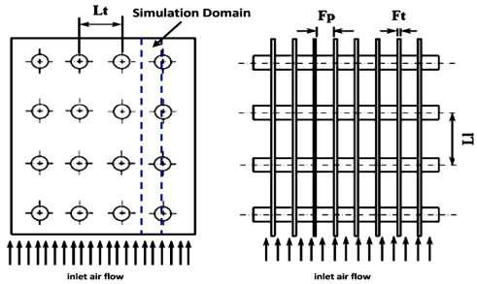

Figure 1: Physical model with staggered arrangement

Because of the symmetry of the tube bank geometry, only a portion of the domain needs to be modeled. The computational domain is shown in outline in Figure

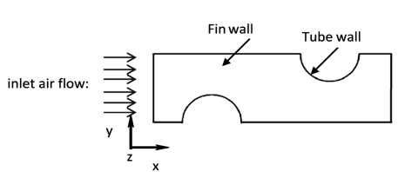

Figure 2: computational domain with different boundaries of fin tube heat exchanger

**CFD Analysis of Plate Fin with Elliptical Tube Inclined at 30o Heat Exchanger**

**1. CAD geometry**

In this work, a two-dimensional CAD model of a sheet metal fin with an elliptical tube inclined by 30 ° is created using a modular design of the ANSYS workbench. According to that of the table above and the figure shows a two-dimensional view of the plate fin with an elliptical tube inclined by a 30 ° heat exchanger.

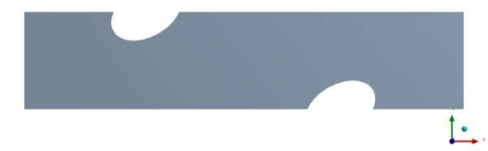

Figure 3: CAD model of plate fin with elliptical tube inclined at 30o heat exchanger

**Meshing:**

After completing the CAD geometry of the plate fin with an elliptical tube inclined by 30°, the heat exchanger is imported into the ANSYS workbench for a further calculation of the fluid dynamics. The next step is meshing. CAD geometry is divided into a large number of small parts called meshes. in this book it is 16650 and the total number of elements is 16300. The types of elements used are rectangular, which is a rectangular shape with four knots on each element.

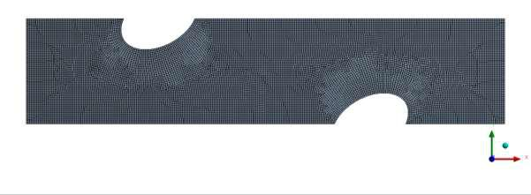Figure 4.: Meshing of plate fin with elliptical tube inclined at 30o heat exchanger

After performing computational fluid dynamic analysis on plate fin with elliptical tube inclined at 30o heat exchanger the temperature distribution over the plate fin with elliptical tube inclined at30o has been observed. The temperature distribution at Plate fin and tube heat exchangers has been from 353.1K to 268.9K which shows the temperature drop of 84.2 degree.

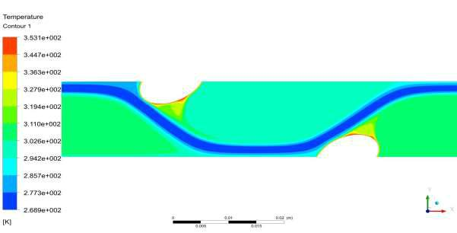

Figure 5: Temperature distribution over the plate fin with elliptical tube inclined at 30o heat exchanger

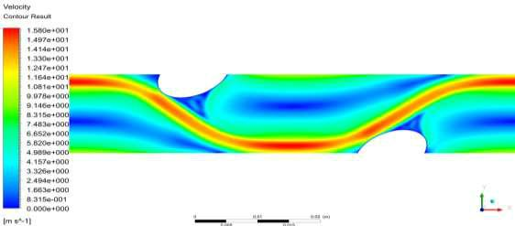After performing computational fluid dynamic analysis on plate fin with elliptical tube inclined at 30o heat exchanger the velocity distribution over the plate fin with elliptical tube inclined at 30o has been observed. The maximum velocity at plate fin with elliptical tube inclined at 30o heat exchangers has been recorded is 15.8 m/sec.

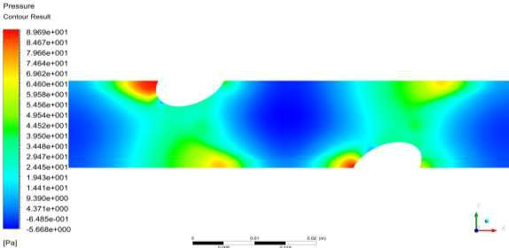

Figure 6 Velocity distribution over the plate fin with elliptical tube inclined at 30o heat exchanger

After performing computational fluid dynamic analysis on plate fin with elliptical tube inclined at 30o heat exchanger the pressure distribution over the plate fin with elliptical tube inclined at 30o has been observed. The maximum pressure at over the plate fin with elliptical tube inclined at 30o heat exchangers has been recorded is 89.69Pa.

**RESULTS AND DISCUSSION**

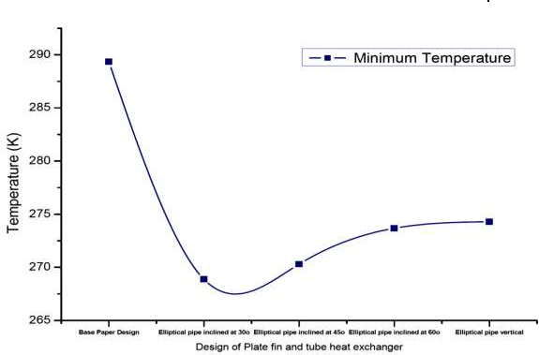The main goal of this paper is to study the optimal design of a plate fin heat exchanger using a computer-assisted dynamic approach to fluids and maximizing heat production. A total of five models of finned tube and plate heat exchangers are used in this work and the CFD analysis was performed to achieve maximum heat transfer

Figure 7: Minimum Temperature Distribution over the plate fin tube heat exchanger

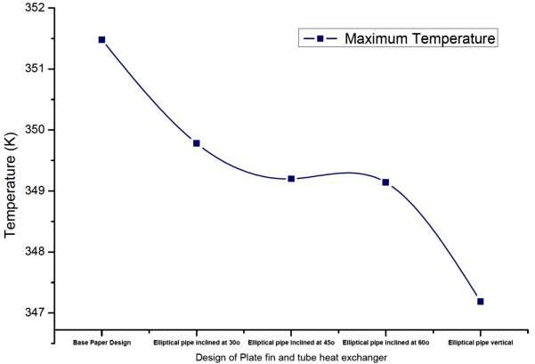

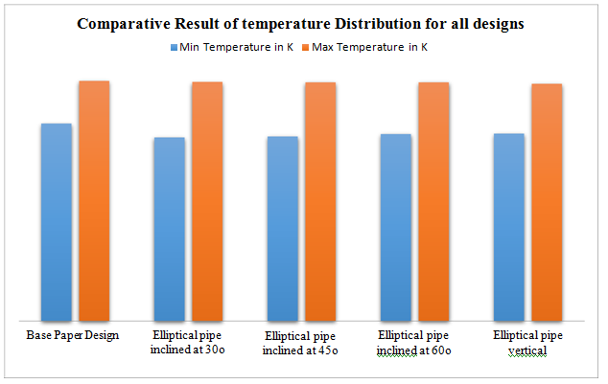

Figure 8: Comparative Result of temperature Distribution for all designs

From the above results, it was observed that the maximum and minimum temperature for the design of the base paper (plate fin and tube heat exchanger with circular tube arrangement) was 351.38 K and 289, 26 K per exchanger finned and tube heat exchanger with elliptical tube arrangement. An inclination of 30 ° was observed at 349.68 K and 268.77 K for fin and tube heat exchangers with an arrangement of 45 ° inclined elliptical tubes at 349.02 K and 270.03 K for heat exchangers heat with fins and tubes with an arrangement of elliptical tubes inclined at 60 ° 349.04 K and 273.48 K and for heat exchangers with fins and tubes with an arrangement of the elliptical tube inclined at 90 ° (vertical ellipse) were observed 347.29 K and 274.29 K, respectively. It has also been observed that the heat transfer capacity for plate fins and tube heat exchangers with an arrangement of elliptical tubes inclined by 30 ° with respect to the basic design of the paper is 23.022%, for plate fins and tube heat exchangers with an elliptical arrangement of the tube inclined by 45 ° with respect to the basic design of the paper, the value is 21.026% for plate fins and tube heat exchangers with an arrangement of the inclined elliptical tubes of 60 ° compared to the basic design of the paper is 17.067% and for the plate fins and tube heat exchangers with an elliptical tube arrangement inclined by 90 ° (vertical ellipse) the basic design of the paper is 14.078%.

**6.1 Conclusion**

The main objective of the study of the optimal design of plate and fin heat exchangers through a computer-assisted fluid-dynamic approach and the maximization of thermal power. After performing a computerized analysis of fluid dynamics on various plate and fin heat exchanger designs, the following conclusions were drawn.

* The maximum and minimum temperature for the base paper design (flat tube heat exchanger and circular tube heat exchanger) was observed at 351.38 K and 289.2626 K, therefore the temperature difference is 62.12 degrees.
* The maximum and minimum temperature for heat exchangers with plate fins and tubes with an arrangement of the elliptical tube inclined by 30 ° was observed at 349.68 K and 268.77 K, so the temperature difference is 80, 91 degrees and better heat transfer performance than the base card design 23, 22%.
* The maximum and minimum temperature for heat exchangers with plate fins and tubes with a 45 ° inclined arrangement of the elliptical tube was observed at 349.02 K and 270.03 K, so the temperature difference is 78 , 9 degrees and improved heat transfer performance compared to the base card design 21, 26%.
* The maximum and minimum temperature for heat exchangers with plate fins and tubes with an arrangement of the elliptical tube inclined by 60 ° was observed at 349.04 K and 273.58 K, therefore the temperature difference is 75 , 46 degrees and better heat transfer performance than the base card design 17, 67%.
* The maximum and minimum temperature for heat exchangers with plate fins and tubes with an arrangement of the elliptical tube inclined by 90° (vertical ellipse) was observed at 347.29 K and 274.39 K, therefore the difference of temperature is 72.9 degrees and the heat transfer performance compared to base paper the improved design is 14.78%.

From the above conclusions, it has been observed that the maximum heat transfer can be obtained from a plate and tube fin heat exchanger with an elliptical tube arrangement inclined by 30 ° with a heat transfer capacity of 23.22% more than a circular plate heat exchanger.

Therefore, it is recommended to obtain the heat transfer of the mix if using the plate fins and the tube heat exchanger with an inclined elliptical tube instead of the circular tube arrangement.

**References**

1. hang-Hyo Son, Joon-Young Kong “Heat Transfer Characteristics in a Plate-Fin Heat Exchanger with Single-Phase Flow” IEEA 2020: Proceedings of the 2020 The 9th

International Conference on Informatics, Environment, Energy and Applications March 2020.

1. BasimFreegah, Ammar A.Hussain “CFD analysis of heat transfer enhancement in plate-fin heat sinks with fillet profile: Investigation of new designs” Thermal Science and

Engineering Progress Volume 17, 1 June 2020, 100458.

1. Máté PETRIK, Gábor SZEPESI “CFD analysis and heat transfer characteristics of finned tube heat exchangers” An International Journal for Engineering and Information Sciences,

Vol. 14, No. 3, pp. 165–176, 2019.

1. Abhishek Tiwari, Ram Raja, Rajesh Kumar “Performance Studies on Plate Fin Heat Exchanger with CFD Simulation” International Journal of Engineering and Innovative

Technology (IJEIT) Volume 8, Issue 1, July 2018.

1. Mohd Zeeshan, Sujit Nath “A CFD Analysis to Compare the Performances of Fin and Tube Heat Exchangers having Different Augmentation Techniques” International Journal of Applied Engineering Research ISSN 0973-4562 Volume 13, Number 6 pp. 327-333, 2018.
2. S. Lowrey, Z. F. Sun “Experimental Investigation and Numerical Modelling of a Compact Wet Air-to-Air Plate Heat Exchanger” Applied Thermal Engineering 131 · November 2017.
3. Ahmed Y Taha Al-Zubaydi, Guang Hong “CFD Modelling and Analysis of Different Designs Plate Heat Exchangers” Conference: 10th Australasian Heat and Mass Transfer

Conference (AHMT2016), At Brisbane, Australia, 2016.

1. L. Venkatesh, S. Arunraja, “3D CFD Study of the Effect of Inlet Air Flow Maldistribution on Plate-Fin-Tube Heat Exchanger” International Research Journal of Advanced

Engineering and Science, Volume 1, Issue 4, pp. 67-70, 2016.

1. Hamid Oualli at el. "Enhanced turbulence in the Taylor-Couette flow system" IX International Conference on Computational Heat and Mass Transfer, ICCHMT2016, Procedia Engineering 157 ( 2016 ) 443 – 450.

1. Xiang Peng, Zhenyu Liu & Chan Qiu, Jianrong Tan "Effect of inlet flow maldistribution on the passage arrangement design of multi-stream plate-fin heat exchanger" Applied Thermal Engineering 103 (2016) 67–76.
2. Rafal Wyczolkowski " Computational model of complex heat flow in the area of steel rectangular section" IX International Conference on Computational Heat and Mass Transfer, ICCHMT2016, Procedia Engineering 157 ( 2016 ) 185 – 192.
3. M.Khoshvaght-Aliabadi, S.Zangouei “Performance of a plate-fin heat exchanger with vortex-generator channels: 3D-CFD simulation and experimental validation” International

Journal of Thermal Sciences Volume 88, February 2015, Pages 180-192.

1. C.Mahesh, K.Siva Krishna “CFD Analysis on Flow Through Plate Fin Heat Exchangers with Perforations” ISSN (Print): 2319-3182, Volume -4, Issue-4, 2015
2. G. Harish, Ch.Uma Mahesh, K. B. S. Krishna “CFD Analysis on Flow Through Plate Fin Heat Exchangers with Perforations” Corpus ID: 212440554, Published 2015.
3. Jan Skočilas, Ievgen Palaziuk “CFD Simulation Of The Heat Transfer Process In ACHEVRON Plate Heat Exchanger Using The SST turbulence Model” Acta Polytechnica 55(4):267–274, 2015.
4. Dawid Taler & Paweł Ocłon "Thermal contact resistance in plate fin-and-tube heat exchangers, determined by experimental data and CFD simulations" International Journal of Thermal Sciences 84 (2014) 309e322.
5. Karthik Pooranachandran "Experimental and numerical investigation of a louvered fin and elliptical tube compact heat exchanger" article in thermal science, January 2012,
6. J.N. Mao "Effect of air-side flow maldistribution on thermalehydraulic performance of the multi-louvered fin and tube heat exchanger" International Journal of Thermal Sciences 73 (2013) 46e57.
7. Arafat Ahmed Bhuiyan, A K M Sadrul Islam “CFD analysis of different Fin-and-Tube Heat Exchangers” Proceedings of the 13th Annual Paper Meet 25 September 2010, Dhaka.
8. Y. Zhu, Y. Li “CFD simulation of fluid flow and heat transfer in channels of plate-fin heat exchangers” Huagong Xuebao/Journal of Chemical Industry and Engineering (China)

57(5):1102-1106 · May 2006