**THE VARIOUS AYURVEDIC FORMULATION IN PREVENTION OF HEPATIC DISEASES**

**Prachi Pandey*1, Rahul Pal2, Kavya3 Arsh Chanana4, Ravindra Pal Singh5**

1,2,3,4,5 Department of Pharmaceutics, NIMS Institute of Pharmacy, NIMS University Jaipur, Rajasthan, India.

**[*pandeyprachi167@gmail.com](mailto:*pandeyprachi167@gmail.com)**

**Abstract:**

Liver infection is the 10th most normal reason for death in India according to the World Health Organization. Despite predictable human exertion and medication disclosure, current medication has very little to bring to the table. Nevertheless, ayurvedic classical formulations and drugs so some promising results. Some of the highest prescribed Formulation for liver disorders are liv 52, Arogyavardhini Vati. Phyllanthus Niruri, Curcuma longa is the commonest single herb used by Ayurvedic physicians and herbalists to treat the various liver disorder. Medicinal plants with phytochemical properties which possess strong antioxidants, result in antihepatotoxic activity. In this review paper main highlights are different ayurvedic formulation in used in the hepatic and liver related diseases. Lots of pharmaceutical products play in important role in the treatment.

**Keywords:** Ayurvedic Formulation, Liver Disease, Phytoconstituents, Classical Ayurvedic Marketed Formulations.

**INTRODUCTION**

The Liver is a crucial organ associated with the upkeep of metabolic capacities and detoxification of the exogenous and endogenous difficulties like xenobiotics, drugs, viral contaminations, and constant alcoholism [1]. Liver sickness is the 10th most normal reason for death in India according to the World Health Organization and may influence each one of every five Indians. Around 10 lakh patients with liver cirrhosis are recently analyzed each year in India. Liver cirrhosis is the fourteenth leading cause of death in the world.[2]  Liver issues like viral hepatitis, cirrhosis, alcoholic liver infection, greasy liver, jaundice, and so forth do not have explicit treatment modalities in current medication even though they are the reason for death. No explicit safe and no hepatic harm remedy has been found in traditional medication. Medicinal items utilized are found to give just indicative alleviation to the patient with the hepatic problem without dealing with the fundamental side effects.

Ayurveda herbal formulations are in extraordinary interest for essential medical care as a result of their use in different issues and higher safety edges and lesser expenses. These different plans contain different plant medicates, and metals which could offer a chance to treat the different liver infections, what's more, gives a new expectation for what's to come.

**LIVER- AYURVEDIC PERSPECTIVE**

The liver and its dysfunctions are characterized and depicted in Ayurveda concerning blood as a significant constituent of human sciensce. In Ayurveda, the job of the liver is disclosed according to pathogen (dosa), tissues (dhatu) and its turn of events, muscle (mamsa), heart (hrid), blood (rakta), breath (pranavaha srotas), and discharge (mala).

The liver might be influenced by illnesses including this system. The liver is the biggest organ of the body, contributing around 2% of the body weight in the normal human. It is associated with the vast majority of the physiological cycles, which incorporate development, resistance, sustenance, energy digestion, and reproduction. Synthesis and discharge of bile, albumin, prothrombin, and the creation of the compliments which are the significant effectors of the humoral part of the immune system happen primarily in life.[3]

The support of a sound liver is imperative for well-being. Tragically, environmental toxins, poor dietary patterns, alcohol consumption and remedial medication use frequently abuse this essential organ, and as a result, there is a generally decrease in metabolic capacity of the liver. This hepatotoxicity ultimately leads to sicknesses like hepatitis, cirrhosis, alcoholic liver sickness and at last outcomes in hepatic malignant growths (liver cancer).

As per Ayurvedic, the accumulation of unusual harmful liquids around the liver makes blockage (srotorodh) that hinders the emission of bile bringing about liver enlargement and different liver issues. Impaired digestive power (agni) has been viewed as the essential etiological factor.[4]

After going through classical text and literature, it is clear that Liver is directly or indirectly involved in the following diseases such as:

1. **Gulma (Jaundice):** The significance of Gulma is pindakara [round and hard mass]. It is the stomach bump which is caused because of aggravation and encapsulation of Vata Dosha (kupita Anila moodhatwat) which doesn't provide insight about its site of beginning (Goodha Gulmodaya) and spreads broadly like the bushes (Gulmavat vishalatwaat). It is normally known gaseous tumour of abdomen. According to modern science it is called jaundice.[5]
2. **Panduroga** **(Anemia):** Panduroga is generally considered as anemia. At the point when the pitta overwhelming doshas get disturbed in the tissues, the tissues go through inflammation and get weak and lax. Tissue of the body become heavy. This leads to deterioration of varna (color), bala (strength and insusceptibility), sneha (unctuousness of the body, the defensive fat support) furthermore, different characteristics of ojas (ojas is important of all the tissues and thus addresses immunity).[6]
3. **Kamla (Cirrhosis):** It is a term utilized in Ayurveda to depict an illness which looks like Jaundice. Pandu and Kamala are supposed to be the illnesses which are interrelated. They are additionally supposed to be have normal beginning. At the point when Pandu isn't dealt with as expected it can lead to Kamala. Along these lines, Kamala can be considered as an impact of untreated Pandu or Pandu which runs a chronic course. [7][8]
4. **Udarroga (Hepatitis):** Agnidosha [defective digesting strength] and Mala Vruddhi [increase in byproducts/bleak matter] are the purposes behind diseases like Udara (stomach illnesses including ascites). In case there is suppression of Agni (force of processing and digestion), and if the individual takes Polluted food, this prompts acid reflux because of which Doshas get aggregated. This causes vitiation of Prana (a variety of Vata Dosha), Agni (digestive enzyme) and Apana ((another variety of Vata, identified with removal of faeces, flatus, urine and so forth) and obstruction to the different channels of circulation. The vitiated Doshas get stopped between the skin and the muscle tissue and cause broad distension of lower part of abdomen. This brings about Udara (unyielding stomach illnesses including Ascites).[9]
5. **Kumbha Kamala- Halimak, Alasa:** At the point when jaundice proceeds for over one month and manifestations become genuine with dull yellow hued pee, defecation, profound yellow eyes, general swelling (edema) of the body, a devastating pain in the joints, it is called Kumbha-Kamala, which, when it creates in its course such indications as fever, hurting pain in the limbs, dizziness, laziness, sluggishness and starvation comes to be known as Lagharaka. This, in its turn, when set apart by an over-the-top prevalence of the unhinged Vayu and Pitta is called Alasa, also called Halimaka [10]
6. **Madatyaya (Alcoholic liver diseases):** Madatyaya consist of two words Madaa and Atyay. Mada implies Harsh (Excitement) Atyay implies Atikrama (abundance). This over excitment is brought about by overabundance utilization of Madya [alcohol]. Depending upon the contribution of the Dosha, its harmful impacts happen Because of inordinate and the inappropriate utilization of alcohol caused 'Madatyaya'. It is Tridoshaja Vyadhi (sickness brought about by contribution of each of the three Doshas - Vata, Pitta and Kapha.[11] [12]
7. **Granthi** **(minor neoplasm):** is a confined little swelling inside the subcutaneous fat tissue, muscle or then again blood veins; it is round, erect, and tied.
8. **Arbuda (major neoplasm):** is a round, stable, huge, painless swelling at one site; it extends gradually with more deep roots.

## AYURVEDIC PRODUCTS

The Indian Traditional Medicine like Ayurveda, Siddha and Unani e predominantly based on the utilization of plant materials and treating different kinds of Liver problems. Plant drugs formulations have acquired significance and popularity due to their safety, adequacy and cost effectiveness. Different formulations are prepared on the principle of synergetic activities as marvel of positive herb-herb interaction.

In Ayurvedic old style texts, cleansing cycle (sodhana chikitsa including panchakarma) utilizing inward and outer meds which can dispose of pathogens (dosas), remedial treatment (shamana chikitsa) pacifies pathogens (dosas), adjustment of metabolic defects (dhatwagni chikitsa), immunotherapy (rasayana), anti-cancerous drugs (vyadhipratyanika chikitsa) and suggestive therapy (lakshanika chikitsa) and careful therapy with herbal and mineral medications (Shastra chikitsa), these are the overall line of therapy for a liver disorders.

The fundamental standards of Ayurveda are discovering the reason for an ailment and reestablishing the harmony between the three significant bodily systems by providing insufficient substances and by lessening the unnecessary ones (tridosa siddhanta).

In any case, a few herbs and traditional formulations have shown promising outcomes. The current review gives an overall audit of the traditional Ayurveda items, protected Ayurveda items alongside pharmacological activities of natural meds.

**CLASSICAL AYURVEDIC HERBAL FORMULATIONS FOR LIVER DISORDER**

Many classical an important formulation in various doses forms are mentioned in ayurvedic literatures. Visionary formulate various compound to select several herbs with properties that it shows effect against key aspect of individual case, like in case of some Dosha, digestive power, organs, tissues and symptoms involved. Single drug can address more than one particular ailment of liver.

Use of metals as medicine is often consider toxic, but in Ayurveda we make them into biocompatible form by method like detoxification processes like Shodhana (Purification), Marana (Incineration), Bhavana (Trituration) etc. which removes the toxin from metals and increase their therapeutic efficacy of a high grade.[14] These are called *Bhasma,* some of the examples are Erand bhasma yoga, mandoor bhasma, Abhrak bhasma (K(Mg,Fe)3AlSi3O10(F,OH)2), Mandur bhasma (Ferric Oxide or red iron oxide)[15][16]

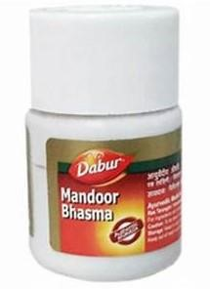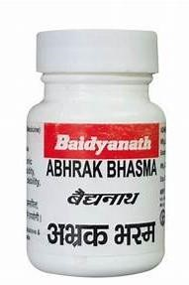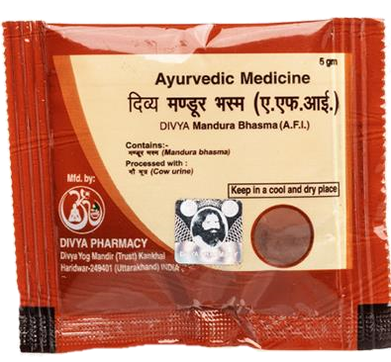

**Figure1 - Mandoor Bhasma, Abhrak Bhasma, Mandur Bhasma**

Dhatri Lauh is a classical ayurvedic formulation. Ingredient of dhatri Lauh are Dhatri (Emblica officinalis), Loha Bhasma (Iron Bhasma), Yashtimadhu (Licorice). These ingredients are powdered they are ground for seven days, dried in earthen pots. Then they rolled in to tablets.[20]

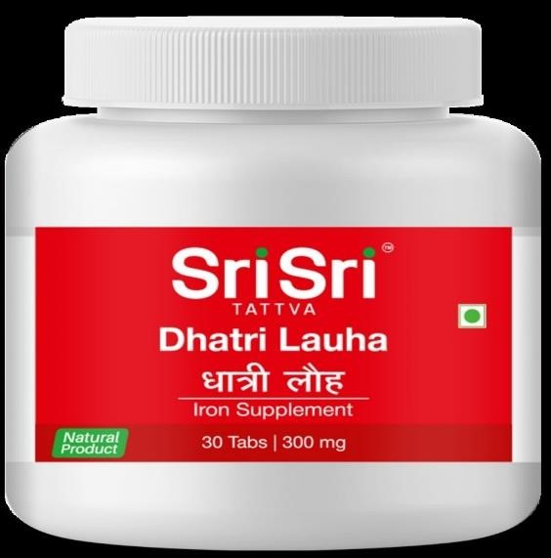

**Figure 2- Dhatri Lauh**

Churnsare medicinal powdered formulation used for of treatments. Churn are prepared by the crushing and sifting of herbs and minerals to achieve a desired consistency. Different churanas are used for liver disease, for example Haridradi Churna, Laghuhingvadi Churna, Yavanikadi Churna, Yakrit Plihantak Churna, Tryashunadi Churna, Sindhavadi Churna, Shankhanabhi Churna, Marichadi Churna, Narach Churna, Navayasa Churna.[22][23]

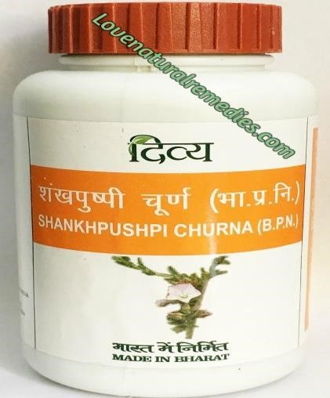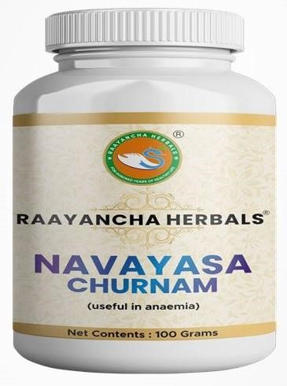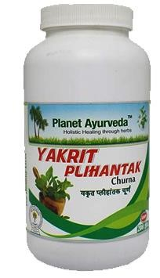

**Figure 03- Shankhpushpi Churna, Navayasa Churna, Yakrit Plihantak Churna**

Lepa is practiced in ayurveda since long time. It generaly consists of 53%, clay 36%, mineral 7% organic substance, 4% water and also can consist of fuller Earth, green clay, rose water, orange oil, almeka are also included. Example Shankhadi Lepa, Moolakaksharadi Lepa, Moolaka Ksharadi Lepa, Kushthadi Lepa, Haridradi Lepa, Vatadi Lepa, Swajikdi Lepa.[24][25]

Rasa basically means taste, some formulations are Arogyavardhini vati is polyherbal-mineral a classical formulation mentioned in Ayurveda. Abhaya (Chebulic Myrobalan fruit rind), Maricha (Black pepper), Krishna (Long pepper fruit), Tankana Bhasma (Borax) g, Dhattura

(Datura metel), Snuhi Ksheera (quantity sufficient for grinding).[26]

Agnikumar Ras is herbomineral classical formulation. Agnikumar Ras contain purified Mercury and Sulphur, black pepper, Processed in fresh lime juice and many other ingredients.[27]

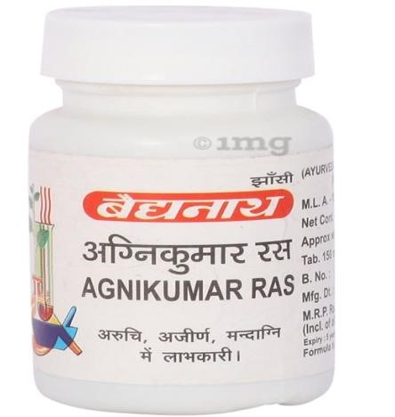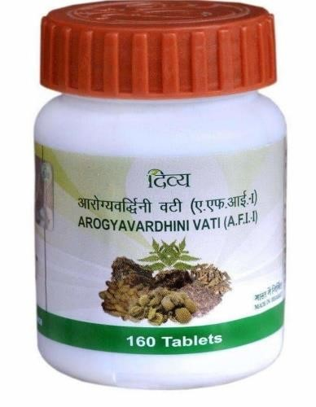

**Figure 04- Agnikumar Ras, Arogyavardhini vati**

Ghrita is a medicine which is based to extract active metabolites from herbs is ghee. It isprepared by heating with fine mixture of herbs grill dehydrated i.e., Transfer of fat-soluble metabolite to the ghrita for example Haridradi Ghrut, Bivladhya Ghrut, Rohitak Ghrut, Pippali Ghrut, Pippalayadi Ghrut, Pippalichitrak Ghrut. [28] [29]

All herbal formulations are compiled and categories in different categories.

## Classical Ayurvedic Products- [Combination of Single Diseases Conditions]

Abhyaristh is a Ayurvedic formulation that boosts your digestive health and eliminates toxins from your body. It improves digestion, increases appetite, reduces gas formation. It’s key ingredient are Harad (Terminalia chebula), Munnaka (Vitis vinifera), Mahua (Madhucaindica), Vaividang (Embeliaribes), Gudd (Jaggery), Gokhru (Tribulusterrestrisz), Nisoth (Operculinaturpetum), Dhaniya (Coriandrumsativum), Dhaiful (Woodfordiafruticosa), Indrayanmul (Citrulluscolocynthis), Chavya (Piper retrofractum), Saunth (Zingiberofficinale), Dantimul (Baliospermummomtanum), Mochras (Salmaliamalabarica)[17]

Arogyavardhini Vati highly effective ayurvedic medicine it increases your energy and boosts your immunity. It rejuvenates your body and mind with this potent ayurvedic medicine. Shudha, Mercury, Shudhha Gandhak, Louh Bhasma, Abhrak Bhasma, Tamra Bhasma, Shudha Shilajeet, Shudha Guggul, Chitrak Mool, Kutki, Neem Patra Ras, Harad, Baheda, Amla.[18][19]

Shankha Bhasma brings relief to you from chronic indigestion problems. It is a time-tested medication that soothes your stomach, heals the damages from contaminations and boosts your digestion. Main ingredient is Shankh Nabhi and Kanji. [21]

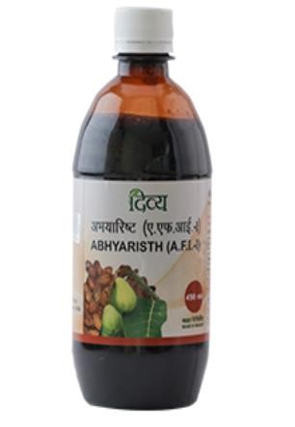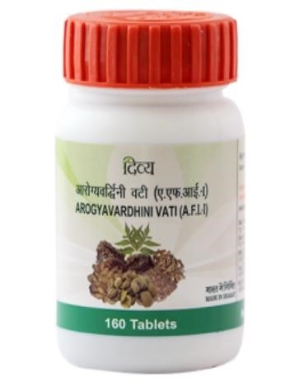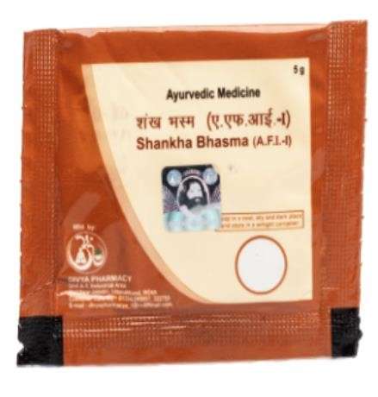

**Figure 05- Abhyaristh, Arogyavardhini Vati and Shankha Bhasma**

**TABLE 01: Classical ayurvedic herbal formulations for liver disorder [30]**

|  |  |  |  |  |
| --- | --- | --- | --- | --- |
| **Name of formulations** | **Diseases** |  | **Name of formulations** | **Diseases** |
| Abhayadi Chatussama  Vati | Kamla | Panchamootrasava | Pleeha |
| Abhayarishta | Udarroga | Pippali Yoga | Pleeha |
| Agnikumar Rasa | Pleeha | Panchashya Rasa | Kamla |
| Agasti Rasa | Udarroga |  | Pippali Loha Yoga | Pleeha |
| Arbudahar Rasa | Arbuda | Pleehari Vatika | Pleeha |
| Arkadi Tail | Pleeha | Pleeharnavo Rasa | Pleeha |
| Arogyavardhini Vati | Kamla, Pleeha | Rohitak Ghrut | Arbuda |
| Ayorajadi Churna, Yoga | Yakrit, Kamla | Raudra Rasa | Yakrit |
| Bhallatak Modak | Pleeha | Saurashtadi Kwath | Yakrit |
| Bivladhya Ghrut | Pleeha | Shankhanabhi Churna | Pleeha |
| Dhatari Loha | Kamla | Shankha Yoga | Kamla |
| Erand bhasma yoga | Pleeha | Shankhadi Lepa | Arbuda |
| Haridradi Churna | Kamla | Shargeshthadi Kwath | Pleeha |
| Haridradi Ghrut | Kamla | Sharpunka Yoga | Kamla |
| Haridradi Lepa | Arbuda | Sharpunkhadi Kalkav | Pleeha |
| Indravarunayadi Kashay | Pandu | Shigru Kawath | Yakrit |
| Kshara Gutika | Yakrit | Shigrumooladi Lepa | Arbuda |
| Kushthadi lepa | Pleeha | Shilajtavadi Yoga trayam | Kamla |
| Laghuhingvadi Churna | Pleeha | Shilajatu Yoga | Kamla |
| Lashuna Yoga | Pleeha | Shuktikshardi Yoga | Pleeha |
| Lokanath Rasa | Yakrit | ShwetPunarnava Moola Yoga | Pleeha |
| Moolaka Ksharadi Lepa | Arbuda | Yakrit Plihantak Churna | Pleeha |
| Moolakabeejadi Lepa | Arbuda | Upodikadi Abhyang Lepa | Arbuda |

**Classical Ayurvedic Products - [Combination of Two Diseases Conditions]**

Abhayadi Modak is a patent product of Zandu Pharmaceuticals, it is used to treat digestive problem regular fever and anaemia, ingredient in abhayadi Modak table are Chebulic myrobalan, Black Pepper, Ginger, Vidanga, Long Pepper, Long Pepper root, Cinnamon, Tej Patra, Nagarmotha, Purging Croton.[31] [32]

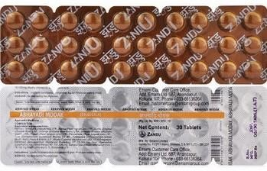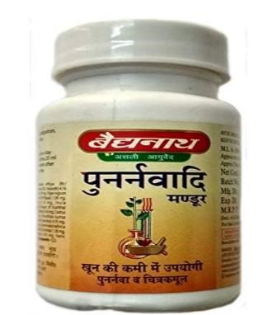

**Figure 06 -Abhayadi Modak, Mandoora Vatakam**

Mandoora Vatakam ayurvedic medicine for anaemia liver and skin disorders.

Tapya (Purified and incinerated copper pyrite), Darvi Twacha (Bark of Berberis aristate), Chavya(Root of long pepper) Devadaru(Pepper, Long pepper, Ginger), Amla (Emblica officinalis), Haritaki, Vibhitaki, Musta(Cyperus rotundus Vidanga), Chitraka(Plumbago zeylanica), Mandoora (Purified Ferric oxide) [33][34]

Pippalyadi ghrita is an ayurvedic medicine, ghee is the base of this medicine Pippalyadi Ghrita Ingredients are Pippali, Dhanavi (Solanum xanthocarpum), Tikta (Picrorhiza kurroa), Sariva (Hemidesmus indicus), Amla (Emblica officinalis), Tamalaki (Aegle marmelos), Musta (Cyperus rotundus), Hima (Santalum album), Palani (Gentiana kurroa), Sevya (Vetiveria zizanioides), Draksha (dry grapes), Ativisha (Desmodium gangeticum), Ghrita, water.[35] [36]

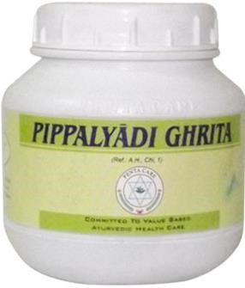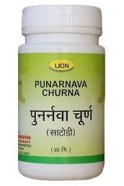

**Figure 07- Pippalyadi ghrita and Punarnava churna**

Punarnava reduces bilirubin level to prevent jaundice, can be use in effective in loss of digestive powe, enlarged spleen, also relieving abdominal pains. It can be used as different form juice, past, churna, decoction, Churna is a powdered formulation. To make mix half tea spoon of churna with honey. [38] [37]

Rohitakadi Yoga Coarse powder of Rohitaka stem (Aphanamixis polystachya) is plunged in decoction of Terminalia chebula for 7 days. Later it is scoured with hands and sifted. This ought to be taken for drinking.[39]

Yakrit Plihari loha is use or live and spleen disorders, it is a Ayurvedic medicine in table form Shuddha Parada (Herbal purified Mercury) Shuddha Gandhaka(Herbal purified Sulphur), Loha Bhasma (Bhasma prepared from Iron), Abhraka Bhasma(Purified and processed Mica), Tamra Bhasma (Bhasma prepared from Copper), Haridra (Curcuma longa), Shuddha Jayapala (Croton tiglium), Tankana Bhasma(Borax),

Shilajatu(Asphaltum),Danti(Baliospermum montanum), Trivrit(Operculina turpethum), Chitraka(Lead Wort), Nirgundi (Vitex negundo), Trikatu(Pepper, long pepper, ginger

Ardraka)[40][41]

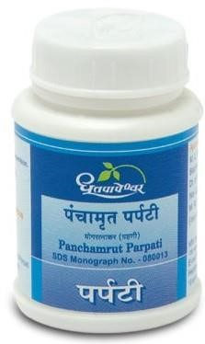

**Figure 08- Yakrit Plihari loha**

**TABLE 02: Classical ayurvedic herbal formulations for liver disorder**

|  |  |  |  |  |
| --- | --- | --- | --- | --- |
| **Name of formulations** | **Diseases** |  | **Name of formulations** | **Diseases** |
| Abhayadi Modak | Pleeha, Pandu | Pippalayadi Ghrut | Pleeha, Udarroga |
| Arogyavardhini Vati | Pleeha, Udarroga | Punarnavadi Churna | Pleeha, Udarroga |
| Chitrakadi Loha | Yakrit, Pleeha | Prabhavati Gutika | Udarroga, Gulma |
| Darvyadi Mandoor Vatak | Pandu, Kamla | Sammoha Lauham | Pandu, Kamla |
| Dravyadi Loha | Pandu, Kamla | Rohitakadi Yoga | Pleeha, Gulma |
| Gudpippali modak | Yakrit, Pleeha | Rohitakasav | Yakrit, Pleeha |
| Kirattiktadi Churna | Pandu, Kamla | Vahanikumar Rasa | Yakrit, Pleeha |
| Mahakshar | Pleeha, Gulma | Yakrut Pleehari Loha | Yakrit, Pleeha |
| Pandukuthat Rasa | Pleeha, Pandu |  |  |

## Classical Ayurvedic Products- [Combination of Three Diseases Conditions]

Abhaya Vati is used in the treatment of jaundice, anemia etc. it a tablet drug. Abhaya Vati Ingredients are Abhaya (Terminalia chebula), Maricha (Piper nigrum), Krishna (Piper longum), Tankana Bhasma (Borax), Dhattura (Datura metel), Snuhi Ksheera (Latex of Euphorbia neriifolia L.) [43]

Agnimukha Lavana is a Ayurvedic medicine, should be taken with buttermilk. It cures enlargement of liver and spleen. It contains Chitrakamula (roots of Plumbago zeylanica), Trivrit (Operculina turpetum), Danti mula (roots of Baliospermum montanum), Amalaki

(Emblica officinalis), Haritaki (Terminalia chebula), Ruchaka lavana, Rock salt. [44]

Chitrakadi Ghritacures abdominal gas, gulma. It ingredient are Chitraka (Plumbago Zeylanicum Linn.), Shwetha Sariva (Hemidesmus indicus), Bala (Sida Cordifolia Linn), Nalla Sugandhi (Ichno Carpus frutescens R.), Draksha (Vitis vinifera Linn.), Indravaruni/ (Citrullus Coloegnthis stkard), Pippali (Piper Longun Linn.), Citraphala (Trichosanthes brateata), Madhuka (Glycyrrhiza glabra Linn.), Haritaki (Terminalia Chibula Ritz.), Amalaki (Emblica officinalis Gaertn.), Kshira (milk), Ghrita (ghee), Tavakshira (Curcuma angustifolia Roxb.), suger. [45] [46]

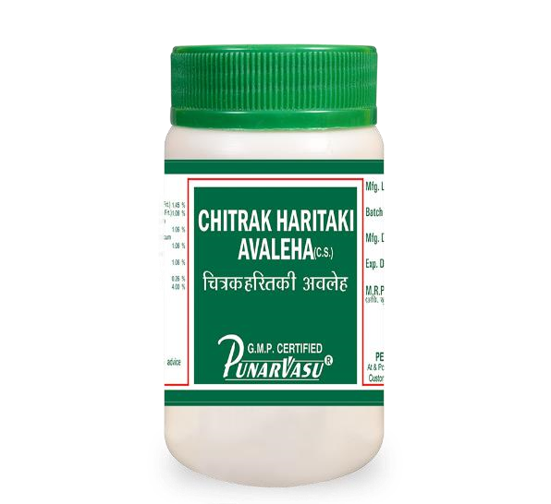

**Figure- 09 Chitrakadi Ghrita**

Kravyad Rasa is use in treatment of spleen disorders, ascites, etc.Kravyada Rasa ingredient Rasa (Herbal purified Mercury), Shuddha Gandhaka (Herbal purified Sulphur), Shulva Bhasma (Bhasma prepared from copper), Loha Bhasma (Bhasma prepared from Iron), Jambirarasa (Lemon juice extract), Panchakola Kwatha (quantity sufficient for grinding), Juice of Amlavetasa (Garcinia pedunculata), Bhasma (Borax), Maricha Black pepper,

Chanaka amla vari.[47]

**TABLE 03: Classical ayurvedic herbal formulations for liver**

|  |  |  |  |  |
| --- | --- | --- | --- | --- |
| **Name of formulations** | **Diseases** |  | **Name of formulations** | **Diseases** |
| Abhayadi Vati | Ykrut, Pleeha, Udarroga | Kravad Rasa | Pleeha, Gulma, Udarroga |
| Adrakmatulunga valeha | Pandu, Kamla, Udarroga | Lashun Tail | Yakrut, Pleeha, Gulma |
| Agnimukha Lavana | Ykrut, Pleeha, Udarroga | Gutika | Ykrut, Pleeha, Udarroga |
| Chitrak Ghrut | Yakrut, Pleeha, Gulma | Mahadravak Rasa | Yakrut, Pleeha, Gulma |
| Eladi Churna | Pleeha, Udarroga, Kamala |  | Marichadi Churna | Gulma, Pleeha Udarroga |
| Hansa Mandoor | Pandu, Kamla, Halimak |  | Narach Churna | Gulma, Pleeha Udarroga |
| Khandasam Churna | Pandu, Kamla, Halimak | Pleehari Rasa | Yakrut, Pleeha, Gulma |
|  |  | Savitra Vatak | Pandu, Kamla, Udarroga |

## Classical Ayurvedic Products- [Combination of Four Diseases Conditions]

Abhaya Lavana is a medical powder drug used in treatment of liver. Used in treatment of liver. Ingredients of Abhaya Lavana are Paribhadra, Palasha, Arka, Snuhi, Apamarga, Chitraka(Lead Wort), Varuna, Agnimantha, Vasuka, Swadamshtra - Small caltrops (whole plant) - Tribulus terrestris Linn, Brihati(Indian Nightshade), Kantakari(Yellow berried nightshade) , Pootika, Asphota, Kutaja , Koshataki, Punarnava, Water for decoction, Ajaji (Small fennel), Shunti(Ginger Rhizome), Maricha(Black pepper), Pippali (Long pepper fruit), Hingu (Asa foetida), Yamani, Pushkara, Shati. [48] [49]

Mrityunjaya Rasa is prepare from mixture of fruitful herbs and minerals. This formulation is known to treat various kinds of liver disorder. Ingredient of mrityunjaya Rasa Shuddha

Vatsanabha, Maricha (Black pepper), Pippali Piper longum, Shuddha Gandhaka Tankana Bhasma (Borax), Shuddha Hingula, Shuddha Parada.[51]

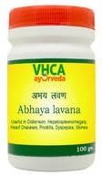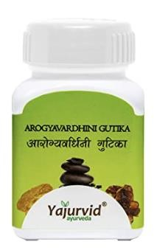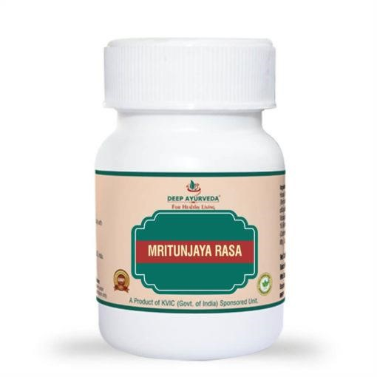

**Figure- 10 Abhaya Lavana Arogyavardhini Gutika & Arogyavardhini Gutika**

Arogyavardhini Gutikais used in the treatment of liver diseases, fever, skin diseases, etc. It helps to provide help in treating infections, fever, oedema, indigestion and obesity.Key Ingredients are Kajjali, Haritaki, Bibhitaka, Amlaki, Lauha Bhasma, Abhraka Bhasma, Tamra Bhasma, Shuddha Shilajatu, Shuddha Guggulu, Chitraka, Katuki.[51]

**TABLE 04: Classical ayurvedic herbal formulations for liver disorder [42]**

|  |  |  |
| --- | --- | --- |
| **Sr. No.** | **Name of formulations** | **Diseases** |
| **01.** | Abhaya Lavana | Yakrut, Pleeha, Gulma, Pandu |
| **02.** | Agnigarbha Gutika | Yakrut, Pleeha, Gulma, Pandu |
| **03.** | Agnikumar Lauha | Yakrut, Pleeha, Gulma, Halimaka |
| **04.** | Mahamrutyunjya Rasa | Yakrut, Pleeha, Gulma, Pandu |
| **05.** | Tamrshwar Gutika | Yakrut, Pleeha, Pandu, Udarroga |

**CONCLUSION**

The liver is a one-of-a-kind organ in the body, it can reinforce itself. Be that as it may, when the harm is extreme, scar tissue causes cirrhosis so, the liver can't work adequately. Ayurvedic liver products help reestablishes the effectiveness of the liver, secure the deficiency of functional integrity of the cell layer, ensure hepatic parenchyma against poisons, advances recovery of liver cells, control the advancement of the sickness and protect from further liver harm and guarantee early reclamation of hepatic role in ineffective hepatitis. They help in the prevention and treatment of Alcoholic liver, viral hepatitis, pre-cirrhotic conditions and early cirrhosis Protein-energy malnutrition, less craving, liver harm because of Radiation and chemotherapy-included.

Today different liver diseases are one of the principal health concerns around the world, with liver cirrhosis and medication introducing hepatotoxicity. liver cirrhosis is the 14th driving reason for deaths on the planet and could be the 12th driving reason for deaths shortly. Customary treatment modalities are restricted, costly and risk of adverse effects seen. Different formulations prepared from herbs and minerals play a significant part in the treatment of liver diseases. In this review article, an attempt has been made to collect and compile names of different classical ayurvedic formulations for liver disease according to the diseases the cure.

**REFERENCE**

1. Dienstag JL and Isselbacher KJ: Toxic and drug‐induced hepatitis, 15th eds.

Chapter 296, In Harrison’s Principles of Internal Medicine. Braunwald E. The McGraw‐Hill Companies, In, 2007

1. Pandey, Prachi & Pal, Rahul & Chanana, Arsh & Singh, Ravinder. (2023). BIOLOGICAL SYNTHESIS OF METAL BASED NANOPARTICLES INCLUDING BACTERIA AND FUNGI. 79-89. 10.36673/AJPAMC.2022.v10.i03.A11.
2. Bhatt N and Deshpande M: Liver Disorders and Potential Medicinal plants: A Review Study. Int J Ayu Pharm Chem 2018; 9(1): 218-241
3. Prof. MS Krishnamurthy. MD (Ayu)., PhD. https://easyayurveda.com/2014/05/28/gulma-abdominaltumor-a-unique-disease-inayurveda/, accessed on 14 December 2017
4. Agnivesh, Shastri K, Gorakhnath and Chaturvedi G: CharakSamhitaChp. 16/4, 5, 6 Varanasi; Chaukhambha Bharati Academy 2004; 2: 487
5. Agnivesh, Shastri K, Gorakhnath and Chaturvedi G: CharakSamhitaChp. 5/9-11, Varanasi; Chaukhambha Bharati Academy 1984; 2: 382.
6. Yadavji TA: Sushruta Samhita (Uttar Tantra): PanduRoga Pratisedha, 44/4 2nd edition, Varanasi: Chaukambha Orientalia 2009: 729
7. Pandey, Prachi & Pal, Rahul & Thakur, Shiva Kant & Sharma, Vidhi & Chanana, Arsh & Singh, Ravinder. (2023). FUTURE ASPECTS & MODIFICATION IN CARBON- NANOPARTICLES IN TREATMENT AND DIAGNOSIS. WORLD JOURNAL OF PHARMACY AND PHARMACEUTICAL SCIENCES. 12. 307-324. 10.20959/wjpps20232-24094.
8. Tripathi B: Charak Samhita Sutra Sthana 24/25: Varanasi: choukhamba publication 2004; 434-435
9. Bhatt et al., IJPSR, 2018; Vol. 9(10): 4056-4070. E-ISSN: 0975-8232; P-ISSN: 2320-5148
10. Pal, Rahul & Pandey, Prachi & Thakur, Shiva Kant & Chanana, Arsh & Singh, Ravinder. (2023). DRUG DESIGN AND DEVELOPMENT INVOLVING NOVEL SOFTWARE IN PHARMACEUTICALS. Asian Journal of Pharmaceutical Analysis. 10. 90-106. 10.36673/AJPAMC.2022.v10.i03.A12.
11. Upadhyay S.N, Singh R. K, Banerjee R; Toxicological Evaluation of Shatamuli Mandoor; Volume 4, Issue 11, 1133; Journal of Pharmacy and Pharmaceutical Sciences.
12. [Buwa, Savit](http://nopr.niscair.res.in/browse?type=author&value=Buwa%2C+Savita)[aPatil, Subhash,](http://nopr.niscair.res.in/browse?type=author&value=Patil%2C+Subhash) [Kulkarni;](http://nopr.niscair.res.in/browse?type=author&value=Kulkarni%2C+P+H) Hepatoprotective action of Abhrak Bhasma, an Ayurvedic drug in albino rats against hepatitis induced by CCl4; Oct-2001, NISCAIR-CSIR, India, 1023
13. <https://www.patanjaliayurved.net/product/ayurvedic>medicine/arishta/divyaabhyaristh/2
14. [Kumar G,](https://www.sciencedirect.com/science/article/abs/pii/S0378874112000050#!) Srivastava A; Safety evaluation of an Ayurvedic medicine, Arogyavardhini vati on brain, liver and kidney in rats; [Volume 140, Issue 1,](https://www.sciencedirect.com/science/journal/03788741/140/1) 6 March 2012, Pages 151-160; [Journal of Ethnopharmacology](https://www.sciencedirect.com/science/journal/03788741)
15. Kumar, D., Parkhi, V., & Vaghela, D. (2019, April 3). Clinical effect of Manjisthadi Kwatha orally and Pippali Churna Pratisaran in the management of Gingivitis– A Case Study. *International Journal of AYUSH Case Reports*, *3*(1), 28-31.
16. Pandey, Prachi & Pal, Rahul & Chanana, Arsh & Singh, Ravindra. (2023). PLGA NANOPARTICLE AS A CARRIER IN COLON TARGETING DRUG DELIVERY SYSTEM. 11. 336-343. 10.36673/IJRPNS.2022.v11.i05.A39.
17. Garg S, Mishra A and Gupta R; Fingerprint Profile of Selected Ayurvedic Churn/Preparations: An Overview; Garg et al., Altern Integ Med 2013, 2:6
18. Lakshmi M, Revathi R, Kumar A.R; Physico-chemical analysis of selected churnas formuations; Indian Journal of Research in Pharmacy and Biotechnology ISSN: 2321-5674; ISSN: 2320 – 3471.
19. Snehapriya P. R and Venkatesh B. A; Rasaoushadies in The Management of ShiroKarnanasa and Mukha-Danta Roga-A Critical Review; World Journal of Pharmaceutical Research; Volume 9, Issue 12, 1444-1453.
20. Shah N: Bharat Bhaishjya Ratnakar (Vol 1-5) Sanskrit text with Hindi translation, New Delhi: Jain Publishers;2009: 444.
21. [Satturwar, P M,](http://nopr.niscair.res.in/browse?type=author&value=Satturwar%2C+P+M) [Fulzele, S V,](http://nopr.niscair.res.in/browse?type=author&value=Fulzele%2C+S+V) [Joshi, S B,](http://nopr.niscair.res.in/browse?type=author&value=Joshi%2C+S+B) [Dorle, A K;](http://nopr.niscair.res.in/browse?type=author&value=Dorle%2C+A+K) Hepatoprotective activity of *Haridradi ghrita* on carbon tetrachloride-induced liver damage in rats; Dec-2003, NISCAIR-CSIR, India, 1447-1451
22. [Satturwar, P M,](http://nopr.niscair.res.in/browse?type=author&value=Satturwar%2C+P+M) [Fulzele, S V,](http://nopr.niscair.res.in/browse?type=author&value=Fulzele%2C+S+V) [Joshi, S B,](http://nopr.niscair.res.in/browse?type=author&value=Joshi%2C+S+B) [Dorle, A K;](http://nopr.niscair.res.in/browse?type=author&value=Dorle%2C+A+K) Hepatoprotective activity of *Haridradi ghrita* on carbon tetrachloride-induced liver damage in rats; Dec-2003, NISCAIR-CSIR, India, 1447-1451
23. Pal, Rahul & Pandey, Prachi & Chanana, Arsh & Singh, Ravindra & Waheed, Saman & Katiyar, Aparna. (2023). Recent Approaches on 3D Printing (3DP) in Pharmaceuticals as Dominance Role in Traditional Formulation. 8. 989.
24. [https://www.ayurmedinfo.com/2012/05/10/mandoora-vatakam-benefits-dosageside-effects-ingredients/](https://www.ayurmedinfo.com/2012/05/10/mandoora-vatakam-benefits-dosage-side-effects-ingredients/)
25. Swati K, Arvind K.P, Martand V.S; Conceptual Study of Virechana Karma by Abhayadi Modak in Khalitya; International Journal of Ayurvedic Medicine, 2014, 5(4), 283-287
26. Rashmi TM, Sathish HS, Thirunavukkarasu MS; Trend of Ayurvedic Research Studies on Pandu Roga and Future Guidelines; International Journal of Applied Ayurved Research ISSN: 2347- 6362
27. Pandey, Prachi & Thakur, Shiva Kant & Chanana, Arsh & Pal, Rahul. (2023). BIODEGRADABLE POLYMER’S ENHANCING DRUG DELIVERY ACTIVITY IN DIFFERENT NOVEL DRUG DELIVERY SYSTEM. WORLD JOURNAL OF PHARMACY AND PHARMACEUTICAL SCIENCES. 12. 2046-2069. 10.20959/wjpps2023.
28. Dhodapkar S.P and Kale A.B; Composite Dietary Management with Agni Chikitsa in Malnourished; World Journal of Pharmaceutical Research, Volume 7, Issue 10, 1057-1069.
29. Ghuraiya S. and Mandal S.K; Clinical Study to Evaluate the Efficacy of Punarnava Churna on Vyana Bala Vaishamya; vol 6, issue 8, August 2018.
30. <https://sdlindia.com/products/vikrant/parpati/panchamrut-parpati.html>
31. Bhatt et al., IJPSR, 2018; Vol. 9(10): 4056-4070
32. https://www.ayurmedinfo.com/2012/07/24/abhaya-vati-benefits-dosageingredients-side-effects/
33. Digambar W.V, Shirbhate A.M; Critical Review on Current Scenario of

Hepatotoxicity and Its Ancient Perspective; World Journal of Pharmaceutical Research, Volume 10, Issue 12, 791-812

1. Pal, Rahul & Pandey, Prachi & Waheed, Saman & Thakur, Shiva Kant & Sharma, Vidhi & Chanana, Arsh & Singh, Ravindra. (2023). TRANSDERMAL DRUG DELIVERY SYSTEM (TDDS) AS A NOVEL TOOL FOR DRUG DELIVERY. 12. 688-711. 10.20959/wjpr20232-26997.
2. [https://www.ayurmedinfo.com/2012/06/19/abhaya-lavana-benefits-dosageingredients-side-effects/](https://www.ayurmedinfo.com/2012/06/19/abhaya-lavana-benefits-dosage-ingredients-side-effects/)
3. Perera S.S, Silva G, Naffeza N.M.S; Role of Medicated Ghrita and Taila Formulations in the Management of Stree Vandhyatva; Bandaranayake Memorial

Ayurveda Research Institute; vol 2, no 3 (2020): December

1. <https://ayurvedacart.in/classical-medicines/lavana>
2. Kureshi A, Patil V; Lavana Kalpas: An Ayurvedic Approach of Salt; Aayushi International Interdisciplinary Research Journal (AIIRJ), VOL- VII ISSUE- VII JULY 2020
3. Kureshi A, Patil V; Lavana Kalpas: An Ayurvedic Approach of Salt; Aayushi International Interdisciplinary Research Journal (AIIRJ), VOL- VII ISSUE- VII JULY 2020
4. Dr. Abhishek, Ashok Kumar BN, Sujatha K, & Sunil Kumar. (2017). Analytical evaluation of Mrityunjaya Rasa. Journal of Ayurveda and Integrated Medical Sciences, *2*(06), 53-55.
5. Swarnalatha PL, Reddy PN. Hepatoprotective activity of Sphaeranthus amaranthoides on D-galactosamine induced hepatitis in albino rats. Asian Pacific Journal of Tropical Biomedicine 2012;2(3): S1900-S1905.