SEMI -AUTOMATIC FLOOR CLEANING MACHINE
(BLUETOOTH CONTROL)
Sakshi Chougule ¹, Namira Tamboli ², Rutuja Kamble ³ , Kamlesh Mahajan⁴ ,
Prof. Rajkumar Patil ⁵.
DEPARTMENT OF MECHANICAL ENGINEERING
ANNASAHB DANGE COLLEGE OF ENGINEERING AND TECHNOLOGY ,ASHTA ,SANGLI ,INDIA.
ABSTRACT
Floor cleaning machines are commonly used in developing countries since many years Automated because of high cost of labor, time, efforts and affordability. The concept is not popular in developing or emerging economic countries. Reasons for non-popularity are cost of machine and operational charges in terms of power tariff. This article is based upon on our innovative project to design, development and manufacturing of semi-automatic floor cleaning machine which will work on solar energy, battery or electricity. A semi-automatic floor cleaning machine is developed by keeping basic consideration for less energy consumption, machine as well as operational cost reduction, reduce the human effort, environment friendly and easy to handle. Base of the project was to use renewable energy which is abundant in most of the countries, will have less environmental impact and easy to construct for commercial scale in future.
- INTRODUCTION
The floor cleaner is functional for cleaning the floors in homes, offices, auditoriums, shops, and big computer halls; as it is easy to use. Anyone can operated this device. As a result, it is very helpful in homes, clinics, etc. Cleaning takes very little time and costs very little money. Maintenance expenses are lower. Machines of all kinds are frequently used for this. But their methods of operation vary, and the price is also very high. We created this machine because it requires an electricity source to solve this issue.
This Project features a very easy drive mechanism that is user-friendly for everyone. The machine's dimensions and portability make it simple to move from one location to another. The floor cleaner is a easy and modern household item that even kids can use safely and simply. It is crucial for all homes, institutions, and other establishments..
- METHODOLOGY
Planning
Software Development

- 2.1 Planning
- 2.1.1 Design
The design contains a attractive and high durable machine compare to the other machines available in the market. The design is compact and light weight which makes it easy and simple to use.
- 2.2 Implement
- 2.2.1 Development
The machine is made up of a number of components like wiper, DC motor, mop and brushes. These components are mounted on a welded chassis made of mild steel square bar measuring one inch in length, and they are all linked by an electrical system. SMPS is used to convert he AC supply to 12 V DC supply which is used to give supply to DC motor.
- MODELING AND ANALYSIS

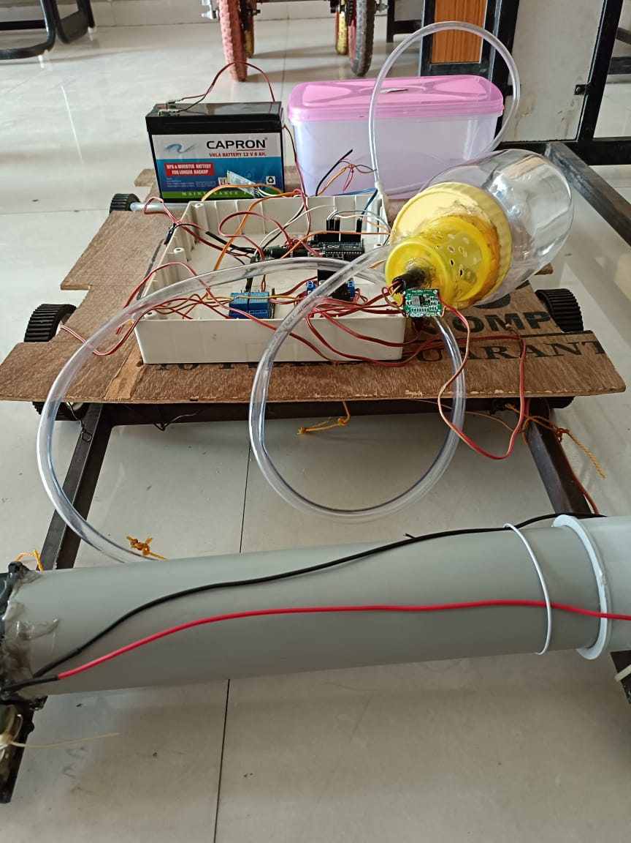 | 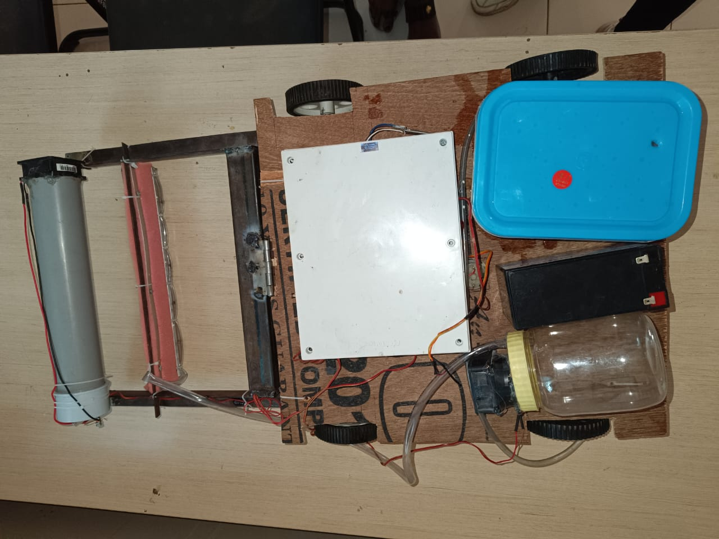

Figure 1: Project Setup.

- RESULTS AND CONCLUSION
The designed and manufactured product is completely functional and produces the required motion. In a room, it is being tested, and the findings are positive. During power crises, a manually controlled floor cleaner can be used instead of an automated one. Both fabrication and design are very simple. Overall, the idea is very beneficial, and there is plenty of opportunity for creativity in the mechanical components. The optimization process won't stop until the finest result is reached. Overall, the project achieved its goals and will undoubtedly alter the robotics and floor washing eras. The algorithm is built to offer 90% efficiency in the automation part, which is too high given the current situation. The area of sensing is one where advancements can be achieved..
- REFERENCES:-

- AadilArshad2, Nand kishor S. Kale3, Ansari M Bilal4, Prof. D. M. Ugle5 Muhammad Kashif Shaikh Ghaffar1, M. Department of Mechanical Engineering ,STC SERT Shegaon “DESIGN AND DEVELOPMENT OF FLOOR CLEANING MACHINE” International Journal of Advance Engineering and Research Development Volume 5, Special Issue 06, April-2018 (UGC Approved)
- C .R .Balamurugan*, P.Kirubha, S.ArunKanna, E.R.Hariprasath, C.Anupriya Department of EEE/Karpagam College of Engineering/Coimbatore, India“Bluetooth Based Automatic Floor Cleaning System” International Journal of ChemTech Research CODEN (USA): IJCRGG, ISSN: 0974-4290, ISSN(Online):2455-9555 Vol.11 No.04, pp 55-62, 2018
- Mr.S. Rameshkumar1, M. Selvakumar2, S. Senthilkumar3, P. Surya4, I. Thilagavathi5 “Design and Fabrication of Multipurpose Floor Cleaning Machine” International Journal of Advanced Science and Engineering Research Volume: 3, Issue: 1, 2018 ISSN: 2455-9288
- Nikhil Murlidhar Chopade Student, Mechanical Department, DES’s COET Dhamangaon Rly, India “Modified Floor Cleaning Machine” International Journal of Emerging Technologies in Engineering Research (IJETER) Volume 5, Issue 4, April (2017)

