**DESIGN OF URBAN STORMWATER DRAINAGE AT GANDHINAGAR TP AREA BASED ON CIVILSTORM SOFTWARE**

**Mr. Dipak Jadav1, Prof. Kinnari Mishra2**

1Student, ME Infrastructure Engineering, LDRP Institute of Technology and Research, Gandhinagar, Gujarat, India

2Professor, ME Water Resource Engineering, LDRP Institute of Technology and Research, Gandhinagar, Gujarat, India

**ABSTRACT**

This research focuses on the design and effective distribution of Urban Rainwater also termed as Storm Water Network Design in Engineering. Storm Water Network Design is need for society due to rapid urbanization. As today all the cities are moving towards rapid development growth, there is minimal chance of natural runoff in the ground leading to massive flooding in the developed city. Estimation of Runoff and based on the projected estimation to provide optimal design of stormwater network design for Gandhinagar, Sargasan TP area is the focus of this research work. Catchment area, runoff coefficient and rainfall Intensity are the key factors governing the design. Rational Method is used for the estimation of stormwater runoff which is widely used in Literature.

The efficient design will be provided using the Bentley Civil Storm software for the study area. The Stormwater network will be designed to collect excess runoff and will be discharged into the nearby outfall location.

**Keywords:** Storm Water Network, IDF, Runoff- Estimation, TP Area, Rational Method, Gumbel Distribution, Civil Storm, QGIS

1. **INTRODUCTION**

Gandhinagar is the capital of Gujarat state and is also known as green city. After saturation and limitation of infrastructure development in the sector area, resulted in the urbanization of outside sector area like Sargasan, Kudasan, Rayasan, etc. in Gandhinagar city. The growth of urbanization of the city, reduces the pervious land and increases the impervious surface. Due to which it occurs the low penetration of rainwater in the ground. Runoff is generated from roads, walkways, parking lots, rooftops, less pervious soil, and other footprints which prevent the infiltration of stormwater. Thus, runoff volume increases and flooding happen in the city.

**Study Area**

Gandhinagar is a planned city located in the state of Gujarat, India. It serves as the administrative capital of Gujarat and is situated approximately 23 km north of Ahmedabad, the commercial capital of the state. The city was named after Mahatma Gandhi, the father of the nation, and was planned by two Indian architects, H. K. Mewada and Prakash M. Apte. It was built in the 1960s to replace Ahmedabad as the capital city of the state. The city is also home to several government offices, including the Gujarat Legislative Assembly, Gujarat High Court, and various state government departments. Gandhinagar has a thriving economy and is home to several industries, including information technology, pharmaceuticals, and textiles.

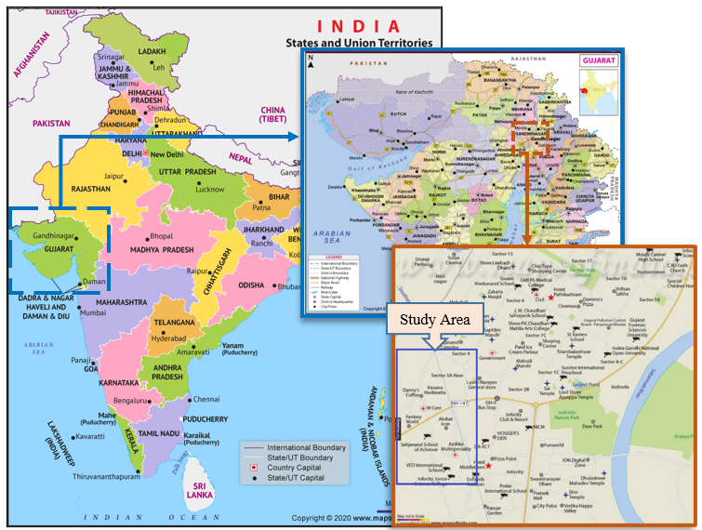

**Figure 1:** Study Area [1]

1. **METHODOLOGY**

The process and methodology for new approaches in stormwater management are always in development with the application of leading principles such as, sustainable development, watershed planning, ecosystem management. Storm water management demands the use of water for treating or transforming the stormwater runoff. These objects often must compete for space with the rest of utility components and users of land on the watershed. That is why the planning of the storm water management systems must be in accordance with general development plans on the watershed.

This paper shows a hierarchical approach to planning of the storm water management and drainage system design. The methodology section of this research paper covers a detailed description of the data collection, design basis, steps for the software and results. The purpose of this section is to enable readers to evaluate the reliability and validity of the study. Routing plan was prepared with the data gathered from the concerned authority and catchment marking was done using GIS Software. Later, IDF curves were generated. The model was generated and deigned using CivilStorm software. The detail results will be discussed in section 4 of this research paper.

**Figure 2** Flow Diagram of Methodology

1. **Design Basis**

Rational method [2] was referred before starting of detailed methodology. In stormwater network, rational method is widely used to calculate runoff. The Rational Method expresses a relationship between rainfall intensity and catchment area as independent variables and the peak flood discharge resulting from the rainfall as the dependent variable. The same is adopted here for the estimation of runoff, which is as follows,

$$Q=10CiA$$

Where,

Q - Runoff Discharge in m3/hr

C - Co-efficient of runoff

i - Intensity of rainfall in mm/hr

A - Area of the catchment in hectares

1. **Data collection**

Data collection refers to the process of gathering information or data for research purposes. It is an important aspect of the research process and involves the systematic and structured gathering of information from various sources. Data plays the important role in process, analysis, and conclusion of research work. Base map provides the background for network plotting and rainfall data gives the intensity of the storm runoff generation.

Base map is provided by the GUDA [3] (Gandhinagar Urban Development Authority) which includes the plot boundaries and road network with road levels as shown in Figure 3. Daily rainfall data is collected from IMD [4] (India Meteorological Department) as shown in Figure 4.

|  |  |
| --- | --- |
|  |  |
| **Figure 3:** Base Map | **Figure 4:** Daily Rainfall Data |

1. **Routing plan preparation**

A routing plan is a crucial part of network design and deployment. It involves the process of designing a network topology and defining the path that data packets will follow when traveling from one network node to another. A Stormwater network alignment is placed at the centre of the road which depicts the pipe alignment. The pipe alignment will be on the network alignment as shown in figure. After each 30m interval manhole is placed on the pipe alignment. AutoCAD software was used to place the manhole at equal intervals.

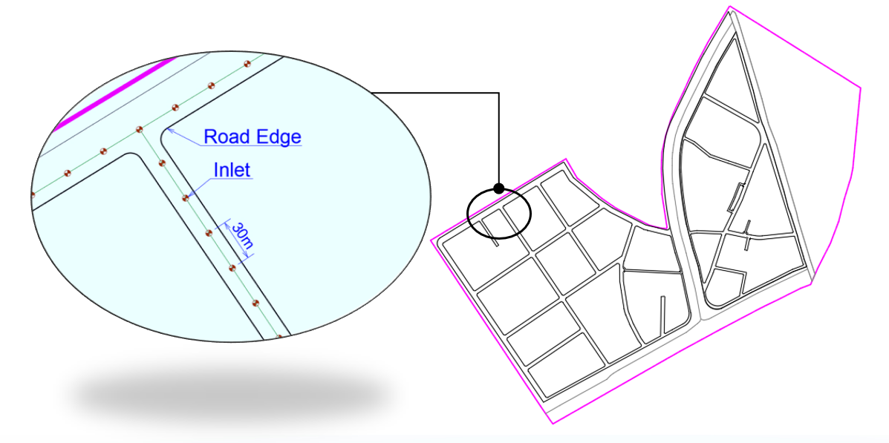

**Figure 5:** Routing plan

1. **Catchment Preparation**

The catchment preparation process is a critical step in stormwater management. It involves the analysis and design of the stormwater drainage system for a particular area, also known as a catchment. After determining the topography of the catchment area and the surface material, which can influence the flow of water, the drainage characteristic is identified. This information can be obtained from topographical maps or field surveys. Study area is mainly divided into plots and roads as per runoff coefficient of catchment area. Calculating the amount of water that will flow into the catchment during a rainfall event. This can be done using rainfall data, catchment area size, and surface characteristics. The effective stormwater catchment system is generated that will minimize the risk of flooding and other storm-related issues in the area. Catchment area are converted into shape file with the help of QGIS software. As shown in Figure 6, magenta and blue color represent the plot and road area respectively.

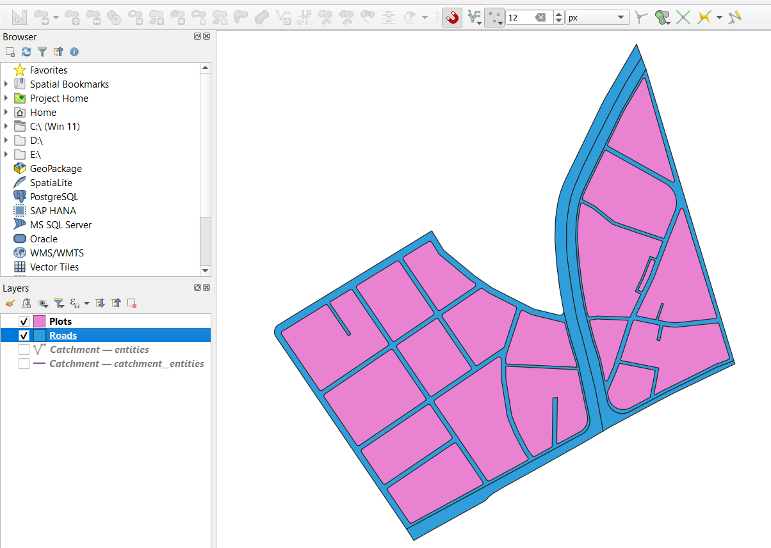

**Figure 6:** Catchment Area

1. **IDF Curve**

The rainfall intensity duration frequency curves are graphical representation of the probability that a given average rainfall intensity will occur within a given period. Providing mathematical relationship between the rainfall intensity i, the duration d, and the return period T(or equivalent to the annual frequency of exceedance f), the IDF curves allow for the estimation of the return period of an observed rainfall event or conversely of the rainfall intensity corresponding to a given return period. Design storms derived from IDF curves are commonly adopted in water resources engineering for designing of urban drainage systems, evaluating the endurance of hydraulic structures, and assessing regional flood vulnerabilities. To get intensity against duration and frequency, IDF (Intensity-Duration-Frequency) curve is prepared with the help of rainfall data and Gumbel distribution method. Detailed methodology and steps are defined in separate research paper [5].

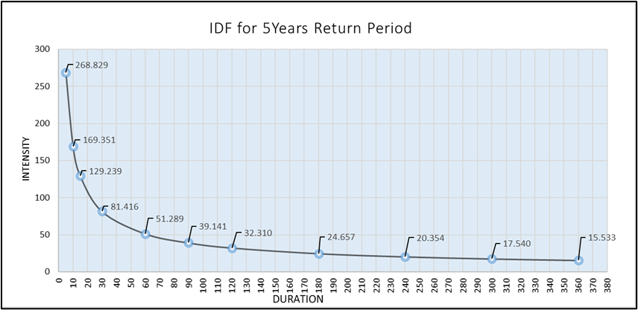

**Figure 7:** IDF Curve for 5years return period

1. **MODELING AND DESIGN ANALYSIS**

In CivilStorm software, model building is first and prior step before designing the stormwater network drainage.

1. **Model Building**

The Model Builder tool in CivilStorm, allows to create, edit, and manage Model Builder to be used in the model-building/model-synchronizing process. Model builder converts the non-graphical and/or graphical data into software entities like manhole, pipe, outfall, and catchment area. After specifying a target, Model Builder will perform the selected operation. For manhole, pipe, and outfall, excel files are used. Shape file is used to develop the catchment area. As shown in Figure 8, data source needs to select for each element and map with relative information.

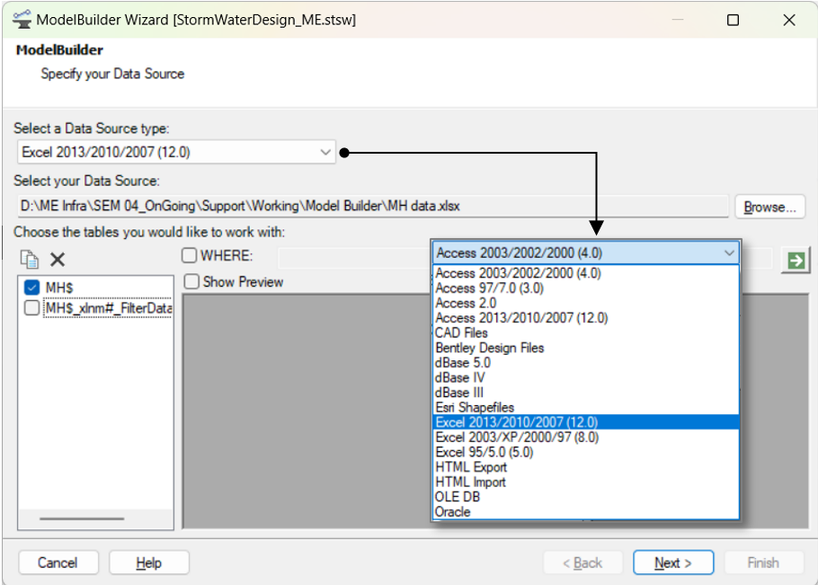

**Figure 8:** Model Builder tool

1. **Design Constraint setup**

Pipe diameters, invert elevations, node structures, and inlets can be all designed with the same set of design constraints. The option to adjust these values individually for each pipe or structure. The Default Design Constraints dialog is divided into the three tabs; Gravity Pipe, Node and Inlet. As shown in Figure 9, design constraint is set up in software. Key design constraints considered for the research is mentioned as follows,

Velocity: 0.60m/s to 3.00m/s

Cover: 1m to 5m

Slope: 1000 (1/S) to 25 (1/S)

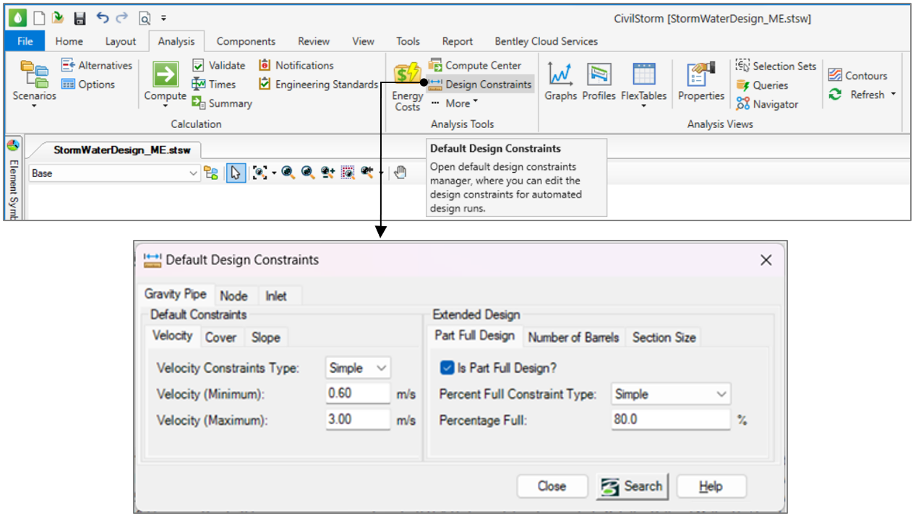

**Figure 9:** Design Constraint

1. **Compute model**

Designing of pipe diameter, invert levels, slope of pipe are designed according to design standards form CPHEEO manual [2]. Design criteria is considered such as self-cleansing velocity, scouring velocity, minimum earth cover, maximum depth of cut, discharge location and level. The following steps are given for detailed understanding of design using software, software is helping us to reduce the manual iterations and minimize the manual error. As shown in Figure 10, compute key is available to run the design in software. After computing, user notification is showing the problematic areas and suggestions for the better design. By checking and solving each message and optimizing the design as per the software error message designing process will be completed.

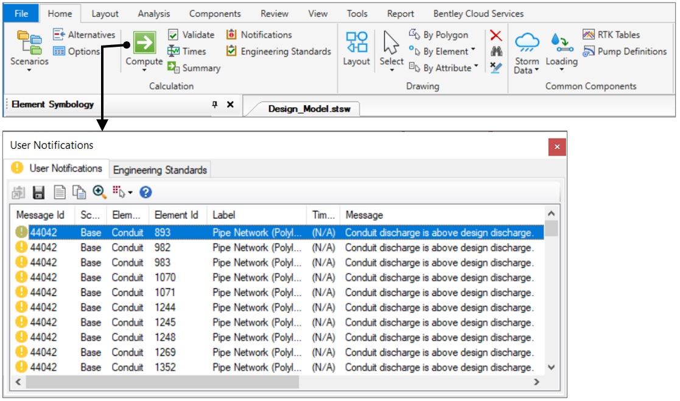

**Figure 10:** Compute the model

1. **RESULTS AND DISCUSSION**

The finding of the carried research work is discussed in this segment. Various design parameters were analyzed, and result was optimized. The result obtained is generated from the specific algorithm of the software, based on input data and pre-defined design constraints. After the model is computed, as per the suggested design criteria modeler needs to check it manually to avoid the error. If the model does not meet the specified design criteria, simulation is done manually by optimizing the diameter.

The model was optimized on velocity parameters by changing diameter and/or slope of the pipe. The diameter wise length result generated after the final optimization of model is as follows:

**Table 1.** Diameter Wise Length

| **Pipe Diameter (mm)** | **Length (m)** |
| --- | --- |
| 300 | 138.7 |
| 350 | 120.0 |
| 400 | 146.3 |
| 450 | 298.6 |
| 500 | 166.9 |
| 600 | 617.8 |
| 700 | 665.2 |
| 800 | 957.1 |
| 900 | 929.5 |
| 1000 | 893.6 |
| 1100 | 558.6 |
| 1200 | 810.9 |
| 1400 | 1200.5 |
| 1500 | 444.1 |
| 1600 | 534.6 |
| 1800 | 1664.6 |
| 2200 | 177.4 |
| 2400 | 819.8 |
| **Total** | **11144.2** |

1. **CONCLUSION**

In conclusion, urban stormwater design is an essential aspect of modern urban planning and development. The increasing urbanization and climate change have made it necessary to develop sustainable and resilient stormwater management practices that can effectively mitigate the negative impacts of urban stormwater runoff. Rainfall intensity – duration – frequency curve is prepared with detailed study and analysis of rainfall data. With the help of received map, stormwater network alignment is finalized and discharged in natural drain. Pipe network is designed for stormwater network of near 11km length which consist of diameter range from 300mm to 2400mm concrete pipe. There are 382 manholes and 4 outfalls discharging into natural drain.

1. **ACKNOWLEDGEMENTS**

I would like to express my deepest appreciation to my family. I'm deeply indebted to I would also like to extend my deepest gratitude to all my guide and professors.

1. **REFERENCES**

|  |  |
| --- | --- |
| [1] | "Map of India," [Online]. Available: https://www.mapsofindia.com/. |
| [2] | CPHEEO, "Manual on Storm Water Drainage Systems," vol. I, August, 2019. |
| [3] | G. U. D. Authority, "GUDA". |
| [4] | I. M. Departmrnt, "IMD". |
| [5] | D. Jadav, "Developing Rainfall Intensity–Duration–Frequency Relationship with IDF Curve for Gandhinagar City," *Gradiva Review Journal,* vol. 9, no. 2, February 2023. |