# A descriptive study on “Role of Digital Marketing on Mutual Fund Investment”



**CAPSTONE PROJECT REPORT**

Submitted by

|  |
| --- |
| Ruchika – 12104434 |
| Tanmayee Yadavalli – 12115190 |
| Sunny Kuwar – 12115206 |
| Muskan Chawla – 12108169 |
| Rahul Mane- 12106761 |

In partial fulfilment of the requirements for the award of the degree of

**MASTER OF BUSINESS ADMINISTRATION (MBA)**

**Mittal School of Business**

## LOVELY PROFESSIONAL UNIVERSITY

**Phagwara (Punjab)**

## TO WHOMSOEVER IT MAY CONCERN

This is to certify that the project report titled “**Role of Digital Marketing on Mutual Fund Investment”** carried out by Ruchika, Tanmayee Yadavalli, Sunny Kuwar, Muskan Chawla, Rahul, has been accomplished under my guidance & supervision as a duly registered MBA student of the Lovely Professional University, Phagwara. They are submitting this project in partial fulfilment of the requirements for the award of the Master of Business Administration (MBA) from Lovely Professional University. Their dissertation represents their original work and is worthy of consideration for the award of the degree of Master of Business Administration.

(Name & Signature of the Faculty Advisor)

Date

## DECLARATION

We hereby declare that our Project Report titled “**Role of Digital Marketing on Mutual Fund Investment”** is a genuine record of our own work carried out as per the requirement for the award of degree of Master of Business Administration (MBA) at Lovely Professional University, Phagwara, Punjab. Any literature, data or works done by others and cited within this dissertation have been given due acknowledgement and listed in the reference section.

Date :

**Acknowledgement**

### At the very outset, we have an opportunity to carry out our project on **“**Role of Digital Marketing on Mutual Fund Investment**”** We would like to take this opportunity to express our profound sense of gratitude and respect to all those who helped us throughout the duration of this project. We are highly thankful to Mr. Amanjot Singh Sayan, for her active support, valuable time and advice, whole-hearted guidance, sincere cooperation and pains-taking involvement during the study and in completing the project. This period proved for us one of the most productive and knowledgeable experiences of our career. It provided us an opportunity to upgrade our skills as well as sharpen our professional knowledge and understanding in an environment that was intellectually stimulating.

**Introduction**

With the pooled resources of several members in a mutual fund, investments in assets like stocks, bonds, and short-term debt are made. The portfolio, or the total holdings, of the mutual fund are what distinguish it as a mutual fund. A mutual fund's shares are bought by investors. Professional money managers that work with mutual funds invest the money in the fund to provide returns for the investors. A mutual fund's portfolio is created and managed in line with the prospectus's stated investment objectives. All parties involved in the fund business, such as investors, mutual fund agents, financial planners, investment counsellors, and fund personnel, must thus improve their awareness of the sector.

Open-ended mutual fund plans are ones that are always accepting new investors and have available units for purchase. Money can be bought or sold without restriction. These plans are not just perpetual, but they are also not traded on any significant marketplaces. They give investors extra liquidity because the buyback facility is available.

Closed-ended mutual fund plans are ones that have a limited lifespan before they need to be redeemed. The units are listed on the stock market when the sale is completed. The supply-demand equilibrium has an impact on unit costs.

Growth strategies concentrate on equity investments with high rates of return. Income Schemes are investments in fixed assets that regularly produce an income for their owners.

Investments made in "balanced schemes" are assured to grow at a pace that is both respectable in terms of return and not overly speedy. Investments in debt and equity are frequently made with financial resources. These pools of funds are invested in short-term, highly lucrative, and liquid assets like Treasury bills and commercial paper.

Money market accounts that are tax-deferred provide investors a tax savings. Equity-linked pension plans and savings plans do not include capital gains on specific assets.

The best investment strategy is to use index schemes. The yields and the yield on the Index are essentially identical.

Potential investors must have a thorough understanding of mutual funds before taking any action. There is a positive connection, supposing the investor has some knowledge with mutual funds. The relationship between the two is unfavourable when investors lack expertise. Mutual funds' many benefits help to explain why they could displace other investment alternatives in the future. There are other options and ways to invest with third parties for people who are worried about CapitaLand's lack of resources for meticulous accounting and market monitoring.

The benefits listed below are generally available to all investors from mutual funds:

The knowledgeable managers of mutual funds meticulously assess each company's past and future with assistance from the fund's own Investment Research Team to decide which stocks are most suited for the Program's goals.

By buying shares in a number of companies in several markets, mutual funds can diversify their investment risk. Diversification reduces losses since it is extremely unlikely for all equities to crash at the same time and in the same proportion. We accomplish this by keeping track of brokers and companies, as well as by managing a mutual fund with a sizable sum of money you may make on your own. Investing in a mutual fund may be convenient and time-saving.

Mutual funds may offer superior returns in the long and medium term since they invest in a wide range of assets.

The cost of investing through mutual funds is less expensive than investing directly in the capital markets because of economies of scale in brokerage, custodial, and other costs.

The system is transparent since it regularly updates you on the value of your investment, the proportion of money allocated to various asset classes, the investment plan, and the outlook of the fund managers.

Or, to put it another way, high-quality stocks may be too expensive for ordinary investors to afford. Due to the fact that mutual funds are pooled assets, even a relatively small investor may benefit from the fund's strategy.

As all mutual funds are required to register with SEBI and adhere strictly to its regulations, the industry is carefully regulated. The SEBI often monitors the operation of investment funds.

According to the findings of a SEBI study of fund companies, the biggest difficulty mutual fund providers have while advertising MF products is: Investors struggle with a lack of financial knowledge and comprehension. Traditionally, overseas wholesalers have been the primary means of selling MF. Nonetheless, the encounters have been difficult.

an absence of financial literacy.

Concern over possibly catastrophic losses as a result of stock market fluctuations. Oversaturation of the market for fund managers and investment programmes.

due to a lack of knowledge and trust with distributors and fund firms.

Due to the intangibility of financial services, it could be challenging for investors to comprehend and recognise their advantages without the distributor's coercive marketing or instruction. The majority of investors in India are regular people, particularly those in their 60s and 70s.

Similar to other industries, the financial services sector has adopted digital platforms in response to the rapid advancement of information and communication technology. Like many other industries, the mutual fund industry must embrace digital change to be competitive. Make sure clients can quickly get the information they require whenever they do so if you want them to continue patronising your company. Mutual fund companies must use digital media marketing to advertise their mutual funds and other financial products on platforms like Facebook, Twitter, Google +, and others.

The development of digital marketing has made it simpler for mutual fund companies to connect with a wider investor base and has also greatly improved the informational convenience for potential investors. This study's major goal is to analyse how digital marketing influences investors' mutual fund selections, and its secondary goal is to identify the most significant demographic variables influencing online investing activity.

By selecting one of the techniques from the list below, you may benefit from some of the most well- liked ones while investing in mutual funds.

Part 1 of "Trying to Time the Market": The core of this strategy is the ability to enter and exit key markets, assets, or sectors at the right periods. The best course of action is to purchase shares of stock at a loss and then sell them at a profit. Yet because the market is unpredictable, previous knowledge is essential.

Financial ratios, the Profit and Loss account on the company's Balance Sheet, and other factors are examples of market timing indicators. These characteristics provide investors a clear competitive advantage. They can now see where the markets are headed in the future thanks to this.

Buy-and-Hold Trading In the mutual fund sector, the buy-and-hold investing approach is very popular. As the name suggests, this strategy encourages buyers to buy and hold onto their investments for a very long period. The most crucial thing to remember is to avoid letting market fluctuations influence you or cause you anxiety.

This strategy is wise regardless of the state of the market since your earnings will always outweigh your losses. Consequently, for investors looking to the future, this is the best course of action. Also, it is simple to implement because all you need to do is sometimes check on it and invest a small amount of time.

Using SEPs and SEP-IRAs for Investments: A Systematic Investment Plan is one of the best ways to invest in mutual funds (SIP). SIPs are used because they require regular contributions into mutual funds of a set size.

This approach makes it feasible to use rupee cost averaging, which is a significant benefit. With this method, you might buy more units while the market is weak and vice versa. As a result, more mutual fund units might be purchased for less money overall.

Systematic Transfer Plans, or STPs, are another way to invest in mutual funds. Investors can transfer funds between mutual funds using STPs. Investors can transfer funds automatically from one mutual fund programme to another on a recurrent basis thanks to automatic STPs. It's also important to note that STP users have the option of using rupee cost averaging.

Before making any form of financial commitment, it is essential to consider your risk tolerance while making investments. A mutual fund investment works the same way.

Intelligent mutual fund investors are aware of the need of maintaining portfolio diversity in accordance with their unique risk profiles. You may reduce risk by spreading out your assets over a variety of asset classes and subclasses. This strategy also aids in creating a diverse portfolio.

Also, when buying mutual funds, one should not use leverage. We need to find a balance to shield them from losses during market downturns.

When you use a performance weighting strategy, you must often monitor your investments and change your allocations in response to the performance of your money. It is possible to profit from the best-case scenario and record income.

This strategy combines market timing with the buy-and-hold strategy. Investors will be able to observe the results of this method after a few years of monitoring and evaluating performance.

Mutual funds have about 6.05 billion Indian rupees invested in them (60.5 million) Let's start with Chapter 1: Let's begin with an opening paragraph first.

### Stocks and Bonds:

With the pooled resources of several members in a mutual fund, investments in assets like stocks, bonds, and short-term debt are made. The portfolio, or the total holdings, of the mutual fund are what distinguish it as a mutual fund. A mutual fund's shares are bought by investors. Professional money managers that work with mutual funds invest the money in the fund to provide returns for the investors. A mutual fund's portfolio is created and managed in line with the prospectus's stated investment objectives. All parties involved in the fund business, such as investors, mutual fund agents, financial planners, investment counsellors, and fund personnel, must thus improve their awareness of the sector.

Open-ended mutual fund plans are ones that are always accepting new investors and have available units for purchase. Money can be bought or sold without restriction. These plans are not just

perpetual, but they are also not traded on any significant marketplaces. They give investors extra liquidity because the buyback facility is available.

Closed-ended mutual fund plans are ones that have a limited lifespan before they need to be redeemed. The units are listed on the stock market when the sale is completed. The supply-demand equilibrium has an impact on unit costs.

Growth strategies concentrate on equity investments with high rates of return. Income Schemes are investments in fixed assets that regularly produce an income for their owners.

Investments made in "balanced schemes" are assured to grow at a pace that is both respectable in terms of return and not overly speedy. Investments in debt and equity are frequently made with financial resources. These pools of funds are invested in short-term, highly lucrative, and liquid assets like Treasury bills and commercial paper.

Money market accounts that are tax-deferred provide investors a tax savings. Equity-linked pension plans and savings plans do not include capital gains on specific assets.

The best investment strategy is to use index schemes. The yields and the yield on the Index are essentially identical.

### BEHAVIORAL INVESTMENT IN A MUTUAL FUND: -

Making wise financial decisions requires having a solid understanding of mutual funds. There is a positive connection, supposing the investor has some knowledge with mutual funds. The relationship between the two is unfavourable when investors lack expertise. Mutual funds' many benefits help to explain why they could displace other investment alternatives in the future. There are other options and ways to invest with third parties for people who are worried about CapitaLand's lack of resources for meticulous accounting and market monitoring.

The benefits listed below are generally available to all investors from mutual funds:

The knowledgeable managers of mutual funds meticulously assess each company's past and future with assistance from the fund's own Investment Research Team to decide which stocks are most suited for the Program's goals.

By buying shares in a number of companies in several markets, mutual funds can diversify their investment risk. Diversification reduces losses since it is extremely unlikely for all equities to crash at the same time and in the same proportion. We accomplish this by keeping track of brokers and companies, as well as by managing a mutual fund with a sizable sum of money you may make on your own. Investing in a mutual fund may be convenient and time-saving.

Mutual funds may offer superior returns in the long and medium term since they invest in a wide range of assets.

The cost of investing through mutual funds is less expensive than investing directly in the capital markets because of economies of scale in brokerage, custodial, and other costs.

The system is transparent since it regularly updates you on the value of your investment, the proportion of money allocated to various asset classes, the investment plan, and the outlook of the fund managers.

Or, to put it another way, high-quality stocks may be too expensive for ordinary investors to afford. Due to the fact that mutual funds are pooled assets, even a relatively small investor may benefit from the fund's strategy.

As all mutual funds are required to register with SEBI and adhere strictly to its regulations, the industry is carefully regulated. The SEBI often monitors the operation of investment funds.

Investors' lack of awareness and comprehension of financial topics is the biggest obstacle that mutual fund providers confront while advertising MF products, according to the findings of a SEBI study of fund houses. Traditionally, overseas wholesalers have been the primary means of selling MF. Nonetheless, the encounters have been difficult.

an absence of financial literacy.

Market oversaturation for investment programmes and fund managers.

* fear of suffering catastrophic losses as a result of stock market fluctuations. due to a lack of knowledge and trust with distributors and fund firms.

Due to the intangibility of financial services, it could be challenging for investors to comprehend and recognise their advantages without the distributor's coercive marketing or instruction. The majority of investors in India are regular people, particularly those in their 60s and 70s.

Similar to other industries, the financial services sector has adopted digital platforms in response to the rapid advancement of information and communication technology. Like many other industries, the mutual fund industry must embrace digital change to be competitive. Make sure clients can quickly get the information they require whenever they do so if you want them to continue patronising your company. Mutual fund companies must use digital media marketing to advertise their mutual funds and other financial products on platforms like Facebook, Twitter, Google +, and others.

The development of digital marketing has made it simpler for mutual fund companies to connect with a wider investor base and has also greatly improved the informational convenience for potential investors. This study's major goal is to analyse how digital marketing influences investors' mutual fund selections, and its secondary goal is to identify the most significant demographic variables influencing online investing activity.

By selecting one of the techniques from the list below, you may benefit from some of the most well- liked ones while investing in mutual funds.

Part 1 of "Trying to Time the Market": The core of this strategy is the ability to enter and exit key markets, assets, or sectors at the right periods. The best course of action is to purchase shares of stock at a loss and then sell them at a profit. Yet because the market is unpredictable, previous knowledge is essential.

Financial ratios, the Profit and Loss account on the company's Balance Sheet, and other factors are examples of market timing indicators. These characteristics provide investors a clear competitive advantage. They can now see where the markets are headed in the future thanks to this.

Buy-and-Hold Trading In the mutual fund sector, the buy-and-hold investing approach is very popular. As the name suggests, this strategy encourages buyers to buy and hold onto their investments for a very long period. The most crucial thing to remember is to avoid letting market fluctuations influence you or cause you anxiety.

This strategy is wise regardless of the state of the market since your earnings will always outweigh your losses. Consequently, for investors looking to the future, this is the best course of action. Also, it is simple to implement because all you need to do is sometimes check on it and invest a small amount of time.

Using SEPs and SEP-IRAs for Investments: A Systematic Investment Plan is one of the best ways to invest in mutual funds (SIP). SIPs are used because they require regular contributions into mutual funds of a set size.

This approach makes it feasible to use rupee cost averaging, which is a significant benefit. With this method, you might buy more units while the market is weak and vice versa. As a result, more mutual fund units might be purchased for less money overall.

Systematic Transfer Plans, or STPs, are another way to invest in mutual funds. Investors can transfer funds between mutual funds using STPs. Investors can transfer funds automatically from one mutual fund programme to another on a recurrent basis thanks to automatic STPs. It's also important to note that STP users have the option of using rupee cost averaging.

Before making any form of financial commitment, it is essential to consider your risk tolerance while making investments. The same is true of mutual fund investing.

Intelligent mutual fund investors are aware of the need of maintaining portfolio diversity in accordance with their unique risk profiles. You may reduce risk by spreading out your assets over a variety of asset classes and subclasses. This strategy also aids in creating a diverse portfolio.

Also, when buying mutual funds, one should not use leverage. We need to find a balance to shield them from losses during market downturns.

When you use a performance weighting strategy, you must often monitor your investments and change your allocations in response to the performance of your money. It is possible to profit from the best-case scenario and record income.

This strategy combines market timing with the buy-and-hold strategy. Investors will be able to observe the results of this method after a few years of monitoring and evaluating performance.

Mutual funds have about 6.05 billion Indian rupees invested in them (60.5 million) Frequent SIP account contributions to Indian Mutual Fund schemes.

Systematic Investment Plan (SIP) is a mutual fund investment plan (methodology) that enables investors to make recurrent monthly investments of a specified amount in a mutual fund scheme. The smallest monthly SIP payment is $500. SIPs feature a small, recurring monthly payment, much like normal contributions. You can invest in mutual funds by setting up a systematic investment plan (SIP), which eliminates the need for monthly check sending. Because SIPs enable disciplined investing and rupee cost averaging without the need for market timing, investors in Indian mutual funds are becoming more and more interested in them.

In November 2022, the Indian mutual fund industry's average assets under management (AAUM) were at Rs 40,49,440 crore. As of 30 November 2022, mutual funds in India were managing a total of Rs. 40,37,561 crore.

The AUM of the Indian MF Industry has increased significantly during the past ten years, rising from

$7.93 trillion on November 30, 2012 to $40.38 trillion on November 30, 2022. From $22.79 trillion on November 30, 2017, to $40.38 trillion on November 30, 2022, the AUM of the MF Industry has nearly doubled.

The industry's AUM broke the $10 trillion barrier ($10,000,000,000,000) for the first time in May of 2014, and in little over three years, in August of 2017, the AUM reached the $20 trillion mark ($20,000,000,000,000.). By November 2020, the total value of assets under management (AUM) will

surpass $30 trillion. thirty lakh crores. On November 30, 2022, the industry's AUM was 40.38 trillion. (40.38 billion rupees).

As of November 30, 2022, there were 13,98 crore (139.8 million) folios (accounts), the bulk of which were invested in equity, hybrid, and solution-oriented schemes (111.8 million).

The monthly amounts collected beginning in FY 2016–17 are as follows:

|  |  |  |  |  |  |  |  |
| --- | --- | --- | --- | --- | --- | --- | --- |
| **Month** |  | **SIP Contribution ₹ crore** | | | | | |
|  | **FY 2022-23** | **FY 2021-22** | **FY 2020-**  **21** | **FY 2019-20** | **FY 2018-**  **19** | **FY 2017-**  **18** | **FY 2016-**  **17** |
| **Total during FY** | **1,00,581** | **1,24,566** | **96,080** | **1,00,084** | **92,693** | **67,190** | **43,921** |
| March |  | 12,328 | 9,182 | 8,641 | 8,055 | 7,119 | 4,335 |
| February |  | 11,438 | 7,528 | 8,513 | 8,095 | 6,425 | 4,050 |
| January |  | 11,517 | 8,023 | 8,532 | 8,064 | 6,644 | 4,095 |
| December |  | 11,305 | 8,418 | 8,518 | 8,022 | 6,222 | 3,973 |
| November | 13,306 | 11,005 | 7,302 | 8,273 | 7,985 | 5,893 | 3,884 |
| October | 13,041 | 10,519 | 7,800 | 8,246 | 7,985 | 5,621 | 3,434 |
| September | 12,976 | 10,351 | 7,788 | 8,263 | 7,727 | 5,516 | 3,698 |
| August | 12,693 | 9,923 | 7,792 | 8,231 | 7,658 | 5,206 | 3,497 |
| July | 12,140 | 9,609 | 7,831 | 8,324 | 7,554 | 4,947 | 3,334 |
| Jun | 12,276 | 9,156 | 7,917 | 8,122 | 7,554 | 4,744 | 3,310 |
| May | 12,286 | 8,819 | 8,123 | 8,183 | 7,304 | 4,584 | 3,189 |
| April | 11,863 | 8,596 | 8,376 | 8,238 | 6,690 | 4,269 | 3,122 |

Digital Marketing's Important Role in the Financial Sector: The nation's economy depends heavily on the banking industry. Financial industry marketing is notoriously difficult to keep up with. Institutions such as banks, credit unions, private lenders, investment banks, and insurance companies are included in the financial services sector. The main objective of financial marketing is to connect companies and people who need financial services. Digital marketing strategies fill up some of the gaps that the financial sector has in terms of important components.

The banking and insurance sectors are among the most important components of the economies of all nations. The financial sector is crowded with several governmental and private entities while being one of the most lucrative. In order to raise their presence online, Financial Services must spend in digital marketing. Yet, because it already largely relies on more traditional types of promotion, the banking sector has been sluggish to adopt digital marketing methods. You have a range of options for interacting with customers when using multi-channel marketing. Financial institutions that use an omnichannel strategy must offer consistency and continuity across all channels when it comes to the client experience. Websites should be designed with elements that pique users' attention and keep them there in order to deliver a seamless user experience. All mobile devices should be able to simply and swiftly load websites. If you don't have a good grip on the most efficient digital marketing strategies, managing digital advertising and marketing in the banking and financial sectors is not as simple as it first appears. It demands a thorough mastery of a variety of tools in addition to analytical and marketing prowess. This makes it obvious that giving priority to digital marketing services is necessary.

Digital nudging is the practise of influencing people's judgements in situations where they have access to a variety of alternative solutions by leveraging clues in the user interface. Enterprise resource planning (ERP) dashboards and web-based forms are two examples of digital choice environments.

People have to make decisions every day, but the outcomes of those decisions are influenced by both the structure of the decision-making environment in which that data is given as well as the conscious weighing of the pros and cons of the many accessible possibilities. Future information systems practise and research will be greatly influenced by digital nudging, particularly design-oriented information systems research. In order to avoid unexpected effects and random digital prodding, information systems designers must be mindful of the behavioural implications of interface design aspects. This is so that user interfaces can always point people in the right directions (depending on how information is presented). As more is discovered about the behavioural effects of interface- design decisions on user behaviour, digital nudging research is anticipated to become a prominent area of design science study. New design theories that use psychological and behavioural economics insights to the unique difficulties of online decision-making have the potential to develop.

### Part Two: A Literature Review

The phrase "digitalization" describes the process through which a firm moves from analogue to digital techniques. The objective of becoming paperless, or completely digitising a firm, is to hasten the shift away from paper and into the twenty-first century. His company is now managing the whole production chain, including product design and development, digitally as a consequence of his efforts.

FinTech, or financial technology, is influencing the direction of the financial services industry. Digitalization has increased the financial sector's effectiveness and productivity, which has sped up the economy's transition into a new growth phase. Some industries have undergone dramatic change as a result of the development of digital technology. An investigation by PWC found that the potential implications of emerging technologies like blockchain, big data, virtual reality, AI, and robotics may require asset management organisations to change their current methods of operation. It is already being used by several AMCs in their analyses, marketing campaigns, and daily operations. Although they have recognised the benefits of early adaptation, considerable effort has to be done before mutual fund companies as a whole can be meaningfully changed.

As social media platforms like Facebook, Instagram, and Twitter are some of the most effective marketing tools available, e-commerce firms are improving their methods for connecting with their customers by predominantly leveraging these channels. Also, these sites' dynamic interaction is assisting users in changing their fundamental presumptions, worldviews, and beliefs that shape those worldviews. As a result, a number of AMCs are working to inform the nation's youth about the advantages of investing in mutual funds.

Customers are positively impacted by the emergence of various social media groups and are motivated to make purchases. This transformation, brought about by the digital revolution, has created new opportunities and increased reliance on reference groups, social contacts, and opinion leaders.

Financial innovations that have the potential to upend the industry's status quo are not only present now, but also the wave of the future. The conundrum is whether we're too slow to keep up with the trends or whether you're ready for the quick development of business models. Among the cutting edge financial technologies that are already in use include artificial intelligence, bitcoin, crowd funding, and robotic investment advisers. Reduce the time it takes for business partners to respond. Essentially, the problem is that we have just begun; there is still plenty t Both regulatory agencies and industry partners will need to adapt and benefit from this. Understanding the complex world of financial technology has been made easier for us by reading the works of our famous forebears.

As a result, more significant changes are taking place in the financial services sector than anyone could have imagined even five years ago. Take into account the cutting-edge mobile technologies that are being created, since they are being embraced by many financial institutions and will lead to better point of sale systems for the offspring of these organisations. Technology breakthroughs are revolutionising several areas of the financial sector, including banking, payments, asset management, and many more. Throughout the last 20 years, they have witnessed the development of India's financial services sector. The Indian government has put into effect many measures intended to expand and open up the nation's financial services industry. The scale of the MF industry has increased over the past three years, and the phrase "financial inclusion" is the catchphrase that best describes the intention behind these developments. Since 2012, the sector's growth has been exponential, with yearly double-digit growth becoming the norm. Average Assets Under Managed (AAUM) in the Indian Mutual Fund Industry topped 23 lakh crores in January 2018, marking an important turning point in the growth of the sector.

Simply put, the mutual fund industry in India is flourishing.

According to AMFI's definition, mutual funds may be offered by corporate agents, which can include banks, or independent agents. Many other direct-access techniques are being looked into by mutual fund companies. Recent years have seen the emergence of new direct solutions to make mutual fund investment more easy for investors. They include of the establishments' own facilities, websites, phones, mobile devices, and ATM kiosks.

Mutual fund firms would profit from going digital in order to attract as many potential investors as possible given how many people in our country have access to the internet.

Internet platforms have been used for MF distribution advancements for a while. The first to introduce such systems in 2009 were the Bombay Stock Exchange and the National Stock Exchange of India.

On the websites of mutual fund companies, investors may buy and sell plans by using a user name, password, or personal identification number (PIN). These systems, however, do not offer a comprehensive breakdown of investment holdings.

You may also utilise online transaction portals like Fundsindia.com and Fundsupermart.com to avoid having to remember several login details. Users of these sites seldom ever have to pay. Customers must pay a minimal registration fee to open an online investing account with a bank or online brokerage like ICICIdirect.com in order to trade mutual funds. NSE introduced a new platform called MF Simple in December 2014 that enables customers to conduct MF trades without a DMAT account. AMFI introduced MF Utility, a platform for centralised distribution, in January 2015. By integrating significant stakeholders like RTAs, Distributors, RIAs, Banks, AMCs, etc. via an effective "Transaction Aggregating Portal," it is feasible to move risk away from the traditional paper-based transactions.

**Chapter 3: - Research Methodology:**

|  |  |  |  |  |  |  |  |  |  |  |  |  |  |  |  |  |  |
| --- | --- | --- | --- | --- | --- | --- | --- | --- | --- | --- | --- | --- | --- | --- | --- | --- | --- |
| **Name** | **Age** | **Monthy income** | **Occupation** | **Education Qualification** | **Online users reviews on mutual funds help in making quick and appropriate decisions.** | **Website of mutual funds do not provided accurate information and are in appropriate.** | **I consider investing in funds which I find in my e-mail.** | **I actively look out for mutual fund ads online.** | **I will recommend people in my network to invest in mutual funds online.** | **I go through mutual funds information available on facebook and other social media networks.** | **I believe the information on social media while making investment decisions** | **I usually share the information related to investments pertaining to mutual funds.** | **I consider the suggestions which I get in social media** | **The reviews I get on social media, I consider them seriously.** | **I believe the information on referrals while making investment decisions.** | **I consider the suggestions which I get from referrals.** | **The reviews I get through referrals, I consider them seriously** |
| Ritika Singh | 21-30 | 80000-100000 | business | post graduate | Neutral | Neutral | Neutral | Neutral | Neutral | Neutral | Agree | Neutral | Agree | Neutral | Agree | Agree | Agree |
| Shreya kaur | 21-30 | less than 20000 | student | post graduate | Agree | Neutral | Neutral | Neutral | Neutral | Neutral | Agree | Neutral | Agree | Agree | Agree | Agree | Agree |
| Supradip Sutradhar | 21-30 | less than 20000 | student | graduate level | Neutral | Neutral | Disagree | Agree | Neutral | Neutral | Neutral | Agree | Strongly Agree | Agree | Agree | Neutral | Neutral |
| Kota Ravindra Reddy | 21-30 | less than 20000 | student | post graduate | Neutral | Agree | Neutral | strongly agree | Neutral | Strongly agree | Agree | Agree | Strongly Agree | Strongly agree | Strongly agree | Strongly agree | Agree |
| Rutvik patel | 21-30 | less than 20000 | others | post graduate | Neutral | Neutral | Neutral | Disagree | Neutral | Neutral | Neutral | Neutral | Neutral | Neutral | Neutral | Neutral | Neutral |
| Chandaluri. Bhargavi Naimisha | 21-30 | less than 20000 | student | post graduate | Strongly agree | Agree | Disagree | Strongly Disagree | Disagree | Agree | Neutral | Strongly disagree | Neutral | Neutral | Strongly disagree | Strongly disagree | Strongly disagree |
| Sushma | 21-30 | less than 20000 | student | post graduate | Agree | Agree | Neutral | Agree | Agree | Agree | Agree | Agree | Agree | Strongly agree | Agree | Agree | Agree |
| Sunny kuwar | 21-30 | less than 20000 | student | post graduate | Agree | Neutral | Neutral | Agree | strongly agree | Neutral | Agree | strongly agree | Agree | Neutral | Agree | Agree | Strongly agree |
| Rahul Mane | 21-30 | 20000-40000 | student | graduate level | Strongly agree | Agree | Agree | Agree | Agree | Agree | Neutral | Neutral | Agree | Neutral | Neutral | Strongly agree | Strongly agree |
| Ruchika | 21-30 | less than 20000 | student | post graduate | Disagree | Neutral | Agree | Agree | Agree | Agree | Agree | Agree | Agree | Agree | Agree | Strongly agree | Strongly agree |
| Sanjeev Kumar | 0-20 | more than 100000 | business | graduate level | Strongly agree | Neutral | Neutral | Neutral | Neutral | Neutral | Neutral | Neutral | Neutral | Neutral | Neutral | Neutral | Neutral |
| Sarvadnya.S. Wanzre | 21-30 | less than 20000 | student | post graduate | Agree | Neutral | Agree | Neutral | strongly agree | Neutral | strongly agree | Disagree | Neutral | Agree | Strongly agree | Neutral | Neutral |
| Srikanth | 21-30 | 40000-80000 | professional | post graduate | Agree | Agree | Neutral | Agree | Agree | Neutral | Strongly disaree | Neutral | Disagree | Neutral | Neutral | Neutral | Neutral |
| Ankit Govind Rao | 21-30 | less than 20000 | student | post graduate | Agree | Agree | strongly agree | Agree | strongly agree | Neutral | Neutral | Disagree | Strongly disagree | Agree | Agree | Agree | Strongly agree |
| Ritika Singh | 21-30 | 80000-100000 | business | post graduate | Neutral | Agree | strongly agree | strongly agree | Disagree | Neutral | Neutral | Neutral | Neutral | Strongly agree | Neutral | Neutral | Strongly agree |
| Jayashree | 21-30 | less than 20000 | professional | post graduate | Agree | Agree | Agree | Agree | Agree | Agree | Agree | Agree | Agree | Agree | Agree | Agree | Agree |
| Manish kumar | 21-30 | 20000-40000 | business | others | Strongly agree | Strongly Disagree | strongly agree | strongly agree | strongly agree | Agree | strongly agree | strongly agree | Strongly Agree | Strongly agree | Strongly agree | Agree | Agree |
| Amol | 21-30 | more than 100000 | business | post graduate | Neutral | Strongly agree | Neutral | strongly agree | Agree | Neutral | strongly agree | Neutral | Strongly Agree | Strongly agree | Strongly agree | Agree | Agree |
| Mohini Saini | 21-30 | less than 20000 | student | graduate level | Strongly agree | Agree | Agree | strongly agree | Agree | Agree | strongly agree | strongly agree | Strongly Agree | Strongly agree | Agree | Strongly agree | Agree |
| Supriya Kumari | 21-30 | less than 20000 | student | post graduate | Disagree | Agree | Strongly Disagree | strongly agree | Strongly Disagree | Agree | Agree | Strongly disagree | Strongly disagree | Neutral | Neutral | Neutral | Strongly disagree |
| Ria Hembrom | 21-30 | 80000-100000 | business | graduate level | Agree | Agree | Neutral | Disagree | Neutral | Agree | Neutral | Neutral | Neutral | Neutral | Disagree | Agree | Agree |
| Pankaj yadav | 21-30 | 80000-100000 | professional | graduate level | Agree | Strongly agree | Disagree | Disagree | Neutral | Disagree | Agree | Neutral | Agree | Agree | Agree | Strongly agree | Agree |
| Nayan | 21-30 | 20000-40000 | private service | post graduate | Strongly agree | Strongly agree | strongly agree | strongly agree | strongly agree | Agree | Agree | Agree | Strongly Agree | Agree | Neutral | Agree | Agree |
| Dushant Dharmik | 21-30 | less than 20000 | student | post graduate | Agree | Agree | Strongly Disagree | Strongly Disagree | Strongly Disagree | Strongly Disagree | Strongly disaree | Disagree | Strongly disagree | Strongly disagre | Strongly disagree | Strongly disagree | Strongly disagree |
| Gaurav agrawal | 21-30 | 20000-40000 | business | graduate level | Strongly agree | Strongly agree | strongly agree | strongly agree | strongly agree | Strongly agree | strongly agree | strongly agree | Strongly Agree | Strongly agree | Strongly agree | Strongly agree | Strongly agree |
| Chetna Shastri | 21-30 | 20000-40000 | professional | post graduate | Neutral | Neutral | Neutral | Neutral | Neutral | Neutral | Neutral | Neutral | Neutral | Neutral | Neutral | Neutral | Neutral |
| Deepak Sonnawar | 21-30 | less than 20000 | student | graduate level | Strongly agree | Disagree | Disagree | Agree | Agree | Agree | strongly agree | strongly agree | Neutral | Neutral | Neutral | Neutral | Neutral |
| Gaurav agrawal | 21-30 | less than 20000 | student | graduate level | Strongly agree | Strongly agree | strongly agree | strongly agree | strongly agree | Strongly agree | strongly agree | strongly agree | Strongly Agree | Strongly agree | Strongly agree | Strongly agree | Strongly agree |
| Ishika rathore | 21-30 | less than 20000 | private service | graduate level | Strongly agree | Strongly agree | Neutral | Agree | Agree | Agree | Agree | Agree | Agree | Neutral | Neutral | Agree | Neutral |
| Somya | 21-30 | 20000-40000 | private service | graduate level | Agree | Agree | Disagree | Disagree | Agree | Disagree | Neutral | Neutral | Agree | Agree | Agree | Agree | Agree |
| James Anthony | 21-30 | 20000-40000 | private service | graduate level | Agree | Neutral | Agree | Neutral | Agree | Neutral | Neutral | Agree | Agree | Neutral | Agree | Agree | Agree |
| Pulkit | 21-30 | 80000-100000 | private service | graduate level | Agree | Agree | Neutral | Disagree | Neutral | Agree | Agree | Neutral | Neutral | Agree | Agree | Agree | Agree |
| Anand yadav | 21-30 | 20000-40000 | private service | graduate level | Agree | Neutral | Disagree | Neutral | Agree | Disagree | Disgree | Neutral | Agree | Agree | Agree | Agree | Disagree |
| Yug Bajpayee | 21-30 | 20000-40000 | private service | graduate level | Strongly agree | Strongly Disagree | Strongly Disagree | Strongly Disagree | strongly agree | Strongly Disagree | Strongly disaree | Disagree | Strongly disagree | Strongly disagre | Strongly disagree | Strongly disagree | Strongly disagree |
| Lokesh Markam | 21-30 | less than 20000 | private service | graduate level | Agree | Agree | Neutral | Agree | Neutral | Agree | Neutral | Neutral | Neutral | Agree | Agree | Agree | Agree |
| Lovely | 21-30 | less than 20000 | student | post graduate | Agree | Agree | Neutral | Neutral | Neutral | Agree | Neutral | Neutral | Neutral | Agree | Neutral | Neutral | Agree |
| Rashmi | 21-30 | less than 20000 | student | school level | Agree | Agree | Agree | Agree | Agree | Agree | Agree | Agree | Agree | Agree | Agree | Agree | Agree |
| Sheetal Gobari | 21-30 | 20000-40000 | professional | graduate level | Agree | Neutral | Neutral | Disagree | Agree | Agree | Agree | Agree | Neutral | Neutral | Agree | Agree | Agree |
| Adarsh | 21-30 | 80000-100000 | private service | graduate level | Neutral | Agree | Neutral | Strongly Disagree | Agree | Neutral | Disgree | Neutral |  |  |  |  |  |
| Dixit | 21-30 | 20000-40000 | business | post graduate | Strongly agree | Strongly agree | strongly agree | strongly agree | strongly agree | Strongly agree | strongly agree | strongly agree | Strongly Agree | Strongly agree | Strongly agree | Strongly agree | Strongly agree |
| Pari | 21-30 | more than 100000 | professional | school level | Strongly agree | Strongly agree | strongly agree | strongly agree | strongly agree | Strongly agree | strongly agree | strongly agree | Strongly Agree | Strongly agree | Strongly agree | Strongly agree | Strongly agree |
| Rahil Singh Manhas | 21-30 | less than 20000 | student | graduate level | Neutral | Neutral | Neutral | Neutral | Neutral | Neutral | Neutral | Neutral | Neutral | Neutral | Neutral | Neutral | Neutral |
| Bhavana | 0-20 | less than 20000 | student | graduate level | Neutral | Neutral | Neutral | Agree | Agree | Agree | Agree | Agree | Agree | Agree | Agree | Agree | Agree |
| Khushi | 31-50 | 20000-40000 | professional | school level | Strongly agree | Strongly agree | strongly agree | strongly agree | strongly agree | Strongly agree | strongly agree | strongly agree | Strongly Agree | Strongly agree | Strongly agree | Strongly agree | Strongly agree |
| Aashana Khaladkar | 21-30 | 20000-40000 | private service | post graduate | Neutral | Neutral | Neutral | Disagree | Disagree | Disagree | Agree | Neutral | Neutral | Agree | Agree | Agree | Agree |
| Tanya Mishra | 0-20 | less than 20000 | student | graduate level | Agree | Neutral | Disagree | Neutral | Neutral | Disagree | Neutral | Neutral | Disagree | Neutral | Agree | Strongly agree | Strongly agree |
| Swayam salwatkar | 21-30 | 20000-40000 | business | post graduate | Strongly Disagre | Neutral | strongly agree | Disagree | Strongly Disagree | Strongly Disagree | Neutral | Neutral | Strongly Agree | Strongly agree | Neutral | Disagree | Strongly disagree |
| Padma balapure | 31-50 | more than 100000 | professional | school level | Strongly agree | Neutral | Neutral | Agree | Strongly Disagree | Strongly Disagree | Strongly disaree | Disagree | Neutral | Neutral | Neutral | Strongly agree | Strongly agree |
| Aastha Malviya | 21-30 | less than 20000 | student | post graduate | Neutral | Neutral | Neutral | Neutral | Neutral | Neutral | Neutral | Neutral | Neutral | Neutral | Neutral | Neutral | Neutral |
| Vaishali ghode | 31-50 | less than 20000 | others | post graduate | Neutral | Neutral | strongly agree | strongly agree | Disagree | Disagree | Disgree | Agree | Neutral | Neutral | Agree | Strongly agree | Strongly disagree |

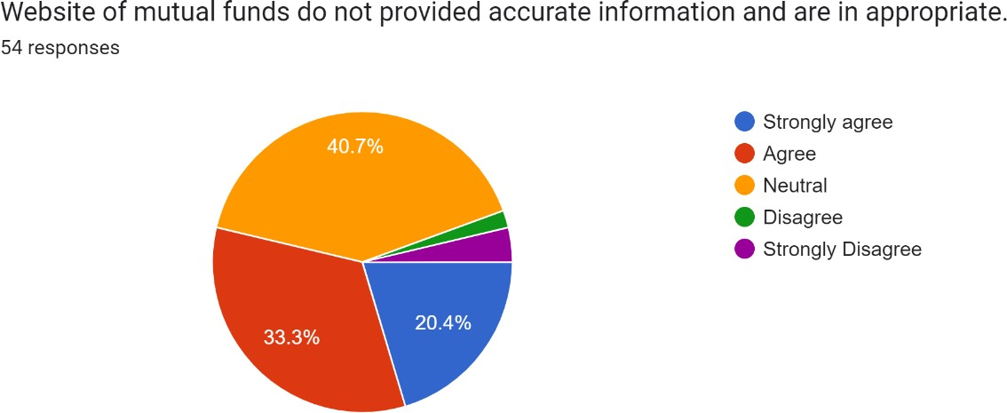

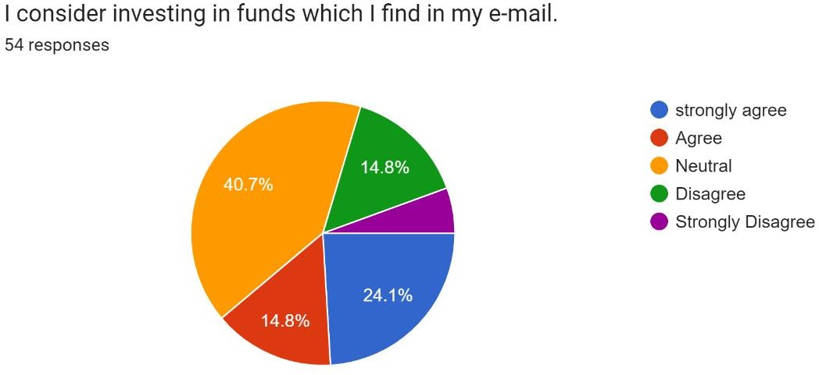

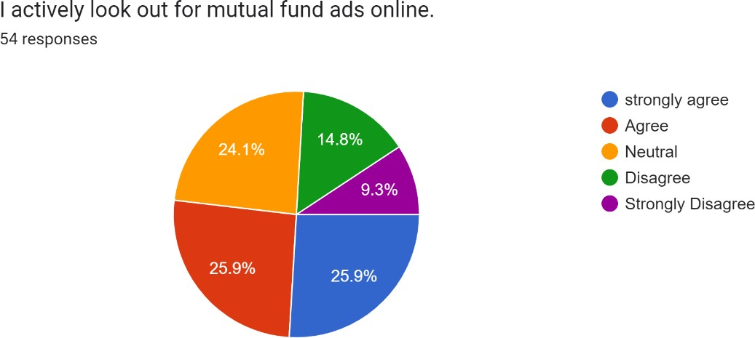

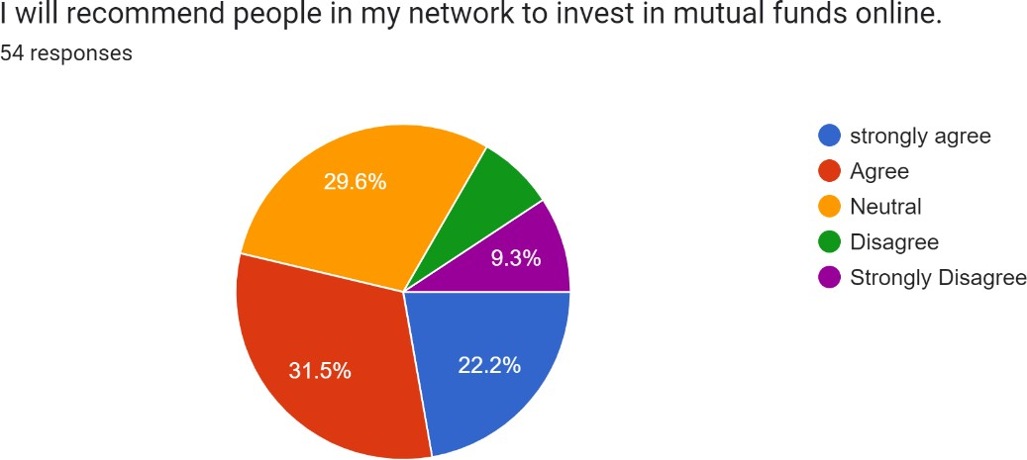

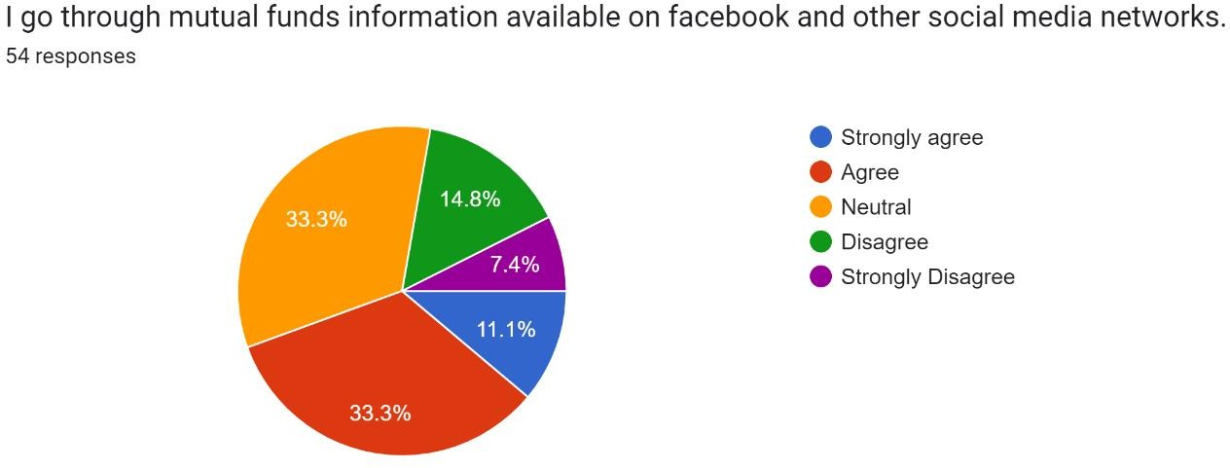

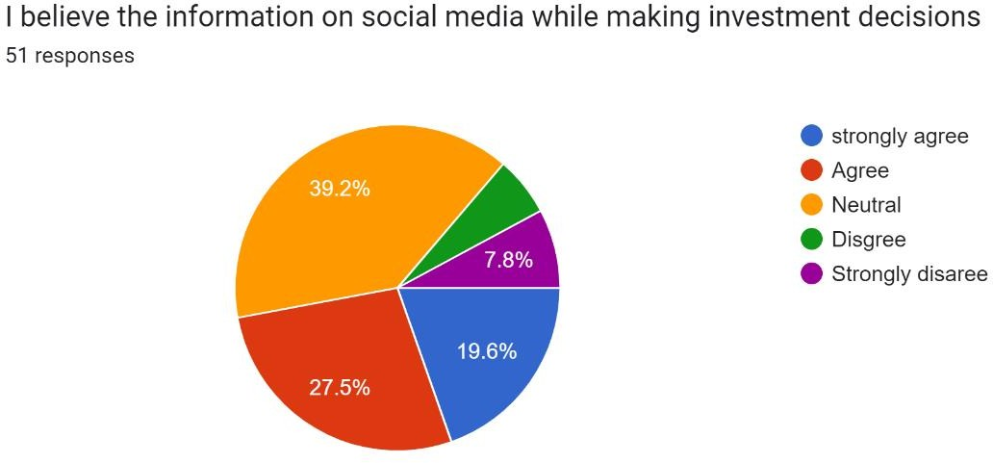

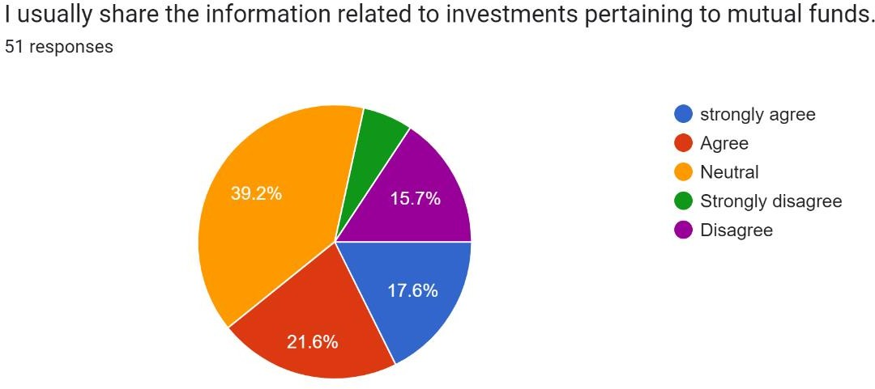

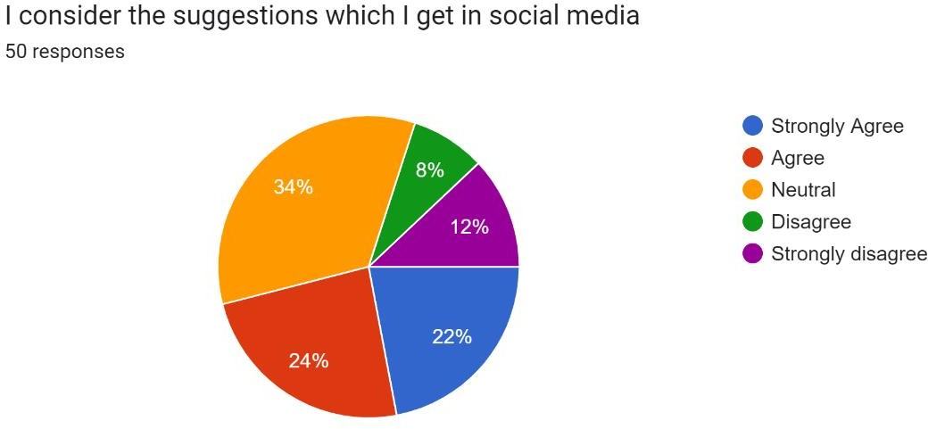

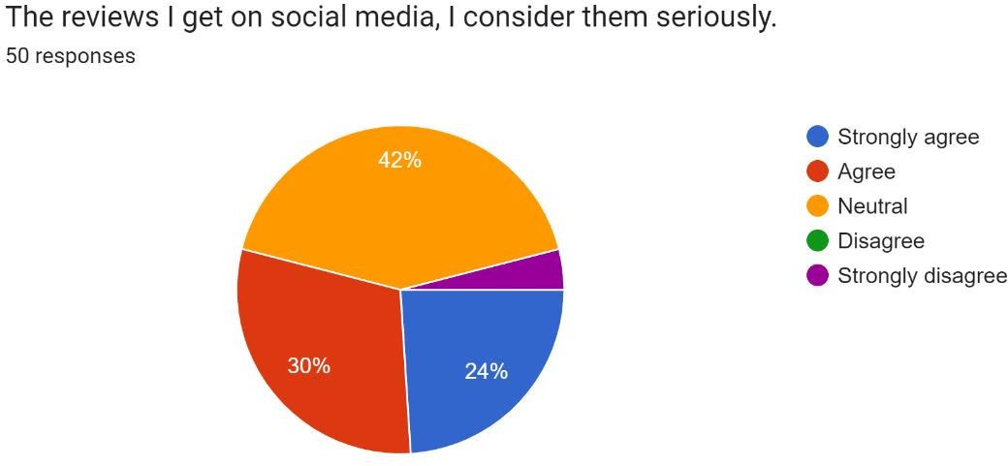

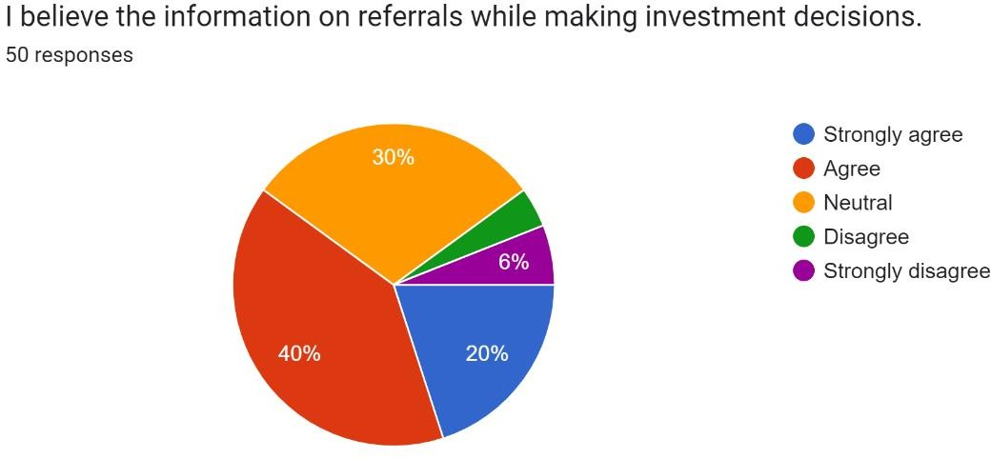

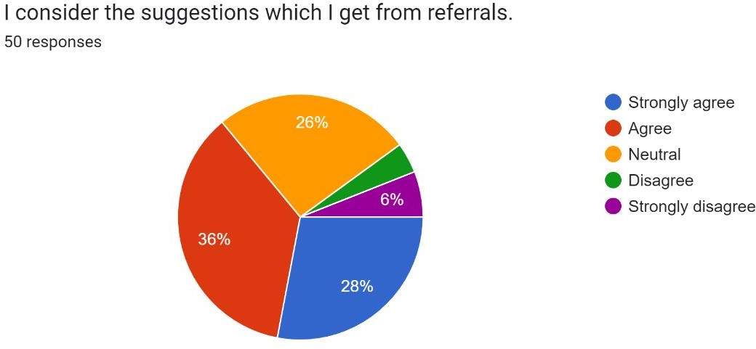

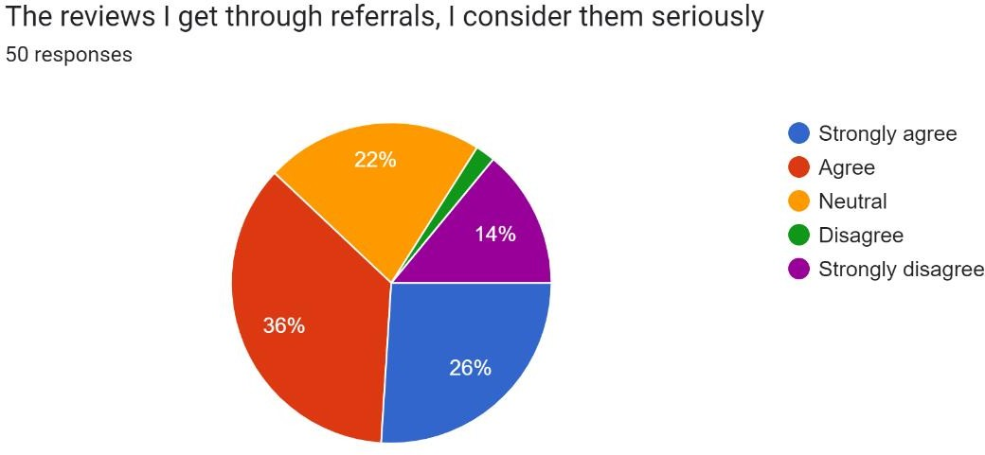

We gathered primary data in the form of the charts below using a Google form for interpretation. Aged 18 to 50 are welcome. For this study, we polled students, professionals, and consumers of private services to gain a sense of the influence of social media. In order to determine if the websites individuals visit give reliable data, we have gathered replies. This helped us to ascertain that just 20% of respondents strongly agree with anything. Only over 33% of people believe this to be true, against 40% of neutral people. Based on the responses, we have come to the conclusion that social media does significantly affect people's decisions, and this is true regardless of demographics like age, education, and money. Customers frequently rely their purchases on what others have said on these websites. The great majority of mutual fund investors discovered these products through social media and bought them based on information found online.

# Book chapter

## Introduction

Due to a lack of consumer trust, mutual funds offered through websites have historically been difficult to understand; nonetheless, as members of Generation X, we are more likely to acquire goods through online channels than through conventional brick-and-mortar establishments. One of the reasons firms are successful is because they are educating people about the advantages of mutual funds for risk management.

Study of the Literature

choosing a term life insurance policy. We conclude that (1) demand for mutual funds is inelastic, (2) shifts in consumer sentiment have a positive impact on demand, and (3) both short- and long-term interest rates matter. Age, gender, income, and educational attainment are a few examples of variables that may have an impact on investors' choices. To find out more about where individual investors receive their information, what they believe about various parts of investing techniques, and what influences their decisions when it comes to purchasing and selling stocks, Shanmugham interviewed 201 of them. Rajarajan discovered a link between lifestyle clusters and investment-related characteristics. Customers' opinions of quality circles, customer complaint lines, quality banking, telebanking, and client meetings at private banks were examined by Soch and Sandhu in 2000. The existence of strong investor protections is a prime example of the security of one's belongings.

The study's findings are positive since they shed information on how investors perceive mutual funds and the variables influencing their investing choices and actions. Researchers Manish Mittal and Vyas attempted to categorise investors in 2008 based on their level of risk tolerance and the types of investments they made. A person's investing decision may be influenced by a variety of characteristics, including age, income, education, and marital status, according to empirical research. This study aims to categorise Indian investors into several personality types and examine the correlation between a wide variety of demographic information and the investing personalities displayed by these people. According to Fatima Alinvi and Babri, a person's preferences might vary greatly depending on their demographics and stage of life. In order to maintain current customers and attract new ones in the insurance sector, it is crucial to cultivate a customer-centric culture.

We set out to discover why certain investors like investing in some mutual fund plans over others. The capacity of a corporation to meet the expectations of its investors determines the success of a marketing plan. According to what we've observed, a lot of consumers pick mutual fund businesses because they think they'll give them a greater return on their money. Consumers in India are unaware of mutual fund products and how to save more money.

STUDY DEFICIT

The main goal of the study is to understand the variables that affect how much money investors invest in mutual funds. Prior research on mutual funds and financial technology has only looked at the performance of the funds in the past. Details about consumer preferences, how technology is used to make investment decisions, a summary of pertinent financial data, etc. The use of integrated technology to increase investment in India's 73 mutual funds has not yet been the subject of any published study. This research aims to meet that requirement. The recently released Paytm App for direct mutual fund investing supports the study's findings. It anticipates the number of investors to increase over the next three to five years and has sped up the flow of capital into mutual fund products.

Research has been conducted on a variety of mutual fund-related topics, as mentioned above. There have been discussions on how demographics and other factors might affect mutual fund selection and investment. Age, gender, and wealth are a few variables that may have an impact on demography. The impact of a person's career on their decision to invest in a mutual fund, however, is not well understood. This is flawed in some way. The following hypothesis and goal have been put out to help close this gap.

Research Methodology:

Data: The information we gathered was primary. The Google forms we developed received close to 50 The Google forms we developed received close to 50 answers.

How collected: The questions were created using the mutual fund industry's digitization as a foundation.

Time Frame: The time frame we used was close to three weeks.

Sample Size: We used 50 investors as our sample size. They answered to our prepared questions. Sample Area: Jalandhar was the location we chose as our sample region.

Targeted population: Youth made up the majority of the targeted group.

Conclusion

Using this example, financial advisers want to maintain open lines of communication with their customers so that they can quickly communicate information with them on asset evaluations, purchase/sale choices, and the following execution of the decision that was mutually agreed upon. The study will also make an effort to compile a thorough list of all the various industries that have adopted digital technologies. Going future, we want to advise mutual fund providers on the best ways to employ digital technologies. The main goal of this study is to answer the following question: Has the development of digital technology led to an increase in the asset base of the sector, the number of financial advisers, the number of consumers of financial services, or the number of consumers of these services abroad? (Indian citizens) This essay will go into more detail on the question of whether the advent of digital platforms has increased the effectiveness of dealing with mutual funds and the enthusiasm of their stakeholders. This suggests that the elderly are resistant to social media's ability to persuade. . This suggests that the elderly are resistant to social media's ability to persuade. We can teach millennials how to invest in mutual funds, but because of the generation gap and the fact that most people take their time with money, it's difficult to motivate them to do so. People in small communities (or "towns") are especially well-equipped to understand how mutual funds function and how they may be utilised to boost savings by investing in them because of how widely accessible social media is to them.

### Part V: Conclusions

Internet reviews of mutual funds are frequently the most useful to investors when picking which to invest in. The amount of investors that supported it was 38.2%. Some stockholders also expressed their disapproval.

Many prospective investors are leery of the information supplied on freely available websites when it comes to investing in mutual funds. Just 33.5% of respondents were in total agreement, while 42.5% were doubtful.

* Mutual fund-related emails have become a significant source of investors. According to the poll results, some investors have only seen online advertising because they are the only ones available (25.5 percent of investors were indifferent, 25.5 percent were agree, and 25.5 percent were highly agree).
* On the internet, investors were recommending others to invest in mutual funds. 30.9% of respondents said they would advocate investing in mutual funds online.

Facebook and other social media platforms are used by many investors to research mutual funds.

They find information on mutual funds and utilise it to help them make investing decisions.

* A whopping 44% of investors admit to telling others about their mutual fund holdings.
* Some investors may opt to heed social media investing advice, while others may decide to reject it.
* Investors occasionally take assessments at face value and occasionally do not.
* Investors believed that referral data was essential to their decision-making. 39.2% of investors judged the information to be essential.
* Don't simply consider the facts; also consider the suggestions made in these suggestions.
* The response from the recommendations was also taken into consideration by the investors. Just over a third (35.3%) of financiers gave them significant consideration.

### Chapter 6- Concluding Remarks

India's mutual fund business is one area where the digitization of financial services has advanced significantly. The main parties participating in a mutual business are Investors (both retail and institutional), Financial Advisers (both independent and networked), Registrars and Transfer Agents (RTAs), and Banks. Participation of these people and organisations is essential to the mutual fund industry's success. how the dynamics and effectiveness of the parties in attaining their objectives are impacted by digitization. As an example, Financial Advisers prefer to keep lines of communication open with their clients to enable the free flow of information pertinent to valuations, purchase/sale decisions, and the subsequent execution of the decision reached after mutual consultation. AMCs must stay in contact with their distributors and investors to inform them of developments, choices, and actions involving investments. The research will also make an effort to compile a list of all the different fields that have embraced digital methods. We'll aim to offer guidance on how mutual fund companies may embrace digital technologies in the future. The primary goal of the study is to provide an answer to the following query: Has the sector grown in terms of assets under management (AUM), independent financial advisors (IFAs), new clients, and global clients as a result of digitalization? (Nationals of India). In this article, the issue of whether the emergence of digital platforms has improved the effectiveness of dealing with mutual funds and the zeal with which their stakeholders are involved is explored in further detail.

We may infer from this that social media's ability to convince older people is ineffective. Due to the generational divide and the fact that most people take their time when it comes to money, it can be difficult to convince the millennial generation to invest, but we can educate them how to do so by showing them how to invest in mutual funds. Through these, we educate them about the

advantages and disadvantages of investing in mutual funds. People in smaller communities (or "towns") are particularly well-equipped to comprehend how mutual funds work and how they can use them to increase their savings due to the extensive social media reach.

# Reference

<https://papers.ssrn.com/sol3/Delivery.cfm/nber_w25056.pdf?abstractid=3250602&type=2>

[https://www.iosrjournals.org/iosr-jbm/papers/Conf.18011-2018/Volume-](https://www.iosrjournals.org/iosr-jbm/papers/Conf.18011-2018/Volume-2/Marketing/9.%2066-73.pdf) [2/Marketing/9.%2066-73.pdf](https://www.iosrjournals.org/iosr-jbm/papers/Conf.18011-2018/Volume-2/Marketing/9.%2066-73.pdf)

<https://www.mastertrust.co.in/Blog/strategies-to-invest-in-mutual-funds>

<https://www.rankhigher.in/digital-marketing-for-mutual-funds-in-india/>

[https://www.researchgate.net/publication/340169399_The_role_of_digital_technologies_on_](https://www.researchgate.net/publication/340169399_The_role_of_digital_technologies_on_growth_of_mutual_funds_industry) [growth_of_mutual_funds_industry](https://www.researchgate.net/publication/340169399_The_role_of_digital_technologies_on_growth_of_mutual_funds_industry)

<https://papers.ssrn.com/sol3/Delivery.cfm/nber_w25056.pdf?abstractid=3250602&type=2>

[https://www.iosrjournals.org/iosr-jbm/papers/Conf.18011-2018/Volume-](https://www.iosrjournals.org/iosr-jbm/papers/Conf.18011-2018/Volume-2/Marketing/9.%2066-73.pdf) [2/Marketing/9.%2066-73.pdf](https://www.iosrjournals.org/iosr-jbm/papers/Conf.18011-2018/Volume-2/Marketing/9.%2066-73.pdf)

<https://www.amazon.in/Mutual-Funds-India-Strategies-Investment/dp/0761997954>

### http://shodh.inflibnet.ac.in:8080/jspui/bitstream/123456789/7263/7/07_bibliography.pdf

<https://www.sebi.gov.in/sebi_data/DRG_Study/OpportunitiesChallenges.pdf>

<https://www.ejbmr.org/index.php/ejbmr/article/view/334>