Indian Road Traffic Sign Detection and Recognition Using Convolutional Neural Network (CNN)

## Gyana Chopra1, Dr. Harsh Lohiya2, Mr. Rishi Singh Kushwah3

Research Scholar, Sri Satya Sai University of Technology and Medical Sciences, Sehore (M.P.), India1

Assistant Professor, Sri Satya Sai University of Technology and Medical Sciences, Sehore (M.P.), India2

Assistant Professor, Sri Satya Sai University of Technology and Medical Sciences, Sehore (M.P.), India3

**ABSTRACT**

For the development of intelligent system detection and recognition of traffic sign is very crucial. We proposed an algorithm for enhancing the traffic sign detection and recognition that address the problems such as such as how easily affected traditional traffic sign detection is by the environment, and poor real-time performance of deep learning-based methodologies for traffic sign recognition. In this paper, we use convolutional neural network and pickle file model for the recognition of traffic sign. For the analysis of image dataset, it is taken from the GSTRB (German Traffic Sign Recognition Benchmark) which comprises 51,839 images and it is divided into training and testing sets. The experimental results of proposed methodology generate the accuracy about 99% for each traffic sign, which is much better than the existing traffic sign recognition system. This improvement is of considerable importance to reduce the accident rate and enhance the road traffic safety situation, providing a strong technical guarantee for the steady development of intelligent vehicle driving assistance.

**Keywords:** Traffic Sign, Intelligent vehicle, Convolutional Neural Network, GSTRB, Traffic Sign recognition.

# INTRODUCTION

With the quickening process of innovation and the growing of car proprietorship, road traffic safety has developed more and more central everywhere the world, expressly in the advanced countries. In fact, there are extensive volumes of people who lose their survives due to traffic accidents in each year and the yearly normal volume of such people aspects growing. [1] As an imperative element of intelligent transport system, unconventional driver support system of intellectual vehicles will alert the probable danger, help the chauffeur with navigation and supervision, and variety driving safer and easier. Examples of such a organization contain adaptive cruise controller, lane withdrawal threatening system, collision circumvention system, night vision, traffic sign acknowledgment, and so on [2]. Generally, dialogue, imperative material nearby the traffic condition, existing to drivers, is regularly encoded as painterly signals alike traffic signs, traffic lights, road marks, etc. In positive environments, human visual discernment can be precious by various features such as exhaustion, drunk driving and driving tightness. To growth road safety, an ADAS has to recognize this visual language, and permit the information to drivers by using unlike slants with traffic sign recognition (TSR) [3].

In India, it is a country that has a widespread and impenetrable road network. On these roads, the traffic signals benefit the driver in enchanting the driving conclusions appropriately. These traffic signals exertion as the noiseless helper to the driver. These indicators tell approximately the complaint of the road forward. So that the driver can take the improved and effective conclusion nearby how to drive and what are the influences to take care of. Normally, these signs are used to presage the driver nearby the possessions which are constrained or which can help the driver to sidestep the coincidence. Occasionally these indicators are correspondingly rummage-sale to border the driver to go overhead the limitation restricted on that road, like the rapidity limit. Every driver on road must be accustomed with all these signs and this is confirmed while philanthropic driving license to any driver.

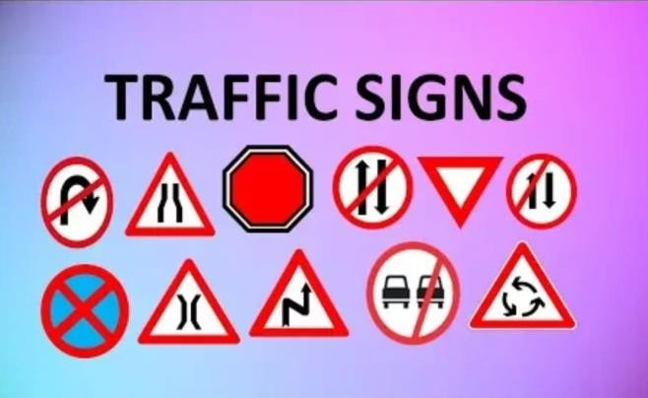

Fig.1 Different traffic signs used during driving

Normally, all the traffic warbles use violent colors so that they can be effortlessly noticed by the drivers driving on the roads. All of them are retained very unassuming in expression so that even the driver driving at a very respectable speed can effortlessly read them. It's compulsory for all the drivers to realize and shadow all the traffic signs. The traffic signals are used to tell the guidelines and boundaries over that road with the help of unpretentious and easy graphical symbols.

# TRAFFIC SIGN IN INDIA

Traffic signs are the noiseless chatterers on the street. Is it the individual overdue the wheel or a unimaginative, having a detailed information about road safety is obligatory for whole previously thumping the streets. Traffic signs stretch information nearby the street environments gaining, proposition instructions to be pursued at the principal crossing or intersections, inform or controller drivers, and sanction proper operational of street traffic. Being unacquainted of street signs is corresponding to chucking attentiveness to the tempest. It can central to penalization of life and property. A person is imaginary to be habituated (get complete a adorned or oral test) with the traffic signs and symbols before locating a driving license in India. Habitually, there are three unalike kinds of street symbols in India.

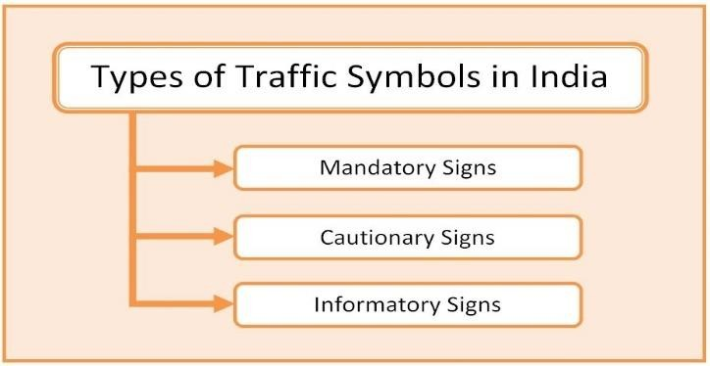

Fig. 2: Types of traffic symbols used in India

### **Mandatory Signs**

As we can appreciate from the name that these are the signs which requirement to be surveyed appropriately experimental it is a delinquency to unfollow them. One might be dispensed challan if he/she fails to monitor them. These signs are used to variety certain the free undertaking of vehicles concluded the road network.[4] The driver made cognizant of the boundaries completed the road with the help of these symbols. Sings Originates under this grouping is like: Stop, Give Way, No entry, Pedestrian Prohibited, Horn Prohibited, No Parking, No stopping or standing, Speed limit, Right Hand Curve, Left Hand Curve, Right hair Pin Bend, Left Hair Pin Bend, Narrow Road Ahead, Narrow Bridge, Pedestrian Crossing, School Ahead, Round About, Dangerous Dip, Hump or Rough, Barrier Ahead.

### **Cautionary Signs**

These symbols are recycled to cognizant the driver nearby the threats on the road ahead. These symbols are similarly used to cognizant the driver nearby the safety hazards ahead or on the road. These symbols are used to make drive aware and take proper action over them else accident may happen. So, the driver follows these to avoid a personal loss as well as the loss of the infrastructure.[4] These symbols aware the driver so that he/she is able to tackle the upcoming situation. Signs comes under this category is like: Right Hand Curve, Left hand Curve, Right Hand Pin Bend, Left Hand Pin Bend, Right Reversal bend, Left Reversal Bend, Steep Ascent, Steep Descent, Narrow Road Ahead, Road Wideness Ahead, Narrow Bridge, Slippery Road, Loose Gravel, Cycle Crossing, Pedestrian Crossing, School Ahead, Men At Work, Cattle, Falling Rocks, Ferry.

### **Informatory Signs**

These symbols afford further material to the road users. These symbols communicate the employer nearby the road's basic material such as terminus. These are not required signals but are used to support the road users. [4] The symbols come below this grouping is like: Public Telephone, Petrol Pump, Hospital, First Aid Post, Eating Place, Light Refreshment, Resting Place, Through Road, Through Side Road, Park This Side Parking Lot Scooter & Motor Cycle, Parking Lot Cycle, Parking Lot Cars.

# RELATED WORK

**Jingwei Cao et al. (2019)**improved traffic sign detection and recognition algorithm for intelligent vehicles is proposed to address problems such as how easily affected traditional traffic sign detection is by the environment, and poor real-time performance of deep learning-based methodologies for traffic sign recognition. Firstly, the HSV color space is used for spatial threshold segmentation, and traffic signs are effectively detected based on the shape features. Secondly, the model is considerably improved on the basis of the classical LeNet-

5 convolutional neural network model by using Gabor kernel as the initial convolutional kernel, adding the batch normalization processing after the pooling layer and selecting Adam method as the optimizer algorithm. Finally, the traffic sign classification and recognition experiments are conducted based on the German Traffic Sign Recognition Benchmark.[6]

**Alexander Hanel et al. (2018)** contributed the selected datasets are compared regarding the applicability for traffic sign detection. The comparison covers the process to produce the synthetic images and addresses the virtual worlds, needed to produce the synthetic images, and their environmental conditions. The comparison covers variations in the appearance of traffic signs and the labeling strategies used for the datasets, as well. A deep learning traffic sign detector is trained with multiple training datasets with different ratios between synthetic and real training samples to evaluate the synthetic SYNTHIA dataset. A test of the detector on real samples only has shown that an overall accuracy and ROC AUC of more than 95% can be achieved for both a small rate of synthetic samples and a large rate of synthetic samples in the training dataset.[7]

**Q. Yao et al. (2016)**motivated to efficiently survey traffic signs while mapping the road network and the roadside landscape. Inspired by the manual delineation of traffic sign, a drawing strategy is proposed to quickly approximate the boundary of traffic sign. The most common speed-limit sign circle and the statistic color model of traffic sign are studied in this paper. Anchor points of traffic sign edge are located with the local maxima of color and gradient difference. Starting with the anchor points, contour of traffic sign is drawn smartly along the most significant direction of color and intensity consistency. The temporally salient traffic sign is then detected statistically and automatically as the rare event of having a traffic sign. The proposed algorithm is tested with a diverse set of images that are taken in Wuhan, China with the MMS of Wuhan University. Experimental results demonstrated that the proposed algorithm can detect traffic signs at the rate of over 80% in around 10 milliseconds. It is promising for the large-scale traffic sign survey and change detection using the mobile mapping system.[8]

**Faming Shao et al. (2018)**proposed a novel approach for real-time traffic sign detection and recognition in a real traffic situation was proposed. The experimental results based on Chinese and German traffic sign databases showed that the proposed method obtained a comparable performance with the state-of-the-art method, and furthermore, the processing efficiency of the whole process of detection and classification was improved and met the real-time processing demands.[9]

**Xiaoguang HU et al. (2012)**proposed a method using visual attention mechanism to detect traffic sign , which is reasonable. In our method, the whole scene will firstly be analyzed by visual attention model to acquire the area where traffic signs might be placed. And then, these candidate areas will be analyzed according to the shape characteristics of the traffic sign to detect traffic signs. In traffic sign detection experiments, the result showed the proposed method is effectively and robust than other existing saliency detection method.[10]

**Victor J. D. Tsai et al (2016)**aimed on developing techniques for detecting, extracting, and positioning of traffic signs from Google Street View (GSV) images along user-selected routes for low-cost, volumetric and quick establishment of the traffic sign infrastructural database that may be associated with Google Maps. The framework and techniques employed in the proposed system are described.[11]

**Safat B.Wali et al.(2015)**developed an efficient TSDR system which contains an enriched dataset of Malaysian traffic signs. The developed technique is invariant in variable lighting, rotation, translation, and viewing angle and has a low computational time with low false positive rate. The development of the system has three working stages: image preprocessing, detection, and recognition. The system demonstration using a RGB colour segmentation and shape matching followed by support vector machine (SVM) classifier led to promising results with respect to the accuracy of 95.71%, false positive rate (0.9%), and processing time (0.43 s). The area under the receiver operating characteristic (ROC) curves was introduced to statistically evaluate the recognition performance. The accuracy of the developed system is relatively high and the computational time is relatively low which will be helpful for classifying traffic signs especially on high ways around Malaysia. The low false positive rate will increase the system stability and reliability on real-time application.[12]

**Yassmina Saadna and Ali Behloul(2017)**introduced an overview of some recent and efficient methods in the traffic sign detection and classification. Indeed, the main goal of detection methods is localizing regions of interest containing traffic sign, and we divide detection methods into three main categories: color-based (classified according to the color space), shape-based, and learning- based methods (including deep learning). In addition, we also divide classification methods into two categories: learning methods based on hand-crafted features (HOG, LBP, SIFT, SURF, BRISK) and deep learning methods. For easy reference, the different detection and classification methods are summarized in tables along with the different datasets. Furthermore, future research directions and recommendations are given in order to boost TSR’s performance.[13]

**Canan Tastimur et al. (2016)** presented image processing techniques are used to detect traffic signs and Fuzzy Integral is used to recognize traffic signs. Both more accuracy rate results and low computational cost are obtained in terms of recognition stage by using positive aspects of algorithms taken as input parameters with Fuzzy Integral in the traffic sign recognition system. Experimental results showed that proposed method gives high accurate results in a reasonable time.[14]

**Manjare and Hambarde (2014)** presented two different methods for road sign detection and recognition which has based on color and shape. The first method is Gielis curve fitting. In this method algorithm is applied to different shapes like circular, triangular, octagonal. Fitting contour points into a Gielis curve takes a lot of time, which naturally cannot be acceptable in a real-time system. Hence, further investigation and improvement is required to decrease the processing time. It gives 85% accuracy for road sign recognition. The second method is based on neural network. The Neural network stages were performed to recognize the traffic sign patterns. The first step is to reduce the number of MLP inputs by preprocessing the traffic sign image, and the second step is to search for the best network architecture by selecting a suitable error criterion for training with LMA. Using neural network, road sign classification gives 90% accuracy for different type of signs (circular, triangular, octagonal).[15]

# PROPOSED WORK

As the proposed system is designed to overcome off the problems and limitation came in all past works. So first let's have a look over the basic architecture of the system with an example so that we can easily the working. The architecture is further divided into four different phases as the requirements. The proposed system has a very simple structure as compared to the past system of recognition of Traffic symbols.

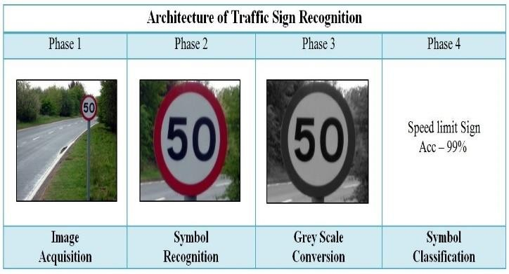

Fig. 3: Architecture of traffic sign recognition system

So, this is how the basic architecture looks like. The Proposed system has following layers in it.

* 1. Image Acquisition
  2. Symbol recognition
  3. Grey Scale Conversion
  4. Symbol Classification

#### Image Acquisition

As the word itself related to the creation of a digital image of a visual scene or it also means to collect a digital image. When we make anything in which the input is the image so the source of that image is a very big factor to take care of. So, in the proposed system, we are assuming that all the vehicles are totally equipped with cameras, so there the source of the image is the Camera. Ss the camera will capture the live recording and will send the information or will send the digital image to the system. So, this whole process is focused over giving input of the system and the image acquisition example shown in fig 5.3.

#### Symbol recognition

As in the above diagram you can see that we have an image of a road with a symbol in it. The image is captured with a camera placed over a car. So that digital image came from phase one is the image of the whole scenario. So, we need to frame out the symbol and this can be simply done with fetching the shape of the symbol. The symbols are mostly shaped in Round, Triangle, and square. So, with the help of many simple and predefined approaches, we can get the symbol. Out major focus is to speed up the classification problem. So, in this phase the image came from phase one will be processed and the output given is the image of the symbol shown in fig. 5.3. **Grey Scale Conversions**

The CNN or ConvNet works best when any greyscale images are given for prediction. The unique part of the proposed system is we trained the system with the help of a grey scaled image database so that it can easily and rapidly classify the images. As when we convert a digital image into a greyscale image, we simply reduce the dimensions of the image. As in traffic signals, we have only two colors, so using them in greyscale doesn't create any bad impact over the system. By using the greyscale data, we reduced the dimension of the data and hence we increased the speed of processing the image. So, all over using a greyscale image in the case of traffic light system will have a proper positive impact over the proposed system and it is shown in fig. 5.3.

#### Symbol Classification

As we are in the last phase of classifying the symbol. From the phase three, we got the greyscale image of the symbol, so in this phase, we just need to classify the image that which kind of traffic symbol is this. So when we trained CNN(Convolutional Neural Network) we used the greyscale image dataset so the model which is trained to classify needs a greyscale image in its input. This phase will give us the prediction of the symbol showing in the image. As when we trained CNN to avoid training, again and again, we dumped the model into a pickle file. The same pickle file is further used for prediction purposes. The pickle file is a very simple way to carry any model from one place to another as well we can simply use the model form this file just by importing the model, we don't need the same large space again and again. So, this is about the basic architecture of the proposed system shown in fig. 4.

#### Description of Data Flow Diagram

Now for better understanding of proposed system, let’s try to understand it with the help of the DFD of the process.

As the DFD is divided into two parts

1. Training of the System
2. Testing of the System

As when we are dealing with any machine learning or deep learning or predictive modeling task, we need to train the model with help of heavy datasets but we can't carry the datasets everywhere, plus training of the system is a time taking procedure. So, we cannot carry out the training again and again, here the need for pickle file comes. We can simply dump our model into the pickle file and further use the file for prediction. There are many advantages of that file as the file in very small in size, very fast, we just need to import the model and we can simply use it. So, after the training part we taken out the pickle file and used it into the prediction part to carry out the prediction easily and rapidly.

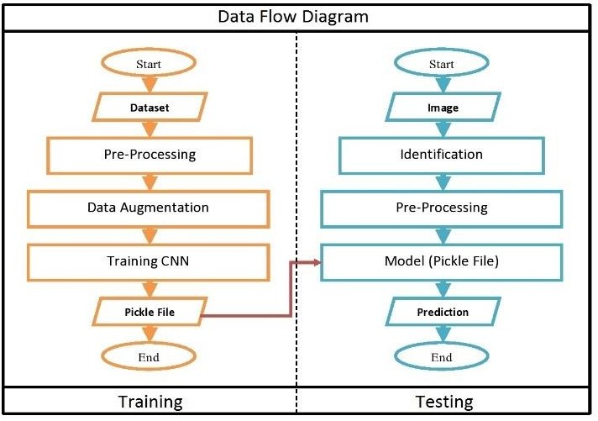

Fig. 4: Dataflow diagram of Proposed system

As in the proposed system, our main task is to assist the driver in taking proper decisions concerning traffic signals as well as identifying them. In this, the proposed system is taking images from the system but we can also arrange a camera and connect the live stream with the system to get live updates. The system will take either the live stream or images and will tell which type of traffic signal is this and also tell the accuracy of the system in prediction.

#### Training

It simply means making the machine learn or determine. the problem is a supervised machine learning problem. In this kind of problem, we have a dataset in which we have certain outputs for certain inputs.

1. Dataset: As we need to classify all the symbols, so we need a huge database of different images. Many online websites provide such databases. So we need to collect a large number of images of every traffic symbol and place them all in separate folders and train the model with them. The problem in the images we collected is that images are of different shapes or dimensions. In this step, we collected a database from Kaggle.
2. Pre-Processing: As when we are using a large number of images to train the model, then for simplifying the process we take few pre- processing steps in the database as we need all images of the same length & Height, The dimension and color scheme of all images must be same. So in pre-Processing, we equalized the dimensions of the images so that the training of the system can be done efficiently.
3. Data Augmentation: Our proposed system is using CNN as the classifying model. So, CNN can robustly classify the objects or images from which it is trained. If we train the model with simple and flat images so then when we will try to implement it in real-time then issues will rise as there are not flat images, there is a variance in images like Camera angler, position, brightness, and all. So, for this, we do the augmentation which is used are collected images to form a large number of different invariant images, and then we train the model with the help of that large database. SO that our CNN must be able to handle all kinds of variance in images.
4. Training CNN: So finally, we are a proper and a huge database. Now, this is the time we need to use the images as the features and the name of the symbol in the image as the label. We'll train the convolutional neural network CNN for this because when the problem is classifying images then CNN gives the best results. As our way to giving inputs is a bit different, we first convert the image in Greyscale image then after we give it as the input of the CNN.
5. Pickle File: Once we are done with training of the model. We need to save the model so that whenever we want to use the model, we don't need to train the model again. So, dumping the model in the pickle file is the best option we can choose. So, in this step, we dumped the trained model in a pickle file so that we can reuse it simply.

#### Testing / Experiment of Real-Time Use

It simply means to test the learning of the machine. When we are done with the training of the model, we simple dumped the model in a pickle file. Now we need to test the system that our proposed system and model are working with good accuracy or not.

1. Image: As when we are taking data from either the system or the real-time. So, when we are using real-time data of a camera attached to the vehicle then the predictions will be on live cam else when we are working with images then we can simply give the image as the input of the model. So here we are using the manual input of the image to give input to the model.
2. Identification: As the image is of the scene, we need to pick out the image of the traffic symbol. So, in India, mostly the symbol are of either circle or in square shape. So there are many pre-defined methods to pick the shape out from the photo. So in this step, we can use any method to find our shape and to generate an image that mostly contains the traffic symbol. It must not have any other object on the farm.
3. Pre-Processing: Now as we have trained the model with a resolution of 32*32 now we need to convert the image in that resolution for better prediction. As well as we need to convert the image into a greyscale image so that it can work as per our system designed.
4. Model: So here we call the pickle file which we dumped in the training process. Then we'll load the trained model and then pass the inputs to that model. Here we are using the pickle file to complete this step.
5. Prediction: As we are in the testing phase of the system. So what we'll do is we'll pass approx 100 random images of a few types of traffic symbols. Then after well save the predicted results in the list. As well as we'll save the accuracy of the prediction and then plot the graphs over the collection of the accuracy to check that where the results are going.

#### Running

Running the model simply means that here we are using the pickle file which we dumped and will use the same to assist the driver or we can say that for real-time predictions. Pickle File is used to save the trained model in a file so that we don't need to train the model again and again. Then the input can be simply given to the pickle file model and outputs will be generated. The output will be the name of the symbol with the percent accuracy of the prediction taken out.

#### Advantages of Proposed System

Our proposed system has following advantages than the existing system which is discussing below:

1. The proposed system is using the greyscale image, as a greyscale image is smaller in size and dimension so the proposed system will take less space as compared to the previous models.
2. The Proposed system is using a greyscale image which has a lower dimension than RGB images, so the speed of the proposed system is higher than the old systems.
3. As in the proposed system, we are using a pickle file for prediction so this made the computation requirements low. Dumping the trained model into a file and using the same to carry out the predictions.
4. The proposed system is using greyscale image so it's pretty good in handling blur images too. The past systems are not capable of handling blur images properly.
5. The proposed system is using a simple working architecture as compared to the past systems. The simplicity of architecture gives additional advantage to the space and the speed of the system.

# EXPERIMENTAL RESULTS

Here all the graphs are plotted in Histograms of Accuracy. On the proposed work we have implemented a model for the prediction of Traffic Symbols from an image. So for the testing purpose what we have done is we had passed 100 to 105 images of 16 Different types of traffic symbols. When we want to test the model what we need to do is pass different images and compare the results with the actual values. So for this, we have tested the model by passing all those 100 to 105 images of all 16 types of Traffic Symbols. The x-axis of histogram represents the accuracy achieved and y-axis represents the no. of sample tested. In these histograms, the bar length denotes which accuracy range is getting maximum hits. This means when we tested the model then all the symbols are predicted accurate but have the following accuracy. So with that accuracy, we have represented them in the histogram to have a pictorial form.

### **Turn Right Ahead Traffic Sign Analysis**

Here we have taken 102 samples for testing From Turn Right Ahead Traffic Symbol. In which 60 of the samples achieved the accuracy of 99.2 so the bar length over that range is 100. So that states is most of the sample achieved that accuracy with accurate name prediction.

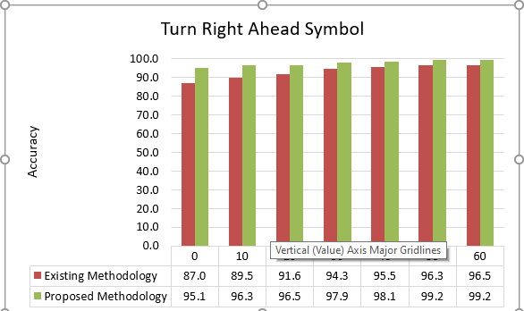

Fig. 5: Accuracy analysis of turn right ahead traffic symbol

### **Turn Left Ahead Traffic Sign Analysis**

Here we have taken 102 samples for testing From Turn Left Ahead Traffic Symbol. In which 78 of the samples achieved the accuracy of 99.1 so the bar length over that range is 100. So the accuracy achieved for the prediction of turn left ahead traffic sign is better with the same name of traffic sign.

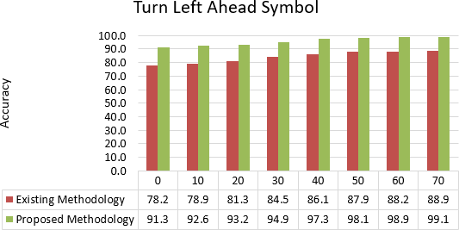

Fig. 6: Accuracy analysis of turn left ahead traffic symbol

### **Stop Traffic Sign Analysis**

Here we have taken 102 samples for testing from stop Traffic Symbol. In which 95 of the samples achieved the accuracy of 99.7 so the bar length over that range is 100.0. So the accuracy achieved for the prediction of stop traffic sign is better with the same name of traffic sign.

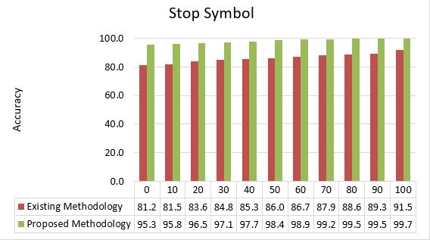

Fig. 7 Accuracy analysis of stop traffic symbol

### **Speed Limit (60km/hr) Traffic Sign Analysis**

Here we have taken 102 samples for testing from speed limit Traffic Symbol. In which 100 of the samples achieved the accuracy of 99.6 so the bar length over that range is 100.0. So the accuracy achieved for the prediction of speed limit traffic sign is very good with the same name of traffic sign.

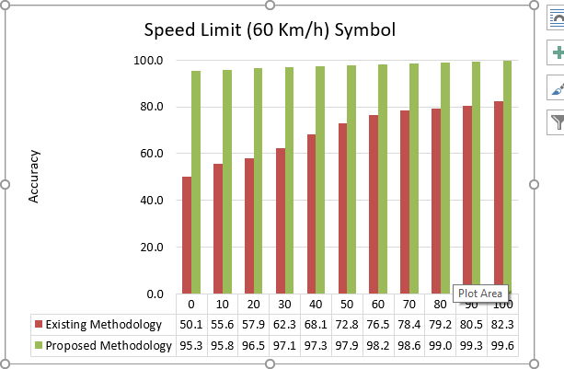

Fig. 8: Accuracy analysis of speed limit (60km/hr) traffic symbol

1. **CONCLUSION**

This thesis illustrates a new detection and recognition algorithm in the context of Indian road signs using convolutional neural network approach in the illumination gray-scale image and artificial neural network classifier trained by robust ConvNet. The gray scale image is chosen because gray scale doesn't create any bad impact over the system. By using the gray scale data we reduced the dimension of the data and hence we increased the speed of processing the image. So all over using a gray scale image in the case of traffic light system will have a proper positive impact over the proposed system. In this proposed system we use pickle file model which we dumped during the processing and this file also used to save the trained model in a file so that we don't need to train the model again and again. The segmentation results illustrate that it is robust in different illumination conditions. A precise road sign recognition system with greater accuracy is very crucial to contribute more safety and efficiency. In this regard, the experimental results represent that this system carries significant classification rate. The proposed model it is evident that the overall correct classification rate of the CNN classifier using Convet and pickle file model is about 99 %. In addition, a comparison is drawn among the state of the art classifier where the CNN outperforms in all scenarios. The proposed system offers better accuracy for the detection and recognition of traffic sign but this system recognizes only few road traffic sign so in future work, we determined to take into account a number of contests for further enhancement of the proposed system. In this regard we are planning to address the subsequent issues:

1. To identify all sorts of road signs
2. To identify array of road signs on the sight
3. To identify signs when images are taken under night brilliance
4. To proliferate the data set and
5. To develop this proposed for the real time application

# REFERENCES

* 1. B. R. Litman & H. Ahn. (1998). Predicting financial success of motion pictures. In B. R. Litman (Ed.), the motion picture mega-industry. Boston, MA: Allyn & Bacon Publishing, Inc.
  2. Kumar and Kumar, “Predicting Movie Success or Failure using Linear Regression & SVM over Map- Reduce in Hadoop”, International Journal of Innovative Research in Computer and Communication Engineering, Vol. 6, Issue 6, June 2018.
  3. “Prediction of Movies popularity Using Machine Learning Techniques”, International Journal of Computer Science and Network Security, VOL.16 No.8, August 2016, pp 127-131.
  4. Chaudhari et al., “A Data Mining Approach to Language Success Prediction of A Feature Film”, International Journal of Engineering Sciences & Management Research, 2016, pp. 1-9.
  5. Meenakshi et al., “A Data mining Technique for Analyzing and Predicting the success of Movie”, Journal of Physics: Conf. Series 1000 (2018) 012100 doi :10.1088/1742-6596/1000/1/012100. Pp 1-9.
  6. Quader et al., “A Machine Learning Approach to Predict Movie Box-Office Success”, 20th International Conference of Computer and Information Technology (ICCIT), 22-24 December, 2017.
  7. G. Diamantopoulos and M. Spann 2005 Performance analysis of CART and C5.0 using sampling techniques Advances in Computer Applications. 11 3, pp. 233– 243.
  8. [https://www.edureka.co/blog/what-is-machine-](https://www.edureka.co/blog/what-is-machine-learning/) [learning/](https://www.edureka.co/blog/what-is-machine-learning/)
  9. Christopher M. Bishop, “Pattern Recognition and Machine Learning (Information Science and Statistics)”, 2006. Page-3
  10. Russel, “Artificial Intelligence: A Modern Approach”,January 1, 2015
  11. [Hastie](https://www.amazon.com/s/ref%3Ddp_byline_sr_book_1?ie=UTF8&field-author=Trevor%2BHastie&text=Trevor%2BHastie&sort=relevancerank&search-alias=books) et al. “The Elements of Statistical Learning: Data Mining, Inference, and Prediction”, Second Edition (Springer Series in Statistics) , 2016, pp. 28. [online]. Available: [https://www.amazon.com/Elements-Statistical-](https://www.amazon.com/Elements-Statistical-Learning-Prediction-Statistics/dp/0387848576/ref%3Das_li_ss_tl?keywords=The%2BElements%2Bof%2BStatistical%2BLearning&qid=1568592984&s=gateway&sr=8-1&linkCode=sl1&tag=inspiredalgor-20&linkId=24fe5039a6ba4a7cdecce0ee0074d3ed&language=en_US) [Learning-Prediction-Statistics.](https://www.amazon.com/Elements-Statistical-Learning-Prediction-Statistics/dp/0387848576/ref%3Das_li_ss_tl?keywords=The%2BElements%2Bof%2BStatistical%2BLearning&qid=1568592984&s=gateway&sr=8-1&linkCode=sl1&tag=inspiredalgor-20&linkId=24fe5039a6ba4a7cdecce0ee0074d3ed&language=en_US)
  12. Richard S. Sutton et al., “Reinforcement Learning: An Introduction (Adaptive Computation and Machine Learning”,2018, second edition, pp.-2. [Online]. Available : [https://www.amazon.com/Reinforcement-](https://www.amazon.com/Reinforcement-Learning-Introduction-Adaptive-Computation) [Learning-Introduction-Adaptive-Computation.](https://www.amazon.com/Reinforcement-Learning-Introduction-Adaptive-Computation)
  13. A. Smola and S. Vishwanathan, Introduction to Machine Learning. United Kingdom at the University Press, Cambridge, October 1, 2010.
  14. [Online]. Available: [www.analyticsvidhya.com.](http://www.analyticsvidhya.com/)Sunpreet Kaur, Sonika Jindal “A Survey on Machine Learning Algorithms”, International Journal of Innovative Research in Advanced Engineering (IJIRAE)2016,Issue 11, Volume 3.
  15. W. Gerstner, “Supervised learning for neural networks: a tutorial with JAAv exercises”.
  16. o. R. .s. P. breiman L, friedman J.H., “Classification and regression trees.” Belmont CA Wadsworth International group, 1984. B. C. U. P.E.tgoff, “Multivariate decision trees: machine learning,” no. 19, 1995, pp. 45–47.