**A critical study on cloud based LMS: Need of tomorrow**

Vikas Tonde

Zeal College, Pune, Maharashtra, India

[tondev23@gmail.com](mailto:tondev23@gmail.com)

Prapti Patil

Zeal College, Pune, Maharashtra, India

[praptipatil084@gmail.com](mailto:praptipatil084@gmail.com)

Snehal Patil

Zeal College, Pune, Maharashtra, India

[snehal0314patil@gmail.com](mailto:snehal0314patil@gmail.com)

Dr. B.J Mohite

Zeal College, Pune, Maharashtra, India

[babasaheb.mohite@zealeducation.com](mailto:babasaheb.mohite@zealeducation.com)

**Abstract :**

*Cloud services in education have gained attention as a way to transform the way students learn and teachers teach. This literature review investigates the potential of cloud services in education, evaluates their effectiveness and recommends best practices for protecting sensitive student data. The review focuses on current research and literature in the field, and explores the various ways in which cloud services are being used in education, their effectiveness, and the security and privacy implications of using cloud services. The findings suggest that cloud-based systems have the potential to improve student engagement and achievement, provide cost-effective solutions for data storage and multimedia resources, enable group projects and peer-to-peer learning and enhance learning through simulations and virtual reality experiences. However, there are also concerns about security and privacy of sensitive student data. The review also identifies areas in need of further research. Overall, the literature review highlights the potential of cloud services in education to transform the way students learn and teachers teach but more research is needed to fully understand their potential and recommend best practices.*

Keywords:- Cloud services, Cloud computing, Cloud-based learning, Online education

1. **Introduction:**

In recent years, the use of cloud services in education has gained significant attention as a way to transform the way students learn and teachers teach. Cloud computing, also known as cloud services, refers to the delivery of computing resources and services over the internet. These resources and services can include storage, processing power, software, and data. In the context of education, cloud services can be used to support a wide range of educational activities, such as online learning, virtual labs, and collaboration.

The potential benefits of cloud services in education are numerous. For example, cloud-based learning management systems have the potential to improve student engagement and achievement by providing access to interactive and personalized learning experiences. Additionally, cloud services can make education more cost-effective by providing a way to store and share large data sets and multimedia resources. Furthermore, cloud-based collaboration tools can enable group projects and peer-to-peer learning.

However, the use of cloud services in education also raises important security and privacy concerns. As sensitive student data is stored and shared over the internet, there is a risk of data breaches and unauthorized access. Therefore, it is crucial to understand the security and privacy implications of using cloud services in education and to implement best practices for protecting sensitive student data.

The purpose of this literature review is to investigate the potential of cloud services in education, evaluate their effectiveness, and recommend best practices for protecting sensitive student data. The review will focus on current research and literature in the field, and will explore the various ways in which cloud services are being used in education, the effectiveness of these uses, and the security and privacy implications of using cloud services in education. The review will also identify gaps in the literature and areas in need of further research.

1. **Statement of Problem:**

Despite the potential of cloud services to transform the way students learn and teachers teach, there is a lack of research on the specific ways in which cloud services can be used in education, the effectiveness of these uses, and the security and privacy implications of using cloud services in education. Therefore, there is a need for further research to investigate the potential of cloud services in education, evaluate their effectiveness, and recommend best practices for protecting sensitive student data. In view above researcher has selected topic “A critical study on cloud based LMS: Need of tomorrow” for in depth study.

1. **Research Objective:**

* To provide a comprehensive review on cloud computing in learning.
* To clarify the services provided by cloud computing in learning.
* To study the needs in the teaching environment with the help of cloud computing.
* To make awareness of cloud services for adding values in the traditional education system.
* To identify some key challenges and future perspectives in learning.

1. **Research Methodology**

A systematic literature review (SLR), which is the research methodology used for this project, falls under the category of fundamental research. The formulation of hypotheses and generalizations is the primary objective of fundamental research. It searches for data with a range of applications to support hypotheses that are already widely accepted in a particular industry or field of endeavor.

The goal of this study is to examine metaverse elements that could improve the current educational system. For the purpose of ensuring impartiality in the context of information selections and results in representations, we applied the techniques outlined by Keele, S. (Guidelines for Performing Systematic Literature Reviews in Software Engineering).

**Data Collection**

We used secondary data collection methods to complete the research.

**Secondary data**

Reviewed other works that had already been published, looked into journals, and browsed various websites to gather accurate information about the use of the metaverse in education.

1. **Conceptual Background:**

Cloud services, also known as cloud computing, refers to the delivery of computing resources and services over the internet. These resources and services can include storage, processing power, software, and data. In the context of education, cloud services can be used to support a wide range of educational activities, such as online learning, virtual labs, and collaboration. Additionally, cloud services can provide access to large data sets, multimedia resources, and educational software that may not be available locally.

The use of cloud services in education has the potential to improve student engagement and achievement by providing access to interactive and personalized learning experiences. Additionally, cloud services can make education more cost-effective by providing a way to store and share large data sets and multimedia resources. Furthermore, cloud-based collaboration tools can enable group projects and peer-to-peer learning. Cloud-based simulations and virtual reality experiences can enhance learning in various subject areas, cloud-based analytics can improve the effectiveness of instruction and personalize learning.

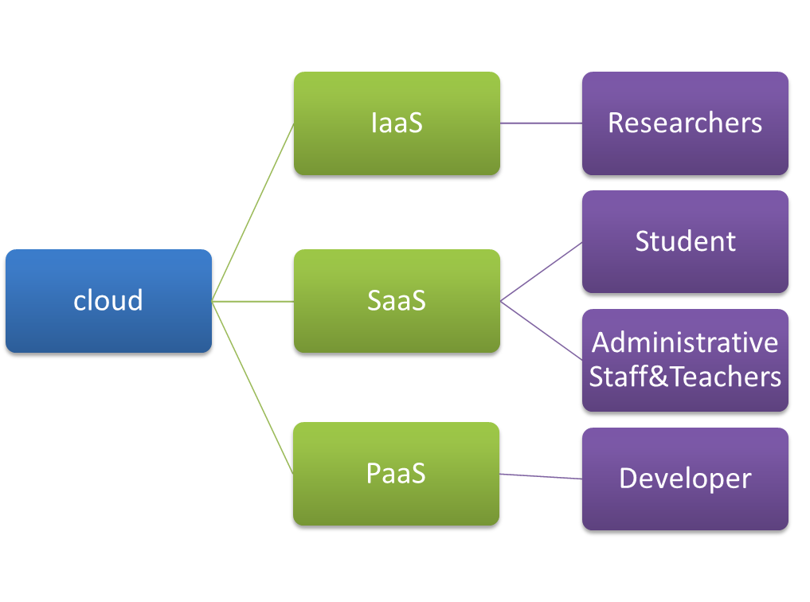

**Fig -Use of cloud in Education**

Cloud-based educational apps can also have a significant impact on student motivation and learning outcomes. Language-learning software based on the cloud can be a great tool for foreign language instruction. Cloud-based virtual labs can provide hands-on science and technology education. This can be particularly useful for remote, rural, or underfunded schools that may not have the resources to provide these types of experiences otherwise.

However, there are also concerns about the security and privacy of using cloud services in education. As sensitive student data is stored and shared over the internet, there is a risk of data breaches and unauthorized access. Therefore, it is important to consider the security and privacy implications of using cloud services in education and to implement best practices for protecting sensitive student data. Additionally, the impact of cloud-based learning on teacher professional development and training is also a key area of consideration.

Overall, the use of cloud services in education is a promising area of research that has the potential to transform the way students learn and teachers teach. However, more research is needed to fully understand the potential of cloud services in education, evaluate their effectiveness, and recommend best practices for protecting sensitive student data.

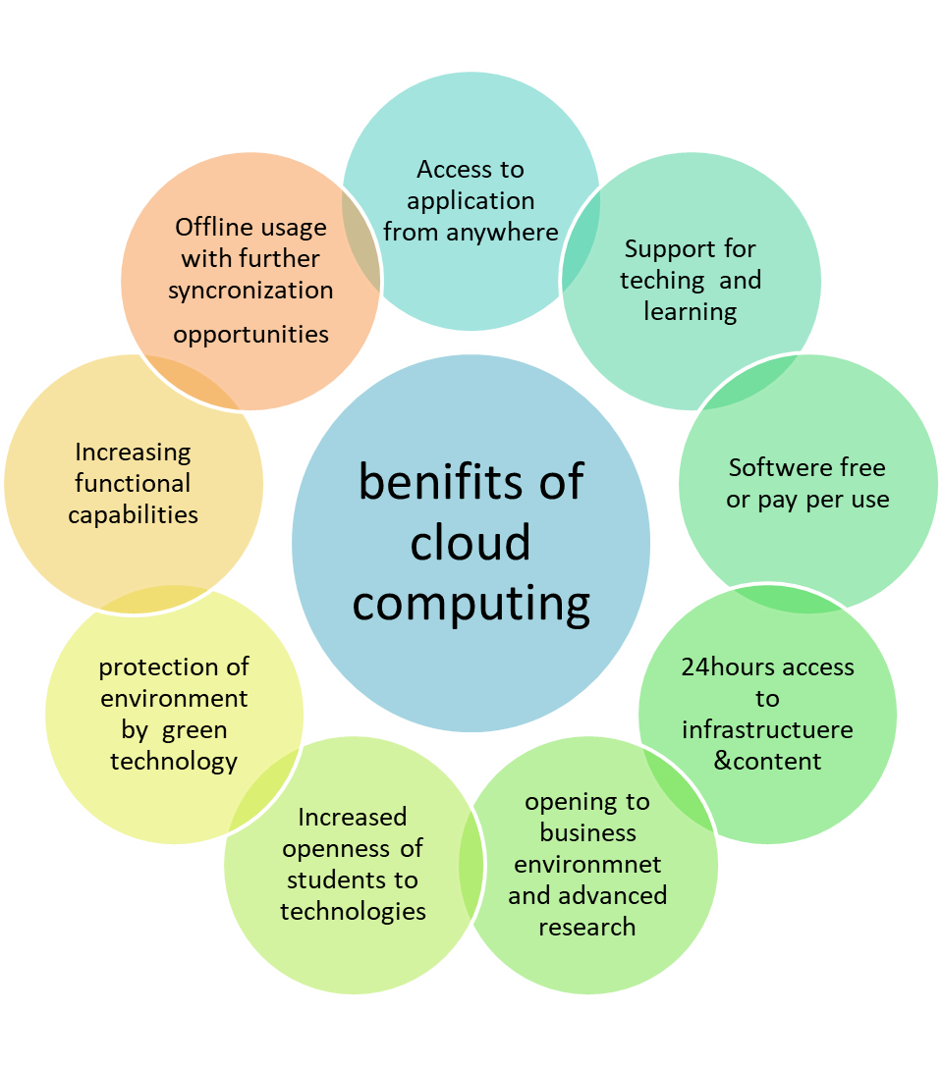

**Fig -Benefits of cloud computing**

1. **Findings and Suggestions**

Findings

1. Cloud-based learning management systems have the potential to improve student engagement and achievement by providing access to interactive and personalized learning experiences.
2. Cloud services can make education more cost-effective by providing a way to store and share large data sets and multimedia resources.
3. Cloud-based collaboration tools can enable group projects and peer-to-peer learning.
4. Cloud-based simulations and virtual reality experiences can enhance learning in various subject areas.
5. Cloud-based analytics can improve the effectiveness of instruction and personalize learning.
6. Cloud-based educational apps can have a significant impact on student motivation and learning outcomes.
7. Cloud-based virtual labs can provide hands-on science and technology education.
8. Cloud-based language-learning software can be a great tool for foreign language instruction.
9. The use of cloud services in education raises important security and privacy concerns.
10. Best practices for protecting sensitive student data need to be implemented.

Suggestions:

1. Investigate the potential for cloud-based learning management systems to improve student engagement and achievement.
2. Study the use of cloud-based virtual labs for hands-on science and technology education.
3. Examine the cost-effectiveness of using cloud services for storing and sharing large data sets and multimedia resources.
4. Explore the use of cloud-based collaboration tools for group projects and peer-to-peer learning.
5. Evaluate the effectiveness of using cloud-based language-learning software for foreign language instruction.
6. Investigate the potential for cloud-based simulations and virtual reality experiences to enhance learning in various subject areas.
7. Study the impact of cloud-based educational apps on student motivation and learning outcomes.
8. Evaluate the security and privacy implications of using cloud services in education and recommend best practices for protecting sensitive student data.
9. Study the impact of cloud-based learning on teacher professional development and training.
10. Investigate the use of cloud-based analytics to improve the effectiveness of instruction and personalize learning.
11. **Conclusion:**

In conclusion, the use of cloud services in education has the potential to transform the way students learn and teachers teach. From improving student engagement and achievement through cloud-based learning management systems, to providing access to hands-on science and technology education through virtual labs, the possibilities are endless. Additionally, cloud services can make education more cost-effective by providing a way to store and share large data sets and multimedia resources, and enable collaboration for group projects and peer-to-peer learning. Furthermore, cloud-based language-learning software can improve foreign language instruction and cloud-based simulations and virtual reality experiences can enhance learning in various subject areas.

However, it is important to consider the security and privacy implications of using cloud services in education, and to implement best practices for protecting sensitive student data. Additionally, cloud-based learning can impact teacher professional development and training and cloud-based analytics can improve the effectiveness of instruction and personalize learning. Through continued research and experimentation, we can fully realize the potential of cloud services to enhance education and empower students and teachers alike.

1. **References**

[1] The Application of Cloud Computing in Education Informatization: Bo Wang et al, 978-1-4244-9763- 8/11/$26.00 ©2011 IEEE pp-2673-2676

[2] Cloud-onomics in education, IBM Cloud Academy, Web Site. Cloud 9: Future Compatible Computing in Education, <http://www.ibm.com/ibm/files/T641866T23726I58/EBE03001USEN.PDF/>

[3] Silanis e-SignLive Services. Software-as-a-Service (SaaS) e-Signature Service, <http://www.eignlive.com/services.html/>

[4] Salesforce.com foundation, Higher Education Solution. Taking higher education to a higher level, <http://www.salesforcefoundation.org/products/discounts/higher-ed/>

[5] Understanding Cloud Computing in Education - Web Site. VCL Conceptual Overview Diagram, [http://kasunpanorama.blogspot.com/2010/07/understanding-cloudcomputing- feel-easy.html/](http://kasunpanorama.blogspot.com/2010/07/understanding-cloudcomputing-%20feel-easy.html/)

[6]EFFECTIVE WAYS CLOUD COMPUTING CAN CONTRIBUTE TO EDUCATION SUCCESS-Advanced Computing: An International Journal (ACIJ ), Vol.4, No.4, July 2013

[7]Prof. Kirti Samrit, “An Assessment Approach of Intelligent Transportation System using Information Technology: Literature Review ”, at International Conference organized INCON, by IBMR, Chinchwad, dated21 -22nd January 2017.

[8]Dr. B. J. Mohite, “Issues and Strategies in Managing E-Waste in India”, Indian Journal of Research in Management, Business and Social Sciences (IJRMBSS), I ISSN No. : 2319-6998 I Vol. 1 I Issue 1 I Mar. 2013

[9]MAIN BENEFITS AND LIMITATIONS OF USING CLOUD COMPUTING IN HIGHER EDUCATION: <https://www.researchgate.net/figure/MAIN-BENEFITS-AND-LIMITATIONS-OF-USING-CLOUD-COMPUTING-IN-HIGHER-EDUCATION_tbl1_276509434>

[10] Implementation-of-cloud-computing-in-Education-A-Mathew

[www.semanticscholar.org/paper/Implementation-of-Cloud-Computing-in-Education-A-Mathew/fea25b788f23f9b964cd71a0e90a5866d0f028b1](https://www.semanticscholar.org/paper/Implementation-of-Cloud-Computing-in-Education-A-Mathew/fea25b788f23f9b964cd71a0e90a5866d0f028b1)

[11] Keele, S. Guidelines for Performing Systematic Literature Reviews in Software Engineering; Technical Report2016,Ver. 2.3 Technical Report; EBSE: Durham, UK, 2007