**Using LT Spice tools, design and perform a first-order sigma-delta modulator simulation.**

**Wael Saad Ahmed**

University of Tikrit, Tikrit, Salahaddin, Iraq

**ABSTRACT**

Also proposed is a fully absolute sigma-delta ADC based on the form and modeling of a high-gain, two-power operational amplifier enabled by 90 nm nanotechnology and a switched capacitor with a first-order modulator. Both of these devices are based on 90nm nanotechnology. A low-power, high-efficiency, first-order, 1-bit sigma-delta ADC with a bandwidth of 10MHz. This circuit converts analog indicators to digital. A single-digit sigma-delta (L-1") first request modulator has been designed, rebuilt, evaluated, and decided to be robust using a state-of-the-art 1.8V LTspice CMOS 250nm power supply. Comparative Simulation Sigma A low-power, small-area, and traditional A/D converter is simulated to demonstrate that Delta gives superior performance.

**Keywords:** sigma, simulation, Ltspice, cmos, 90 nm,

1. **INTRODUCTION**

Over the past few decades, the semiconductor industry's technological advancements have been driven by transistor scaling. Moore's law, in which the number of transistors has doubled, has been the primary driver for the semiconductor industry. This has resulted in a phenomenal increase in the functionality of the integrated circuit (IC). As more transistors were added in subsequent developments, more distinct functions or systems were integrated over time. Transistors' steady miniaturization and advancements in manufacturing processes have fueled this staggering expansion. A device known as an AID (Analog-to-Digital) converter converts an analog voltage signal into a digital number[1]. The majority of signals we encounter in the real world are analog. However, digital signals are required for some applications, such as digital signal processing. The need for low-cost, high-performance AID and DIA (digital-to-analog) converters that integrate a significant amount of analog circuitry with digital circuitry has grown as a result of technological advancements in digital VLSI circuits[2]. Sadly, noise coupling issues have made it difficult to combine sensitive analog and digital circuitry on a single chip. Sigma-Delta Modulation (SDM) was created to overcome delta modulation's drawbacks. The difference between the current signal and the sum of the previous difference is quantified by sigma-delta systems[3]. .

1. **SIGMA-DELTA ARCHITECTURE'S OPTIMAL TOPOLOGY**

Oversampling converters don't need sample and hold circuits because they typically use switched-capacitor circuits[4]. In Figure 1, Sigma-Delta modulators are depicted; belong to the over-sampling converters category. In order to determine whether this new sample is larger than the previous one, the comparator compares the input signal to its previous sample[1]. The output is increasing if it is larger, while the opposite is true if it is smaller. The process became known as "delta modulation" because the Greek letter "1" (delta) is used to show the deviation or small incremental change. The quantization of the change in the signal from one sample to the next, as opposed to the absolute value of the signal at each sample, is the foundation of delta modulation. Sigma stands for summing or integrating, which takes place prior to the delta modulation in figure 1, at the input stage, on the digital output[2]; As a result, this method's conversion from analog to digital is referred to as "Sigma-Delta modulation." l's first-order Sigma-Delta modulator design; primarily consists of an integrator. The modulator's order is determined by the forward path's number of integrators[5]. A 1-Bit DAC sends the comparator's output back to the summing input. The average voltage will have to be the same as VIN due to the negative feedback loop that runs from the comparator output through the 1-Bit DAC back to the summing point. As a result, the average DAC output voltage must be the same as the Vin input voltage. In order to determine whether +Vref or -Vref is summed with the input, the 1-Bit DAC is a straightforward multiplexer circuit that is controlled by the comparator's output[3]. The comparator gives an "output high" signal when the integrator output is higher than the reference voltage at the comparator input. The DAC is controlled by this high output, which produces a +Vref output that is subtracted from the input of the modulator to move the integrator output in the opposite direction. Correspondingly when the Integrator yield is not exactly the reference voltage at the comparator input, the criticism way moves the integrator yield in the positive heading. The integrator subsequently amasses the distinction between the information and quantized yield signals and attempts to keep up with the integrator yield around nothing [4].

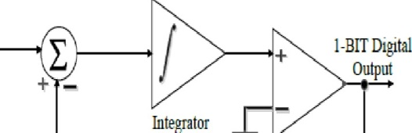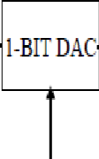

Comparator

1-BITSerial Data

**Figure 1:** 1-bit sigma-delta modulator.

1. **THE IMPLEMENTATION OF OPERATING AMPLIFIER**

The main component of the 21.23 kW/1.23 kW sigma-delta modulator is an operational amplifier. This has significant open-loop gain and simplifies integrator integration for practical applications of the negative feedback concept. It also transmits more bandwidth than the first two harmonics of the input sine wave. Op amps operate at clock rates. This is because of their time difference. An op amp's gain-bandwidth product must be greater than 1 for efficient signal transmission at clock frequencies. 1 shows the amplifier used. P-channel tail current source M7, n-channel current load, and n-channel types M1-M2, A1-M2, pA3-M4, and A3-M4 make up the company. The first stage converts the differential signal into an unbalanced signal with a high differential gain. This stage provides a high differential and differential gain for single-ended switching. The second stage consists of the p-channel load current M6 and the n-channel common-source amplifier MS[8]. The MS and M9AAe semiconductors provide a bias for the op-amp circuit. A typical resistive diode has a bandwidth of 10 MHz between V and -2 V and can provide a reference current of 100 A (gate combination, transistor combination, and M9 combination). Figure 3 shows the frequency response of the ref[5]. The resistance is 1 kOhm, and the current consumption is 23 watts.

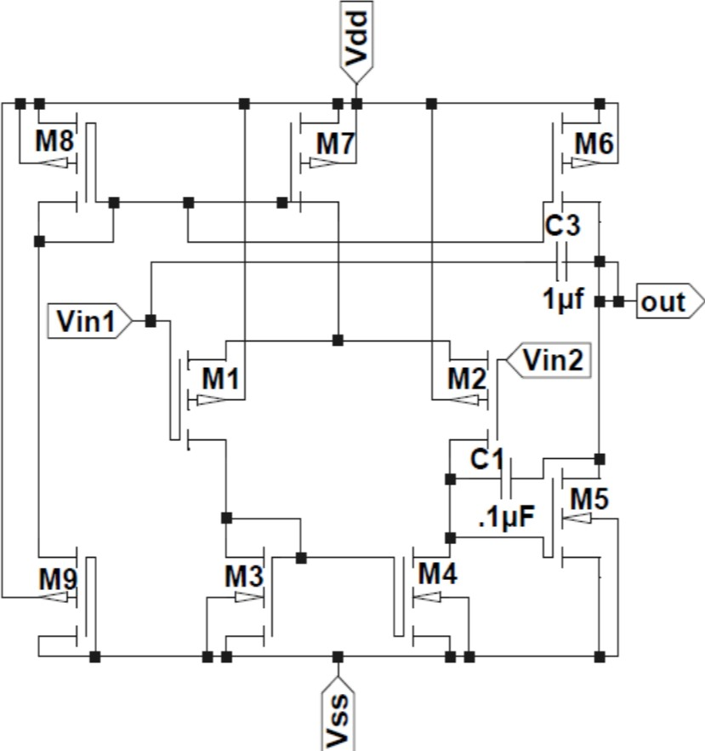

**Figure 2:** Diagram of an operational amplifier.

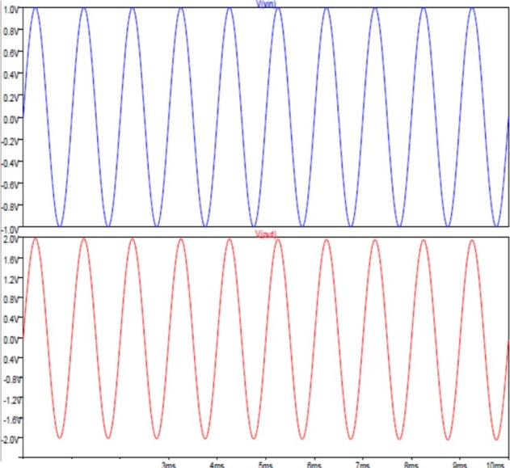

'"' ""'

**Figure 3:** The Op-frequency Amp's response (Input & Output).

1. **THE COMPARATOR'S DESIGN**

The first-order modulation quantizer is a comparator. The comparator only has one bit (1" or "0"), so there are only two stages:"1" represents VDD = +1.SV, and "0" represents VSS = -1.SV. We want a 1 because we want the comparator output to be "0" when the integrator output is greater than the voltage reference (Vref) and the integrator output is less than the voltage reference (Vref)[6]. You can make a simple comparator using an op-amp. Since the comparator is only used for switching between buses, no compensation network is required. I don't want stability. Because it softens the change. When the circuit receives a sinusoidal signal, the comparator switches from positive to negative rail. The high speed of the comparator can be calculated by sending an incremental input signal to the comparator and calculating the time it takes the comparator to reach the final output value[7]. The rotational speed of the comparator determines the clock frequency of the main variable. The count rate of the comparator must be lower than the clock frequency. During half a cycle, the time changes from -2.SV to +2SV. The 10 MHz clock frequency is the best frequency available in the incremental time ramp described above. If the clock frequency exceeds 10 MHz, the output of the comparator will be destroyed. Shy figure in the photo. Figure 5 shows the transient response of the comparator with a bias voltage of 0.5 V.

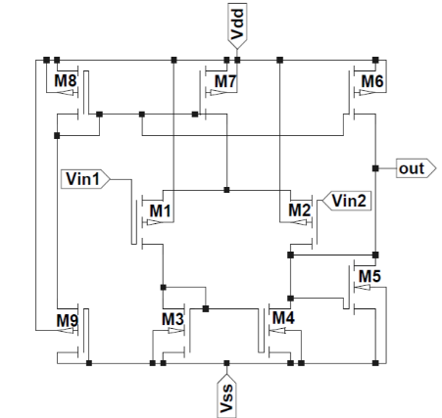

**Figure 4:** Diagram of the Comparator.

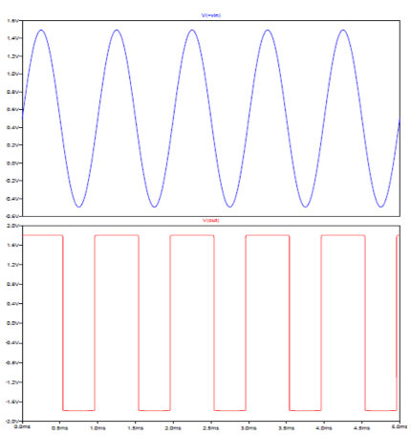

**Figure 5:** Comparator's frequency response (Input & Output).

1. **THE 1-BIT DAC'S DESIGN**

The first-order modulation quantizer is a comparator. A comparator only has one bit (either a 1" or a "0"), so it has only two stages. This two-stage CMOS op-amp comparator provides a 1-bit digital input to the output of the digital-to-analog converter. A 1-bit D/A converter is used to convert the 1-bit digital output of the comparator to an analog signal, which is then fed back to the SC integrator. The DAC has two transfer gates. A voltage divider between the positive and negative 2.5V rails serves as an input to each transmitter gate in response to a 1-bit digital input signal. These rails are called Vref signals. A 1-bit DAC that uses a reference voltage to convert the output digital bit stream to an analog value is an important part of the feedback path. The DAC used is shown in Figure 1. There are two reference voltages in a single-ended DAC. +Vref = +2 and -Vref = -2, where Sv represents the positive and negative reference voltage. The DAC changes the level of legitimacy to align a particular critique with a useful level of legitimacy. Please fill in the missing parts. on figs. Figure 1 shows the frequency response of a digital-to-analog converter. 7. A simple multiplexer circuit can be used to design a 1-bit D/A converter that selects +Vref or -Vref based on a 1-bit digital input signal.

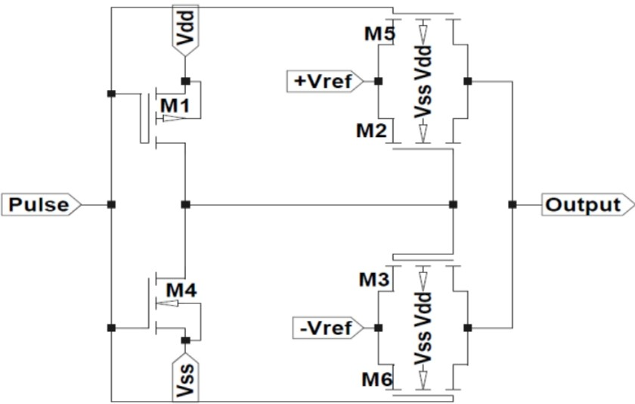

**Figure 6:** Diagram of the DAC

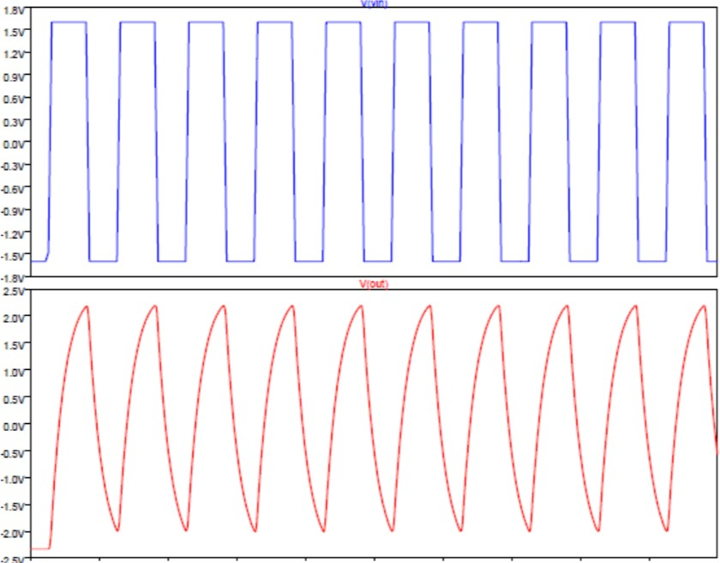

**Figure 7:** The input and output of DAC's frequency response

1. **RESULT AND SEMILUSTION**

The first-order modulation quantizer is a comparator. The comparator only has 1 bit (1" or "0"), so there are only 2 stages. When used with MOS SPICE level 1 model parameters, LTspice simulation (LTspice IV.4.21b linear technique, SPICE simulator) provides theoretical results. 250nm CMOS technology was used to create the main operational amplifier circuit, comparator, and sigma-delta DAC (IL'-.ADC). Figure 8 shows the frequency response of a sigma-delta ADC. The sigma-delta subsystem of a conventional first-order ADC is very well characterized, with input frequencies up to 10 MHz for sinusoidal signals and supply voltages Vdd = +1.8 V and Vss = -1.8 V. The total power used by the Rauschen 6.15NI is 35,426 watts.

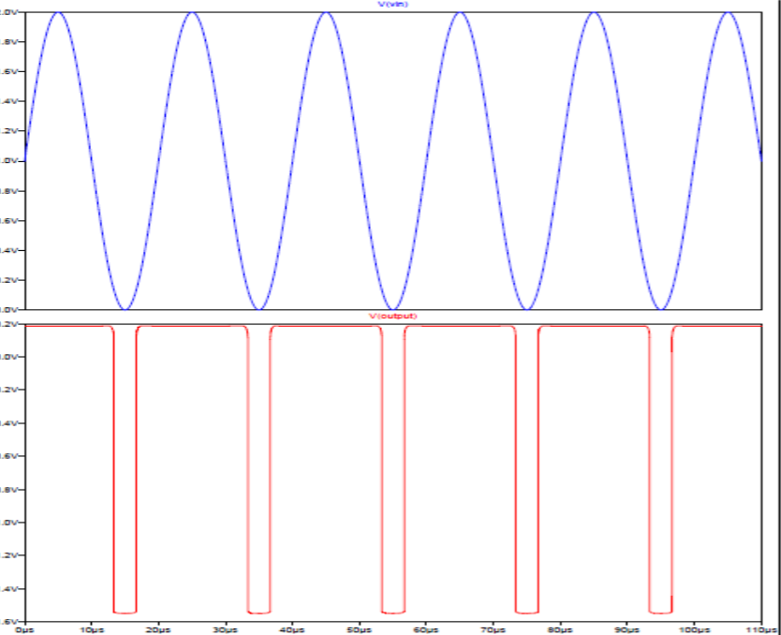

**Figure 8:** The 1-BitSigma­ Delta ADC's frequency response

1. **CONCOLUTION**

The 1-bit sigma-delta 1st order ADC was developed using standard n-well 250nm CMOS technology. As these results indicate, sigma-delta modulators can be used to convert small analog signals into very high-resolution digital output signalsEven though most effective high-threshold transistors are available, switched-capacitor circuits have established themselves as a feasible technique for growing low-voltage, high-decision sigma-delta modulators. Reducing the oversampling element has little impact on the modulator's strength consumption.

**ACKNOWLEDGEMENTS**

To all those who contributed to the success of our research, I would like to use this opportunity to offer my thanks. To everyone who has helped me, I am incredibly appreciative. I appreciate your help and advice, as well as the helpful criticism you occasionally provide. I owe you a debt of gratitude that words cannot adequately convey. My parents' support, love, patience, encouragement, and trust helped make all of this possible, and I want to thank them for that

1. **REFERENCES**
2. Soundararajan, R. (n.d.). Programmable CMOS Analog-to-Digital Converter Design and Testability. LSU Digital Commons. <https://digitalcommons.lsu.edu/gradschool_dissertations/3552>
3. Kommana, S. P. S. (n.d.). First order sigma-delta modulator of an oversampling ADC design in CMOS using floating gate MOSFETS. <https://doi.org/10.31390/gradschool_theses.3638>
4. Kester, W., & Bryant, J. (2005). Sigma-Delta Converters. Data Conversion Handbook, 231–254. <https://doi.org/10.1016/b978-075067841-4/50017-8>
5. Redirecting. (n.d.). Redirecting. <https://linkinghub.elsevier.com/retrieve/pii/B9780750678414500178>
6. Elgreatly, A., Dessouki, A., Abdalla, R., & El-Rabaie, E. S. (2021, February 24). A Survey on Analog-to-Digital Converters’ Architectures and Performance Analysis. Port-Said Engineering Research Journal, 0(0), 0–0. <https://doi.org/10.21608/pserj.2021.53368.1076>
7. Current transformer - Kabushiki Kaisha Toshiba. (n.d.). Current Transformer - Kabushiki Kaisha Toshiba. <https://www.freepatentsonline.com/6822547.html>
8. Mekala, H. (n.d.). Third order CMOS decimator design for sigma delta modulators. LSU Digital Commons. <https://digitalcommons.lsu.edu/gradschool_theses/858>
9. Suda, N., Nishanth, P. V., Basak, D., Sharma, D., & Paily, R. P. (2014, September 10). A 0.5-V low power analog front-end for heart-rate detector. Analog Integrated Circuits and Signal Processing, 81(2), 417–430. <https://doi.org/10.1007/s10470-014-0402-1>