Analysis of You Tube Content Reliability, Quality & Relevance in Context of Electric Vehicles
Jatin Kumar¹, Ashwin A Nair¹, Gaurav Kumar¹
¹Student, Mittal School of Business, Lovely Professional University, Jalandhar, Punjab, India
ABSTRACT (Font-Times New Roman, Bold, Font Size -12)
Based on a questionnaire analysis filled by professionals in the Electric Vehicles Industry, the Quality, Reliability, and Relevance score of the You Tube videos is positively neutral more on the positive side. The sentiment analysis leans more towards positive emotions than negative ones. The analysis identified specific negative emotions and popular concerns related to technical aspects, efficiency, performance, types, characteristics, comparison of EV's to traditional cars, and battery technology. To improve the overall quality, reliability, and relevance of the YouTube content in the context of Electric vehicles, measures such as increasing the production quality, providing accurate and reliable information, ensuring relevance to the target audience, incorporating engaging visuals, and collecting feedback from the respondents are suggested. These measures can enhance the videos' quality, relevance, and reliability while also improving the sentiment analysis.
Keywords: Electric vehicles, YouTube content, Quality, Reliability, Relevance, Topic modelling, Sentiment analysis, Production quality, positively neutral Accurate information, Relevant content, Engaging visuals, Feedback.
- INTRODUCTION (Font-Times New Roman, Bold, Font Size -12)
Electric vehicles are vehicles that run entirely or largely Electrically. Electric vehicles are environmentally friendly due to their low fuel consumption, low engine cost (gasoline or diesel) to maintain. The Electric vehicles marketplace likely to grow at a CAGR of ninety four percent between 2021 & 2030. Incentivizing companies and customers to purchase EVs, rising gasoline prices and greenhouse gas (GHG) emission guidelines have helped the business to grow. By August 2022, there will be 13,92,265 Electric vehicles on Indian highways (Ministry of Transport and Highways, India). Another 45-50 million Electric cars on the road by 2030. Overall, the Electric car industry likely to create fifty million secondary jobs and ten million jobs by 2030. (IVCA-EY-Indus Law Report). Nitti Aayog assessments that the Electric vehicles funding market in India will reach $50 billion by 2030. The number of Electric vehicles in India has risen significantly and Electric vehicles charging company profits have increased due to positive GOI rules and incentives. Electric vehicle sales in India grew by one forty nine percent between 2021 and 2022 to forty-nine thousand six zero seven.
  - Types of Electric vehicles
(BEV)Battery Electric Vehicle-The total number of electric vehicles in India has grown rapidly and EV charging companies' revenues have increased thanks to favourable regulations and incentives from the Indian government. Electric vehicle sales in India increased by 149% between 2021 and 2022 to 49,607 units, (HEV)Hybrid Electric Vehicle-In addition to the motor, the HEV also has an electric motor. Batteries, engine power fuel supply Electricity for the machine. Both the electric motor and the engine engage the transmission at the same time, (PHEV)Plug-Hybrid Electric Vehicle-The word "series hybrid" used for PHEVs. It has a motor and an engine. You can choose from two types of fuel: conventional fuel (such as gasoline) and alternative fuel (such as biodiesel). A rechargeable battery can also power it. the battery can charge externally, (FCEV)Fuel Cell Electric Vehicle-A different name for FCEVs is Null Emission Vehicles. They use "fuel cell technology" to generate the electricity necessary for cars. The chemical energy of the fuel converted at once into electrical energy.
  - Challenges in the Electric Vehicle Industry
Poor infrastructure: The lack of infrastructure includes not only a lack of charging stations, but also home charging schemes. One of the main problems for those considering electric vehicles is the lack of infrastructure. Charging a heavier electric car can be difficult if the owner of the electric car does not have the necessary installation (automatic circuit, cables, and ground), Lack of standardization: EV adoption rates in community-based communities have declined due to lack of demand. Because no single charging station can serve all types of electric vehicles, every second an electric scooter has its own charging socket, which impacts the charging station infrastructure. Moreover, the lack of standards is a limitation of the Indian electric vehicle industry, which is killing the current and prospects of the electric vehicle market, Maximum temperature: The battery works best when used in a temperature range of 15-40 degrees Celsius. Kerala, Uttarakhand, Rajasthan, Meghalaya electric vehicles should not be used in extremely hot or cold locations due to the significant effect of temperature on electric vehicle battery performance.

  - Reviews of Related Work
“A Review of Prostate Cancer Information on YouTube™: Implications for Patient Education and Decision Making” Prostate cancer is the second most common cancer in men in the United States, with a lack of research devoted to the types of prostate cancer information available on social media outlets. YouTube™, as a widely used video sharing website, has emerged as a common platform for health-related information, including prostate cancer. This study aimed to describe the most widely viewed YouTube™ videos related to prostate cancer, and its findings have important implications for patient education and decision making. The study found that the majority of the 100 most viewed prostate cancer videos on YouTube™ were uploaded by consumers and medical or government professionals, and the purpose of most videos was to provide information. The videos by medical and government professionals and news sources supplied information more often than those by consumers and commercial sources. Additionally, the most common topics were information related to prostate cancer, treatment options, and PSA testing and routine screening. The rise of technology and social media platforms like YouTube™ makes it increasingly important for patients to acquire the skills and knowledge to identify credible information to help inform their decisions. Therefore, this study emphasizes the need for reliable and accurate information on prostate cancer to be easily accessible on social media platforms like YouTube™ to ensure that patients can make informed decisions about their health. Additionally, healthcare providers should consider leveraging these platforms to communicate and disseminate accurate information to their patients. (2) “A Social Media Content Analysis of Mediterranean Diet Videos on YouTube: Evaluating Information Quality and Viewer Engagement” The Mediterranean diet has been shown to have numerous health benefits, including reduced risk of chronic diseases such as cardiovascular disease, type 2 diabetes, and cancer. With the increasing popularity of social media platforms, YouTube has appeared as a source of health information for many individuals. However, there is a lack of research on the quality of Mediterranean Diet information available on YouTube. The purpose of this study was to conduct a social media content analysis of YouTube videos describing the Mediterranean Diet. Data was collected by three independent content experts in August 2020, utilizing a standard rubric and protocol. The DISCERN instrument, a 16-item tool designed to assess reliability, dependability, and trustworthiness of an online source, was used to measure information quality. The results of the study show that most of the videos on the Mediterranean diet were educational in nature. However, a third of the videos were found to be less clear and less credible on the information presented. Most of the videos were posted by an individual, and the majority were rated as medium quality. User engagement, as measured by the number of views, comments, likes, and dislikes, varied widely across all sources of media. The study also suggests that there is no correlation between the number of views, comments, likes, and dislikes and video quality. The findings of this study highlight the potential of YouTube as a means of health promotion and education for the Mediterranean diet. However, the quality of the content available on YouTube varies significantly, showing a need for further research and intervention to ensure the availability of high-quality Mediterranean diet content on diverse online video sharing platforms. This study provides a foundation for future research to identify predictors of high-quality Mediterranean diet content on social media platforms. (3) “Assessing the Quality of Physical Literacy Videos on YouTube: Implications for Online Health Education” The Internet has become an essential source of health information, with YouTube serving as a popular platform for individuals seeking health-related content. Physical literacy is an important health-related outcome that promotes an active lifestyle, and YouTube has the potential to serve as a resourceful educational space for physical literacy information. However, the quality of information available on YouTube is not always reliable, and it is essential to assess the quality of physical literacy videos on YouTube. The study aimed to assess the content, exposure, engagement, and information quality of physical literacy videos on YouTube. The researchers collected and analyzed 300 YouTube videos on physical literacy, coding each video's title, media source of upload, content topics related to physical literacy, content delivery style, and adherence to adapted HON code principles of information quality. The findings revealed that physical literacy videos focusing on physical activity and behaviors were the strongest predictor of high-quality ratings, followed by videos covering affective domains (motivation, confidence, and self-esteem) of physical literacy. Additionally, videos using presentations and testimonials had high-quality information about physical activity, which was found to be an essential factor in the delivery of physical literacy information. The study's findings indicate that providers of physical literacy and health-related online video content should adhere to expected quality standards to ensure the reliability and usefulness of the information. As ethical standards increase, YouTube has the potential to enhance video resources, virtual networking opportunities, as well as the sharing, dissemination, accumulation, and enrichment of physical literacy information for all. The study highlights the importance of quality assessment and the need for content creators to prioritize the quality of information they upload on YouTube.

(4) “Exploring Mobile Learning Opportunities in Teacher Education: A Content Analysis of YouTube Videos from Higher Education Institutions in Ghana” In Africa, Higher Education Institutions (HEIs) are exploring the potential of mobile learning to improve educational access and quality, particularly in teacher education. This paper aims to investigate how YouTube videos developed by HEIs in Ghana feature participatory approaches to problem-solving while promoting mobile learning opportunities for educators. The current research on mobile learning in Africa has primarily focused on its value for students, with recent attention shifting towards its potential in teacher development. One trend that has opened prospects for exploring learning opportunities is the use of mobile communication. Mobile devices are being used to support improvements in educational access and quality in the African Regions. HEIs are striving to develop content and have materials available to meet the demands of their learners. This paper presents a content analysis aimed at addressing mobile learning opportunities saw in teacher education of Higher Institutions. The study's findings indicate that mobile learning projects that focus on access to open education resources, such as supplemental tutorials and content creation, are becoming more accessible through mobile devices for teacher development. YouTube videos developed by HEIs in Ghana feature participatory approaches to problem-solving while promoting educators' acceptance of mobile learning. This approach enables new ways for HEIs to promote the use of mobile learning opportunities. Mobile learning has the potential to improve educational access and quality in African regions, particularly in teacher education. HEIs are exploring the use of mobile devices to develop content and provide learning opportunities for their learners. This paper highlights the importance of participatory approaches to problem-solving while promoting educators' acceptance of mobile learning. Findings from the content analysis suggest that mobile learning projects focused on open education resources are becoming more accessible through mobile devices for teacher development. The study provides insights into the use of mobile learning in teacher education, which could inform the development of mobile learning policies and strategies in HEIs in Ghana and other African regions. (5) “Healthcare Information on YouTube: A Review of the Peer-Reviewed Literature” YouTube has become a popular platform for disseminating health information, but concerns have been raised about the quality and accuracy of the information provided. This literature review aims to provide an overview of the existing research on healthcare information available on YouTube, highlighting the characteristics of the information, the techniques used to analyze it, and its potential impact on patient beliefs and decisions. The authors conducted a systematic search of PubMed and Web of Knowledge databases using two search phrases: (1) YouTube* AND Health* and (2) YouTube* AND Healthcare*. The inclusion and exclusion criteria were applied, and 18 articles were identified for review. The review found that YouTube is increasingly being used as a platform for disseminating health information, with content and frame analysis being the primary techniques employed to analyses the characteristics of this information. The review also identified that YouTube contains misleading information that contradicts reference standards, and the probability of a lay user finding such content is relatively high. Additionally, the retrieval of relevant videos is dependent on the search term used. However, videos from government organizations and professional associations were found to contain trustworthy and high-quality information. The review also noted that YouTube is used as a medium for promoting unscientific therapies and drugs that are yet to be approved by appropriate agencies, and it has the potential to change the beliefs of patients concerning controversial topics such as vaccinations. This literature review emphasizes the need to design interventions to enable consumers to critically assimilate the information posted on YouTube with more authoritative information sources to make effective healthcare decisions. Healthcare professionals should be aware of the potential impact of YouTube on their patients and should educate them about the potential risks associated with accessing information on this platform. (6) “The Role of Social Information in Online Entertainment and Political Videos: An Automated Content Analysis” The present study examines the role of social information in online entertainment and political videos. Specifically, the study compares the amount and valence of social information presented alongside online entertainment videos and political videos. The authors conducted an automated content analysis of (dis)likes, views, and comments presented alongside 463 videos, with a total of 39,602 comments analyzed. The results show that entertainment videos receive more views and comments compared to political videos. Additionally, the study found that entertainment videos’ comments are more neutral than political videos’ comments. The authors also found that comments with stronger positive or negative valence receive more replies and likes. However, positive valence of political videos had no effect, and stronger negative valence for political videos led to fewer likes. Finally, the study found that as political videos received more comments, the positive valence of their comments became more consistent. These findings suggest that the type of video influences the amount and valence of social information the video receives. Overall, this study provides important insights into the role of social information in online entertainment and political videos. The results have implications for understanding how social information is used and valued by online users, as well as for online content creators looking to optimize their videos for greater engagement and impact. (7) “Message Features of Antismoking Campaigns on YouTube” Smoking is a major public health concern, and antismoking campaigns have been implemented worldwide to raise awareness of the harmful effects of smoking and to promote cessation. In recent years, YouTube has become an increasingly popular platform for disseminating antismoking messages. This content-analytic study examines the message features of antismoking video clips on YouTube and their relationship with audience response mechanisms. Message sensation value (MSV) is a prominent feature of antismoking campaigns, which refers to the extent to which a message evokes emotions, sensations, or arousal. The study found that MSV levels of online antismoking videos are relatively low compared to televised antismoking messages. This finding highlights the need to explore how antismoking campaigns can effectively utilize MSV in online platforms such as YouTube. The study also found that threat appeals are the predominant message strategy in antismoking videos on YouTube. Threat appeals involve communicating the negative consequences of smoking and are commonly used in public health campaigns. However, the effectiveness of threat appeals in promoting behavior change has been debated. Further research is needed to investigate the role of different types of message appeals in antismoking campaigns on YouTube. The study also examined the relationship between message characteristics and audience response mechanisms, such as the number of viewers, viewer ratings and number of comments. The findings suggest that message characteristics are related to viewer reach and viewer preference. This highlights the importance of understanding the audience's response to antismoking messages on YouTube and tailoring messages to meet their needs and preferences, this study provides valuable insights into the message features of antismoking campaigns on YouTube and their relationship with audience response mechanisms. The findings suggest the need to explore the effective use of MSV in online platforms and the role of different types of message appeals in promoting behavior change. Understanding the audience's response to antismoking messages is crucial in developing effective public health campaigns on YouTube. (8) “A Content Analysis of COVID-19 Related Videos on YouTube: Implications for Public Health Communication” social media has become a popular platform for institutions, government departments, and healthcare professionals to disseminate health-related information to many people simultaneously. In recent years, YouTube has been recognized as a key public information source during crises caused by viral infections such as Zika, H1N1, swine flu, and most recently, COVID-19. Many people search YouTube for health-related information, making it a valuable resource for public health communication. Social media has become a popular platform for institutions, government departments, and healthcare professionals to disseminate health-related information to many people simultaneously. In recent years, YouTube has been recognized as a key public information source during crises caused by viral infections such as Zika, H1N1, swine flu, and most recently, COVID-19. Many people search YouTube for health-related information, making it a valuable resource for public health communication. Social media has become a popular platform for institutions, government departments, and healthcare professionals to disseminate health-related information to many people simultaneously. In recent years, YouTube has been recognized as a key public information source during crises caused by viral infections such as Zika, H1N1, swine flu, and most recently, COVID-19. Many people search YouTube for health-related information, making it a valuable resource for public health communication. This literature review highlights the importance of YouTube as a platform for public health communication during crises caused by viral infections. The study shows that YouTube is a popular source of COVID-19 related information, with news channels being the primary contributors. However, the study also highlights the limitation of YouTube as a platform for public health communication, which is the lack of verification of videos produced by authorized healthcare professionals. This limitation needs to be addressed to maximize the potential of YouTube in disseminating accurate and reliable health-related information to the public. Overall, this study suggests that YouTube can be a valuable resource for public health communication, but improvements need to be made to ensure the quality and reliability of the information provided. (9) “YouTubers Followed by Children in Primary Education in Spain and the Need for Media Education” With the rise of mobile technologies and the internet, children and young people are exposed to a vast range of media and content. YouTube has emerged as one of the most popular platforms for children, and influencers on this platform have a significant impact on their followers. This paper reviews the research on the main YouTubers followed by children in primary education in Spain and discusses the need for media education to ensure appropriate psychosocial development. With the rise of mobile technologies and the internet, children and young people are exposed to a vast range of media and content. YouTube has emerged as one of the most popular platforms for children, and influencers on this platform have a significant impact on their followers. This paper reviews the research on the main YouTubers followed by children in primary education in Spain and discusses the need for media education to ensure appropriate psychosocial development. YouTubers have a significant impact on the psychosocial development of children. They can shape their values, beliefs, and attitudes towards a range of issues, including consumerism, gender, and relationships. Studies have found that children who follow YouTubers are more likely to be influenced by their opinions and are more likely to emulate their behavior. This highlights the importance of ensuring that the content created by YouTubers is appropriate for their young audiences. YouTubers have a significant impact on the psychosocial development of children. They can shape their values, beliefs, and attitudes towards a range of issues, including consumerism, gender, and relationships. Studies have found that children who follow YouTubers are more likely to be influenced by their opinions and are more likely to emulate their behavior. This highlights the importance of ensuring that the content created by YouTubers is appropriate for their young audiences. (10) “Attributions of LGBTQ Bullying and Harassment in the It Gets Better Project: An Ethnographic Content Analysis” The It Gets Better Project (IGBP) is a popular YouTube channel that provides messages of hope to at-risk LGBTQ and questioning youth. This study employs Ethnographic Content Analysis (ECA) and the theoretical lens of attribution to examine how LGBTQ bullying and harassment are discussed in the IGBP and to what they are internally and externally attributed. Bullying and harassment experienced by LGBTQ individuals have been linked to negative mental health outcomes such as depression, anxiety, and suicide. The IGBP aims to provide a message of hope to these individuals, but little research has examined how the project discusses the root causes of bullying and harassment and how it proposes solutions. The study's findings revealed that external attributions were more prevalent than internal attributions in discussions of types of harassment and bullying experienced by LGBTQ individuals. The IGBP focused on institutions such as schools and governments as both the cause of and remedy for bullying and harassment. The project also emphasized the role of community support and the importance of self-acceptance and resilience in overcoming bullying and harassment. The literature on LGBTQ bullying and harassment has highlighted the negative impact of stigma and discrimination on the mental health of LGBTQ individuals. The IGBP offers a message of hope to these individuals and aims to provide a sense of community and support. This study's findings suggest that the project's focus on external attributions and institutional solutions may be effective in addressing the root causes of bullying and harassment. However, future research is needed to examine the long-term impact of the IGBP on the mental health and well-being of at-risk LGBTQ and questioning youth. (11) “Analyzing the Use of YouTube as a Promotional Tool in the 2014 Indian Parliamentary Elections: An Exploratory Study” The increasing use of social media has revolutionized the way political parties engage with voters. This exploratory study analyses the use of YouTube as a promotional tool during the Indian Parliamentary Elections 2014, the first social media-based elections in India. The study examines the YouTube advertisements of two major political parties, the Indian National Congress (INC) and the Bhartiya Janta Party (BJP), for various parameters, such as the general characteristics of each video, the types of message appeal used, and the dominant content of the advertisements. The study found that both parties used YouTube to emphasize their political agenda and persuade voters through logical arguments. The INC focused more on the identity of their party, while the BJP stressed on their candidate. Both parties used positive campaigning to appeal to voters and addressed various national and developmental issues. They strategically expressed an optimistic future for the country under the dynamic leadership of their respective prime ministerial candidates. The study adds value to existing studies on political advertising and communication literature by integrating the functional theory of political discourse, the concept of 'video style,' and the visual culture concept in the political domain. The study's findings have important implications for political parties, political marketers, and lawmakers as social media occupies a significant place among young and educated voters, acting as a stimulant to voter engagement. The literature on political communication and advertising has shown the importance of understanding the use of new media by political parties to engage with voters. The present study contributes to this literature by examining the use of YouTube in the 2014 Indian Parliamentary Elections. The study highlights the need for political parties to effectively use social media to convey their message and persuade voters. Additionally, the study's theoretical framework provides a useful lens for analyzing political communication in the digital age. (12) “A Literature Review on the Use of YouTube as a Platform for Patient Education on Chronic Obstructive Pulmonary Disease” Chronic obstructive pulmonary disease (COPD) is a common and debilitating respiratory condition, affecting millions of individuals worldwide. Patient education is an important aspect of COPD management, and social media platforms such as YouTube have emerged as a potential means of delivering this education. The present study aimed to conduct a social media content analysis of COPD patient education videos on YouTube. The literature suggests that YouTube is a popular platform for health information-seeking behavior, with a high percentage of individuals using it to obtain information on medical conditions. However, the quality and accuracy of health information on YouTube can vary widely, and it is essential to identify reliable and trustworthy sources. The present study found that over half the COPD patient education videos on YouTube included information on medication management, with far fewer videos on smoking cessation. Most of the videos were posted by health agencies or organizations and were rated as high quality based on adherence to HON code guidelines for posting trustworthy health information on the Internet. However, user-generated content received the lowest quality scores. Overall, the study suggests that COPD education via YouTube has the potential to reach and inform patients, but existing video content and quality vary significantly. Future interventions should direct individuals with COPD to engage with high-quality patient education videos on YouTube that are posted by reputable health organizations and qualified medical professionals. Patients should be educated to avoid and critically view low-quality videos posted by individual YouTube users who are not health professionals. The present study highlights the potential of YouTube as a platform for patient education on COPD, but also underscores the need for quality control and the importance of directing patients towards reliable and trustworthy sources of health information. Further research is needed to identify effective strategies for utilizing YouTube as a means of delivering patient education on COPD and other medical conditions.

- METHODOLOGY
For the next part of Research which contains the survey through the questionnaire method of data collection will be used and that will be done by using the printed copy of the questionnaire filled by the professionals of Electric Vehicle Industry, we will use a combination of diverse questions to get the most accurate results followed by the analysis of identified You Tube content in context of Reliability, Quality & Relevance.
  - Research Questions
Reliability of You tube Content in Context of Electric Vehicles?
Quality of You tube Content in Context of Electric Vehicles?
Relevance of You tube Content in Context of Electric Vehicles?
  - Methods
- Questionnaire
- Topic Modelling
- Sentimental Analysis
- MODELING AND ANALYSIS
The paper will analyse the reliability, quality and relevance of the content using various tools and techniques. Explore real-world information provided by the automobile’s community and Content including subtitles and comments. As we know that video is a trend and the consumption of video content is increasing day by day compared to other content on the internet because it is easier to understand, clear and can understood by all types of people. An analysis conducted on YouTube videos related to Electric vehicles. We identified more than one hundred videos related to the topic. thirty videos were removed for having non-English subtitles, fifteen were removed for being shorter in size, and an additional Twenty-five videos were removed for not being relevant. A diverse sample of thirty videos was then selected and shown to professional of the Electric vehicle industry & then Feedback was collected through a relevant questionnaire.
- We collect data from eighteen professionals showing separate set of five videos to Eighteen Professionals in the Electric vehicle Industry.
- Points has been allocated in accordance with the level of Quality, Relevance & Reliability reported by the Professionals for question one five points scale is used & in second question one point is allocated for each Positive response.
- Variables used for preparing Questionnaire: Gender, Age, Monthly Income, Youtubers Knowledge, Fake Review on You Tube, Paid Sponsorships on You Tube, Comments on You Tube, Price, Profit Margin, Awareness, Sources of these variables is Research & Literature Reviews.
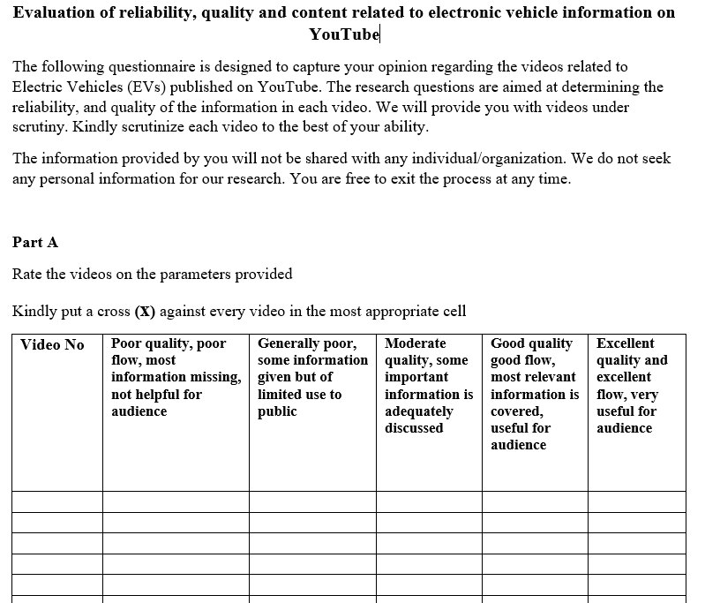
Figure 1: Questionnaire Part A
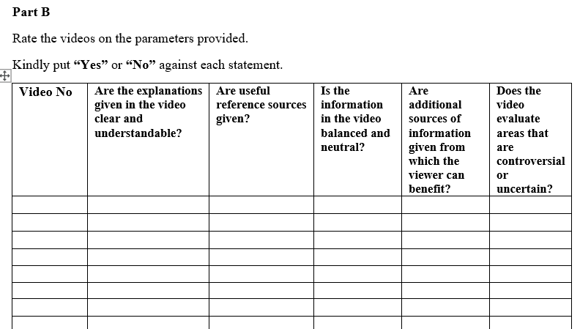
Figure 2: Questionnaire Part B
Table: 1
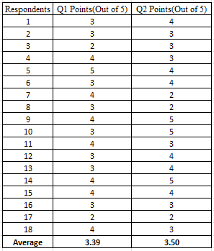
- Based on the descriptive statistics, the mean score for Q2 Points is slightly higher than the mean score for Q1 Points, the median score for Q1 Points is 3, while the median score for Q2 Points is 4, indicating that the scores for Q2 Points may be slightly more skewed towards higher values.
- Looking at the frequency distribution tables, we can see that most respondents gave scores of 3 or 4 for both Q1 Points and Q2 Points, with relatively few scores of 1 or 5. This suggests that most respondents had a moderate level of agreement with both Part A and Part B of the questionnaire.
- Analysing the scores given to Part A and Part B, we can see that the mode for Part A is 3, indicating that the most common score given was a moderate level of agreement (Moderate quality some important information is adequately discussed), For Part B, the mode is first question, indicating that the most common score given a strong level of agreement with the majority of all respondents (Are the explanation given in video Clear & Understandable)
  - Topic Modelling
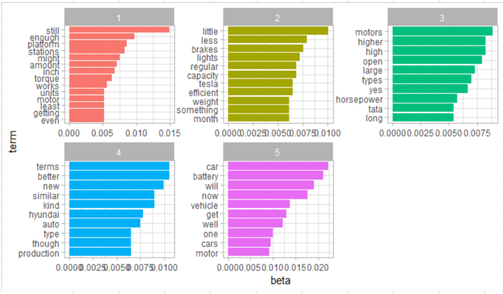
Topic modelling performed on the final sample of 30 videos selected Topic modelling can help show the main themes and topics discussed in the content, such as the features and benefits of different Electric vehicle models, charging infrastructure, and government incentives for buying Electric vehicles. This can help researchers, manufacturers and marketer understand the perception and interests of the audience.

Figure 3: Topic Modelling Analysis

  - Sentimental Analysis
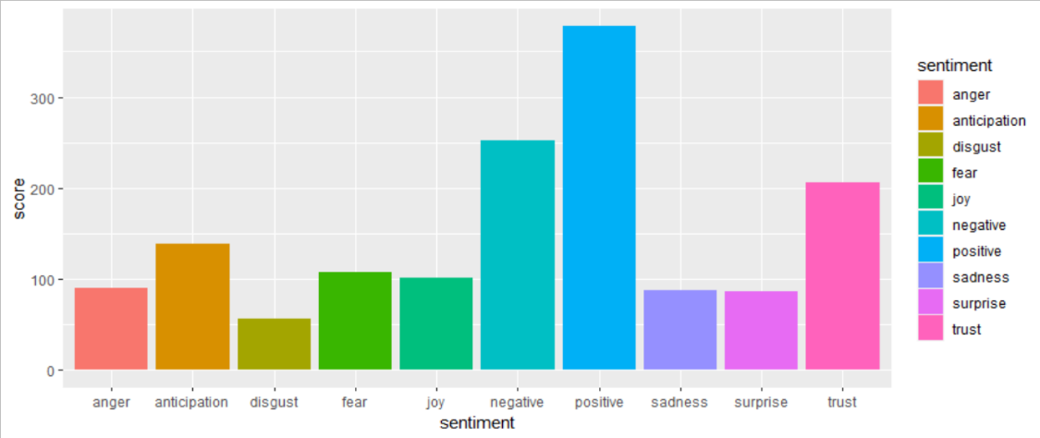
- Sentiment analysis used to find the overall tone and attitude towards Electric vehicles in the content, such as whether it is positive, negative, or neutral. This can help researchers, manufacturers and marketer understand how the audience is responding to Electric vehicles, and how to better market the product. Figure 4: Sentimental Analysis
- RESULTS AND DISCUSSION
The analysis of the Responses suggests that there was no significant difference between the mean scores of Part A and Part B. However, the respondents tended to give higher scores in Part B compared to Part A. The most given score in Part A having the mode of 3, and Part B having the mode of question first question (Are the explanation given in video Clear & Understandable). We can say that the reliability, quality & relevance as per the respondents is satisfactory neither too bad & more on the positive side. People are facing issues related to the useful reference sources & unneutral, unbalanced information provided by some of the You Tubers.
Table 2. Top 5 Topics
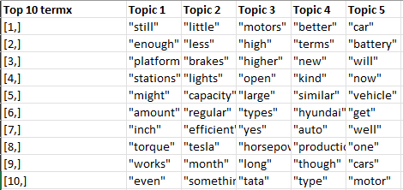
The Top 5 Topics with Top 10 Term is mentioned on the lefthand figure. The top trend from the lefthand side mentioned variables includes Electric Vehicle performance & infrastructure, efficiency of tesla, types & features of motors, advancements in the automobile industry, electric vehicle batteries & technology. Overall, the topic modelling suggests that the audience's interest is centered around the performance, efficiency, and infrastructure of electric vehicles, as well as advancements in the automobile industry and technology.
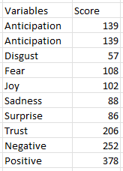
Table 3. Top Variables
The sentiment analysis based on the given variables suggests that the audience has a mixed sentiment with a higher presence of positive emotions (e.g., positive, trust, anticipation, joy) but also a significant presence of negative emotions (e.g., negative, fear, sadness, disgust) The presence of anticipation, Joy, Trust suggests a positive sentiment such as happiness, pleasure, reliability & confidence. On the other hand, Disgust, Fear, Sadness is a negative emotion associated with aversion, repulsion, danger, threat, loss, disappointment & despair, presence of Surprise sentiment is an emotion associated with unexpected events or information. depending on the context, surprise can either be positive or negative.

- CONCLUSION
Based on the analysis, we can conclude that the Quality, Reliability, and Relevance Score of videos is positively neutral more one the positive side as per Questionnaire analysis filled by professionals of the Electric Vehicles Industry. The average score out of maximum 10 score for both the videos indicates that the respondents found the videos to be of good quality, reliable, and relevant to some extent. However, there is still room for improvement in these areas, as the score is not too high. Based on topic modelling & sentimental Analysis scores, we can conclude that the sentiment analysis leans more towards positive emotions than negative ones. The positive emotion score (378) is higher than the negative emotion score (252), indicating that the context being analyzed is generally viewed positively. There are still some areas of concern. The scores for Disgust, Fear, and Sadness are relatively low compared to the other emotions, which suggests that there may be certain aspects of the context that are triggering negative emotions in some individuals. In Topic Modelling top 10 term are identified with five different trending topics. Technical aspects & practicality, efficiency & Performance, types & characteristics, comparison of EV’s to traditional cars, Battery technology & EV’s as future vehicle option are popular concerns identified from the topic modelling analysis. To improve the sentiments, we should identify the specific triggers for negative emotions: Further analysis should be conducted to identify the specific triggers for negative emotions such as Disgust, Fear, and Sadness. To improve the overall Reliability, Quality & Relevance of the You Tube Content in context of Electric vehicles following measures can be taken. Increasing the production quality of the videos, providing accurate and reliable information, ensuring that the information presented in the videos is accurate and reliable, ensuring the videos are relevant to the target audience, incorporating engaging visuals & collecting feedback from the respondents.
ACKNOWLEDGEMENTS (optional)
The authors can acknowledge professor, friend or family member who help in research work in this section.
- REFERENCES & CITATIONS
- Basch, C.H. et al. (2016) A content analysis of YouTube™ videos related to prostate cancer, SAGE Journals. American Journal of Men's Health. Available at: https://journals.sagepub.com/doi/10.1177/1557988316671459 (Accessed: 2022).
- Benajiba, N. et al. (2022) Video clips of the Mediterranean Diet on YouTube TM: A Social Media Content Analysis, American journal of health promotion: AJHP. U.S. National Library of Medicine. Available at: https://pubmed.ncbi.nlm.nih.gov/36191140/ (Accessed: 2022).
- Bopp, T. et al. (2019) Moving beyond the gym: A content analysis of YouTube as an information resource for physical literacy, International journal of environmental research and public health. U.S. National Library of Medicine. Available at: https://pubmed.ncbi.nlm.nih.gov/31510001/ (Accessed: 2022).
- Flimmons, E.B. and Kinuthia, D.W. (no date) Mobile learning in Ghana: A content analysis of YouTube videos promoting teacher development opportunities within Higher Education, transform2015.net. transform2015.net. Available at: http://transform2015.net/live/Resources/Papers/Mobile%20Learning.pdf (Accessed: 2022).
- Madathil, K.C. et al. (2015) Healthcare information on YouTube: A systematic review, SAGE Journals. Health Informatics Journal. Available at: https://journals.sagepub.com/doi/10.1177/1460458213512220 (Accessed: 2022).
- Moller, A.M. et al. (2018) Exploring user responses to entertainment and political videos: An Automated Content Analysis of You Tube, SAGE Journals. Social Science Computer Review. Available at: https://journals.sagepub.com/doi/10.1177/0894439318779336 (Accessed: 2022).
- Paek, H.-J., Kim, K. and Hove, T. (2010) Content analysis of antismoking videos on YouTube: message sensation value, message appeals, and their relationships with viewer responses, Academic.oup.com. Health Education Research. Available at: https://academic.oup.com/her/article/25/6/1085/660720 (Accessed: 2022).
- Parabhoi, L. et al. (2021) YouTube as a source of information during the COVID-19 pandemic: A content analysis of YouTube videos published during January to March 2020 - BMC Medical Informatics and decision making, bmcmedinformdecismak.biomedcentral.com. BMD Medical Informatics and Decision Making. Available at: https://bmcmedinformdecismak.biomedcentral.com/articles/10.1186/s12911-021-01613-8 (Accessed: 2022).
- Ph.D, P.R.A., Ph.D, V.G.P. and Ph.D, I.B.F. (1970) YouTube and influencers in childhood. content analysis and educational proposals, www.redalyc.org. ICONO 14, Revista de comunicación y tecnologías emergentes. Available at: https://www.redalyc.org/journal/5525/552563435012/html/ (Accessed: 2022).
- Phillips, L.M. (2013) Offering hope and making attributions through YouTube: An exploratory ethnographic content analysis of the social change-oriented "it gets better project", thejsms.org. The Journal of Social Media in Society. Available at: https://thejsms.org/index.php/JSMS/article/view/11 (Accessed: 2022).
- Sohal, S. and Kaur, H. (2018) A content analysis of YouTube political advertisements: Evidence from Indian Parliamentary Elections, journals.sagepub.com. Journal of Creative Communications. Available at: https://journals.sagepub.com/doi/10.1177/0973258618761408 (Accessed: 2022).
- Stellefson, M. et al. (2014) YouTube as a source of chronic obstructive pulmonary disease patient ..., sagepub.co.uk/journalsPermissions.nav. Chronic Respiratory Disease. Available at: https://journals.sagepub.com/doi/10.1177/1479972314525058 (Accessed: 2022).

