**An Innovative Life Cycle Assessment Technique for an RC Building's Ecological and Social Sustainability in assessment of Seismic Risk**

**Jitendra Gupta1, Dr. Jyoti Yadav2**

1M. Tech Scholar, Dept. Of Civil Engineering, Sarvepalli Radhakrishnan University, Bhopal, M.P, India

2Assistant Professor, Dept. Of Civil Engineering, Sarvepalli Radhakrishnan University, Bhopal, M.P, India

**ABSTRACT**

The design and evaluation of civil infrastructures should follow a sustainable engineering decision-making method that considers the environment, economics, and society. This research offers a fresh method for evaluating the ecological and social viability of a case study structure that experienced seismic activity over its useful life. The time-dependent likelihood of breaching a limit state is evaluated using an approach that takes the representational uncertainty of seismic activity into account. The losses to the environment and society brought on by the earthquake are connected to the earthquake-induced damages. A case study building's life cycle assessment (LCA), which takes time-dependent seismic reliability into account, is done. Because to the seismically caused damages, the LCA findings showed high risk-based contributions during the rehabilitation phase. In the context of social sustainability, the time-dependent likelihood of collapse within a year might serve as a benchmark indication for human safety.

**Keywords:** Life cycle analysis, loss estimation, time-dependent seismic risk, sustainability

1. **INTRODUCTION**

In this study "Our Shared Future," the phrase "sustainable development" is established as a consequence of discussions between ecologists and economists. A sustainable development is one that "meets the requirements of the present without jeopardizing the capacity of future generations to satisfy their own needs," according to this research. Development and sustainability work together to balance traditional notions of economic expansion with current environmental concerns. Claims that one of the primary features of modern society is the disparity in time scale between the society's rapid development and the environmental cycle served to further emphasize this idea (slow). A collection of goals, sustainable variables/parameters, indicators, and performance standards make up a framework for sustainability evaluation. The main aims of sustainable development are often expressed in terms of the triple-bottom-line (TBL) approach, which is based on the concurrent attainment of environmental, economic, and social goals. This strategy is shown in Fig. 1. The community, end users, and decision-makers often create these goals. The relationship between the built environment and its economic, social, and ecological contexts is what defines sustainable building. In particular, the economic factors should be taken into account for building care and preservation not only during the construction phase but also throughout the structure's service life. By using the Life-Cycle Cost (LCC) analysis and taking into consideration both structural performance and energy efficiency standards, these elements may be assessed. The socio-political consequences of sustainability for the built environment are often used to refer to a range of concerns including social acceptability, fairness and opportunity, and the proper design of social services (such as health, education, and housing welfare). Additional elements of sustainability that have been explored in relation to building projects include life cycle benefit-based design, life quality index, risk acceptance with reference to decision making, and intergenerational fairness. Despite the fact that building sustainability has several facets, the environment receives a lot of attention. This is a result of the city metabolism's significant effects on the environment in terms of resource exploitation and energy use. According to reports, the building industry, which includes residential construction, accounts for up to 40% of global material consumption, 30% to 40% of overall energy demand, and 40% to 60% of greenhouse gas emissions. To achieve a sustainable society in a fair amount of time, the building sector thus plays a crucial role. The TBL's environmental component focuses on the harmony between the use and replenishment of natural resources. In terms of organizations, this component is represented by the mentality of only using natural resources that can be replicated in nature and by only emitting emissions that can be naturally absorbed by the surrounding environment. This dimension may be achieved through reusing and recycling resources, redesigning goods and processes to use less resources, substituting renewable resources for non-renewable ones, and implementing circular economy models. The organizational attitude towards preserving and growing the human and social capital of the communities in which organizations operate is referred to as the social component of the TBL Job satisfaction, quality of life, social integration in communities, solidarity, equality and justice in the allocation of commodities and services, and equitable educational opportunities are all included in social sustainability. Last but not least, the TBL's economic component refers to the organizational mindset to add value and strike a balance between costs and revenues throughout the production and distribution of products and services. The TBL's economic component is focused on the organization's financial and economic performance. These three factors interact, cross across, and sometimes clash. For instance, owing to the additional expenditures required for more environmentally friendly manufacturing methods, economic sustainability may suffer as a result of environmental sustainability. To pursue all of these, companies must, however, operate holistically. When an organization does not support one of these dimensions, they do not behave sustainably [12,17,18]. Each dimension stands for a required but insufficient requirement for attaining sustainability. Organizations struggle to address the TBL while generally succeeding in creating synergies between the environmental and economic components of sustainability. Figure 1 shown the Triple Bottom Line (TBL) and sustainability standards.

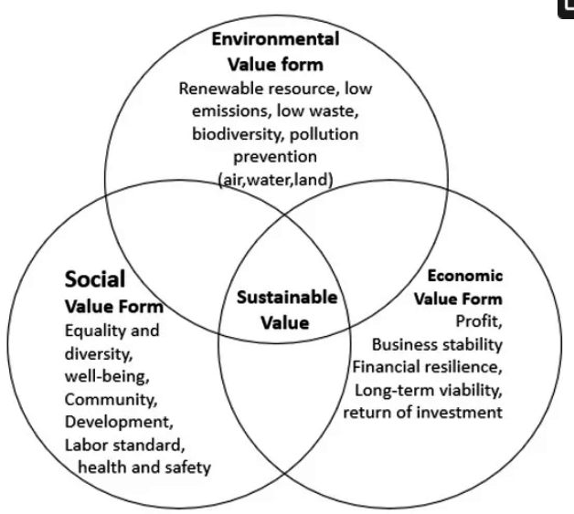

Figure 1: show the Triple Bottom Line (TBL) and sustainability standards

1. **METHODOLOGY**

A detailed explanation of the methods used in the current study is provided in this section. Then, over the lifespan of the infrastructure, the probability of exceeding a set of structural limit states is estimated. The predicted life-cycle environmental impact indicators are then determined by taking into consideration the initial environmental effect of construction, the extra impact associated to damage and repair operations based on the amount of damage, and/or the final end-of-life/recycling activities. This methodology's estimates are predicated on a very particular set of guidelines for the maintenance of the structure. When choosing between various seismic upgrading alternatives while adhering to predetermined reliability limits, the technique described here for the assessment of predicted life-cycle environmental effect may also be applied.

* **Multi-hazard assessment of the limit state probability**

Let Tmax denote the service lifetime of the structure, N the maximum number of critical events that can take place during Tmax and the repair time for the structure. The probability P(LS;Tmax) of exceeding a specified limit state LS in time Tmax can be written as:

*P* (*LS*; *Tmax*)  *P* (*LS* | *i*) *P* (*i*; *Tmax*)

* **Estimation of fragilities**
* **The probability of collapse in a year**

In the previous sections, it is explained how the probability of exceeding the limit state LS can be calculated from above Eqn. It is also of interest to calculate the probability of exceeding the limit state in a year. In general, the probability of exceeding the limit state in the time interval [T, T +T] can be calculated as:

*P* (*LS*; [*T, T*  *T]*)  *P* (*LS*; *T*  *T)*  *P* (*LS*; *T)*

|  |  |  |  |  |
| --- | --- | --- | --- | --- |
|  | **SR** | **OD** | **SD** | **CO** |
| **Foundation structures** | 0% | 0% | 30% | 100% |
| **Elevation Structures** | 0% | 15% | 60% | 100% |
| **Nonstructural** | 15% | 35% | 80% | 100% |
| **Water and electrical systems** | 0% | 20% | 75% | 100% |
| **Major appliances** | 0% | 10% | 50% | 100% |

Table 1. Percentage of material components needed for the building rehabilitation depending on the limit state

As an example, the elevation structures, as reported in Table 1, may require a number of additional materials and overall operations which is equal to 0%, 15%, 60% and 100% in weight of the initial ones in correspondence of SR, OD, SD, and CO limit states, respectively.

**3. RESULTS & DISCUSSION**

The LCA results are shown in Figure 2. According to previous LCA studies on housing between 50 and 70 percent of the environmental consequences associated with the total lifespan of a home are caused by the consumption of energy during the occupancy phase. The typical usage of a home, which includes the consumption of heating fuel, water, and electricity, is the most significant phase of the house's life cycle for each of the four investigated environmental effect categories. It should be noted that the subcategories of the life cycle phase (such as transportation and construction-related stages, etc.) are not given in a disaggregated fashion since they contribute a very little amount (less than or equal to 6% of the total). In the case of RD and HH impact categories, material manufacturing, both as the original (pre-use phase) and as replacement materials (maintenance phase), contributes significantly (slightly more than 40%). For other impact categories, the contribution of the pre-use and maintenance period is between 25 and 30 percent (CC and EQ). For the vast majority of effect categories, the End of Life period has a negligible influence.

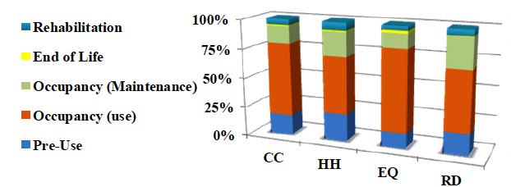

Figure 2. LCA results for the four damage categories: CC, Climate Change; HH, Human Health; EQ, Ecosystem Quality; RD, Resource Depletion

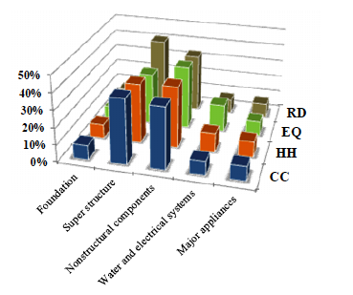 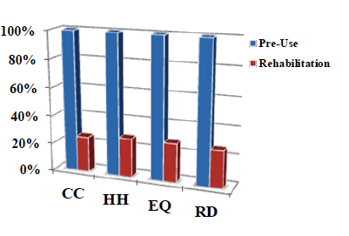

1. (b)

Figure 3. LCA results for the building components a) and LCA results comparing the rehabilitation phase and pre-use phase b): CC, Climate Change; HH, Human Health; EQ, Ecosystem Quality; RD, Resource Depletion

Figure 3 a) depicts the LCA results for the environmental effect categories during the Pre-Use phase. separated into individual construction components. The structural elements (superstructure) and nonstructural components contribute between 30% (superstructure for EQ impact category) and 41% (nonstructural components for EQ impact category) (super structure for RD impact category). In each effect category, the contribution of the remaining building components is around 10% for each kind of building component. In the instance of the HH impact category, the estimated effect associated with the rehabilitation phase reaches 6.5% of the total impact. Fig. 4 b) depicts a comparison between the rehabilitation phase and the pre-use phase: about 25% of the initial environmental effect (stated as 100%) is anticipated to be the result of seismic damage happening over the building's lifespan. It should be noted that the statistics acquired during the rehabilitation phase were calculated as average values across the building's service life and are highly reliant on the building's seismic performance. So, the environmental effect of a certain structural and/or nonstructural design option may be treated as a benchmark variable in sustainable development context decision making challenges.

**4. CONCLUSIONS AND RECOMMENDATIONS**

This report gives a first attempt to evaluate the sustainability of constructions exposed to seismic risk. A technique is suggested for conducting a probabilistic Life Cycle Assessment of the structure while taking into consideration the projected loss's time-dependent relationship with seismic risk. the temporally varying Calculating the probability of a structure collapsing within a year, a proxy for life-safety and reliability factors, takes into account both the building's service life's seismic activity uncertainties as well as any residual damage caused by the series of earthquake occurrences. According to the research, the likelihood that a seismic event will occur affects the LCA findings for different life cycle stages of a building in terms of all four environmental indicators. In comparison to the original building phase, it accounts for around 25% of the impact load and about 6% of the overall environmental effect. Last but not least, the authors want to stress that the current study shows the importance of a multi-criteria and multi-disciplinary decision-making process that takes into account the design of structural systems, seismic hazard analysis, architectural considerations, local customs, and the choice of building materials. According to the authors, understanding how risk, the environment, and society interact with one another in order to achieve sustainable growth should be a must for practitioners and operators in the construction sector.

**5. REFERENCES**

1. Gencturk, B., Hossain, K., and Lahourpour, S. (2016). “Life cycle sustainability assessment of RC buildings in seismic regions.” Engineering Structures, Elsevier BV, 110, 347–362.

2. Berto, L., Saetta, A., and Simioni, P. (2012). “Structural risk assessment of corroding RC structures under seismic excitation.” Construction and Building Materials, Elsevier BV, 30, 803–813.

3. Manfredi, G., Asprone, D., F. Jalayer, A. Prota, and G. Manfredi (2008). Probabilistic evaluation of blast-induced progressive collapse of a seismically upgraded RC structure. Beijing, China hosts the 14th Congress on Earthquake Engineering. Paper ID: 13-0032

4. The Department of Environmental Quality is abbreviated DEQ (2010). A Life Cycle Approach to Prioritizing Residential Building Waste Prevention Techniques in the State of Oregon. The Phase 2 Report Version 1.4, Oregon State.

5. Faber, M.H. and Rackwitz, R. (2004). Structural Engineering International, 14:3,237-248, Sustainable decision making in civil engineering.

6. Goulet, C.A. et al (2007). Assessment of the seismic performance of a reinforced-concrete frame structure that conforms to building codes, from seismic danger through collapse safety and economic damages. 36, 1973-1997, Earthquake Engineering & Structural Dynamics.

7. Manfredi, G., Jalayer, F., D. Asprone, A. Prota, and G. Manfredi (2011). Multi-hazard infrastructure upgrade decision making based on life-cycle cost factors. 40:10,1163-1179, Earthquake Engineering & Structural Dynamics.

8. Jolliet, O. et al (2003). New Life Cycle Impact Assessment Technique, IMPACT 2002+ 8:6,324-330 in the International Journal of Life Cycle Assessment.

9. Kneifel, J.D. (2010). Life-cycle carbon and cost study of new commercial building energy efficiency solutions. Energy and Construction, 42,333-340.

10. Lee, Y., Kim, K. and Lee, S. (2010). Evaluation of a construction plan intended to improve the social health of public dwellings. 45, 1551-1564, Building and Environment.

11. Nassén, J. et al (2007). Input-output study of direct and indirect energy consumption and carbon emissions throughout the construction phase of buildings. Energy. 32,1593-1602.

12. Ortiz, O., Castells, F. and Sonnemann, G. (2009). Sustainability in the building industry: an analysis of current LCA-based innovations. 23:1,28-39 Construction and Building Materials.

13. Pulselli, R.M., Simoncini, E., Pulselli, F.M. and Bastianoni, S. (2007). Energy analysis of building construction, maintenance, and use: indexes for assessing the sustainability of housing. Energy and Construction, 39:5,620-628.

14. S. Taghavi and E. Miranda (2003). Response evaluation of nonstructural components. Berkeley, California's Pacific Earthquake Engineering Research Center published PEER Report 2003/05 in 2003.

15. Willard, B. (2002). The sustainability edge - seven advantages of a triple bottom line business case British Columbia's New Society Publishers V0R 1X0, Canada