INTRODUCTION
Electric vehicles are vehicles that run entirely or largely Electrically. Electric vehicles are environmentally friendly due to their low fuel consumption, low engine cost (gasoline or diesel) to maintain. The Electric vehicles marketplace likely to grow at a CAGR of ninety four percent between 2021 & 2030. Incentivizing companies and customers to purchase EVs, rising gasoline prices and greenhouse gas (GHG) emission guidelines have helped the business to grow. By August 2022, there will be 13,92,265 Electric vehicles on Indian highways (Ministry of Transport and Highways, India). Another 45-50 million Electric cars on the road by 2030. Overall, the Electric car industry likely to create fifty million secondary jobs and ten million jobs by 2030. (IVCA-EY-Indus Law Report). Nitti Aayog assessments that the Electric vehicles funding market in India will reach $50 billion by 2030. The number of Electric vehicles in India has risen significantly and Electric vehicles charging company profits have increased due to positive GOI rules and incentives. Electric vehicle sales in India grew by one forty nine percent between 2021 and 2022 to forty-nine thousand six zero seven.
Types of Electric vehicles
(BEV) Battery Electric Vehicle
(HEV) Hybrid Electric Vehicle
(PHEV) Plug-Hybrid Electric Vehicle
(FCEV) Fuel Cell Electric Vehicle

(BEV) Battery Electric Vehicle
The total number of electric vehicles in India has grown rapidly and EV charging companies' revenues have increased thanks to favourable regulations and incentives from the Indian government. Electric vehicle sales in India increased by 149% between 2021 and 2022 to 49,607 units.
(HEV) Hybrid Electric Vehicle
In addition to the motor, the HEV also has an electric motor. Batteries, engine power fuel supply Electricity for the machine. Both the electric motor and the engine engage the transmission at the same time.
(PHEV) Plug-Hybrid Electric Vehicle
The word "series hybrid" used for PHEVs. It has a motor and an engine. You can choose from two types of fuel: conventional fuel (such as gasoline) and alternative fuel (such as biodiesel). A rechargeable battery can also power it. the battery can charge externally.
(FCEV) Fuel Cell Electric Vehicle
A different name for FCEVs is Null Emission Vehicles. They use "fuel cell technology" to generate the electricity necessary for cars. The chemical energy of the fuel converted at once into electrical energy.

Challenges in the Electric Vehicle Industry
Poor infrastructure:
The lack of infrastructure includes not only a lack of charging stations, but also home charging schemes. One of the main problems for those considering electric vehicles is the lack of infrastructure. Charging a heavier electric car can be difficult if the owner of the electric car does not have the necessary installation (automatic circuit, cables and ground).
Lack of standardization:
EV adoption rates in community-based communities have declined due to lack of demand. Because no single charging station can serve all types of electric vehicles, every second an electric scooter has its own charging socket, which impacts the charging station infrastructure. Moreover, the lack of standards is a limitation of the Indian electric vehicle industry, which is killing the current and prospects of the electric vehicle market.
Maximum temperature:
The battery works best when used in a temperature range of 15-40 degrees Celsius. Kerala, Uttarakhand, Rajasthan, Meghalaya electric vehicles should not be used in extremely hot or cold locations due to the significant effect of temperature on electric vehicle battery performance.
Content analysis from the perspective of Electric vehicles
The top Electric vehicle YouTube channel on the web, rated by views, subscribers, number of videos and news. The paper will analyse the reliability, quality and relevance of the content using various tools and techniques. Explore real-world information provided by the Turba community, and Content including translations and commentary. As we know that video is a trend and the consumption of video content is increasing day by day compared to other content on the internet because it is easier to understand, clear and can understood by all types of people. easy due to flexibility in nature. Various youtubers are making videos on Electric vehicles in India and around the world, but our focus is on the Indian region.
Research Questions
Reliability of You tube Content in Context of Electric Vehicles?
Quality of You tube Content in Context of Electric Vehicles?
Relevance of You tube Content in Context of Electric Vehicles?

Content analysis of political ads on YouTube: Evidence from the Indian parliamentary elections
In this study, YouTube ads for the Indian National Congress and the Bhartiya Janta Party were analysed using the common features of each video, different messaging addresses, and the main content of the ad. Polls show that INC is more focused on party identity while BJP is more focused on party identity. The findings of the study include the main political groups, political brokers, and politicians, as social media is important among young, educated voters who encourage political participation.
Content analysis of anti-smoking videos on YouTube: the relationship between message value, message appeal, and audience reaction.
This content-analytic study examined 934 anti-smoking YouTube videos, focusing on three different message addresses, message sensitivity levels, and other communication elements often seen in anti-smoking campaign literature. To measure message accessibility, audience preferences, and audience engagement, and relate these four factors to audience interactive response characteristics (number of viewers, viewers, and comments) on YouTube. The results show the following: online anti-smoking videos have a lower MSV than TV anti-smoking messages, warning appeals are the most common message strategy used in messages, and video features are related to viewers' likes and dislikes. YouTube is a common place for anti-smoking messages.
Explore user reactions to entertainment and political videos:
Ratings for YouTube content are done automatically, and YouTube content is often accompanied by added user-generated content about it. It is the number of comments, views, likes or social media. But the social information consequences of entertainment films are poorly understood. A computerized content analysis of the likes and views of forty sixty-three videos and thirty-nine thousand six hundred two comments revealed that political videos received fewer views and comments than entertainment videos. Also, compared to political videos, comments on entertainment videos are more objective. Finally, they found that positive ratings of comments on election videos increased, except for political movies, where negative political ratings lead to less likes and positive political ratings did not affect political movies.
Trends and user feelings of the sleep-enhancing effects of watching music on YouTube: a quantitative and thematic content analysis.
The purpose of this study was to assess the propensity of YouTube users to watch sleep-inducing music videos. Users determine how these music videos affect sleep ability and analyse the content of comments about what includes music videos that improve sleep. With a large regional diversity of viewers, they have seen a significant increase in the use of sleep-enhancing music videos.

Moving beyond the gym: A content analysis of YouTube as an information source for physical literacy
It aims to assess the content, impact, engagement, and information quality of literacy videos posted on YouTube, finding that literacy is a lifelong health outcome and supports an active lifestyle. Emotional dimensions of physical literacy (e.g., self-confidence, and self-esteem) were the best predictors of quality after movies, physical activities, and behavioural videos. Therefore, producers of online content about physical literacy and health must be aware of the necessary quality standards.
Mobile learning in Ghana: A content analysis of YouTube videos promoting development opportunities for higher education teachers.
African universities are investigating the learning opportunities that mobile devices can bring to teachers. New research is beginning to explore the potential of mobile learning for students and researchers. This strategy supplies additional opportunities for higher education institutions to encourage the use of mobile learning methods.
Giving Hope and Contribution Through YouTube: Ethnographic Analysis Ethnographic Research Focused on Social Change Projects for the Better
Dan Savage and Terry Miller created the YouTube channel. A better project to respond to teenage deaths. This study uses ethnographic content analysis and an attributional theoretical lens to understand LGBTQ discrimination and harassment discussed in IGBP and internalized and externalized labels. Findings that find organizations as a source or vehicle for intimidation and harassment show that external harassment and discrimination are more common and "underrepresented" than internal accountability.
Content analysis of YouTube™ videos related to prostate cancer.
Prostate cancer is the second most common cancer in men in the United States after skin cancer. This study aims to find the most popular YouTube videos about prostate cancer. consumer
A content analysis of the reliability and quality of YouTube videos as a source of health related post-COVID pain information.
During this virus, increased people are turning to the internet and YouTube is emerging as the main source for learning about the coronavirus. More people are turning to the Internet to learn about the disease, and YouTube has become a valuable tool for studying the coronavirus. This study looked at the production quality and instructional utility of YouTube videos about post-COVID pain.
"It's OK to Be Sad, But Don't Lose Hope": A Content Analysis of Infertility Videos on YouTube by Audience Preferences.
This study was designed to characterize the content of popular porn-related YouTube videos and find elements of each video that match user preferences. The most popular YouTube videos and audience data (such as likes, views and comments) are collected using the search term "disability". Treatment results, information sharing, failed emotional elements, and mentoring are the focus of the film.
Audience engagement on YouTube: A content analysis of the relationship between advertising message attributes and audience response
The data collection approach includes the analysis of more than forty-seven YouTube-based video-audio election ads, linking message addresses, identities, and formats for audience reach and influence. The method of data collection consisted of the analysis of forty-seven YouTube videos that combined audio-visual election advertising, message address, nature, message type, and audience engagement. The results support the limited use of YouTube by proving that viewers do not see news availability and that viewers associate it with news quality.
YouTube as a source of information during the Covid-19 pandemic: Content analysis of YouTube videos published between January and March 2020
YouTube has videos on science and health to find health information. YouTube has been recognized as an important source of information during the disasters caused by H1N1, swine flu, Zika, and most recently, COVID-19. Healthcare organizations should use YouTube for this purpose, as it can be an important resource for sharing information about public health issues such as viral diseases.
YouTube and childhood influence. Content analysis and instructional recommendations
Children and youth are developing new frameworks for understanding, interacting with and consuming media and materials due to the availability of mobile technology and the Internet. The results show that he prefers Spanish YouTubers and uses games or jokes related to his channel. Finally, an overview of the materials used by children of these channels to access the Internet, pedagogical recommendations to create a suitable media education for the psychosocial development of children.
A content analysis of the reliability and quality of YouTube videos as a health resource on post-COVID pain
During this virus, people are online, and YouTube has appeared as the main source for learning about the coronavirus. Musculoskeletal pain has a significant impact on quality of life in the picture of COVID-19, which occurs when symptoms of COVID-19 persist for more than a month. The purpose of this study is to evaluate the informational value and effectiveness of YouTube videos in the post-COVID crisis.
YouTube as an educational resource for people with chronic obstructive pulmonary disease: a social media content analysis
Each video was double coded to look for data quality, topic, published media source, data quality as defined by the HON Coding Standard for Publication of Trusted Health Information Online, and measures for audience impact and engagement. Films are classified as excellent quality, and many are released by health organizations or groups. The purpose of this study is to investigate social media sharing of YouTube patient education videos for chronic obstructive pulmonary disease. Each video was coded twice, identifying the topic covered, the media source it was published in, data quality as defined by the HON Coding Standard for Online Publication of Trusted Health Information, and measures of audience impact and engagement. Films are rated as high-quality films, and many are distributed by health organizations or groups.
Health information on YouTube: a systematic review
YouTube has gained popularity as a platform for publishing health information; The main method used by the researcher to analyse the characteristics of this data is content and structure analysis. YouTube usually has false information that violates reference standards, and the average user is unlikely to find such content; and YouTube has reliable and high-quality information and videos from government agencies and trade associations.
Research Methodology
Till Now
For this study, we went though many of the studies and research carried out earlier to have the references, we used the different carried out research and studies as secondary data for data collection and this was done by using the internet to find out relevant data according to our topic of Research. We analyse various literatures on the related topics.
What to do-
For the next part of Research which contains the survey through the questionnaire method of data collection will be used and that will be done by using the printed copy of the questionnaire filled by the professionals of Electric Vehicle Industry, We will use a combination of diverse questions to get the most accurate results followed by the analysis of identified You Tube content in context of Reliability, Quality & Relevance.
Following three methods we will use for analysing You Tube Content
- Questionnaire
- Topic Modelling
- Sentimental Analysis

Identification of Variables
S.no | Named Variables | Source
1) | Gender | Research & Literature Review
2) | AGE | Research & Literature Review
3) | Monthly Income | Research & Literature Review
4) | You Tubers Knowledge | Research & Literature Review
5) | Fake Review on YouTube | Research & Literature Review
6) | Paid Sponsorships on You Tube | Research & Literature Review
7) | Comments on You Tube | Research & Literature Review
8) | Price | Research & Literature Review
9) | Profit Margin | Research & Literature Review
10) | Awareness | Research & Literature Review

Note - Questionnaire in Context of Electric Vehicles

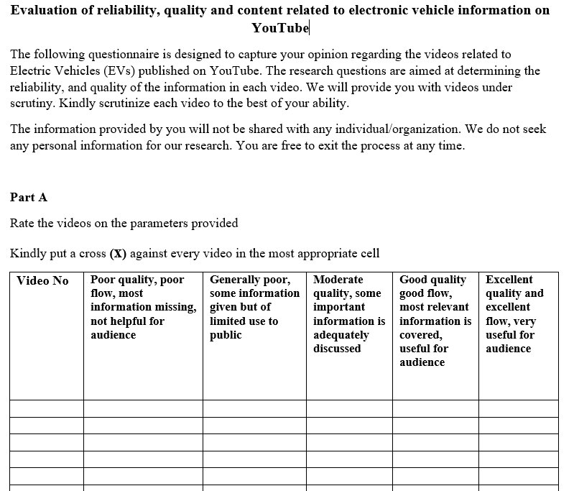
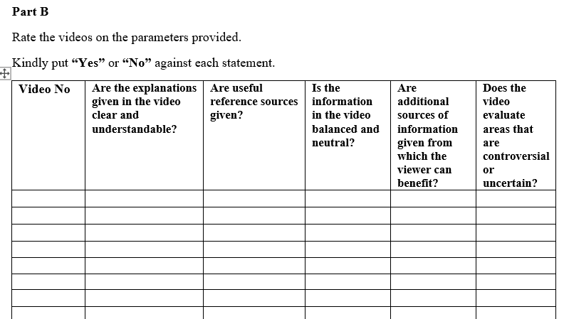

Questionnaire
An analysis conducted on YouTube videos related to Electric vehicles. We named more than one hundred videos related to the topic. 30 videos were removed for having non-English subtitles, 15 were removed for being shorter in size, and an additional 25 videos were removed for not being relevant. A diverse sample of thirty videos was then selected and shown to professional of the Electric vehicle industry & then Feedback was collected through a relevant questionnaire.

- We collect data from eighteen professionals showing separate set of five videos to 18 Professionals in the Electric vehicle Industry.
- A score has been allocated in accordance with the level of Quality, Relevance & Reliability reported by the Professionals.

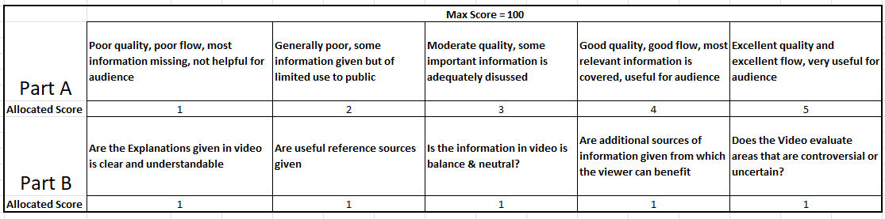
Max Score for 1 video = 20
Max Score for 5 videos = 20 *5 = 100

Results
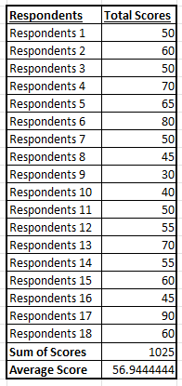
From the result mentioned on the left-hand side, we sum all the scores of 18 respondents who have seen a diverse set of five different videos & then take average of all respondents, As mentioned the maximum possible score is 20 for both the parts of questionnaire A & B

Formula = Total Amount of Scores / Number of Respondents
Total no of Respondents = 100
Total Amount of Scores
Average Score = 1025/18
=56.944
From the above calculations we analyse that the Quality, Reliability & Relevance Score is neutral neither bad neither too Good but more on the positive side.

Topic Modelling
Topic modelling can help show the main themes and topics discussed in the content, such as the features and benefits of different Electric vehicle models, charging infrastructure, and government incentives for buying Electric vehicles. This can help researchers, manufacturers and marketer understand the perception and interests of the audience.
Topic modelling performed on the final sample of 30 videos selected: -
Results for the same has shown below: -
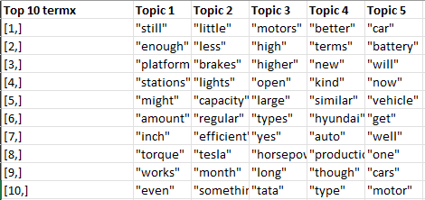

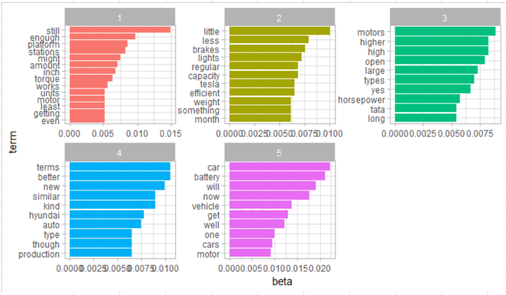

Sentimental Analysis
Sentiment analysis used to find the overall tone and attitude towards Electric vehicles in the content, such as whether it is positive, negative, or neutral. This can help researchers, manufacturers and marketer understand how the audience is responding to Electric vehicles, and how to better market the product.
Topic modelling performed on the final sample of thirty videos selected: -
Results for the same has shown below: -

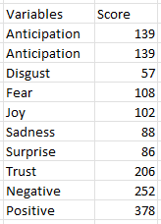

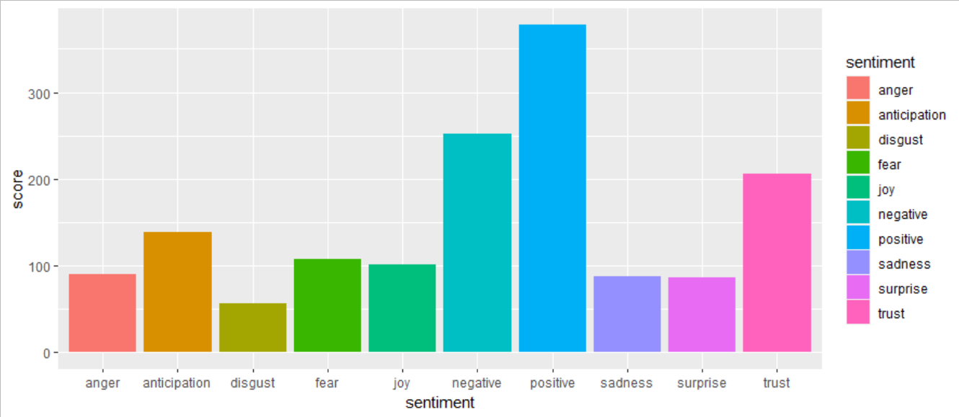

Conclusion & Recommendations
The primary goal of this learning was to measure Quality, Reliability & Relevance of You Tube Content in Context of Electric vehicles, The construct used to do so were knowledge, Genuineness and Quality of content for viewers in context of Electric vehicles, to measure their reliability, quality & relevance.
Apart from few variables, overall Percentage of the variables on this construct reflected that major numbers of Personnel are neutral towards the content of EV’s on You Tube. Most of them is in the category of neither fully dissatisfied or fully satisfied with the Quality and other variables such as relevance, reliability in the questionnaire for the survey Whereas most of them have positive outlook towards the future of Electric vehicles.
In conclusion, this research designed to analyse the subject matter of YouTube videos related to Electric vehicles toward understand the perceptions and interests of the audience, as well as the overall tone and attitude towards Electric vehicles in the content. The research used a combination of methods including a questionnaire, topic modelling, and sentimental analysis. The results of the questionnaire showed that the Quality, Reliability & Relevance Score is neutral neither bad neither too Good but more on the positive side Through topic modelling, the research identified the main themes and topics discussed in the content, such as the features and benefits of different Electric vehicle models, charging infrastructure, and government incentives for purchasing Electric vehicles. Additionally, sentimental analysis revealed the overall tone and attitude towards Electric vehicles in the content is positive. This research can provide valuable insights for researchers, manufacturers, and marketers in the Electric vehicle industry to better understand the audience and improve their marketing strategies. Further research can be done to include a larger sample size, and to include multiple languages in the analysis.

