**Spatio-Temporal Assessment of Land Use and Land Cover Changes: A Geographical Study of Neem Ka Thana Tehsil, Rajasthan**

**by**

**Dr. Seeta Meena**

**Department of Geography, University of Rajasthan**

**Jaipur, India**

**Email:** [seetameena1390@gmail.com](mailto:seetameena1390@gmail.com)

**Abstract**

Human activities are changing the terrestrial environment at an unprecedented rate, magnitude and spatial scale. Rapid urbanization is also a result of such anthropogenic activities, although the rapid and unplanned urbanization of the world is posing many challenges to the immediate and surrounding environment. This process is accompanied by rapid conversion of agricultural land, water bodies and vegetation to a built up/impervious surface. Furthermore, the rapid change of land use/land cover due to urban development affects biodiversity and ecosystems as well as local and regional climate. Hence most of the urban centres are facing significant changes in land use/land cover (LULC). Urbanization and industrialization can lead to land use and land cover dynamics, so this study is important to understand and analyse changes in environmental components and also to ensure sustainability. In the presented research paper, the changes in land use and land cover have been studied in Neem Ka Thana Tehsil. Mainly secondary sources of data have been used for this purpose. The findings of this study revealed that there has been a significant increase in the percentage of the mining, built-up and agricultural areas.

**Key words: Land use, Land cover, Urbanization, Industrialization and Dynamics.**

**Introduction**

Human activities are changing the terrestrial environment at an unprecedented rate, magnitude and spatial scale. (Turner II, et al., 1994). Rapid urbanization is also a result of such anthropogenic activities, although the rapid and unplanned urbanization of the world is posing formidable challenges to the immediate and surrounding environment (Lu et al., 2004; Khorram, 1999). The twenty-first century is known as the urban century since it witnessed nearly half of the world's population living in urban areas. About 70% of the world's population is projected to reside in metropolitan areas by 2050. In addition, an additional 2.5 billion people are projected to move into cities globally between 2018 and 2050, with Asia and Africa accounting for nearly 90% of the increase. As a result, cities in developing countries are gradually becoming urban centres. These nations appear to have experienced rising levels of urban population concentration over the previous fifty years. Urban areas are important for the growth of society and the economy. The rapid and haphazard urbanization of the developing world, however, presents significant environmental challenges for the immediate and neighbouring areas. The rapid development of urban areas and the growth of man-made land cover against declining natural cover are considered to be two of the main factors contributing to global climate change. Increasing man-made land cover in metropolitan areas while reducing natural cover.

This process is accompanied by a rapid conversion of agricultural land, water bodies and vegetation to a built up/impervious surface (Lilisand, et al., 2005). In addition, rapid change of land use/land cover due to urban development affects biodiversity and ecosystems as well as local and regional climate (Luck and Wu, 2002; Khandelwal et al., 2017). Hence most of the urban centres are facing significant changes in land use/land cover (LULC).

Urbanization and industrialization can lead to land use and land cover dynamics, so this study is important to understand and analyse changes in environmental components and also to ensure sustainability (Kafy et al., 2021; Ji et al., 2006). Changes in land use land cover, especially the natural vegetation and water bodies in the formation of UHI (Urban Heat Islands) (Ibrahim, 2017). It refers to a phenomenon where an urban area is significantly warmer than its surrounding rural areas, because it is highly concentrated. For rapidly growing urban populations, paved land cover has increased, which has also led to an increase in land surface temperature (LST) (Hasanlu and Mostofi, 2015). At the local scale, the expansion of built-up areas alters the physical and geometric properties of the land surface in contrast to the natural land cover, thereby altering the surface energy and radiation budget (Fall et al., 2010; Anderson, 1976). The increase of impervious surfaces such as roads, buildings and industrial farms in urban areas leads to an increase in the absorption of incoming shortwave radiation and a noticeable decline in the emission of long-term radiation (Alawami, 2020). It also creates many negative effects on the health of the local residents. Thus, this research article attempts to assess changes in various land use land cover classes in the Neem ka Thana Tehsil.

**Study Area**

The study area of ​​the presented research paper is Neem Ka Thana Tehsil. It is located in the Sikar district of the north-eastern part of the Rajasthan state, at a distance of 120 km from Jaipur. In the south-east of this tehsil are hilly areas, in the north are plains and in the west are Udaipurwati tehsil (Jhunjhunu). The total area of ​​Neem Ka Thana Tehsil is 118822 hectares. It is an agrarian economy tehsil and most of the population is rural. However, since the new economic policy reforms of 1991, rampant changes can be seen in this tehsil. This tehsil is shown using figure 1.

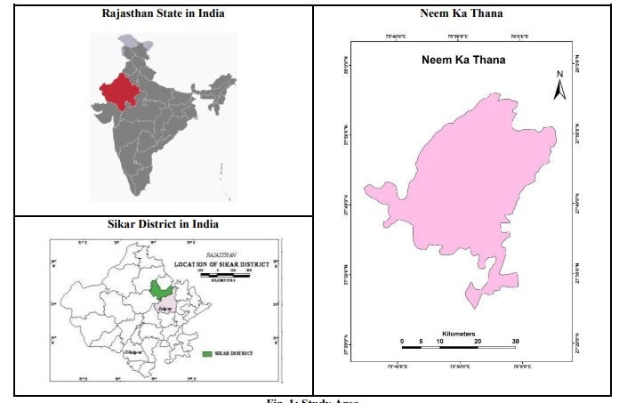

**Figure 1: Study Area**

**Data and Methodology**

The dynamics of land use and land cover in Neem Ka Thana Tehsil has been obtained in three phases: -

**1. Data Acquisition and Processing**

Remote sensed Landsat TM (Thematic Mapper) 1990 and OLI (Operational Land Images) 2016 data obtained from the Earth Explorer website of the United States Geological Survey (USGS). Landsat data is known for good spatial resolution and has been providing data since 1973.

**2. Layer Stacking and Sub-set Creation**

Layer stacking is a process of combining a panchromatic band into a composite or multispectral band. Then a False Colour Composite (FCC) is prepared in which red colour is given to the near infrared band, green colour is given to the red band and blue colour is given to the green band. FCC separates features of the Earth's surface and is widely used for classification purposes.

**3. Image Classification for Land Use and Land Cover**

Band numbers 1 to 5 and 7 have been used for the 1990 Landsat TM data while band numbers 1 to 7 have been used for the 2016 Landsat OLI data.

**Table 1: Description of land use land cover classes**

|  |  |
| --- | --- |
| **Land Use / Land Cover Classes** | **Details** |
| **Built-up area** | **Residential, commercial, industrial, transport and facilities** |
| **Mining areas** | **All Mining areas** |
| **Water bodies** | **All water bodies like ponds, small rivers and drains** |
| **Agriculture** | **All crops** |
| **Aravalli Hills** | **Aravalli Hills and Natural Vegetation** |
| **Bare land** | **Area without vegetation cover** |
| **Uncultivated land** | **Uncultivated agricultural land** |

***Source: United States Geological Survey, 1990-2016***

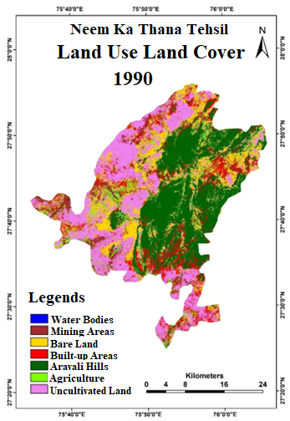

**Figure 2: Land Use Land Cover of 1990**

***Source: United States Geological Survey, 1990-2016***

The land use and land cover map (1990) of Neem Ka Thana Tehsil shows that the least area (0.045 %) comes from water sources while the maximum area (32.81 %) comes from Aravalli hills.

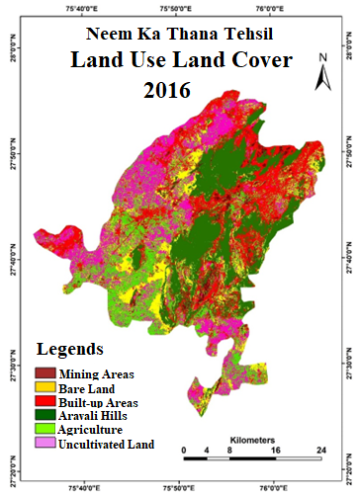

**Figure 3: Land Use Land Cover of 2016**

***Source: United States Geological Survey, 1990-2016***

This figure 3 shows that in 2016, absence of water sources was recorded in this tehsil. Built-up area, mining area and agricultural area have increased significantly while the area of ​​Aravalli hills, bare land and uncultivated land has decreased.

**Accuracy Assessment of Land Cover Classification**

Accuracy is rated for how closely the results verify relative to the real world. It is a general term for comparing classifications of geographic data that are believed to be true. To assess the accuracy of land use classification an error matrix of the referenced data has been prepared to calculate the accuracy of the user and producer. The error matrix is ​​alternatively called the confusion matrix. The percentage of matched numbers to the total number of sites was calculated using the following formula, called the overall accuracy (OA).

**Overall accuracy = Σ diagonal value /N (1)**

The accuracy is similarly evaluated for each individual land use class. There are two approaches for estimating the accuracy of different land use classes - one is User's Accuracy (UA) and the other is Producer's Accuracy (PA). UA measures the error of the commission and indicates the probability of a site classified in a category that is actually available in that category. User accuracy is calculated by dividing the number of correct classifications by the total number of classifications in a category. However, the manufacturer's accuracy measures the error of omission. It is calculated by dividing the number of matched sites by the total number of sites multiplied by the matched data. It measures the percentage of each land use that has been accurately classified. The p-omission error refers to the proportion of landmarks that are not classified in the referenced map. Both PA and UA are obtained using the following formulas.

**Omission Error = $\left(Σ off Diagonal element of column∕Column total\right)×100$ (2)**

**Producer’s Accuracy (%) = $\left(Diagnal value of{column}/{Column}total\right)×100$ (3)**

**Commission Error = $\left(Σ off Diagonal element of{row}/{Column}total\right)×100$ (4)**

**User’s Accuracy = $\left(Diagnal value of{row}/{Row}total\right)×100$ (5)**

Another method used to assess the accuracy of land use classification is the kappa co-efficient (K). It is a continuous multivariate technique for accuracy evaluation. This change measures agreement and is more efficient than the overall accuracy of satellite images. It is also a measure of the proportional (or percentage) improvement by the classifier over a purely random assignment to classes. This change measures agreement and is more favourable than the overall energy of the satellite images.

**Kappa Co-efficient (K) = $\left(ΝΑ-Β\right)∕(Ν^{2}-Β)$ (6)**

Where N is the number of pixels in the error matrix (the sum of all R individual cell values). The kappa coefficient values ​​range from 0 to 1. A value of 1 means perfect precision and as it approaches 0 it loses its precision. The kappa coefficient is a more refined measure than the overall accuracy.

**Table 2: Assessment of Accuracy of Land Use Land Cover Classes: Neem Ka Thana Tehsil (1990)**

|  |  |  |  |  |  |  |  |  |  |  |  |
| --- | --- | --- | --- | --- | --- | --- | --- | --- | --- | --- | --- |
| **Year** | **Land Use Land Cover Class** | **Built-up Area** | **Mining Area** | **Water bodies** | **Agriculture** | **Aravali Hills** | **Bare Land** | **Uncultivated Land** | **Total** | **User’s Accuracy** | **Kappa Coefficient** |
| **1990 1990** | **Built-up Area** | **403** | 10 | 0 | 2 | 3 | 5 | 3 | 426 | 94.60 | **0.93** |
| **Mining Area** | 5 | **241** | 0 | 0 | 2 | 6 | 4 | 258 | 93.41 |
| **Water bodies** | 0 | 1 | **69** | 0 | 2 | 3 | 1 | 76 | 90.78 |
| **Agriculture** | 4 | 2 | 1 | **330** | 6 | 3 | 2 | 348 | 94.82 |
| **Aravali Hills** | 2 | 4 | 5 | 8 | **361** | 0 | 0 | 380 | 95 |
| **Bare Land** | 5 | 2 | 0 | 1 | 0 | **338** | 8 | 354 | 95.48 |
| **Uncultivated Land** | 4 | 5 | 0 | 2 | 1 | 7 | **349** | 368 | 94.83 |
| **Total** | 423 | 264 | 75 | 343 | 375 | 362 | 367 | **2210** |  |
| **Producer’s Accuracy** | **95.27** | **91.2** | **92** | **96.2** | **96.26** | **93.37** | **95.09** |  |  |  |
| **Total Accuracy** | **94.61** | | | | | | |  |  |  |

**Source: Computed by the researcher with the help of GIS & SPSS**

**Table 3: Assessment of Accuracy of Land Use Land Cover Classes: Neem Ka Thana Tehsil (2016)**

|  |  |  |  |  |  |  |  |  |  |  |
| --- | --- | --- | --- | --- | --- | --- | --- | --- | --- | --- |
| **Year** | **Land Use Land Cover Classes** | **Built-up Areas** | **Mining areas** | **Agriculture** | **Aravali Hills** | **Bare Land** | **Uncultivated Land** | **Total** | **User’s Accuracy** | **Kappa Coefficient** |
| **2016**  **2016** | **Built-up** | **395** | 5 | 2 | 3 | 6 | 5 | 416 | 94.95 | **0.94** |
| **Mining Areas** | 8 | **248** | 01 | 0 | 2 | 2 | 261 | 95.01 |
| **Agriculture** | 3 | 2 | **301** | 8 | 5 | 4 | 323 | 93.18 |
| **Aravali Hills** | 0 | 1 | 7 | **361** | 2 | 3 | 374 | 96.52 |
| **Bare Land** | 5 | 4 | 2 | 1 | **6** | 359 | 376 | 94.31 |
| **Uncultivated Land** | 4 | 5 | 1 | 1 | 6 | **359** | 381 | 95.47 |
| **Total** | 415 | 265 | 314 | 374 | 353 | 381 | **2102** |  |
| **Producer’s accuracy** | **95.27** | **91.28** | **96.20** | **96.26** | **93.37** | **95.09** |  |  |  |
| **Total Accuracy** | **94.95** | | | | | |  |  |  |

**Source: Computed by the researcher with the help of GIS & SPSS**

**Table 4: Area under different land use and land cover in Neem Ka Thana Tehsil (1990–2016)**

|  |  |  |  |  |
| --- | --- | --- | --- | --- |
| **Land Use Land Cover Classes** | **Area * (1990)** | **(%)** | **Area * (2016)** | **(%)** |
| **Water bodies** | **0.54** | **0.045** | **-----** | **-----** |
| **Mining Area** | **54.01** | **4.49** | **77.23** | **6.42** |
| **Bare Land** | **212.32** | **17.65** | **140.51** | **11.68** |
| **Built-up Area** | **160.72** | **13.36** | **256.72** | **21.34** |
| **Aravali Hills** | **394.70** | **32.81** | **322.40** | **26.80** |
| **Agriculture** | **59.78** | **4.97** | **185.86** | **15.45** |
| **Uncultivated Land** | **320.59** | **26.65** | **219.90** | **18.28** |

**\*Area (in sq km)**

**Source: Calculated by Researcher with the help of Arc-GIS.**

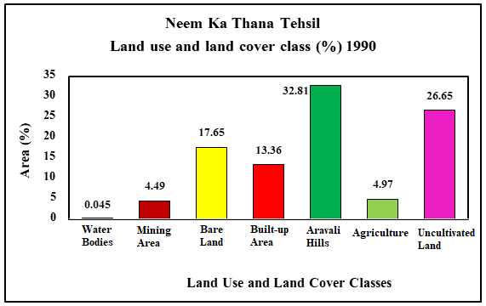

**Figure 4: Land Use Land Cover Classes (1990)**

**Source: Developed by Researcher with the help of Arc-GIS.**

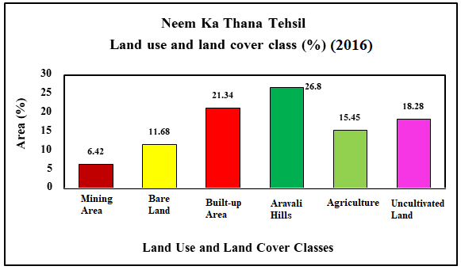

**Figure 5: Land Use Land Cover Classes (2016)**

**Source: Developed by Researcher with the help of Arc-GIS.**

**Table 5: Land Use and Land Cover Change from (1990 - 2016)**

|  |  |  |
| --- | --- | --- |
| **Land Use Land Cover Class** | **Change in Area (Sq. Kilometres)** | **(1990-2016) % Change** |
| **Mining Area** | **+23.21** | **+1.93** |
| **Bare Land** | **-71.81** | **-5.97** |
| **Built-up Area** | **+95.99** | **+7.98** |
| **Aravali Hills** | **-72.30** | **-6.01** |
| **Agriculture** | **+126.07** | **+10.48** |
| **Uncultivated Land** | **-100.69** | **-8.37** |

**Source: Created by Researcher with the help of Arc-GIS.**

**Source: Created by Researcher with the help of Arc-GIS.**

**Figure 6: Land Use and Land Cover Change from (1990 - 2016)**

**Findings**

The main results of this study revealed that there has been a significant increase in the percentage of mining, built-up areas and agriculture area. While the area of ​​bare land, Aravalli hills and uncultivated land has decreased. Land use and land cover dynamics in Neem Ka Thana Tehsil has been achieved in three steps: 1. Data acquisition and processing, 2. Layer stacking and sub-set creation, 3. Image classification for land use land cover. Here the land use land cover is divided into categories namely built-up area, mining area, water bodies, agriculture, Aravalli hills and bare land. The land use and land cover map (1990) of Neem Ka Thana Tehsil shows that the least area (0.045 %) comes from water bodies while the maximum area (32.81 %) comes from Aravalli hills. In the year 2016, after 27 years, the water bodies were registered absent from this tehsil. Built-up area, mining area and agricultural area have increased while Aravalli hills, bare land and uncultivated land area have decreased.

Thereafter the accuracy of the land use classification has been assessed. The overall accuracy of this estimation is 94.95. Till the year (1990–2016), the area under different land use and land cover in Neem ka thana tehsil is highest recorded near Aravalli hills (26.80 %), while lowest was found near water bodies. The most positive change in land conversion over the years (1990 – 2016) has been recorded in agriculture (+10.48%).

**Conclusion**

Remote Sensing and GIS have emerged as an essential and important tool for collecting information on various aspects of Earth such as land surface temperature, land use, land cover changes, atmospheric conditions and processes, global heat balance, etc. The present study has been carried out for an industrial area named Neem Ka Thana Tehsil in Sikar district of Eastern Rajasthan. Two time period data i.e., 1990 and 2016 have been used to understand and examine the land use and land cover. Land use. The study of land cover is used in various research as a way to measure causes, consequences, and their ecological effects. The findings of this study can help enhance natural resource management to meet the demands of present and future generations in a sustainable manner.

Also, policy and environment are two important factors influencing urban development. The combination of classification images of Landsat TM and ETM+ data is an effective way to dynamically research land use change. Industrialization and urbanization and thus the ever-increasing built-up environment are primarily responsible for changes in land use and land cover. While these processes are inevitable, there is a need to incorporate policies to deal with transforming land use land cover changes. Hence, this research paper will assist the planners in formulating sustainable land use policies for the study area.

**References**

Alawamy et al. 2020. “Detecting and analyzing land use and land cover changes in the region of Al-Jabal Al-Akhdar, Libya using time-series Landsat data from 1985 to 2017,” Sustainability, 12, 11, 4490.

Anderson, J.R. (1976). A land use and land cover classification system for use with remote sensor data. US Government Printing Office, Washington, D.C. *Geological Survey Professional Paper,* (964), 1-2.

Fall, S., Niyogi, D., Gluhovsky, A., Pielke, R. A., Kalnay,E., Rochon, G. (2010). Impacts of land use land cover on temperature trends over the continental United States: Assessment using the North American Regional Reanalysis. *International Journal of Climatology,* 30, 1980–1993.

Hasanlou and Mostofi, 2015. **Investigating urban heat island estimation and relation between various land cover indices in Tehran city using Landsat 8 imagery**. Proceedings of the 1st International Electronic Conference on Remote Sensing, Basel, Switzerland. 1-11

Ibrahim (2017). Urban land use land cover changes and their effect on land surface temperature: Case study using Dohuk city in the Kurdistan Region of Iraq. *Climate,* 5(13), 2-3.

Ji, W., Ma ,J., Twibell, R. W., Underhill, K. (2006). Characterizing urban sprawl using multi-stage remote sensing images and landscape metrics. Computer Environ Urban System, 30(6), 861–879.

# Kafy et al. 2021. Modeling the relationship between land use/land cover and land surface temperature in Dhaka, Bangladesh using CA-ANN algorithm. Environmental Challenges, 4, 1-22.

Khorram, S. (1999). Accuracy assessment of remote sensing derived change detection. *American Society for Photogrammetry and Remote Sensing,* Bethesda.

Khandelwal, S., Goyal, R., Kaul, N., Mathew, A. (2017). Assessment of land surface temperature variation due to change in elevation of area surrounding Jaipur, India. *The Egyptian Journal of Remote Sensing and Space Sciences,* 21(1), 87 – 94.

Lillesand, T., Kiefer, R, W., Chipman, J. (2015). Remote sensing and image interpretation, Wiley Luck, M., Wu, J. (2002). A gradient analysis of urban landscape pattern: a case study from the Phoenix metropolitan region, Arizona, U.S.A. *Landscape Ecology,* 17, 327 – 330.

Lu,D., Mausel,P., Brondizio,E., Moran,E.(2004). Change detection techniques. *International Journal of Remote Sensing,* 25(12), 2365–2401.

Turner, B. L., Meyer, W., Skole, D. (1994). Global land use / land cover change: Towards an integrated study. *Ambio*, 23(1), 91-95.