**OCEAN WASTE COLLECTION TECHNOLOGY: A SYSTEMATIC REVIEW**

**Ms Geetanjali Rokade1, Mrs. Laxmi Kale2, Mrs. Sphurti Deshmukh3**

1Assistant Professor, IT, PCCOE, Nigdi, Pune, Maharashtra, India

2Assistant Professor, IT, PCCOE, Nigdi, Pune, Maharashtra, India

3Assistant Professor, IT, PCCOE, Nigdi, Pune, Maharashtra, India

**ABSTRACT**

With the increase in population and rising consumption the need for implementation of proper waste collection facilities rises. This need can especially be seen in the water bodies where disposal of waste is at high levels and poses a threat to the environment and the living organisms in water. The motive of this paper is to study the various currently employed technologies related to ocean surface waste collection and propose a new methodology for the sunken waste. Following steps were taken to write this paper: 1) Analyzed the current situation, 2) Identified the main approaches and technologies related to the cleaning and collection in various water bodies, 3) Listed the various electronic equipment, 4) Identified the research gaps. Based on all the research that we went through now we are proposing a new methodology which is filling the voids in the existing technologies.

**Keywords:** Waste Collection, Ocean surface waste, sunken waste.

1. **INTRODUCTION**

According to one estimate, the Indian population is 140.76 crores as of 2021 and the world population is 788.84 crores as of 2021.With the gradual growth of population there is constant generation of waste. All this waste is not properly disposed of and this creates harm to the environment especially water bodies. Water resources are one of the most exploited resources. We have been dumping waste in water bodies for several years and now this issue has been elevated because it is creating serious changes in the ecosystem. There are 5.25 trillion pieces of plastic waste estimated to be in our oceans.

269,000 tons float, 4 billion microfibers per km² lodge below the surface. 70% of our debris sinks into the ocean's ecosystem, 15% floats, and 15% lands on our beaches. 8.3 million tons of plastic are discarded in the sea yearly. This consists of 236,000 micro plastics which marine animals mistake for food. Globally, 500 marine locations are identified as dead zones. 80% of the marine pollution in the ocean between continents is caused by agricultural waste, untreated sewage, and pesticides. About 100 million marine animals every year die from plastic garbage alone. 100,000 marine animals perish each year after becoming entangled in plastic – and these are merely a few we find! One in three marine vertebrate species are discovered to be trapped in litter, and North Pacific fish consume 12–14,000 tones of plastic yearly. Animals in the gyres are unsafe due to our marine pollution and trash. Blockhead sea turtles chase what, unfortunately, appears to be plastic bags as jellyfish. Most marine life can't separate their food from plastic trash. These creatures starve to death, stopping up their stomachs with plastic so they can't eat genuine food. Marine plastic contamination is viewed as in 100 percent of turtles, 59% of whales, and 36% of seals in late examinations.

The air isn't protected either, over 90% of all seabirds are found to have plastic pieces in their stomachs. Warm blooded creatures like seals suffocate in the 705,000 tons of disposed of fishing nets - this alarming peculiarity has been named 'phantom fishing'. 500 marine areas are presently recorded as no man's lands all around the world, as of now the size of the Unified Realm's surface (245,000 km2). Our coral reefs house some 25% of all marine life known to man. At the point when it interacts with marine plastic, the likelihood of it passing on goes from 4%-89%.The greater part of fish we consume could have ingested plastic and microfibers.

The UN has recognized this issue under SDG 14 which expresses that: The Maintainable Improvement Objectives (SDGs), otherwise called the Worldwide Objectives, were embraced by the Unified Countries in 2015 as a general source of inspiration to end destitution, safeguard the planet, and guarantee that by 2030 all individuals appreciate harmony and success. The 17 SDGs are coordinated, they perceive that activity in one region will influence results in others, and that improvement should adjust social, monetary and ecological maintainability. Nations have resolved to focus on progress for those who are farthest behind. The SDGs are intended to end neediness, craving, help, and oppression of ladies and young ladies. The imagination, skill, innovation and monetary assets from society are all important to accomplish the SDGs in each specific situation. To accomplish SDG14, and the more extensive Manageable Advancement Objectives (SDGs) perceiving cultural cycles close to that of commitments from science and technology is similarly significant.

The Assembled Countries System Show on Environmental Change (UNFCCC) and the 2018 Talanoa Discourse Stage is an illustration of the more prominent acknowledgment of the job of mankind in achieving change. Talanoa, a customary Fijian word signifying "to talk or talk'' is utilized in the Pacific and has been embraced all the more broadly to portray a course of comprehensive, participatory and straightforward exchange, the reason for which is to share stories, construct compassion and to use sound judgment for a long term benefit. This way of thinking ought to be taken on while considering future partner commitment exercises in sea perception to expand the commitment to supportable advancement to assist humankind.

This paper investigates the significance of partner commitment in sea perception as shown by various contextual analyses. It starts by presenting partner commitment inside existing coordination structures, for example, the US's Interagency Sea Noticing Framework (IOOS®), and the European Sea Noticing Framework (EOOS) and the grassroots methodologies utilized; where IOOS was principally settled as a local area driven drive and EOOS looks to expand on a similar vote based model. The paper then features different drives, for example, public-private organizations, which are normally settled to satisfy a business or cultural need, and presents the job of the "third'' or willful area. This area ordinarily contains Non-Legislative Associations (NGOs) with an expansive dispatch to create and share information and advance local area interest for public advantage. The paper will investigate the worth partner commitment can bring as well as taking note of existing weaknesses, for example, the absence of geological reach in the cases introduced which are based on the information and experience of those contributing. At last, the paper will make suggestions for what's to come.

LIFE UNDERNEATH WATER

The world's seas drive worldwide frameworks that make the Earth livable for humanity. How we deal with this indispensable asset is fundamental for humankind in general, and to offset the impacts of environmental change. North of three billion individuals rely upon marine and waterfront biodiversity for their livelihoods. Nonetheless, today we are seeing 30% of the world's fish stocks overexploited, arriving at underneath the level at which they can deliver economical yields. Seas likewise retain around 30% of the carbon dioxide created by people, and we are seeing a 26 percent increase in sea fermentation starting from the start of the modern transformation. Marine contamination, a staggering larger part of which comes from land-based sources, is arriving at disturbing levels, with a normal of 13,000 bits of plastic litter to be tracked down on each square kilometer of sea. The SDGs mean to oversee and shield marine and seaside environments from contamination, as well as address the effects of sea fermentation reasonably. Upgrading preservation and the economical utilization of sea based assets through global regulation will likewise assist with relieving a portion of the difficulties confronting our seas.

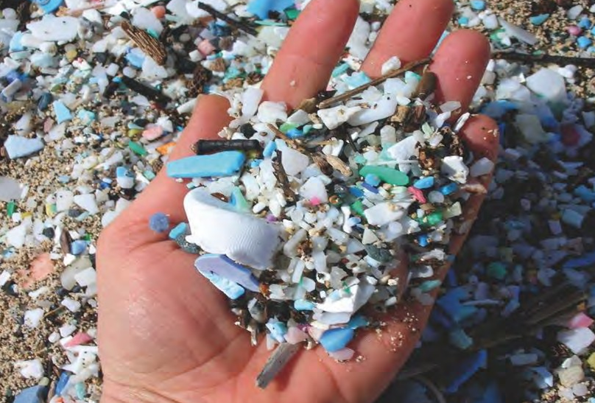

**Figure1:** More Ocean waste than fish

1. **ANALYSIS AND LEATERATURE RIVEW**

Related Ocean waste study is presented in this section.

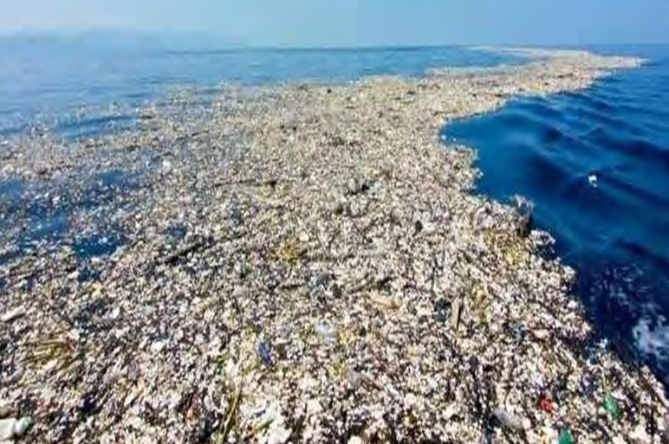

**Figure2:** Ocean Waste

**2.1 SYSTEM 002 / "JENNY":**

The ocean cleanup system 002, named as Jenny, is the first machine employed for large-scale cleanup. It works by pulling an 800-meter long synthetic coastline through the surface of the ocean where plastic has been hoarded. The machine is pulled by 2 vessels which are attached on the ends. The tension makes a U shaped barrier. This barrier collects all the floating pieces into a confinement zone. The speed of the vessels is 0.75 m/s. The coastline spreads up to 1800 meters. The System 002 test campaign in the Great Pacific Garbage Patch was carried out over 12 weeks from July 2021 to October 2021. The tests were successful and proof of technology was confirmed. The System 002 will continue cleaning the Great Pacific Garbage Patch.

**2.2 FRED:**

Clear Blue Sea is a nonprofit organization founded by Susan Baer and Jessica Gottdank. They came up with the technology of FRED for cleaning the surface water garbage. It is a solar powered Floating Robot for eliminating debris. FRED is ascendable for bays, rivers and oceans. Materials used by FRED are: Pontoon Hulls, Conveyer Belt, Remote control, auto-navigation, Solar panels, battery system, embedded sensors, data communication. The two FRED prototypes are: 6 foot FRED prototype and 16 foot FRED junior prototype. Student teams at University of San Diego built FRED prototype. Testing of FRED prototype was conducted in Mission Bay[5].

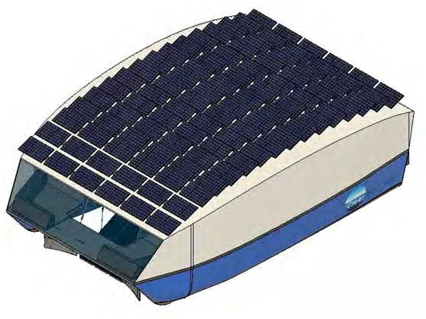

**Figure3:** Floating Bot for under water Ocean Waste Management

**2.3 FUTURE BOTS FOR UNDERWATER OCEAN CLEANING:**

In September 2021, around the coast of Dubrovnik, Croatia, two robots were being tested to measure their ability to recognize garbage and steer underwater. Dr De Schutter and his team are building a team of litter collecting robots for the Sea Clear project, which is made up of four different robots that will work collectively and jointly. A robotic container, which stays on the ocean surface, will act as a hub by providing electrical power to the other robots and will accommodate a computer that is the main brain of the system. There are three other bots, two which function underwater and an aerial drone, which will be fastened to the vessel. The system will be able to differentiate between debris and other items on the seafloor, such as animals and seaweed, by using artificial intelligence. An algorithm will be instructed with a number of images of various items it might come in contact with, from plastic bottles to fish, so that it learns to distinguish between them and pick out trash [6].

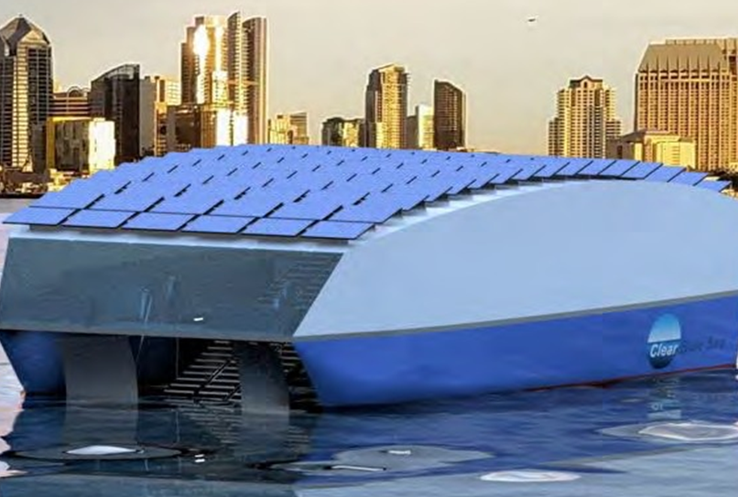

**Figure4:** Floating Bot for under water Ocean Waste Management

1. **METHODOLOGY**

By analyzing all the research papers and going through various websites about the existing technologies we can conclude that there exist many competent machines which are related to ocean surface cleanup. But there are very few effective machines for cleaning up the sunken waste in the ocean. The bots which are under process for the underwater cleanup are very complex and require a large amount of power supply.

We propose a system which is

1.Compact-A compact innovation in this field will not disturb the aquatic ecosystem.

2.Use of Renewable energy sources-Solar and electric power sources can be used so as to create a sustainable impact.

3.Powerful algorithm-A strong algorithm can be designed to distinguish between living creatures in the ocean from the waste .

4.Use of Convolution Neural Networks( CNN )-It can be employed to check whether the area is 100 percent cleaned or not.

1. **CONCLUSION**

A total and reasonable sun based controlled answer for protecting water bodies is offered, which comprises of a water-surface cleaning robot alongside coastal reconnaissance. Utilization of open-source tech stacks guarantees that the code base is front line and minimal expense. The proposed arrangement is both proactive and responsive. The calculation for recognizing trash should be prepared thoroughly for further developed speed and exactness in recognition of trash in dynamic scenes caught in picture outlines. Size of the robot should be upward scaled for genuine water bodies and a more noteworthy cap for trash assortment. An armada of robots might be expected to be used relying on the region of the water body to be covered and the normal result that a solitary robot displays upon on location testing. Power arrangement of the bot should be tried after arrangement and adjustments can be made to expand proficiency. At long last, the enhanced arrangement can be straightforwardly placed into utilization for saving water bodies

1. **REFERENCES**
2. Shreya Phirke, Abhay Patel, Jash Jani, “Design of an autonomous water cleaning bot” <https://doi.org/10.1016/j.matpr.2021.04.044>, 2214-7853/ 2021 Elsevier Ltd. Received 10 February 2021 Received in revised form 1 April 2021, Accepted 5 April 2021
3. “IoT-Enabled Smart Waste Management Systems for Smart Cities: A Systematic Review”, INNA SOSUNOVA 1 AND JARI PORRAS 1,2, (Member, IEEE)IEEE Access- Digital Object Identifier 10.1109/ACCESS.2022.3188308
4. [HTTPS://WWW.CONDORFERRIES.CO.UK/](https://www.condorferries.co.uk/)
5. [HTTPS://WWW.UNDP.ORG](https://www.undp.org/)/
6. [HTTPS://WWW.GLOBALGOALS.ORG/](https://www.globalgoals.org/)
7. [HTTPS://WWW.DESIGNBOOM.COM/](https://www.designboom.com/)
8. [HTTPS://WWW.CLEARBLUESEA.ORG/MEET-FRED/](https://www.clearbluesea.org/meet-fred/)
9. HTTPS://EC.EUROPA.EU/
10. J. W. Levis, M. A. Barlaz, J. F. DeCarolis, and S. R. Ranjithan, ‘‘A generalized multistage optimization modeling framework for life cycle assessment-based integrated solid waste management,’’ Environ. Model. Softw., vol. 50, pp. 51–65, Dec. 2013, doi: 10.1016/j.envsoft.2013.08.007.
11. S. E. Vergara and G. Tchobanoglous, ‘‘Municipal solid waste and the environment: A global perspective,’’ Annu. Rev. Environ. Resour., vol. 37, no. 1, pp. 277–309, Nov. 2012, doi: 10.1146/annurev-environ-050511- 122532.
12. T. Anagnostopoulos, A. Zaslavsky, K. Kolomvatsos, A. Medvedev, P. Amirian, J. Morley, and S. Hadjieftymiades, ‘‘Challenges and opportunities of waste management in IoT-enabled smart cities: A survey,’’ IEEE Trans. Sustain. Comput., vol. 2, no. 3, pp. 275–289, Jul. 2017.
13. T. Anagnostopoulos, A. Zaslavsky, I. Sosunova, P. Fedchenkov, A. Medvedev, K. Ntalianis, C. Skourlas, A. Rybin, and S. Khoruznikov, ‘‘A stochastic multi-agent system for Internet of Things-enabled waste management in smart cities,’’ Waste Manage. Res., J. Sustain. Circular Economy, vol. 36, no. 11, pp. 1113–1121, Nov. 2018, doi: 10.1177/0734242X18783843.
14. V. R. S. Cheela and B. Dubey, ‘‘Review of application of systems engineering approaches in development of integrated solid waste management for a smart city,’’ in Water Resources and Environmental Engineering II. Singapore: Springer, 2019, doi: 10.1007/978-981-13-2038-5_16.
15. A. V. de Souza Melaré, S. M. González, K. Faceli, and V. Casadei, ‘‘Technologies and decision support systems to aid solid-waste management: A systematic review,’’ Waste Manage., vol. 59, pp. 567–584, Jan. 2017, doi: 10.1016/j.wasman.2016.10.045.
16. N. P. Adriyanti, A. Gamal, and O. C. Dewi, ‘‘Solid waste management models: Literature review,’’ in Proc. 2nd Int. Conf. Smart Grid Smart Cities (ICSGSC), Aug. 2018, pp. 37–40, doi: 10.1109/ICSGSC.2018.8541350.
17. G. Soni and S. Kandasamy, ‘‘Smart garbage bin systems—A comprehensive survey,’’ in Proc. Int. Conf. Intell. Inf. Technol., 2018, pp. 194–206, doi: 10.1007/978-981-10-7635-0_15.
18. B. Esmaeilian, B. Wang, K. Lewis, F. Duarte, C. Ratti, and S. Behdad, ‘‘The future of waste management in smart and sustainable cities: A review and concept paper,’’ Waste Manage., vol. 81, pp. 177–195, Nov. 2018, doi: 10.1016/j.wasman.2018.09.047.
19. K. Dhyani and N. Patel, ‘‘Smart trash monitoring and segregation system using emerging technology—A survey,’’ in Proc. Int. Conf. Adv. Inform. Comput. Res., 2019, pp. 667–674, doi: 10.1007/978-981-13-3140-4_60.
20. M. Topaloglu, F. Yarkin, and T. Kaya, ‘‘Solid waste collection system selection for smart cities based on a type-2 fuzzy multi-criteria decision technique,’’ Soft Comput., vol. 22, no. 15, pp. 4879–4890, Aug. 2018, doi: 10.1007/S00500-018-3232-8.
21. M. S. Chaudhari, B. Patil, and V. Raut, ‘‘IoT based waste collection management system for smart cities: An overview,’’ in Proc. 3rd Int. Conf. Comput. Methodologies Commun. (ICCMC), Mar. 2019, pp. 802–805, doi: 10.1109/ICCMC.2019.8819776.
22. S. Kitchenham and B. Charters, ‘‘Guidelines for performing systematic literature reviews in software engineering,’’ Softw. Eng. Group School Comput. Sci., Math. Keele Univ. Keele, Staffs, U.K., Dept. Comput. Sci., Univ. Durham, Durham, U.K., EBSE Tech. Rep. EBSE-2007-01, 2007.
23. F. Shull, J. Singer, and D. I. K. Sjøberg, Eds., Guide to Advance Empirical Software Engineering. London, U.K.: Springer, 2008, doi: 10.1007/978-1-84800-044-5_11.
24. J. Zeng, J. Zhang, and Y. Liu, ‘‘Blockchain based smart park: Cleaning management,’’ in Proc. 2nd Int. Conf. Blockchain Technol. Appl., Dec. 2019, pp. 53–58, doi: 10.1145/3376044.3376046.
25. S. Li, K. Sun, M. Qi, and J. Liu, ‘‘Design of beverage packaging identification and recycling system based on zedboard,’’ in Proc. 7th Int. Conf. Inf. Technol., IoT Smart City, Dec. 2019, pp. 175–180, doi: 10.1145/3377170.3377219.
26. S. Faye, F. Melakessou, W. Mtalaa, P. Gautier, N. AlNaffakh, and D. Khadraoui, ‘‘SWAM: A novel smart waste management approach for businesses using IoT,’’ in Proc. 1st ACM Int. Workshop Technol. Enablers Innov. Appl. Smart Cities Communities, Nov. 2019, pp. 38–45, doi: 10.1145/3364544.3364824.
27. S. K. T. Utomo, T. Hamada, and N. Koshizuka, ‘‘Low-energy smart trash bin architecture for dynamic waste collection system,’’ in Proc. 2nd Int. Conf. Future Netw. Distrib. Syst., Jun. 2018, pp. 1–7, doi:10.1145/3231053.3231077.