**PhotoChain: A Blockchain based Secure Photo Sharing Framework for Cross-Social Network**

1 Mrs. Veeradanya K S, 2Ajith Kumar S, 3Anil Kumar R, 4Kalyan Kumar K

1Assistant Professor, Department of Computer Science Engineering, Adhiyamaan College of Engineering(Autonomous),Hosur, India

2,3,4 Student, Department of Computer Science Engineering., Adhiyamaan College of Engineering(Autonomous),Hosur, India

**ABSTRACT:** The popularity of online social networks has led to increased sharing of photos, but the privacy of these photos can be compromised when they are spread to other platforms. Existing solutions do not always provide efficient social network services while ensuring privacy. PhotoChain is a proposed blockchain based framework that allows for secure photo sharing across social networks with dissemination control, face masking, photo integrity verification , access control and dynamic privacy policy generation. Smart contracts ensure consistent consensus on dissemination control and the framework includes robust photo ownership identification mechanisms to prevent illegal reprinting. A prototype has been implemented and tested to demonstrate the security, efficacy, efficiency of the framework.

**I. INTRODUCTION**

The vast usage of social networking sites has led users to inadvertently disclose personal information making it crucial for users to take precautions to protect their privacy. Social-networking users may or may not have the idea of getting their personal information leaked or could protect the malicious attackers and may perpetrate significant privacy breaches. The rest of the 21st century has seen the extreme popularization of the Internet and the growth of web services which facilitate participatory information sharing and collaboration. Social Networking Sites (SNSs) have become a boundless communication medium to keep in touch beyond boundaries. SNSs are a part of human culture rather than just a web application. Use of SNSs has outpaced almost every field such as news agencies, big and small companies, governments, and famous personalities etc. to interact with each other. With the adoration of sharing, Facebook has stood out as the most renown SNSs in the world where people hangout for hours. With the extravagance of technology and services, sharing of news, photos, personal taste and information with friends and family has led to an ease. But along with this user privacy should also be taken into consideration. An issue related to privacy with facebook users has been constantly appearing in the international press either because of the company's privacy policy or because of users unaware-ness of content sharing consequences. As research says the simple disclosure of date and place of birth of a pro le in Facebook can be used to predict the Social Security Number (SSN) of a citizen in the U.S. Many times just by simply publishing their friend’s list, users might be revealing a large amount of information.

**II. LITERATURE SURVEY**

The following are the discussions made by reviewing the literature that helps in developing the proposed system efficiently and effectively.

Influencing Photo Sharing Decisions on Social Media: A Case of Paradoxical Findings [1]. This paper describes a new approach to privacy in social networks. The authors propose a model for organizing social network connections into "circles," which can be used to manage privacy settings and control the sharing of personal information. This approach provides users with greater control over their personal data, improving privacy and security in social networks.

My Privacy My decision: Control of Photo Sharing on Online Social Networks [2]. This paper describes a new approach to privacy in social networks that allows users to manage privacy settings in a collaborative and decentralized way. The authors propose a model for creating "privacy suites" that are shared among a group of friends, allowing them to collectively manage their privacy settings and control the sharing of personal information. This approach provides users with greater control over their personal data and improves privacy and security in social networks.

Privacy-Protected Photo Sharing in Social Media Platform [3]. This paper describes a new approach to access control for online photo albums. The authors propose a model that uses tags and linked data to define access control policies for photo albums. This approach allows users to manage access to their photos based on the content of the photos and their relationships to other data, improving privacy and security in online photo sharing.

Security Concerns during Photo Sharing in Social Network Platforms [4]. This paper describes the issue of photo privacy in a world where individuals are often tagged in photos without their consent. The authors argue that simply untagging oneself from photos is not a sufficient solution and suggest alternative approaches to address the issue. The paper proposes a set of design guidelines for social media platforms to enhance user control over photo privacy and promote responsible tagging practices. Overall, the paper highlights the importance of considering user privacy in the design of social media platforms.

**III. PROPOSED SYSTEM**

PhotoChain, a blockchain-based secure photo sharing framework that provides powerful dissemination control for cross-social network photo sharing,

Combined with blockchain, Gaussian Blur for Face Masking, PreHash Algorithm for Photo integrity verification and Access Control, Mechanism can achieve secure data sharing, data retrieving, and data accessing with fairness and without worrying about potential damage to user’s interest.

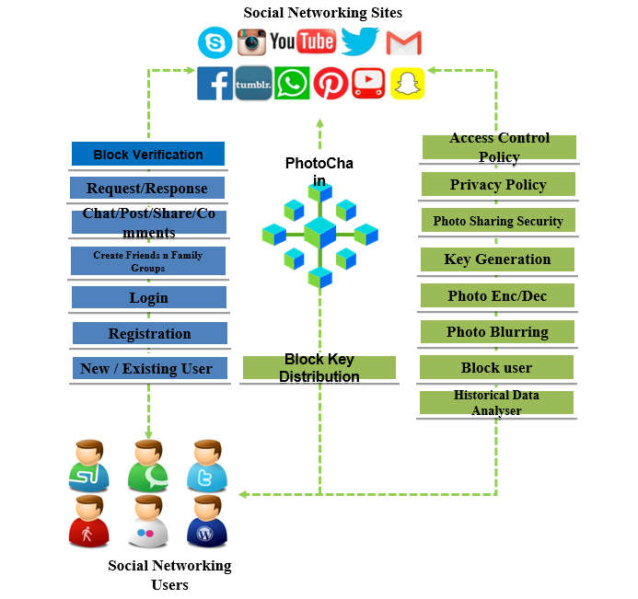

***Fig.1 : System Architecture***

The architecture consists of several components,including blockchain network, the client application, Gaussian Blur algorithm and PreHash algorithm. Let’s look each of these components in more details:

BlockChain Network: The blockchain network is the underlying technology that powers the photochain platform. It is a decentralized network of computers that work together to maintain a secure and transparent ledger of all the transactions on the platform. The blockchain network used by PhotoChain is based on Ethereum, a popular blockchain platform that supports the development of smart contracts.

Client Application: The client application is the user-facing part of the PhotoChain platform.It is a mobile or web-based application that enables users to upload,view and share their photos securely. The client application is designed to be user-friendly with an intuitive interface that allows users to easily navigate and use the platform.

Gaussian Blur Algorithm: It is a common image processing technique that applies a Gaussian filter to an image, smoothing out the details and reducing the noise, resulting in a blurred image. It works by convolving the image with a Gaussian function to create a blurred version of the original image.

PreHash algorithm:It is a method for verifying photo integrity and enabling access control. It involves generating a hash code from the photo’s metadata and comparing it to a precomputed hash code to determine if the photo has been tampered with or if the user has the appropriate access privileges.

**IV. WORKING**

The PhotoChain architecture includes a blockchain network for maintaining a secure and transparent ledger of transactions, a user-friendly client application for uploading,viewing and sharing photos Gaussian Blur algorithm for face masking and PreHash algorithm for photo integrity verification and access control.The blockchain network used in Ethereum,which supports smart contracts for consistent consensus on dissemination control. The client application provides a secure and intuitive interface for users. The Gaussian Blur algorithm is used to protect the privacy of users by blurring faces in photos. The PreHash algorithm ensures photo integrity and access control by generating and comparing hash codes. The architecture provides a high level of security and privacy, making transactions on the platform immutable and tamper-proof. This ensures that photos shared on the platform are protected from unauthorized tampering or deletion.

**V. CONCLUSION**

Wide spread of smart mobile devices with high-resolution cameras and user-friendly social networks applications make photo sharing an easy and therefore popular activity.However, most photo sharing services lack a sound solution for protecting users’ privacy.In this project, we designed, implemented and evaluated an extended control framework for blockchain enabled privacy-preserving photo sharing across different social networks, called PhotoChaon. It helps social networking users to preserve their privacy requirements assigned on their uploaded photos, by controlling the operations of the following users on a dissemination chain.Meanwhile, it binds the access control policies to photos without disturbing the display phase. As a result, PhotChain could help social networking users to hide privacy areas away from unwanted viewers even in different social networks.Photochainnot only protects the shared photos so that no unauthorized users can access them, but also enables users to blur their image search so that the search can also be shared to across social networking site obviously without leakage on the query contents or results.Moreover, PhotoChain not only protects users’ privacy but also reduces the system overhead. Evaluation results demonstrated its effectiveness. The concept of PhotoChain which provides confidentiality, Integrity and privacy.Not only does the proposed scheme not interrupt information sharing among legitimate users, but also it prevents unauthorized users from obtaining the private information.

**VI. REFERENCES**

[1] A. Kapadia, F. Adu-Oppong, C. K. Gardiner, and P. P. Tsang, ”Social circles: Tackling privacy in social networks”, in Proc. Sympsable Privacy Security, 2008.

[2] J. Bonneau, J. Anderson, and L. Church, ”Privacy suites: Shared privacy for social networks”, in Proc. Symp. Usable Privacy Security, 2009.

[3] C. A. Yeung, L. Kagal, N. Gibbins, and N. Shadbolt, ”Providing access control to online photo albums based on tags and linked data”, pp. 9-14, 2009.

[4] A. Besmer and H. Richter Lipford. Moving beyond untagging: photo privacy in a tagged world. In Proceedings of the SIGCHI Conference on Human Factors in Computing Systems, pp. 1563-1572, 2010.

[5] Barbara Carminati, Elena Ferrari, Raymond Heatherly, Mu-rat Kantarcioglu, Bhavani Thuraisingham, ”Semantic web-based social network access control”, pp. 108-115, 2011.

[6] CareerBuilder. Number of Employers Using Social Media to Screen Candidates has Increased 500 Percent Over the Last Decade. Accessed: Jun. 8, 2019. [Online].Available:https://www.careerbuilder.com/share/aboutus/pressreleasesdetail.aspx?sd=4%2f28%2f2016&id=pr945&ed= 12%2f31%2f2016

[7] J. Bort. A High School Coach was Fired for this Facebook Photo. Accessed: Jun. 8, 2019. [Online]. Available:<https://www.chron.com/technology/businessinsider/article/A-HighSchool-Coach-Was-Fired-For-This-Facebook-4975389.php>

8] J. Dent. Revenge Porn: Image-Based Abuse Hits ‘One in Five’ Australians. Accessed: Jun. 8, 2019. [Online].Available:<https://www.bbc.com/news/world-australia-39777192>

[9] G. Kaszubska. Not Just ‘Revenge Porn’—Image-Based Abuse Hits 1 in 5 Australians. Accessed: Jun. 8, 2019. [Online]. Available: https://www.rmit.edu.au/news/all-news/2017/may/not-just-_revengeporn–image-based-abuse-hits-1-in-5-australian

[10] A. C. Squicciarini, S. Sundareswaran, D. Lin, and J. Wede, ‘‘A3P: Adaptive policy prediction for shared images over popular content sharing sites,’’ in Proc. 22Nd ACM Conf. Hypertext Hypermedia, New York, NY, USA, 2011, pp. 261–270