The Impact of Business intelligence on the Effectiveness of Decision Making

**Vrajesh Modh, Jyoti Jain, Soudip Bhaduri**

Student, Masters of Business Administration, Parul Institute Of Management And

Research, Vadodara, Gujarat, India.

Assistant Professor, Masters Of Business Administration, Parul Institute Of Management

And Research, Vadodara, Gujarat, India.

**ABSTRACT**

**This study investigates the idea of business intelligence (BI) and its influence on the quality of decision making inside businesses. The use of data analysis techniques and tools to acquire, combine, and analyse vast volumes of data to assist decision making is referred to as business intelligence (BI). The report presents an overview of BI and its different components, such as data warehousing, data mining, and online analytical processing. The study investigates the link between BI and decision-making quality, emphasising how BI may assist businesses in making better informed, data-driven decisions. The research also cites various problems that firms may encounter while implementing BI, such as data quality concerns and reluctance to change. BI technologies provide a synergistic potential for quality decision making and organisational success. In IT firms, BI technologies provide a synergistic potential for quality decision making and organisational growth. BI solutions may help firms make informed, data-driven choices and enhance their performance by giving useful insights into company processes.**

**Keywords:** Business Intelligence, data mining, Data warehousing

1. **INTRODUCTION**

**In the cutthroat business world of today, firms are always looking for ways to enhance their decision-making procedures. Business Intelligence is one strategy that has received a lot of attention recently (BI). In today's data-driven world, BI has become a vital tool for businesses wanting to acquire a competitive edge. Business intelligence (BI) can assist organisations in making more educated, data-driven choices by offering rapid, accurate, and actionable insights into business operations. The purpose of this paper is to examine the idea of BI and how it affects how well decisions are made within businesses. The study will focus on how BI may assist firms in making better decisions by examining the connection between BI and decision-making quality.**

1. **METHODOLOGY**

**Both primary and secondary data types in this work have been utilized. Primary research has data Sample size of 60. Tools of data collection were questionnaires only. Primary data collected from the Indian finance & accounting (F&A) KPO firm. Which offer full-suite accounting services to their customers right from transactional activities like accounts payable to financial reporting with dashboards. Secondary data have been collected through books, journals, Business documents, Government publications, Literature reviews, Case studies whereas primary data have been collected from organisation of private employee. The data used for case study was cleaned and specific it to the small target to analyze.**

1. **MODELING AND ANALYSIS**

**Primary research analysis:**

Result based on google questionnaire survey form.

**Secondary research analysis through case study:**

**Problem Statement:**

Make a visual dashboard that help manager to take decisions of day to day operations.

The purpose of this case study is to understand the nature of business problem that company is facing on day to day basis. Adventure works cycles large multinational manufacturing company produces & distribute metal & composite bicycle American & Asian commercial market.

**Solution:**

A dashboard is a visual representation of all of your data. While it may be used in a variety of ways, its primary purpose is to deliver information at a glance, such as KPIs. A dashboard is often located on its own page and gets data from a connected database.

Make a visual dashboard is a vital tool for analysts and data scientists, but can also be used by middle managers —especially department managers— who need to make decisions and examine the performance of their business area.

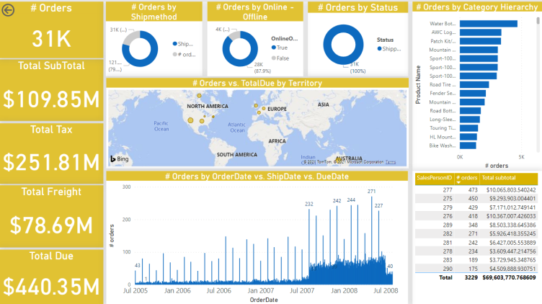

The above dashboard shows some important analytic numbers of thecompany

1. Number of orders
2. Total SubTotal
3. Total Tax
4. Total Freight
5. Total Due
6. **RESULTS AND DISCUSSION**

In the evolution of hardware and software, new software methods to organizing and presenting data are progressively developed. These new software solutions are required for increasing the efficacy of BI, owing to new ways of viewing data, graphical reports, simplicity of use, and so on. As an illustration of OLAP-based software solutions for business intelligence platforms, consider the application is distinguished by a specific rate of generating pictorial results from multiple data sources. Data can be entered into the application straight from the Microsoft Excel software or from relational systems. Based on OLAP, various user apps, simple and graphical reports, can be created.

1. **CONCLUSION**

BI system is a technical globalisation in the market that allows a business to deal with a new intelligence revolution. If the BI System achieves its goals, decision-making processes will be more effective, direct, and time-efficient, risks will be reduced, and there will be no room for ambiguity in the workplace, and competition will be more global, posing a significant challenge to the business as a whole. As a result, business intelligence satisfies and promotes good decision-making in all circumstances.

1. **REFERENCES**

[1] https://flylib.com/books/en/4.65.1.23/1/

[2] https://www.onemodel.co/blog/people-analytics-dashboard-examples

[3] https://www.youtube.com/watch?v=c4fqFTuU3p4

[4] Baars, H, Kemper, HG. Management Support with Structured and Unstructured Data - an Integrated Business Intelligence Framework.

*Information Systems Management* 2008; 25:2. 132-148.

[5] https://sourceessay.com/the-impact-of-business-intelligence-on-the-quality-of-decision-making/

[6] https://online.uncp.edu/articles/mba/business-intelligence-drives-decision-making.aspx

[7] https://www.analyticsinsight.net/business-intelligence-and-its-impact-on-the-quality-of-decision-making/