Reforms in Educational sector in India- A Comparative approach with other countries for strategic formulation

**Dr. Jabir Moosa K. P, Associate Professor, MES Engineering college- Kuttipuram, MBA Department**

**Dr. Suraj.E.S, Associate Professor, Naipunnya Business School, Thrissur, Kerala**

**&**

**Mr. Deepak K, Assistant Professor, MES Engineering college- Kuttipuram, MBA Department**

**Abstract**

The purpose of the research is to determine the impact and opportunities of educational reforms with special focus on comparative approach with other countries. This research is based on a thorough examination of a new set of educational reforms in India, which was conducted based on secondary data. The educational systems of several countries are compared to India's educational system in this research. It looks at which country in the world has the best educational system. Education is a fundamental human right that plays a crucial part in the growth of a country. India has a literacy rate of roughly 74 percent, making it the world's popular country. Although India's literacy rate is increasing, many states still have poor literacy rates due to various factors. This study throws lights on the strategies to implemented in the educational sector in India.

**Key words: Educational sector, Reforms, Literacy**

1. **INTRODUCTION**

Education budget focusing primarily on digital education, the establishment of a digital university, job creation, agricultural universities, and programmers' skill development. The education budget for 2022 has been set at Rs 1,04,278 crore, up Rs 11,054 crore from last year. The education budget for 2021-22 was allocated Rs. 93,223 crores, a 6% decrease from the previous year. The new estimate came in at Rs 88,002 crore. The overall allocation for the education sector in the Union Budget 2023 has increased by around 8.3% to Rs 1.13-lakh crore compared to last year. However, it is still far from achieving the National Education Policy (NEP's) target to increase the spending on education to six percent of the GDP. In addition to the 157 medical colleges constructed since 2014, 157 nursing institutions will be developed. The National Book Trust and the Children’s Book Trust will supply books in local languages and English to physical libraries. One of the IITs will receive research and development funding for developing lab-grown diamonds. The center will hire 38,800 instructors and support personnel for the 740 Eklavya schools that serve 3.5 lakh tribal students. The future of education is digitization, and NEP is paving the road for e-education in India. Distributing more funds will promote online and digital education to increase accessibility. Moreover, equal learning opportunities for learners in urban and rural areas will only boost the economy.+

The increased funding has been earmarked for a range of initiatives, including establishing new research and teaching institutions, establishing new digital infrastructures, and providing scholarships for economically disadvantaged students. These initiatives are expected to significantly expand access to higher education in India, allowing more people to benefit from the increased opportunities available. Students will have access to a digital university that will provide world-class quality education in accordance with ISTE standards. The top public universities and institutions in the country shall interact as a network of hub-spokes. The introduction of the Vibrant Villages Programme, under which DTH access to Doordarshan and educational channels will be offered to villages in the northern border areas, will boost digital infrastructure in rural areas. Other budget ideas, such as the Bharatnet optical fibre network project and the 5G spectrum auction, will aid in the promotion of digital education. The school budget for 2022 places a strong emphasis on skilling programmes, which is a good thing for the country because the COVID-19 pandemic has erupted in this field.

The school budget for 2022 places a strong emphasis on skilling programmes, which is a good thing for the country because the COVID-19 pandemic has erupted in this field. As per the announcements, The MoE and MSDE's Skill Hub Initiative will be introduced in 5000 skill centres during the next year. ITIs will begin skill-building classes. For youth skilling, upskilling, and reskilling, the Digital Ecosystem for Skilling and Livelihood DESH-Stack e-portal will be launched. The e-portal will also offer API-based, trustworthy skill certifications, payment, and discovery layers to help people find relevant jobs and start businesses. The skill sector will be reoriented to encourage continuous skilling, sustainability, and employability, and the National Skill Qualification Framework (NSQF) will be aligned to support this. In order to achieve Aatmanirbhar Bharat, Nirmala Sitharaman stated that the government aims to create 60 lakh employment in 14 sectors through PM Gati Shakti and the Production Linked Incentive (PLI) Scheme. Animation, gaming, and comics might all see an increase in employment. A task force to promote animation, visual effects, gaming, and comics (AVGC) will be established to actualize the sector's potential, which is a very positive step. This will also help with hands-on learning. Start-ups will be encouraged to help support 'Drone Shakti' and Drone-as-a-Service, which will create jobs. In India, certain industries, such as agriculture and urban planning, are being given more attention in order to improve higher education. States will be urged to update agricultural university curricula to accommodate the needs of natural, low-budget, and organic farming, as well as contemporary agriculture. Five current academic institutions in various regions will be transformed into urban planning centres of excellence. These centres would receive Rs 250 crore in endowment money to promote India-specific knowledge in urban planning and design. The AICTE will take the lead in improving the curricula, quality, and accessibility of urban planning courses at other universities. In the Gujarat International Finance Tec-City, or GIFT City, world-class foreign universities and institutions will be permitted. Another point worth mentioning is the National Telemental Health Program, which was announced in Budget 2022 in awareness of how the COVID-19 pandemic affected people of all ages, including students, not just physically but also mentally. A network of 23 telemental health centres of excellence will be part of the programme..

**2. Review of Literature**

This review focus on the different educational systems followed in different countries. The Philippines has a lively and diverse education system, with the government, with the help of the private sector, offering a wide range of educational opportunities from early childhood through college and university levels throughout the nation. The provision of basic education is overseen by the Department of Education (DepEd). Kindergartens, international schools, and religious schools are all part of the private sector. In 2015-2016, 14.9 million pupils were enrolled in elementary education and 6.01 million in secondary school. The Philippines has finally launched its most ground-breaking transformation to the schooling system in decades, the K-12 reform, three years after the Enhanced Basic Education Act (EBEA), also known as the K-12 law, was passed.

K-12 makes secondary education compulsory and extends compulsory attendance to grades 11 and 12. It also adds two years to secondary school. Prior to its introduction, the Philippines was Asia's only country with a 10-year basic education system, and one of only a few on the globe. Kindergarten was also mandated by the EBEA as the beginning of obligatory formal education, and the Kindergarten Act of 2012 made pre-school free. In August 2016, 1.5 million Filipino pupils entered 11th grade, with seniors choosing one of four tracks: academic, technical-vocational, sports, or the arts. Much of the criticism of the proposal, which prompted five different Supreme Court petitions, was focused on whether the country's teachers, schools, and administration were capable of implementing the reform. Before he was elected, President Duterte was sceptical of the programme, but he changed his opinion in May 2016 after a team from the Department of Education persuaded him that the adjustment was required since Filipino kids were lagging behind their peers. Through the development of critical thinking skills and a love of culture and the arts, Filipinos should find education "really liberating."

France has never looked back since Napoleon established the university and secondary educational systems in France. It is currently ranked among the top five greatest educational systems in the world. In the course of three years, France enacted a slew of new educational policies. From the age of three, the government aims to make school compulsory for all children. In France, children are only required to attend school from the age of six, when they begin primary school. However, most children (98.9%) also attend nursery for three years before entering kindergarten, leading detractors to claim that this is only a symbolic reform. Teachers have a duty to be 'exemplary’: The law aims to codify the idea that teachers have a responsibility to serve as role models for their students. Critics believe that this will limit freedom of expression, but the administration has replied by stating that this responsibility will apply in the framework of present legislation that ensures civil officials' freedom of expression. The French government intends to establish a new agency to assess the educational system. The new body would be composed of 14 members, the majority of whom would be selected by the government. Unions and others have expressed concerns that the council will no longer be independent.

The Standing Conference in Germany released a supplement to its strategy "Education in the Digital World" in November 2020, which includes the efforts made by the Länder to implement the strategy against the backdrop of the corona pandemic's consequences on the education sector. The Standing Conference endorsed a "Recommendation on the Use of Digitized Teaching and Learning Formats in Vocational Schools to Maintain the Subject Class Principle" in September 2021. This recommendation takes into account the requirements for vocational education and training outlined in the Standing Conference's "Education in the Digital World" strategy (application and use of digital devices and work techniques, personal vocational skills, self- management and self-organisation, data protection and data security, critical handling of digitally networked media, and the consequences of digitisation for the world of life and work). The Standing Conference presents specific recommendations on instructional, organizational administrative, and legal factors to consider while employing digitalized teaching and learning forms.

The Task Force, chaired by Joel I. Klein, former superintendent of New York City public schools, and Condoleezza Rice, former US Secretary of State, warns that "educational failure puts the United States' future economic prosperity, global standing, and physical safety in danger." The Task Force claims that the country "will not be able to keep pace—much less lead—globally unless it steps to repair the problems it has allowed to fester for far too long." Implement educational standards and examinations in areas that are critical to national security. "States should expand the Common Core State Standards with the help of the federal government and industry partners, ensuring that students master the skills and information needed to protect the country's national security."Make structural modifications to ensure that students have a variety of options. According to the report, "Innovation will be encouraged by increased choice and competition in an environment of equitable resource allocation."

**3. OBJECTIVES OF THE STUDY**

➢ To study the outline of educational reforms in India

➢ To analyse how Indian educational system has been affected by educational reforms.

**4. SOURCES OF DATA**

. The study uses secondary data. Secondary data were collected from books, personal sources, journals, newspapers, websites, and government documents. Tables, figures, and information for reviewing the literature are among the data collected for the study. Additional resources like, working papers, research papers, and economic dailies are also referred for this purpose.

**5. ANALYSIS**

Budget allocation for education in 2021–22 shows that School education and literacy show a 2.2 percent annualized change, whereas higher education shows a 1.9 percent annualized change. This is a 2.1 percent annual increase over actual expenditure in 2019–20.

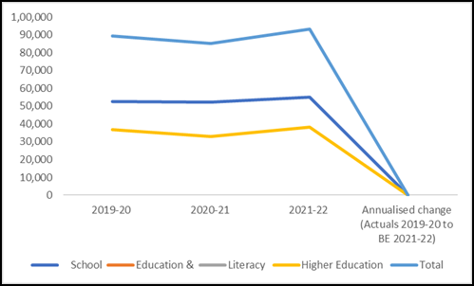

Sources: Expenditure Budget - Ministry of Education, 2021-22; PRS

The major categories in which the ministry spends its expenditures. According to the sources, 12 percent of the fund goes to autonomous bodies like the Kendriya Vidyalaya Sangathan (KVS) and the Mid-Day Meal Programme, while 8 percent goes to central universities, Indian Institutes of Technology, and statutory and regulatory bodies like the University Grants Commission (UGC) and the All-India Council for Technical Education (AICTE).

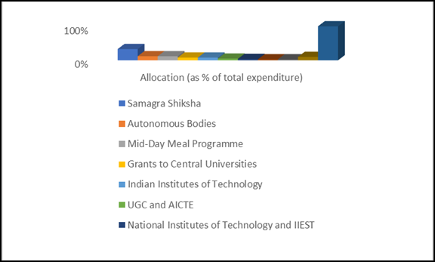

Based on the below data , trend in the use of funds given to the department between 2010–11 and 2020–21. As seen in the table, the use of funds allocated has decreased during the last three years. In both 2010-11 and 2018-19, the utilisation rate was greater than 100 percent.

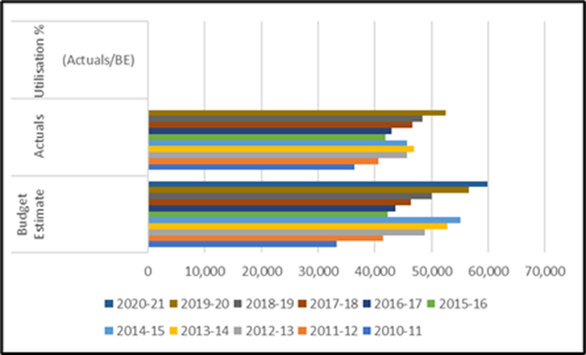

Below data illustrates a comparison of budget estimates and actual expenditures for the department between 2010–11 and 2020–21. As shown in the table, over the last three years, the utilisation rate has been over 90% of the budget forecasts. In 2016-17 and 2017-18, the Department exceeded its budget projections, reaching 100 percent utilization.

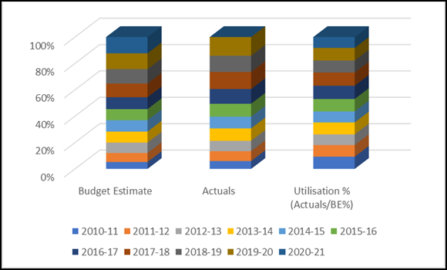

Taking everything into consideration, the education system in the United States is the finest. The United States stays number one in the Education Ranking in the 2020 Best Countries Report, a ranking and analytical program by U.S. News & World Report, BAV Group, and the University of Pennsylvania's Wharton School. The focus on research-based learning is a defining element of American colleges. Researchers are always on the cutting edge of research and looking for fresh ideas. Innovation and creativity have always been emphasized in their teaching philosophy. In order to get a decent grade in the United States, students must participate in regular testing, homework, and classroom activities. Students participate in conversations about the challenges and offer suggestions for solutions.

**6. CONCLUSION**

The government is now entirely focused on improving the quality of education in India's educational system. For the growth of education, the government has established a number of policies and suggestions. India joined the United Nations' E9 programme in April 2021, which aims to build a digital learning and skills initiative for marginalised children and youth, particularly girls. The Indian government provided a budget of 5.28 billion for higher education and 7.56 billion for school education and literacy in the Union Budget 2021-22. By 2030, India's higher education system is expected to feature more than 20 universities among the top 200 universities in the world. With an annual research and development (R & D) budget of US $140 billion, it is expected to be among the top five countries in the world in terms of research production.

**7. REFERENCES**

[**https://www.financialexpress.com/budget/union-budget-fy23-the-big-digital-push-education-needed/2427037/**](https://www.financialexpress.com/budget/union-budget-fy23-the-big-digital-push-education-needed/2427037/)

[**https://www.careerindia.com/study-abroad/usa/why-should-you-choose-usa-for-higher-education-011031.html**](https://www.careerindia.com/study-abroad/usa/why-should-you-choose-usa-for-higher-education-011031.html)

[**https://www.indiatoday.in/business/budget-2022/story/union-budget-education-budget-2022-increases-by-11-86-major-areas-of-budget-allocation-education-schemes-education-plans-1907451-2022-02-01**](https://www.indiatoday.in/business/budget-2022/story/union-budget-education-budget-2022-increases-by-11-86-major-areas-of-budget-allocation-education-schemes-education-plans-1907451-2022-02-01)

[**https://oxfordbusinessgroup.com/overview/thorough-examination-**](https://oxfordbusinessgroup.com/overview/thorough-examination-substantial-reform-has-brought-it-variety-challenges#%3A~%3Atext%3DK%2D12%20Implementation%26text%3DK%2D12%20extends%20compulsory%20schooling%2Csystem%20of%20just%2010%20years)[**substantial-reform-has-brought-it-variety-**](https://oxfordbusinessgroup.com/overview/thorough-examination-substantial-reform-has-brought-it-variety-challenges#%3A~%3Atext%3DK%2D12%20Implementation%26text%3DK%2D12%20extends%20compulsory%20schooling%2Csystem%20of%20just%2010%20years)[**challenges#:~:text=K%2D12%20Implementation&text=K%2D12%20ex**](https://oxfordbusinessgroup.com/overview/thorough-examination-substantial-reform-has-brought-it-variety-challenges#%3A~%3Atext%3DK%2D12%20Implementation%26text%3DK%2D12%20extends%20compulsory%20schooling%2Csystem%20of%20just%2010%20years)[**tends%20compulsory%20schooling,system%20of%20just%2010%20yea**](https://oxfordbusinessgroup.com/overview/thorough-examination-substantial-reform-has-brought-it-variety-challenges#%3A~%3Atext%3DK%2D12%20Implementation%26text%3DK%2D12%20extends%20compulsory%20schooling%2Csystem%20of%20just%2010%20years)[**rs**](https://oxfordbusinessgroup.com/overview/thorough-examination-substantial-reform-has-brought-it-variety-challenges#%3A~%3Atext%3DK%2D12%20Implementation%26text%3DK%2D12%20extends%20compulsory%20schooling%2Csystem%20of%20just%2010%20years)

[**https://www.thelocal.fr/20190212/french-schools-get-set-for-new-round-**](https://www.thelocal.fr/20190212/french-schools-get-set-for-new-round-of-education-reforms/)[**of-education-reforms/**](https://www.thelocal.fr/20190212/french-schools-get-set-for-new-round-of-education-reforms/)

[**https://eacea.ec.europa.eu/national-policies/eurydice/content/national-**](https://eacea.ec.europa.eu/national-policies/eurydice/content/national-reforms-school-education-25_en)[**reforms-school-education-25_en**](https://eacea.ec.europa.eu/national-policies/eurydice/content/national-reforms-school-education-25_en)

[**https://prsindia.org/budgets/parliament/demand-for-grants-2021-22-**](https://prsindia.org/budgets/parliament/demand-for-grants-2021-22-analysis-education)[**analysis-education**](https://prsindia.org/budgets/parliament/demand-for-grants-2021-22-analysis-education)

[**https://www.futurelearn.com/info/futurelearn-international/explore-**](https://www.futurelearn.com/info/futurelearn-international/explore-india-education-system)[**india-education-system**](https://www.futurelearn.com/info/futurelearn-international/explore-india-education-system)

[**https://www.upgradabroad.com/articles/best-education-**](https://www.upgradabroad.com/articles/best-education-system-in-the-world/)[**system-in-the-world/**](https://www.upgradabroad.com/articles/best-education-system-in-the-world/)