**E-Commerce Website**

**Kunal Surana1, Shital Waghmare2, Yash Kale3, Yash Ashture4,Ms.Megha Garud5**

1Computer Diploma Student, Computer science and engineering, JSPM's Bhivrabai Sawant Polytechnic, pune, Maharashtra, india

2 Computer Diploma Student, Computer science and engineering, JSPM's Bhivrabai Sawant Polytechnic, pune, Maharashtra, india

3 Computer Diploma Student, Computer science and engineering, JSPM's Bhivrabai Sawant Polytechnic, pune, Maharashtra, india

4Computer Diploma Student, Computer science and engineering, JSPM's Bhivrabai Sawant Polytechnic, pune, Maharashtra, india

5Computer Diploma Project Guide, Computer science and engineering, JSPM's Bhivrabai Sawant Polytechnic, pune, Maharashtra, india

**ABSTRACT**

An e-commerce website is an online platform that enables businesses to sell products and services over the internet. The growth of the internet has led to an increase in the number of e-commerce websites, with many businesses opting to have an online presence to reach a wider audience. E-commerce websites typically offer a range of features such as product catalogs, shopping carts, secure payment gateways, and order management systems. They also provide customers with the ability to search for and compare products, read product reviews, and make informed buying decisions. E-commerce websites are a vital tool for businesses looking to expand their customer base and increase sales, offering convenience, accessibility, and a personalized shopping experience.

**INTRODUCTION**

E-commerce websites provide a range of features to support online transactions, including product catalogs, shopping carts, and secure payment gateways. They also offer customers the ability to search for products, compare prices, and read reviews from other shoppers. With the rise of mobile devices, many e-commerce websites have become optimized for mobile platforms, allowing customers to shop on-the-go and from anywhere.

E-commerce has transformed the way businesses operate, allowing them to reach customers beyond their physical locations, reduce overhead costs, and operate 24/7. As e-commerce continues to grow, businesses are increasingly looking for innovative ways to engage customers, personalize the shopping experience, and stay competitive in the ever-evolving digital marketplace.

**METHODOLOGY**

**Scoping and planning**

* **Scoping:**

1. **Business goals: Identify the business goals for the e-commerce website, such as increasing sales, expanding customer reach, improving customer experience, or launching a new product line.**
2. **Target audience: Define the target audience for the website, including demographics, psychographics, and buyer personas.**
3. **Competitor analysis: Conduct a competitive analysis to identify the strengths and weaknesses of your competitors' e-commerce websites.**
4. **Functional requirements: Identify the functional requirements of the e-commerce website, such as product catalog, shopping cart, payment gateway, shipping options, and customer service.**
5. **Technical requirements: Determine the technical requirements of the website, such as platform, hosting, security, and performance.**
6. **Content strategy: Create a content strategy that aligns with the business goals and target audience, including product descriptions, blog posts, social media content, and email marketing.**

* **Planning:**

1. **Website structure: Develop a website structure that is user-friendly and easy to navigate. This should include a homepage, product pages, category pages, shopping cart, checkout page, and contact page.**
2. **Design: Create a visually appealing design that reflects the brand's identity and resonates with the target audience.**
3. **Platform: Select an e-commerce platform that meets the technical requirements and supports the functional requirements of the website.**
4. **Hosting: Choose a reliable hosting provider that ensures website uptime and fast loading speed.**
5. **Security: Implement security measures to protect customer data, such as SSL certificate, two-factor authentication, and encryption.**
6. **Payment gateway: Integrate a secure and reliable payment gateway that supports multiple payment options and is compliant with PCI DSS standards.**
7. **Shipping options: Offer a range of shipping options, such as standard, express, and international shipping, and provide real-time tracking information.**
8. **Customer service: Provide excellent customer service, including a help desk, live chat, and email support.**
9. **Marketing: Develop a marketing plan that includes SEO, social media, email marketing, and paid advertising to attract and retain customers.**
10. **Analytics: Set up website analytics to track key performance indicators, such as website traffic,**

**Conceptual design and research :-**

1. **User Experience:** The user experience (UX) of an e-commerce website is crucial to its success. Your website should be easy to navigate, with clear categories and product pages that provide all the necessary information for customers to make informed decisions. Consider adding search and filtering functionality to help customers quickly find what they are looking for.
2. **Visual Design:** The visual design of your website is also important, as it will be the first thing customers see when they visit your site. Choose a design that is visually appealing and reflects your brand, while still being easy to read and navigate.
3. **Product Catalog:** Your product catalog should be well-organized and easy to browse. Each product listing should include clear product images, detailed descriptions, pricing information, and any other relevant information. Consider adding customer reviews and ratings to help build trust with potential customers.
4. **Shopping Cart and Checkout**: The shopping cart and checkout process should be as streamlined and user-friendly as possible. Make it easy for customers to add items to their cart, view their cart, and checkout. Consider offering guest checkout for customers who do not want to create an account.
5. **Payment and Security:** Your e-commerce website should have a secure payment gateway that is easy to use and supports a variety of payment options. Make sure your website is SSL certified and that customer information is encrypted to protect against fraud and data breaches.
6. **Shipping and Returns:** Be clear about your shipping and return policies, and provide detailed information about shipping options and costs. Consider offering free shipping for larger orders or for customers who sign up for your newsletter.
7. **Customer Service:** Provide excellent customer service by offering multiple channels for customers to get in touch with you, such as email, phone, or live chat. Consider adding an FAQ section to your website to answer common customer questions

**Development of methodology**

1. **Requirements Gathering:** Start by gathering requirements for the website. This includes defining the scope of the project, identifying the target audience, understanding the business goals, and defining the features and functionality required.
2. **Design and User Experience:** Create wireframes and mockups to visualize the layout, navigation, and user interface of the website. Define the user experience, including how customers will browse and purchase products, how the shopping cart will work, and how the checkout process will be structured.
3. **Development:** Begin building the website, including front-end development, back-end development, and integration with third-party systems such as payment gateways and shipping providers. Test the website thoroughly to ensure it is functioning correctly and meets the requirements.
4. **Content Creation:** Create high-quality content for the website, including product descriptions, images, and videos. Develop a content strategy to ensure that the website has a consistent and engaging tone of voice, and that the content is optimized for search engines.
5. **Quality Assurance:** Test the website rigorously to ensure that it is functioning correctly, is free from bugs and errors, and meets the requirements. This includes testing the website across multiple devices and browsers to ensure it is responsive and works correctly on all platforms.
6. **Launch:** Once the website is complete, it can be launched. Ensure that all the necessary systems and processes are in place, such as inventory management and order fulfillment. Monitor the website closely in the early stages to identify and address any issues that may arise.
7. **Maintenance and Optimization:** After the website is launched, ongoing maintenance and optimization are required. This includes monitoring website performance, analyzing website analytics to identify areas for improvement, and making updates and improvements to the website on an ongoing basis.

Extra Features

* Primary category/product navigation
* Secondary navigational elements
* Search the products
* Offers and promotions

**MODELING AND ANALYSIS**

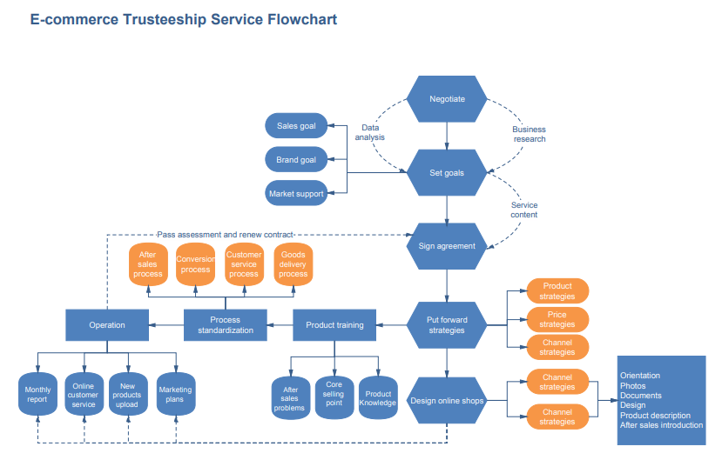Fluid and Material which are used is presented in this section. Table and Fluid should be in prescribed format.

**Figure 1:** E-commerce block diagram

The ***e-commerce website*** site shows how it uses database design to handle data used for e-commerce management tasks (ERD). It shows how the database links the different parts of the website. This shows how are put together logically by naming entities, their properties, and how they interact with each databases other.

**RESULTS**

The e-commerce website is working properly and with no bugs and tha site is online with its domain working and executing its tasks

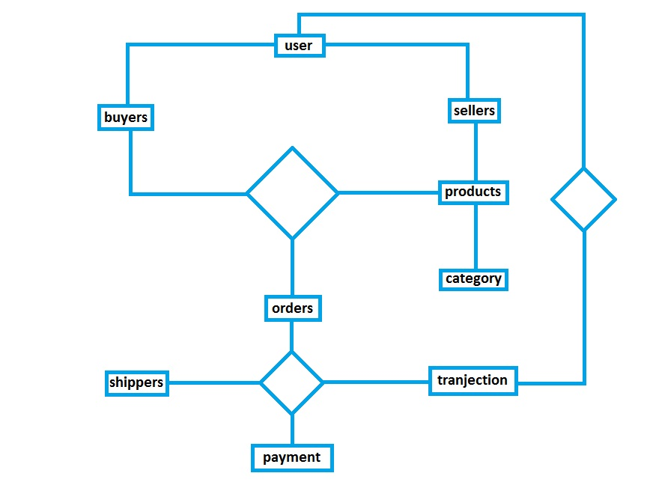

**Figure 2:** Block diadram of e-commerce

**CONCLUSION**

In conclusion, e-commerce websites have become an integral part of the modern business landscape. They provide businesses with the opportunity to reach a wider audience, sell products and services online, and generate revenue. E-commerce websites have several advantages over traditional brick-and-mortar stores, including lower overhead costs, 24/7 availability, and a more extensive reach.

The success of an e-commerce website depends on several factors, including its design, functionality, product offerings, customer service, and marketing efforts. A well-designed and user-friendly website that offers high-quality products and excellent customer service can lead to increased sales revenue, a high conversion rate, customer acquisition and retention, and high customer satisfaction.

E-commerce websites have revolutionized the way businesses operate, providing opportunities for growth, expansion, and increased profitability. As technology continues to evolve, the importance of e-commerce websites is likely to continue growing, and businesses that embrace this trend are likely to be more successful in the long run.

**REFERENCES**

<https://in.docs.wps.com/module/common/loadPlatform/?sa=00&st=0t&sid=sIC2h2-yzAaDKg6AG>

<https://www.techtarget.com/searchcio/definition/e-commerce#:~:text=E%2Dcommerce%20(electronic%20commerce),or%20consumer%2Dto%2Dbusiness>.

<https://www.researchgate.net/figure/Figure-410-Block-diagram-of-E-commerce_fig6_283511036>

<https://acknowledgementletter.com/acknowledgement-for-commerce-project/#:~:text=Acknowledgement%20For%20Commerce%20Project%20Class,is%20responsible%20for%20the%20project>.

<https://www.masterclass.com/articles/how-to-write-a-conclusion#:~:text=A%20conclusion%20is%20the%20final,impression%20on%20the%20central%20idea>.

.