Mini Forklift Robot Control Design Using Microcontroller For Industrial Applications

Mananpreet Singh Ankit Singh Vijay Kumar Tayal

Department of Electrical and Electronics Engineering Amity University Uttar Pradesh Noida, INDIA

*Abstract*— This paper describes the hardware implementation of a miniature forklift robot to pick up objects from a base and place them in a designated storage slot. A standard smart phone with an installed android app served as the hardware for transmitting commands to the microcontroller. The precise calibration of the driving component’s power requirements and location as well as the electric signals is required by means of microcontroller programming. The manual work can be replaced by proposed work. Further, storing and arranging goods can be done automatically in short time and cost effective manner. This can reduce the manual cost with higher logistics efficiency.

**Keywords— Forklift; Robot; Bluetooth Module; Microcontroller Introduction**

1. INTRODUCTION

In literature various studies discusses about the remote control system design to control a robot car by utilizing the button system from Android [1-4]. The interface module is used to connect Android to the controller is HC-05 and for the Android control system downloaded from Play store [5]. The primary driving force behind putting this concept into practice is the creation of space-saving storage solutions that enable effective packaging of lighter products into spaces that are not designed for human mobility but are roomy enough for robots. This is crucial in situations, like the storage of chilled goods, where every cubic meter of the storage unit is necessary and expensive. The power to operate the forklift are either given using gasoline or electricity [6]. Even though this is an extreme example of automation, a hybrid loading and unloading workforce can be created by using the forklift bot as a helper or aid to existing employees. The most ideal method of productive labor is this symbiotic relationship between man and machine. A four-wheeled robot that can follow instructions from the operator, the forklift prototype. Four rotating wheels are included.

The major goal of this work is to develop a remotely controlled forklift bot by exploiting the technological advantages of robots and robotic circuits to give a potential storage solution for light weight products. The robot is able move on its own and carry out the necessary tasks using embedded systems. Pulse Width Modulation on a DC

Motor/Gear Motor is used to control movement. Additionally, motors that could be remotely controlled by normal electronic circuits were attached to move the bot. The numerous components wired to the logic circuit needed to be connected after it was programmed. AVR Atmega 16, a low-power CMOS 8-bit microcontroller based on the AVR improved, was utilised as the primary control device in this instance. It provides for precise control of the numerous electronic components in accordance with the operator's inputs. This paper is organized as follows: section II presents the block diagram of proposed system; various components used are described in section III, section IV elaborates the hardware implementation and finally conclusion is discussed in section V.

1. BLOCK DIAGRAM OF PROPOSED SYSTEM

A robust and adaptable circuit made up of an ATMega microcontroller and a bluetooth module is used to drive the robot, enabling precise control of the various electronic components in accordance with user inputs.

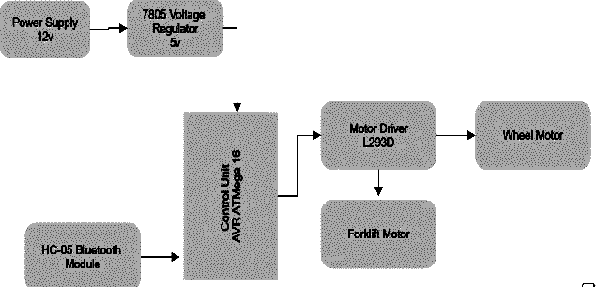

Fig. 1 Block Diagram of Proposed System

A typical smart phone with an installed self-made Android app serves as the hardware for transmitting commands to the microcontroller. Wireless signals are sent from the phone to the Bluetooth module built within the logic unit. The power and location of the driving components must be carefully calibrated to the electric signals they receive to write a program for this circuit. The design was carried out in four stages viz. (i) theoretical design and analysis (ii) material selection and part fabrication (iii) electronic hardware selection and testing (iv) programming the Microcontroller and the android app.

1. COMPONENTS USED

The ATmega16 microcontroller, part of Atmel's Advanced Virtual RISC series, was made by Atmel Corporation.

The following are the major components used in this work

(i) AVR ATMega 16 Microcontroller (ii) L293D Motor Driver (iii) 7805 Voltage Regulator (iv) Crystal Oscillator

(v) Capacitor (vi) Resistor (vii) HC-05 Bluetooth Module

(viii) DC Gear Motor (viii) Snapper (ix) Battery etc.

1. *AVR Atmegha 16*

The ATmega16 microcontroller, part of Atmel's Advanced Virtual RISC series, was made by Atmel Corporation.

They are used to collect the required data from any peripheral input devices, such as meters, sensors etc. via controlling Program [7]. It is equipped with a cutting-edge RISC (Reduced Instruction Set Computing) system and a potent microcontroller. The features of this 8051 microcontroller's enhanced version surpass those of the 8051 microcontrollers. This has four ports, EEPROM, ROM, RAM and CPU. The features of this microcontroller are visible in the section below. we can observe the features of this microcontroller.

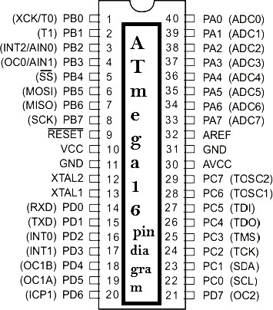

Figure. 2 ATMega 16 Pinout

This microcontroller has 40 pins. Each pin has requirements. These are divided into four ports and can accommodate either input or output connections. The ports are A, B, C, and D. These four ports group the forty pins together. The pin diagram is shown in Fig. 2. The high-performance microcontroller ATmega16 can process 8 bits of data at once. It uses 8 bits of memory data. and make use of minimal power usage. It has a RISC architecture that has been improved. It includes 131 potent built-in instructions. For a simple process, these instructions can be executed in a single cycle. Up to 16 million instructions can be processed each second (MIPS). It can operate at a maximum frequency of 16MHz. There are 32 internal registers. These registers assist in bridging the gap between the CPU and the outside peripherals. The ATmega16 offers a variety of applications because to its sophisticated characteristics. It is a compact computer. Microcontrollers was one example of digital devices invented for automatic

controller systems [8-9]. The following are a few ATmega16 applications: The ATmega16 has mostly been utilised in domestic appliances, industrial systems, automation of vehicles, embedded systems, as well as Arduino-based works and motor control systems.

1. *L293D Motor Driver*

The L293D motor Driver IC is an integrated circuit typically used to control the motors in an autonomous system. It can drive two motors simultaneously. With the help of this 16 pin motor driver IC, user may drive a DC motor in either direction or regulate its speed. L293D is a dual H-bridge motor driver IC. This is the most commonly used circuit for managing a motor. One H-bridge can provide bidirectional DC motor drive. There are 8 pins on both sides of integrated circuit. Each has two input pins, two output pins, and one enable pin motor. This IC can be operated in a voltage range of 4.5 V-36 V. This can work safely up to current levels of 600 mA in both directions.

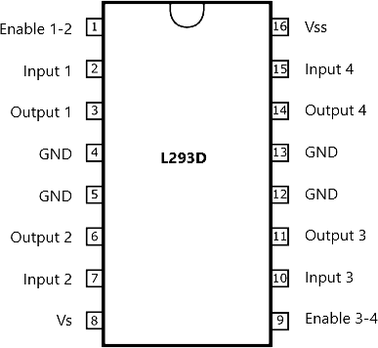

Figure. 3 Pin Diagram of L293D Motor Driver

It is developed to drive various loads such as stepper motors, solenoids and relays and higher rating loads. L293D motor drivers are frequently chosen by users due to several factors including low cost (in comparison to other drivers), simplicity of control, appropriate size and shape, no requirements of heat sinks and protection. The L293D Motor Driver IC has higher noise immunity with maximum current 1.2A per channel.

1. *Bluetooth Module*

In this work HC05 module is selected as a Bluetooth module. This is a serial port protocol module. This is suitable for communication applications. This module can work in 2 modes either AT mode or communication mode. The configuration settings are done in AT mode, whereas the communication mode functions to perform Bluetooth

communication with other devices [10].

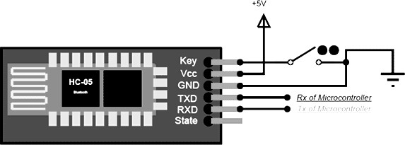

Figure. 4. Connection Diagram of Bluetooth Module

There are 6 pins-

* 1. *In order to activate the AT commands Key/EN is utilised. Depending upon the Key/EN pin high/low the module will work in command mode/data mode.*
  2. *The 5 V supply is connected with Vcc pin.*
  3. *For ground connections GND pin is used.*
  4. *In order to transmit the serial data TXD pin is used.*
  5. *To receive the serial data RXD pin is used.*
  6. *The connection or no connection of module is described by state pin.*

In order to enter the command mode, the key pin is to be grounded; otherwise, it will automatically enter the data mode. The Bluetooth device should be identified as soon as the module is enabled. User can then connect using the saved password. By entering customized user input, the name, password, and other default values can be changed. The major applications of bluetooth module includes-

(i) Robotic applications (ii) communicate with laptops, mobile phones and microcontrollers (ii) Communicate with Laptop, Desktops, and mobile phones

1. *Bluetooth Module*

In the feedback loop of an amplifier, crystal oscillators make use of a piezoelectric circuit element that is mechanically resonant. Hence the name, this element is typically a quartz crystal. Crystal oscillator is a high stable frequency reference, which can be used in communication, radio, radar etc [10-12]. Quartz crystal oscillator is the most stable and precise oscillator [14]. A characteristic known as piezoelectricity is present in some crystals and electrically polarized ceramics. When the electric field applied across two faces is altered, piezoelectric materials' dimensions (such their thickness) vary. Like this, when a force is applied to a substance, an electric charge is produced. The mechanical to electrical energy

conversion can be done by this. Thus, these devices may be utilized to generate the sound, as force transducers and microphones, among many other things. In addition, they are utilized in SAW filters.

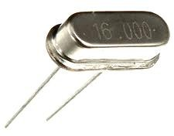

Figure. 5. Crystal Oscillator

Electronic oscillator circuits come in a variety of forms, including the following: Linear oscillators, including the Hartley, Phase-shift, Armstrong, Clapp, and Colpitts oscillators. Relaxation oscillators include the voltage- controlled oscillator, the ring oscillator, the rover oscillator, and the multivibrator (VCO). The quartz crystal oscillator typically operates at a 16MHz frequency.

In most microcontrollers, a standard oscillatory circuit consists of two parts: (i) The active component of the oscillator circuit, which is on-chip in most microcontrollers, is an inverting amplifier with voltage gain. (ii) A frequency-selective feedback path - The quartz crystal, capacitors, and resistors work together to create the frequency-selective feedback path. The oscillator system of the microcontroller's feedback path includes external hardware.

1. *7805 Voltage Regulator*

One type of electrical component needed to keep a steady voltage across any electronic device is the voltage regulator. Voltage swings can lead to an unfavourable outcome in an electronic system. Based on the system voltage need, keeping a stable voltage is necessary to achieve that. For instance, a basic LED consumes no more than 3V. The diode will become damaged once the voltage exceeds this value. It is also typical of all electrical and electronic components. All the system's components will suffer harm as soon as the voltage rises. A voltage regulator is used to supply a controlled power source to get around this problem. A linear voltage regulator with three terminals, including one for the fixed output voltage of 5V, is the IC 7805. This voltage is applied in many different situations. Different manufacturers, including Texas Instruments, ST Microelectronics, ON Semiconductor, Infineon Technologies, Diodes integrated, etc., can currently develop such regulator. There are various types these such as SOT-223, TO-263, TO-3 etc. But TO-220 is the packaging

that is most usually used. This voltage regulator's corresponding integrated circuits (ICs) include ICs LM7809, LM7806, LM317, LM7905, XC6206P332MR, and LM117V33.

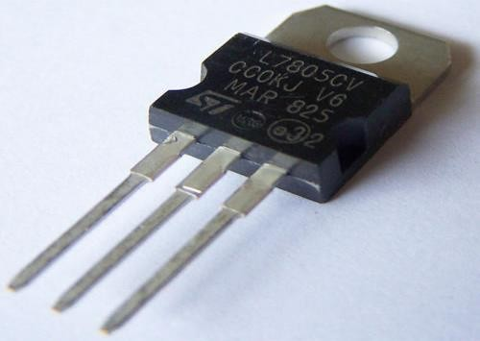

Figure. 6 7805 Voltage Regulator

The IC 7805 voltage regulator features are:

1. *Reduced components requirement.*
2. *Maximum current rating of 1.5 Amp.*
3. *Maximum/minimum input voltage range is 7V-25V.*
4. *Maximum temperature of junction is 1250C.*

The applications of 7805IC include output regulators in variety of electronic circuits. They are further used in UPS, CD players etc.

D.C Gear Motor

A particular kind of electrical motor is a gear motor. The primary function of a gear motor is to generate large amounts of torque with little motor output in terms of horsepower or speed. Gear motors are used in a wide range of products, including many home appliances and gadgets. In one simple- to-mount and simple-to-configure package, gear motors are combination of reduction gears and an electric motor. The usage of gear motors considerably decreases the complexity and cost of designing and constructing power tools, equipment, and appliances due to the advantage of low speed with high torque.

By using gear motors, affordable low-horsepower motors may deliver powerful motive force at a low speed such as in robotics, hospital tables, jacks, winches, and lifts. A DC gear motor can be made to to power a tiny clock or can be as large to lift a building.

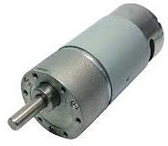

Fig. 7. DC Gear Motor

When choosing a motor or gear motor, some of the most typical specifications to consider are- duty cycle, rotation, RPM, power, current, and diameter of shaft etc. Further, when choosing a gear motor for a particular application, the user must consider the performance curves (Fig. 8).

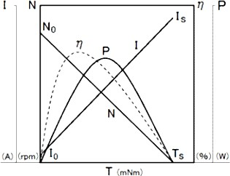

Fig. 8 Performance Curves

From Fig. 8, the speed-torque depicts a linear relationship for the gear motor. Depending on whether the voltage increases or decreases, this line will move laterally. Speed and efficiency decrease as torque rises. Poor output performance results from increased torque, and once the motor hits its stall torque, the device will finally stop working. From no load to full motor lock, a straight line represents the range. This graph illustrates the connection between amperage and torque. The torque calculations can be carried out by considering the speed-load requirements. The performance curves are generally provided by majority of motor manufacturers.

1. HARDWARE IMPLEMENTATION

In this research work, design and fabrication of forklift have been studied. Fig. 9 shows the overall hardware model of the proposed work. The hardware model consists of an ATMega16 microcontroller [16]–[19], a Bluetooth module, a motor driver, and a DC output.

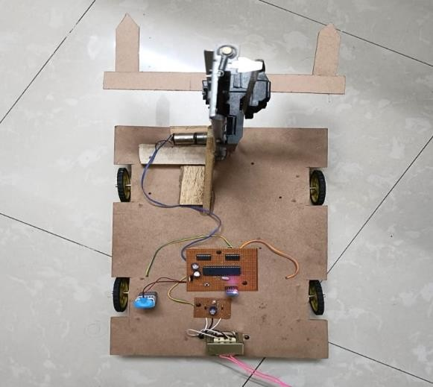

Fig. 9. Model of Proposed Work

The prototype of the system is designed and developed successfully. The RF modules are working well.

1. CONCLUSION

In order to save the human efforts with higher degree of precision in domestic and industrial applications, there is a need for robot. The proposed work provides a cost effective solution to control the designed robot by application of wireless communication network with RF modules. This increases the user’s safety by means of providing better flexibility from distance operation. Thus, the poor visibility issues causing manual errors are also minimized. This increases the efficiency and productivity. The rated load can be tolerated by the proposed forklift. Further, the robot is cost effective and highly reliable. The future work may include to improve the stability of robot at faster speeds and turns.

ACKNOWLEDGMENT

The authors are greatly thankful to Department of Electrical and Electronics Engineering, Amity School of Engineering and Technology, Amity University Uttar Pradesh, Noida, INDIA for providing laboratory facilities to conduct the experiments and hardware implementation of this work.

REFERENCES

1. Loh Poh Chuan, Ayob Johari, Mohd Helmy Abd Wahab, Danial Md. Nor, Nik Shahidah Afifi Md. Taujuddin, “An RFID Warehouse Robot”, In Proceeding of IEEE International Conference on Intelligent and Advanced System (ICIAS2007), pp. 451– 456, 2007.
2. K.T. Vivaldini, J. P. M. Galdames, T. B. Pasqual, R. C. Araújo, R. M. Sobral, M. Becker, and G. A. P. Caurin, “Robotic Forklifts for Intelligent Warehouses: Routing, Path Planning, and Autolocalization"**,** in IEEE–International

Conference on Industrial Technology, Viña del Mar– Valparaíso, Chile, pp. 1463 - 1468, 2010.

1. Zhengyin Zhou, Tianding Chen, Di Wu, Changhong Yu, “Corridor Navigation and Obstacle Distance Estimation for Monocular Vision Mobile Robots", JDTA: International Journal of Digital Content Technology and its Applications, vol. 5, no. 3, pp. 192-202, 2011.
2. B.Ranga Raju. 2014. ARM7 Microcontroller based Robot controlled by an Android mobile utilizing Bluetooth, IJIRT, vol. 1, pp. 23-56, 2015.
3. M amin, R Ananda, J Eska. Analis penggunaan driver mini victor l298n terhadap mobil robot dengan dua perintah android dan arduino nano. Jurnl teknologi dan system informasi. vol 6. pp. 145-342, 2019.
4. Allwyn, L.M., Karan, K.N., Ganesh, A.B., Prathamesh, B.G., Omkar, K.S., Abhijeet, N.N., “Design and development of mechanical forklift”, International Research Journal of Engineering and Technology, vol. 5, no. 3, pp.1125-1136, 2018.
5. A. Sagahyroon and T. Al-khudairi, ”FPGA Based Acquisition of Sensor Data” Proc. of Int. Conf. on Ind. Tech., ICIT, pp. 239– 257. 2004
6. F. M. Cady, Microcontrollers and Microcomputers: Principles of Software and Hardware Engineering, Oxford University Press, pp. 106-113, 1997.
7. V. Sharma and V. K. Tayal, "Hardware implementation of sun tracking solar panel using 8051 micro-controller," International Conference on Reliability, Infocom Technologies and Optimization (Trends and Future Directions) (ICRITO), pp. 483-486, 2017.
8. S.Anusha, M.Madhavi, R.Hemalatha “Home Automation Using ATmega328 Microcontroller and Android Application”, International Research Journal of Engineering and Technology (IRJET), pp. 289-324, 2015.
9. M. Fajar, “Implementasi Bluetooth. HC–05 untuk Memperbarui Informasi Pada Perangkat Running Text. Berbasis Android Kadar Air Tanah Dengan Menggunakan. Mikrokontroler Arduino Nano”. Malang: Jurnal EECCIS vol. 9, pp. 456-568, 2016.
10. B. Parzen, "Design of crystal and other harmonic oscillators," John Willy &k Sons, pp. 362-363, 1983.
11. Smith, S.C.; Sen, P.K.; Kroposki, B., “Advancement of energy storage devices and applications in electrical power systems”, In Proceedings of the IEEE Power and Energy Society General Meeting-Conversion and Delivery of Electrical Energy in the 21st Century, Pittsburgh, PA, USA, pp. 1–8, 2008.
12. Sahin, M.E.; Blaabjerg, F. A hybrid PV battery/supercapacitor system and a basic active power control proposal in MATLAB/Simulink. Electronics, pp.243-247, 2020.
13. Asad A.Abidi., "Phase noise and jitter in CMOS ring oscillators," IEEE Journal of Solid-State Circuits, vol. 41, no.8, pp. 1803-1817, 2006.
14. A. N. N. Chamim, D. Ahmadi, and Iswanto, “Atmega16 implementation as indicators of maximum speed,” Int. J. Appl. Eng. Res., vol. 11, no. 15, pp. 8432–8435, 2016.
15. Iswanto, S. Suripto, F. Mujahid, K. T. Putra, N. P. Apriyanto, and Y. Apriani, “Energy Harvesting on Footsteps Using Piezoelectric based on Circuit LCT3588 and Boost up Converter,” Int. J. Electr. Comput. Eng., vol. 8, no. 6, pp. 4104– 4110, 2018.
16. K. Purwanto, I. -, T. Khristanto, and M. Yusvin, “Microcontroller-based RFID, GSM and GPS for Motorcycle Security System,” Int. J. Adv. Comput. Sci. Appl., vol. 10, no. 3, pp. 447–451, 2019.
17. T. Padang Tunggal, A. Supriyanto, N. M. Zaidatur Rochman, I. Faishal, I. Pambudi, and I. Iswanto, “Pursuit Algorithm for Robot Trash Can Based on Fuzzy-Cell Decomposition,” Int. J. Electr. Comput. Eng., vol. 6, no. 6, pp. 2863, 2016.