**PAPER TITLE, FONT TYPE-Times New Roman 14**

**First Author1, Second Author2, Third Author3 (Font-Times New Roman, Bold, Font Size -12)**

1Designation, Department, Institute, City, State, Country (Font Size -11)

2Designation, Department, Institute, City, State, Country

3Designation, Department, Institute, City, State, Country

**ABSTRACT (Font-Times New Roman, Bold, Font Size -12)**

An abstract is a summary of entire paper should be written in Times new roman with font size- 10. The abstract should not be more than 200 words and written in single paragraph. This electronic document is a “live” template. The abstract includes the overall purpose of the study you investigated, the basic design of the study, results of your analysis and brief summary of your interpretations and conclusion

**Keywords:** Analysis, investigation, research (5-6 Keywords, Font-Times New Roman, Font Size – 10).

1. **INTRODUCTION (Font-Times New Roman, Bold, Font Size -12)**

Now a days e-commerce sites are widely used for online business. An E-commerce portal which will allow merchants and traders to sell their products on the internet. A trading portal website for trading companies. The primary goal of a trading portal System is to sell wholesale products online and the basic idea is that customers can buy wholesale products online. It provides the user with a category of various products. The system helps in buying items and products through Online by choosing the listed product from website.

**METHODOLOGY**

. **Scoping and planning**

This phase focuses on the planning of the project’s overall direction, including the definition of the project’s scope, objectives, and timelines. The deliverable from this phase is this Design Plan.

**Conceptual design and research**

In this phase, the conceptual design of the methodology is developed and research on existing methodologies is conducted. Research is performed from independent research firms, such as the Gartner Group, Forrester Research, and CIO.com. These research firms sometimes publish the methodologies that consulting firms use. Consulting firms’ websites are another source for researching E-commerce strategy methodologies.

**Development of methodology**

The actual methodology is developed in this phase. Detailed descriptions of each task in the methodology are documented, including the objectives, inputs, approach, relevant models, applicable tools and techniques, outputs, and any references. The methodology is to be documented in an appropriate format, be it a Word document or HTML pages.

**Implementation of methodology**

The methodology will be implemented with a client. This phase includes the marketing of E-commerce strategy development services and the closing of the sale, followed by the actual implementation.

**Revision of methodology**

Final touches and revisions to the methodology are made in this phase. The majority of these revisions come from experiences on the client project. Sample reports and any additional references are added to the methodology.

**2.1 Subheading**

* Primary category/product navigation
* Secondary navigational elements
* Search
* Offers and promotions

**2.2 Subheading**

We’ll go over some best practice tips and also offer some real-life website header inspo from a handful of top online retailers that have really nailed it with header design. And remember: testing is everything, so be sure to experiment with these elements to see which leads to the most conversions.

1. **MODELING AND ANALYSIS**

Fluid and Material which are used is presented in this section. Table and Fluid should be in prescribed format.

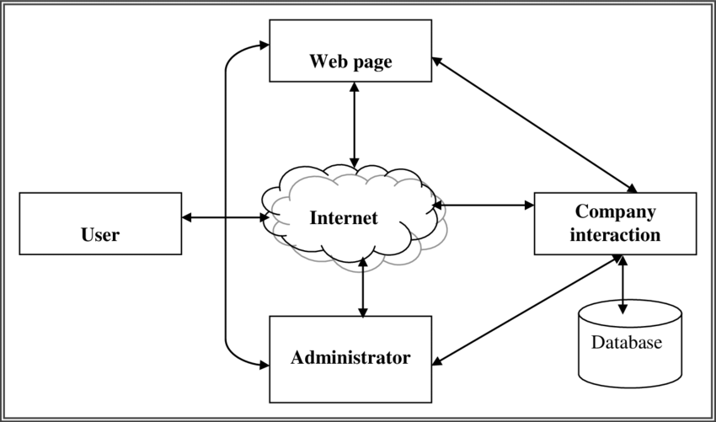

**Figure 1:** E-commerce block diagram

The ***e-commerce website*** site shows how it uses database design to handle data used for e-commerce management tasks (ERD). It shows how the database links the different parts of the website. This shows how are put together logically by naming entities, their properties, and how they interact with each databases other.

1. **RESULTS AND DISCUSSION**

Electronic commerce eliminates the concept of national borders in transactions between enterprises and consumers. It will increase the number of crossborder transactions that take place, and will therefore be a force in the creation of increasingly borderless markets. The emergence of cross-border transactions on the Internet gives developed and developing countries (both companies and individuals) the opportunity to participate in global markets, and can be a tool for overcoming the disparities between countries (or individuals) in access to. 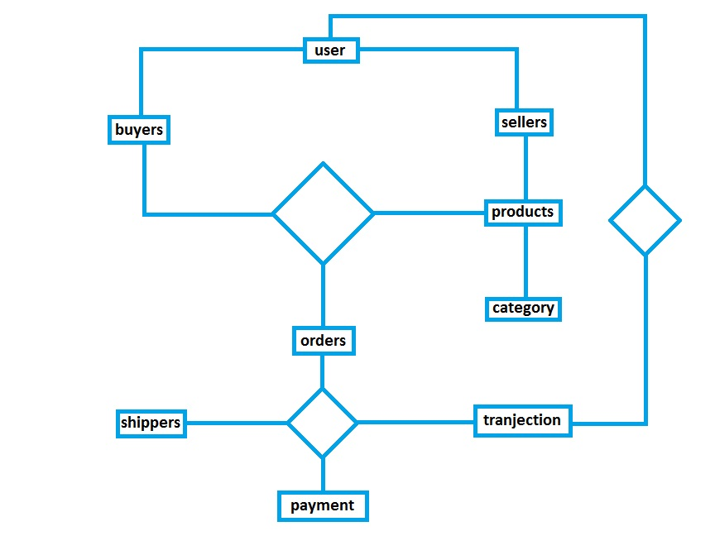

**Figure 2:** Block diadram of e-commerce

user could be buyer and seller both so a relationship must be maintained discreetly . Sellers provide products and buyers bought so products and buyers create order table. To complete successful order we need shippers and transaction from users.  users and transaction records need to be connected.

**6 CONCLUSION**

 E-Commerce has undeniably become an important part of our society. The successful companies of the future will be those that take E-Commerce seriously, dedicating sufficient resources to its development. E-Commerce is not an IT issue but a whole business undertaking. Companies that use it as a reason for completely re-designing their business processes are likely to reap the greatest benefits. Moreover, E-Commerce is a helpful technology that gives the consumer access to business and companies all over the world.

**7 ACKNOWLEDGEMENTS (optional)**

We, the students of Engineering College, find ourselves to be privileged to have golden opportunity to develop website under the guidance of such people without whom designing and developing website successfully would have been just impossible for us. We are thankful to them.

**5 REFERENCES**

<https://in.docs.wps.com/module/common/loadPlatform/?sa=00&st=0t&sid=sIC2h2-yzAaDKg6AG>

<https://www.techtarget.com/searchcio/definition/e-commerce#:~:text=E%2Dcommerce%20(electronic%20commerce),or%20consumer%2Dto%2Dbusiness>.

<https://www.researchgate.net/figure/Figure-410-Block-diagram-of-E-commerce_fig6_283511036>

<https://acknowledgementletter.com/acknowledgement-for-commerce-project/#:~:text=Acknowledgement%20For%20Commerce%20Project%20Class,is%20responsible%20for%20the%20project>.

<https://www.masterclass.com/articles/how-to-write-a-conclusion#:~:text=A%20conclusion%20is%20the%20final,impression%20on%20the%20central%20idea>.

.