**New Step Of Technology In Medical Field:Robotic surgery**

**Siddhesh kanase1, Rida shaikh2 , Alisha Bijapure 3,Aditya Ghodke4**

1Siddhesh kinase ,Chemical Engineering, MIT-WPU

2 Rida shaikh, Bio Engineering, MIT-WPU

3Alisha Bijapure, Computer Science Engineering, MIT-WPU

4Aditya Ghodke, Mechanical Engineering MIT-WPU

---------------------------------------------------------------------***---------------------------------------------------------------------

**Abstract -** Surgical robotics is a recent technology that holds a remarkable promise. Robotic surgery is often presented as a new revolution, and it is one of the most talked about topic of discussion in surgery today.There is no doubt that they will become an important instrument in the surgical field as the extent of their use is still evolving.This paper provides a brief introduction to the robotic surgeries and its surgical system, advantages and disadvantages in the surgical system, impact of covid 19 on robotic surgeries leading to increase in value of robotic surgeries, da vinci single port robotic surgery in gynaecological tumour. The surgical systems included in the list of systems are the Da Vinci, Raven, Mirosurge, Sehance, Flex Robotic, Versius and Sport. It gives the current development in the surgical system. It also shows the accuracy of the respective surgical system and results of the most used surgical system

***Key Words*:** Robotic Surgery, Robot-assisted surgery, Minimally invasive surgery, Covid-19, Da vinci Surgical System.

**1.INTRODUCTION** *( Size 11, Times New roman)*

This paper provides the recent development in Laparoscopic, Endoscopic and Robotic Surgery . We discussed one of the technologies in the medical field ,laparoscopic & endoscopic robotic surgery. Endoscopic surgery is one of the minimally invasive surgeries. In the endoscopic surgery, surgeons perform the surgeries using endoscopes and forcepasses. Laparoscopy is a type of surgical procedure that allows a surgeon to access the inside of the abdomen and pelvis without having to make large incisions in the skin. This procedure is known as minimally invasive surgery. This paper writtens to solve the main drawback in this kind of surgeries, is composed of miniature camera robot and redundant robotic grasper In the endoscopic surgery, traumas of the patients can be smaller than those of in laparotomies. The major reasons for laparoscopic surgery on the colon include diverticulosis, the removal of large growths called polyps that can't be completely removed by colonoscopy, and colon cancer which includes Stomach Surgery, Gallbladder Surgery, Anti-Reflux Surgery. Laparoscopic surgery does not convert a major operation into a minor one. The surgery is still considered major, but the recovery time is quicker, because of the smaller incisions. Although laparoscopy & laparoscopic surgery are regularly and frequently performed, there are risks attached. In case robotic surgery reduces the difficulties in surgery. To reduce such difficulties and/or assist medical Doctors in various situations, applying robotics technology into the field of medicine has been studied [19]–[21]. As the surgeon can freely operate the robotic surgical tool, It can be reached upto the part of the body that would be impossible to reach. In the absence of the fulcrum effect in control positioning and monitor reduces the need for the surgeon to shift to awkward positions when operating the instrument. These ergonomic controls and system position allow for better hand-eye coordination and decrease in musculoskeletal problems in the surgery. despite the promising improvements of robotic surgical systems.[34] Robot-assisted procedures accounted for 15.1% of all general surgeries in 2018, up from just 1.8% in 2012, according to a study published Friday in JAMA Network Open.

## 1.1.HISTORY

Every study of the history of robotic surgery starts with the author Karel Capek who was a czech playwright, responsible for the short introduction of the history of robotic surgery in his play Rossum’s Universal Robots. In which he described the term ‘robot’ for the first time. Although there is current application of robots in different fields, in Medical Field Robot-assisted surgery is still evolving over the past few years.[1] Different Authors have different definitions of the first robotic procedure of the modern era. The most honors were awarded to Kwoh et al [2] , who’s PUMA 560 robotic system undertook neurological biopsies with great accuracy. The same system being used by Davies et al [3]undertook transurethral resection of the prostate (TURP) which would be termed as PROBOT later. PROBOT failed to gain wider clinical appeal. In the late 1980s more than 50 years ago, ROBODOC (an Integrated Surgical System, Sacramento,CA), the orthopedic image-guided system was developed by Hap Paul, DVM, and William Bargar, MD, for prosthetic hip replacement[4]. In the same year, The National Aeronautics and Space Center (NASA) developed the first concept of surgical robotics along with researchers from Stanford.[5] . The ROBODOC system achieved a formal FDA approval and was almost instantly approved in Europe and later in the US. In 1992 the first ROBODOC procedures were initiated.

The US military recognised the significant link between surgeons who are far away from the war zone and patients through robotic platforms as there was a possibility of reducing deaths and illness from service in the war. The development of thoughts economically in public and economic sectors was made possible by researchers involved in the military interest group.[6][7] Computer Motion received direct funding to develop the Automated Endoscopic System for Optimal Positioning (AESOP) robotic platform enabling the surgeon to vocalize and control the position of the laparoscopic camera system. This system was later modified into what was called as the ZEUS operating system. Predecessor of what eventually became Intuitive Surgical, released the SRI Green Telepresence system which later underwent radical evolution before turning into the early version of the current da Vinci system. The unique selling point and innovation, crucially proved the dominance of da Vinci system. This system dominated the robotic surgical field for over a decade.[8]

**1.2 ROBOTIC SURGERY**

Robotic-assisted surgery performs operations with the use of robotic systems. This type of surgery was developed to enhance a surgeon’s capabilities in operation and to overcome the limitations. Although more commonly associated with minimally invasive surgery to robot assisted minimally invasive , it can be also used in open surgery. Robotic surgery is more advantageous over the minimally invasive surgery due to its more benefits in surgery. For patients, the benefits they will experience is similar to that of minimally invasive surgery.It reduces the risk of surgery so patients will have shorter hospital time and faster recovery time. Pain and trauma will also be reduced . Also, the risk of infection will be greatly lowered and blood loss is reduced. As for surgeons, RMIS has a greater advantage because it provides: enhanced dexterity, greater precision, and better visualization. One of the major advantages of using a robotic surgery system involves the enhanced dexterity provided to the surgeon. With the use of robot arms, operations can be done in smaller and tighter spaces. Moreover, the increase in degrees of freedom from the robot arms increases the reach that would otherwise be limited using a traditional laparoscopy. Fatigue also does not affect the robot, allowing the surgeon to work longer and in a more comfortable position. RMIS has numerous advantages over other forms of surgery. One of these is its ability to provide better visualization and enhanced dexterity.Aside from having the capability to perform various tasks, the systems also have the potential to experience latency. This is something that the developers are currently working on in order to be approved for global use.Aside from having the capability to perform various tasks, the systems also have the potential to experience latency. This is something that the developers are currently working on in order to be approved for global use. Additional features such as sensors and haptic feedback also ensure the accuracy of the robot arms movement. Greater visual image is also a plus point of robotic surgery as the systems integrate cameras to give pictures and videos on the operation being done on the patient. Also, with the camera being movable, it gives the surgeon a better view of the surgery as the camera can be moved to give a different point of view. Even with the many benefits, RMIS has several drawbacks that obstruct additionally the global application of RMIS. Such obstructions include cost and haptic feedback of the robotic system. Robotic systems are more seldom used due to the expenses needed for a single operation. Haptic feedback may also be inaccurate for the surgeon causing him or her to be unable to properly control the amount of force needed which can result in problems in the operation. Moreover, there are chances of dormancy of connection from the computer to the robot. Computing all the current problems found in the systems, further consideration, and evaluation is still to be decided upon for the standardization of robotic systems before they are to be approved for global application.[34]

**2.0 ROBOTIC SURGICAL SYSTEMS**

In this section, ongoing and commercially-available robotic surgical systems will be discussed. This section includes details on the mechanism, brief history and additional features of the robotic surgical systems. .[34]

**2.1Zeus Surgical System**

The ZEUS Robotic Surgical System (ZRSS) was a medical robot designed to assist in surgery, originally produced by the American robotics company Food and Drug administration in 1994 to assist surgeons in minimally invasive surgery. The ZRSS itself was cleared by the FDA seven years later, in 2001. ZEUS had three robotic arms, which were remotely controlled by the surgeon. The first arm, Automated Endoscopic System for Optimal Positioning, was a voice-activated **endoscope, allowing the surgeon to see inside the** patient's body. The other two robotic arms mimicked the surgeon's movements to make precise incisions and extractions with 5 DOF micro wrist instruments attached to it. ZEUS was discontinued in 2003. It is used in laparoscopic procedures. In visual it involves glass with polarising filters with lens on it which allows surgeons to see the images from both the cameras.

**2.2** **DA VINCI SURGICAL SYSTEM**

The da Vinci surgical system is developed by Intuitive Surgical Inc. and approved by the FDA as the first surgical system of general laparoscopic surgery. The da Vinci surgical system gives an advanced set of instruments to surgeons to use in performing RMIS. The term “robotic” often misleads people. Robots don’t perform surgery with the help of a surgeon . A surgeon performs surgery with da Vinci by using instruments that he or she guides through the console. The da Vinci system translates the surgeon's hand movements at the console in real time, operating the instruments while performing the procedure through the RMIS. The arm of instruments move like a human hand, but with a greater range of motion. The da Vinci vision system also delivers highly magnified, 3D high-definition views of the surgical area. The instrument size makes it possible for surgeons to operate through a few small incisions.

**2.3 RAVEN**

The Raven is a surgical robot that has two cable-driven with 7 driven arms for laparoscopic surgery research from applied dexterity. It is intended to facilitate collaborative research on advances in surgical robots.The raven development was started in 2002 in the University of washington. It is created to optimize the delivery of position Also, it was funded by the department of defense to meet the need of a military-grade surgical robot which could be deployed in the field with a research team led by Blake Hannaford and Jacob Rosen. In the year 2006, RAVEN was tested in a remote site in California where testing of cutting, dissecting, and suturing was done. Subsequent experiments have also been done on animal models such as gallbladder removal [23]. Around 2010 to 2011, RAVEN II was developed. It was designed to be a cable-driven robot with 7 DoF (6 robotic arms + grasper) while the software is operated through Linux and ROS. For the surgical system, a master-slave topology was also used. In 2013, Applied Dexterity was created to expand the RAVEN research community. Currently, RAVEN III is the latest model with the RAVEN ecosystem serving an open source system where researchers can modify and program the movement and setting of the robotic system. The main goal of the RAVEN system is to foster collaboration between researchers by sharing software and hardware improvements.

**2.4Mirosurge**

In 2010 MiroSurge was presented to the public for the first time. Mirosurge is developed by the DLR, Institute of robotics and automation. It is a modular system . This system consists of 7 DOF,a 3D display , two haptic input devices with 3 robot arms which are incorporated into the robotic system which is also called MIRO. The MIRO is a robotic arm which uses impedance and position to control developed in 2008 [25]. Kinematics for the robotic arm is redundant, hence it can adjust in multiple ways to meet a specific position. The kinematic redundancy also allows the user to directly interact with the robot wherein the impedance control system and gravity compensation make it possible for collision detection and human-computer interaction.[24]

**2.5. Sehance**

The Senhance Surgical System is digitising laparoscopy by integrating advanced technology – robotic precision, haptic sensing, eye-tracking camera control, and improved economics with skilled laparoscopists while focusing on responsible economics. The open-platform architecture allows for compatibility with 3DHD and fluorescence vision systems along with other existing hospital investment in laparoscopy. Senhance is a robotic surgical system developed by TransEnterix Surgical Inc., which received FDA approval on. The Senhance robotic surgical system is made with 3 robotic arms and 3D HD view. It features haptic feedback, advanced eye sensing and head movement sensing for camera controls. For haptic feedback, it allows the surgeon to feel the stiffness of the tissue while the head controls the depth and the zoom of the camera. 3D glasses are used in tandem with the camera and foot pedals are added for energy activation [11]. An image of the robot and the console Upon inspection of the FDA, they consider the Senhance to be equivalent to the Da Vinci robotic surgical system. However, in terms of design, the console of the Senhance is more similar to that of the traditional laparoscopic instrument as opposed to Da Vinci’s more intuitive console. Also, the Senhance has been approved for use in different areas of the globe, such as Europe, Japan, and the USA

**2.6 FLEX**

Robotic Made by Medrobotics Corporation, the Flex Robotic System is a single robot arm that can be steered along a non-linear path with the use of the Flex Colorectal Drive from the Flex Robotic Colorectal System [29]. The robotic surgical system uses a snake-like endoscope with two channels for the insertion of other laparoscopic instruments making it possible to be inserted in body orifices such as the mouth and anus. The flexible snake-like mechanism of the Flex system also allows for less abrasion and damage as the tools maneuver inside the body. In addition to this, the articulating instruments take up less space because of its small footprint with a 3mm diameter shaft. FDA has given its approval for the device on May 4, 2017

**2.7 Versius**

Versius is developed by CMR Surgical which is a UK-made robotic surgical system. It can be portable and has a small footprint of 38cm x 38cm. Versus has been designed to support surgeons to perform more minimal access surgery, enabling you to operate in your own way by optimising port placement for your patient, but with all the benefits of robotics. Versius acclaims and expands what a person can do, helping to improve outcomes for patients. Compared to manual laparoscopy, the fully articulated wrists, direct hand to instrument mapping, and integrated stable 3D HD visualisation on Versus provides amazing accuracy, control, skill and amazing depth of understanding. This gives you the means to perform surgical steps with greater precision and limpidity. Laparoscopic surgery is physically and mentally demanding, causing three in four surgeons to experience back pain. Versius has intuitive instrument and vision monitoring and an open console design allowing you to sit upright or stand, keeping you comfortable for longer each day

**2.8 SPORT** SPORT is a robotic surgical system made for single port laparoscopic surgery or RMIS. It is made as a highly stated instrument with replaceable end effector tips. As an instrument, it is divided into 3 sections: S works, the distal section, and the tip section. S works focus on the translational movement as the distal section focuses on double-axis multi-articulated movement while the tip section allows for the rotation and grasping. As of 2019, SPORT plans on commercializing the system in the EU rather than in the USA, the two largest markets for RMIS.

**3.0 DA VINCI SINGLE PORT ROBOTIC SURGERY IN GYNAECOLOGICAL TUMORS**:

Robotic surgery is one of the increasingly common treatments for gynecologic tumors along with laparoscopy in minimally invasive surgery. [9] Decrease in after surgical pain and duration of the hospital stay are the advantages of minimally invasive surgery[10] Shin , el , till today are the only two researchers worldwide that reveal clinical gynecologic history with da Vinci SP surgical system. Fig.1 Photographs of da Vinci SP surgical system. (A) External view of the instruments and camera docked through SP cannula fixed to GelPOINT Mini (Applied Medical). (B) External view of injecting vasopressin into the myoma with the instruments and camera docked through SP cannula fixed to Uni-Port (Dalim). (C) Inside view of the para aortic lymph node dissection in endometrial cancer surgical staging surgery. (D) Morcellation of myomas in an endoscopic bag.[11] Small incisions have improved cosmetic outcomes proving it a key advantage of robotic single port surgery . While performing the surgery a 2.5 cm vertical umbilical skin incision is made. Incision of size larger than 1.5 cm is commonly used in robotic laparoscopic surgery. For accommodation of special robotic single port entry system and assistant instruments, a larger incision is needed. The umbilical wound appears similar to single port laparoscopic surgery[12] Fig.2 Incision size after closing the umbilicus in da Vinci SP robot surgery to remove a gynecological tumor. The incision size was less than 2.5 cm.[13] 20% of the amount of robotic surgeries have expanded over the last 5 years. Rapid development of gynecologic robotic surgeries for benign and malignant gynecologic diseases have been reported by Lee, et al and has been developing continuously.[14] While maintaining surgical dexterity and by minimizing surgical incision, the da Vinci SP surgical System 4The system may be used more widely with improved surgical instruments in the near future

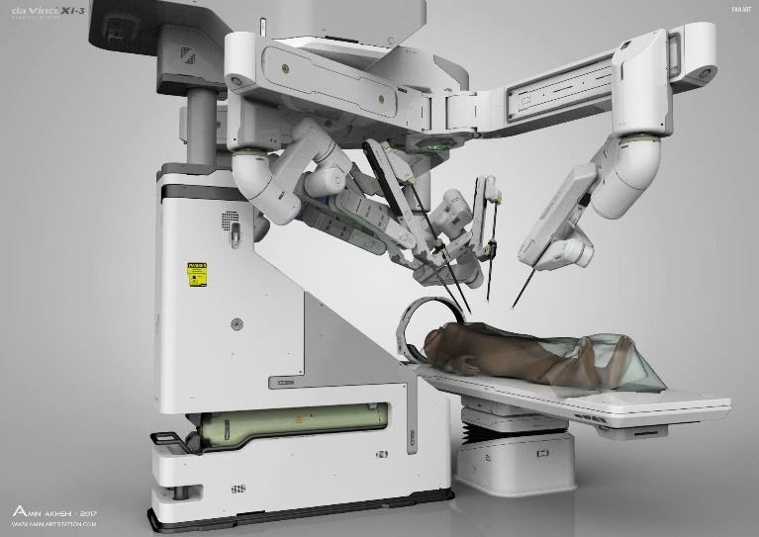

FIGURE 1 DA VINCI SURGICAL SYSTEM

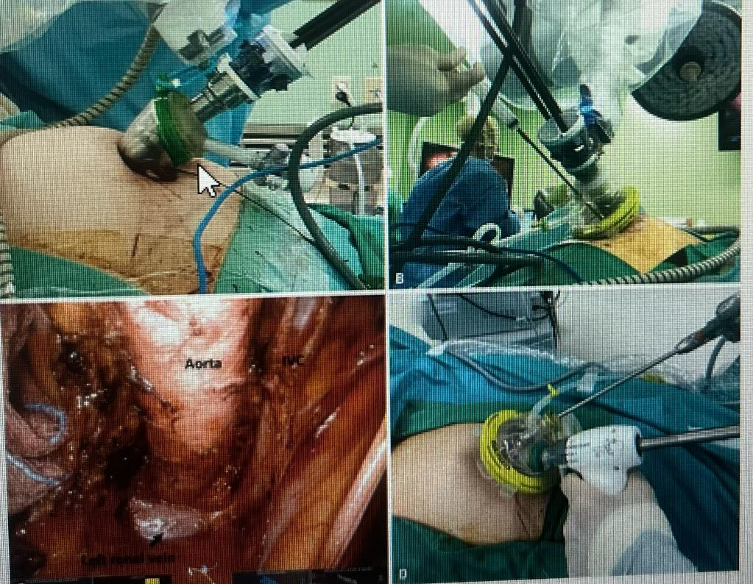

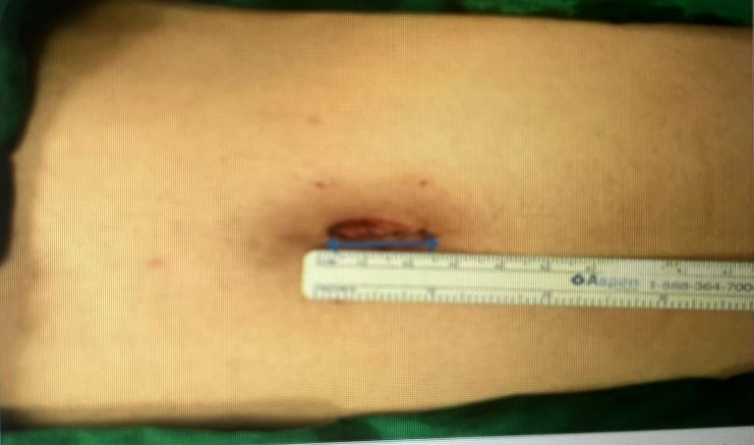

**4.0 IMPACT OF COVID-19 ON ROBOTIC SURGERIES:**

The medical field during COVID 19, the health care system created innovative solutions and adapted and survived surgical landscape by trying to return to pre pandemic practices and slowly return the non-emergent surgical procedures.[15] Following Covid pandemic the clinical advantages of the robotic surgery has never been more important. As suggested by the research, robotic surgery is related to enhanced clinical results for patients.[16]. Increased use of robotic surgery may result in decreasing use of hospital resource utilization[17]. Robotic surgery is related to fewer complications and the robotic surgeons have the lowest rate of operative complications. Due to Covid 19 many hospitals around the globe froze non-emergency surgical procedures considering safety concerns. Although it was necessary for societal safety, the surgical waiting period continued to grow[18]. Other challenges were posed while returning to non-emergency procedures. The availability and transmission risk to surgeons and medical staff, hopital resources and healthcare of the workers and patients were taken into consideration.[19]. With an already fragile health care system, efforts were made to use the surgical modal quality for best patient outcomes and minimum strain on the system.

**4.1ADVANTAGES OF ROBOT-ASSISTED SURGERY**

Robotic Surgery (assisted) is considered a boon to the field of medicine as it has numerous advantages and benefits when compared to the conventional open surgeries and MIS. Robot assistance is also used in open surgeries. Hospitalization is usually described as a traumatizing experience by patients. It creates both physical and physiological impacts on patients as hospitalization for a long period of time hinders with a person’s work-life.[31] Robot-assisted surgery requires smaller incisions which in turn reduces blood loss. It results in reduced scarring. The number of incisions are also less. As the incisions made are usually smaller when compared to MIS, it reduces pain and trauma of the patient. This consequently reduces the healing time of the patient and results in faster recovery rate and smaller hospitalization period. The risks of any infection are also greatly reduced as there is no biological exposure.[34] The incisions made are more precise as it provides the surgeon with clearer graphics that provide more details. The robot arms used in these surgeries generally have 6-7 degrees of freedom and there is more range of motion than a surgeon.

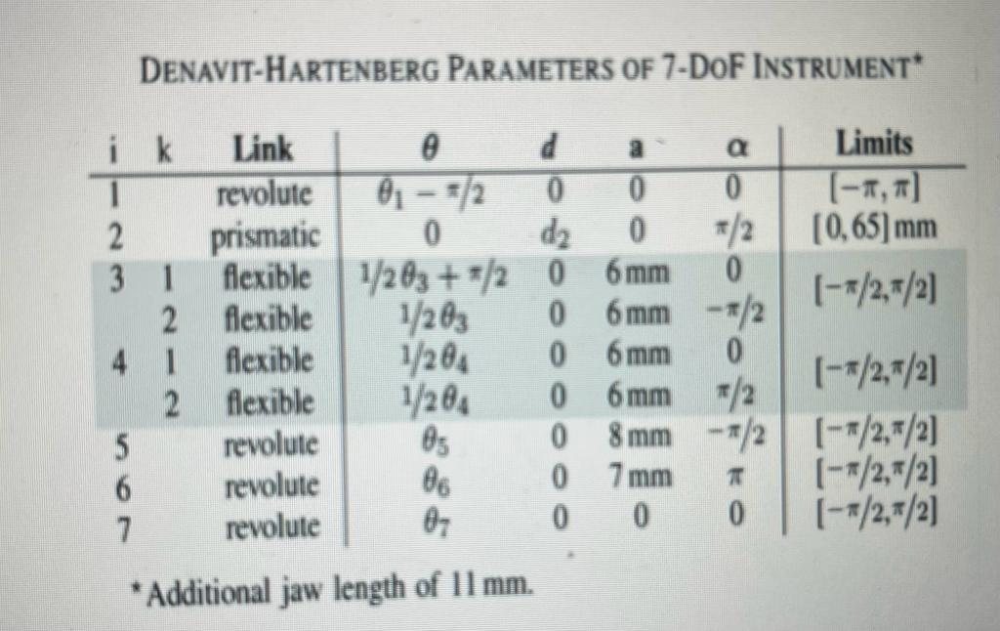

Fig 3. the table shows the range of the degrees of freedom of robotic arm used in surgeries.[32]

More complicated and advanced surgeries which have more health risks for the patients usually take hours to be completed by a team of surgeons. This causes surgeons to be fatigued. Robot arm, on the other hand, does not experience any exhaustion or tiredness. Moreover, the surgeon does not need to bend in awkward positions in order to operate the robot during surgery.[1]Robotic arms are more suitable to exploit narrow excess routes.[31] colour mapping depth data of internal organs can also be obtained instantly and in turn makes it easier to locate tumors, etc and to make more precise incisions accordingly

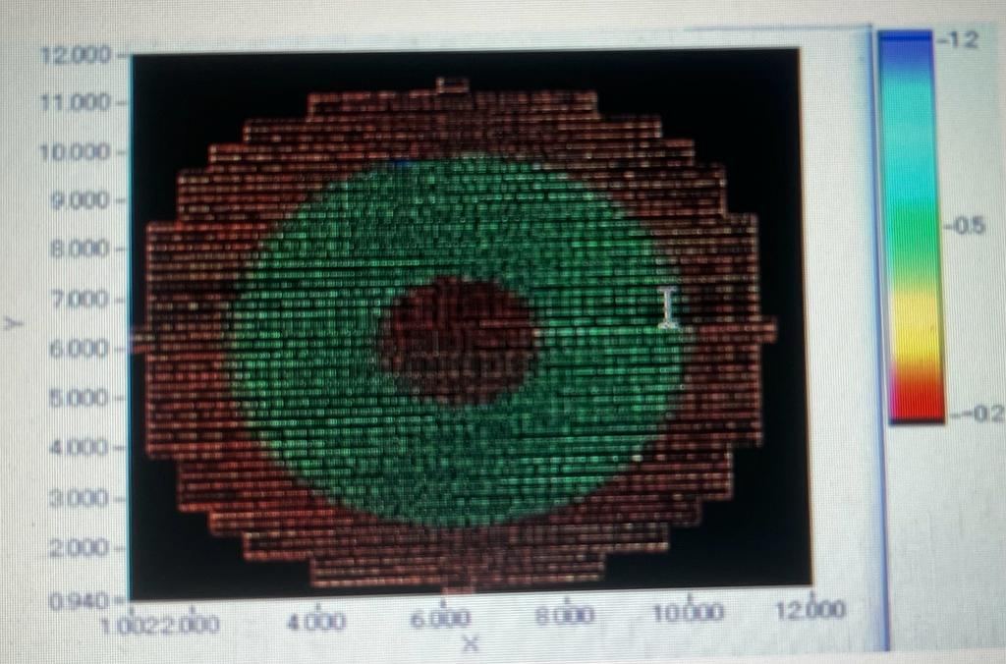

(Fig 3. Colour mapping depth data of human brain after surface scanning.)[35]

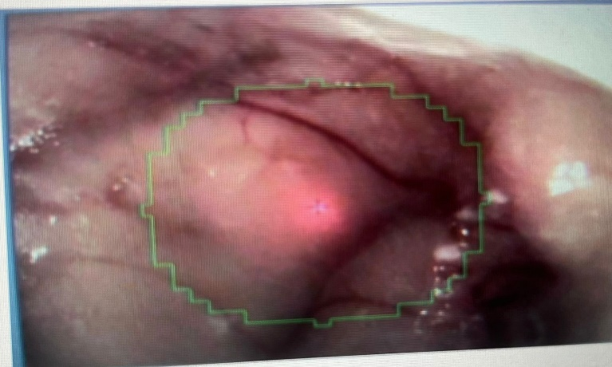

(Fig 4. CCD camera image of a dissected porcine brain with an imposed outline of the sphere.)[35]

**4.2DISADVANTAGES OF ROBOT-ASSISTED SURGERY**

Like every technological development, robot-assisted surgery also comes with a fare-share of drawbacks. Using robot-arms it gets difficult to insert flexible tools and guide them into especially the abdominal tract. Robotic surgery model consists of various cables used to transmit information about the depth of abnormalities like tumors, etc in the patient’s body, and communicate with the doctor operating the device via a computer in the same space. These cables can restrict the range of motion of robotic devices and consume the already limited workspace. These may intertwine during the surgery. There is a time-delay between the surgeon’s instructions and the movement of the robot arms. This time delay can cause serious damage to the patient’s health in case of an emergency. Another ambiguity due to this delay is that it hinders the stability and performance of bilateral teleoperation systems. Factors like space and maneuverability are also big limitations and hence hinders development in this field. Cost of the mechanism is the most crucial drawback and this hinders with its marketability. As the surgeon is not in contact with the tools, he/she may not be able to control the amount of force required to make incisions as he/she cannot experience the effects. Force greater than required causes serious physical damage to the patient. It has similar kinds of hazards as open surgery, including injuries to intra-abdominal organs. There also are risks of medical complications such as stroke, heart attacks and blood clots in the legs. General anesthetic is generally very safe, but occasionally There are problems with this as well. Smaller incisions generally mean less pain and discomfort compared to large abdominal incisions. Robotic and other minimally invasive surgeries can minimize the risks of pneumonia and blood clots in the legs, because only small incisions are required. The benefits of any surgical procedure cannot be guaranteed. Pre-operative assessment of a patient’s overall health is a key element in every surgical decision at UC Davis Health. Successful outcomes depend on both the patient and the procedure. Patients should always discuss all treatment options with their physician to understand the risks and benefits. Not all patients are suitable for robotic surgery. Severe medical problems and/or advanced age may mean that the patient cannot tolerate the special positioning and length of the procedure. Severe obesity is a common limitation, although robotic surgery can sometimes be successful when standard laparoscopy is not feasible. Severe intra-abdominal scar tissue due to previous surgery may prevent a minimally invasive approach. Your surgeon will discuss treatment options and help you decide the best course of action.

**4.3 RESULTS**

Since the invention and theory, Robotic surgery has shown an evolutionary scope in the medical field. Many Robotic Surgical systems were made but only a few which were approved and used for years. One of the main factors of robotic surgery is accuracy, which makes the system well known. Their continuous upgradation and evolution has surpassed many aspects in surgery till today.

|  |  |
| --- | --- |
| ZEUS SURGICAL SYSTEM | 93% |
| DA VINCI SURGICAL SYSTEM | 98% |
| RAVEN | 90% |
| MIROSURGE | 89% |
| SEHANCE | 85% |
| FLEX | 87% |
| VERSIUS | 85% |
| SPORT | 70% |

**5.0 CONCLUSIONS**

Although still new in the medical field, robotic surgery is a pioneer evolution in surgery that has and will have extensive significance. With continuous upgradation of accuracy and agility, the technology allows surgeons to perform operations that were generally not manageable to minimal access techniques. As a result, the advantages of minimal access surgery may be acceptable to a wider range of procedures. Safety has become well established, and many cases have reported approvable outcomes. According to the attestation inserted in the technology assessment, robot-assisted surgery may have an effect on numerous clinical results in patients experiencing prostatectomy, partial nephrectomy, or hysterectomy, and benefits vary between indications. Results on robot-assisted cardiac surgery were sparse but tended to favour robot-assisted surgery in regards to duration of hospital stay

**ACKNOWLEDGEMENT**

We would like to thank our group members for their efforts and hardwork for their contribution in the project. Our group members include Rida Shaikh, Alisha Bijapure, Siddhesh Kanase and Aditya Ghodke

**REFERENCES**

[1] Tim Lane, Consultant Urologist and Robotic Surgeon, Annals of The Royal College of Surgeons of England (2018) [2] Kwoh YS, Hou J, Jonckheere EA, Hayati S IEEE Trans Biomed Eng. 1988 Tim Lane, Consultant Urologist and Robotic Surgeon, Annals of The Royal College of Surgeons of England (2018) [3] Davies BL, Hibberd RD, Ng WS, Timoney AG, Wickham JE Proc Inst Mech Eng H. 1991 Tim Lane, Consultant Urologist and Robotic Surgeon, Annals of The Royal College of Surgeons of England (2018) [4]Corliss WR, Johnson EG. Teleoperators and Human Augmentation. An AEC-NASA Technology Survey. 1967. Washington, DC: Office of Technology Utilization, National Aeronautics and Space Administration. [5] HWR Schreuder, RHM Verheijen Department of Women and Baby, University Medical Centre Utrecht, Utrecht, the Netherlands Correspondence: Prof RHM Verheijen, Department of Woman and Baby, University Medical Centre Utrecht, Utrecht, the Netherlands(2008) [6] Surgical robotics: the early chronicles: a personal historical perspective. Satava RMSurg Laparosc Endosc Percutan Tech. 2002 Feb Tim Lane, Consultant Urologist and Robotic Surgeon, Annals of The Royal College of Surgeons of England (2018) [7] The evolution of and early experience with robot-assisted mitral valve surgery. Felger JE, Nifong LW, Chitwood WR Jr Surg Laparosc Endosc Percutan Tech. 2002 Feb Tim Lane, Consultant Urologist and Robotic Surgeon, Annals of The Royal College of Surgeons of England (2018) [8] Challacombe BJ, Khan MS, Murphy D, Dasgupta P World J Urol. 2006 Jun; 24 [9] Young Hwa Kwak Hwajung Lee Kieun Seon Young Joo Lee Yong Jae Lee Sang Wun Kim Da Vinci Sp Single- Port Robotic Surgery in Gynecologic Tumors: Single Surgeon’s Initial Experience with 100 Cases. Yonsei University College of Medicine , Seoul, Korea. (2022) [10]Von Gruenigen VE, SaPwyer MD, Pomsky LE, Hurd WW. Recent innovations in minimally invasive surgery and implications for gynecology. J Gynecol Surg 2009. Young Hwa Kwak Hwajung Lee Kieun Seon Young Joo Lee Yong Jae Lee Sang Wun Kim Da Vinci Sp Single- Port Robotic Surgery in Gynecologic Tumors: Single Surgeon’s Initial Experience with 100 Cases. Yonsei University College of Medicine , Seoul, Korea. (2022) [11] Fig2.Yonsei University College of Medicine 2022.Yonsei Med J. 2022 Feb;63(2):179-186 [12] Young Hwa Kwak Hwajung Lee Kieun Seon Young Joo Lee Yong Jae Lee Sang Wun Kim Da Vinci Sp Single- Port Robotic Surgery in Gynecologic Tumors: Single Surgeon’s Initial Experience with 100 Cases. Yonsei University College of Medicine , Seoul, Korea. (2022) [13] Fig.2 :Yonsei University College of Medicine 2022.Yonsei Med J. 2022 Feb;63(2):179-186. [14] Lee S, Kim MR, Seong SJ, Paek J, Lee YS, Nam EJ, et al. Trends in robotic surgery in Korean gynecology. Gyne Robot Surg 2020;1:50–56. Young Hwa Kwak Hwajung Lee Kieun Seon Young Joo Lee Yong Jae Lee Sang Wun Kim Da Vinci Sp Single- Port Robotic Surgery in Gynecologic Tumors: Single Surgeon’s Initial Experience with 100 Cases. Yonsei University College of Medicine , Seoul, Korea. (2022) [15] (2020) New cases of COVID-19 in world countries. Johns Hopkins Coronavirus Resource Center, Johns Hopkins University & Medicine. https://coronavirus.jhu.edu/data/new-cases [16] Increasing minimally invasive hysterectomy: effect on cost and complications. Jonsdottir GM, Jorgensen S, Cohen SL, Wright KN, Shah NT, Chavan N, Einarsson JI Obstet Gynecol. 2011 May; 117(5):1142-1149

|  |  |
| --- | --- |
|  |  |
|  |  |