IDENTIFICATION OF PLANT DISEASE USING IMAGE PROCESSING TECHNIQUE

**Manikandan C**

Computer Science and Engineering Bannari Amman Institute of Technology,

Sathyamangalam, India [manikandan.cs19@bitsathy.ac.in](mailto:manikandan.cs19@bitsathy.ac.in)

**Manojkumar S**

Computer Science and Engineering Bannari Amman Institute of Technology,

Sathyamangalam, India [manojkumar.cs19@bitsathy.ac.in](mailto:manojkumar.cs19@bitsathy.ac.in)

**Dr.K.Saranya**

Assistant Professor/CSE Bannari Amman Institute of Technology, Sathyamangalam, India [saranyaks@bitsathy.ac.in](mailto:saranyaks@bitsathy.ac.in)

**Haran H**

Computer Science and Engineering Bannari Amman Institute of Technology,

Sathyamangalam, India [haran.cs19@bitsathy.ac.in](mailto:haran.cs19@bitsathy.ac.in)

***Abstract***—*Agriculture productivity is a key factor in economic growth. This is one of the reasons that plant disease detection is crucial in the sector of agriculture, as the presence of illness in plants is extremely common. If necessary precautions are not followed in this region, plants suffer major consequences, which have an impact on the quality, quantity, or productivity of the corresponding products. For instance, the United States has pine trees that are susceptible to a dangerous illness called small leaf disease. The use of an automatic method for plant disease detection is advantageous because it lessens the amount of labour required to monitor large crop farms and can identify disease symptoms at their earliest stage, when they first emerge on plant leaves. The automatic identification and categorization of plant leaf diseases using an image segmentation system is presented in this work. It also includes an overview of various disease categorization strategies that can be applied to the detection of plant leaf disease. Discrete & Convolution technique is used for image segmentation, a crucial step in the disease diagnosis process for plant leaf disease.*

***Keywords****— CNN, Naïve Bayes, automatic, detection, disease.*

1. **INTRODUCTION**

In today's world, the agricultural land mass serves as more than just a source of food. The Indian economy is heavily reliant on agricultural output. As a result, it is crucial to identify plant diseases in the agricultural area. Use of an automatic disease detection technology is advantageous for spotting a plant disease in its very early stages. For instance, the United States has pine trees that are susceptible to a dangerous illness called small leaf disease. The afflicted tree grows slowly and perishes within six years. Alabama and Georgia are affected, as are other Southern US states. Early discovery in these situations might have been beneficial. Experts can identify and detect plant problems with nothing more than their own naked eyes nowadays, according to the current approach for disease detection in plants. This requires a sizable team of experts and ongoing plant monitoring, both of which are quite expensive when dealing with huge farms. Nevertheless, in some nations, farmers lack access to sufficient resources and even know they can consult specialists. Because of this, consulting specialists is expensive and time-consuming. The suggested method works well in these circumstances for keeping an eye on vast fields of crops.

It is simpler and less expensive to automatically identify diseases based just on their symptoms on plant leaves. In order to enable image-based automatic process control, inspection, and robot guiding, this also supports machine vision.

Visual diagnosis of plant diseases is more time-consuming, less accurate, and only practicable in a few locations. But, using an automatic detection method will require less work, less time, and result in a higher degree of accuracy. Brown and yellow spots, early and late scorch, and other common bacterial, viral, and fungal diseases are all present in plants. Image processing is performed to quantify the size of the diseased area and identify any differences in colour.

The technique of dividing or classifying an image into different regions is known as image segmentation. Currently, there are numerous methods for accomplishing picture segmentation, from the straightforward there sholding approach to sophisticated colour image segmentation techniques. Usually, these components correspond to something that people can easily split into independent items and see. There are numerous techniques for segmenting photos because computers lack the ability to recognise items intelligently. The image's numerous attributes are the basis

for the segmentation procedure. This could be a fragment of an image, colour information, or boundary information.

# PROBLEM STATEMENT

In India, agriculture plays a crucial role in economic growth. In India, the agricultural industry employs about half of the workers. Pulses, rice, wheat, spices, and spice products are all produced in the greatest quantities worldwide in India. The quality of the products that farmers produce, which is dependent on plant growth and yield, determines the farmers' economic growth. Thus, it is critical to identify plant diseases in agriculture. Diseases that prevent plant growth are quite likely to affect plants, which has an impact on the ecology of the farmer. When a plant disease is found early on, it is desirable to utilise an automated disease detection technique. Plant diseases can show up in many areas of the plant, including the leaves. The manual diagnosis of plant disease using leaf images takes a lot of time. To automate the process of illness identification and categorization using leaf photos, computational techniques must be created.

# EXIXTING SYSTEM

To retrieve leaf biochemical data such as leaf mass per area (LMA), equivalent water thickness, and leaf chlorophyll concentration (Chl), the leaf optical model PROSPECT is frequently employed (EWT). The majority of techniques for determining leaf pigment content are based on reflectance spectra and may encounter issues during the inversion process. By including continuous wavelet analysis into the PROSPECT model inversion procedure, this study suggests a novel inversion technique. The merit function for inversion is constructed using the wavelet modified spectra from different scales in this method rather than directly inputting reflectance as in most studies. Using information from wheat and rice crop small-plot trials, the performance of the proposed strategy was assessed. Our test results showed that, in comparison to reflectance spectra and vegetation indices, wavelet-transformed spectra provided improved inversion performance (VIs). For Chl and retriev, Chl and and the wavelet decom composition scales are separate scales for Chl and Car. Without the use of calibration models, this inversion technique has a significant deal of potential for forecasting the leaf pigment content of various crops.

# PROPOSED SYSTEM

The Nave Bayes method is used to diagnose the diseases in this suggested system. In addition, we compare the growth times needed for the plant with and without a certain disease.

The percentage of the damaged region is displayed, and as a result, a list of fertilisers and organic disease-treating techniques is suggested as part of the outcome. The diseases on which we focus in the suggested system are Brown spot, Bacterial leaf steak, and Black horse riding.

# FEATURES IN PROPOSED SYSTEM

* In comparison to the SVM method, Navie Bayes requires less data sets.
* It's capable of making probabilistic forecasts.

# HARDWARE REQUIREMENTS

Processor : Intel Core i3.

Ram : 4 GB DDR2 RAM

Monitor : 15” COLOR

Hard Disk : 100 GB

# SOFTWARE REQUIREMENTS

Back End : SQLITE Operating System : Windows 07

IDE : Eclipse, Android Studio

# METHODOLOGY

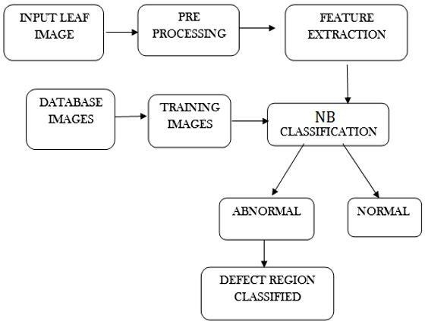

**IMAGE ACQUISITION:**

For this study, a digital camera was used to capture colour photographs of the weeds and the crops. In the fields, the sample pictures are taken. Images are collected throughout the day at various periods. In order to make the classification issue more challenging, crops and weeds with different canopy sizes were chosen. The weed and crop photographs were captured with a digital camera and a natural light source at a 45-degree angle to the ground. The camera is positioned

2.15 metres above the ground. When taking pictures, the camera's resolution is set to 3648 x 2736 pixels. To speed up calculation during the experimental analysis, all of the photos were downsized to 320 by 240 pixels.

# IMAGE SEGMENTATION:

The goal of this step is to make an image's representation as straightforward as possible so that it may be more easily understood and analysed. This stage is the essential method of image processing since it serves as the foundation for feature extraction. Images can be segmented using a variety of techniques, including thresholding, Otsu's algorithm, and k-means clustering. Based on a collection of features, the k- means clustering divides objects or pixels into K number of classes. By reducing the sum of squares of distances between the items and the clusters that correspond to them, classification is accomplished.

# IMAGE MATCHING:

The process of matching is used to determine whether a pattern exists within a given description. An essential application in the realm of image processing is image matching. In the form of n-dimensional feature vectors, images are represented. The features of objects belonging to the same class are the same as those of objects belonging to a different class. Features are employed in the image matching process to determine whether or not two photos are similar. Even we are able to determine whether or not the pattern image is a subset of the original image. The feature vectors of several photos are compared in order to determine similarities. A quick matching method should be able to identify similarities or differences.

# IMAGE PRE-PROCESSING:

**RGB TO GRAY SCALE**

The procedure used for grey transformation is used to convert colour images to grayscale. By reducing the amount of colour data in the image, grey transformation speeds up the subsequent processing. In the grayscale image, the colour contrast that distinguishes the background from the plants in the colour images should be preserved as much as feasible. A grayscale image, commonly known as a black-and-white image, is an image in which each pixel contains a single sample and only information about intensity.

# Describe GRAYSCALE. Why is GRAYSCALE?

A grayscale or grayscale image is one in which the value of each pixel is a single sample indicating only a quantity of light, that is, it conveys only intensity information, in photography, computers, and colorimetry. Pictures of this type are completely formed of shades of grey, ranging from black at the weakest intensity to white at the strongest. They are also known as black-and-white or monochromatic images. Grayscale images are distinct from one-bit bi-tonal black-and-white images, which are images with only two colours, black and white, in the context of computer imaging (also called bi-level or binary images). There are numerous shades of grey in between in grayscale photos.

When only one frequency (in practise, a restricted band of frequencies) is acquired, grayscale images can be produced by measuring the intensity of light at each pixel in accordance with a specific weighted combination of frequencies (or wavelengths). In such circumstances, the images are monochromatic proper. The electromagnetic spectrum is

open to theoretically any location for the frequencies (e.g. infrared, visible light, ultraviolet, etc.).

An picture with a defined grayscale colour space that maps the sample values to the achromatic channel of a standard colour space, which is based on the observed characteristics of human vision, is said to be colorimetric (or, more precisely, photometric).

There is no special mapping from such a colour image to a grayscale image if the original colour image does not have a specified colour space or if the grayscale image is not meant to have the same human-perceived achromatic intensity as the colour image.

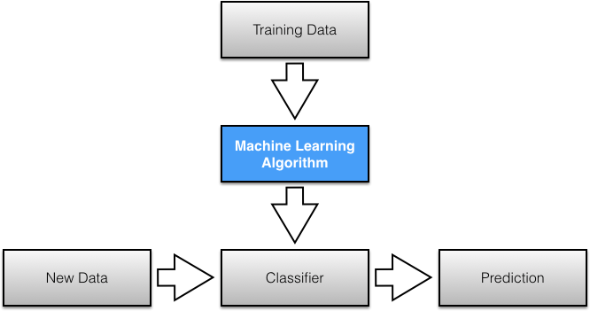

# NAIVE BAYES ALGORITH:

The Bayes Theorem is the foundation of the probabilistic machine learning method known as Naive Bayes, which is utilised for a variety of classification problems. In order to eliminate any potential for misunderstanding, we will thoroughly explain the Naive Bayes method in this post.

Naive Bayes is a fantastic illustration of how the most straightforward answers are frequently the most effective. Despite recent developments in machine learning, it has shown to be not only quick, accurate, and dependable but also simple.

It has been used successfully for many things, but it excels at solving natural language processing (NLP) issues.

The Bayes Theorem is the foundation of the probabilistic machine learning method known as Naive Bayes, which is utilised for a variety of classification problems. In order to eliminate any potential for misunderstanding, we will thoroughly explain the Naive Bayes method in this post.

A straightforward mathematical procedure for computing conditional probabilities is known as Bayes' Theorem.

The possibility of an event happening given that another event has already occurred (via assumption, presumption, statement, or evidence) is known as conditional probability.

The equation is: —

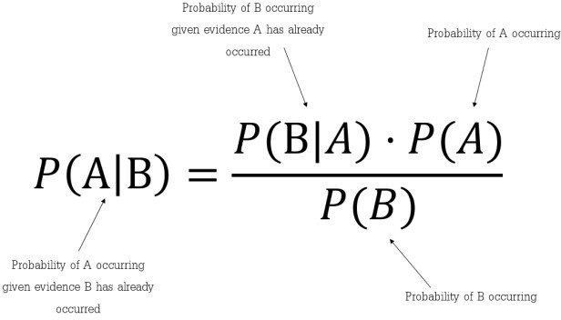m.put(rgb, counter);

}

}

String colourHex = getMostCommonColour(m);

}

It provides information about how frequently A occurs when B occurs, denoted by the symbol P(A|B), also known as the posterior probability. When we know how likely A is on its own, written P(A), how likely B is on its own, written P(B|A), and how frequently B occurs provided that A occurs, written P(B|A) (B).

Bayes' Theorem, to put it simply, is a method of determining a probability when we are aware of a given set of other possibilities.

# CODINGS:

**BITMAP Extraction**

Image preprocessing: (Bitmap extraction and Grayscale conversion)

package Util;

import android.graphics.Bitmap;

import java.util.Collections; import java.util.Comparator; import java.util.HashMap; import java.util.LinkedList; import java.util.List;

import java.util.Map; publicclass ImageColour {

public ImageColour(Bitmap image) throws Exception { int height = image.getHeight();

int width = image.getWidth(); Map m = new HashMap();

for (int i = 0; i < width; i++) for (int j = 0; j < height; j++) {

int rgb = image.getPixel(i, j); int[] rgbArr = getRGBArr(rgb);

if (!isGray(rgbArr)) {

Integer counter = (Integer) m.get(rgb); if (counter == null)

counter = 0; counter++;

publicstatic String getMostCommonColour(Map map) {

List list = new LinkedList(map.entrySet()); Collections.sort(list, new Comparator() {

publicint compare(Object o1, Object o2) {

return ((Comparable) ((Map.Entry) (o1)).getValue())

.compareTo(((Map.Entry) (o2)).getValue());

}

});

Map.Entry me = (Map.Entry) list.get(list.size() - 1); int[] rgb = getRGBArr((Integer) me.getKey());

return Integer.toHexString(rgb[0]) + " " + Integer.toHexString(rgb[1]) + " " + Integer.toHexString(rgb[2]);

}

publicstaticint[] getRGBArr(int pixel) { int red = (pixel >> 16) & 0xff;

int green = (pixel >> 8) & 0xff; int blue = (pixel) & 0xff;

returnnewint[]{red, green, blue};

}

publicstaticboolean isGray(int[] rgbArr) { int rgDiff = rgbArr[0] - rgbArr[1];

int rbDiff = rgbArr[0] - rgbArr[2];

int tolerance = 10;

if (rgDiff > tolerance || rgDiff < -tolerance) if (rbDiff > tolerance || rbDiff < -tolerance) {

returnfalse;

}

returntrue;

}

}

*Image cropping and view manager module code:*

package Util;

if (mStart == 0) {

mStart = now;

import android.content.Context; import android.graphics.Canvas; import android.graphics.Movie; import android.net.Uri;

import android.os.SystemClock; import android.util.AttributeSet; import android.util.Log;

import android.view.View;

import java.io.FileNotFoundException; import java.io.InputStream;

publicclass GifImageView extends View {

private InputStream mInputStream; private Movie mMovie;

privateint mWidth, mHeight; privatelong mStart;

private Context mContext;

public GifImageView(Context context) { super(context);

this.mContext = context;

}

public GifImageView(Context context, AttributeSet attrs) { this(context, attrs, 0);

}

public GifImageView(Context context, AttributeSet attrs, int defStyleAttr) {

super(context, attrs, defStyleAttr); this.mContext = context;

if (attrs.getAttributeName(1).equals("background")) { int id = Integer.parseInt(attrs.getAttributeValue(1).substring(1));

setGifImageResource(id);

}

if (mMovie != null) {

int duration = mMovie.duration(); if (duration == 0) {

duration = 1000;

}

int relTime = (int) ((now - mStart) % duration); mMovie.setTime(relTime);

mMovie.draw(canvas, 0, 0); invalidate();

}

}

publicvoid setGifImageResource(int id) { mInputStream =

mContext.getResources().openRawResource(id); init();

}

publicvoid setGifImageUri(Uri uri) { try {

mInputStream = mContext.getContentResolver().openInputStream(uri);

init();

} catch (FileNotFoundException e) { Log.e("GIfImageView", "File not found");

}

}

}

# OUTPUT:

}

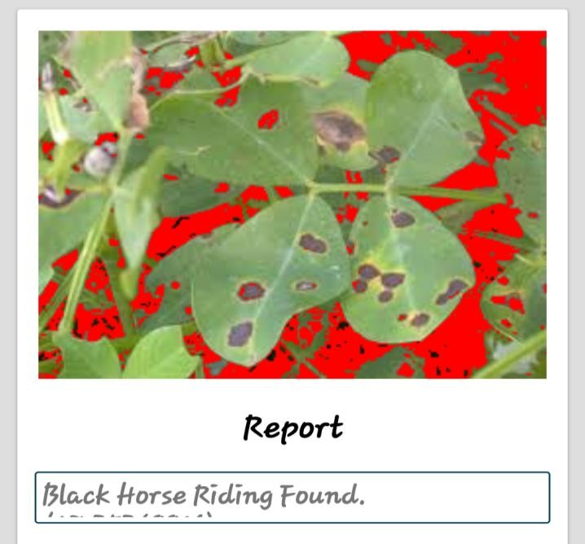}

privatevoid init() { setFocusable(true);

mMovie = Movie.decodeStream(mInputStream); mWidth = mMovie.width();

mHeight = mMovie.height();

requestLayout();

}

@Override

protectedvoid onMeasure(int widthMeasureSpec, int heightMeasureSpec) {

setMeasuredDimension(mWidth, mHeight);

}

@Override

protectedvoid onDraw(Canvas canvas) { long now = SystemClock.uptimeMillis();

**II. CONCLUSION**

In this study, area thresholding-based segmentation and classification techniques are established. To get the precisely categorised images, area thresholding techniques and excess green grey transformation (ExG) are coupled. The system displays a reliable and efficient classification of camera-taken photos. The image segmentation algorithm is a very helpful tool for processing images, both before and after other processing. It has been demonstrated that the outcomes are better when the plants are depicted separately from one another. For a reliable study, the lighting conditions are also crucial.

# References

1. Wenjiang Huang, Qingsong Guan, Juhua Luo, Jingcheng Zhang, Jinling Zhao, Dong Liang, Linsheng Huang, and Dongyan Zhang, “New Optimized Spectral Indices for Identifying and Monitoring Winter Wheat Diseases”, IEEE journal of selected topics in applied earth observation and remote sensing,Vol. 7, No. 6,

June2014

1. Dr.K.Thangadurai, K.Padmavathi, “Computer Visionimage Enhancement For Plant Leaves Disease Detection”, 2014 World Congress on Computing and CommunicationTechnologies.
2. Monica Jhuria, Ashwani Kumar, and Rushikesh Borse, “Image Processing For Smart Farming: Detection Of Disease And Fruit Grading”, Proceedings of the 2013 IEEE Second International Conference on Image Information Processing(ICIIP-2013
3. Zulkifli Bin Husin, Abdul Hallis Bin Abdul Aziz, Ali Yeon Bin Md Shakaff Rohani Binti S Mohamed Farook, “Feasibility Study on Plant Chili Disease Detection Using Image Processing Techniques”, 2012 Third International Conference on Intelligent Systems Modelling andSimulation.
4. Mrunalini R. Badnakhe, Prashant R. Deshmukh, “Infected Leaf Analysis and Comparison by Otsu Threshold and k-Means Clustering”, International Journal of Advanced Research in Computer Science and Software Engineering, Volume 2, Issue 3, March2012.
5. H. Al-Hiary, S. Bani-Ahmad, M. Reyalat, M. Braik

and Z. ALRahamneh, “Fast and Accurate Detection and Classification of Plant Diseases”, International Journal of Computer Applications (0975 – 8887)Volume 17–

No.1, March2011

1. Chunxia Zhang, Xiuqing Wang, Xudong Li, “Design of Monitoring and Control Plant Disease System Based on DSP&FPGA”, 2010 Second International Conference on Networks Security, Wireless Communications and TrustedComputing.

[8]A. Meunkaewjinda, P. Kumsawat, K. Attakitmongcol and A. Srikaew, “Grape leaf disease detection from color imagery using hybrid intelligent system”, Proceedings of ECTI-CON2008.