## MODELING AND ANALYSIS OF PLANETARY GEAR TRAINS USING FINITE ELEMENT METHOD

## 1 BATCHU YESWANTH, 2 S. KUSUMA KUMARI 3K SIVA RAJU

1M.Tech Student, Department of Mechanical Engineering, Helapuri Institute of Technology and Science,

Eluru, Andhra Pradesh.

2 Assistant Professor, Department of Mechanical Engineering, Sir C.R.Reddy College of Engineering,

Eluru, Andhra Pradesh.

3 AssistantProfessor, Head of the Department, Department of Mechanical Engineering, Helapuri Institute of Technology and Science, Eluru, Andhra Pradesh.

**ABSTRACT**

Planetary gear trains are generally used in helicopters, aircraft engines, automobiles, and wind turbines for speed reduction and slowdown motors and increase the torque. The general problems in a common gearbox are gear failure problems due to the wear and tear of the gears during rotating and the vibrations produced while transmission. This problem occurs in most gearboxes but in the case of the planetary gearbox, these problems can’t be found before failure due to the complex shape of the planetary gearbox. The main objective of this project is to develop a parametric model of the planetary gearbox by using Catia v5 and perform the Static modal analysis in ansys software by using the various materials like Structural steel, AL 7075, 15Ni5Cr4Mo1, Grey cast Iron using different revolutions (2500rpm, 3500rpm) under static and modal loading conditions. Comparisons of Stress, strains, deformations using Ansys .Finally were concluded on the best material based on the results

# INTROUDCTION OF PLANETARY GEAR:

Planetary gearbox is extensively utilized in commercial machineries and system gear to obtain pace discount, which in flip will increase the torque. These gearboxes are used in lots of applications together with strength transmission machine and hybrid transmission structures. Planetary tools trains are one of the essential subdivisions of the simple planetary tools train arrangement. The Planetary tools educate arrangement in wellknown has a crucial “solar” gear which meshes with and is surrounded via planet gears. The outer maximum gear, the hoop tools, meshes with each of the planet gearsThe planet gears are attached to a cage or carrier that keeps the planets in relative orbit. Planetary equipment is a widely used business product in mid-stage precision industry, which includes printing lathe, automation meeting, semi-conductor equipment and automation gadget. Planetary gearing could boom torque and reduce load inertia even as minimized the velocity. To examine with traditional gearbox, planetary tools box has several benefits. One benefit is its unique mixture of both compact arrangement and splendid energy transmission efficiencies. A ordinary efficiency loss in a planetary gearbox association is best 3% in step with degree. This kind of performance guarantees that a excessive percentage of the strength being input is transmitted thru the gearbox, in place of being wasted on mechanical losses inside the gearbox. Another benefit of the planetary gearbox arrangement is load distribution. Because the weight being transmitted is shared among a couple of planet gear, torque functionality is significantly improved. Higher load ability, as well as higher torque density is obtained with more planet gear in the system. The planetary gearbox arrangement also creates greater stability due to the even distribution of mass and increased rotational stiffness.

.**WORKING OF EPICYCLIC GEARBOX**

## The principle of operation of the planetary gearbox is primarily based at the truth that one of the gearwheels (e.G., sun gear, planetary equipment and crown) is fixed to achieve the torque or output speed. Items required Due to the previous configuration, a high torque is received at high speeds. The transmission ratio has changed. Let's see how we will get these reports.

## FIRST GEAR RATIO

## This gives a torque-to-automobile ratio which facilitates the car to transport out of its original state and is accomplished via repairing the gears, thereby rotating the service with the energy supplied to the heater.

## Second gear ratio

## This affords a high pace dating with the vehicle to help the vehicle reach better speeds as you force: these relationships are received via solving the sun tool, making the planetary carrier, and the detail, a riding element. Ring using excessive-speed relationship to attain.

## Reverse gear ratio

This acceleration reverses the path of the output shaft, which constantly transports the automobile's route. The device is disassembled by means of setting a planetary support, remodeling the motive force right into a gear and a solar tool.

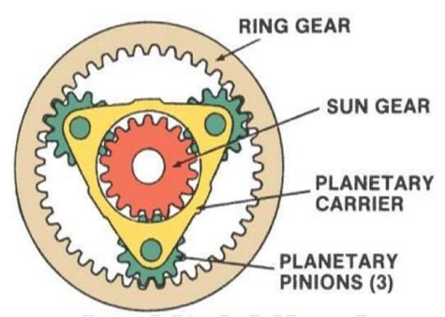

**Figure 1 Planetary gear**

**RING GEAR-** It is a tools that seems like a hoop equipment. Its internal floor has angular incisors and is located out of doors the planetary tools container. The internal teeth of the hoop equipment hold a constant mesh with a collection of planetary gears at the outer factor.

**SUN GEAR-** It is a equipment with beveled enamel inside the middle of the planetary gearbox; The sun equipment keeps regular internal touch with the planetary gear and is attached to the input shaft of the planetary equipment.

**PLANET GEARS-** These are small gears which can be used among the crown and the sun tools.The planetary tools shaft is attached to the planetary equipment help, which carries the output shaft of the planetary gearbox.Planetary gears can rotate around their axis, or they can rotate among rings

**ADVANTAGES OF PLANETARY GEAR SYSTEM**

1. The planetary gear device may be used to make certain a better transmission ratio in a compact space. That is why we choose to use planetary gears in conditions where pace discount is needed in a compact area.
2. For comparable transmission ratios, the planetary appliance system is lighter than normal transmission.
3. The power transmission efficiency will be relatively good compared to traditional gearboxes. A greater part of the energy supply will be provided using this leverage scheme.
4. The planetary gear system will have greater torque transmission capabilities and less inertia
5. As we are able to see right here, the switch rate will be allotted on multi-gadget gears, so the load distribution might be excellent and the torque switch will also be improved through the usage of planetary tools transmission.
6. For planetary equipment structures, the guiding and guiding elements are concentric, so the guiding and guiding device may be hooked up on the equal line, saving area.
7. For planetary gear structures, the guide and guide elements are concentric in order that publications and guide gadgets may be mounted on the identical line, saving area.
8. The quality of service is also good compared to the traditional life of gear boxes for a uniform load.

# DISADVANTAGES OF PLANETARY GEAR SYSTEM

1. Compared with traditional gearboxes, the cost of gear systems can be high.
2. The design and manufacture of planetary appliance systems is very complex.
3. It is difficult to determine the effectiveness of planetary gear systems.
4. Firstly, the ratio of debt to equity must be accurate
5. Some planetary gear specifications generate additional noise during use.
6. To avoid leverage, the guide limb

# LITERATURE REVIEW

A literature assessment on planetary equipment educate design and analysis was done and a brief report of the same is offered as under:

Lehao Chang et.Al.[1] provided observe on strong version for determining the mesh stiffness of cylindrical gears. The deformation of gear tooth turned into separated right into a global term as well as a local contact term that combines the benefits of both the finite element method and analytical contact theory. The proposed method has higher computational efficiency and improved consistency when compared to traditional FE models using contact elements since it uses the substructure method and even the mesh technique. The mesh stiffness is greatly influenced by the gear body parameters. Mesh stiffness will be reduced as rim and web thickness are reduced. Furthermore, the size of the central hole will result in a noticeable change in mesh stiffness. The contact ratio of the gear pair changes as the helix angle, face width, pressure angle, and addendum coefficient change, and the same is true for mesh stiffness fluctuations and vibration of the gear pair.

Dr. Alexander Kapelevich [2] reported analysis and layout of differential epicyclical gear arrangements that offer extremely high equipment ratios. But this became suitable for low torque software like positioning in robotics.

Ovidiu Bunga et. Al.[3] of their look at on most advantageous mass minimization layout of two stage coaxial velocity reducer with Genetic Algorithm compared the traditional design of pace reducer with gold standard layout through GA. The have a look at approximately the change-off between the mass and the service existence changed into presented & they concluded that the desired service existence must be sacrificed with 75% for a 2.5 kg saving (more or less 7%).

Bernad et. Al.[4] presented a take a look at on light weight layout of planetary gears transmission. Higher range of applied planet gears effects in a higher mesh load component, in addition to an increasing difficulty in assembling the planets with low numbers of tooth. Thus the variety of tooth for the crucial gears turned into extended as a way to atone for the benefit of a higher energy department for better numbers of applied planets. Difference inside the centre distances of two equipment pairs was offset via making use of addendum modifications for transmission ideas with high tools ratios. In that case the addendum modifications can not be implemented in the first-class way to lessen the tooth-load elements, or to increase performance. One opportunity in order to gain same centre distances would be to use extraordinary everyday modules for every transmission stage.

Syed Ibrahim Dilawer et. Al.[5] provided look at on optimal layout of the tools train with the load evaluation finished within the gear trains by varying the module (three, 4, five, 6) for all of the gears for three different power degrees 10 HP, 15 HP and 20HP.

Cheon-Jae Bahk et al. [6] provided a nonlinear dynamic version of a planetary equipment with tooth profile amendment (TPM). The minimum dynamic response turned into done at special combination of solar–planet and ring–planet mesh TPM. Different TPMs are required for minimizing gear vibration depending on the amount of mesh stiffness fluctuation and the mesh segment. Different TPM minimizes the vibration at different vibration modes.

Complete Planetary Gearboxes with Torque, Weight, Costs, and Dimensional Restrictions.. PlanetaryVariant- Generator allows an arbitrary quantity of completely described planetary gearbox versions to be created routinely the usage of features for the format of equipment-ranges, shaft dimensions, bearings and planet service; given the specified torque capacity, lifestyles requirement, safety factors and the overall ratio. As distinct via the person, gearbox versions with unique number of levels and unique distribution of the ratios over the ranges are calculated. The weight reduction become higher than predicted, going up to 30%. Manufacturing price reduction was even higher, going up to 50%.

B. Venkatesh et. All [10] of their take a look at of design, modeling & production of helical tools carried a iterative study to design the tools by using AGMA & verified the consequences with ANSYS for the equipment used in marine utility with variation in fabric.

Dr. Ing. T. Schulze et. Al.[11] Presented record on load distribution in planetary gears the use of MDESIGN software program. The uniform load distribution on equipment flank gives better lifestyles. The Mdesign software gives whole product information in the early section of product lifestyles cycle (PLC).

G.G G.G. Antony[12] in take a look at on precision planetary gear-heads supplied advantages of planetary equipment-heads the use of with servo automobiles.

Antony[12] in look at on precision planetary gear-heads provided blessings of planetary equipment-heads the use of with servo cars.

Christopher G. Cooley1 el Al [13] The dynamics and vibration of planetary gears and planetary gears is a almost essential engineering hassle with many technical challenges. Planetary gears have a well described herbal frequency and vibration because of their cyclic symmetry. With the complexity of the version (including 3-D effects, continuous elastic flexibility and gyroscope outcomes)to attract user rotation, this structure is durableThe planetary gear's forced response model identifies the resonances of chain link stiffness fluctuations and nonlinearity caused by tooth separation.which also occurs in the measurements of the real planetary gear systems. By suggesting an appropriate number of teeth to reduce the speed of the bond, some of the harmonics of the response disappeared. Experiments with planetary gears are even rarer, and include complex phenomena such as elastic gear vibration.Planetary gear models are becoming more realistic and complex, with features such as elastic gear deformations, gyroscopic effects, and tooth changes.astic deformations of gears, gyroscopic effects and tooth changes. Research has addressed several production errors in planetary gears and the way these mistakes affect the dynamic response. The tooth floor modalities used in almost all gears should be designed the use of a planetary tools version of the system the use of remoted solar planet fashions and pair of annular planets. S. S. Sutar el Al [14] Try to use experimental and analytical techniques to calculate retaining or braking torque in epicyclic gear trains. The results are nearly the equal. Errors between analytical and experimental methods are because of mechanical and frictional losses that occur during the execution of the experiment. We have the potential to in addition validate experiments and analysis consequences in modeling software program consisting of Catia, UG and solid works as future targets for this test. The assessment of the consequences of the analysts and the experiments for the couple results in an mistakes of five.99% to 7.54%. This manner that the efficiency of the experimental setup is used 100%. There are some friction losses and mechanical losses. Several parameters impact the torque outcomes, consisting of engine efficiency, friction losses that occur among the belt and the cable drum, the pressure of the spring.

**FINDINGS OF LITERATURE REVIEW:**

From the above study on literature review of design and analysis of planetary gears following are few important points to be noted:

1. The extensive research in the field of planetary gear design has already been done.
2. b) Many researchers reported study on single stage planetary gears arrangement.
3. c) Planetary gear box are compact and light weight than the conventional gear box.
4. In design of planetary gear box, iterative considerations need to be given for composite arrangement to have minimum number of components, higher transmission efficiency, and higher load carrying capacity.
5. High reductions ratios are possible in single stage differential planetary gear arrangement but will work for low torque applications only like positioning systems in robotics, aerospace.

# PROJECT OVER VIEW

# OBJECTIVE OF THE PROJECT:

* Study the different Journals Related to the Planetary gear assembly.
* Study the complete design analysis concepts about the Planetary gear.
* Study the different materials Structural steel, Grey cast iron, 15Ni5Cr4Mo1, structural steel,Al 7075
* To design Planetary gear using the catia v5 software.
* Create Finite element model of the Planetary gear ANSYS software.
* Perform Structural analysis (Pre processor ,solution, post processor)
* Perform Static analysis to calculate the von-misses stress, Total deformation, Strain, Shear stress and Total deformation at different frequencies
* Finally concluded the suitable material of the Planetary gear assembly based on the stress, and total deformation values.

# 

# METHODOLOGY

Step 1: Collecting information and data related to planetary gear Assembly

Step 2: A fully parametric model of the planetary gear is created in catia software. Step 3: Model obtained in IGS File

Step 4 Analyzed using ANSYS 14.5 (work bench) to obtain stresses, strain, deformation, Shear stress in static analysis and Total deformation at different frequencies.

Step 5: Finally, we compare the results obtained from ANSYS using different materials. Step 6: Finally find out the best material of the planetary Gear.

# MATERIAL PROPERTIES:

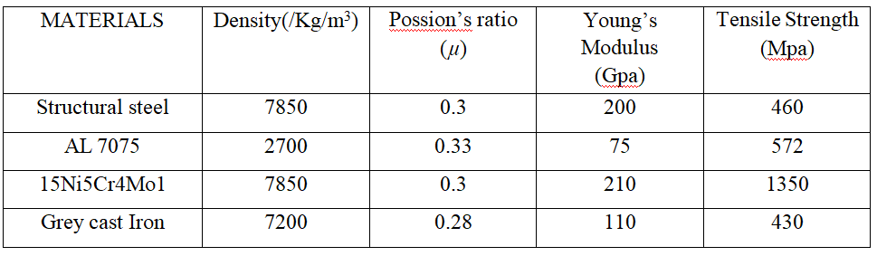

# GEAR DIMENSIONS

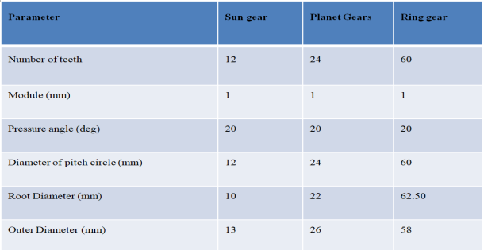

# INTRODUCTION OF CATIA

# DIMENSIONS AND DESIGN PROCEDURE IN CATIA:

## SUN GEAR:

Go to the sketcher workbench create the sun gear as per dimensions after go tot the part design apply pad .

## PLANET GEAR:

Go to the sketcher workbench create the planet gear as per the dimensions after go to the part design work bench create the pad

## RING GEAR:

Go to the sketcher workbench create the ring gear as per the dimensions after go to the part design work bench create pad as shown below figure

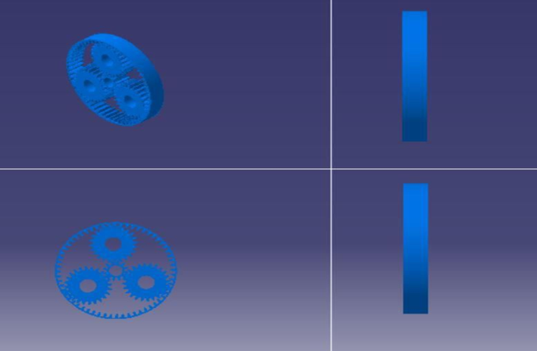

**Figure 2 Multi view of planetary gear assembly unit**

# INTRODUCTION TO ANSYS

ANSYS is a large-scale multipurpose finite element program developed and maintained by ANSYS Inc. to analyze a wide spectrum of problems encountered in engineering mechanics**.**

# PROGRAM ORGANIZATION:

The ANSYS program is organized into two basic levels:

* + - Begin level
    - Processor (or Routine) level

The Begin level serves as an entry and exit point for the ANSYS programme. It is also used for global programme controls such as changing the job name, clearing the dataset (zeroing out), and copying binary files. When you first enter the program, you are at the Begin level.

Coupled-area masses are really a special case of one of the above loads, in which results from one analysis are used as masses in any other analysis. For example, you could apply magnetic forces calculated in a magnetic field evaluation as pressure loads in a structural evaluation.

**STATIC ANALYSIS:**

A static analysis calculates the results of regular loading conditions on a shape, at the same time as ignoring inertia and damping effects, such as those because of time varying loads. A static analysis can, however, consist of consistent inertia masses (including gravity and rotational pace), and time-various hundreds that may be approximated as static equal masses (including the static equivalent wind and seismic masses normally described in many building codes). A static evaluation can be both linear or nonlinear. All styles of nonlinearities are allowed - massive deformations, plasticity, creep, pressure stiffening, contact (gap) elements, hyper elastic factors, and so on. This analysis offers a clean concept whether the shape or aspect will face up to for the carried out maximum forces. If the strain values obtained in this evaluation crosses the allowable cost, it's going to bring about the failure of the structure within the static condition itself. To keep away from the sort of failure, this analysis is important.

**MODELING OF SOLID ELEMENT:**

Modeling solid element named SOLID 45 is taken. It is the element which is having a higher

order 3-D, 8-node element. The element is defined by 8 Nodes having three ranges of freedom at every node: translations in the nodal x, y, and z guidelines. The element has plasticity, creep, swelling, strain stiffening, large deflection, and huge strain capabilities. It additionally has mixed components functionality for simulating deformations of nearly incompressible elastoplastic materials, and completely incompressible hyper elastic materials. The geometry, node places, and the coordinate gadget for this element are shown in the determine. In addition to the nodes, the element enter records consists of the orthotropic or anisotropic material residences. Orthotropic and anisotropic material guidelines correspond to the element coordinate guidelines.

**SYSTEM CONFIGURATIONS**:

# The current work employs ANSYS version for computational numerical analysis.

# 15.0 running on Pentium IV device, having 4GB ram and 160GB hard disk with Windows XP running gadget

# FINITE ELEMENT METHOD

# INTRODUCTION

The Basic concept in FEA is that the body or shape may be divided into smaller factors of finite dimensions known as “Finite Elements”. The authentic body or the structure is then taken into consideration as an assemblage of these factors connected at a finite wide variety of joints called “Nodes” or “Nodal Points”. Simple capabilities are selected to approximate the displacements over every finite detail. Such assumed capabilities are known as “form capabilities”. This will represent the displacement with inside the element in terms of the displacement at the nodes of the element.

## FEA has been used robotically in high extent production and production industries for decades, as to get a product layout wrong might be destructive. For example, if a large producer had to remember one version by myself due to a hand brake design fault, they might come to be having to replace up to few tens of millions of hand brakes. This will purpose a heavier loss to the enterprise.

## Basic Steps in FEA

# • Discretization of the area

# • Application of Boundary conditions

# • Assembling the system equations

# • Solution for system equations

# • Post processing the outcomes.

# ANALYSIS PROCEDURE IN ANSYS:

Designed component in catia workbench after imported into ansys workbench now select the steady state thermal analysis .

1. ENGINEEERING MATERIALS (MATERIAL PROPERTIES).
2. CREATE OR IMPORT GEOMENTRY.
3. MODEL(APPLY MESHING).
4. SET UP(BOUNDARY CONDITIONS)
5. SOLUTION
6. RESULTS

# STATIC STRUCTURAL ANALYSIS

# Static structural analysis computes the stresses, displacements, shear stress, and forces in structures caused by a load with no significant inertia or damping effects. It is assumed that the workload and response conditions are stable; that the loads and the structure's response change slowly with respect to time.The Ansys workbench solver can be used to calculate a static structural load. There are several types of loading that can be used in a static analysis.

# BOUNDARY CONDITION AT STATIC ANLAYSIS:

# 

**Figure 3 RPM 2500**

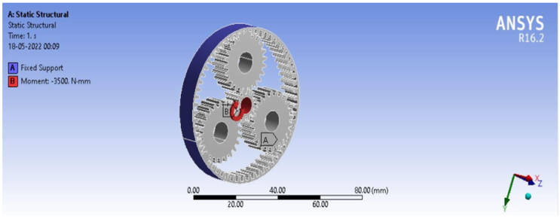

**Figure 4 RPM 3500**

# BOUNDARY CONDITION AT MODAL ANLAYSIS:

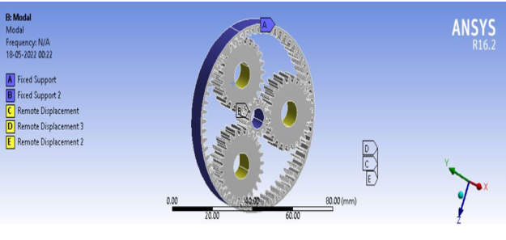

**Figure 5 Boundary Condition at Modal Analysis**

# 

# RESULTS AND DISCUSSIONS

# The CAD models are used to simulate the operating conditions and ANSYS Workbench is used to simulate the structural strength of the gears. The static structural simulation is selected in ANSYS Workbench. The CAD models are made the usage of Catia v5. The mesh used is shown in figures 6 to nine.Apply the boundary conditions 2500Rpm and 3500Rpm centre gear . The outcomes are received underneath figures

# 7.1 15 Ni 5Cr4Mo1 Material:

# 

**Figure 6 Von-misses stress at 2500 Rpm of 15 Ni 5Cr4Mo1 Material**

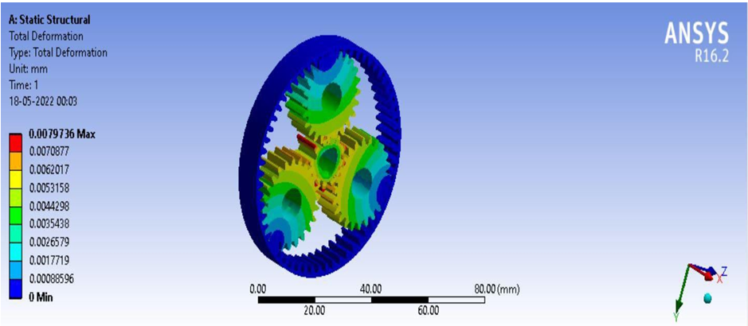

**Figure 7 Total deformation at 2500 Rpm of 15 Ni 5Cr4Mo1 Material**

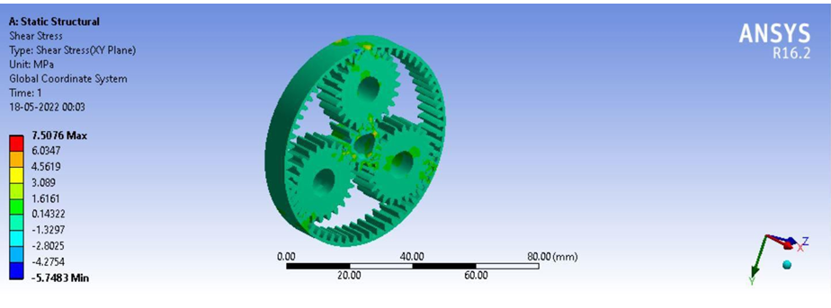

**Figure 8 Shear stress at 2500 Rpm of 15 Ni 5Cr4Mo1 Material**

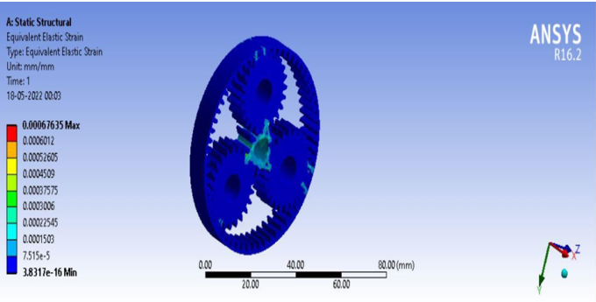

**Figure 9 Strain at 2500 Rpm of 15 Ni 5Cr4Mo1 Material**

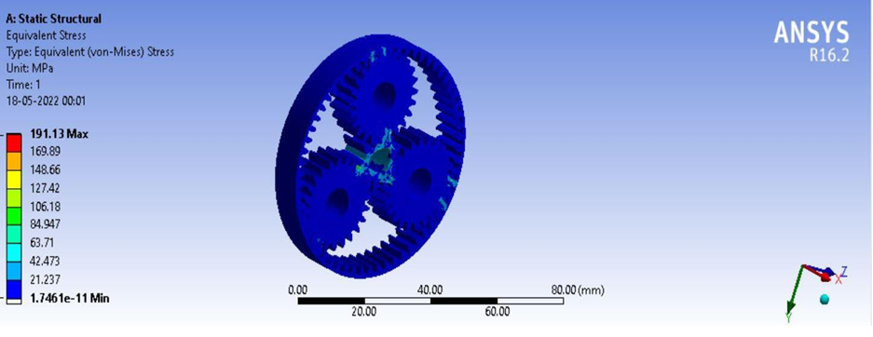

**Figure 10 Von-misses stress at 3500 Rpm of 15 Ni 5Cr4Mo1 Material**

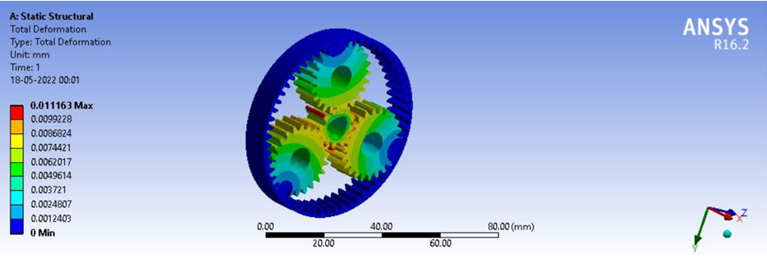

**Figure 11 Total deformation at 3500 Rpm of 15 Ni 5Cr4Mo1 Material**

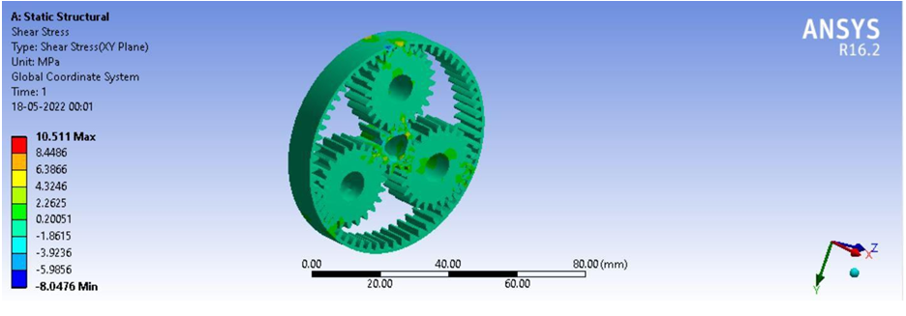

**Figure 12 Shear stress at 3500 Rpm of 15 Ni 5Cr4Mo1 Material**

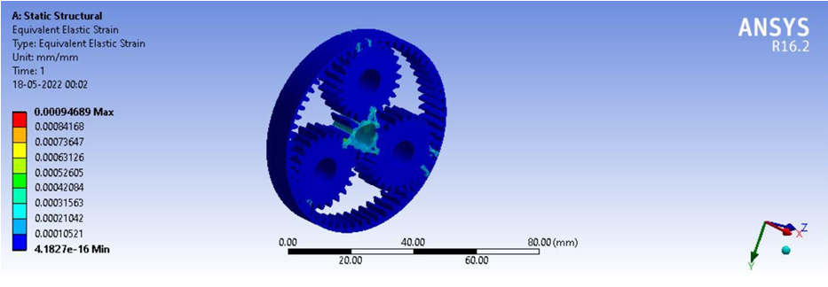

**Figure 13 Strain at 3500 Rpm of 15 Ni 5Cr4Mo1 Material**

# AL7075 Material:

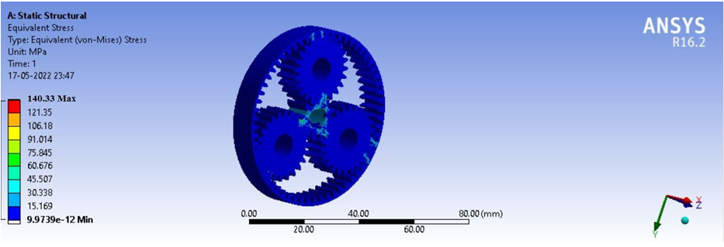

## Figure 14 Von-misses stresz at 2500 Rpm of AL 7075 Material

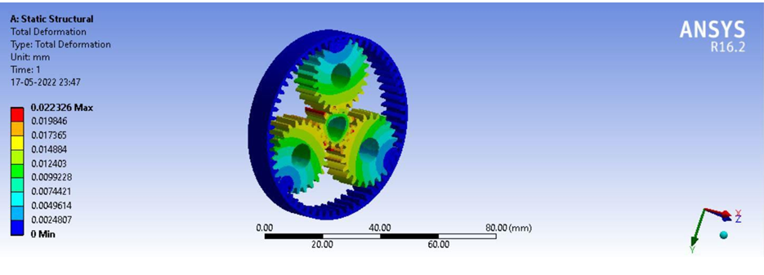

**Figure 15 Total deformation at 2500 Rpm of AL 7075 Material**

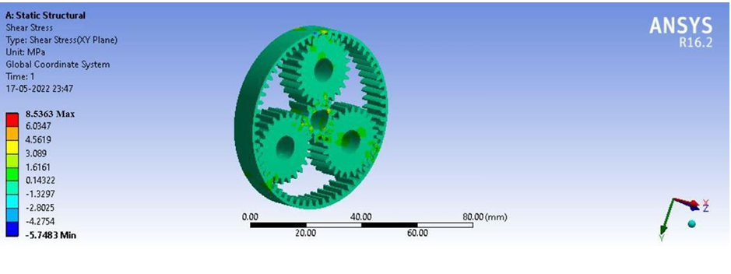

**Figure 16 Shear stress at 2500 Rpm of AL 7075 Material**

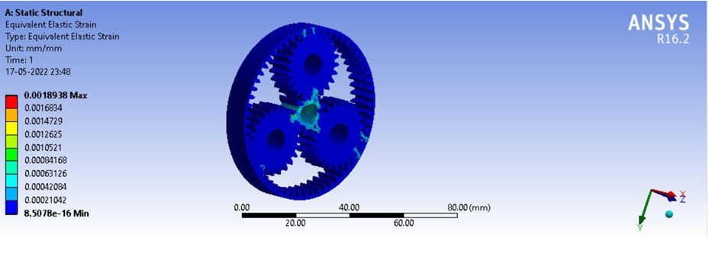

**Figure 17 Strain at 2500 Rpm of AL 7075 Material**

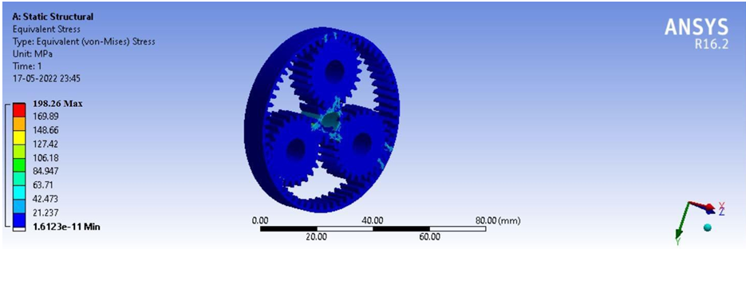

**Figure 18 Von-misses stress at 3500 Rpm of AL 7075 Material**

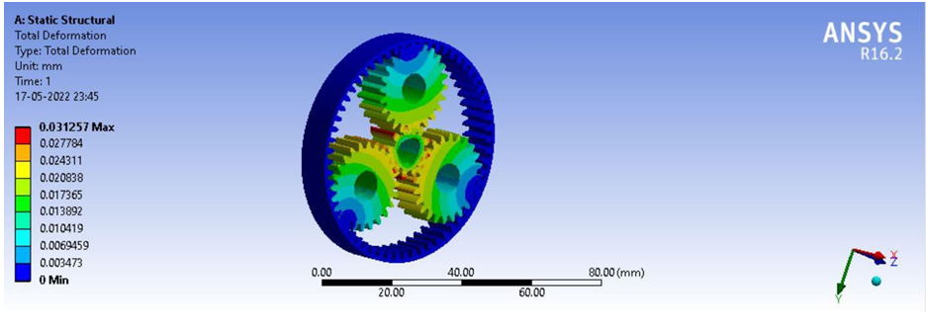

**Figure 19 Total deformation at 3500 Rpm of AL 7075 Material**

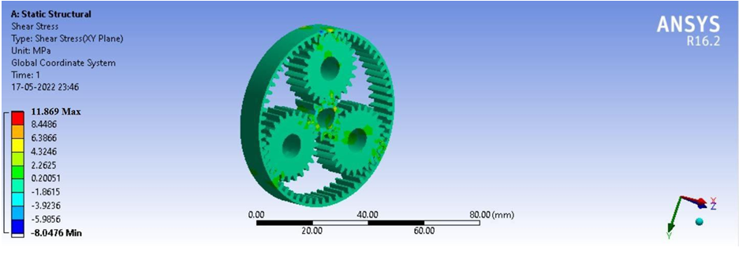

**Figure 20 Shear stress at 3500 Rpm of AL 7075 Material**

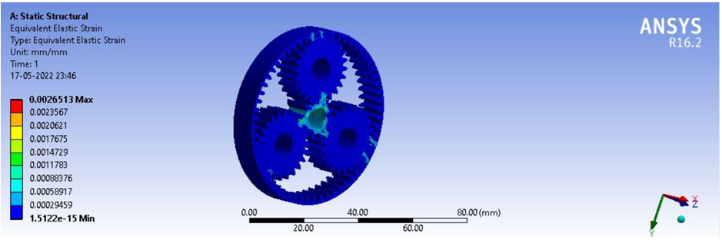

**Figure 21 Strain at 3500 Rpm of AL 7075 Material**

# Grey cast Iron Material:

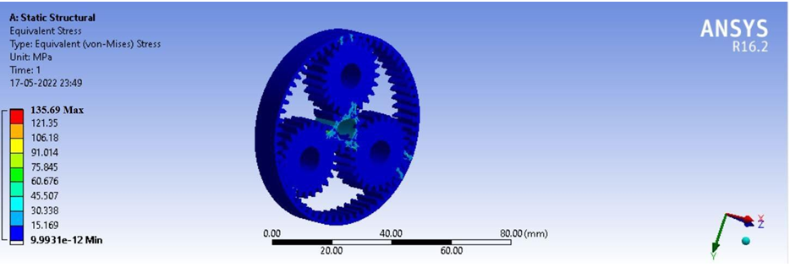

**Figure 22 Von-misses stress at 2500 Rpm of Grey cast Iron Material**

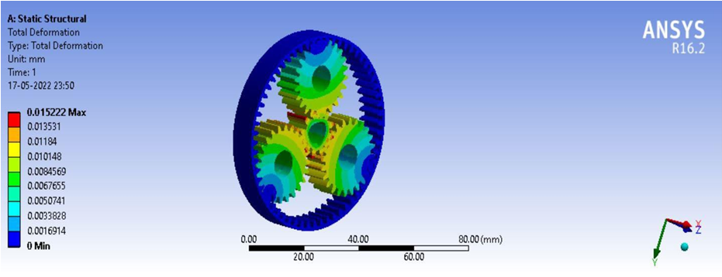

**Figure 23 Total deformation at 2500 Rpm of Grey cast Iron Material**

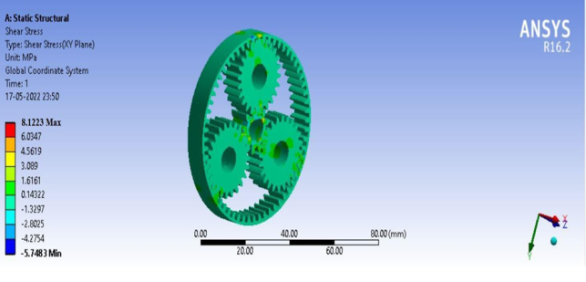

**Figure 24 Shear stress at 2500 Rpm of Grey cast Iron Material**

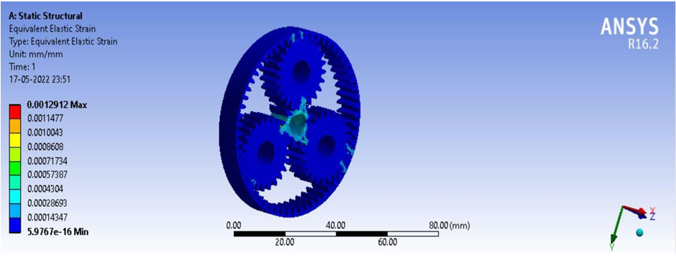

**Figure 25 Strain at 2500 Rpm of Grey cast Iron Material**

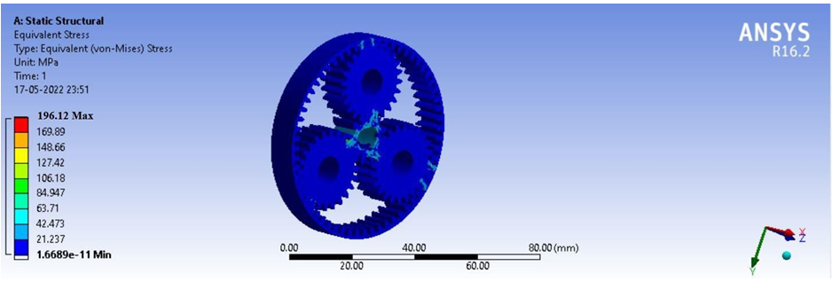

**Figure 26 Von-misses stress at 3500 Rpm of Grey cast Iron Material**

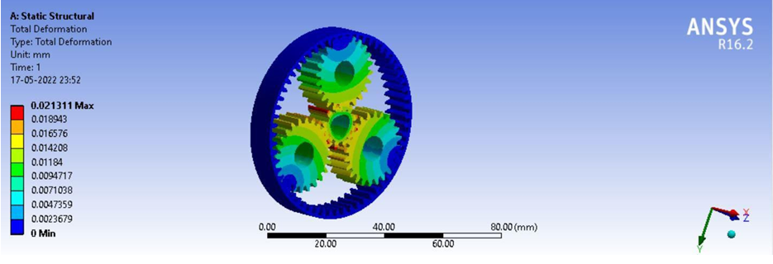

**Figure27 Total deformation at 3500 Rpm of Grey cast Iron Material**

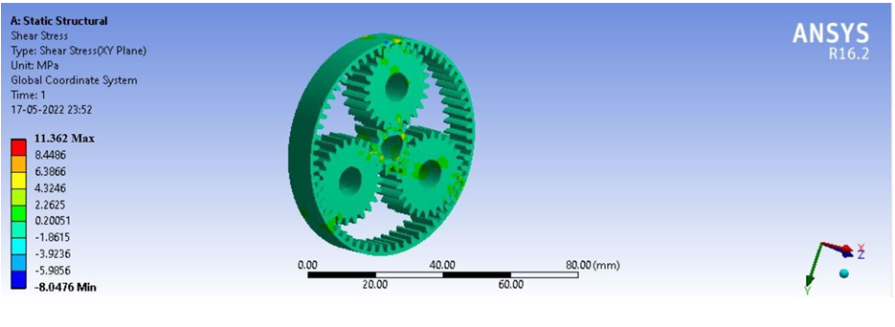

**Figure 28 Shear stress at 3500 Rpm of Grey cast Iron MATERIAL**

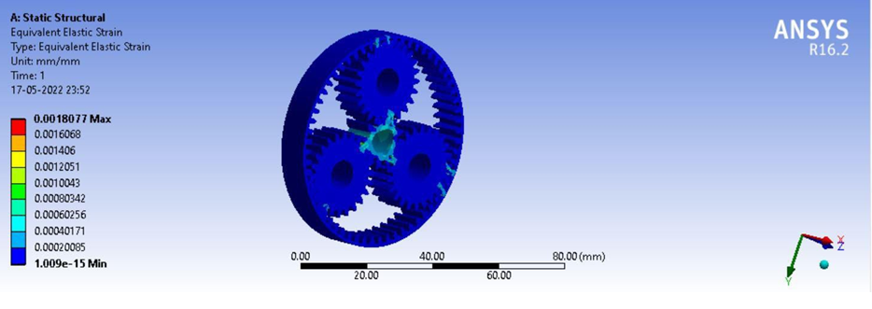

**Figure 29 Strain at 3500 Rpm of Grey cast Iron Material**

# MODAL ANALYSIS:

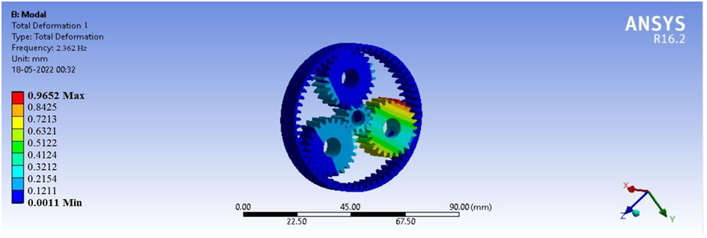

**Figure 30 Total deformation at Mode 1 of 15 Ni 5Cr4Mo1 Material**

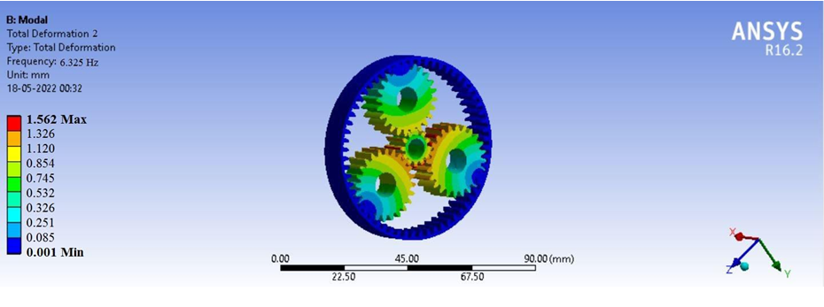

**Figure 31Total deformation at Mode 2 of 15 Ni 5Cr4Mo1 Material**

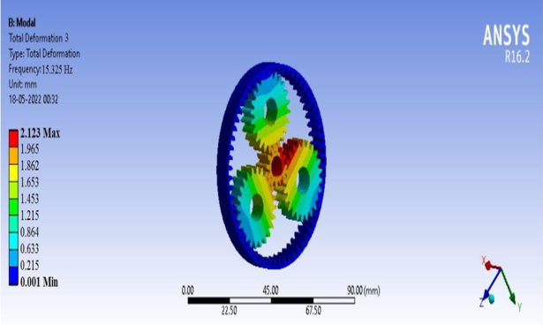

**Figure 32 Total deformation at Mode 3 of 15 Ni 5Cr4Mo1 Material****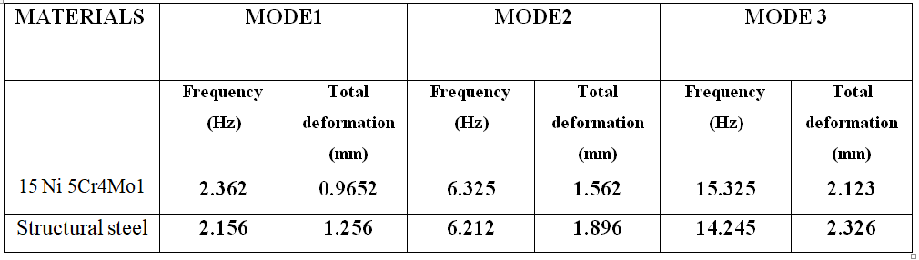**

# GRAPHS

# VON-MISSES STRESS GRAPH:

We can have a look at that in case of Von-misses pressure of the Planetary equipment meeting unit is made of 15 Ni 5Cr4Mo1, AL 7075, GREY CAST IRON, STRUCTURAL STEEL. Here do not forget

the 2 cases 2500 Rpm, and 3500 Rpm. Higher Von-misses pressure acquired Al7075 and low Von-misses strain are 15 Ni 5Cr4Mo1 Material When as compared to closing materials as shown underneath graph.

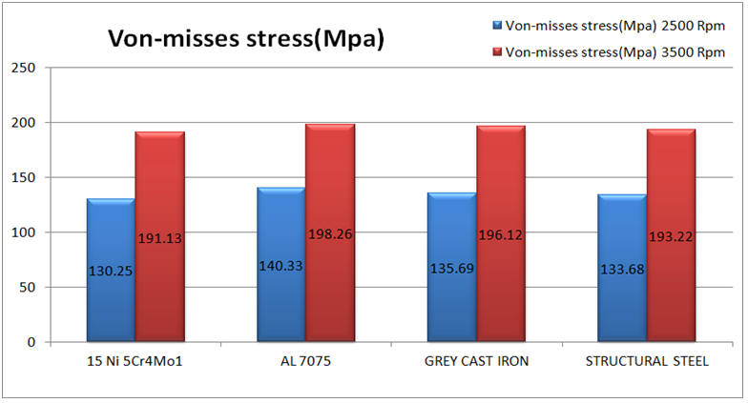

**Figure 33 Von-misses stress graph**

## TOTAL DEFORMATION GRAPH:

We are able to take a look at that in case of Total deformation of the Planetary equipment meeting unit is made of 15 Ni 5Cr4Mo1, AL 7075, GREY CAST IRON, STRUCTURAL STEEL. Here

take into account the two cases 2500 Rpm, and 3500 Rpm. Higher Total deformation obtained Al7075 and low Total deformation are 15 Ni 5Cr4Mo1 Material When as compared to ultimate materials as proven underneath graph.

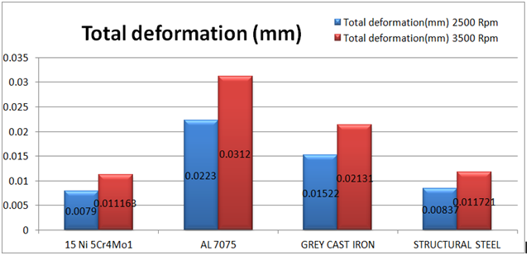

**Figure 34 Total deformation Graph**

# SHEAR STRESS GRAPH:

Static structural analysis computes the stresses, displacements, shear stress, and forces in structures caused by a load with no significant inertia or damping effects. It is assumed that the workload and response conditions are stable; that the loads and the structure's response change slowly with respect to time.

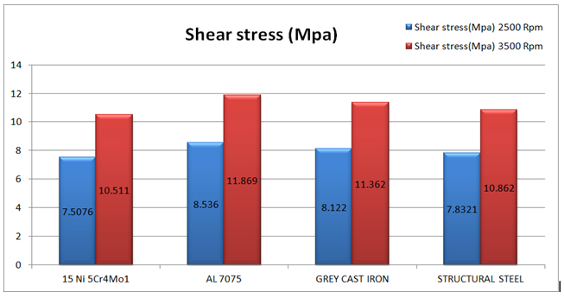

**Figure 35 Shear stress graph**

# STRAIN GRAPH:

We can study that in case of Strain of the Planetary equipment assembly unit is made up of 15 Ni 5Cr4Mo1, AL 7075, GREY CAST IRON, STRUCTURAL STEEL. Here keep in mind the two cases 2500 Rpm, and 3500 Rpm. Higher Strain obtained Al7075 and low Strain are 15 Ni 5Cr4Mo1 Material When as compared to closing materials as proven underneath graph.

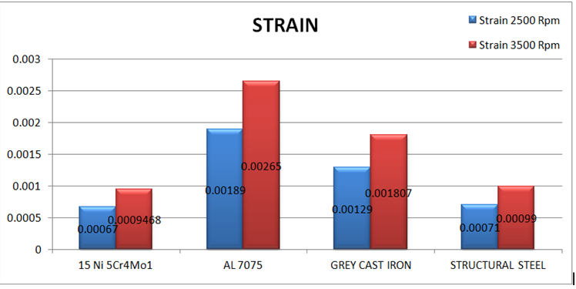

**Figure 36 Strain graph**

# CONCLUSION

Planetary gears are extensively used in lots of industries. Since the gear of the planetary tools mechanism is one of the maximum essential components, and one of the gears will affect the whole transmission gadget, it is necessary to find the reason of lowering the equipment failure. Epicycle tools have many blessings, which include extended torque, decreased comparative size, decreased weight, advanced performance, and very compact packaging, in order that they had been extensively used in industry, but there is no standard research on synthesis with admire to exceptional parameters which includes module, material, and energy of the epicyclic equipment trains. In planetary equipment trains there may be relative motion between the axes, which facilitates to transfer very excessive speed ratios in small dimensions into a small space. Design and evaluation is accomplished of planetary equipment the use of numerous materials like structural metal,al 7075,grey cast iron, 15 Ni 5Cr4Mo1 carried out the static and modal anlaysis

. Finally find out the 15 Ni 5Cr4Mo1 is the best material because of Low von-misses stress, shear stress, Total deformation, Strain in static analysis and Total deformation at different frequencies in modal analysis. Lubrication mechanisms and lubricants and bearings suitable for the gearbox have also been selected.

**REFERENCES**

[1]. Lehao Chang, Geng Liu, Liyan WuDr, ―A strong model for determining the mesh stiffness of cylindrical gears‖ Mechanism and Machine Theory 87 (March-2021) PP: ninety three– 114

[2]. Dr. Alexander Kapelevich Analysis of High Gear Ratio Epicyclic Drives GEAR

TECHNOLOGY, June 2020 PP: 61-67

[3]. Ovidiu Buiga, Lucian Tudose ―Optimal mass minimization design of a two-stage coaxial helical speed reducer with Genetic Algorithms‖ Advances in Engineering Software 68 (2018) PP: 25–32

[4]. Light-Weight Layout for Gear Reduction Transmitters, Bernd-Robert Höhn, Karsten Stahl, and Philipp Gwinner GEAR TECHNOLOGY, Sept. Sept. 2012, PP: 96-103

[5]. Syed Ibrahim Dilawer, Md. Abdul Raheem Junaidi, Dr.S.Nawazish Mehdi ―Design, Load Analysis and Optimization of Compound Epicyclic Gear Trains‖ American Journal of Engineering Research ISSN 2320-0936 Vol.-02, Issue-10, 2019, PP: 146-153

[6]. Cheon-Jae Bahk, Robert G. Parker ―Analytical research of tooth profile amendment effects on planetary equipment dynamics‖ Mechanism and Machine Theory 70 (2020) PP: 298–319

[7]. Dr.-Ing. T. Schulze, Dipl.-Ing.C. Hartmann, Prof. Dr.- Ing. B. Schlecht, ―Calculation of Load Distribution in Planetary Gears for an Effective Gear Design -