**Heart Disease Predication**

**Jay Lokhande1, Chaitanya Mungase 2, Aditya Lokhande 3, Prajwal Dhamdhere 4**

1 Computer, JSPM Bhivrabai Sawant Polytechnic, Pune, Maharashtra, India

2 Computer, JSPM Bhivrabai Sawant Polytechnic, Pune, Maharashtra, India

3 Computer, JSPM Bhivrabai Sawant Polytechnic, Pune, Maharashtra, India

4 Computer, JSPM Bhivrabai Sawant Polytechnic, Pune, Maharashtra, India

Prof. Ankita Dawkhar, Computer, JSPM Bhivrabai Sawant Polytechnic, Pune, Maharashtra

**ABSTRACT**

Heart plays significant role in living organisms. Diagnosis and prediction of heart related diseases requires more precision, perfection and correctness because a little mistake can cause fatigue problem or death of the person, there are numerous death cases related to heart and their counting is increasing exponentially day by day. To deal with the problem there is essential need of prediction system for awareness about diseases. Machine learning is the branch of Artificial Intelligence(AI), it pro- vides prestigious support in predicting any kind of event which take training from natural events. In this system , we calculate accuracy of machine learning algorithms for predicting heart disease, for this algorithms are k-nearest neighbor, decision tree, linear regression and support vector machine(SVM). We also calculate the desired prescription after detecting heart disease. For implementation, Python programming with OpenCV is best tool, which have many type of library, header file, that make the work more accurate and precise.

1. **INTRODUCTION**

Health-care information systems tend to capture data in databases for research and analysis in order to assist in making medical decisions. As a result, medical in- formation systems in hospitals and medical institutions become larger and larger and the process of extracting useful information becomes more difficult. Tradi- tional manual data analysis has become inefficient and methods for efficient com- puter based analysis are needed. To this aim, many approaches to computerized data analysis have been considered and examined. Data mining represents a significant advance in the type of analytically tools. Heart plays significant role in living organisms. Monitoring and Detection of heart related diseases requires more precision, perfection and correctness. As a little mistake can cause

1. **METHODOLOGY**

The process starts with data manipulation. Next, four models will be investigated for finding a prediction model.

* 1. **S** Data Preprocessing

First, each attribute’s correlation to DM is analyzed. e.g. number of pregnancies is transformed into a nominal attribute. The value 0 indicates non-pregnant and 1 indicates pregnant. The complexity of the dataset was reduced by this process. second, some missing and incorrect values in the dataset due to errors are removed. for example, body mass index could not be 0, which indicates that the real value was missing. To reduce the influence of meaningless values, the training data is used to replace all missing values.

* 1. Data Classification

The Model Consists Of Double-Level Algorithms. In The First Level, Authors Used The Improved K-Means Algorithm To Remove Incorrectly Clus- tered Data. The Optimized Dataset Was Used As Input For Next Level. Then, They Used The Logistic Regression Algorithm To Classify The Remaining Data.

1. **MODELING AND ANALYSIS**

The architecture of our proposed system is shown in figure.

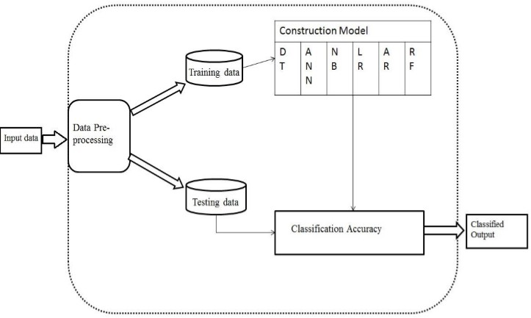



Figure 3.1: Architecture diagram

1. **RESULTS AND DISCUSSION**

## Advantages

* + - The use of this application online social network in day to day life.
    - The advantage of this project is to decrease the death ratio.
    - Get treatment on time.

## Applications

* + - Hospital
    - Old Age Homes
    - Medical Centers

1. **CONCLUSION**

The symptoms of heart disease are familiar for everyone. But no one can predict when it may happen and also the prediction will not give any instance status

i.e. normal or abnormal. Our research intension is to notify the patients that neither normal nor abnormal at its early stage. The application of data mining algorithms shows it better performance results among themselves. This app will be supposed to predict the heart attack from the chest pain at an early stage and guide the person to take treatment early such as to get their ECG done as early as possible and get evaluated from a doctor to make diagnoses of heart attack.

1. **REFERENCES**
2. A. Abdellatif, H. Abdellatef, J. Kanesan, C. -O. Chow, J. H. Chuah and H. M. Gheni, ”An Effective Heart Disease Detection and Severity Level Classification Model Using Machine Learning and Hyperparameter Optimization Methods,” in IEEE Access, vol. 10, pp. 79974- 79985, 2022, doi: 10.1109/AC CESS.2022.3191669.
3. K. S. K. Reddy and K. V. Kanimozhi, ”Novel Intelligent Model for Heart Disease Prediction using Dynamic KNN (DKNN) with improved ac curacy over SVM,” 2022 International Conference on Business Analytics for Technology and Security (ICBATS), 2022, pp. 1-5, doi: 10.1109/IC BATS54253.2022.9758996..
4. T. Xue and Z. Jieru, ”Application of Support Vector Machine Based on Particle Swarm Optimization in Classification and Prediction of Heart Disease,” 2022 7th International Conference on Intelligent Computing and Signal Processing (ICSP), 2022, pp. 857-860, doi: 10.1109/ICSP54964.2022.9778616.
5. G. S. Reddy Thummala and R. Baskar, ”Prediction of Heart Disease us ing Decision Tree in Comparison with KNN to Improve Accuracy,” 2022 International Conference on Innovative Computing, Intelligent Communication and Smart Electrical Systems (ICSES), 2022, pp. 1-5, doi: 10.1109/IC SES55317.2022.9914044. 1