**Tracking and Evaluation of the Speed of Portable Vehicles based on Video Processing using Python**

**Jampani Ravi1, V. Pavan1, V. Yuktha Sri1, V. Srinu1, Y. Gowtham Kumar1**

**1Department of Electronics and Communication Engineering,**

**S.R.K.R. Engineering College, Bhimavaram, A.P, India**

**ABSTRACT** - This paper portrays and targets the convenience and other advantages in the determination of the speed of a vehicle. Currently, vehicle speed determination is playing a vital role in the continuous improvement and enhancement of the Intelligent Transportation System. With the usage of image and video processing techniques, more attention has been created to the estimation of vehicle speed and counting the vehicles density in the considered input video. Video footage is captured and analyzed to monitor the speed of a real vehicle without using any camera calibrations. An average error upon +/- 3km/h speed detection was observed for various video recorded inputs. The vehicle's position, the type of vehicle, and the nature of driving at the point of video capturing are certain parameters taken into consideration.

**Keywords**- Python (Vs code), dlib, OpenCV.

**INTRODUCTION**

In the recent years we can see there is a vast increase in the number of vehicles all around the globe. Along with the increase in number of vehicles increases the number of accidents [14]. Therefore, it is important to limit the speed of the vehicles at certain zones or areas. Radar speed measurement tools are commonly used for this purpose which can be inaccurate in certain cases such as in sensing smaller vehicles with weaker echoes. Also it is difficult for these tools to detect vehicles changing in speeds too often or fast. Therefore, there is a need for a better technique to detect the speed of the moving vehicles [21]. Than using expensive sensors such as radars, the vehicles video streaming could be used for this purpose. The video stream of the moving vehicle is given as an input, then it is passed through the filter for detecting its speed [17]. As a result of the enormous growth in the population, the number of vehicles being used is drastically increased. Therefore, the traffic is heavily induced on the roads of the urban and cities. According to recent incidents and studies, there are occurring several accidents which lead to physical disabilities and sometimes even leads to death [20]. Major causes for these incidents are over-speeding, reckless driving, using cell phones while driving, going in the wrong way, improper vehicle conditions, and even it may be due to drunk and drive [1]. Therefore, it is crucial to make certain limitations on the vehicle's speed in certain regions or zones.

**LITERATURE SURVEY**

The most important part in the determination of the vehicle speed is involved based on its identification and tracking [6]. So, tracking and detecting vehicle speed is one of the important aspects of traffic management systems [3]. In most cases, the Doppler radar technique is considered in our traffic department and law enforcement department. Based on the radio waves projected towards the vehicle, variation in the frequency of reflected wave measurements leads to determining the speed of the vehicle [8]. In the field view, it limits an object while moving and no other vehicles nearby are not moving. Errors (cosine error) caused due to radio interference and line of sight in the determination of the moving vehicle's speed [10].

Based on digital aerial, optics images, frame difference, motion trajectories, and calibrated cameras are applied for vehicle identification and speed detection using image and video processing in various previous works Not only high-end camera capture but also works on blurred images [12]. For image restoration, the blurred motion image and the length of the blurred image are some of the blur parameters used [15]. However, different accuracy results were obtained for vehicle true speed through various devices [17]. Transportation researchers and practitioners have a quite common problem due to a lack of knowledge of accuracy among various devices [18]. “Vehicle speed detection system,” in 2009 IEEE International Conference on Signal and Image Processing Applications[1].This paper presents a flat out response for completing a getting ready module on traffic cameras that is fit for following every vehicle in the camera outline and looking over its speed reliably. A season structure for various vehicle following is used that utilizations Kalman channel and Hungarian Algorithm to pick checks. A speed estimation structure is outlined that is sufficiently liberal to work with camera feed from any edge without game-plan and camera mounted in any event stature of 7m. The system has been attempted PC made approaches in like manner as avowed conditions and speed measures have been gotten with most noteworthy goof of under 3kmph.Research of vehicle speed detection algorithm in video surveillance [2].This paper, demonstrates another Speed Detection Camera System (SDCS) that is appropriate as a radar elective. SDCS uses a few picture getting ready frameworks on video stream in on the web - got from single camera-or pulled back mode, which makes SDCS fit for figuring the speed of moving articles keeping up a central division from the standard radars issues. SDCS offers an en-over the top choice rather than traditional radars with a close precision or far unrivalled. SDCS frameworks can be withdrawn into four one of a kind stages; first stage is Objects exposure sort out. Which uses a flavour figuring subject to joining a flexible establishment subtraction methodology with a three-plot differencing estimation which gets a handle on the affirmed weight of using fundamentally versatile establishment subtraction? The second stage is Objects following, which consolidates three remarkable exercises, Object division, Object venturing, and Object run extraction. Articles following assignment considers the various potential states of the moving thing like; simple after, object has left the scene, object has entered the scene, and object cross by another article, and article leaves and another enters the scene. Third stage is speed check organize, which is settled from the proportion of lodgings eaten up by the thing to pass by the scene. The last stage is Capturing Object’s Picture form, which gets the image of things that maltreatment past what many would consider possible. SDCS is recognized and tried in various examinations; it showed to have achieved a pleasing execution. Vehicle speed measurement technique using various speed detection instrumentation [3].Advanced technology offers us various alternatives for collecting traffic data. However, different devices often result in different accuracy to the true speed of the drivers. Lack of knowledge of accuracy between different devices is often cited as a common problem for both transportation researcher and practitioner. This paper discusses the most accurate traffic data measurement device when compared to the true driving speed of the driver using the V-BOX GPS validated with the dash box of the test vehicle. The paper illustrates and discusses the significant value R 2 of the traffic data using scatter plot, root mean squared error (RMSE), mean absolute error (MAE) and mean absolute percentage error (MAPE). The paper covers two classes of advanced traffic data collection devices which are intrusive (automated traffic classifier) and off road portable speed measurement devices (laser gun, radar gun and manual count). Results showed that automated traffic classifier have the smaller discrepancies or deviations followed by laser gun, manual count and radar gun when comparing to the global positioning system (GPS). It is extremely important to notify which devices have the most accurate data collection as any study can only be as accurate as the data on which it is based. Video size comparison for embedded vehicle speed detection travel time estimation system by using raspberry pi [4].As traffic keeps growing up, the issue with respect to the street mishap in like way developing rapidly. The difficulty occurred because of the fast of vehicles out on the town. This paper proposed a vehicle speed affirmation and travel time estimation structure utilizing Raspberry Pi to review the speed of going vehicles through this framework. The structure is required to perceive the moving vehicles and figure its speed. The structure utilized OpenCV as a picture arranging programming to see and seek after the moving vehicles. Several sorts of getting size of the video are utilized in this structure to check and quantify the presentation of the presented board. “Vehicle speed zone utilizing corner unmistakable confirmation”, in Proceedings of the 2014 Fifth International Conference on Signal and Image Processing [5].The paper manages the subject of affirmation of vehicle speed dependent on data from video record. In hypothetical part we delineate the most critical methodology, explicitly Gaussian blend models, DBSCAN, Kalman channel, Optical stream. The execution part is contained the assistant plan and the portrayal of procedures for correspondence of individual pieces. The end contains the fundamental of got video records utilizing various vehicles, various natures of driving and the vehicle position at the time of chronicle. By virtue of the improvement that is developed in PC vision and AI, we can discover usage of these frameworks in different areas. One of them is traffic viewing and the heads framework, where the centrality is as of recently making with making urbanization. This paper goes for speed unmistakable verification or estimation of vehicles from video stream. These days the most remarkable approach to manage assess speed is by utilizing the radar hardware, hence it is essential to propose some various considerations like evaluating vehicle speed from video stream. Rather than equipment reliance that is issue with radar frameworks we can utilize picture dealing with, which is commonly subject to programming execution. Vehicle Speed Detection and Identification from a Single Motion Blurred Image [6]. Motion blur is a result of finite acquisition time of practical cameras and the relative motion between the camera and moving objects. Traditionally, the image degradations caused by motion blur are treated as undesirable artifacts and usually have to be removed before further processing. In this work, we propose a novel approach for vehicle speed detection based on a single motion blurred image as opposed to the most commonly used RADAR and LIDAR devices for traffic law enforcement. The motion blur parameters are estimated from a single motion blurred image and the length of motion blur is used for image restoration. The restored image is then used to obtain other parameters for vehicle speed estimation. The images taken with the vehicle's license plates are used for both the assistance of image restoration and the identification of the vehicle. We have established a link between the motion blur information of a 2D image and the speed information of a moving object. Experiments have shown the results of less than 2% error for both local and highway traffic compared to video-based speed estimation methods.

**PROBLEM STATEMENT**

Tracking a car is a process of finding a moving car using a camera. Capturing a car video sequence from a surveillance camera requires an application to improve performance tracking. This technology increases the number of applications such as traffic control, traffic monitoring, traffic flow, security etc. The estimated cost of using this technology will be much lower. Video and image processing is used for traffic monitoring, analysis and monitoring of traffic conditions in many cities and urban areas. Various speed measurement methods have been proposed in recent years. All methods try to increase the accuracy and reduce the cost of using the hardware. The goal is to build an automated system that can accurately locate and track the speed of any vehicles from online video frames.

**Camera Motion:** If there is movement in the camera viewing area, such as videos captured by unstable or vibrating cameras, video processing will be a challenge. The result of this situation is it is often represented as a blurring of movement in the video scene that affects both the detection and tracking steps Harder. Motion blurring can be avoided by temporarily removing blurring or balancing a single blurring kernel throughout the picture. The cause of this condition is natural causes such as spirits.

**Low Light Mode:** At night and in other low light conditions such as tunnels, cars cannot be seen with their visible features and only part of them can be seen by the headlights or rear headlights. Therefore some parts that do not produce light or are exposed to light from a great distance will appear black. This lack of physical features can affect detection and tracking processes. Another challenge here is to pair the lights found to be considered as individual vehicles. Binary conversion of an image using a sufficient amount of threshold can deal with such situations. At night videos, car headlights / rear lights and bad lighting that can cause loud noises can lead to a lot of difficulty in finding work.

**Different Types of Vehicles:** As there are different vehicle categories, if the acquisition system is based on classifying cars by their visual features such as headlights and bumpers, some vehicles may be classified as incorrect. This challenge is most common in finding a patrol car.

**Congested Traffic Situations:** In the context of urban traffic, traffic jams and traffic congestion are two common causes. Car crashes can occur whenever the car is passing behind other vehicles in front of the camera. Closure in both partial or complete forms, may affect the process of calculating the background frame. If the vehicle acquisition system is based on mobility information, congested traffic conditions may significantly affect results. Powerful Changes: In this case the moving object reveals the rear, such as when a parked car exits the parking lot. In other words some parts of the scene may contain movement but should be considered as a domain. Background removal techniques are generally sensitive to dynamic variables, while the temporary separation method is more compatible with them because more recent frames are also involved in the calculation of moving regions.

**Audio:** Video signal is usually loud. Video surveillance retrieval systems should deal with damaged signals affected by various types of sound, such as sensory noise or pressure artifacts. Sound can affect both detection and tracking functions.

**PROPOSED MODEL**

Based on the various analysis, this paper explores a method of approach that provides the advantage of video and image processing accurately monitoring vehicle speed in real-time projects. The proposed model gives us detailed information about the vehicle and its corresponding parameters related to the considered input video footage.

**METHODOLOGY:**

I. VIDEO INPUT

Video is nothing but still images that change in its pixel’s intensities concerning time which illustrates in the generation of stimulated movements. In simple words, still images can be known as consecutive image frames. In the image frames we have static objects and portable objects. Static objects are climatic conditions, nonmotile objects, road, divider planes and any motionless belongings. Portable objects are moving vehicles, walkers, etc. Thus, the data of portable objects is used to count and evaluate its speediness in real-time. Various formats of videos are available in the present technology. Based on the main source we consider capturing or recording through webcams, smartphone cameras, CCTV, and digital cameras. Here we used a MPEG-4 video file format with an extension of mp4.

Using OpenCV in python language we implemented our algorithms. OpenCV has many libraries and functionalities that are useful in the various steps ahead. This source code can be utilized on an average processor. First, the video footage is taken as input through a function called videoCapture(‘filename’). To access the webcam, we should pass ‘0’ as an argument to the videoCapture () function, instead of the direct path.

By using methods in Open CV such as ‘read ()’ and ‘imwrite ()’, the video gets read in the form of frames and will be saved as an image to a specified file. In the next step, the video source is divided into frames. Since it may have several frames at the rate of 20 to 30 fps, which leads to undesirable redundancy frames and execution time of the source code upsurges. Further processing can be done after the grayscale conversion. The quality of the video should be optimum, or moderate pixels are most likely preferred.

1. DETECTION OF VEHICLE

Vehicle detection can be done using Haar Cascade Classifier which is an effective way for object detection. A machine learning method called Haar Cascade trains the classifier by using both positive and negative images. Where positive images are those that contain the images which we want our classifier to identify, negative images are images of everything else, which do not contain the object we want to detect. By using this approach of machine-learning, we use cascade Classifier () method which takes as input an appropriate xml file.

1. VEHICLE TRACKING

The proposed approach uses the dlib’s implementation of the correlation tracking algorithm. This algorithm needs correlation tracker function from a library known as dlib in python. The process of vehicle tracking according to this algorithm is firstly taking an initial set of object detections, secondly creating a unique ID for each of the initial detections and finally tracking each of the objects as they move around frames in a video, maintaining the assignment of unique IDs. Furthermore, object tracking allows us to apply a unique ID to each tracked object, making it possible for us to count unique objects in a video. And the total count of the number of vehicles passed will be printed in the output console. The mentioned tracking algorithm has these following features: only require the object detection phase once (i.e., when the object is initially detected), will be extremely fast — much faster than running the actual object detector itself, be able to handle when the tracked object "disappears" or moves outside the boundaries of the video frame, be able to pick up objects it has "lost" in between frames. Further, depending on the car ID the speed detection of the respective vehicle takes place. Active strategy to choose a search window for vehicle detection using an image context was proposed a deep CNN framework (Attention Net) to capture the vehicle by sequential actions with top-down attention. Attention Net has achieved satisfactory performance on vehicle detection benchmark, by sequentially refining the bounding boxes. Proposed a sequential search strategy to detect visual vehicles in images, where the detection model was trained by proposed a deep RL framework to select a proper action to capture an vehicle in an image.

IV. SPEED DETECTION

The speed detection of the vehicle is done by obtaining the position of the vehicles that is taken from above phases. For detecting speed, a process called Centroid Tracking will be implemented as it relies on the Euclidean distance between (1) Current object centroids, or things the centroid tracker has previously observed, and (2) New object centroids between a video's consecutive frames. The centroid tracking algorithm is a multi-step process. The steps that are included are: firstly, accepting bounding box coordinates and computing centroids, computing Euclidean distance between new bounding boxes and existing objects, update (x, y)-coordinates of existing objects, then registering new objects and deregistering old objects. A ppm value defines the number of points or divisions for each meter of the subject that the camera is imaging. The pixel per meter (ppm) value is used to convert the distance in terms of meter units. As the distance between the initial and final positions of the vehicle in frames is calculated by Euclidean formula and the time elapsed will be processed using the methods in a library time in python, we finally calculate time and distance. So, by using the simple formula speed=distance/time, speed of the vehicle would be determined. For finding out the speed of the vehicle, the system has to know the weight of the pixel. The speed of the vehicle is enrolled by the common speed of all focus in that vehicle. Finally, we find the bundling number at which the article or the vehicle entered and left the scene. The speed estimation is done by figuring the measure of edges taken up by the vehicle to go in the scene and the length of each bundling is known. The in and out time taken by the vehicle in the scene is found and the speed estimation is settled.

**Advantages:** • Detection of multiple moving vehicles in a video sequence • tracking of the detected vehicles. • Identification of Vehicle types. • Counting the total number of vehicles passing in videos.

**Objectives**:• Detection of multiple moving vehicles in a video sequence. • Tracking of the detected vehicles. • Colure identification of Vehicles. • Counting the total number of vehicles in videos.

**FLOWCHART:**

Extracting individual frames from the video

Pre-processing and Gray-scaling the frames

from the video

Vehicle Detection using cascade classifier from the video

Distance calculation using change in pixels

Counting the number of vehicles every time and displaying it

Calculating time elapsed using video frames

Displaying the result

**Block Diagram of vehicle speed detection system:**

**Input Video**

**Pre-processing**

**Vehicle Detection**

**Vehicle Tracking**

**Speed Detection**

**RESULTS:**

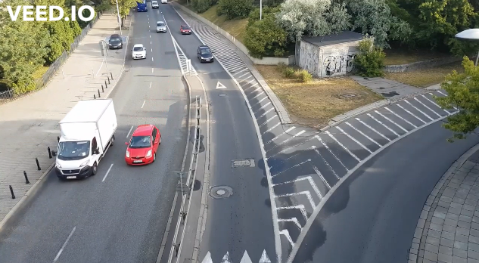

**Fig. 1(a): Input frame** **Fig. 1(b): Output frame**

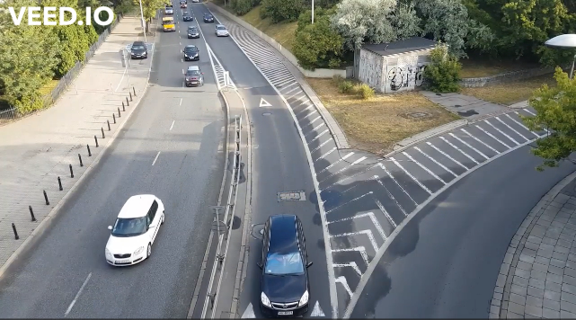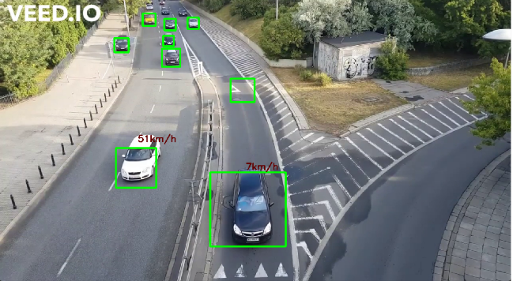

**Fig. 2(a): Input frame** **Fig. 2(b): Output frame**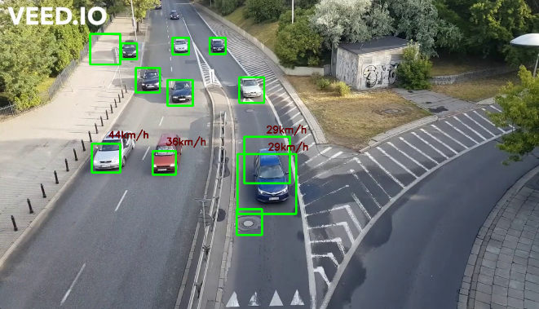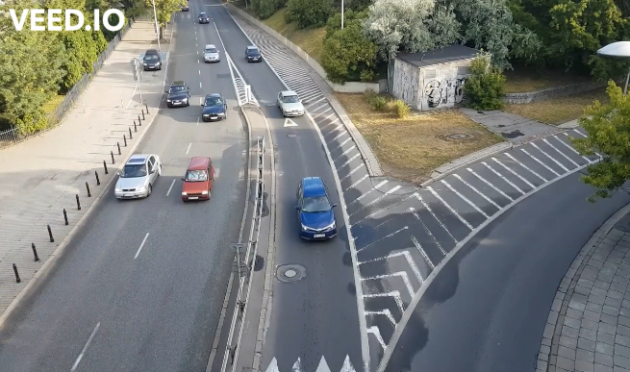

**Fig. 3(a): Input frame** **Fig. 3(b): Output frame**

**CONCLUSION:**

In this paper, we have proposed the vehicle recognition and its approximation speed evaluation by calculating the Euclidean distance between the position in two different frames when the vehicle is in motion. Along with the detection and evaluation of speed, it gives the count of the vehicles moving in the frame of input video footage. We have used OpenCV and dlib libraries to implement the source code using video processing techniques. The actual speed of the vehicle is comparable to accuracy of the proposed system speed evaluation. The methodology portrayed in this paper has strong practicability and good robustness but it exists certain minor deviations in the results similar to other methods. One of the limitations of the system is that it is not efficient at detection of occlusion of the vehicles which affects the accuracy of the counting as well as classification. This problem could be solved by introducing the second level feature classification such as the classification on the bases of color. Another limitation of the current system is that it needs human supervision for defining the region of interest. The user has to define an imaginary line where centroid of the contours intersects for the counting of vehicles hence the accuracy is dependent on the judgment of the human supervisor. Furthermore the camera angle also affects the system hence camera calibration techniques could be used for the detection of the lane for the better view of the road and increasing the efficiency.

**REFERENCES:**

[1] M. Tursun, and G. Amrulla, “A video based real-time vehicle counting system using optimized virtual loop method”, IEEE 8th International workshop on Systems Signal Processing and their Applications (WoSSPA), 2013.

[2] M. Lei, D. Lefloch, P. Gouton, K. Madani, “A video based real-time vehicle counting system using adaptive background method”, IEEE International conference on Signal Image Technology and Internet Based Systems (SITIS'08), pp. 523-528, 2008.

[3] N.C. Mithun, N.U. Rashid, and S.M. Rahman, “Detection and classification of vehicles from video using multiple time-spatial images”, IEEE Transactions on Intelligent Transportation Systems, vol 13, no 3, p. 1215-1225, 2012.

[4] R.T. Collins, et al., “A system for video surveillance and monitoring”, VASM final Report, Robotics Institute, Carnegie Mellon University, 2000, pp.1-68.

[5] G. Yang, “Video Vehicle Detection Based on SelfAdaptive Background Update”, Journal of Nanjing Institute of Technology (Natural Science Edition), vol 2, p. 13, 2012

[6] R.H. Pena-Gonzalez, M.A Nuno-Magada, “Computer vision based real-time vehicle tracking and classification system”, IEEE 57th International Midwest Symposium on Circuits and systems (MWSCAS), pp. 679-682, 2014.

[7] A. Suryatali, V.B. Dharmadhikari, “Computer Vision Based Vehicle Detection for Toll Collection System Using Embedded Linux”, International Conference on Circuit, Power and Computing Technologies (ICCPCT), pp. 1-7, 2015.

[8] N. Seenouvong, U. Watchareeruetai, C. Nuthong, K. Khongsomboon, “A Computer Vision Based Vehicle Detection and Counting System”, IEEE 8th International conference on Knowledge and Smart Technology (KST), pp.224-227, 2016.

[9] A.B. Godbehere, A. Matsukawa, and K. Goldberg, “Visual tracking of human visitors under variable-lighting conditions for a responsive audio art installation”, IEEE, American Control Conference (ACC), pp. 4305-4312, 2012.

[10] P. KaewTraKulPong, and R. Bowden, “An improved adaptive background mixture model for real-time tracking with shadow detection”, Video-based surveillance systems, Springer. pp. 135-144, 2002.

[11] Z. Zivkovic, “Improved adaptive Gaussian mixture model for background subtraction”, 17th International Conference on Pattern Recognition(ICPR), 2004.

[12] Z. Zivkovic, and F. van der Heijden, “Efficient adaptive density estimation per image pixel for the task of background subtraction”, Pattern recognition letters, vol 27, no 7, pp. 773-780, 2006.

[13] K. Robert, “Night-time traffic surveillance: A robust framework for multi-vehicle detection, classification and tracking”, Sixth IEEE International Conference on Advanced Video and Signal Based Surveillance (AVSS'09), pp. 1-6, 2009.

[14] F. Liu, and H. Koenig, “A survey of video encryption algorithms”, computers & security, vol. 29, no 1, pp. 3-15, 2010.

[15] E. Bas, A.M. Tekalp, and F.S. Salman, “Automatic vehicle counting from video for traffic flow analysis”, IEEE Intelligent Vehicles Symposium, 2007.

[16] H. Rabiu, “Vehicle detection and classification for cluttered urban intersection”, International Journal of Computer Science, Engineering and Applications, vol 3, no 1, p. 37, 2013.

[17] M. Seki, H. Fujiwara, and K. Sumi, “A robust background subtraction method for changing background”, Fifth IEEE Workshop on Applications of Computer Vision, 2000.

[18] J.J. Gibson, “The perception of the visual world”, 1950.

[19] K. Wu, et al., “Overview of video-based vehicle detection technologies”, 2011.

[20] N. Friedman, and S. Russell, “Image segmentation in video sequences: A probabilistic approach”, Proceedings of the Thirteenth conference on Uncertainty in artificial intelligence, 1997, Morgan Kaufmann Publishers Inc.

[21] C. Stauffer, and W.E.L. Grimson, “Learning patterns of activity using real-time tracking”, IEEE Transactions on pattern analysis and machine intelligence, 2000. Vol 22, no 8, pp. 747-757, 2000.