**Finger Print Based Electronic Voting System**

**Adimula Mukesh1, Ch.Koti Varaprasad2, A. Jaya Krishna Murthy3, M. Rajamouli4 and Dr A Venkataramana5**

1Student, 3rd year Diploma in ECE, Government Polytechnic, Medchal, Telangana, India

2 Student, 3rd year Diploma in ECE, Government Polytechnic, Medchal, Telangana, India

3Lecturer in Physics, Government Institute of Electronics, Secunderabad, Telangana, India

4Lecturer in ECE, Government Polytechnic, Medchal, Telangana, India

5Senior Lecturer in ECE and HOD i/c, Government Polytechnic, Medchal, Telangana, India

**ABSTRACT**

**Electronic voting is an advanced system and gives higher security when combined with biometrics. We developed electronic technology based voting system, which includes a fingerprint module used to capture the fingerprints of the people. This project has extra scopes such as Fingerprint module compared to the existing traditional system. The scanner scans the fingerprint of the voter and compares with database. If it is authorized person, then the person is allowed to cast his/her vote. If not, a warning message is displayed on the LCD along with the beep sound, it also alerts the security management. Using push buttons, the vote casting mechanism will be carried out. LCD is used to display the related messages such as warnings, vote casted and the results. The impressions consist of the patterns formed by ridges that cover the skin of the fingertips. Fingerprints provide one of the most reliable methods of identification. This system is verified by Considering 127 voters and found that the system successfully worked out.**

**Keywords:**Arduino UNO, Fingerprint Module, LCD Display.

**I. INTRODUCTION :-**

Biometrics are biological measurements that can identify individuals. It analyses human body characteristics such as fingerprints, facial recognition, retina, voice patterns, iris scan, DNA and hand measurements for Authentication. Biometric identification has developed widely in our everyday security. Fingerprint scanners serves quick identification of features (extraction algorithm) of the people and stores in a database. The main work of these devices is that to examine the fingerprint data compares it to the database of other fingerprints by using matching algorithm.

In this project work, Fingerprint based electronic voting system is developed. We have concentrated on designing a machine along with fingerprint authentication and a database. Several machines can be installed in each polling station for elections in India.

In our project we have used fingerprint scanner for the identification of the voters. We know that the thumb prints of every individual is unique, it helps in reducing the errors. A database is created using a laptop that contains the fingerprint images of all the voters as required. Illegal and repetition votes can be identified easily with accurate coding by using Arduino software.

**II. LITERATURE SURVEY :-**

**A. Electronic Voting in India**

Our country’s EVM machines were developed by the Election commission of India in partnership with two companies, The Electronics Corporation of India (ECIL) and Bharat Electronics Limited (BEL). These companies are owned by the Indian Government, they are not under the administrative control of the Election commission[2].The 1st Generation EVM’s were developed by ECIL in the early 1980s, they were used certain parts of the country, but were never adopted nation-wide. They introduced the style of system used up to today, including the separate control and ballot units. The 1st generation EVMs were manufactured on hitachi 6305 microcontroller and used firmware stored in external UV-erasable PROMs along with 64kb EEPROMs for storing votes. The 2nd Generation machines were developed in 2000 by both ECIL & BEL. These machines moved the firmware into the CPU and upgraded other components. They were gradually increased in greater numbers and used nation-wide in the beginning of 2004 [2]. The 3rd Generation designed by the election commission which incorporates additional changes in it.

According to Election Commission statistics, there were 1,378,352 EVMs in use in July 2009 4,48,000 were manufactured from 2006 to 2009.with 2,53,400 from BEL and194,600from ECIL. The remaining 9,30,352 were the 2ndGeneration models manufactured from 2000 to 2005, with 4,40,146 from BEL and 4,90,206 from ECIL [4].The 1stGeneration machines are considered too risky to use in national Elections because their 15 year service life has expired [5]. In the 2009 parliamentary Elections, there were 41,71,56,494 votes casted, for an average of 302 votes per machine [6].

**B. Evaluation of Voting Equipment**

Voting equipment which were widely adopted is divided

in five types [2].

1. Paper based voting

2. Lever voting machine

3. Direct recording electronic voting machine

4. Punch card

5. Optical voting machine

**III. PROPOSED SYSTEM :-**

The Proposed System of our project is shown below in Fig.1.

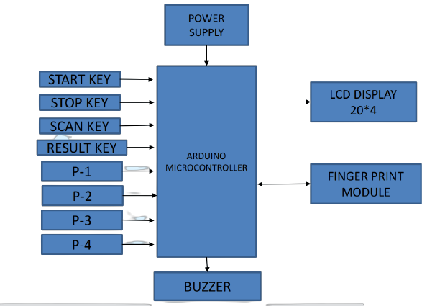

Fig.1. Proposed system of fingerprint based electronic voting system.

The system mainly aims for developing an electronic voting machine which helps in, free and fair way of conducting elections. Our electronic voting technology includes a fingerprint module which is used to store the fingerprints of the people initially using feature extraction algorithm. This project consists of several units such as fingerprint module, Arduino microcontroller, 20*4 LCD display, push buttons and buzzer. The voter first places his finger on the fingerprint module which checks for the authentication of the user, If the voter is the authorized user, then he is able to cast his vote to his desired contender by simply pressing button. The microcontroller unit will process his vote by incrementing of one vote and the final result will be shown in LCD display. Embedded ‘C’ Language is used to perform this intelligent work.

The Description of each and every used in the project is Explained below :-

**ARDUINO MICROCONTROLLER**

It has communication ports and input/output ports. We can connect different types of peripherals on the board.Controller is like a brain of our project, It has features like 14 digital input/output pins, 6 analog inputs, 16MHz ceramic resonator, power jack, USB connection, ICSP Header and a reset button.

**FINGERPRINT MODULE**

For the identification purposefingerprint module is the most popular one. The module used here is R305. It works by examining a finger pressed against a smooth surface, The fingure’s ridges and valleys are scanned and a series of distinct points where ridges and valleys end or meet are called minutiae. Fingerprint recognition system uses minutiae points for the comparison other fingerprint’s and matched by matching algorithm.

**20*4 LCD DISPLAY**

It can display 20 characters per line and there are 4 lines. It displays Each character in 5*7 pixel matrix. It has two registers called command and data. It provides a user interface. It is used to display related messages, warnings and results of the elections.

**POWER SUPPLY**

It consists of a Transformer, rectifier, filter, 7805 and 7812 voltage regulators these all components are incorporate together to provide the regulated power supply to the unit which is first converted into 12V AC. 12V AC is converted into DC using rectifier circuit. 5V is provided using 7805 voltage regulator to the circuit.

**PUSH BUTTONS**

It is a simple switch mechanism for controlling some portions of the machine. It controls an electrical circuit in which the operator manually presses a button to activate a particular function.

**BUZZER**

It is an audio signaldevice, Which is used to produce a beep sound. When an unauthorized person attempts to vote or repetition of vote, then it will alerts the security by blowing the buzzer.

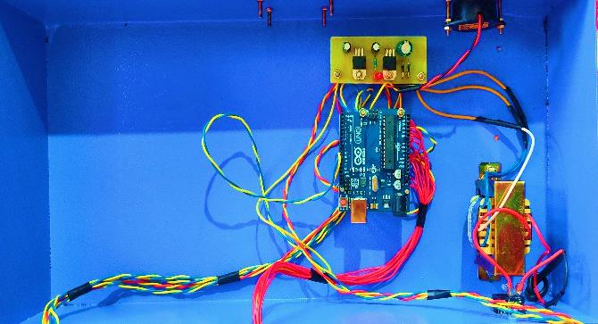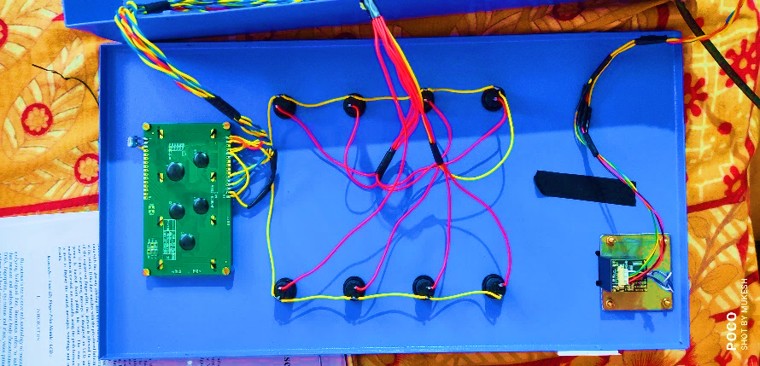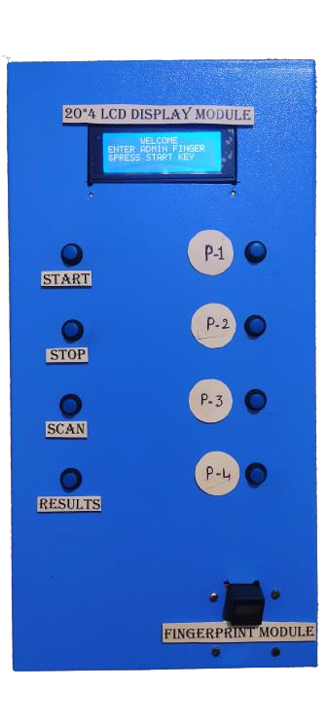The Final Outcome of the proposed fingerprint based Electronic Voting System is shown below in Fig.2.

Fig.2.Final outcome of the proposed fingerprint based electronic voting system.

**IV. WORKING :-**

**FLOW CHART :-**Work Flow of the proposed fingerprint Based Electronic Voting system is shown below in Fig.3.

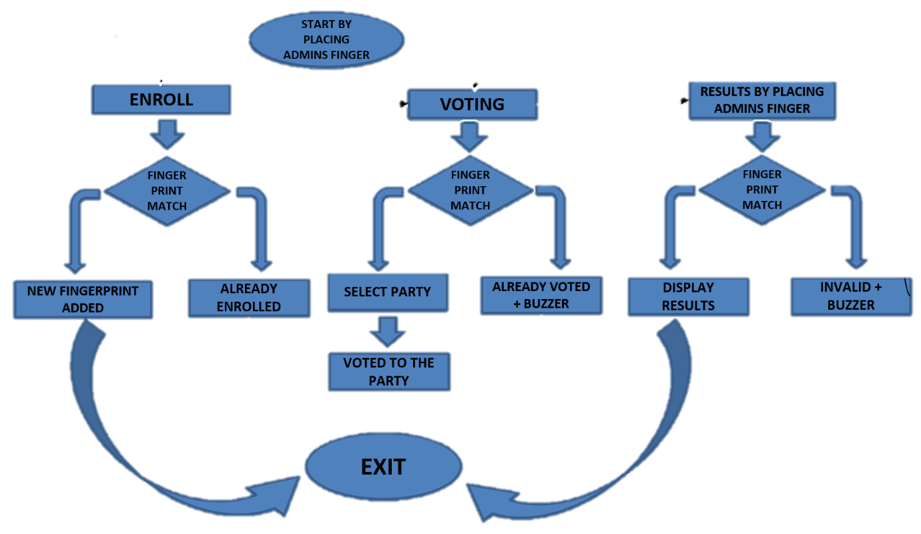

Fig.3. Working flow of the proposed fingerprint based electronic voting system.

**PROCESS OF VOTERS VERIFICATION:** The process voters verification during elections is shownbelow in Fig.4.

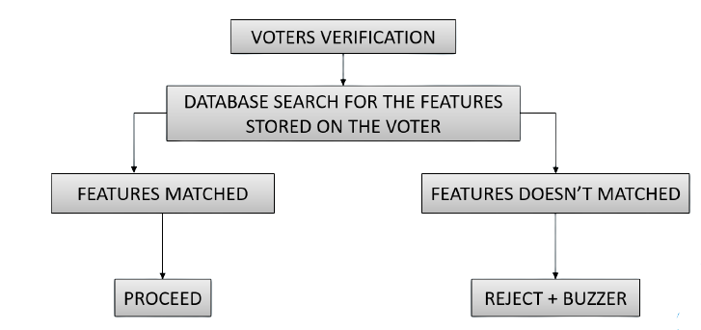

Fig.4. Process of voters verification.

**PROCESSING &COUNTING:-**Processing and Counting work flow is shown in the Fig.5.

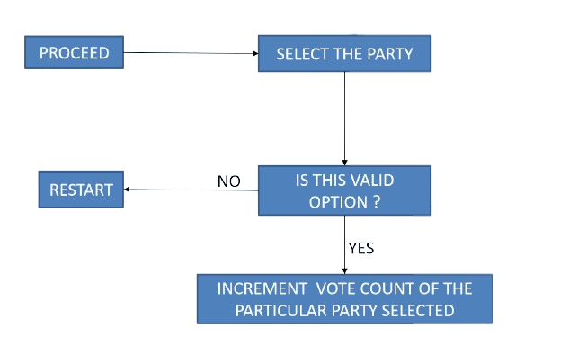

Fig.5. Processing and counting of the votes

**B. METHODOLOGY**

It is implemented with both software and hardware using different tools in it.

**1) Software** :-

* Arduino IDE
* Used embedded ‘C’ Language

**2) Hardware** :-

* Fingerprint module
* Aduino microcontroller
* LCD display
* An iron box to look as a perfect machine

**V. RESULT :-**

**A. Enrollment :-**Enrollment of the voter before elections period is shown below in Fig.6.

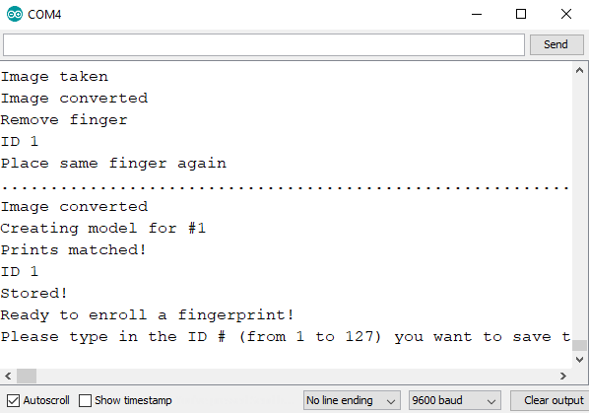

Fig.6. Enrolloling of the voter

**B. VOTING :-**

* + Requires Fingerprint identification of the admin to start the polling of votes by placing finger on scanner and press start key.
  + Casting of votes by voters can be done by placing their fingers on scanner and press scan key, then cast your vote to your favourite contender by pressing the appropriate button, vote is incremented by one to the particular contender.
  + After the completion of polling of elections, admin need to stop the polling by placing finger on scanner and press stop key.
  + Results can be retrieved by admin by placing finger on the scanner and press Results key.

**NOTE** :-

* It prevents from repetition of votes by the same voter by blowing a buzzer, then the security management will get alert.
* When an un-registered voter attempts to vote, then it prevents by the beep sound from the buzzer.
* It is under the control of admin only.

**VI. ADVANTAGES** :-

* Voter can Vote from any polling place irrespective of the location.
* Less time required forVoting and Counting.
* Avoids illegal voting.
* In case of any malpractice the authorities could immediately notified.
* Increased security and less man power required.
* Greater accuracy and faster tabulation of results on the polling day itself.
* Ease of transportation due to its compact size.

**VII. CONCLUSION & FUTURE SCOPE :-**

We presented an electronic technology based voting system, which includes a fingerprint module used to capture the fingerprints of the people. This project has extra scopes such as Fingerprint module compared to the existing traditional system. The scanner scans the fingerprint of the voter and compares with database.

It could be interfaced with printer to get the hard copy of the result almost instantly from the machine itself. Face and Iris detection technology can be added for further security. GSM module can be used to send the SMS confirmation to the voter.

**REFERENCES :-**

[1] Rudrappa B. Gujanatti and shivaram N. tolanur “A fingerprint based voting system”, International journal of engineering research and technology (IJERT), Vol.4 issue 05, PP.887-892, may-2015.

[2] Press trust of india.

[3] Murughendra S. Nemagoud and Shanta S. Reddy “A fingerprint based voting system”, International journal of engineering research and technology (IJERT), Vol.4 issue 05, PP.887-892, may-2015.

[4] Election Commission of India.

[5] Sangameshwarneelagund “A fingerprint based voting system”, International journal of engineering research and technology (IJERT), Vol.4 issue 05, PP.887-892, may-2015.

[6] A.K. Agarwala, D.T. Shahani, and P.V. Indiresan. Report of the expert committee for evaluation of the upgraded electronic voting machine (EVM), sept.2006.