**A STUDY ON DEVELOPMENT OF PRODUCTION PLANNING AND CONTROL DESIGN**

1. **Dr.K.Baranidharan**

**Associate Professor MBA**

**Sri Sai Ram Institute of Technology**

**Chennai**

[**baranidharan.mba@sairamit.edu.in**](mailto:baranidharan.mba@sairamit.edu.in)

**2. Dr.V.Selvakumar**

**Associate Professor MBA**

**Sri Sai Ram Institute of Technology**

**Chennai**

**3. T. Illakkiya**

**Assistant Professor MBA**

**Sri Sai Ram Institute of Technology**

**Chennai**

**4.. Dr.Suganya**

**Assistant Professor Commerce**

**Idhaya College for Women**

**Kumbakonam**

**5. Dr N. Selvakumar**

**Assistant Professor Commerce**

**Annai Vailankanni Arts College**

**Thanjavur**

**Abstract**

Production planning is a pre-production activity. It is the pre-determining of production requirements such as labour, materials, machines and production processes. Ray Wild defines production planning as the identification, acquisition, and disposition of all facilities necessary for the future production of a product. It represents the design of the production system. In addition to resource planning, he will organize production. Based on the estimated demand for the company's products, he will establish a production program to achieve the stated goals using various resources. Through this study, an attempt was made to identify the key areas for improvement in the development of the production plan and control design at Brakes India. The objectives of this study included analysing the various benefits and advantages that production planning and control offers, assessing the effectiveness of training provided for planning and production control, an important step in the execution of production planning and control, the factors that need to be improved in the production system, and knowing the level of employee satisfaction with the production planning Existing control design and production. Manufacturing companies use quality assurance programs to gain a competitive advantage in the marketplace and reduce defect rates on the production line. Production control is an essential part of these programs, as it aims to eliminate waste from production processes through planning and organization. Its many benefits can be discussed with workers and production line managers. The study allowed Brakes India to assess the various elements needed to develop a new design for their existing production planning and control operations.

**Key Words: Production, Planning, Training, Quality, Waste.**

**Introduction**

The techno-financial state of affairs of India, emphasize on competitiveness in manufacturing. Indian industries must streamline the manufacturing sports and gain the most usage of firms` sources to beautify the productivity. Production making plans and manage serves as a beneficial device to coordinate the sports of the manufacturing machine via way of means of right making plans and manage machine.

Production making plans and manage is wanted to acquire: 1. Effective usage of firms` sources. 2. To acquire the manufacturing goals with appreciate to exceptional, quantity, price and timeliness of transport. 3. To attain the uninterrupted manufacturing float if you want to meet clients numerous call for with appreciate to exceptional and devoted transport schedule. 4. To assist the organization to deliver exact exceptional merchandise to the consumer at the nonstop foundation at aggressive rates.

Production Control Inspite of making plans to the minute details, maximum of the time it isn't viable to acquire manufacturing a hundred in line with cent as in line with the plan. There can be innumerable elements which have an effect on the manufacturing machine and due to which there's a deviation from the real plan.

Some of the elements that have an effect on are: 1. Non-availability of materials (because of shortage, etc.) 2. Plant, device and device breakdown; 3. Changes in call for and rush orders; 4. Absenteeism of workers; and 5. Lack of coordination and verbal exchange among diverse purposeful regions of business.

**Product quality**

Product quality has a direct impact on customer satisfaction, brand reputation and bottom line profits. If a customer buys a defective product, the business may lose customer base and future revenue-generating ability. Production control helps line managers, supervisors, and employees spot defects before they reach customers. Analysis of captured defects helps identify system failures that, when corrected, can lead to process improvement initiatives. Producing high-quality products is one of the most effective ways for manufacturers to outperform their competitors.

**Reduce waste**

Over-processing, scrap, rework, and over-transportation are some of the wastes that can exist in a manufacturing facility. It is difficult to identify and dispose of waste without using a standardized method. Production control incorporates technical measures and quality assurance principles to eliminate production inefficiencies. Done properly, production control can improve lead times. It can also improve employee morale, as being productive makes it easier to get work done.

**Reduction of running cost**

Production control can reduce costs associated with quality degradation. Scraps and other forms of waste can be tied to the general ledger expense account and assigned to an amount of $ 1. This process helps executives identify costs associated with wasteful and inefficient operations. Overhead is an important factor in a company's competitiveness in the market. By eliminating waste, businesses can gain market share and increase profits.

**Better decision making**

Without the proper information, it will be difficult for plant managers to direct staff and monitor production systems. Quality tools such as control charts allow administrators to distinguish between normal process deviations and critical process flaws. The specific cause of the variation is due to 4 defective equipment, ineffective processes, or human error. Production control identifies system flaws and enables managers to make better operational decisions.

**Review of Literature**

**Jean Luc Habiyaremye, Fillemon Nangolo, Ester Angula, and et. al.(2021),** did a research on “Balancing of the Production Line Process in the Manufacturing of the Hand Grinder” implies that there are many problems with the mechanical and manual processes involved in manufacturing hand grinders. There are various issues such as B. Large work in process (WIP) inventory, unreasonable allocation of workflows, chaotic assembly line layouts, and unbalanced assembly lines. Visualization of workspace layouts and production line process diagrams is done using a value stream map (VSM). This study creates a flow chart of future value for optimizing the production line of hand grinders. In this study, industrial engineering (IE) techniques helped improve manufacturing flows and layouts, identifying workflow bottlenecks. Even when IE methods are combined with the Genetic Algorithm (GA), they are a useful tool for balancing and eliminating all consecutive manufacturing problems. The upgraded production line has succeeded in reducing production lead time (PLT), reducing inventory activity, eliminating unnecessary movement of people, and balancing the flow line's production system and layout.

**Frenette Southwood, Michelle White(2021),** did a study on “Elicited Production of Part/Whole and General Specific Articles by Four- to Nine-Year-Old Afrikaans- and South African EnglishSpeaking Monolinguals This study examines the use of articles, especially the development of part / whole and general / specific article distinctions in Afrikaans and English-speaking children. Previous studies comparing the development of these distinctions have yielded conflicting results. Extensive research on the two languages has been conducted to fill this gap in literature. There were two research questions: (a) Is the development of the article system done four years after birth in terms of partial or whole and general or specific distinctions. And in particular, is there a difference between the production of the child part or whole and the general or specific article. The article production task was conducted by 1012 Afrikaans and 413 South African English aged 4-9 years. The result is that not all items are mastered even at the age of 9, and items with partial or total distinctions are more difficult than items with general or specific distinctions in all age groups. is showing.

**Mohammad Ammar, Abid Haleemn and et. al.(2021),** did a research on “Improving material quality management and manufacturing organizations system through Industry 4.0 technologies” implies that In this changing era, Industry 4.0 technology is being introduced in many parts of the world. These technologies are used in the development of smart materials, smart factories, smart logistics, smartware housings, and smart supply chains. From a business perspective, it has the potential to solve complex manufacturing problems. This paper provides a detailed study of various Industry 4.0 technologies for improving material quality and manufacturing systems. We have listed the various technologies available, their characteristics, and the benefits of effective management in emerging industries. Digital technology helps businesses optimize material waste and inventory, resulting in cost savings. Remote collaboration makes it easy for on-site and off-site employees to collaborate when they need it. Ultimately, these technologies help reduce communication gaps and keep information up to date. Smart Predictive Analysis helps you properly monitor equipment in the industry that uses Industry 4.0 technology. Material defects can be detected and corrected at an early stage. In addition, this creates transparency in systems and processes to meet customer expectations

**Need for the study**

Production planning is a pre-production activity. This is a pre-determination of manufacturing requirements such as human resources, materials, machinery and manufacturing processes. Ray Wild defines that “production planning is the determination, procurement, and placement of all the equipment needed for future production of a product.” This represents the design of the production system. In addition to planning resources, she organizes production. A production program is created based on the estimated demand for the company’s products. To achieve the goals set by various resources. Through this research, researchers are trying to identify key areas in need of improvement in the development of production planning and control design at Brakes India.The study is made in order to make improvements in the production planning and control design to reduce the down time occurred due to the PPC. The major issue related to the PPC is with the setup issue. This causes the down time around 1376 minutes which is approximately equal to 23 hours. Set-up issue arises due to the following reasons: Hand Change, change over from one model to another model, material non-availability. Another major issue related to PPC is waiting for material which includes waiting for housing, waiting for carrier

**Scope and significance of the study**

Manufacturers use quality assurance programs to gain market competitiveness and reduce errors on the production line. Production control is an important part of such a program as it aims to remove waste from the manufacturing process through planning and organization. Many of its benefits can be discussed with the workers and managers of the production line. This study allows Brakes India to assess the various factors needed to develop new designs for existing production planning and management activities. Changes in the existing production may improve the efficiency of the production process which in turn improves the productivity. Various inputs are required to manufacture a product. The quality of the final product is directly proportional to the quality of the inputs that enter the manufacturing process. Therefore, planning is also needed to ensure that the appropriate inputs enter the production process. Appropriate combinations of inputs are essential to achieving a certain level of production. The perfect product can only be created if the required combination of inputs is met. However, as the composition changes, the final product changes. Appropriate adjustments between machines, equipment and workers must be ensured. This reduces waste and ultimately costs. Management function is production planning. Planning is a stepping stone to effective management. Actual performance can be checked against set criteria and deviations can be easily corrected. Scheduling ensures continuous delivery of materials and components without interruption. This eliminates idle time in the production process.

**Objectives of the study**

• To study the development of Production, Planning and Control design at Brakes India Private Limited

• To Analyse the various benefits and benefits provided by production planning and management

• To assess the effectiveness of production planning and management training.

**Sample Size**

Samples were collected from employees and workers of the organization. The total sample size of both is 120.

**Analytical Tools**

The data collected were edited, coded and processed. Percentage technique is used in order to simplify the figure for diagrammatic representation. The following techniques are used to analyze the collected data and information. ✓ Percentage Analysis ✓ Chi-Square Analysis ✓ Correlation ✓ One way Anov

**Statistical Analysis**

CHI- SQUARE TEST I – (ψ2 ) Chi-square is the sum of the squared difference observed (o) and the expected (e) data (or the deviation, d), divided by the expected data in all possible categories.

Null hypothesis (Ho): There is no relationship between the Experience and the Income.

Alternate hypothesis (H1): There is relationship between the Experience and the Income.

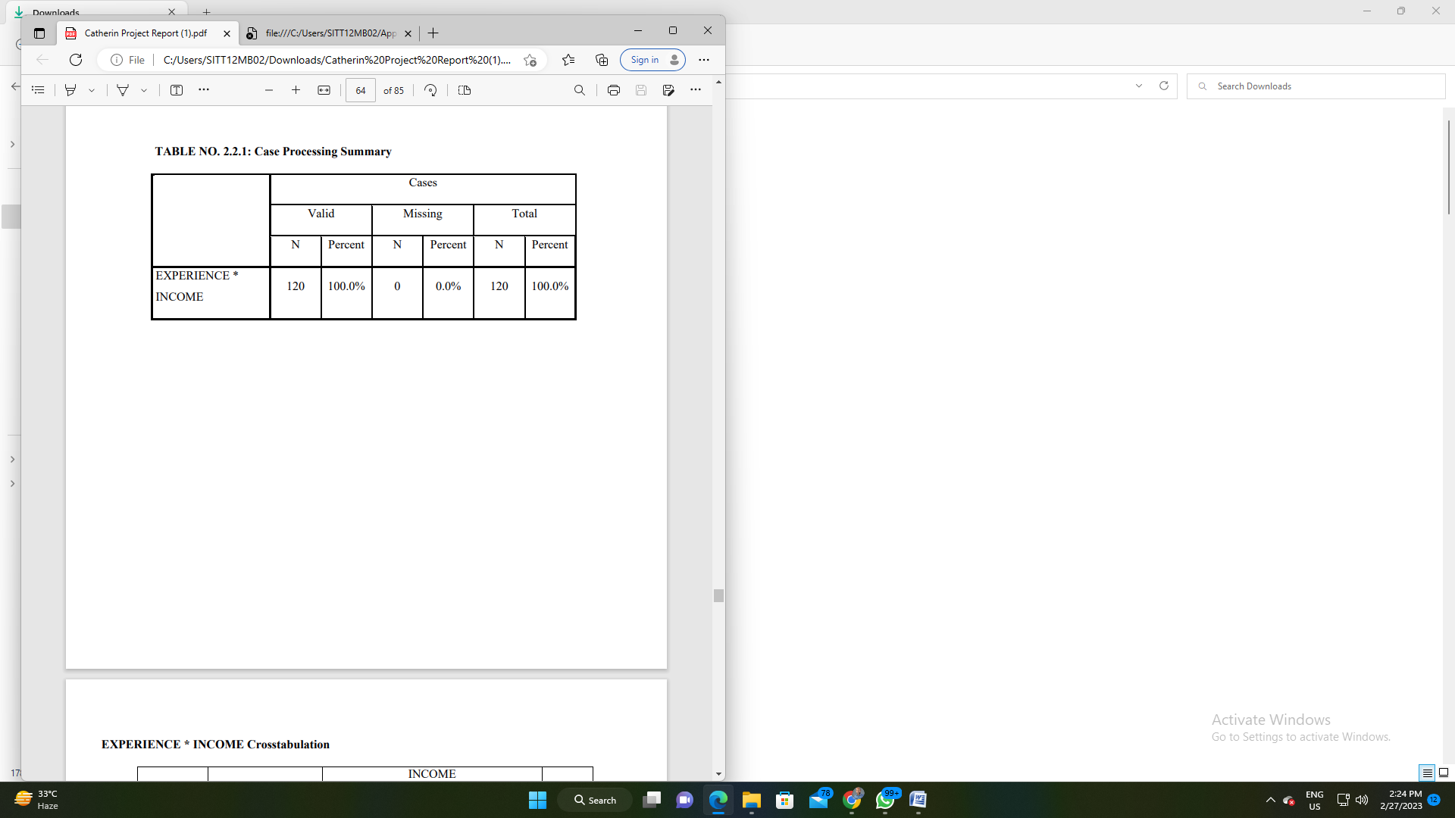

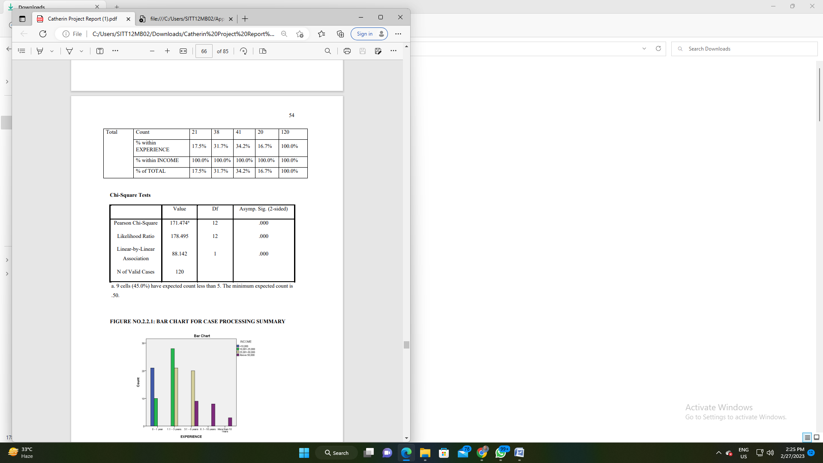

Degree of Freedom= (r-1) *(c-1) = 4*3= 12 Calculated value = 171.474 Tabulated value = 21.026 Z = Z cal >Z tab Z= 171.474>21.026 Hence, the Alternate hypothesis [H1] is accepted INFERENCE: Since the calculated value is greater than the tabulated value, we accept the alternate hypothesis and hence there is a relationship between the Experience and the Income.

**ONE-WAY ANOVA CLASSIFICATION**

Null hypothesis (Ho): There is a significance difference between ultimate benefit a company gets through effective production planning and control activities and the company preferred production planning and control.

Alternate hypothesis (H1): There is no significance difference between ultimate benefit a company gets through effective production planning and control activities and the company preferred production planning and control.

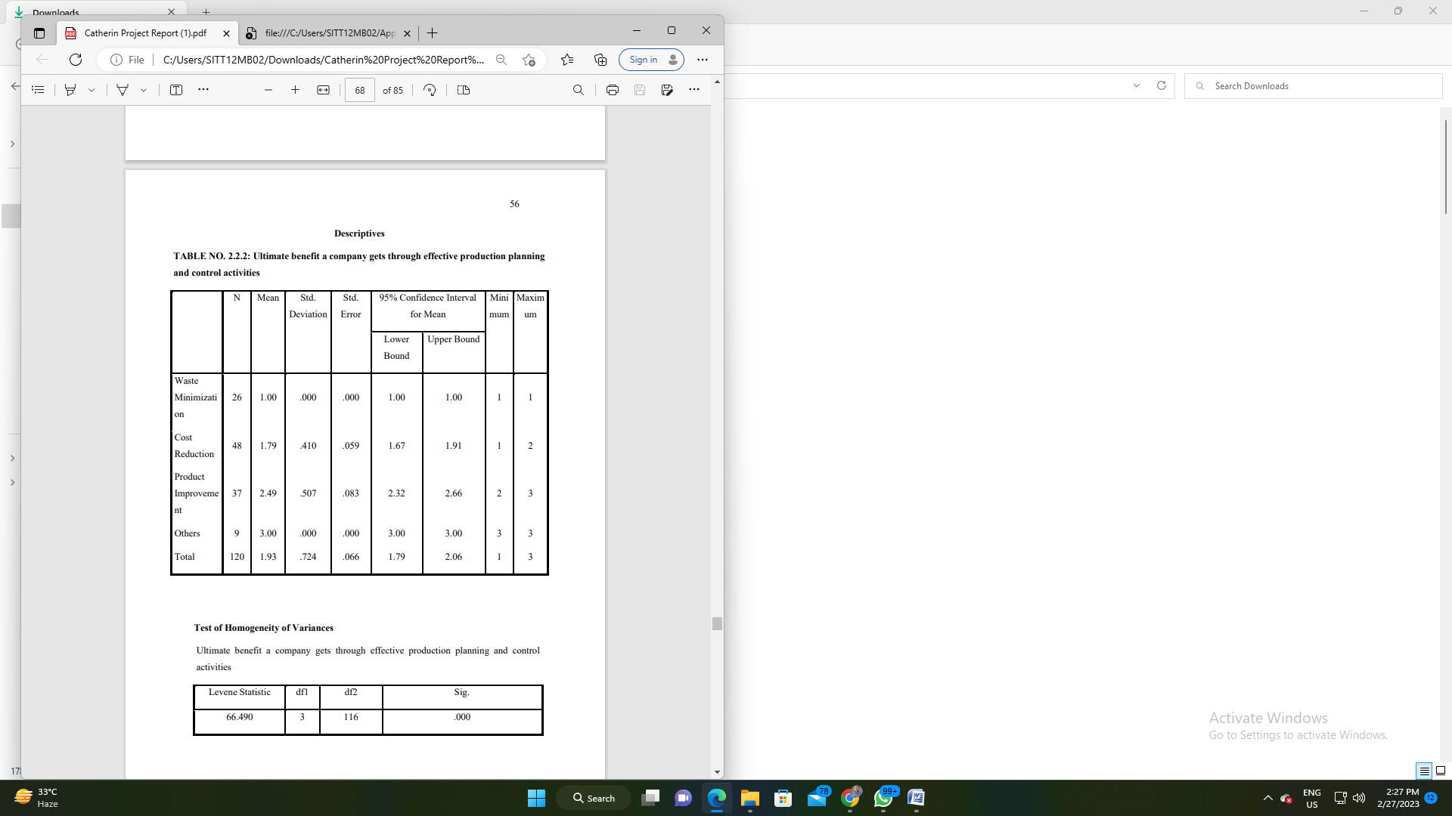

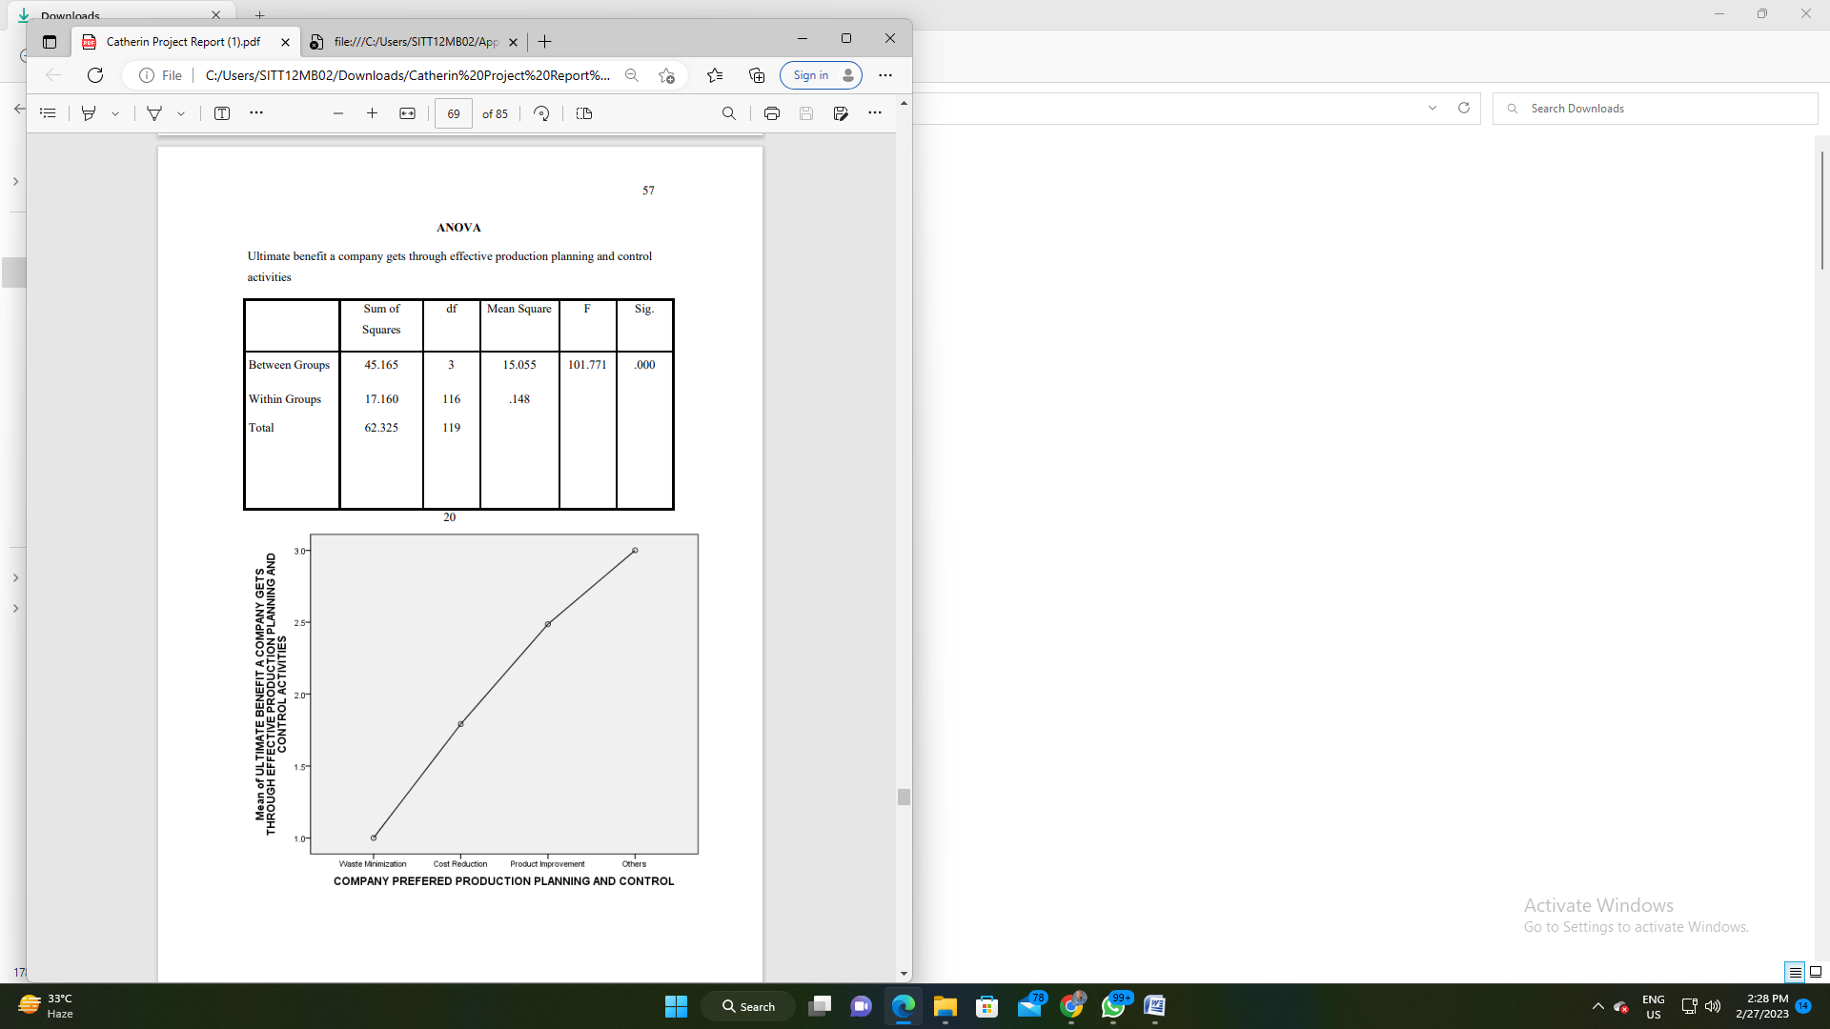

**FINDINGS OF THE STUDY** • Most of the respondents are finished UG. • Most of the respondents have the most enjoy of 3years. • Most of the respondents are above the age of 35years • Most of the respondents are Males withinside the organization. • Most of the respondents are incomes the profits of 50,000. • Most of the respondents were concerned in manufacturing and making plans manipulate for greater than five years. • Most of the respondents decide on all of the above declaration may be very essential step withinside the implementation of manufacturing making plans and manipulate. • Most of the respondent of the respondent says extended cost out of your present clients is the remaining advantage a organization can get thru powerful manufacturing making plans and manipulate sports. • Most of the respondents are strongly is of the same opinion that manufacturing making plans and manipulate make sure a everyday and regular waft of manufacturing. • Most of the respondent says manufacturing fee financial savings thereby enhancing the lowest line is the primary benefit of sturdy manufacturing manipulate. • Most of the respondents strongly agreed with manufacturing manipulate makes it viable to decrease the charges related to negative quality. • Most of the respondent says organization favoured fee discount making plans and manipulate. • Most of the respondent says organization affords education for each new updates approximately the modern improvements in manufacturing making plans and manipulate. • Most of the respondents suppose inner kind of running shoes is used for accomplishing those manufacturing making plans and manipulate education programmers. • Most of the respondents say ok education substances given for the duration of those productions making plans and manipulate education programmers is powerful. • Most of the respondents are surprisingly happy approximately the education given for manufacturing making plans and manipulate. 62 • Most of the respondents strongly agree that the elements that want to be stepped forward withinside the manufacturing gadget are Plant, device and system breakdown • Most of the respondent considers that it's miles very smooth to method to put into effect the manufacturing making plans and manipulate. • Most of the respondents are surprisingly happy with the cutting-edge manufacturing making plans and manipulate sports at Brakes India. • Most of the respondents requirements components with the uncooked substances and WIP. of the respondent are privy to the rejected substances withinside the organization location • Most of the respondent says fashionable reorder amount parameters are required to function constant order amount • Most of the respondents say that screw ups in shipping dedication facilitates us to take a look at the weak spot in making plans and manipulate branch.

**Suggestions For The Study**

• In order to investigate the weaknesses of production planning and management departments, it is necessary to regularly monitor the default of delivery obligations of goods. This avoids customer complaints and improves customer satisfaction • The company can publish a self-explanatory online training video about production planning and management activities. This saves your company training time and costs. Employees can watch this online training video at any time. • The quality of all productive maintenance needs to be improved to avoid plant, equipment and machine failures. • Create in-house communication systems or mobile apps to avoid lack of coordination and communication between different functional areas of the company. • You can use production and planning management software to better manage job.

**Conclusion Of The Study**

Production planning and control usually involves organizing and planning the manufacturing process. Specifically, it is planning the coordination and control of routing, placement, placement and control, materials, methods, machines, tools, and deployment times. Based on this project, researchers have identified various weaknesses in production planning and control, such as order cancellations, customer complaints, and delivery bottlenecks, through research and analysis using statistical tools. Based on the findings, some valuable suggestions were made to improve production planning and control design. The discussed benefits of production planning and control will improve organizational improvements for regular and on-time delivery, better supplier communication for raw material procurement, reduced inventory investment, reduction of production cost by improving efficiency, smooth flow of all production processes, reducing wasted resources, save production costs to improve profitability. Its will also regulates the inventory management, organize the production schedules, optimizes the utilization of resources and production process, ensures smooth flow of production process, ensures production cost savings thereby improving the bottom line and controls wastage of resources.

**Journals**

• Achim Kamper, Johannes Triebs, Ansgar Hollah, Christoph Lienemann (2019), “Remanufacturing of Electric vehicles: Challenges in production planning and control”, Procedia manufacturing, Volume 33, 2019, Pg: 280-287 • Andrea Sianesi, Maria Caridi(2000), “Multi-agent systems in production planning and control: An application to the scheduling of mixed-model assembly lines”, International Journal of Production Economics, Politecnico di Milano, Dpt. di Economia e Produzione, Piazza Leonardo da Vinci, 32-20133 Milano. • Ashkan Memari, Abdul Rahman Bin Abdul Rahim and Robiah Binti Ahmad (2014), “Production Planning and Inventory Control in Automotive Supply Chain Networks, International Conference on Industrial, Engineering and other applications of Applied Intelligent Systems, June 2014 • Boysen N, Fliedner M, Scholl A (2009), Production planning of mixed-model assembly lines: overview and extensions, Production Planning and Control, 2009 - Taylor & Francis, the Management of operations, Volume 20, 2009- Issue-5, Pg: 455-471 • Daniel R.Guide, Jr.Vaidyanathan Jayaraman, Rajesh Srivatsan(1999), Robotics and ComputerIntegrated Manufacturing, Volume 15, Issue 3, June 1999, Pages 221-23 • Dingwei Wang, Xian-Zhang Chen & Ying Li(2007), Experimental push/pull production planning and control system, Pages 236-241 | Published online: 27 Apr 200

**Books**

• Gupta, S.P., Statistical Methods, New Delhi, Sultan Chant & Sons Publishers, Thirty Fourth Edition, 2005. • Production And Operation Management – by S.A. Chunawalla, Patel • Production planning and control – by k. Shridhara bhat & K.Aswathappa. • Kothari, C.R., Research Methodology - Methods & Techniques , New Delhi, New Age international (P) Ltd., Publishers, Second Edition,2004. • P.N. Arora and S. Arora, Statistics for Management, New Delhi, Sultan Chand & Company Ltd, First Edition, 2003.

**Websites**

• www.prodplan.org • www.answers/topic/ppc.com • www.mangamentorg.com • www.wikipedia.org • www.scribd.co