MECHANICAL AND WEAR BEHAVIOUR OF ALUMINIUM COMPOSITE REINFORCED WITH CHROMIUM BORIDE AND CHROMIUM CARBIDE

S.GUNASEKARAN1, Prof.R.SURENDRAN2 , Dr.N.NANDAKUMAR3, Dr.S.PERIYASAMY4

1PG Scholar, Engineering Design ,Government College Of Technology, Coimbatore, 641013.

2Assistant Professor ,Mechanical Engineering Department , Government College Of Technology, Coimbatore, 641013.

3 Professor, Mechanical Engineering Department, Government College Of Technology, Coimbatore, 641013.

4Associate Professor , Mechanical Engineering Department , Government College Of Technology, Coimbatore, 641013.

INTRODUCTION

Metal matrix composites consist of a metal matrix filled with nano ceramic particles featuring physical and mechanical properties very different from those of the matrix. The properties that can be improved by nano particles include damping, mechanical strength, and wear resistance to the base material. MMCs are now being widely used in much industrial application for their desired mechanical properties. Metal matrix composites can be classed as having either continuous or discontinuous fibre reinforcement. Discontinuous reinforced MMCs appear to offer more potential due to their ease of manufacture. The common manufacturing processes used to achieve these composites are powder metallurgy techniques, vapour deposition, diffusion bonding, and infiltration of liquid metal into the fibre bundles under pressure. Aluminium alloys and composites have, in most applications, exhibited superior performance compared to their rival metals. The choice of aluminium alloys and composites derives from one important attribute of aluminium metal—light-weight. Light-weight translates into many important outcomes in engineering applications.

In 2024 aluminum alloy, these elemental percentages are 4.4% Cu, 1.5% Mg, and 0.6% Mn, nominally and this clearly explains why 2024 aluminum is known for its high strength because copper, magnesium, and manganese greatly increase the strength of aluminum alloys. This strength comes at a disadvantage, however the high percentage of copper in 2024 aluminum greatly reduces its resistance to corrosion. There are usually trace amounts of impurity elements (silicon, iron, zinc, titanium, etc.). The density of Al 2024is 2.77g/cm3 (0.100 lb/in3), which is slightly higher than pure aluminum (2.7g/cm3, 0.098 lb/in3). 2024 aluminum is machined very easily and has decent workability, allowing it to be both cut and extruded if need be. Al 2024 is a high strength alloy at room temperature and even at elevated temperatures. In addition, it displays superior finish ability and fair to good workability together with good machinability. This alloy shows a relatively low ductility at room temperature and is generally heat treated in various conditions to suit particular applications. It finds wide use in many aerospace structural elements, military vehicles, bridges and weapons manufacture because of its excellent strength. Therefore, further improvements in the mechanical properties of this alloy will open up new areas of research. Severe plastic deformation technologies provide new opportunities for developing nanostructures in metals and alloys with improved mechanical properties that are very attractive for various structural and functional applications. The fine refinement in the structure of metals and alloys developed by modern methods of SPD has led to the development of newer ultrafine-grained materials with a unique set of functional and service properties. Al 2024 alloy is a type of aluminium alloy with copper as its primary alloying element. Al 2024 alloy are used in aircraft structural applications as a result of its high strength and fatigue resistance. It is stronger than aluminium 6061 but less adaptable.

Al 7075 is widely used in applications that require high stress and strain resistance, where 2024 is used in application of high cyclic fatigue resistance. The most predominant alloys used for aerospace and tribological applications are Al 2024 and aluminium 7075. Comparatively to aluminium 7075, Al 2024 has poor corrosion resistance and wear resistance which can be enhanced by adding reinforcement. Hence, these abovementioned problems make them compromised in terms of material selection for aerospace and tribological applications, even though Al 2024 have high strength. A recent research investigated the wear characteristic of aluminium MMC reinforced with 10 wt. % Si-based refractory compounds (SBRC) derived from rice husk (RHs). From the results it was observed that with respect to load condition there was an increase in wear volume of the composite (Adeolu et al., 2020).

In a study, tribological characteristics of metal matrix composite of aluminium 6063 fabricated by stir casting process with reinforcement as boron carbide and zirconium silicate. The composition of the reinforcement in the composite was 3%, 6% and 9% by weight and the metal matrix at 88% by weight. It is inferred, composite with 3 wt % boron carbide and 9 wt % zirconium silicate showed improved wear resistance compared to other composites (Panneerselvam et al., 2018). The modern study shows that with the addition of boron carbide particles to Al 2024 alloy results in improved mechanical properties. Microstructure results of this composite shows that, there is a uniform distribution of B4C particles on the Al2024 matrix both on low and high magnification and also it facilitates strong metallurgical bonding between matrix and reinforcements. Addition of B4C also improves the Tensile strength, elastic modulus and ultimate Tensile Strength (Nie et al., 2007).It is identified that the uniform dispersion of reinforcement particles and appreciable improvement in mechanical properties improve the micro hardness of the base metal (Srivastava et al., 2019). In a study a polymer composite reinforced with silicon carbide filled short glass fibre resulted in better erosion resistance when compared with unfilled composite (Kaundal et al., 2012). The goal of this study is to analyse the results of various percentage of chromium boride and carbide mixture as reinforcement in Al 2024 metal matrix on mechanical and tribological properties like tensile strength, wear and hardness.

KEYWORDS: Wear Behaviour, Chromium Boride, Chromium Carbide, Aluminium

MATERIALS AND METHODS

1. Material used

1.1 Al 2024 alloy

Al 2024 is widely used for many applications in aerospace engineering for its desired properties and is used as the metal matrix in this study. The metal matrix binds the reinforced fibres together and distributes the load evenly throughout the material. It provides ductility, protects the reinforcements from surface damage and separates the reinforcement particles and prevents the spread of cracks from one particle to the next one. The major alloying elements of Al 2024 alloy .

|  |  |
| --- | --- |
| Major alloying elements | % by weight |
| Copper | 3.8-4.9 |
| Magnesium | 1.2-1.8 |
| Iron | 0.5 |
| Manganese | 0.3-0.9 |
| Silicon | 0.5 |

1.2 Chromium boride and carbide mixture

In this study, chromium boride and carbide mixture is employed as reinforcement. Chromium boride crystals are mostly used as abrasion-resistant available for anti- wear use. Due to its high hardness and needle-like structure, it provides outstanding resistance to severe abrasion and particle impact erosion. Chromium boride has extensive applications in mineral-based industries, thermal power stations, cement plants and steel plants where severe abrasion and erosion are to be contained. This mixture contains 80% of chromium boride and 20% of chromium carbide.

1.3 Methodology

Appropriate composition of the metal matrix and composite are selected according to the desired properties of the composite and the chemical and mechanical behavior of the metal matrix and reinforcement. According to a study, the addition of carbides is limited to a percentage range of 3% to 15% should only be added to avoid the rapid solidification during the casting process and to observe the impact of chromium boride particles.

Aluminum metal matrix composites are the major structural materials which have found vast scope for engineering applications which is majorly due to their superior characteristics and performance capabilities. Aluminum and its combinations have been utilized as a matrix for an assortment of reinforcements as boron carbide. Additionally, the melting point of aluminum 2024 is sufficiently high to fulfill numerous application necessities, yet having average corrosion resistance property and poor machineability when compared to aluminium 7075. Fabricated pure aluminum 2024 alloy with chromium boride and carbide mixture reinforced using a stir casting technique and investigate the tensile strength, hardness and wear resistance

1.4 Stir casting process

The stir casting process is a liquid state fabrication process and one of the common manufacturing processes used for fabricating composite materials. Stir casting is a liquid state fabrication process in which the reinforcement to be added is uniformly dispersed in the metal matrix. Initially, the metal matrix is melted at the required standard temperature in a muffle furnace and the reinforcement is fed into the muffle furnace with a stirrer powered by an electric motor.

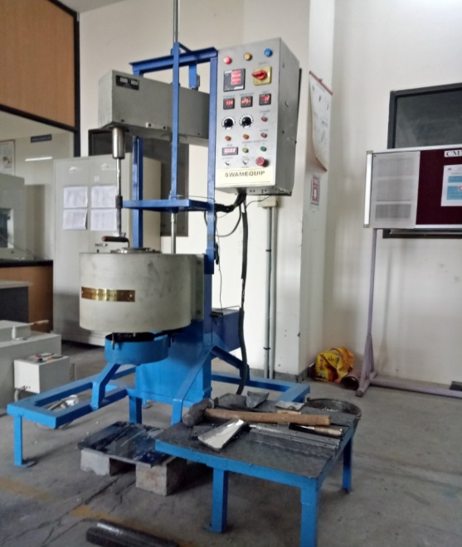

STIR CASTING SETUP

In this study, chromium boride mixture is added as reinforcement to Al 2024 metal matrix. Initially, Al 2024 is fed into the crucible and then to the stir casting furnace. Al 2024 ingots are melted at a temperature of 830 ℃ to 845 ℃, and it is ready for the addition of reinforcements. The schematic diagram of stir casting process.

Chromium boride and carbide mixture is added according to the required proportions to Al 2024 at the stirring speed of 300 rpm for about ten minutes. Meanwhile, the metal dies required are coated with die coating paste to recover the solidified specimen without any loss. Then the Al 2024 metal composite is poured into the die from the crucible.

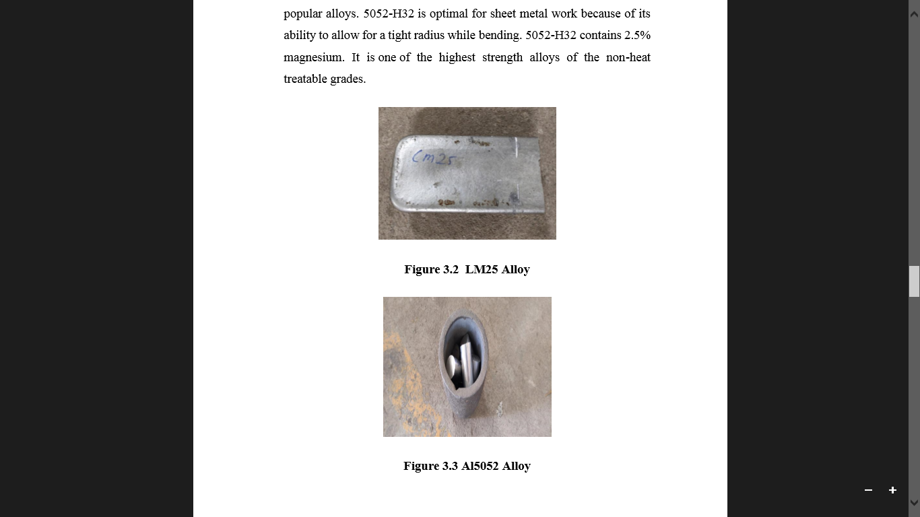

Once Al 2024 metal composite with reinforcement gets cooled and solidified, the final specimen is ready for machining and testing. Fig. 3.3 shows the casting of different proportions and slag formed The following procedure is done for three proportions.

i. Al 2024 950 g / Chromium boride mixture 50 g (5 wt %)

ii. Al 2024 925 g / Chromium boride mixture 75 g (7.5 wt %)

iii. Al 2024 900 g / Chromium boride mixture 100g (10 wt %)

1.5 Procedure

i. Preparation of Specimen: Initially, the specimen is cleaned and gauge length is marked on it.

ii. Range Calculation: A tensile stress value is assumed for which the maximum expected load capacity of the rod is calculated. From this, the range is calculated and this range is set in the UTM.

iii. Placing the Specimen: The handle is operated such that the specimen firmly fits to the top base. The left valve is kept in a fully closed position and the right valve in a normal open position. Open the right valve and close it after the lower table is slightly lifted. Adjust the load pointer to zero with the zero adjusting knobs. By operating the handle, lift the lower crosshead chuck up and grip firmly the lower part of the specimen. Once the specimen is placed, the jaws are locked.

iv. Placing Extensometer: Fix the extensometer on the specimen and set the reading to zero.

v. Load Application: Turn the right control valve slowly to open position to get the desired loading rate. When the specimen is under load, slowly unclamp the locking handle. Note the extension at a convenient load increment. Extensometer must be removed before reaching the yield point. The right valve is used to apply the load and the left valve is used to release the load on the specimen.

vi. Important Load Points: With the increase in load at some point, the load pointer remains stationary. Load corresponding to this indicates the yield point. With further increase in load, the pointer goes backward and specimen breaks. The load before this breaking is the ultimate load. The load at the breaking of the specimen is called as the breaking load.

1.6 Pin-on-disc wear testing

In a pin-on-disc wear tester, a pin is loaded against a flat rotating disc specimen such that a circular wear path is described by the machine. The machine can be used to evaluate wear and friction properties of materials under pure sliding conditions. Either disc or pin can serve as specimen, while the other as counterface. Pin with various geometry can be used. A convenient way is to use ball of commercially available materials such as bearing steel, tungsten carbide or alumina (Al2O3) as counterface, so that the name of ball-on-disc is used.

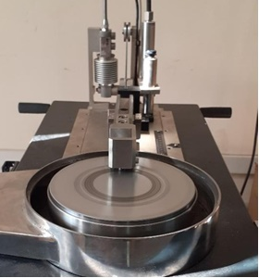

PIN ON DISC SETUP

1.7 RESULTS AND DISCUSSION

1.7.1 Hardness testing

From the results of hardness testing given in the Table 5.2 it is inferred that, Brinell hardness of the specimen with 7.5 wt % of reinforcement is significantly lesser than its virgin alloy. The Brinell hardness of the specimens with 5 and 10 wt % of reinforcement is marginally greater than its virgin alloy. It is also inferred that the specimen with highest tensile strength has the least hardness. Fig. 5.5 shows the hardness testing specimen of various composite after testing.

|  |  |  |  |
| --- | --- | --- | --- |
| Specimen | Reinforcement wt % | Indenter size in mm | Brinell hardness number (BHN) |
| 1 | 5 | 5 | 121 |
| 2 | 7.5 | 5 | 107 |
| 3 | 10 | 5 | 121 |

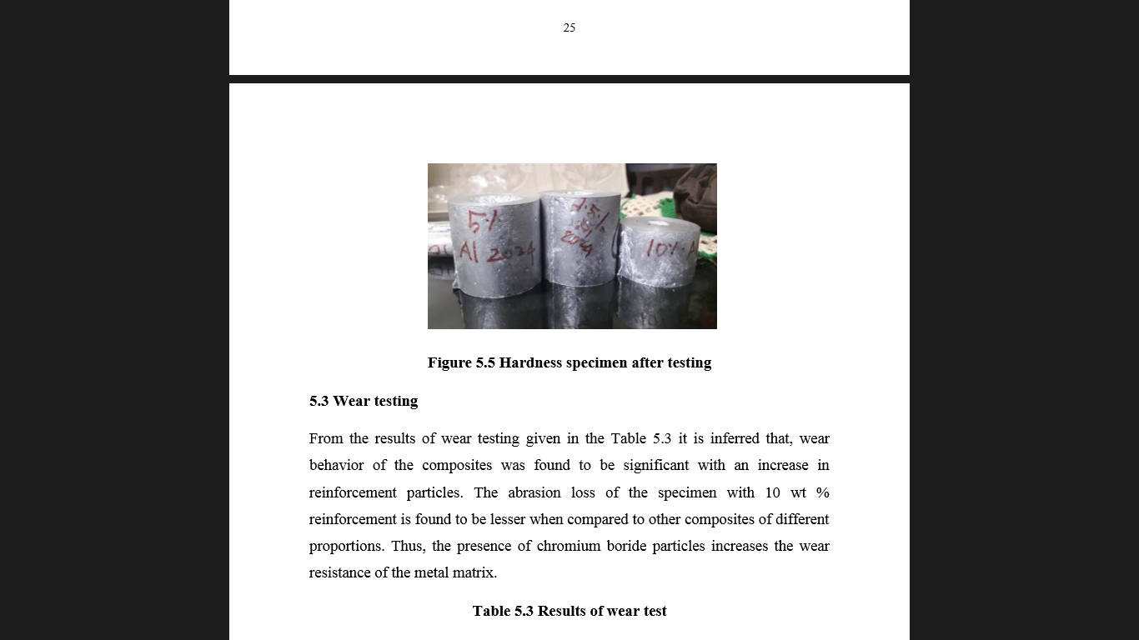

Hardenss sample

1.7.2 Wear testing

From the results of wear testing given in the Table 5.3 it is inferred that, wear behavior of the composites was found to be significant with an increase in reinforcement particles. The abrasion loss of the specimen with 10 wt % reinforcement is found to be lesser when compared to other composites of different proportions. Thus, the presence of chromium boride particles increases the wear resistance of the metal matrix.

|  |  |  |  |  |  |  |
| --- | --- | --- | --- | --- | --- | --- |
| Specime n | Reinforcement wt % | Load in Kg | Initial Weight in gram | Final Weight in gram | Abrasio n loss in gram | Weight loss in percentag e |
| 1 | 5 | 1 | 8.0379 | 7.9492 | 0.0887 | 1.10 |
| 2 | 7.5 | 1 | 8.2534 | 8.1432 | 0.1102 | 1.34 |
| 3 | 10 | 1 | 8.249 | 8.1779 | 0.0176 | 0.87 |

1.8 CONCLUSION

From the current study, it is concluded that, chromium boride can be used as reinforcement to produce aluminium-based MMC. These composites can be used in industrial applications for their improved mechanical properties. The efficiency of the casting was found to be decreasing with an increase in chromium boride reinforcement. Thus, the reinforcement can be added up to 10 wt % to obtain good casting efficiency. Beyond 10 wt %, the solidification of the molten metal increases and results in slag formation. The tensile strength of the composite has improvised with an increment in chromium boride content up to 10 wt %. The tensile strength of the composite with 10 wt % was 30 percent more than tensile strength of Al 2024. However, the hardness of the Al 2024 MMC hardly improved with the addition of chromium boride reinforcement. The wear resistance property of the MMC increased significantly than Al 2024 alloy. The composite with 10 wt % has improved wear resistance with abrasion loss of 0.0176 g

1.9 REFERENCES

[1] Canute, X., & Majumder, M. C. (2018). Investigation of tribological and mechanical properties of aluminium boron carbide composites using response surface methodology and desirability analysis. Industrial Lubrication and Tribology, 70(2), 301–315. DOI: https://doi.org/10.1108/ILT-01-2017-0010

[2]Hynes, N. R. J., Raja, S., Tharmaraj, R., Pruncu, C. I., & Dispinar, D. (2020). Mechanical and tribological characteristics of boron carbide reinforcement of AA6061 matrix composite. Journal of the Brazilian Society of Mechanical Sciences and Engineering, 42(4).

[3] Adeolu Adesoji Adediran, Kenneth Kanayo Alaneme, Isiaka Oluwole Oladele & Esther Titilayo Akinlabi (2020) Wear characteristics of aluminium matrix composites reinforced with Si-based refractory compounds derived from rice husks, Cogent Engineering, 7:1, 1826634. DOI: https://doi.org/10.1080/23311916.2020.1826634

[4] Kaundal, R., Patnaik, A., & Satapathy, A. (2012). Effect of SiC Particulate on Short Glass Fiber Reinforced Polyester Composite in Erosive Wear Environment. Walailak Journal of Science and Technology (WJST), 9(1), 49-64

[5] Kumar, N., Gautam, G., Gautam, R. K., Mohan, A., & Mohan, S. (2015). Synthesis and Characterization of TiB2 Reinforced Aluminium Matrix Composites: A Review. Journal of The Institution of Engineers (India): Series D, 97(2), 233–253. DOI: https://doi.org/10.1007/s40033-015-0091-7

[6] Chinmayee Kar & B. Surekha (2021) Characterisation of aluminium metal matrix composites reinforced with titanium carbide and red mud, Materials Research Innovations, 25:2, 67-75. DOI: https://doi.org/10.1080/14328917.2020.1735683

[7] Nadeem Faisal & Kaushik Kumar (2018) Mechanical and tribological behaviour of nano scaled silicon carbide reinforced aluminium composites, Journal of Experimental Nanoscience, 13:sup1, S1-S13. DOI: https://doi.org/10.1080/17458080.2018.1431846

[8] Oliveira, C. K. N. D., Totten, G. E., Neto, A. L., & Casteletti, L. C. (2008). Micro-abrasive wear of boride layers on AISI D2 tool steel produced by the thermoreactive process. International Journal of Microstructure and Materials Properties, 3(2/3), 241. DOI:https://doi.org/10.1504/IJMMP.2008.018731.

[9] Narayan, S., & Rajeshkannan, A. (2017). Hardness, tensile and impact behaviour of hot forged aluminium metal matrix composites. Journal of Materials Research and Technology, 6(3), 213–219. DOI: https://doi.org/10.1016/j.jmrt.2016.09.006

[10] Nie, C.-Z., Gu, J.-J., Liu, J.-L., & Zhang, D. (2007). Production of Boron Carbide Reinforced 2024 Aluminum Matrix Composites by Mechanical Alloying. Materials Transactions, 48(5), 990–995. DOI:https://doi.org/10.2320/matertrans.48.990