**Immobilization of α-amylase on glass beads and comparison study: Its uses in commercial**

**Hiral D. Trivedi1, Dr. Dinesh S. Patel2.**

**Research Student 1, Professor 2**

**Dr. Dinesh S. Patel (Professor and Principal)**

**E-mail:- trivedihirald@gmail.com**

**Shree P. M Patel College of P.G. Std. & Res. in Sci. Anand. Recognized Research Center for Ph.D. (Applied Chemistry, Forensic Science & M.Phil. in Chemistry)**

**Abstract:-**

In this study, α-amylase was immobilized on glass beads, which are manufactured for laboratory work. To prove that α-amylase was immobilized on glass beads FTIR and SEM study were done. In next step pH study, thermal stability and reusability of support beads reactor were done. Application of immobilized enzyme on glass bead reactors was performed treatment with pineapple juice, sugarcane juice and watermelon juice and in cloth washing. In addition, this study introduces new achievement of immobilized enzyme.

**Keywords**: - α-amylase, immobilization of enzyme, juice treatment, cloth washing, glass beads, natural support.

**Introduction:-** α-amylase is the enzyme that causes the degradation of starch molecules and hydrolyzes them in to small-chain dextrin by acting upon the α- 1,4 glyosidic bond present in starch. α-amylase (4-α-D- glucanohydrolase, EC 3.2.1.1) is an enzyme used extensively in a range of industries including food and beverages, textiles and detergents, drugs and pharmaceuticals, brewing and fine chemicals, bioconversion of solid waste etc. Due to having so many applications areas, it is necessary to produce α-amylases at industrial scale. Amylases have been reported to be produced by plant, animal and microbial sources. Microbial amylase production has been reported to be most effective . One of the main problems for enzymes used in industrial areas is their low stability in these environments. Despite their unique properties, the stability of enzymes needs to be improved for industrial applications. For this reason, industrial enzymes are frequently immobilized onto solid supports. Immobilization may provide many advantages: efficient recovery, reusability and facile separation of the enzyme from the reaction mixture, increased activity and improvement of some catalytic features such as stability and specificity . Immobilized amylases have generally increased stability compared to free enzymes. Covalent binding is one of the immobilization technique due which cure the excessive loss of enzyme activity and protects enzyme from microbial contamination. Physical entrapment of α-amylase in calcium alginate beads has shown as a relatively easy, rapid and safe technique. Glass beads can be used for immobilization of enzymes by entrapment. It has many characteristics like hydrophobicity, biocompatibility, and low biodegradability, high permeability toward water, good adhesion and high affinity towards proteins. It is an inexpensive, inert, non-toxic, high mechanical strength support. In this study, immobilized α-amylase in k-carrageenan beads were used for clarification of fruit juice like pineapple juice, watermelon juice and sugarcane juice. Furthermore, this experimental study prove that the immobilized enzyme can use many time and give nearly same result. This study support to the green chemistry.

There are different types of amylase they are as shown in below chart:

-

Types of amylase

α-amylase

Endoamylase

β-amylase

Exoamylase

Y-amylase

**2. Experimental**

**2.1 Material**

α-amylase **(200U/mg**) from sisco research laboratories Pvt. Ltd. , Phenol, 3-aminopropyltriethoxysilane

Hypo chloride solution from Qualikems Fine Chem. Pvt. Ltd., PEI polyethyleneimine solution from TCI. Glass beads from chemistry lab. Hydrogen peroxide from Atul-scientific Store.

**2.2 Immobilization of α-amylase on glass beads by covalent coupling.**

Many of researcher made different research on immobilization of α-amylase and studied their application. In present research glass beads were used for immobilization of amylase. For this two steps were performed

1. Surface activation or surface cleaning
2. Synthesis of organo-functionalized glass beads

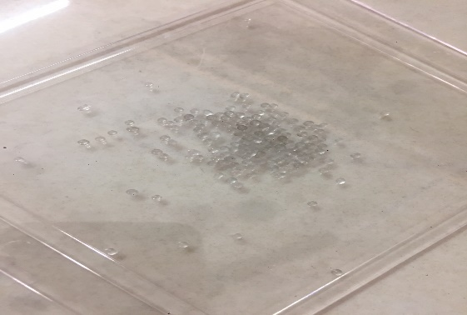

1. surface activation of glass beads

for surface activation of glass beads take 50 gm of glass beads in beaker then 15 ml 30% v/v NaOH was added (15 gm of NaOH pallets in 50 ml of distilled water) then 15 ml 6% H2 O 2 , in next heat the whole contain for 15 min then filter and dry the beads. After this experiment was followed by piranha solution treatment.(H2 So4 30% v/v + H2 O2 6% ) and then heated for 60 min at 90 ˚C. Then beads were dried with suitable process and then organofunctionalized process of glass beads was done

1. Synthesis of organo-functionalized glass beads

From the activated glass beads 50g of glass beads were taken then 100 ml of toluene and 5 ml of 3-aminoPropyl-tiethoxysilane were added. The mixture was stirred under reflux for 18 h. Then beads were removed from solution by filtration and kept in the oven at 110 ˚C for 2 to 3 h.

From the activated glass beads 50g of glass beads. Triethylamine (4 g) and 150 ml dry cyclohexane were charged into a three-necked 250ml round-bottom flask. In next phthaloyl Chloride was added drop wise and stirred well for 30 min. then reaction mixture was stirred at 25 c for 3 h.

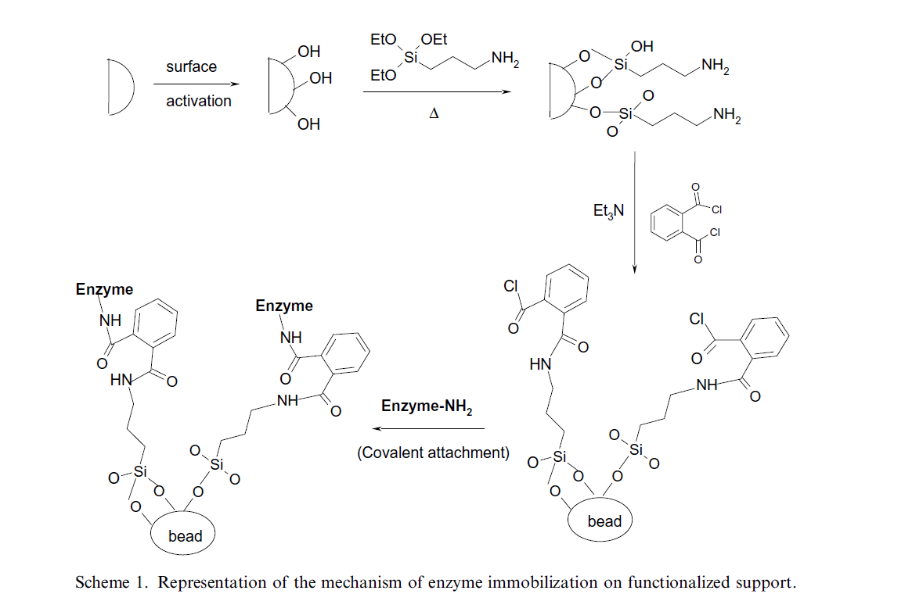

**2.3 Characterization of immobilized enzyme**

FTIR analysis of the support beads was carried out. FTIR was done from laboratory of Charuset University, Changa, Anand, Gujarat. SEM for analysis of natural support (k-carrageenan) beads was done from laboratory SICART (Sophisticated Instrumentation Center for Applied Research & Testing) Anand, Gujarat.

**2.4 Preparation of juice.**

Freshly picked up pineapples were taken and kept at normal room temperature. Pineapple was washed properly and outer skin was removed from it, then fresh juice was made by normal mixture without adding any extra things. After complete filter process, 150 ml of juice was separate out in a beaker to perform assay method.

**2.5 Treatment of immobilized α –amylase to check reusability**

5 ml of juice from was taken in test vial; 0.5 ml of starch solution was added. After adding beads of immobilized enzyme contains 0.05 g of enzyme and phosphate buffer solution (pH=6.9) was incubated at room temperature for 10 minutes. 2 ml of 3, 5-dinitrosalicylic acid was added and vail was incubated in boiling water bath for 10 minutes reducing sugar was determine by spectrophotometer at 540 nm.

**2.6** *p****H* activity profile**

As enzymes consist of protein, the catalytic activity is markedly affected by environmental conditions, especially the *pH* of the aqueous medium. Thus, information on changes in *pH*-activity behavior caused by the immobilization of enzymes is useful for an understanding of the structure-function relationship of enzyme protein. Hence, the activity of the free and immobilized α –amylase has been measured by incubating free and immobilized enzymes at 27 °C for 30 min in the 50 mm phosphate buffers of different pH ranging from 5 to 9 and using ethanol as a substrate. The absorbance of the reaction mixture was measured at 540 nm and correlated to the concentration of the enzyme. From the calibration, plot activity of the enzyme was determined.

**2.7 Thermal stability**

Because of the immobilization of enzyme the heat stability is enhanced, it is advantageous for the industrial application of immobilized enzymes and is thus important in determining the feasibility of immobilized enzymes for a particular application. Therefore, the thermal stability of free and immobilized enzymes was investigated. Free and immobilized enzymes were placed in the optimum pH buffer and incubated at different temperatures (30 to 70 °C) for different time intervals, activity of the enzyme was then determined as described earlier Thermal deactivation constant (Kd) was calculated by using the following equation :

Ln At = In Ao - Kd (t)

Where ‘Ao’ is the initial activity and ‘At’ is the activity after heat-treat for minutes**.**

**3. Result and Discussion**

**3.1 *pH* study**

Every enzyme has an optimum *pH* at which it shows optimum activity. **Figure 2** shows the *pH* activity of free and bounded α –amylase. We have observed that free and entrapped enzyme was showing maximum of 5 to 9 *pH* Change. This shows effect of enzyme immobilization.

***Fig:-2 pH* activity graph of free and immobilized α-amylase on glass beads.**

**3.2 Thermal Stability:**

Enzymes is temperature-dependent. When the temperature increases enzyme reactivity increases and beyond a definite limit, it gets deactivated. **Figure 3** shows that entrapped enzyme show better thermal stability compared to free enzyme. The entrapped enzyme showed better thermal stability as they are encapsulated within the beads.

**Fig:-3 Thermal stability comparative graph of free and immobilized** α-amylase glass beads

**3.3 Storage stability**

For study of residual activities of the free and immobilized enzymes stored at room temperature (30 °C) were determined and the activities were expressed as percentage retention of their residual activities at different times. Immobilized beads were also kept at 5 °C for 56 days and residual activity was examine after every 7 days. Storage stability graph is shown in fig-5.

**Fig:-5 Storage stability graph of free and immobilized α-amylase on glass beads.**

**3.4 FTIR analysis**

FTIR analysis of bead was done. FTIR analysis shows the chemical presence of specific chemical groups of enzyme. Spectra were recorded in the spectral range of 4000 – 500 cm-1. α-amylase have amide group in its structure. 1639.70 cm-1 show the bond starching vibration of amide. 3519.38 cm-1 shows OH starching vibration.

****

Fig:-6 FTIR of α-amylase immobilized glass beads.

**3.5 SEM analysis (Scanning electron microscopy)**

SEM analysis of bead in which have enzyme was entrapped, purpose of this study was to obtain a topographical Characterization of the support beads. SEM photographs were taken using a scanning electron microscope, at required magnification at room temperature. Working distance of 6.5 mm was maintained, and the acceleration voltage used was 20 kV, with the secondary electron image (SEI) as the detector.

C:\Users\Guddi\AppData\Local\Microsoft\Windows\INetCache\Content.Word\S5.tifC:\Users\Guddi\AppData\Local\Microsoft\Windows\INetCache\Content.Word\S5_003.tif

Fig:-7 SEM analysis of α-amylase immobilized glass beads.

**3.6 Reusability of bead:**

Reusability has great importance in industries. It was checked by using beads in the assay method in place of free enzyme solution. The reusability of entrapped enzyme beads was checked as shown in. **Figure-8** bounded enzyme employed approx. 50-55% of its enzyme reactivity after 8 rotations and 20-24 % activity after 10 cycles showing the advantage of immobilized enzyme and which increases its applicability.

Fig:-8 Reusability graph of immobilized α-amylase

**References:-**

1. Aikat K, Bhattacharyya BC (2001) Regeneration of activated Charcoal used in decolorization and purification of crude protease from Rhizopus oryzae. Biotechnol lett 23:1915-1919.

2. Alvarez S, Alvarez R, Riera FA, Coca J (1998) Influence of depectinization on apple juice ultrafiltration. Colloids surf A 138:377-382.

3. Charles, M., Coughlin, R. W., Paruchuri, E. K., Allen, B. R., and Hassel Berger, F. X., Enzymes immobilized on alumina and stainless steel supports, *Biotechnol. Bioeng.,*15, 395, 1975.

4. Falb, R. D., Immobilization of enzymes: overview, in *Enzyme Engineering,* Wingard, L. B., Jr., Ed., Interscience, New York, 1972, 177.

5. Green, M. L. and Crutchfield, G., Studies on preparation of water-insoluble derivatives of rennin and chymotrypsin and their use in the hydrolysis of casein and the clotting of milk, *Biochem. J.,* 115, 183, 1969.

6. B.A. van der Veen, G.J.W.M. van Alebeek, J.C.M. Uitdehaag,B.W. Dijkstra, L. Dijkhuizen, Eur. J. Biochem. 267 (2000) 658.

7. M. Alcalde, F.J. Plou, M.T. Mart´ın, I. Valdés, E. Méndez, A. Ballesteros, J. Biotechnol. 86 (2001) 71.

8. J.A. Rendleman, Biotechnol. Appl. Biochem. 24 (1996) 121.

9. M.T. Mart´ın, M. Alcalde, F.J. Plou, L. Dijkhuizen, A. Ballesteros, Biocatal. Biotransform. 19 (2001) 21.

10. Maniecki, Tomasz P. "The applications of metal-supported chromium-alumina catalysts in C1 reactions." *Catalysis today* 176.1 (2011): 215-218.

11. Nilsson, K.G.I. and Birnbaum, S., *J. Chromatography,* 1991, 587, 268.

12. Kanapieniene, J.J., Kiuberis, J.M. and Simkus, R.A., *Zn. Anal. Khim.,*1992, 47, 2023.

13. Ji, X. And Shang, Y., *FenxiHuaxue,* 1993,21,267.

14. Mertens, R., Lemiere, G.L., Lepovivre, J.A. and Alderweireldt, F.C.,*Biocatalysis,* 1989, 2, 121.

15. Ikeda, T., Kobayashi, D., Matsushita, F,, Sagara, T. and Niki, K,, *J. Electroanal. Chem.,* 1993, 36, 221,

16. Egerer, P„ Haese, W., Schmidt, K. and Perrey, H., DE 1984, 3,416,142.

17. Dwivedi, Sangam L., et al. "Enhancing crop gene pools with beneficial traits using wild relatives." *Plant breeding reviews* 30 (2008): 179-230.

18. *Ramasubbu N, Paloth V, Luo Y, Brayer GD, Levine MJ (May 1996).*[*"Structure of human salivary alpha-amylase at 1.6 Å resolution: implications for its role in the oral cavity"*](https://doi.org/10.1107%2FS0907444995014119)*. Acta Crystallographica D.****52****(3): 435–446.*[*doi*](https://en.wikipedia.org/wiki/Doi_(identifier))*:*[*10.1107/S0907444995014119*](https://doi.org/10.1107%2FS0907444995014119)*.*[*PMID*](https://en.wikipedia.org/wiki/PMID_(identifier))[*15299664*](https://pubmed.ncbi.nlm.nih.gov/15299664)*.*

*19. Rejzek M, Stevenson CE, Southard AM, Stanley D, Denyer K, Smith AM, Naldrett MJ, Lawson DM, Field RA (March 2011). "Chemical genetics and cereal starch metabolism: structural basis of the non-covalent and covalent inhibition of barley β-amylase". Molecular BioSystems.****7****(3): 718–730.*[*doi*](https://en.wikipedia.org/wiki/Doi_(identifier))*:*[*10.1039/c0mb00204f*](https://doi.org/10.1039%2Fc0mb00204f)*.*[*PMID*](https://en.wikipedia.org/wiki/PMID_(identifier))[*21085740*](https://pubmed.ncbi.nlm.nih.gov/21085740)*.*[*S2CID*](https://en.wikipedia.org/wiki/S2CID_(identifier))[*45819617*](https://api.semanticscholar.org/CorpusID:45819617)*.*

*20.* [*"Effects of pH (Introduction to Enzymes)"*](http://www.worthington-biochem.com/introbiochem/effectspH.html)*. worthington-biochem.com. Retrieved 17 May 2015.*

*21.* [*"Amylase, Alpha, I.U.B.: 3.2.1.11,4-α-D-Glucan glucanohydrolase"*](http://www.worthington-biochem.com/BA/default.html)*.***^** *Wadler J (8 September 2009).*

*22.* [*"Chew It Up, Spit It Out, Then Brew. Cheers!"*](https://www.nytimes.com/2009/09/09/dining/09beer.html?pagewanted=all&_r=0)*. New York Times. Retrieved 27 March 2*

23. [**^**](https://en.wikipedia.org/wiki/Amylase#cite_ref-7) *Morren MA, Janssens V, Dooms-Gossens A, Van Hoeyveld E, Cornelis A, De Wolf-Peeters C, Heremans A (November 1993). "alpha-Amylase, a flour additive: an important cause of protein contact dermatitis in bakers". Journal of the American Academy of Dermatology.****29****(5 Pt 1): 723–728.*[*doi*](https://en.wikipedia.org/wiki/Doi_(identifier))*:*[*10.1016/0190-9622(93)70237-n*](https://doi.org/10.1016%2F0190-9622%2893%2970237-n)*.*[*PMID*](https://en.wikipedia.org/wiki/PMID_(identifier))[*8227545*](https://pubmed.ncbi.nlm.nih.gov/8227545)*.*

24. [**^**](https://en.wikipedia.org/wiki/Amylase#cite_ref-8) *Park HS, Kim HY, Suh YJ, Lee SJ, Lee SK, Kim SS, Nahm DH (September 2002). "Alpha amylase is a major allergenic component in occupational asthma patients caused by porcine pancreatic extract". The Journal of Asthma.****39****(6): 511–516.*[*doi*](https://en.wikipedia.org/wiki/Doi_(identifier))*:*[*10.1081/jas-120004918*](https://doi.org/10.1081%2Fjas-120004918)*.*[*PMID*](https://en.wikipedia.org/wiki/PMID_(identifier))[*12375710*](https://pubmed.ncbi.nlm.nih.gov/12375710)*.*[*S2CID*](https://en.wikipedia.org/wiki/S2CID_(identifier))[*23522631*](https://api.semanticscholar.org/CorpusID:23522631)*.*

25. [**^**](https://en.wikipedia.org/wiki/Amylase#cite_ref-9) [*"Sollpura"*](https://web.archive.org/web/20150718042137/http:/www.anthera.com/pipeline/science/sollpura.html)*. Anthera Pharmaceuticals. Archived from*[*the original*](http://www.anthera.com/pipeline/science/sollpura.html)*on 18 July 2015. Retrieved 21 July 2015.*