**A STUDY ON STRESS MANAGEMENT TOWARDS HOSPITAL EMPLOYEES WITH REFERENCE TO NAMAKKAL**

**Priyankadevi V1, Jayasuriya J2**

1Assistant Professor, Department of MBA, Paavai Engineering College, Namakkal, Tamilnadu, India

2PG Student, Department of MBA, Paavai Engineering College, Namakkal, Tamilnadu, India

**ABSTRACT**

This research paper is to know the reasons for stress among hospital employees. Increasing work pressure, financial needs and recent technology are some factors that increase stress for the employee. This is based upon the current study made on above topic. It is clearly picturing the problem of hospital employee faces at work place and causes for stress in employee. Stress is unavoidable on the part of employees irrespective of the gender. Stress management is an art and not all can do it well.

**Keywords:** Stress; Work Pressure; Stress Management; hospital Employee

**1.INTRODUCTION**

Occupational stress Managements is a broad term which encompasses education, facilitation and training in the impact that stress is having on an individual or group. The field of stress managements teaches and promotes skills to relieve the accumulated. Stress management is a wide spectrum of techniques and psychotherapies aimed at controlling a person's level of stress, especially chronic stress, usually for the purpose of and for the motive of improving everyday functioning. Stress produces numerous physical and mental symptoms which vary according to each individual's situational factors.

**2.METHODOLOGY**

According to industrial research institute in research methodology, research always tries to search the given question systematically in our own way and find out all the answers till conclusion. For finding or exploring research questions, a researcher faces lot of problems that can be effectively resolved with using correct research methodology.

**2.1 Sample size**

The sample size in the study is 80.

**2.2 Statistical tools**

* Simple percentage method
* Chi-square test

**PERCENTAGE METHOD**

This method is used to compare two or more series of data, to describe the relationship or the distribution of two or more series of data. Percentage analysis test is done to find out the percentage of the response of the response of the respondent. In this tool various percentage are identified in the analysis and they are presented by the way of Bar Diagrams to have better understanding of the analysis.

No. of Respondents

Percentage = ……………………………… X 100

Total Respondents

**CHI-SQUARE TEST**

It is one of the simplest and widely used non-parametric test in statistical work. The quantity chi-square describes the magnitude of the discrepancy between theory and observation. Which is defined as?

Chi – Square = $\frac{∑\left(oi-Ei\right)2}{Ei}$

Oi = Observed frequency, Ei = Expected frequency

In general, the expected frequency for any can be calculated from the following equations

E = $\frac{RT X CT}{N}$

E = Expected frequency, CT = Column total,

RT = Row total, N = Total number of observations

**3.DATA ANALYSIS AND INTERPRETATION**

**1) GENDER OF THE RESPONDENTS**

The data collected here represents the gender of the respondents. It shows the respondents is male or female.

**TABLE NO- 3.1**

**GENDER OF THE RESPONDENTS**

|  |  |  |
| --- | --- | --- |
| **GENDER** | **NO. OF RESPONDENTS** | **PERCENTAGE (%)** |
| Male | 36 | 45% |
| Female | 44 | 55% |
| **Total** | **80** | **100%** |

**Sources: Primary data**

**INTERPRETATION**

The above table shows that gender of the respondents, 45% of the respondents are male, 55% of the respondents are female. Majority 55% of the respondents are female.

**CHART NO - 3.1**

**GENDER OF THE RESPONDENTS**

**2) AGE OF THE RESPONDENTS**

The data collected here represents the age of the respondents. The list of respondents age criteria.

**TABLE NO - 3.2**

**AGE OF THE RESPONDENTS**

|  |  |  |
| --- | --- | --- |
| **AGE** | **NO. OF RESPONDENTS** | **PERCENTAGE (%)** |
| Below 25 years | 21 | 26% |
| 25 – 30 years | 24 | 30% |
| 30 – 35 years | 22 | 28% |
| Above 35 years | 13 | 16% |
| **Total** | **80** | **100%** |

**Source: Primary data**

**INTERPRETATION**

The above table shows that age of the respondents, 26% of the respondents are below 25 years, 30% of the respondents are between the ages of 25 – 30 years, 28% of the respondents are between the ages of 30 – 35 years and remaining 16% of the respondents are above 35 years**.** Majority 30% of the respondents are between the ages of 25 – 30 years

**CHART NO - 3.2**

**AGE OF THE RESPONDENTS**

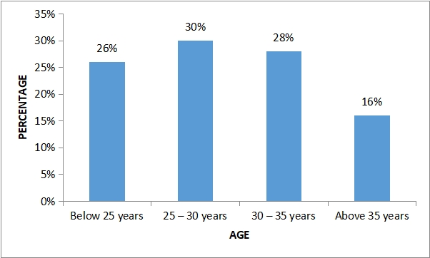

**3) WORK PRESSURE IN THIS ORGANIZATION**

It analyses the work pressure undergone by the employee while working in Hospitals.

**TABLE NO - 3.3**

|  |  |  |
| --- | --- | --- |
| **WORK PRESSURE** | **NO. OF RESPONDENTS** | **PERCENTAGE (%)** |
| Always | 24 | 30% |
| Often | 22 | 27% |
| Sometimes | 22 | 28% |
| Never | 12 | 15% |
| **Total** | **80** | **100%** |

**INTERPRETATION**

The above table shows that work pressure in this organization, 30% of the respondents said always work pressure in this organization, 27% of the respondents said often work pressure in this organization, 28% of the respondents said sometimes work pressure in this organization and remaining 15% of the respondents said never work pressure in this organization. Majority 30% of the respondents said always work pressure in this organization

**CHART NO - 3.3**

**WORK PRESSURE IN THIS ORGANIZATION**

**4) FEEL ABOUT WORKING IN THE HOSPITAL**

It represents the type of feeling employee has while working in hospitals.

**TABLE NO - 3.4**

**FEEL ABOUT WORKING IN THE HOSPITAL**

|  |  |  |
| --- | --- | --- |
| **FEEL ABOUT WORKING** | **NO. OF RESPONDENTS** | **PERCENTAGE (%)** |
| Great | 22 | 27% |
| Satisfied | 25 | 31% |
| Depressed | 18 | 23% |
| Frustrated | 15 | 19% |
| **Total** | **80** | **100%** |

**Source: Primary data**

**INTERPRETATION**

The above table shows that feel about working in the hospital, 27% of the respondents are great, 31% of the respondents are satisfied with working in the organization, 23% of the respondents are depressed with working in the organization and 19% of the respondents are frustrated with working in the organization.

Majority 31% of the respondents are satisfied with working in the organization

**CHART NO - 3.4**

**FEEL ABOUT WORKING IN THE ORGANIZATION**

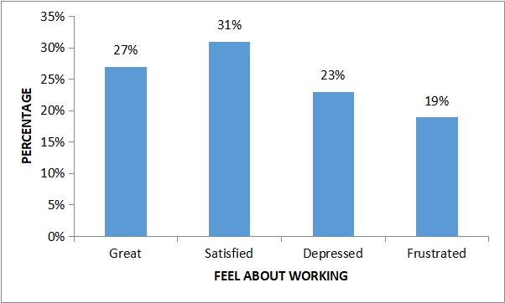

**5) FACE STRESS SITUATION IN ORGANIZATION**

It represents the stress situation respondents facing inside the working place.

**TABLE NO - 3.5**

**FACE STRESS SITUATION IN ORGANIZATION**

|  |  |  |
| --- | --- | --- |
| **FACE STRESS SITUATION** | **NO. OF RESPONDENTS** | **PERCENTAGE (%)** |
| Mostly | 41 | 51% |
| Rarely | 18 | 23% |
| Sometimes | 12 | 15% |
| Not at all | 9 | 11% |
| **Total** | **80** | **100%** |

**Source: Primary data**

**INTERPRETATION**

The above table shows that face stress situation in organization, 51% of the respondents are mostly face stress situation, 23% of the respondents are rarely face stress situation, 15% of the respondents are sometimes face stress situation and 11% of the respondents are not at all face stress situation in organisation. Majority 51% of the respondents are mostly face stress situation in organisation.

**CHART NO - 3.5**

**FACE STRESS SITUATION IN ORGANIZATION**

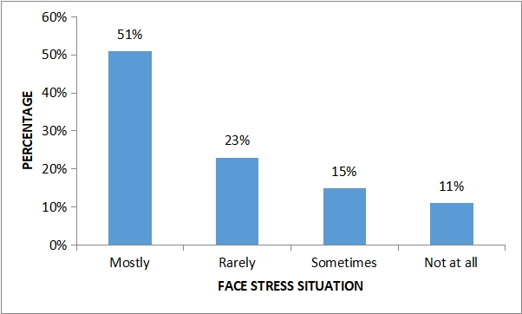

**6) STRESS CAUSING FACTORS**

It represents the factors causing stress to the respondents. Major difficulties gone through by the respondents.

**TABLE NO - 3.6**

**STRESS CAUSING FACTORS**

|  |  |  |
| --- | --- | --- |
| **STRESS CAUSING FACTORS** | **NO. OF RESPONDENTS** | **PERCENTAGE (%)** |
| Work load | 31 | 39% |
| Work environment | 25 | 31% |
| Dealing with Patients | 17 | 21% |
| Others | 7 | 9% |
| **Total** | **80** | **100%** |

**Source:** Primary data

**INTERPRETATION**

The above table depicts thatstress are related to, 39% of the respondents are facing work load related stress, 31% of the respondents are facing work environment related stress, 21% of the respondents are dealing with patients related stress, 9% of the respondents are facing others related stress

Majority 39% of the respondents are facing work load related stress

**CHART NO - 3.6**

**STRESS CAUSING FACTORS**

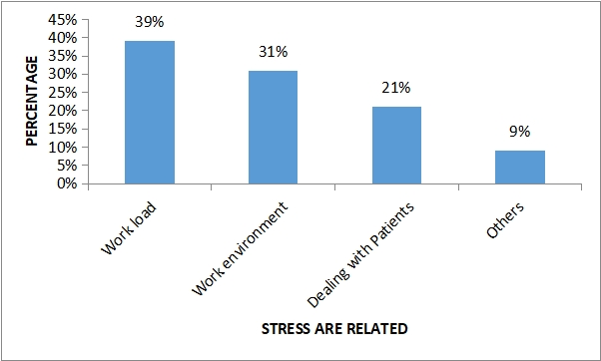

**7) WAY THAT STRESS AFFECTS WORK**

It represents the ways that stress affects the respondents mentally and physically.

**TABLE NO - 3.7**

**WAY THAT STRESS AFFECTS WORK**

|  |  |  |
| --- | --- | --- |
| **STRESS AFFECTS** | **NO. OF RESPONDENTS** | **PERCENTAGE (%)** |
| Health issues | 27 | 34% |
| Lack of concentration | 24 | 30% |
| Absenteeism | 15 | 19% |
| Others | 14 | 17% |
| **Total** | **80** | **100%** |

**Source:** **Primary data**

**INTERPRETATION**

The above table shows that way of stress affects at work, 34% of the respondents said stress affects health issues, 30% of the respondents said stress affects lack of concentration, 19% of the respondents said stress leads to absenteeism and remaining 17% of the respondents are other reason**.** Majority 34% of the respondents said stress affects health issues

**CHART NO - 3.7**

**WAY THAT STRESS AFFECTS WORK**

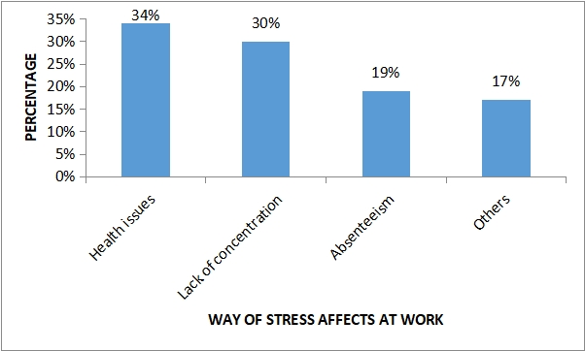

**8) ATTEND STRESS RELATED TRAINING**

It represents the number of respondents attending the stress related training.

**TABLE NO - 3.8**

**ATTEND STRESS RELATED TRAINING**

|  |  |  |
| --- | --- | --- |
| **ATTEND STRESS TRAINING** | **NO. OF RESPONDENTS** | **PERCENTAGE (%)** |
| Yes | 56 | 70% |
| No | 24 | 30% |
| **Total** | **80** | **100%** |

**Source:** Primary data

**INTERPRETATION**

The above table shows that attend stress related training, 70% of the respondents are attending stress related training and 30% of the respondents are not attending stress related training.

Majority 70% of the respondents are attending stress related training.

**CHART NO - 3.8**

**ATTEND ANY STRESS RELATED TRAINING**

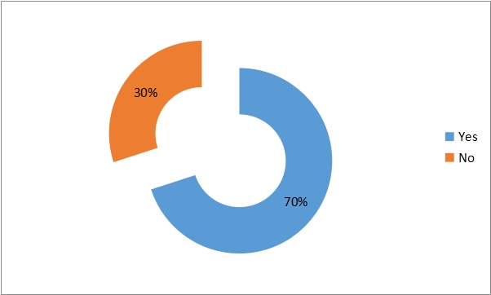

**9) WAYS TO REDUCE STRESS**

It represents the various ways to reduce stress among employee, so that the employee can work freely.

**TABLE NO - 3.9**

**WAYS TO REDUCE STRESS**

|  |  |  |
| --- | --- | --- |
| **WAYS TO REDUCE STRESS** | **NO. OF RESPONDENTS** | **PERCENTAGE (%)** |
| Meditation | 25 | 31% |
| Physical exercise | 32 | 40% |
| Connect with others | 18 | 23% |
| Others | 5 | 6% |
| **Total** | **80** | **100%** |

**INTERPRETATION**

The above table shows that 31% of the respondents are doing meditation to reduce stress, 40% of the respondents are doing physical exercise to reduce stress, 23% of the respondents are connect with others to reduce stress, 6% of the respondents are doing other ways to reduce stress.

Majority 40% of the respondents are doing physical exercise to reduce stress

**CHART NO - 3.9**

**WAYS TO REDUCE STRESS**

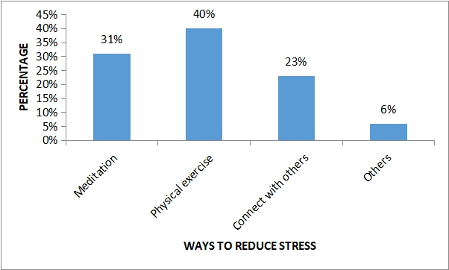

**TABLE NO - 3.10**

**RELATIONSHIP BETWEEN THE AGE OF THE RESPONDENTS AND WORK PRESSURE IN THIS ORGANIZATION**

The table shows the analysis of relationship between age of the respondents and work pressure in this organization.

|  |  |  |  |  |  |
| --- | --- | --- | --- | --- | --- |
| **Age / Work pressure** | **Always** | **Often** | **Sometimes** | **Never** | **Total** |
| **Below 25 years** | 6 | 6 | 6 | 3 | **21** |
| **25 – 30 years** | 7 | 7 | 7 | 3 | **24** |
| **30 – 35 years** | 7 | 6 | 6 | 3 | **22** |
| **Above 35 years** | 4 | 3 | 3 | 3 | **13** |
| **Total** | **24** | **22** | **22** | **12** | **80** |

**Source: Primary Data**

**NULL HYPOTHESIS**

**Ho:** There is no significance relationship between age of the respondents and work pressure in this organization.

**ALTERNATIVE HYPOTHESIS**

**H1:**There is a significance relationship between age of the respondents and work pressure in this organization.

|  |  |  |  |  |
| --- | --- | --- | --- | --- |
| **Particulars** | **Observed Frequency** | **Expected Frequency** | **(O-E)2** | **(O-E)2**  **E** |
| R1 C1 | 6 | 6.3 | 0.09 | 0.014 |
| R1 C2 | 6 | 5.7 | 0.09 | 0.015 |
| R1 C3 | 6 | 5.7 | 0.09 | 0.015 |
| R1 C4 | 3 | 3.0 | 0 | 0 |
| R2 C1 | 7 | 7.0 | 0 | 0 |
| R2 C2 | 7 | 6.6 | 0.16 | 0.024 |
| R2 C3 | 7 | 6.6 | 0.16 | 0.024 |
| R2 C4 | 4 | 3.6 | 0.16 | 0.044 |
| R3 C1 | 7 | 6.6 | 0.16 | 0.024 |
| R3 C2 | 6 | 6.0 | 0 | 0 |
| R3 C3 | 6 | 6.0 | 0 | 0 |
| R3 C4 | 3 | 3.3 | 0.09 | 0.027 |
| R4 C1 | 4 | 3.7 | 0.09 | 0.024 |
| R4 C2 | 3 | 3.5 | 0.25 | 0.171 |
| R4 C3 | 3 | 3.5 | 0.25 | 0.071 |
| R4 C4 | 2 | 1.7 | 0.09 | 0.052 |
| **Calculated value** | | | | **0.505** |

Degree of freedom : (r – 1) (c – 1) = (4– 1) (4– 1) = 9

Level of significance : 5%

Table value : 7.378

Calculated value : 0.505

**RESULT**

Since the calculated value is less than the table value. So we accept the null hypothesis. There is no relationship between age of the respondents and work pressure in this organization.

**4.RESULTS AND DISCUSSION**

**4.1FINDINGS**

1. Majority 55% of the respondents are female.
2. Majority 30% of the respondents are between the ages of 25 – 30 years
3. Majority 30% of the respondents said always work pressure in this organization
4. Majority 31% of the respondents are satisfied with working in the organization
5. Majority 51% of the respondents are mostly face stress situation in organisation.
6. Majority 39% of the respondents are facing work load related stress
7. Majority 34% of the respondents said stress affects health issues
8. Majority 70% of the respondents are attending stress related training.
9. Majority 40% of the respondents are doing physical exercise to reduce stress

**4.2 SUGGESTIONS**

1. Occupational stress is one of the major health hazards of the modern workplace, it accounts for much of the physical illness, substance abuse, and family problems experienced by workers. Also, occupational stress and stressful working conditions have been linked to low productivity, absenteeism, and increased rates of accidents on and off the job. From this study it is concluded that the occupational stress in the organization is low.
2. Correct stress management should start from improved health and good interpersonal relationships. The prevention and management of workplace stress requires organizational level interventions, because it is the organization that creates the stress.
3. Success in managing and preventing stress will depend on the culture in the organization. A culture of openness and understanding, rather than of criticism, is essential. Those house officers who had high level of job stress had low job performance.

**4.3 CONCLUSION**

There are significantly different on severity level among medical professional, medical support, and general support divisions due to those three divisions have different nature of work. Every division experiences different job stress, job pressure, and lack of organisational support. However, the different level of frequency and stress index is insignificant among three divisions. The result revealed that people who work in the medical division have a higher level of stress compare to other divisions. It is unsurprisingly since medical professionals are the key players in the health industry. In general, the work stress of employees in the hospital where research takes place classified as moderate. This condition must be maintained by the management by carrying out stress management program in the hospital to prevent work stress goes into a worse situation in the future

**5. REFERENCES**

**[1] Beehr, t., & newman, j. (1978).** Job Stress, employee health, and organizational effectiveness: a facet analysis, model, and literature review. Personnel Psychology, 31(4), 665-699. http://dx.doi.org/10.1111/j.1744-6570.1978.tb02118.x

**[2] Borg, M., Riding, R., & Falzon, J. (1991).** Stress in Teaching: a study of occupational stress and its determinants, job satisfaction and career commitment among primary schoolteachers. Educational Psychology, 11(1), 59-75. <http://dx.doi.org/10.1080/0144341910110104>

**[3] Davis, K., & Newstrom, J. (1985).** Human behavior at work: organizational behavior. New Delhi: McGraw-Hill.

**[4] Devi,A. (2007).** Occupational stress: a comparative study of women in differentoccupations. Trajan, 35(1), 61-73.

**[5] Dhanalakhsmi, R. (2008).** Factors predicting stress of employees in a public transport corporation. SMART Journal Of Business Management Studies, 4(1), 59—62.

**[6] Jha, S. (1988).** Job stress and employee strain in Indian executives. Work & Stress, 2(3), 233-237. <http://dx.doi.org/10.1080/02678378808259171>.

**[7] Kang, L. (2005).** Stressors among medical representatives: an empirical investigation. Indian Journal Of Industrial Relations, 40(3), 336—356

**WEBSITES**

https://my.clevelandclinic.org/health/articles/11874-stress

https://www.mind.org.uk/information-support/types-of-mental-health-problems/stress/what-is-stress/